Supplementary Information

This information has been provided by the authors to give readers additional information about their work.
Supplement to:
Holm H, Ivarsdottir EV, Olafsdottir Th, et al.
Symptoms, physical measures and cognitive tests after SARS-CoV-2 infection in a large population-based case-control study

Symptoms, physical measures and cognitive tests after SARS-CoV-2 infection in a large population-based case-control study

Hilma Holm¹, M.D.*, Erna V. Ivarsdottir¹, Ph.D.*, Thorhildur Olafsdottir¹, Ph.D.*, Rosa Thorolfsdottir¹, M.D., Ph.D., Elias Eythorsson², M.D., Ph.D., Kristjan Norland¹, Ph.D., Rosa Gisladottir¹, Ph.D., Gudrun Jonsdottir¹, Ph.D., Unnur Unnsteinsdóttir¹, Ph.D., Kristin E. Sveinsdottir¹, B.Sc, Benedikt A. Jonsson¹, M.Sc., Margret Andresdottir¹, M.Sc., David O. Arnar^{1,2,3}, M.D., Ph.D, Asgeir O. Arnthorsson¹, M.Sc., Kolbrún Birgisdóttir¹, B.Sc., Kristbjorg Bjarnadottir¹, Ph.D., Sólveig Bjarnadóttir^{2,3}, Gyda Bjornsdottir¹, Ph.D., Gudmundur Einarsson¹, Ph.D., Berglind Eiriksdottir¹, Elisabet Eir Gardarsdottir¹, Thorarinn Gislason^{2,3}, M.D., Ph.D., Magnus Gottfredsson^{2,3}, M.D., Ph.D, Steinunn Gudmundsdottir¹, M.Sc., Julius Gudmundsson¹, Ph.D., Kristbjorg Gunnarsdóttir¹, M.Sc., Anna Helgadottir¹, M.D., Ph.D., Dadi Helgason², M.D., Ph.D., Ingibjorg Hinriksdottir⁴, M.D., Ragnar F. Ingvarsson² , M.D, Sigga S. Jonasdottir¹, Ph.D., Ingileif Jonsdottir¹, Ph.D., Tekla H. Karlsdottir¹, M.D., Anna M. Kristinsdottir¹, M.Sc., Sigurdur Yngvi Kristinsson^{2,3}, M.D., Ph.D., Steinunn Kristjánsdóttir¹, B.Sc., Thorvardur J. Love^{2,3}, M.D., Ph.D., Dora Ludviksdottir^{2,3}, M.D., Ph.D., Gisli Masson¹, Ph.D, Gudmundur Norddahl¹, Ph.D., Thorunn Olafsdottir¹, Ph.D., Isleifur Olafsson⁵, M.D., Ph.D., Thorunn Rafnar¹, Ph.D., Hrafnhildur L. Runolfsdottir², M.D., Ph.D., Jona Saemundsdottir¹, B.Sc., Svanur Sigurbjornsson¹, M.D., Kristin Sigurdardottir¹, M.D., Engilbert Sigurdsson^{3,6}, M.D., M.Sc., Martin I. Sigurdsson^{3,7}, M.D., Ph.D., Emil L. Sigurdsson^{8,9}, M.D., Ph.D., Valgerdur Steinthorsdottir¹, Ph.D., Gardar Sveinbjornsson¹, M.Sc., Emil A. Thorarensen¹, B.Sc., Bjarni Thorbjornsson¹, B.Sc., Brynja Thorsteinsdóttir¹, B.Sc., Vinicius Tragante¹, Ph.D., Magnus O. Ulfarsson^{1,10}, Ph.D., Hreinn Stefansson¹, Ph.D., Thorsteinn Gislason¹, M.D., Runolfur Palsson^{2,3}, M.D., Mar Kristjansson², M.D., Patrick Sulem¹, M.D., Unnur Thorsteinsdottir^{1,3}, Ph.D., Gudmundur Thorgeirsson^{1,3}, M.D., Ph.D., Daniel F. Gudbjartsson^{1,11}, Ph.D., Kari Stefansson^{1,3}, M.D., Ph.D.

1. deCODE genetics/Amgen Inc., Reykjavik, Iceland
2. Internal Medicine and Emergency Services, Landspitali – The National University Hospital of Iceland, Reykjavik, Iceland
3. Faculty of Medicine, School of Health Sciences, University of Iceland, Reykjavik, Iceland.
4. National Institute of Hearing and Speech in Iceland, Reykjavik, Iceland
5. Clinical Laboratory Services, Diagnostics and Blood Bank, Landspitali – The National University Hospital of Iceland, Reykjavik, Iceland
6. Mental Health Services, Landspitali – The National University Hospital of Iceland, Reykjavik, Iceland
7. Perioperative Services, Landspitali – The National University Hospital of Iceland, Reykjavik, Iceland
8. Department of Family Medicine, University of Iceland, Reykjavik, Iceland
9. Development Centre for Primary Health Care in Iceland, Reykjavik, Iceland
10. Faculty of Electrical and Computer Engineering, University of Iceland
11. School of Engineering and Natural Sciences, University of Iceland, Reykjavik, Iceland

*Hilma Holm, Erna V. Ivarsdottir and Thorhildur Olafsdottir share first authorship.

Table of Contents
Supplementary Methods 5
Overview of the deCODE Health Study and changes to the study to address consequences of SARS-CoV-2 infection 5
The dHS online questionnaire on health and lifestyle 5
General Anxiety Disorder-7 6
Patient Health Questionnaire-9 6
Perceived Stress Scale 6
Short Health Anxiety Inventory 6
Satisfaction With Life Scale 6
36-Item Short Form Survey 6
Additional data for GAD-7, PHQ-9, PSS, SWLS and 36-SF from the iStopMM study. 7
The C19Q questionnaire 7
The Symptom Impact Questionnaire 7
Height and weight 8
Vital signs 8
5-minute orthostatic test 8
Body composition 8
Grip strength 8
Smell test 8
Taste test 9
Hearing test 9
Spirometry 10
Cardiopulmonary exercise test 10
Cognitive tests 10
Digit Coding 10
Letter and Category Fluency 11
Logical Memory 11
Spatial Working Memory 11
Trail Making Test 11
Wechsler Abbreviated Scale of Intelligence 11
Blood tests 11
Ambulatory sleep study 11
Confirmation of SARS-CoV-2 infection 12
Severity scale and categories 12
Batch effect in phenotypic measures 12
Association analyses 13
Comorbidities 14
Asthma 14
Cancer 14
Coronary artery disease 14
Hypertension 14
Immunocompromised state 14
Type 2 Diabetes 15
Chronic kidney disease 15
Liver disease 15
Supplementary Figures 16
Figure S1. Antibody levels and severity categories 16
Figure S2. Days from diagnosis of SARS-CoV-2 to visit at the deCODE Health Study 17
Figure S3. The correlation matrix for recent symptoms obtained from the C19Q questionnaire 18
Figure S4. Time trends in physiological measures 19
References 21

Supplementary Methods

Overview of the deCODE Health Study and changes to the study to address consequences of SARS-CoV-2 infection
The deCODE Health Study (dHS)¹ is an ongoing prospective cohort study in Iceland with extensive phenotypic and genotypic information produced and collected from the participants. More than 16,000 individuals have participated in the study since its initiation in June 2016, aged between 18 and 97 years at recruitment. Participants in the dHS are invited by letter to participate in the study. The letter is followed-up with a phone call to schedule the one study visit to the deCODE Recruitment Center, in Kopavogur, Iceland, and participants are asked to complete an online questionnaire before the visit. The average duration of the study visit is four hours and six minutes. At the beginning of the visit, participants sign an informed consent, undergo a verbal interview concerning their general and current health, vital signs are taken, and potential contraindications for participation in the study as a whole or any of the individual tests are assessed. Most measures and tests in the dHS have been unchanged since the beginning of the study: height and weight, blood pressure, heart rate, pulse oximeter, temperature, bone and whole-body dual-energy X-ray absorptiometry (DXA) scan, 2D hand imaging, 3D body scan, grip strength, smell test, hearing test, voice test, visual acuity, eye endothelial imaging, ocular biomechanics, intraocular pressure, optical coherence tomography eye scan, spirometry, electrocardiogram, and cardiopulmonary exercise test (CPET). Participants also undergo several cognitive tests: letter and category fluency test, trail making test, digit symbol substitution test, rapid visual processing and spatial working memory as well as The Mini International Neuropsychiatric Interview (MINI). Blood samples are collected. A subset of participants is invited to undergo an ambulatory sleep study. In January 2018 we stopped administering the CPET to make time for additional cognitive tests: Wechsler Abbreviated Scale of Intelligence (WASI) matrix reasoning and word comprehension. When we decided to use the dHS to study the health consequences of SARS-CoV-2 infection (the dHS Covid Study), we made the following changes to the study: we modified the online questionnaire (see below), added an on-site questionnaire on SARS-CoV-2 related effects (the C19Q questionnaire), added the Wechsler logical memory test, a 5 minute orthostatic test and reinstated the CPET. To allow time for these additional tests, we removed the following tests: rapid visual processing, the bone density DXA, 2D hand imaging, 3D body scan, eye endothelial imaging, ocular biomechanics and intraocular pressure. All tests are administered by trained staff, and physicians are present at the study site.

The dHS online questionnaire on health and lifestyle
Participants in the dHS are asked to complete the dHS online questionnaire before the study visit. The dHS online questionnaire was partly changed in preparation for the dHS Covid Study including the addition of the following validated questionnaires to assess symptoms of anxiety, depression, stress, and health anxiety: General Anxiety Disorder-7 (GAD-7),² Patient Health Questionnaire-9 (PHQ-9)³, Perceived Stress Scale (PSS),⁴ and Short Health Anxiety Inventory (SHAI)⁵ respectively, the Satisfaction With Life Scale (SWLS) and the 36-Item Short Form Survey (36-SF)⁶ to assess health-related quality of life.

General Anxiety Disorder-7
The 7-item anxiety scale, GAD-7 was used to evaluate symptoms of anxiety. The GAD-7 is considered a valid and efficient tool for screening for GAD and assessing its severity in clinical practice and research.² In particular, evidence supports reliability and validity of the GAD-7 as a measure of anxiety in the general population.⁷ The psychometric properties of the Icelandic translation of the GAD-7 have been tested and deemed satisfactory.

Patient Health Questionnaire-9
The depression module of the PHQ-9 was used to assess depressive symptoms. The PHQ-9 scores each of the 9 DSM-IV criteria for diagnosis of depression as “0” (not at all) to “3” (nearly every day). PHQ-9 has been deemed a reliable and valid measure of depression severity for use in both clinical and research settings.³ Psychometric properties of the Icelandic PHQ-9 were adequate in primary care (Pálsdóttir, V. E. (2007). Unpublished manuscript, Department of Psychology, University of Iceland.). The Icelandic translation of PHQ-9 was used here with the permission of its authors, Agnes Agnarsdottir, Hafrún Kristjánsdóttir, Jakob Smári, Jón Friðrik Sigurðsson and Pétur Tyrfingsson.

Perceived Stress Scale
Psychological stress during the last month was assessed using the 10-item Perceived Stress Scale (PSS-10). Acceptable psychometric properties of the PSS-10 have been established in various settings.⁸ Each of the 10 items are scored on a five-point Likert scale (0-4) with a total score ranging from 0 to 40.⁴ The Icelandic version of PSS-10 was used here with the permission of its author, Arna Hauksdottir. A shorter 4-item version of the Icelandic PSS has been used in studies of the effects of financial and natural disasters in Iceland.^{9,10}

Short Health Anxiety Inventory
Symptoms of health anxiety were assessed using the SHAI, a 14-item version of a full length scale with comparable properties.⁵ The Icelandic version of SHAI was used here with the permission of its authors, Pétur Tyrfingsson, Helgi Héðinsson and Inga Hrefna Jónsdottir. The translation was done in 2014 with the permission of Paul Salkovskis, the author of the original English version.

Satisfaction With Life Scale
Subjective overall wellbeing was evaluated with the Satisfaction With Life Scale (SWLS), a short 5-item instrument designed to measure global cognitive judgments of satisfaction with one's life.¹¹ Satisfactory validity and reliability of the scale have been widely tested and established.¹² The SWLS was translated to Icelandic by Daniel Olafsson and is used here with his permission. A study of a population-based sample of individuals over 40 concluded that the Icelandic version of SWLS is a reliable and valid measure of life satisfaction (Unnarsdottir, Gisladottir, Olafsdottir, 2018).

36-Item Short Form Survey
The short form 36 health survey questionnaire (SF-36, RAND 36-Item Health Survey 1.0) was used to evaluate health related quality of life. The SF-36 is a multifactorial tool which yields an eight-scale profile of scores as well as physical and mental health summary measures.⁶ It is a generic measure that does not target a specific age, disease or treatment group, and has been validated for use among various patient groups and for the general population.^{13,14} The Icelandic SF-36 questionnaire used for this study is based on a translation from GlaxoSmithKline, with minor changes. The original translation was done according to the standards of the International Quality of Life Assessment (IQOLA) project.¹⁵ We estimated the correlated physical health (PCSc) and mental health (MCSc) scores and uncorrelated scores; PCSuc and MCSuc.¹⁶

Additional data for GAD-7, PHQ-9, PSS, SWLS and 36-SF from the iStopMM study.
For additional analysis of GAD-7, PHQ-9, PSS, SWLS and 36-SF scores, we obtained data from the “Iceland Screens, Treats, or Prevents Multiple Myeloma” (iStopMM) study (ClinicalTrials.gov Identifier: NCT03327597). The iStopMM study is a population-based screening study for monoclonal gammopathy of undetermined significance (MGUS) and a randomized controlled trial of follow-up strategies that began in 2016. All 148,704 individuals in Iceland born in 1975 or earlier received a letter inviting them to participate. Participation is based on informed consent and data are stored using encrypted identifiers. A total of 80,759 (54%) provided informed consent to participate in the study. While the main outcome measure of iStopMM is the effect of early detection and treatment of multiple myeloma precursor on survival, a secondary goal is to understand the mental health effects associated with screening an entire population for a cancer precursor. Beginning in 2018 nearly sixty thousand participants who provided their email address have received questionnaires annually, excluding those patients who have been randomized for follow-up in iStopMM. Through iStopMM we thus obtained additional contemporary control data aquired during the pandemic, as well as historical data (before February 2020) for a subset of cases and contemporary controls, allowing for comparison of measures before and after the SARS-CoV-2 infection for cases, and similar analysis of longitudinal measure for controls.

The C19Q questionnaire
Participants answered a self-administered questionnaire on SARS-CoV-2 related effects (the C19Q) on a tablet computer at the study site. The questionnaire was designed by the study authors in Icelandic and has not been formally translated to other languages.
In addition to administering the C19Q in the dHS Covid Study starting in September 2020, we invited a random sample, matched with SARS-CoV-2 cases for age and sex, of pre-pandemic participants (historical controls) in the dHS to answer it online after September 2020 (additional C19Q controls). As of this analysis, 737 pre-pandemic participants (historical controls) in the dHS have answered the questionnaire between September 2020 and September 2021.

The Symptom Impact Questionnaire
The Symptom Impact Questionnaire (SIQR) was added to the C19Q after the study began, in November 2021, to assess symptoms of fatigue. The SIQR was translated to Icelandic by Gunnar Tomasson and Arnor Vikingsson with the permission of Robert Bennett and is used here with their permission and the permission of the Mapi Research Trust, provided by Ronald Friend. The translation was done using the FACIT-methodology that involves i) two independent forward translations by native Icelanders with excellent skills in English and insight into health measurement scales, ii) consolidation to a single Icelandic translation, iii) backward translation of the consolidated Icelandic version by a native English speaker iv) comparison of the original instrument in English and the back-translated version by two experienced clinical investigators with expertise in development and validation of health measurement scales and v) fine-tuning of the Icelandic translated instrument based on comments obtained in step iv).

Height and weight
Height and weight were measured with the seca 285 electronic measuring station (seca, Germany). Body mass index (BMI) was calculated in the standard manner, BMI = kg/m². Obesity was defined as BMI ≥ 30.

Vital signs
Resting blood pressure was measured according to guidelines¹⁷ using the SureSign Vs4 equipment (CIGA Healthcare Ltd, UK). The blood pressure was measured in the left arm unless contraindications were present, with the participant seated, using the appropriate size cuff and positioning the cuff at the level of the patient’s right atrium. The SureSign Vs4 equipment was also used to measure resting heart rate and oxygen saturation of peripheral arterial blood with a pulse oximeter.

5-minute orthostatic test
The 5-minute orthostatic test was administered directly following the electrocardiogram test. Supine blood pressure and heart rate were recorded after relaxation. Participant was then directed to stand up with their shoulders leaning against a wall and heels approximately 15 cm from the wall. Blood pressure and heart rate were immediately recorded and then again every minute for five minutes for a total of six recordings while standing. We used the SureSign Vs4 equipment (CIGA Healthcare Ltd, UK). Symptoms during test were recorded. The blood pressure and heart rate differences were calculated as the measures after 3 and 5 minutes subtracting the measures taken when lying down. Orthostatic hypotension (OH) cases were defined as those with a fall of >20 mmHg systolic or >10 mmHg diastolic after standing for 3 minutes. Postural orthostatic tachycardia (POTS) cases were defined as those with heart rate increase > 30 bpm after standing for 5 minutes.

Body composition
Body composition (distribution of lean and fat mass) was assessed using whole-body fan beam dual-energy X-ray absorptiometry (DXA) scan (Horizon QDR series System, S/N200547, Hologic Discovery A, Hologic Inc., Bedford, USA). The DXA equipment was calibrated daily and scans were performed by trained technicians according to manufacturer‘s instructions. The measures that we used from DXA in our analyses are lean mass index (LMI) and fat mass index (FMI).

Grip strength
Grip strength was measured in a standardized manner based on published recommendations using the JAMAR Hydraulic Hand Dynamometer¹⁸. Three measurements were performed for each hand and hand dominance was recorded. The maximum grip strength of the six measures was used for the analyses.

Smell test
The smell test in the dHS has been described in detail before¹⁹.
Odor perception was tested using 6 odor pens from Sniffin’ Sticks (Burghart Messtechnik GmbH, Wedel, Germany); licorice, cinnamon, fish, lemon, peppermint, and banana.^{20,21} The experimenter placed the odor pen approximately 2 cm in front of participants’ nose for 3 s. Participants were first asked to name the smell (odor naming task). Participants then provided an intensity rating on a Likert scale from 1 to 7 (very mild to very strong), followed by a pleasantness rating from 1 to 7 (very unpleasant to very pleasant). A minimum of 30 s passed between presentations of each odor. Following the smell test, the participants answered questions regarding symptoms of abnormal olfactory function (introduced in the dHS for the dHS COVID study).
Odor intensity and pleasantness ratings for all six odors were summed to form an aggregate odor intensity scale and odor pleasantness scale (individuals who reported that they could not smell the odor at all were assigned 0 points in the intensity rating for that odor). We identified hyposmia cases based on a cutoff at the 10th percentile (per sex and 10 year age groups) of the odor intensity scale in a sample of 13,863 Icelanders before the pandemic, in line with previous approaches that have used the 10th percentile as a cutoff for hyposmia.^{21,22} We subsequently used this threshold to define hyposmia cases in our complete dataset. We identified partial anosmia cases as those who reported finding no smell for at least one odor. Complete anosmia cases, defined as those who found no smell for at least five odors, were too few to include in the analysis. Responses in the odor naming task were coded as correct (2 points), near-misses (1 point) and far-misses (0 points) as previously described¹⁹. An identification score was computed by summing the odor naming points for all six odors. Identification of individual odors was defined as correct naming (2 points).

Taste test
The taste test was introduced in the dHS for the dHS COVID study. We used taste solutions for whole mouth suprathreshold testing of gustatory function (sweet 1 g sucrose in 10 g aqua; sour 0.5 g citric acid in 10 g aqua; salty 0.75 g sodium chloride in 10 g aqua; bitter 0.005 g quinine hydrochloride in 10 g aqua).^{23,24} For each tastant, participants were given a new plastic spoon with two drops of taste solution and asked to identify the taste from a multiple-choice list (sweet, sour, salty, bitter). Participants then provided an intensity rating of the taste from one to seven (very weak to very strong) and pleasantness rating from one to seven (very unpleasant to very pleasant). After each taste participants rinsed their mouth. Following the taste test, participants answered questions regarding symptoms of abnormal gustatory function.
Hypogeusia cases were defined as correct identification of two or fewer tastes. Partial ageusia cases were defined as those who described that they found no taste for at least one taste solution. Complete ageusia cases, defined as those who found no taste for at least three taste solutions, were too few to include in the analysis. Taste intensity and pleasantness ratings for all four tastes were summed to form an aggregate taste intensity scale and taste pleasantness scale (individuals who reported not tasting the taste at all were assigned 0 points in the intensity rating for that taste).

Hearing test
The hearing test in the dHS has been described in detail before²⁵. Pure tone air conduction audiometric screening test was performed by trained staff using the AS608e audiometer (Interacoustics, Denmark). The audiometer delivers pure tones at 0.5, 1, 2, 4, 6 and 8 kHz at different intensity levels, usually starting at 20 dB HL and increased if necessary. For each individual and each ear, the lowest intensity of sound detection is defined as their hearing threshold at that frequency. The pure tone average (PTA) was defined as the average hearing threshold at 0.5, 1, 2 and 4 kHz (according to the WHO classification.²⁹ We define PTA hearing impairment cases as those with PTA>25, and hearing impairment at each frequency, at 0.5, 1, 2, 4, 6 and 8 kHz, was defined as those with hearing thresholds at the corresponding frequency >25.

Spirometry
Post-bronchodilator spirometry was performed using the EasyOne Pro equipment from ndd Medical Technologies in a standardized manner and following published guidelines.³⁰ Two different machines were used in the study. Albuterol was used for bronchodilation. The measures from the spirometry used for the analyses were lower forced expiratory volume in one second (FEV1), forced vital capacity (FVC) and the FEV1/FVC ratio.

Cardiopulmonary exercise test
Participants were tested on a cycle ergometer using an incremental ramp protocol in a standardized manner following published guidelines^{28,29}. Based on a preparation pilot trial of 100 healthy volunteers, we estimated participant workload using the Wasserman equation³⁰ (accounting for sex, height and weight) and multiplying the result by 1.33. We used three Jaeger Vyntus CPX instruments coupled with SentrySuite software for the study. Gas exchange and ventilatory variables were measured continuously as the subjects breathed into a two-way breathing mask that was individually fitted and leak tested. The gas analyzers used were volume- and gas calibrated for barometric pressure, temperature and humidity after each test. Blood pressure was measured every two minutes with a standard cuff sphygmomanometer. Electrocardiogram was obtained at rest in supine position prior to the test and continuously during the test. Oxygen haemoglobin saturation was monitored continuously with a pulse oxymeter.
The test started after the bike has been fitted to the participant and breathing mask, electrocardiogram leads, sphygmomanometer and pulse oximeter connected. The test had four phases: 1) a two minute pre-exercise phase during which the participant rested on the bike and baseline parameters were collected, 2) a one minute warm-up phase without resistance, 3) the exercise phase which lasted on average 10:41 (± 2:27) minutes for women and 9:16 (± 1:47) minutes for men, and 4) a two minute post-exercise phase during which the participant recovered on the bike and post-exercise parameters were collected.
In preparation for the test participants were asked to avoid heavy meals within 3 hours of testing, consumption of alcohol within 12 hours of testing, other vigorous physical exercise within 16 hours, wearing restricting clothing during the test and smoking within 3 hours of testing.
The measures from the cardiopulmonary exercise test used in the analyses were load and VO2_{peak}.

Cognitive tests

Digit Coding
The Coding subtest³¹ from the Wechsler Adult Intelligence Scale, fourth edition, was administered, where participants were asked, using a specific key where symbols are paired with numbers, to correctly draw as many symbols as they can within a 120 second time limit. The number of correctly drawn symbols was recorded.

Letter and Category Fluency
These tests have been described in a previous publication.³² In short, participants were asked to name as many words as they could in one minute, either starting with a certain letter (two attempts, S and H, Letter Fluency³⁶) or a part of a certain semantic category (i.e. animals, Category Fluency³⁷). The total number of words named for both letters was used as an outcome measure of Letter Fluency, and the total number of animals named was used as an outcome for Category Fluency.

Logical Memory
Memory was assessed using the Logical Memory (LM) subtest^{32,35} from Wechsler Memory Scale, third edition. In brief, short stories were read to the participants and the participants subsequently asked to freely recall as much as they could from the stories, both immediately (LM-I Recall Score)) or after a 20-minute delay (LM-II Recall Score). Following the delayed free recall, participants were also asked yes-or-no questions form the stories (LM-II Recognition Score). The LM test was added to the dHS for the Covid Study and thus only contemporary controls were available for comparison between cases and controls.

Spatial Working Memory
Spatial Working Memory (SWM)³⁹ is part of the Cambridge Neuropsychological Test Automated Battery (CANTAB) and has been described previously.³² Participants are presented with boxes on the screen and are instructed to find tokens hidden under them, one at a time. Participants need to remember where they have already searched and where they have already found tokens. Outcome measures used were average between-search errors (i.e. errors where participants searched boxes where they had already found tokens) on screens containing 8 boxes (SWM Between-Search Errors 8) and strategy score (SWM Strategy Score), an indicator of errors in the use of a consistent strategy.

Trail Making Test
As previously described,³² a paper-and pencil version of the Trail Making Test (TMT)³⁷ was administered to participants, where they were asked to connect numbers from 1 through 25 (TMT-A) or to connect numbers and letter, alternating between the two (TMT-B). The time it took participants to complete these tasks was recorded.

Wechsler Abbreviated Scale of Intelligence
Two subtests, Matrix Reasoning and Vocabulary, of the Icelandic version of the Wechsler Abbreviated Scale of Intelligence (WASI-IS)^{38,39} were administered, and the recorded scores used directly as outcome measures.

Blood tests
For blood measurements we used the Sysmex XN-1000 hematology analyzer (Sysmex Corporation, Japan) and the cobas 6000 chemistry analyzer (Roche Diagnostics, Switzerland) according to manufacturer’s instructions, using reagents from the relevant manufacturer.

Ambulatory sleep study
A subset of participants in the dHS study are invited to participate in a Self Applied Somnogram study using the modified A1 System from Nox Medical. Here we report heart rate and heart rate variability (HRV) during sleep. R peak detection was used to located heart beats to estimate heart rate and heart rate variability from electrocardiogram (ECG) sleep measurements. To remove false positive beats signal quality indices were calculated.⁴⁰ K-means clustering was used to split the ECG recordings into wake and sleep states. The wake state were not used for analysis, as they include device setup artifacts. Heart rate was estimated by calculating the mean elapsed time between successive heart beats and HRV was estimated using the root mean square of successive differences (RMSSD) between heartbeats.

Confirmation of SARS-CoV-2 infection
Given the potential of false positive qPCR tests, we required the presence of antibodies for confirmation of SARS-CoV-2 infection. Because of the low prevalence of SARS-CoV-2 infection in Iceland, we required positive results from two pan-Ig antibody assays, from Roche and from Wantai, for a sample to be considered seropositive.⁴¹

Severity scale and categories
For the SARS-CoV-2 cases, we defined a severity scale ranging from 1-8, according to the severity of the acute infection. Those that required intensive care unit (ICU) admission are in group 8 and others that were hospitalized are in group 7. Those that needed evaluation at the Covid-19 clinic are in group 6. All persons diagnosed with SARS-CoV-2 infection by qPCR in Iceland were monitored by the telehealth monitoring service (TMS), and those who were classified with moderate or high severity by the TMS are in group 5. For the remaining individuals, that were classified with low severity by the TMS, we used self-assessment of the severity of the illness, and grouped those that reported severe illness in group 4, those that reported moderate illness in group 3, those that reported mild illness in group 2 and those that reported no illness in group 1. To simplify, we then defined severity categories, ranging from 1-4, where two groups from the severity scale are in each category (Table S1).

Batch effect in phenotypic measures
The majority of phenotypic measures were collected both before the pandemic (historical controls), and during the pandemic (contemporary controls). This data availability during the time from June 2016 to September 2021 allowed for batch effect tests in physiological, blood, and cognitive measures. We compared measures between SARS-CoV-2 cases and controls, using all available controls and contemporary controls separately. Additionally, we compared measures between historic and contemporary controls, where same direction effect for contemporary controls as for cases was interpreted as a possible batch effect in the outcome measures. We then plotted the distribution of the measures by months during the data collection period to help characterize possible batch effects (Figure S4). From these analyses, we observed batch effects for the hearing test, oxygen saturation, grip strength and blood tests.
As an example, for the hearing test, the hearing thresholds were lower for cases compared to all controls and also for contemporary controls compared to historical controls. Plotting pure tone average (PTA) over time we observed that hearing thresholds were higher during a time period from 2018 to 2019 (Figure S4.a). Therefore, we only used controls measured after 2019 for the hearing test.
Grip strength measures were lower during a time period in 2017 (Figure S4.c). Therefore, we only used controls measured after 2017 for the grip strength test. For the oxygen saturation test, we observed that SpO2 was higher after 2019 (Figure S4.b). Therefore, we only used contemporary controls for the oxygen saturation test. Due to batch effects detected in a similar vein as described above, we restrict the control dataset to only contemporary controls for oxygen saturation test (SpO2) (Figure S4.b.), and blood tests.
Because of observed volatility in the blood test measures, often during the whole data collection period and hence, the need to adjust for time effects, we only compare blood measures of cases with those of contemporary controls and adjust for time by applying a smoothing function to month of measure indicator using generalized additive model (gam() and s() in R mcgv package with smooth class = thin plate regression splines). The results were robust to changing the functional form of time in the blood equations to month or week indicators.

Association analyses
When testing for association between phenotypes and SARS-CoV-2 infection, a logistic regression was performed for binary traits and linear regression was performed for quantitative traits. The physiological traits were regressed against SARS-CoV-2 status (1 for SARS-CoV-2 cases, 0 for controls), adjusting for age at time of measure and sex (Table S5). The cognitive traits were similarly regressed against SARS-CoV-2 status, adjusting for age at time of measure, sex and level of education obtained from the online questionnaire (Table S9). Level of education was defined as a quantitative variable ranging from 0-6 in the following manner: 0 for no education, 1 for primary school, 2 for high school, 3 for other secondary education, 4 for undergraduate university degree, 5 for Master’s degree and 6 for Doctorate degree. When testing for association between phenotypes and severity of the acute infection, the traits were regressed against the severity scale. P-values for all regression analyses were obtained with a likelihood ratio test. Individuals with missing data were not used in association analyses. To test for sensitivity of the results to comorbidity, we tested for association between phenotypes and SARS-CoV-2 as described above with indicator variables added for obesity, coronary artery disease, type II diabetes, asthma, hypertension and cancer, restricting the data to nonmissing observations in the comorbidity indicators.When comparing measurements for individuals that participated in the deCODE Health Study both before and during the pandemic, the difference between pandemic and pre-pandemic measurements were calculated for both cases and controls, and regressed against SARS-CoV-2 status, adjusting for age, sex and time between measures using a linear regression (Table S6).
For two of the cognitive traits, TMT-A and TMT-B, we log-transformed the test scores because of right-skewness in their distributions. Test scores for each of the 12 cognitive traits were then adjusted for age, gender and education in a linear model prior to rank-based inverse normal transformation. The normalized and adjusted cognitive test scores were then used in association analyses to report effect estimates in SD units.
We calculated the frequency of memory impairment, defined as z-score of less than or equal to -1.5, among cases and controls for logical memory measures, adjusting for age, gender and educational level. Since cases and controls are not perfectly matched on those three covariates, we estimated parameters for those covariates using the control data as training set, applying the corresponding, measure-specific, parameters to create z-scores for cases and controls.

Comorbidities

Asthma
Asthma diagnoses were based on a combination of physician’s diagnoses and/or ICD-10 diagnoses, including anyone of J45.0, J45.1, J45.8, J45.9, and J46 and/or self-reported by a positive reply to the question: has a doctor confirmed your asthma diagnosis⁴². The data are derived from Landspitali - The National University Hospital of Iceland, the Icelandic Medical Center (Laeknasetrid), as well as Register of Contacts with Medical Specialists in Private Practice and those that had received two or more asthma diagnosis in the Register of Primary Health Care Contacts. Data was collected from the years 1977 to 2020.

Cancer
Information on cancer in the study population comes from the Icelandic Cancer Registry (ICR), which registers all cancer diagnoses in the population using the ICD system. The registry was used to identify cancer diagnoses in the study subjects, including ICD10 codes C00−C96 with the exception of ICD10 C44 (Non-melanoma skin cancer).⁴³

Coronary artery disease
Coronary artery disease diagnoses were based on discharge diagnoses from Landspitali – The National University Hospital of Iceland, the only tertiary care center in Iceland, and data from the Icelandic Causes of Death Register, as previously described.⁴⁴ Coronary artery diseases case status was assigned based on ICD-10 codes (or comparable ICD-9 codes) indicative of CAD (ICD-10: I20.0, I21.x, I22.x, I24.x, or I25.x). Data were collected from 1987 to 2020.

Hypertension
Persons with hypertension were identified as those that had been given the diagnosis by ICD-code and those that had used antihypertensives continuously for more than one year (C02*). Information about hypertension diagnoses were obtained from Landspitali - the National University Hospital of Iceland in Reykjavik, the Primary Health Care Clinics of the Reykjavik area, the Register of Contacts with Medical Specialists in Private Practice and the Register of Primary Health Care Contacts both kept by the Directorate of health, using ICD-10 code I10 and ICD-9 code 401. Data was collected from 1987 to 2020. The drug data originates from the Prescription Medicines Register organized and maintained by the Directorate of Health since 2001.

Immunocompromised state
Immunocompromosed state was defined as immunocompromised from solid organ transplant, blood or bone marrow transplant, immune deficiencies, HIV, use of corticosteroids, or use of other immune weakening medicines. The phenotype was based on the following ICD-10 codes (and comparable ICD-9 codes): Z94.0, Z94.1, Z94.2, Z94.3, Z94.4, Z94.82, Z94.83, Z94.81, Z94.84, B20, D80, D81, D82, D83, D84, D86 or the use of the following drugs: H02A* corticosteroids for systemic use, plain, H02B* corticosteroids for systemic use, combinations, L04A* immunosuppresants, requiring two prescriptions in the two years prior to study participation. The ICD codes originated from Landspitali - the National University Hospital of Iceland in Reykjavik, the Register of Contacts with Medical Specialists in Private Practice and the Register of Primary Health Care Contacts in Iceland. The drug data originates from Landspitali - the National University Hospital of Iceland and the Prescription Medicines Register organized and maintained by the Directorate of Health.

Type 2 Diabetes
Type 2 diabetes cases were identified based on ICD-10 code E11, use of oral diabetes medication (ATC A10B), HbA1C > 6.5, or self-reported history of type 2 diabetes. Individuals with type 1 diabetes (ICD10 E10) were excluded as cases.⁴⁵ The ICD codes originate from the Landspitali – The National University Hospital of Iceland, and the Register of Contacts with Medical Specialists in Private Practice and the Register of Primary Health Care Contacts, both kept by the Directorate of health. The drug data originates from the Prescription Medicines Register organized and maintained by the Directorate of Health since 2001.

Chronic kidney disease
Chronic kidney disease was defined as ICD code for stage 3-5 chronic kidney disease (ICD-10 N18.3-5 and comparable ICD-9 code) or estimated glomerular filtration rate (eGFR) <60 ml/min/1.73 m² as for at least three months.^{46,47} When defining chronic kidney disease, all serum creatinine measurements obtained during an episode of acute kidney injury were excluded and individuals who had eGFR <60 ml/min/1.73 m² for <3 months duration were excluded from the chronic kidney disease sample set. The ICD codes originated mainly from Landspitali - the National University Hospital of Iceland in Reykjavik.

Liver disease
We used the following ICD codes to define diseases of liver: ICD-10 K70-77 and ICD-9 570-573. The ICD codes originate from the Landspitali – The National University Hospital of Iceland, and the Register of Contacts with Medical Specialists in Private Practice and the Register of Primary Health Care Contacts, both kept by the Directorate of Health.

Supplementary Figures

Figure S1. Antibody levels and severity categories
The mean SARS-CoV-2–specific antibody levels among individuals in each severity category is shown using two different pan-Ig antibody assays, from a) Roche and from b) Wantai. The error bars represent 95% confidence intervals.
a)
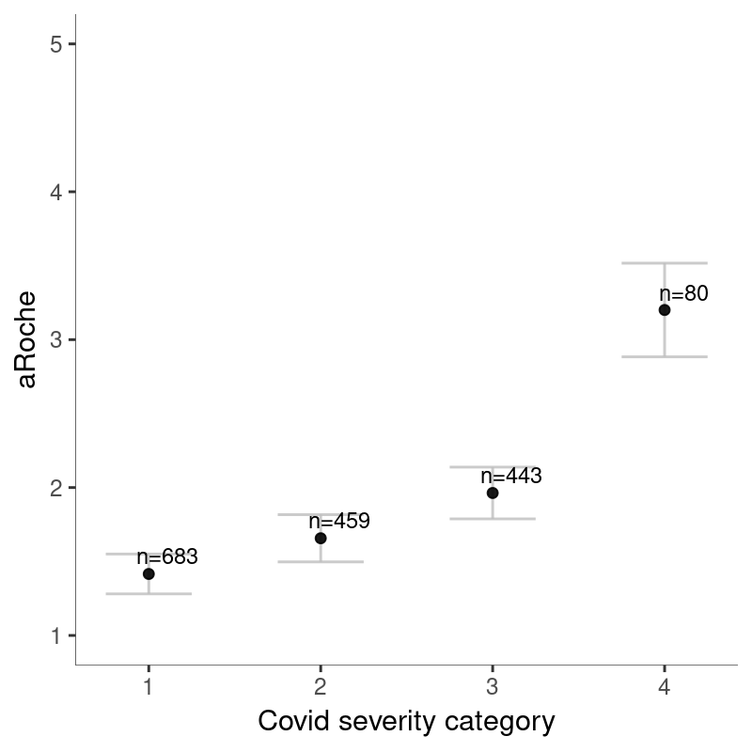
b)
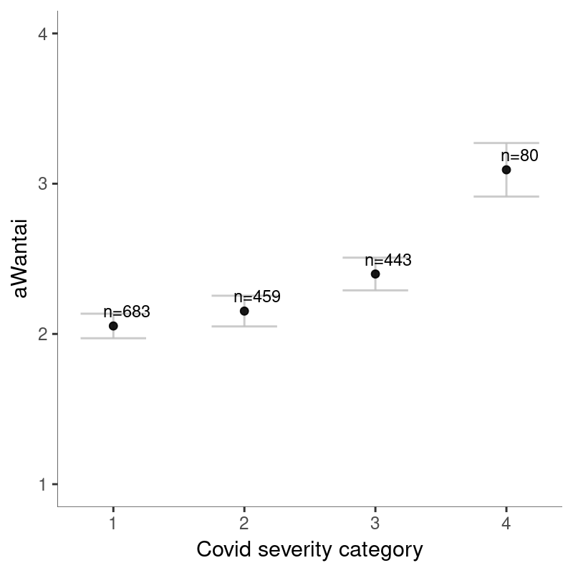

Figure S2. Days from diagnosis of SARS-CoV-2 to visit at the deCODE Health Study
A histogram that shows the distribution of days from diagnosis for the SARS-CoV-2 cases participants.
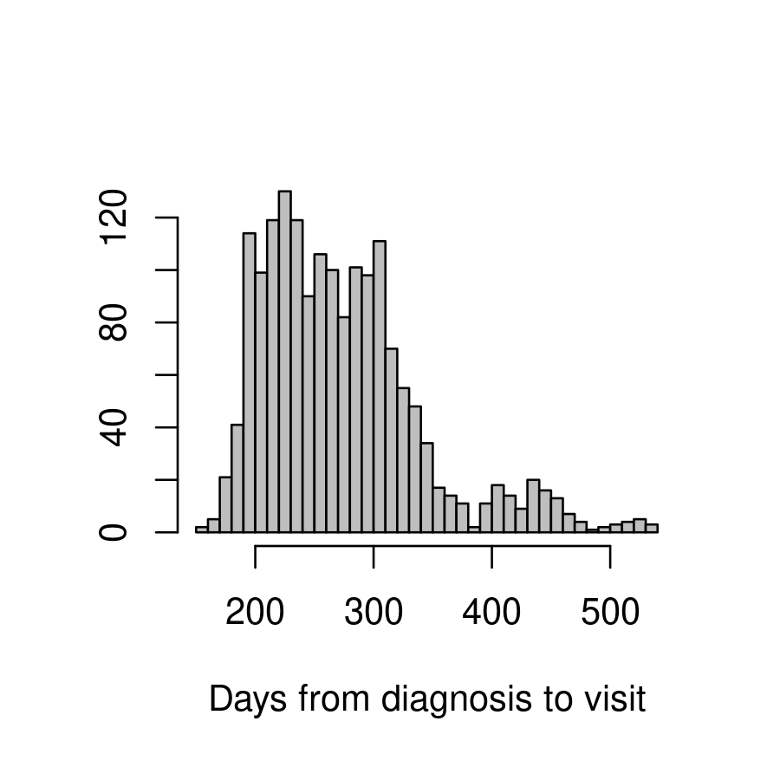

Figure S3. The correlation matrix for recent symptoms obtained from the C19Q questionnaire
The correlation matrix is shown for the recent symptoms that associate most significantly with SARS-CoV-2 status (P < 1.0·10⁻⁶). The recent symptoms are ordered using a hierarchical clustering order.

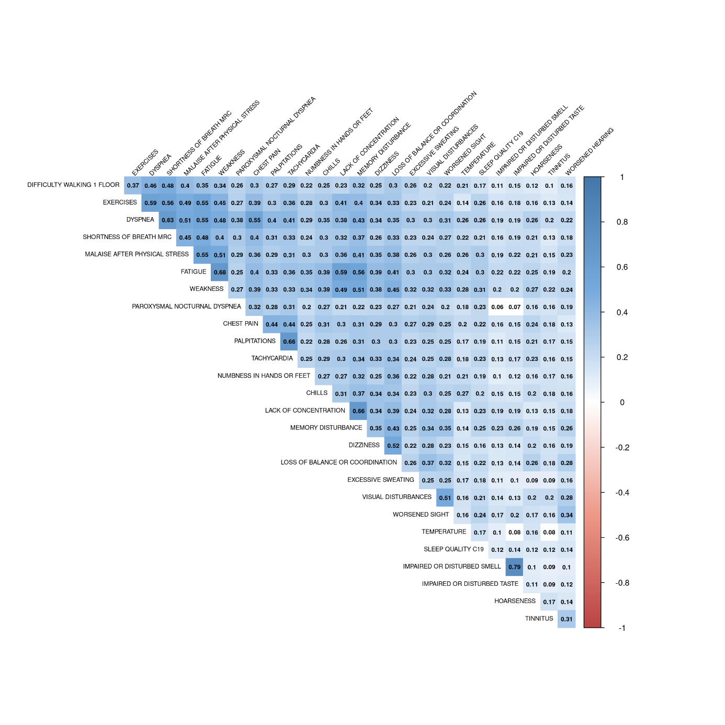

Figure S4. Time trends in physiological measures
The figures show boxplots for each month during the time the measurements were collected. Time trends were observed for a) pure tone average (PTA) hearing thresholds from the hearing test, b) oxygen saturation (SpO2), c) grip strength.

a)
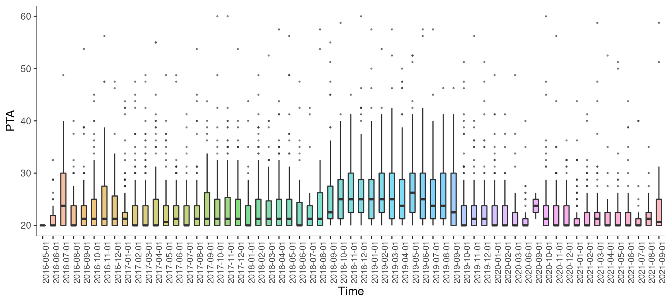
b)
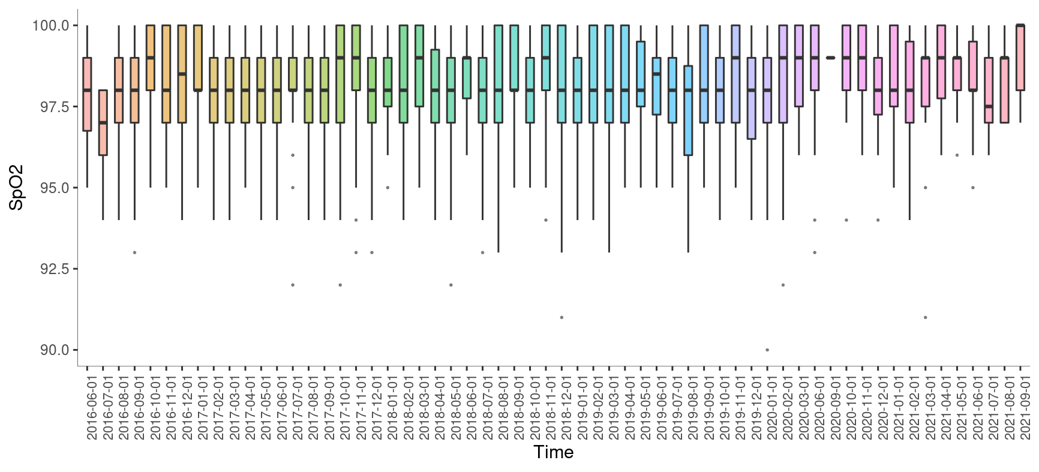

c)
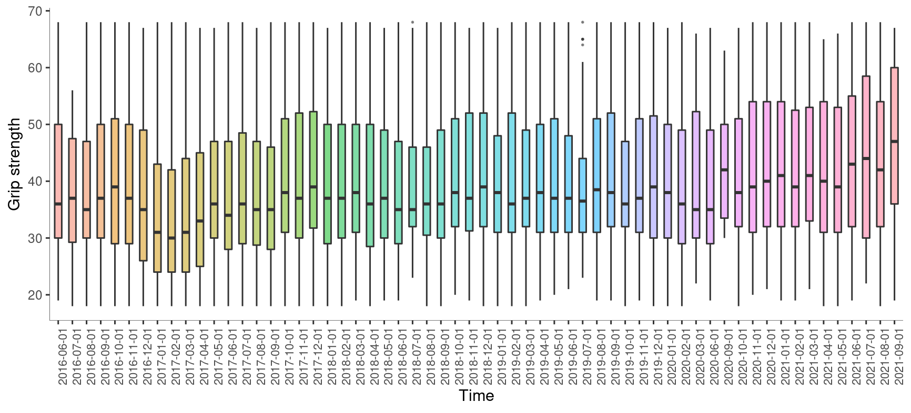

References
1. Ivarsdottir, E. V. et al. Sequence variation at ANAPC1 accounts for 24% of the variability in corneal endothelial cell density. Nat. Commun. 10, 1284 (2019).
2. Spitzer, R. L., Kroenke, K., Williams, J. B. W. & Löwe, B. A brief measure for assessing generalized anxiety disorder: the GAD-7. Arch. Intern. Med. 166, 1092–1097 (2006).
3. Kroenke, K., Spitzer, R. L. & Williams, J. B. The PHQ-9: validity of a brief depression severity measure. J. Gen. Intern. Med. 16, 606–613 (2001).
4. Cohen, S., Kamarck, T. & Mermelstein, R. A global measure of perceived stress. J. Health Soc. Behav. 24, 385–396 (1983).
5. Salkovskis, P. M., Rimes, K. A., Warwick, H. M. C. & Clark, D. M. The Health Anxiety Inventory: development and validation of scales for the measurement of health anxiety and hypochondriasis. Psychol. Med. 32, 843–853 (2002).
6. Ware, J. E. & Sherbourne, C. D. The MOS 36-item short-form health survey (SF-36). I. Conceptual framework and item selection. Med. Care 30, 473–483 (1992).
7. Löwe, B. et al. Validation and standardization of the Generalized Anxiety Disorder Screener (GAD-7) in the general population. Med. Care 46, 266–274 (2008).
8. Lee, E.-H. Review of the psychometric evidence of the perceived stress scale. Asian Nurs. Res. 6, 121–127 (2012).
9. Hauksdóttir, A., McClure, C., Jonsson, S. H., Olafsson, O. & Valdimarsdóttir, U. A. Increased stress among women following an economic collapse--a prospective cohort study. Am. J. Epidemiol. 177, 979–988 (2013).
10. Hlodversdottir, H., Petursdottir, G., Carlsen, H. K., Gislason, T. & Hauksdottir, A. Long-term health effects of the Eyjafjallajökull volcanic eruption: a prospective cohort study in 2010 and 2013. BMJ Open 6, e011444 (2016).
11. Diener, E., Emmons, R. A., Larsen, R. J. & Griffin, S. The Satisfaction With Life Scale. J. Pers. Assess. 49, 71–75 (1985).
12. Pavot, W. & Diener, E. Review of the Satisfaction With Life Scale. 5, 164–172 (1993).
13. Ware, J. E. SF-36 health survey update. Spine 25, 3130–3139 (2000).
14. Garratt, A. M., Ruta, D. A., Abdalla, M. I., Buckingham, J. K. & Russell, I. T. The SF36 health survey questionnaire: an outcome measure suitable for routine use within the NHS? BMJ 306, 1440–1444 (1993).
15. Bullinger, M. et al. Translating health status questionnaires and evaluating their quality: the IQOLA Project approach. International Quality of Life Assessment. J. Clin. Epidemiol. 51, 913–923 (1998).
16. Farivar, S. S., Cunningham, W. E. & Hays, R. D. Correlated physical and mental health summary scores for the SF-36 and SF-12 Health Survey, V.I. Health Qual. Life Outcomes 5, 54 (2007).
17. Muntner, P. et al. Measurement of Blood Pressure in Humans: A Scientific Statement From the American Heart Association. Hypertens. Dallas Tex 1979 73, e35–e66 (2019).
18. Roberts, H. C. et al. A review of the measurement of grip strength in clinical and epidemiological studies: towards a standardised approach. Age Ageing 40, 423–429 (2011).
19. Gisladottir, R. S. et al. Sequence Variants in TAAR5 and Other Loci Affect Human Odor Perception and Naming. Curr. Biol. CB 30, 4643–4653.e3 (2020).
20. Hummel, T., Sekinger, B., Wolf, S. R., Pauli, E. & Kobal, G. ‘Sniffin’ sticks’: olfactory performance assessed by the combined testing of odor identification, odor discrimination and olfactory threshold. Chem. Senses 22, 39–52 (1997).
21. Hummel, T., Kobal, G., Gudziol, H. & Mackay-Sim, A. Normative data for the ‘Sniffin’’ Sticks" including tests of odor identification, odor discrimination, and olfactory thresholds: an upgrade based on a group of more than 3,000 subjects’. Eur. Arch. Oto-Rhino-Laryngol. Off. J. Eur. Fed. Oto-Rhino-Laryngol. Soc. EUFOS Affil. Ger. Soc. Oto-Rhino-Laryngol. - Head Neck Surg. 264, 237–243 (2007).
22. Iravani, B. et al. Relationship between odor intensity estimates and COVID-19 prevalence prediction in a Swedish population. Chem. Senses (2020). doi:10.1093/chemse/bjaa034
23. Vennemann, M. M., Hummel, T. & Berger, K. The association between smoking and smell and taste impairment in the general population. J. Neurol. 255, 1121–1126 (2008).
24. Hummel, T., Hummel, C. & Welge-Luessen, A. Assessment of olfaction and gustation. Management of smell and taste disorders: a practical guide for clinicians. (Thieme, 2013).
25. Ivarsdottir, E. V. et al. The genetic architecture of age-related hearing impairment revealed by genome-wide association analysis. Commun. Biol. 4, (2021).
26. Mathers, C., Smith, A. & Concha, M. Global burden of hearing loss in the year 2000. World Heal. Organ. 1–30 (2000). (2000).
27. Graham, B. L. et al. Standardization of Spirometry 2019 Update. An Official American Thoracic Society and European Respiratory Society Technical Statement. Am. J. Respir. Crit. Care Med. 200, e70–e88 (2019).
28. Balady, G. J. et al. Clinician’s Guide to cardiopulmonary exercise testing in adults: a scientific statement from the American Heart Association. Circulation 122, 191–225 (2010).
29. Mezzani, A. et al. Standards for the use of cardiopulmonary exercise testing for the functional evaluation of cardiac patients: a report from the Exercise Physiology Section of the European Association for Cardiovascular Prevention and Rehabilitation. Eur. J. Cardiovasc. Prev. Rehabil. Off. J. Eur. Soc. Cardiol. Work. Groups Epidemiol. Prev. Card. Rehabil. Exerc. Physiol. 16, 249–267 (2009).
30. Wasserman, K., Hansen, J., Sue, D., Whipp, B. & Casaburi, R. Principles of exercise testing and interpretation. (Lippincott Williams and Wilkins, 2004).
31. Ebaid, D., Crewther, S. G., MacCalman, K., Brown, A. & Crewther, D. P. Cognitive Processing Speed across the Lifespan: Beyond the Influence of Motor Speed. Front. Aging Neurosci. 9, 62 (2017).
32. Stefansson, H. et al. CNVs conferring risk of autism or schizophrenia affect cognition in controls. Nature 505, 361–366 (2014).
33. Ruff, R. M., Light, R. H., Parker, S. B. & Levin, H. S. Benton Controlled Oral Word Association Test: reliability and updated norms. Arch. Clin. Neuropsychol. Off. J. Natl. Acad. Neuropsychol. 11, 329–338 (1996).
34. Morris, J. C. et al. The Consortium to Establish a Registry for Alzheimer’s Disease (CERAD). Part I. Clinical and neuropsychological assessment of Alzheimer’s disease. Neurology 39, 1159–1165 (1989).
35. Bell, B. D. WMS-III Logical Memory performance after a two-week delay in temporal lobe epilepsy and control groups. J. Clin. Exp. Neuropsychol. 28, 1435–1443 (2006).
36. Owen, A. M., Downes, J. J., Sahakian, B. J., Polkey, C. E. & Robbins, T. W. Planning and spatial working memory following frontal lobe lesions in man. Neuropsychologia 28, 1021–1034 (1990).
37. Reitan, R. M. Validity of the trail making test as an indicator of organic brain damage. 271–276 (1958).
38. Wechsler. Wechsler Abbreviated Scale of Intelligence (WASI) Manual. Psychological Corporation. (1999).
39. Gudmundsson, E. Mat á greind fullorðinna: WASI-IS [The Assessment of Intelligence in Adults: WASI-IS]. Menntamalastofnun (2015).
40. Orphanidou, C. et al. Signal-quality indices for the electrocardiogram and photoplethysmogram: derivation and applications to wireless monitoring. IEEE J. Biomed. Health Inform. 19, 832–838 (2015).
41. Gudbjartsson, D. F. et al. Humoral Immune Response to SARS-CoV-2 in Iceland. N. Engl. J. Med. 383, 1724–1734 (2020).
42. Olafsdottir, T. A. et al. Eighty-eight variants highlight the role of T cell regulation and airway remodeling in asthma pathogenesis. Nat. Commun. 11, 393 (2020).
43. Sigurdardottir, L. G. et al. Data quality at the Icelandic Cancer Registry: comparability, validity, timeliness and completeness. Acta Oncol. Stockh. Swed. 51, 880–889 (2012).
44. Helgadottir, A. et al. Variants with large effects on blood lipids and the role of cholesterol and triglycerides in coronary disease. Nat. Genet. 48, 634–639 (2016).
45. Steinthorsdottir, V. et al. Identification of low-frequency and rare sequence variants associated with elevated or reduced risk of type 2 diabetes. Nat. Genet. 46, 294–298 (2014).
46. Sveinbjornsson, G. et al. Rare mutations associating with serum creatinine and chronic kidney disease. Hum. Mol. Genet. 23, 6935–6943 (2014).
47. Gudbjartsson, D. F. et al. Association of variants at UMOD with chronic kidney disease and kidney stones-role of age and comorbid diseases. PLoS Genet. 6, e1001039 (2010).

