Supplementary Materials

Figure S1. Overlap between gene lists of DTC, PDTC, and ATC: (a) only at the gene level, where purple curves link identical genes; (b) including the shared term level, where blue curves link genes that belong to the same enriched ontology term. The inner circle represents gene lists, where hits are arranged along the arc. Genes that hit multiple lists are colored in dark orange, and genes unique to a list are shown in light orange. Dark orange color represents the genes that appear in multiple lists and light orange color represents genes that are unique to that gene list. Purple lines link the same gene that are shared by multiple gene lists. Blue lines link the different genes where they fall into the same ontology term.

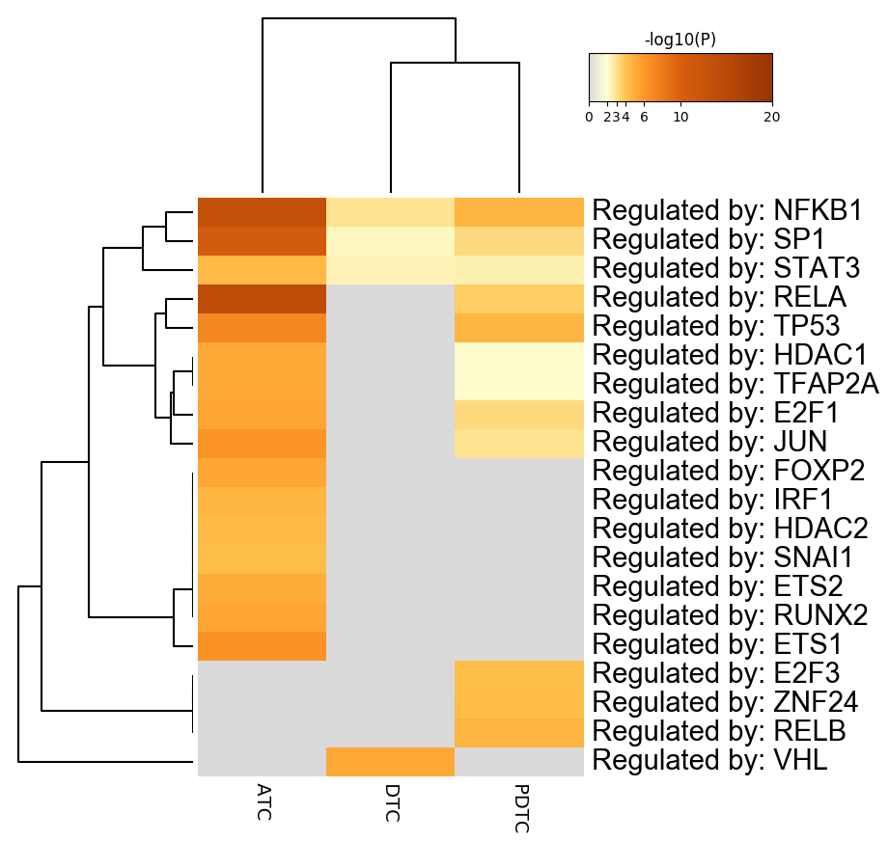
Figure S2. Summary of enrichment analysis of DTC, PDTC, and ATC in TRRUST.
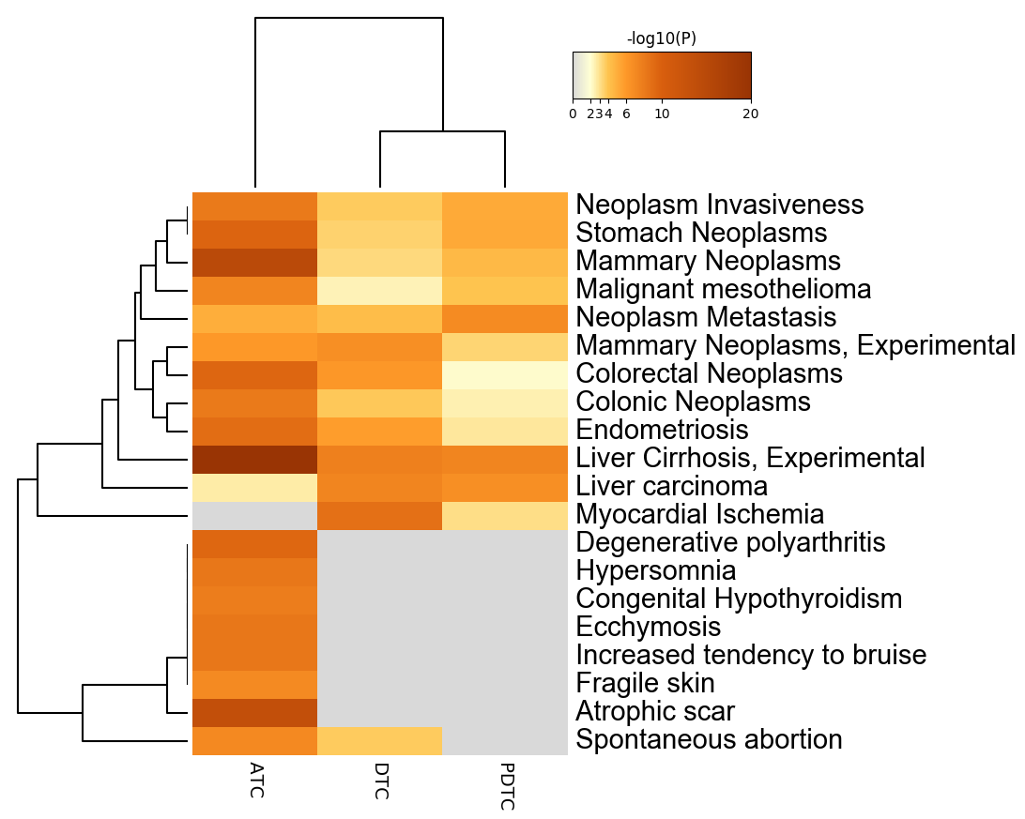
Figure S3. Summary of enrichment analysis of DTC, PDTC, and ATC in DisGeNET12.
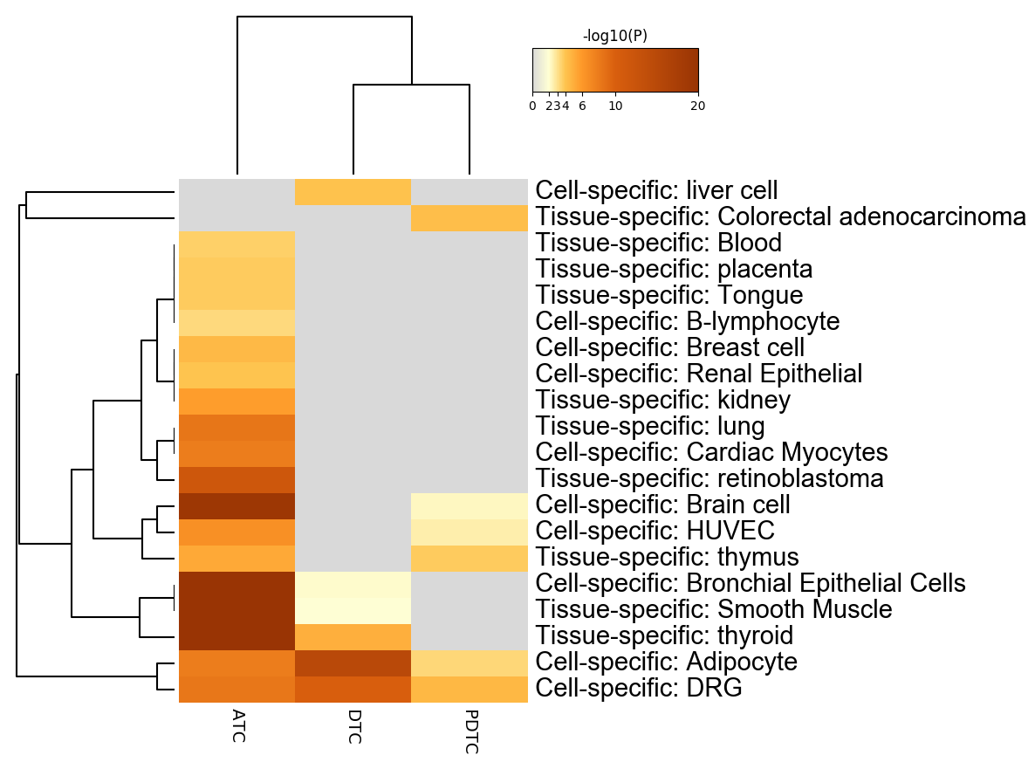
Figure S4. Summary of enrichment analysis of DTC, PDTC, and ATC in PaGenBase13.

Figure S5. Protein-protein interaction network and MCODE components identified in the gene lists of DTC. GO enrichment analysis was applied to the original PPI network and its MCODE network components to assign biological “meanings”, where top three best p-value terms were retained.

Figure S6. Protein-protein interaction network and MCODE components identified in the gene lists of PDTC. GO enrichment analysis was applied to the original PPI network and its MCODE network components to assign biological “meanings”, where top three best p-value terms were retained.

Figure S7. Protein-protein interaction network and MCODE components identified in the gene lists of ATC. GO enrichment analysis was applied to the original PPI network and its MCODE network components to assign biological “meanings”, where top three best p-value terms were retained.

Figure S8. Protein-protein interaction network identified in the gene lists of PDTC-ALL. All lists are merged Colored by Counts(A) and Cluster(B), respectively.

