Supplemental Information
Engineering Surface Oxophilicity of Copper for Electrochemical CO₂ Reduction to Ethanol
Minhan Li,¹ Nan Song,² Fangzhou Zhang,¹ Wei Luo,^{1,*} Jun Chen,³ Wan Jiang,¹ Jianping Yang^{1,4,*}
¹State Key Laboratory for Modification of Chemical Fibers and Polymer Materials, College of Materials Science and Engineering, Donghua University, Shanghai 201620, P. R. China
²State Key Laboratory of Chemical Engineering, East China University of Science and Technology, Shanghai, 200237, P. R. China
³ARC Centre of Excellence for Electromaterials Science, Intelligent Polymer Research Institute, Australian Institute of Innovative Materials, University of Wollongong, Innovation Campus, Wollongong, NSW 2522, Australia
⁴Lead Contact
*Correspondence: wluo@dhu.edu.cn; jianpingyang@dhu.edu.cn

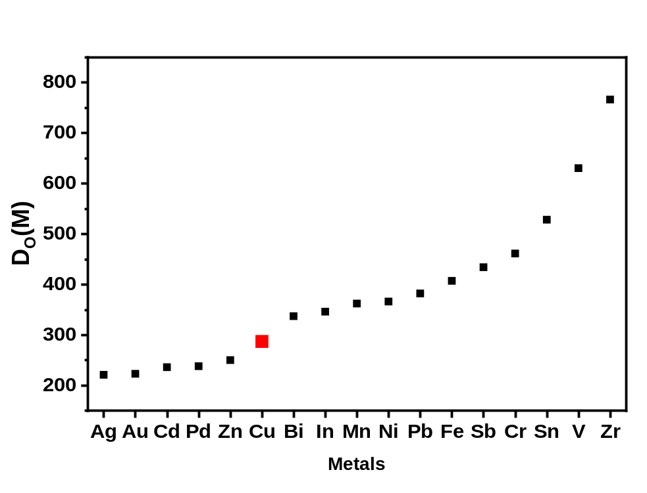
Figure S1 The oxophilicity of common transition metals and p-block metals determined by the bond dissociation enthalpies of metal oxides.¹

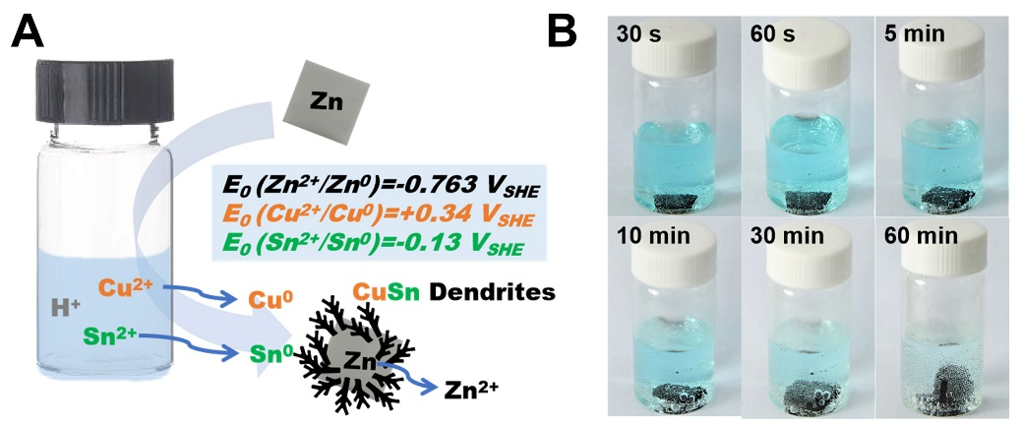
Figure S2 Schematic diagram of the materials synthesis (a). Photographs illustrate the synthesis procedures (b).

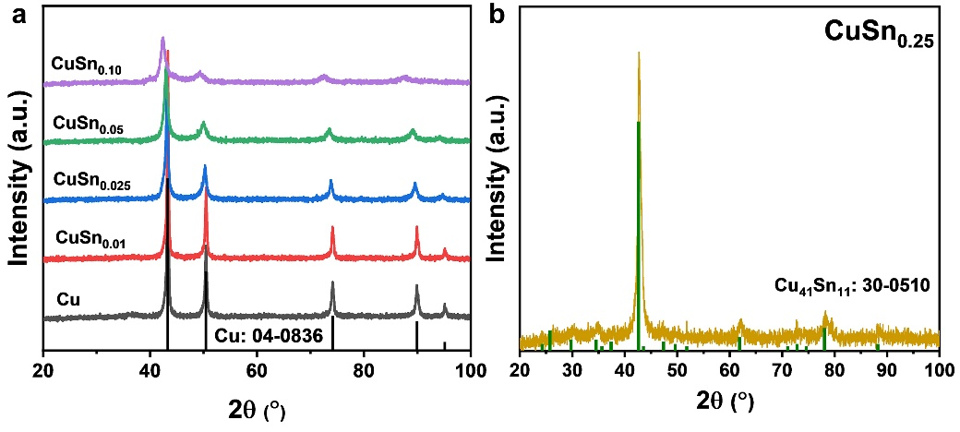
Figure S3 XRD pattern of Cu to CuSn_{0.10} catalysts (a) and CuSn_{0.25} catalyst (b).

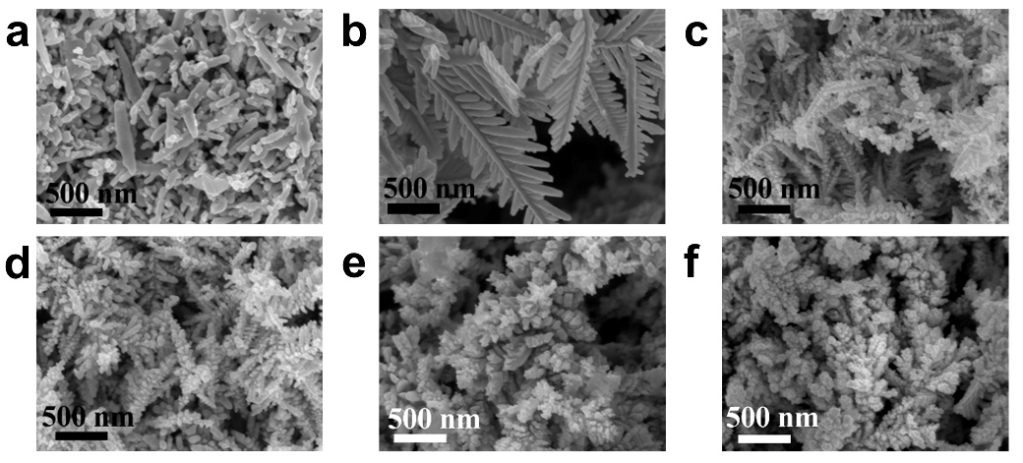
Figure S4 SEM images of (a) bare Cu, (b) CuSn_{0.01}, (c) CuSn_{0.025}, (d) CuSn_{0.05}, (e) CuSn_{0.10}, and (f) CuSn_{0.25} catalysts.

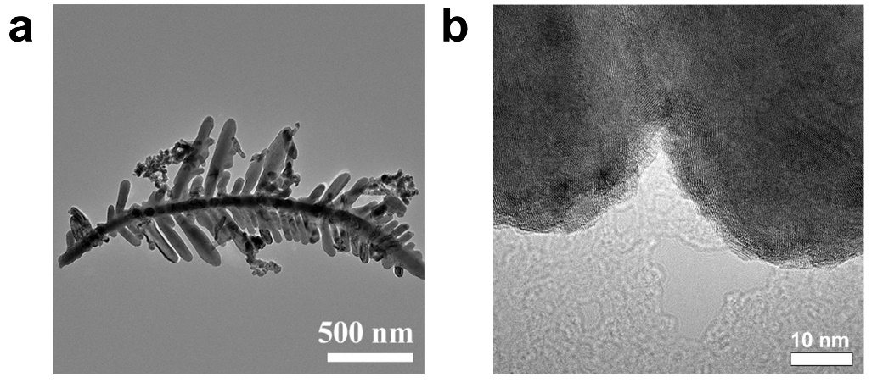
Figure S5 (a)TEM and (b) HR-TEM images of CuSn0.01 catalyst.

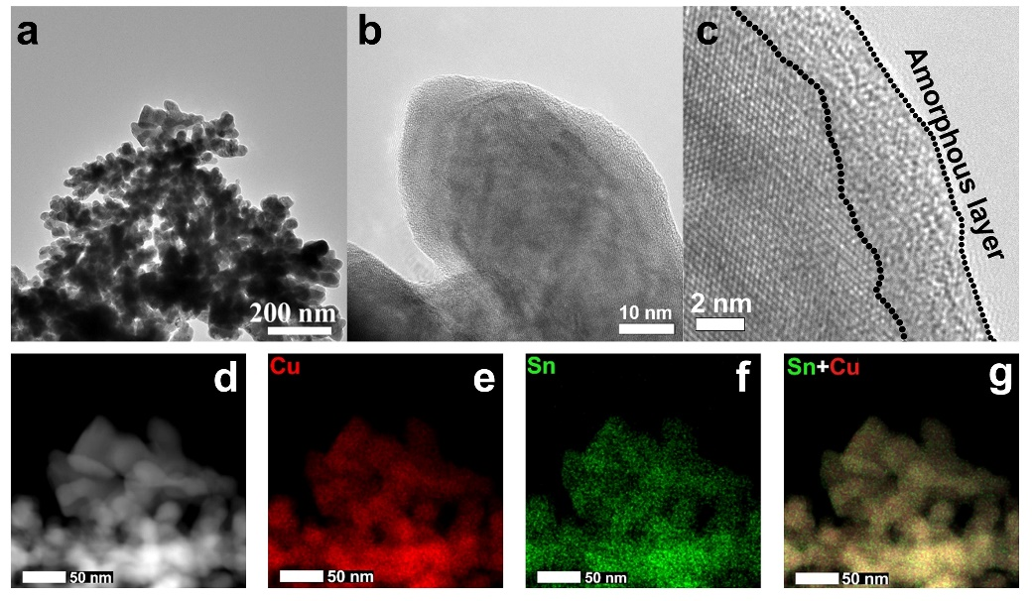
Figure S6 Characterization of CuSn_{0.10} catalyst. (a) TEM image, (b-c) HR-TEM images, (d) HAADF-STEM image, and (e-g) EDS elemental mappings of CuSn_{0.10} catalyst.

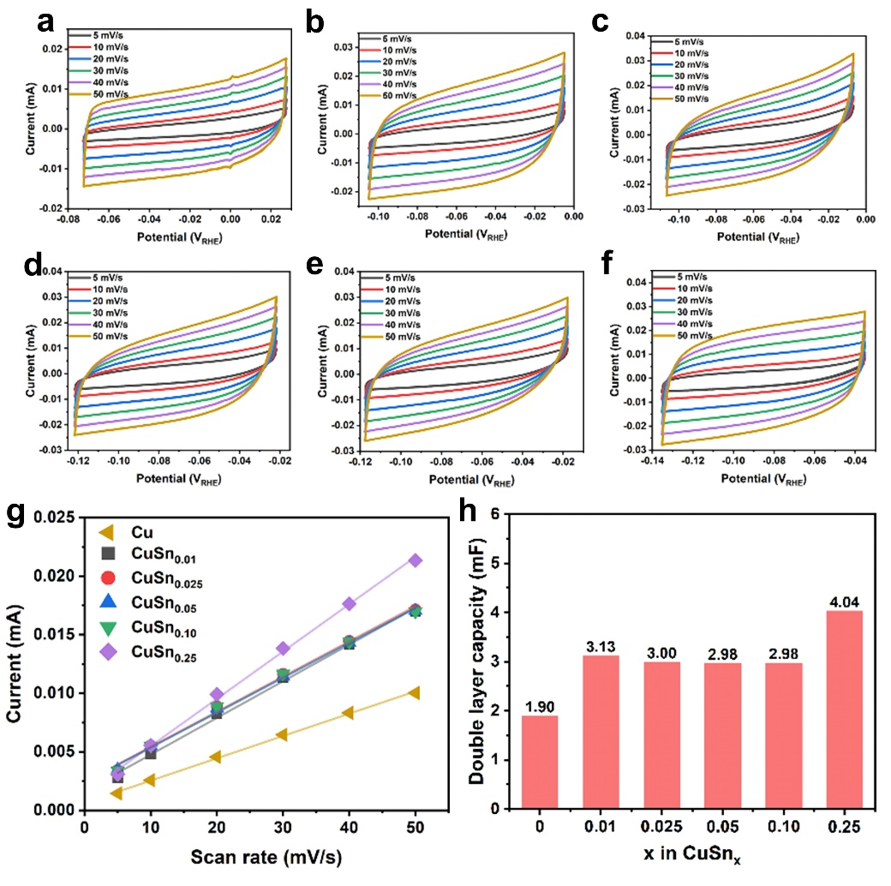
Figure S7 ECSA measurements of CuSn_{x} catalysts. (a-f) Double layer capacities (C_{dl}) measured by CV curves in CO₂-saturated 0.1 M KHCO₃ solution at around open circuit potential (E_{OC} ± 50 mV) of Cu, CuSn_{0.01}, CuSn_{0.025}, CuSn_{0.05}, CuSn_{0.10}, and CuSn_{0.25} catalysts. (g) Charge current density in CV scans plotted against the scan rates for CuSn_{x} catalysts. (h) ECSA values of CuSn_{x} catalysts.

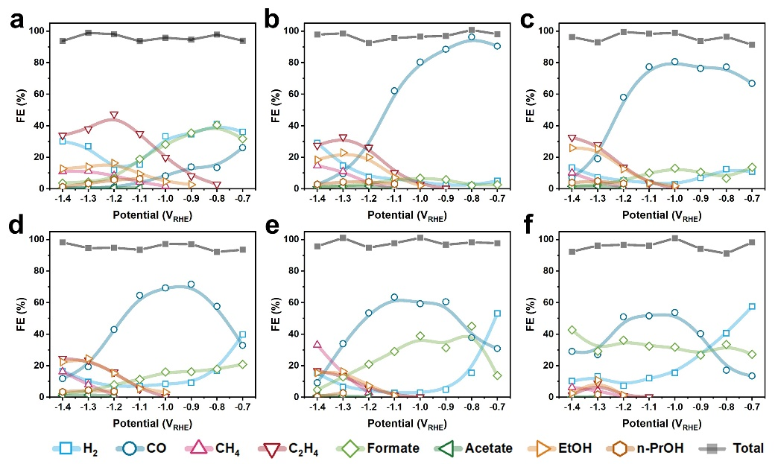
Figure S8 The distribution of reduction products at applied potentials on CuSn_{x} catalysts. (a) Cu, (b) CuSn_{0.01}, (c) CuSn_{0.025}, (d) CuSn_{0.05}, (e) CuSn_{0.10}, and (f) CuSn_{0.25}.

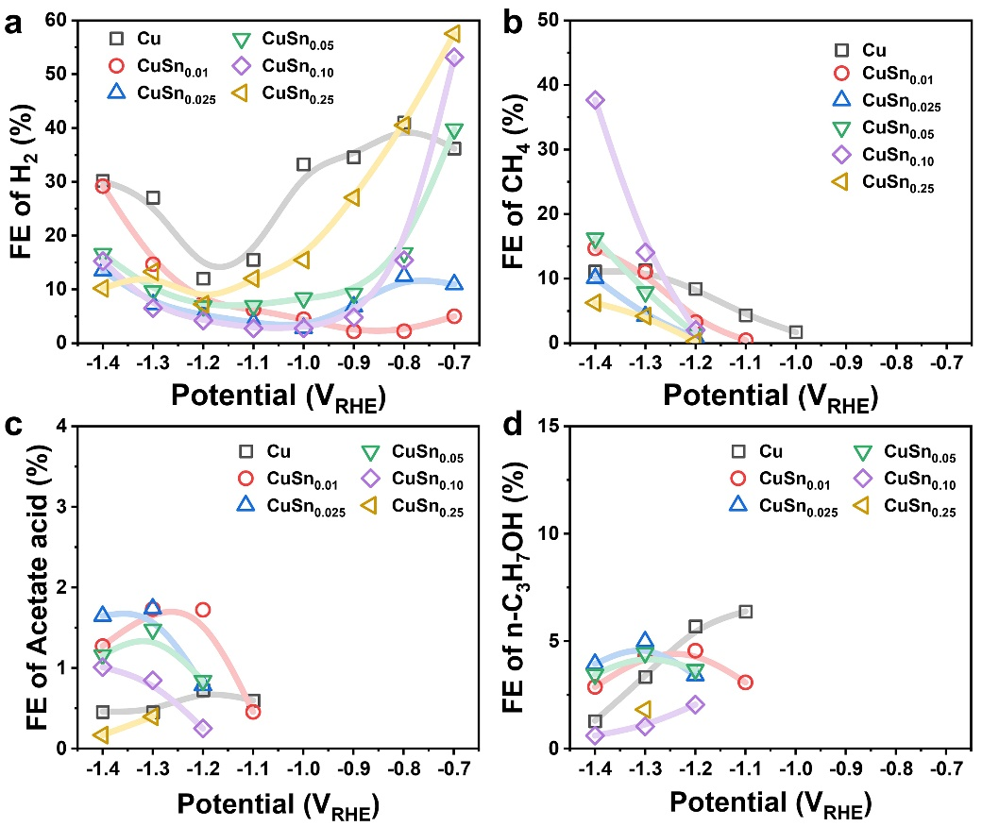
Figure S9 The FEs of reduction products. (a) H₂, (b) CH₄, (c) acetate acid, (d) n-C₃H₇OH.

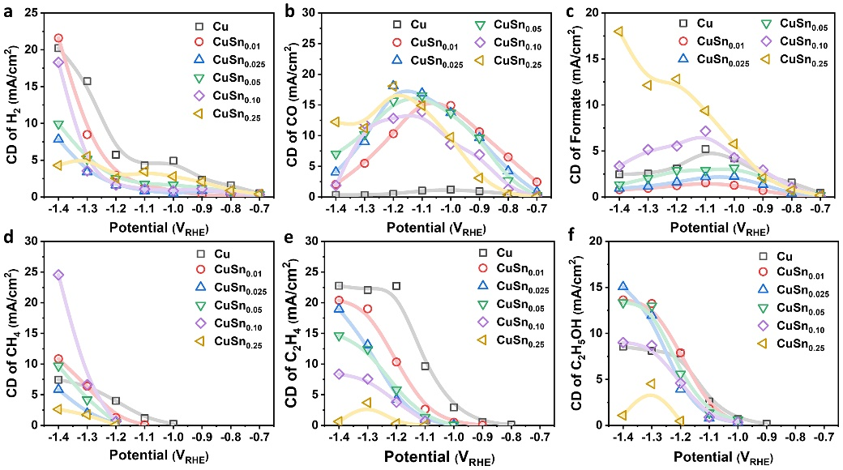
Figure S10 Current density (CD) of the main reduction products. (a) H₂. (b) CO. (c) formate. (d) CH₄. (e) C₂H₄. (f) C₂H₅OH.

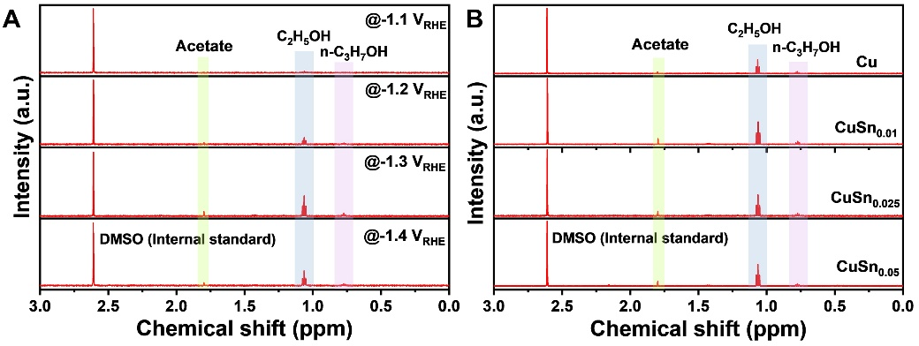
Figure S11 The typical ¹H NMR patterns that shows the peaks for multicarbon liquid products. (a) CuSn_{0.025} catalysts at different potentials. (b) Different catalysts at -1.3 V_{RHE}.

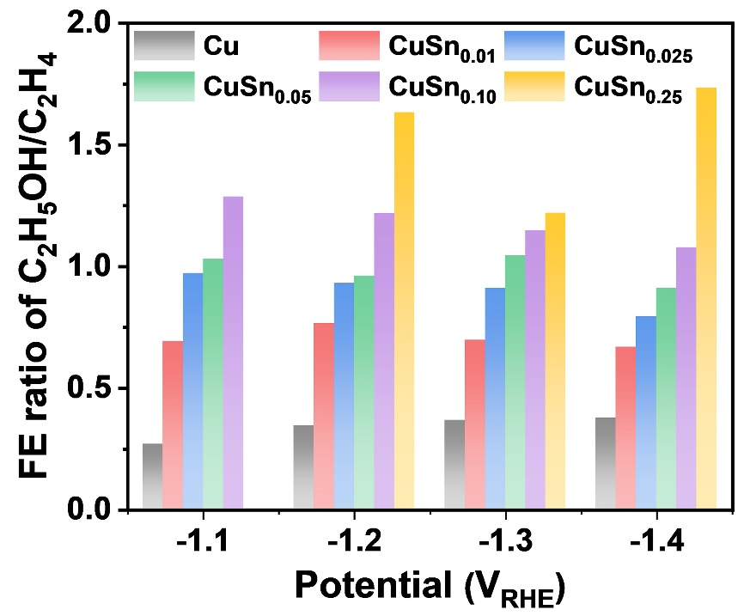
Figure S12 The FE ratio of C₂H₅OH/C₂H₄ on CuSn_{x} catalysts at different potentials.

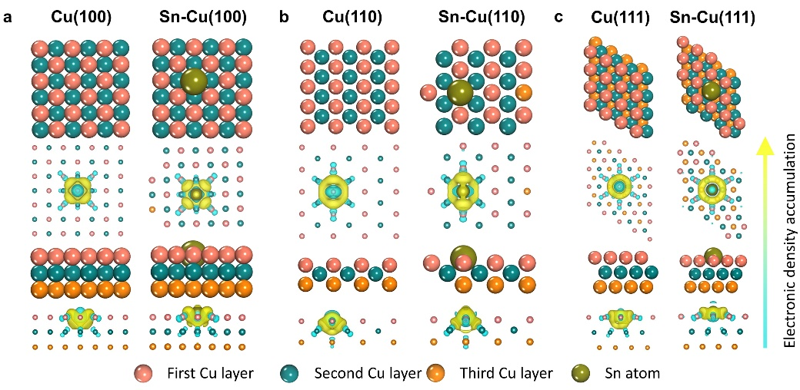
Figure S13 The slab models of Sn modified Cu facets for calculation and the corresponding differential charge analysis.

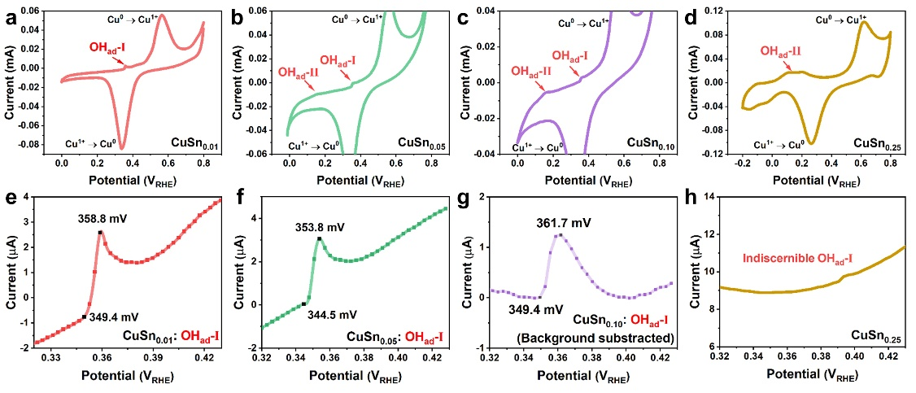
Figure S14 CV curves of (a) CuSn_{0.01}, (b) CuSn_{0.05}, (c) CuSn_{0.10}, and (d) CuSn_{0.25} catalysts. Enlarged CV curves showing OH_{ad}-I adsorption peaks for (e) CuSn_{0.01}, (f) CuSn_{0.05}, (g) CuSn_{0.10}, and (h) CuSn_{0.25}.

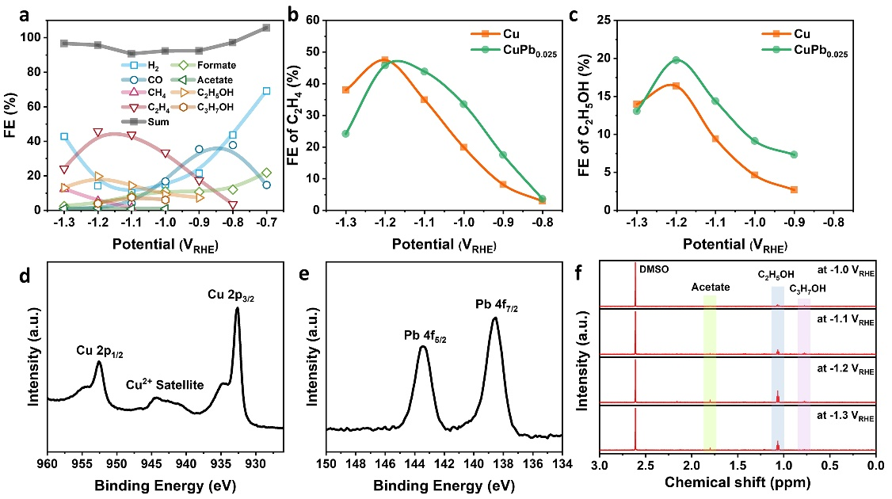
Figure S15 CO₂RR performance and characterization of CuPb_{0.025} catalyst. (a) FEs of all products at different potentials. (b) Comparison of FE of C₂H₄ between bare Cu and CuPb_{0.025} catalysts. (c) Comparison of FE of C₂H₅OH between bare Cu and CuPb_{0.025} catalysts. (d) Cu 2p spectra of CuPb_{0.025} catalysts. (e) Pb 4f spectra of CuPb_{0.025} catalysts. (f) ¹H NMR patterns showing the peaks of multicarbon liquid products for CuPb_{0.025} catalyst.

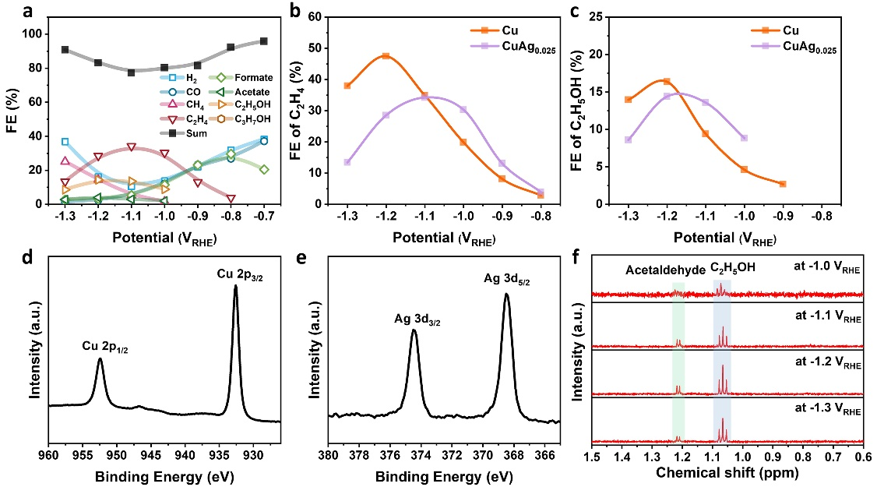
Figure S16 CO₂RR performance and characterization of CuAg_{0.025} catalyst. (a) FEs of all products at different potentials. (b) Comparison of FE of C₂H₄ between bare Cu and CuAg_{0.025} catalysts. (c) Comparison of FE of C₂H₅OH between bare Cu and CuPb_{0.025} catalysts. (d) Cu 2p spectra of CuAg_{0.025} catalysts. (e) Ag 3d spectra of CuAg_{0.025} catalysts. (f) ¹H NMR patterns showing the peaks of multicarbon liquid products for CuAg_{0.025} catalyst.

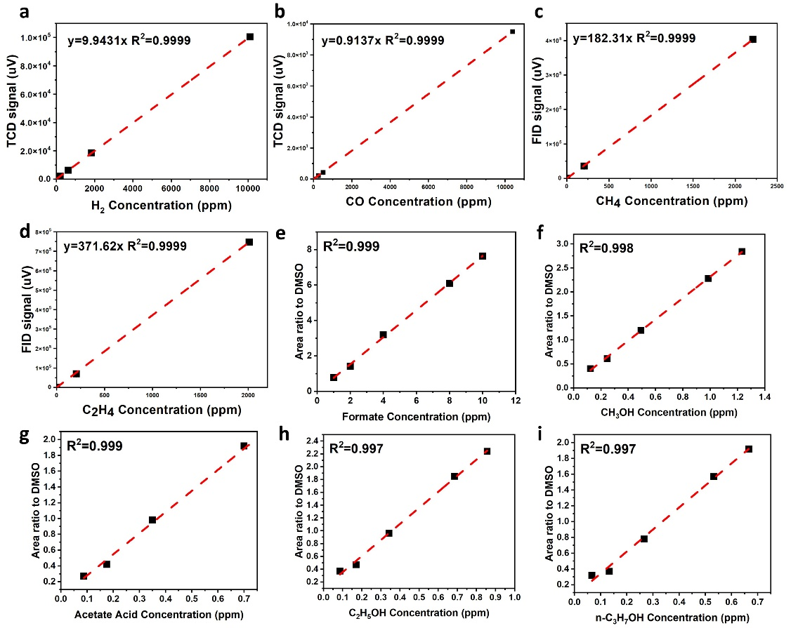
Figure S17 Gas and liquid products calibration. (a-d) Gas products. (e-i) Liquid products.

Table S1 Summary of CO₂RR performance of the CuSn_{x} catalysts in this work and the comparison of other Cu-Sn bimetallic catalysts in the literatures.
Catalyst | Reduction product | Faradic efficiency | Partial current density, mA/cm² | Potential, VRHE | Electrolyte | Reference
CuSn_{0.01} | CO | 96.36 % | 6.51 | -0.8 | 0.1 M KHCO₃ | This work
CuSn_{0.025} | C₂H₅OH | 25.93% | 15.05 | -1.4 | 0.1 M KHCO₃ | This work
Sn/Cu₂O | CO | 87.9 % | ~ 15 (total) | -1.3 | 0.1 M KHCO₃ | ²
Cu₉₇Sn₃ | CO | 98 % | ~ 30 (total) | -0.7 | 0.5 M KHCO₃ | ³
CuSn40 | CO | 90.9 % | ~ 3.3 (-0.8 V_{RHE}) | -1.0 | 0.1 M KHCO₃ | ⁴
Cu-Sn form | CO | 93-94 % | 6.2 | -0.9 | 0.1 M KHCO₃ | ⁵
Cu–Sn20 | CO | 82 % | 0.96 | -0.7 | 0.1 M KHCO₃ | ⁶
Cu-Sn dendrite | CO | 74 % | 11.5 | -1.1 | 0.1 M KHCO₃ | ⁷
SnO₂/CuS NSs | CO | ~70 % | 15.24 | -1.0 | 0.1 M KHCO₃ | ⁸
Sn/Cu-PVDF | CO | 80 % | 104 (gaseous CO₂ feeding) | < -0.9 | 0.1 M KHCO₃ | ⁹
Cu−Sn | CO | 90 % | 1.0 | -0.6 | 0.1 M KHCO₃ | ¹⁰
C-Cu/SnO₂-0.8 | CO | 93 % | 4.6 | -0.7 | 0.5 M KHCO₃ | ¹¹
Cu₈₇Sn₁₃ | CO | 59.5 % | ~ 0.9 | -0.99 | 0.1 M KHCO₃ | ¹²
CuO+SnO₂ | CO | ~ 90 % | ~ 0.5 | -0.6 | 0.1 M NaHCO₃ | ¹³
Cu/SnO_{x}−CNT  (6.2 % SnO_{x}) | CO | 89 % | 11.3 | -0.99 | 0.1 M KHCO₃ | ¹⁴
C-Cu/SnO₂-1.8 | Formate | 85 % | n.a. | -0.9 | 0.5 M KHCO₃ | ¹¹
Cu₅₅Sn₄₅ | Formate | 89.5 % | ~ 2.5 | -1.09 | 0.1 M KHCO₃ | ¹²
Cu/SnO_{x}−CNT  (30.2 % SnO_{x}) | Formate | 77 % | 4.0 | -0.99 | 0.1 M KHCO₃ | ¹⁴
CuSn_{0.175}-NG | CO+Formate | 93 % | n.a. | -1.0 | 0.5 M KHCO₃ | ¹⁵
Cu@Sn | Formate | ~ 100 % | 16.52 | -0.93 | 0.5 M KHCO₃ | ¹⁶
CuSn NPs/C-A | CO | 70.1 % | 1.66 | -0.7 | 0.1 M KHCO₃ | ¹⁷
CuSn NPs/C-A | Formate | 71.5 % | 12.6 | -1.0 | 0.1 M KHCO₃ | ¹⁷
Cu₍₁₎Sn₍₄₎-N-CC | Formate | 90.24 % | 15.56 | -0.97 | 0.5 M KHCO₃ | ¹⁸
Sn-Cu alloy | Formate | 82.3 % | 79 | -1.14 | 0.5 M KCl | ¹⁹
CuSn–10C | Formate | 82 % | 18.9 | -1.0 | 0.1 M NaHCO₃ | ²⁰
CuSn NWs/C-Air | Formate | 90.2 % | 17.33 | -1.0 | 0.5 M KHCO₃ | ²¹

Reference
1. Kepp, K.P. (2016). A quantitative scale of oxophilicity and thiophilicity. Inorg. Chem. 55, 9461-9470.
2. Zhang, W., He, P., Wang, C., Ding, T., Chen, T., Liu, X., Cao, L., Huang, T., Shen, X., Usoltsev, O.A., et al. (2020). Operando evidence of Cu⁺ stabilization via a single-atom modifier for CO₂ electroreduction. J Mater. Chem. A 8, 25970-25977.
3. Ren, W., Tan, X., Qu, J., Li, S., Li, J., Liu, X., Ringer, S.P., Cairney, J.M., Wang, K., Smith, S.C., and Zhao, C. (2021). Isolated copper–tin atomic interfaces tuning electrocatalytic CO₂ conversion. Nat. Commun. 12, 1449.
4. Zhang, S.-N., Li, M., Hua, B., Duan, N., Ding, S., Bergens, S., Shankar, K., and Luo, J.-L. (2019). A rational design of Cu₂O-SnO₂ core-shell catalyst for highly selective CO₂-to-CO conversion. Chemcatchem 11, 4147-4153.
5. Zeng, J., Bejtka, K., Ju, W., Castellino, M., Chiodoni, A., Sacco, A., Farkhondehfal, M.A., Hernández, S., Rentsch, D., Battaglia, C., and Pirri, C.F. (2018). Advanced Cu-Sn foam for selectively converting CO₂ to CO in aqueous solution. Appl. Catal. B: Environ. 236, 475-482.
6. Zhao, Y., Wang, C., and Wallace, G.G. (2016). Tin nanoparticles decorated copper oxide nanowires for selective electrochemical reduction of aqueous CO₂ to CO. J Mater. Chem. A 4, 10710-10718.
7. Ju, W., Zeng, J., Bejtka, K., Ma, H., Rentsch, D., Castellino, M., Sacco, A., Pirri, C.F., and Battaglia, C. (2019). Sn-Decorated Cu for Selective Electrochemical CO₂ to CO Conversion: Precision Architecture beyond Composition Design. ACS Appl. Energy Mater. 2, 867-872.
8. Wang, X., Lv, J., Zhang, J., Wang, X.-L., Xue, C., Bian, G., Li, D., Wang, Y., and Wu, T. (2020). Hierarchical heterostructure of SnO₂ confined on CuS nanosheets for efficient electrocatalytic CO₂ reduction. Nanoscale 12, 772-784.
9. Ju, W., Jiang, F., Ma, H., Pan, Z., Zhao, Y.-B., Pagani, F., Rentsch, D., Wang, J., and Battaglia, C. (2019). Electrocatalytic Reduction of Gaseous CO₂ to CO on Sn/Cu-Nanofiber-Based Gas Diffusion Electrodes. Adv. Energy Mater. 9, 1901514.
10. Sarfraz, S., Garcia-Esparza, A.T., Jedidi, A., Cavallo, L., and c, K. (2016). Cu-Sn Bimetallic Catalyst for Selective Aqueous Electroreduction of CO₂ to CO. ACS Catal. 6, 2842-2851.
11. Li, Q., Fu, J., Zhu, W., Chen, Z., Shen, B., Wu, L., Xi, Z., Wang, T., Lu, G., Zhu, J.-j., and Sun, S. (2017). Tuning Sn-Catalysis for Electrochemical Reduction of CO₂ to CO via the Core/Shell Cu/SnO₂ Structure. J. Am. Chem. Soc. 139, 4290-4293.
12. Morimoto, M., Takatsuji, Y., Yamasaki, R., Hashimoto, H., Nakata, I., Sakakura, T., and Haruyama, T. (2018). Electrodeposited Cu-Sn Alloy for Electrochemical CO₂ Reduction to CO/HCOO⁻. Electrocatalysis 9, 323-332.
13. Schreier, M., Héroguel, F., Steier, L., Ahmad, S., Luterbacher, J.S., Mayer, M.T., Luo, J., and Grätzel, M. (2017). Solar conversion of CO₂ to CO using Earth-abundant electrocatalysts prepared by atomic layer modification of CuO. Nature Energy 2, 17087.
14. Huo, S., Weng, Z., Wu, Z., Zhong, Y., Wu, Y., Fang, J., and Wang, H. (2017). Coupled Metal/Oxide Catalysts with Tunable Product Selectivity for Electrocatalytic CO₂ Reduction. ACS Appl. Mater. Interfaces 9, 28519-28526.
15. Xiong, W., Yang, J., Shuai, L., Hou, Y., Qiu, M., Li, X., and Leung, M.K.H. (2019). CuSn Alloy Nanoparticles on Nitrogen-Doped Graphene for Electrocatalytic CO₂ Reduction. ChemElectroChem 6, 5951-5957.
16. Hou, X., Cai, Y., Zhang, D., Li, L., Zhang, X., Zhu, Z., Peng, L., Liu, Y., and Qiao, J. (2019). 3D core-shell porous-structured Cu@Sn hybrid electrodes with unprecedented selective CO₂-into-formate electroreduction achieving 100%. J Mater. Chem. A 7, 3197-3205.
17. Wang, P., Qiao, M., Shao, Q., Pi, Y., Zhu, X., Li, Y., and Huang, X. (2018). Phase and structure engineering of copper tin heterostructures for efficient electrochemical carbon dioxide reduction. Nat. Commun. 9, 4933.
18. Peng, L., Wang, Y., Masood, I., Zhou, B., Wang, Y., Lin, J., Qiao, J., and Zhang, F.-Y. (2020). Self-growing Cu/Sn bimetallic electrocatalysts on nitrogen-doped porous carbon cloth with 3D-hierarchical honeycomb structure for highly active carbon dioxide reduction. Appl. Catal. B: Environ. 264, 118447.
19. Ye, K., Cao, A., Shao, J., Wang, G., Si, R., Ta, N., Xiao, J., and Wang, G. (2020). Synergy effects on Sn-Cu alloy catalyst for efficient CO₂ electroreduction to formate with high mass activity. Science Bulletin 65, 711-719.
20. Wang, J., Zou, J., Hu, X., Ning, S., Wang, X., Kang, X., and Chen, S. (2019). Heterostructured intermetallic CuSn catalysts: high performance towards the electrochemical reduction of CO₂ to formate. J Mater. Chem. A 7, 27514-27521.
21. Wang, J., Ji, Y., Shao, Q., Yin, R., Guo, J., Li, Y., and Huang, X. (2019). Phase and structure modulating of bimetallic CuSn nanowires boosts electrocatalytic conversion of CO₂. Nano Energy 59, 138-145.

