Dendritic polyethylene glycol-modified folate-nickel nanotubes as an efficient antitumor nano-metal medicine

Zhipeng Dong,ª Nanxia Zhang,ª Jiahao Zhang,ª Jun Luo,ª Yisong Xu,ª Weifang Tang*ª, Baofen Ye*ª, and Yue Wang*ª
a. Key Laboratory of Biomedical Functional Materials, School of Sciences, China Pharmaceutical University, Nanjing 211198, Jiangsu Province, China.

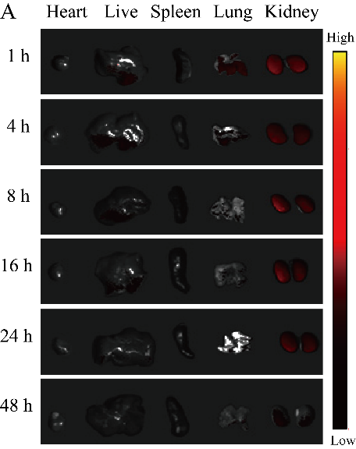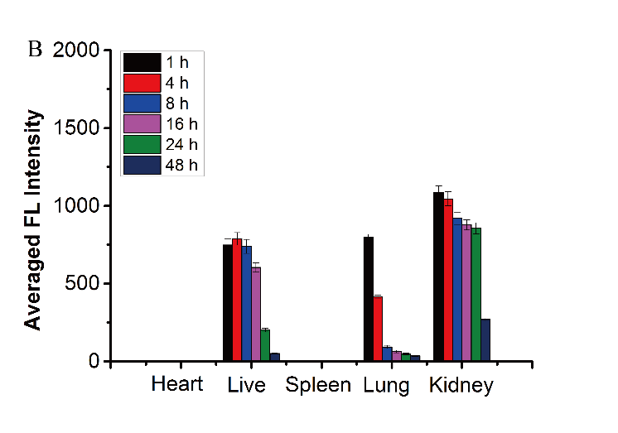
Figure S1. Spectrally resolved ex vivo fluorescence images of organs at 1, 4, 8, 16, 24, and 48 h after injection of the Cy5.5-labeled FA-Ni NTs. All fluorescence images were acquired with 200 ms exposure time (A); Semiquantitative biodistribution of the Cy5.5-labeled FA-Ni NTs in mice determined by averaging the fluorescence intensity of each organ (B).

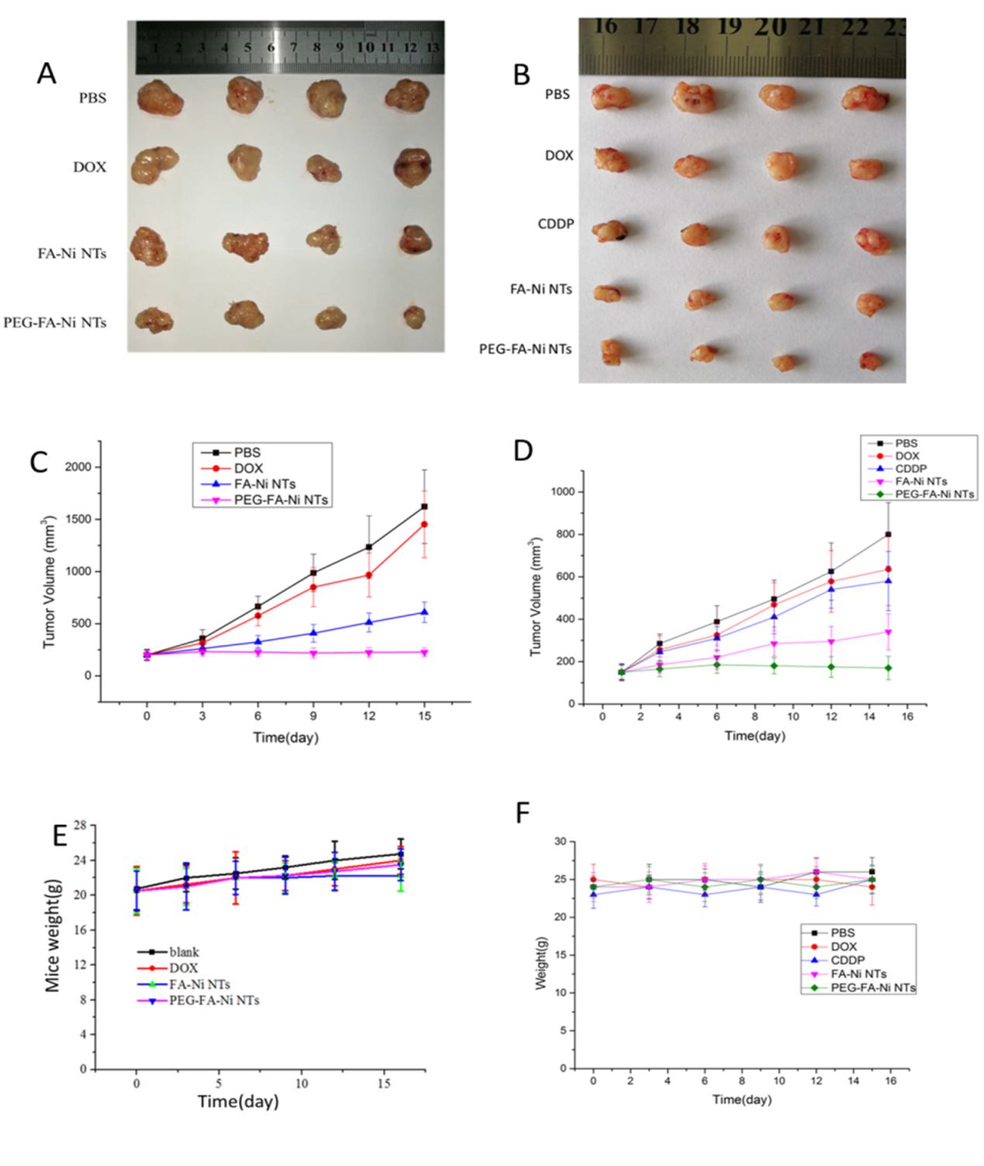

Figure S2. Excised HeLa solid tumors from HeLa mice subjected to different treatments at the 15th day after the first treatment (A); In vivo antitumor effects and systemic toxicity of free DOX, FA-Ni NTs and PEG-FA-Ni NTs. Tumor volume changes of tumor-bearing HeLa mice (C), mice weight changes of tumor-bearing and HeLa mice (E). Excised A549 solid tumors from A549 mice subjected to different treatments at the 15th day after the first treatment (B); In vivo antitumor effects and systemic toxicity of free CDDP, free DOX, FA-Ni NTs and PEG-FA-Ni NTs. Tumor volume changes of tumor-bearing A549 mice (D), mice weight changes of tumor-bearing and A549 mice (F).

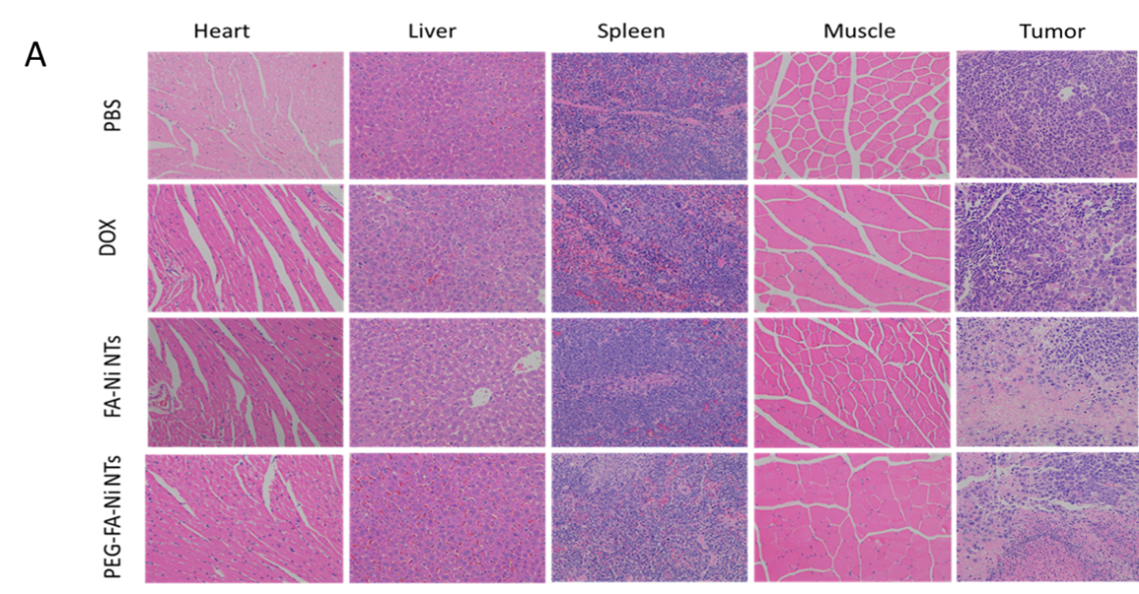
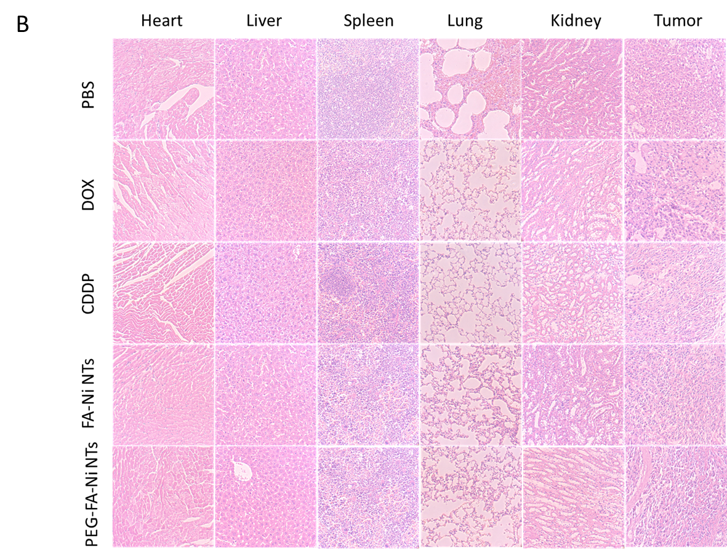

Figure S3. Histological analysis of the HeLa bearing mice tissues with H&E after treatments with PBS, free DOX, FA-Ni NTs and PEG-FA-Ni NTs for 15 days (A); Histological analysis of the A549 bearing mice tissues with H&E after treatments with PBS, free DOX, free CDDP, FA-Ni NTs and PEG-FA-Ni NTs for 15 days (B).

