A

B
Fig. S1. Rarefaction curve, (A- Legedadi Treatment plant and Gefersa Treatment plant) showing the observed number of OTUS across each sample location at (97% sequence similarity cut off.

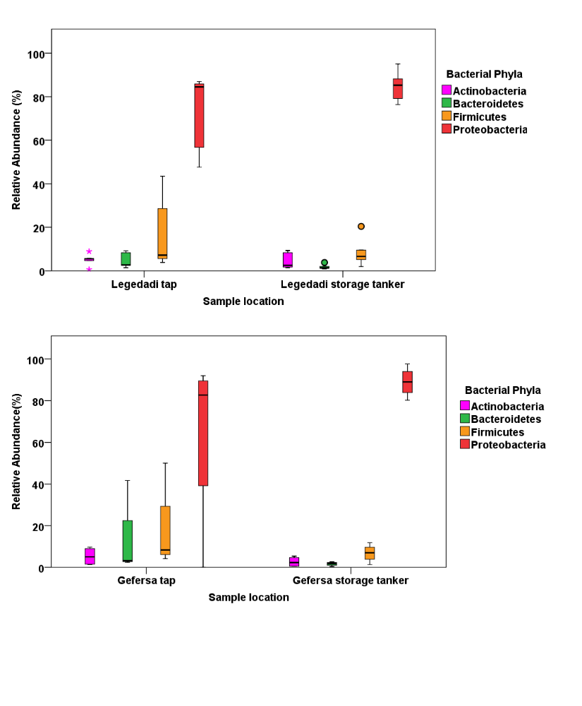
Fig. S2. Relative abundance of dominant phyla across tap and storage tanker sample location of Legedadi and Gefersa treatment. Legedadi tap water sample locations were LT1-LT8 and storage tanker sample locations were LHS1-LHS6. Gefersa treatment plant tap water samples include GT1, GT3, GT4 and GT5 whereas samples form household storage tankers included GHS1, GHS2, GHS3 GHS5, GHS6, GHS7, GHS8, and GHS9
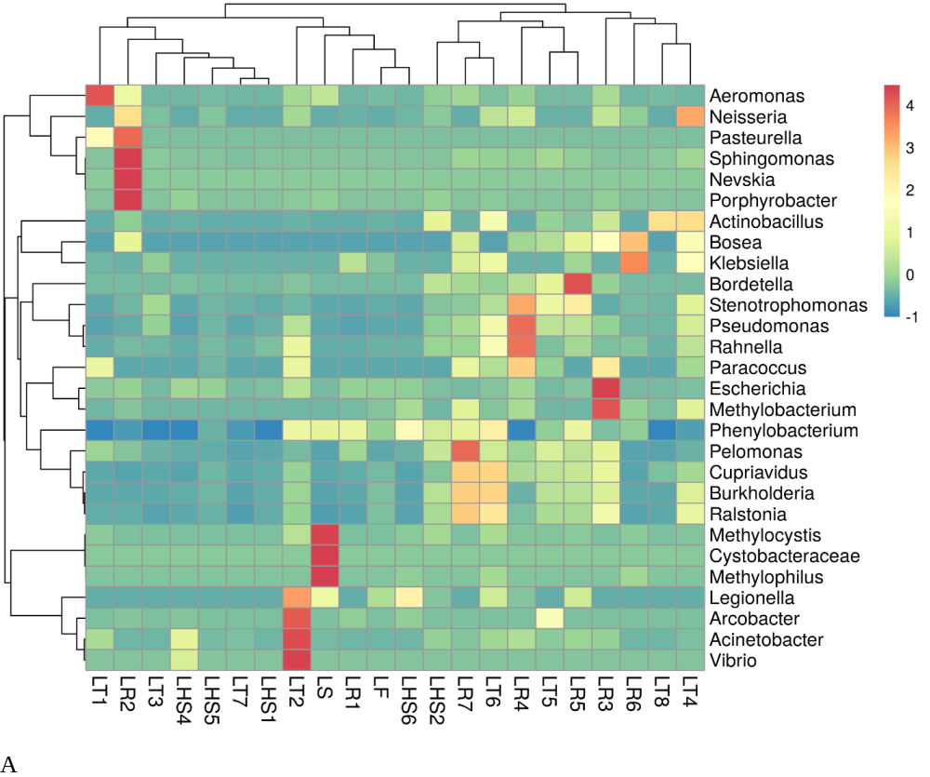
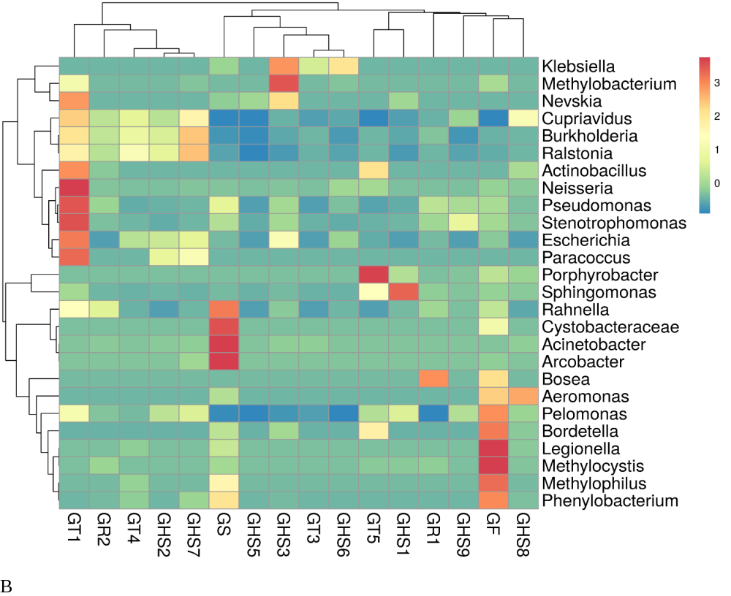
Fig. S3. Heatmap at the Genera level showing the most dominant bacterial taxa at each sample locations of both Legedade (A) and Gefersa (B) treatment plants. The colors indicated the relative abundances of the bacterial taxa and the intensity of colors are indicated with the legend at the right corner of the map. The sample locations are listed randomly based on the dominance of taxa at each sample location.

Table S1 Basic information about drinking water samples
Sample code | Water Type | Drinking water treatment plant | Description | Distance from treatment plants (TPs) (Km)
LS | Source water | Legedadi | Legedadi TP untreated source water | 0
LF | Treated water | Legedadi | Legedadi TP finished water | 0
LR1 | Reservoir | Legedadi | Kotebe Main Reservoir | 15.6
LT1 | Tap from spigot | Legedadi | Legedadi H/hold tape water 1 | 16.5
LT2 | Tap from spigot | Legedadi | Legedadi H/hold tape water 2 | 18
LHS1 | Tap from tank | Legedadi | Legedadi H/hold storage tanker 1 | 19.8
LHS2 | Tap from tank | Legedadi | Legedadi H/hold storage tanker 2 | 20.5
LR2 | Reservoir | Legedadi | Jan meda Reservoir | 21.3
LR3 | Reservoir | Legedadi | Teferi Mekonen Reservoir | 22
LT3 | Tap from spigot | Legedadi | Legedadi H/hold tape water 3 | 22.6
LHS4 | Tap from tank | Legedadi | Legedadi H/hold storage tanker 4 | 23
LR4 | Reservoir | Legedadi | Semen Hotel Reservoir | 23.7
LT4 | Tap from spigot | Legedadi | Legedadi H/hold tape water 4 | 23.2
LHS5 | Tap from tank | Legedadi | Legedadi H/hold storage tanker 5 | 23.7
LT5 | Tap from spigot | Legedadi | Legedadi H/hold tape water 5 | 24
LT6 | Tap from spigot | Legedadi | Legedadi H/hold tape water 6 | 24.9
LR5 | Reservoir | Legedadi | Belay Zeleke Reservoir | 27.5
LT7 | Tap from spigot | Legedadi | Legedadi tap water 7 | 24.5
LHS6 | Tap from tank | Legedadi | Legedadi storage tanker 6 | 18.5
LR6 | Reservoir | Legedadi | Legedadi reservoir 6 | 23
LR7 | Reservoir | Legedadi | Legedadi reservoir 7 | 23.5
LT8 | Tap from spigot | Legedadi | Legedadi H/hold tap water 8 | 18.5
GS | Source water | Gefersa | Gefersa TP untreated source water | 0
GF | Treated water | Gefersa | Gefersa TP finished water | 0
GHS1 | Tap from tank | Gefersa | Gefersa H/hold storage tanker 1 | 7
GR1 | Reservoir | Gefersa | Ras Hailu Reservoir | 8
GT1 | Tap from spigot | Gefersa | Gefersa H/hold tape water 1 | 8.5
GR2 | Reservoir | Gefersa | Paulose Reservoir | 9
GHS2 | Tap from tank | Gefersa | Gefersa H/hold storage tanker 2 | 9.5
GHS9 | Tap from tank | Gefersa | Gefersa storage tanker 9 | 9.8
GHS3 | Tap from tank | Gefersa | Gefersa H/hold storage tanker 3 | 11
GHS5 | Tap from tank | Gefersa | Gefersa H/hold storage tanker 5 | 12
GT3 | Tap from spigot | Gefersa | Gefersa H/hold tape water 3 | 12
GHS6 | Tap from tank | Gefersa | Gefersa H/hold storage tanker 6 | 14
GT4 | Tap from spigot | Gefersa | Gefersa H/hold tape water 4 | 14
GHS7 | Tap from tank | Gefersa | Gefersa H/hold storage tanker 7 | 15.6
GT5 | Tap from spigot | Gefersa | Gefersa tap water 5 | 19.5
GHS8 | Tap from tank | Gefersa | Gefersa H/hold storage tanker 8 | 20
S2 Table. Concentration and purity of genomic DNA extracted from samples across two treatment plants (TPs).
 | Sample code | DNA concentration (ng/µl) | Purity at (260/280) | NCBI Accession Number
Legedadi TP
Source water | LS | 81.29 | 1.8 | SAMN12747839
Finished water | LF | 9.3 | 1.74 | SAMN12747829
Reservoir | LR1 | 4.11 | 2.19 | SAMN12747828
Reservoir | LR2 | 7.16 | 1.41 | SAMN12747830
Reservoir | LR3 | 6.19 | 1.75 | SAMN12747831
Reservoir | LR4 | 13.3 | 1.83 | SAMN12747836
Reservoir | LR5 | 5.86 | 1.42 | SAMN12747834
Reservoir | LR6 | 6.97 | 2.37 | SAMN12747827
Reservoir | LR7 | 10.53 | 1.66 | SAMN12747832
Tap water | LT1 | 9.63 | 1.79 | SAMN12747859
Tap water | LT2 | 10.52 | 1.7 | SAMN12747840
Tap water | LT3 | 12.19 | 1.68 | SAMN12747860
Tap water | LT4 | 8.03 | 1.98 | SAMN12747841
Tap water | LT5 | 9.55 | 2.45 | SAMN12747847
Tap water | LT6 | 7.83 | 1.73 | SAMN12747853
Tap water | LT7 | 10.22 | 1.84 | SAMN12747857
Tap water | LT8 | 10.44 | 1.66 | SAMN12747856
Household storage tank | LHS1 | 12.68 | 1.78 | SAMN12747861
Household storage tank | LHS2 | 11.54 | 1.83 | SAMN12747851
Household storage tank | LHS4 | 6.78 | 1.39 | SAMN12747846
Household storage tank | LHS5 | 9 | 1.52 | SAMN12747858
Household storage tank | LHS6 | 8.36 | 1.55 | SAMN12747852
Gefersa TP
Source water | GS | 69.94 | 1.64 | SAMN12747833
Finished water | GF | 69.94 | 1.86 | SAMN12747837
Reservoir | GR1 | 9.01 | 1.85 | SAMN12747835
Reservoir | GR2 | 8.99 | 2.45 | SAMN12747838
Tap water | GT1 | 9.06 | 1.77 | SAMN12747849
Tap water | GT3 | 6.43 | 1.34 | SAMN12747842
Tap water | GT4 | 7.39 | 1.42 | SAMN12747844
Tap water | GT5 | 10.88 | 1.83 | SAMN12747854
Household storage tank | GHS1 | 10.79 | 2 | SAMN12747862
Household storage tank | GHS2 | 7.16 | 1.87 | SAMN12747863
Household storage tank | GHS3 | 10.15 | 1.75 | SAMN12747848
Household storage tank | GHS5 | 6.95 | 1.93 | SAMN12747850
Household storage tank | GHS6 | 7.41 | 1.81 | SAMN12747843
Household storage tank | GHS7 | 9.71 | 1.55 | SAMN12747845
Household storage tank | GHS8 | 8.94 | 2.12 | SAMN12747855
 | GHS9 | 8.39 | 1.48 | SAMN12747850

