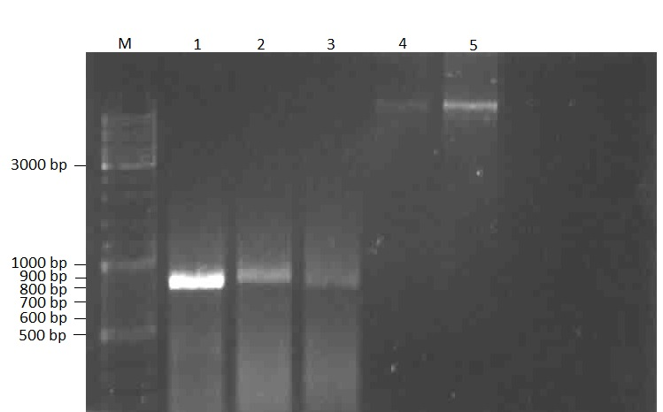
(A)

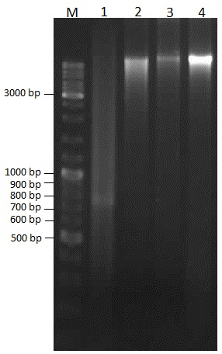
(B)
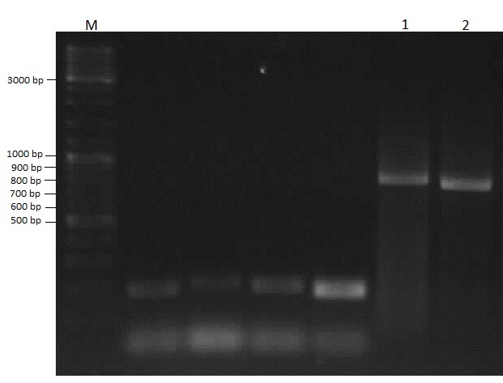
(C)

Figure S5. Supplementary Figures.
- Electrophoresis results of PCR products of RAG1 gene and genomic DNA extraction from C57BL/6 normal mouse sperm by a simple improved kit-based protocol. Lane M: 1 kb DNA ladder, Lane 1: PCR product of RAG1 gene (~860 bp) with the DNA template from sample of mES cells as control, Lane 2 and 3: PCR products of RAG1 gene with the DNA template from sample of 100,000 and 20,000 sperms extracted from the vas deferens, respectively, Lane 4 and 5: genomic DNA samples of 20,000, 100,000 sperms extracted from the vas deferens, respectively. Lane 4 and 5 were cropped for figure 5.

- Electrophoresis results of PCR products of RAG1 gene and genomic DNA extraction from C57BL/6 normal mouse sperm by a simple improved kit-based protocol. Lane M: 1 kb DNA ladder, Lane 1: PCR product of RAG1 gene (~860 bp) with the DNA template from total sperm of epididymis (inefficient protocol of DNA template extraction before optimization), Lane 2: genomic DNA samples of epididymis sperms extracted by inefficient protocol before optimization. Lane 3: genomic DNA sample of 300,000 sperm extracted from the vas deferens and Lane 4: total genomic DNA isolated from the epididymis. . Lane 3 and 4 were cropped for figure 5

- Electrophoresis results of PCR products of RAG1 gene from DNA template extracted from C57BL/6 normal mouse sperm. Lane M: 1 kb DNA ladder, Lane 1 and Lane 2: PCR products of RAG1 gene (~860 bp) with the DNA template from sample of 20,000 sperms and total sperm of epididymis, respectively. Unnumbered lanes are irrelevant of this study and were removed from the image of figure 5 in the main text. Lane M, lane 1 and lane 2 were cropped for figure 5

