Manipulating Interlayer Excitons for Ultra-pure Quantum Light Generation

Huan Zhao^{1,*}, Linghan Zhu², Xiangzhi Li¹, Vigneshwaran Chandrasekaran¹,
Jon Kevin Baldwin¹, Michael T. Pettes¹, Andrei Piryatinski^{1,3}, Li Yang^{2,4,*},
Han Htoon^{1,*}
¹Center for Integrated Nanotechnologies, Materials Physics and Applications Division, Los Alamos National Laboratory, Los Alamos, New Mexico 87545, USA
²Department of Physics, Washington University in St. Louis, St. Louis, Missouri 63130, USA
³Theoretical Division, Los Alamos National Laboratory, Los Alamos, NM 87545
⁴Institute of Materials Science and Engineering, Washington University in St. Louis,
St. Louis, Missouri 63130, USA
*Corresponding authors, Email: huanzha@lanl.gov, yang@physics.wustl.edu, htoon@lanl.gov

- Supplementary Note 1. Sample Preparation
- Supplementary Note 2: Raman of a MoS₂-WSe₂ Heterobilayer on Nanopillars
- Supplementary Note 3: PL image of an HBL on nanopillar arrays
- Supplementary Note 4: Additional PL Spectra of HBL and HTL samples on nanopillar arrays
- Supplementary Note 5: Emission property of an MoS₂/WSe₂ HBL with a large twist angle
- Supplementary Note 6: Pump-power-dependent PL intensity of a QE
- Supplementary Note 7: TRPL of an HBL/hBN sample on nanopillar
- Supplementary Note 8: Comparison between localized Γ-defect IX and moire trapped IX
- Supplementary Note 9: Band-structure calculations under various defect configurations
- Supplementary Note 10: additional PLE data
- Supplementary Note 11: Modeling TRPL of a QE under different laser repetition rates and two-photon correlation function $g$⁽²⁾
- Supplementary Note 12: A diagram of the optical measurement setup
Supplementary Note 1. Sample Preparation
We develop a modified mechanical exfoliation method that allows for easy exfoliation and transfer of 2D monolayers (Supplementary Figure 1a). First, we spin coat a ~10 nm of polyvinyl alcohol (PVA) layer on top of a Si/SiO₂ substrate to enhance the surface adhesivity. Then the 2D thin flakes are exfoliated onto a scotch tape from their bulk counterparts purchased from commercial sources. The tape with 2D flakes is subsequently brought into contact with the modified substrate and heated to 100 ºC for five minutes inside an inert-gas-filled glove box before detaching itself from the substrate. This method can easily produce 2D monolayers with > 100 μm lateral size and well-cleaved edges, which facilitates the alignment of crystallographic axes (Supplementary Figure 1b-d). By covering the exfoliated samples with a PDMS stamp and soaking the PDMS/sample into warm water (50 ºC), the exfoliated flakes attached to the PDMS stamp can readily detach the substrate since PVA is water-soluble. Finally, the 2D flakes are aligned and transferred onto another piece of 2D material or an arbitrary substrate using the well-developed PDMS-based viscoelastic transfer method.¹ Note PDMS can be replaced by other polymers such as PMMA and polycarbonate (PC). This sample preparation method is critical for consistently creating the 1.15 – 1.45 eV emission reported in our work as it can minimize the uncontrolled strain/defect generation during 2D material exfoliation and transfer process. In contrast, building 2D heterostructures by directly exfoliating monolayers onto PDMS followed by subsequent layer-to-layer stacking tends to generate ubiquitous strain and nanobubbles, which hinders the deterministic generation of quantum emitters and often leads to poor interface quality.
The PMMA nano-pillars are fabricated using electron beam lithography. Each nanopillar has a diameter of ~150 nm and a height of ~200 nm. The pitch of the nanopillar array ranges from 3 μm to 6 μm. The heterostructures are annealed overnight inside a cryostat at 400 K temperature before optical measurements.
For the MoS₂-WSe₂ heterobilayer (HBL) sample with an hBN shielding layer (main Figure 1e), we first prepare each individual layer and then stack them together to form an HBL/hBN heterostructure. Next, we transfer the entire heterostructure onto nanopillar arrays. We also tested hBN/HBL/hBN structures but did not find any spectral difference at NIR spectral range compared to the HBL/hBN structure. To prepare samples without defect, the bottom hBN layer is critical as it not only prevents the HBL from nanopillar-induced structural damage but also isolates the HBL from substrate adsorbates.
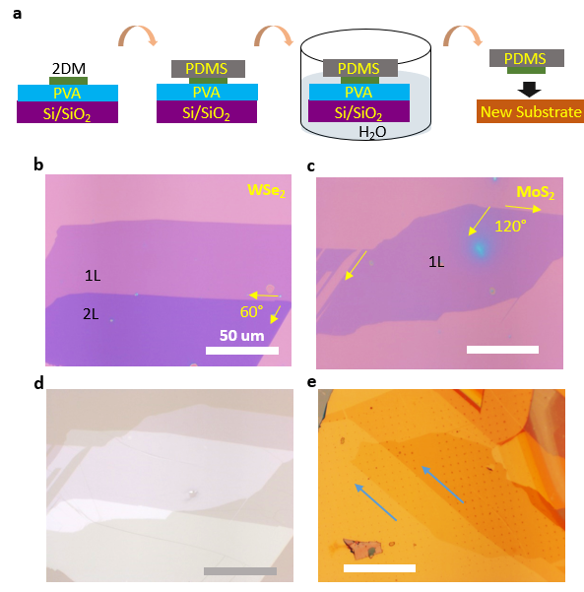
Supplementary Figure 1: Sample preparation. a, the schematic of our modified mechanical exfoliation method for creating and transferring large 2D materials (2DM); b-d, optical images of a WSe₂ and an MoS₂ sample as well as their heterostructure. The well-defined edges are marked by arrows. Monolayers and bilayers are labeled as 1L and 2L, respectively. e, the optical image of the heterostructure transferred on top of nanopillar arrays. Part of the HBL has hBN layers underneath (top right part of the image). Scale bar: 50 μm.

We assembled more than six large MoS₂-WSe₂ heterostructures with twist angles closed to 0 or 60º (near-coherent stacking). Such a small twist angle has been confirmed by polarization-resolved second harmonic generation (SHG) measurements, the Г-K IX emission energy of the HBL before being transferred onto nanopillars, and the alignment of the well-cleaved edges of each monolayer. The small twist angles are created by aligning the well-defined crystallographic axes of each constitutional layers. We also conducted polarization-resolved SHG measurements on some samples to confirm that the stacking is coherent (Supplementary Figure 2). In addition, the emission energy of the Γ-K IX of the heterobilayer (HBL) before being transferred onto nanopillars are measured to confirm the small twist angle. At room temperature, flat HBLs with coherent stacking emit at 1.57 eV while flat HBLs with 30º twist angle emit at 1.62 eV, which is easy to distinguish.²

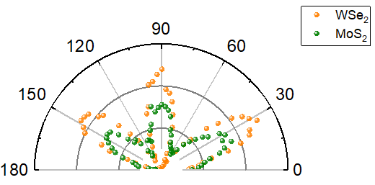
Supplementary Figure 2: Polarization-dependent SHG intensity of a typical heterobilayer. The twist angle is 60º in this sample, as the SHG signals of two monolayers are destructive.

Supplementary Table I is a summary of the NIR IX emissions from different MoS₂/WSe₂ heterostructure configurations.
Supplementary Table I: A summary of the NIR spectral range IX emissions from different sample configurations (MoS₂ and WSe₂ are edge-aligned).
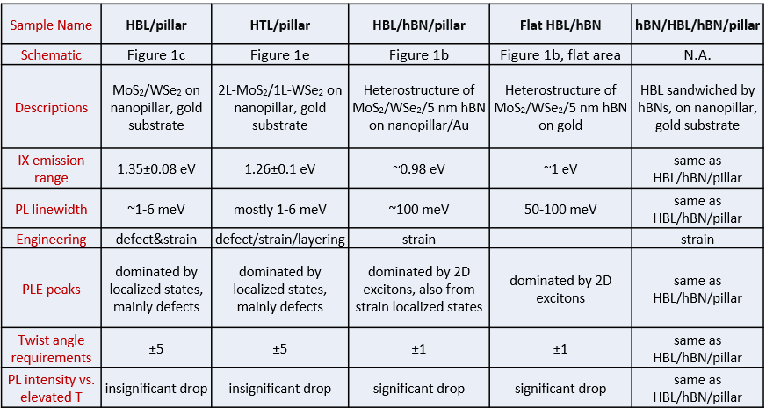

Supplementary Note 2: Raman of a MoS₂-WSe₂ Heterobilayer on Nanopillars
We performed Raman spectroscopy measurements on our HBL samples. The experiment was configured using an 1800 mm⁻¹ holographic grating blazed at 500 nm, a 200 mm confocal hole diameter, and a 100×, 0.9 N.A. objective in air. Spectral calibration was performed using the 1332.5 cm-1 band of a synthetic Type IIa diamond,³ and spectral intensity was calibrated using a VIS-halogen light source (NIST test no. 685/289682-17). Instrumental linewidth broadening was measured to be ~1.6 cm⁻¹ in the configuration used here.
Supplementary Figure 3a presents the optical image an HBL sample, which is part of the image of Supplementary Figure 1e (image flipped). The region outlined by the black box is Raman mapped with a 500 nm step size in x and y. Supplementary Figure 3b-3c display the intensity mapping of MoS₂ A_{1g} and WSe₂ E_{2g}¹ modes, showing the spatial distribution of the Raman signal of each material is consistent with their positions. At nanopillar sites, Raman intensity appears much stronger, particularly for the MoS₂ monolayer. In addition, the Raman signal of MoS₂ is enhanced at the HBL region, suggesting the presence of interlayer coupling. The averaged Raman spectrum of the HBL on nanopillars is plotted together with that of the flat HBL, showing strain-induced Raman redshift for both monolayers. According to a recent study that correlates the strain level and Raman shift of MoS₂, we estimate the strain level to be 0.27%.⁴ The real strain level should be larger than this value as the strain at a 200 nm diameter nanopillar tends to average out over a 500 nm mapping step size.

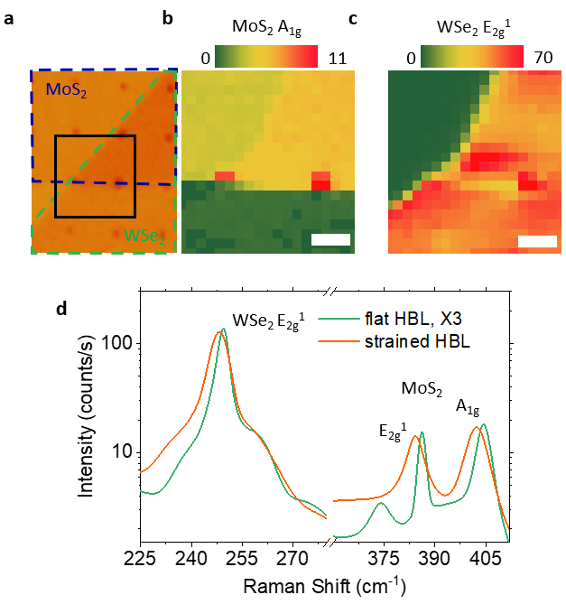
Supplementary Figure 3: Raman mapping and spectra of an HBL. a, an optical image of an HBL, where MoS₂ and WSe₂ monolayers are outlined by purple and green dashed lines, respectively. The black box outlines the Raman mapping region. b, the Raman intensity mapping of MoS₂ A_{1g} mode; c, the Raman intensity mapping of WSe₂ E_{2g}¹ mode. Scalebar: 2 μm. d, Raman spectra of flat and strained HBL sample.

Supplementary Note 3: PL image of an HBL on nanopillar array
Supplementary Figure 4 shows the optical image and the PL image of an MoS₂-WSe₂ heterostructure. The PL image was collected by an InGaAs camera with a detection range from 870 nm to 1600 nm, under wide-field illumination.
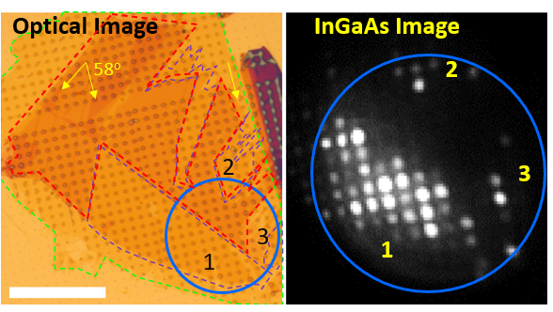
Supplementary Figure 4: Optical and PL images of an HBL. Left panel: an optical image of an MoS₂-WSe₂ heterostructure, where MoS₂ and WSe₂ monolayers are outlined by green and purple dashed lines, respectively. Bi- and tri-layer WSe₂ is outlined by red dashed line. The twist angle is about 2 (or 58) degrees, as estimated from the sharp edges of the two materials. Three HBL regions within the imaging area are labeled. The blue circle outlines the region illuminated by a 750 nm laser using a wide-field configuration, which leads to the PL image displayed in the right panel. Note the region that has monolayer MoS₂ stacked on top of bilayer WSe₂ does not emit brightly. Scalebar: 30 μm.

Supplementary Note 4: Additional PL Spectra of HBL and HTL samples on nanopillar array
Supplementary Figure 5 shows additional PL spectra of HBL and HTL (2L MoS₂/ 1L WSe₂) samples that are not presented in the main figures. Each spectrum was collected from one nanopillar site, which may contain more than one individual emitter. These spectra are "typical” because they represent a diverse range of emission energies, PL linewidths, numbers of PL peaks per pillar, etc. All spectra were taken at 10 K temperature using an InGaAs camera cooled to 77 K.
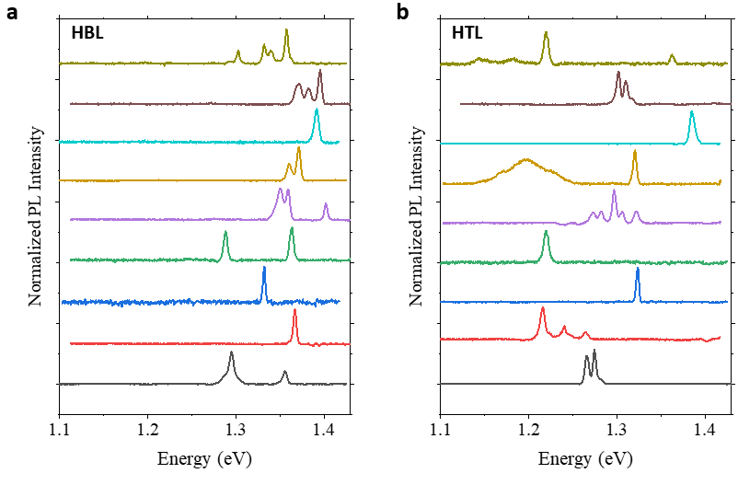
Supplementary Figure 5: Additional PL spectra of HBL and HTL samples. a, PL spectra of HBL samples collected at 9 different nanopillar sites; b, PL spectra of HTL samples collected at 9 different nanopillar sites. Note multiple PL peaks that appeared in one spectrum do not necessarily originate from one emitter, as there could be multiple emitters residing in one nanopillar site that cannot be spatially resolved by far-field optics.
Like the case of WSe₂ monolayer on nanopillar arrays, we often observe multiple emission lines from one nanopillar, which happens more frequently in hetero-trilayers, see Supplementary Figure 6.

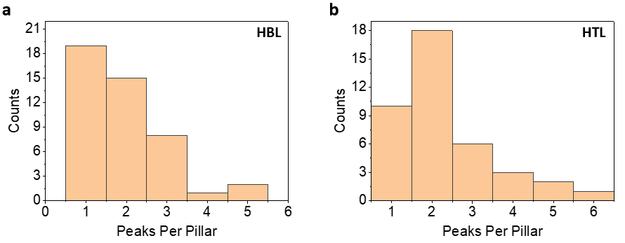
Supplementary Figure 6: Histograms of numbers of PL peaks per nanopillar site. The histograms of PL peaks per nanopillar for a, HBL samples; and b, HTL samples.

Supplementary Note 5: Emission property of an MoS₂/WSe₂ HBL with a large twist angle
Supplementary Figure 7a shows the optical image of an HBL sample on nanopillars. The twist angle is 22º. We checked the PL of all nanopillar sites (~50) that have HBL on top, but only one display emission in 1.15-1.45 eV spectral range, as presented in Supplementary Figure 7b. The excitation power was ~0.1-1 μW, 2 orders of magnitude higher than a typical excitation power used in small-twist-angle HBL measurements. A recent study has reported that MoS₂-WS₂ K-Γ IX emission with large twist angle results in almost vanished PL signal and significantly broadened spectrum,⁵ which is consistent with our findings.
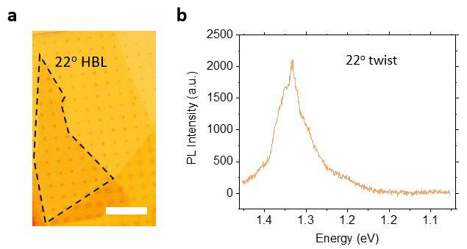
Supplementary Figure 7: MoS₂/WSe₂ HBL with 22º twist angle. a, optical image; b, low-temperature PL spectrum.

Supplementary Note 6: Pump-power-dependent PL intensity of a QE
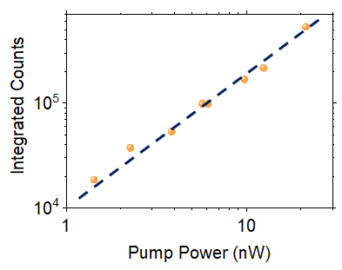
Supplementary Figure 8: Pump-power-dependent emission intensity of the PL peak presented in main Figure 2a shows near-perfect linear scaling with pump-power. The dashed line is a linear fit to the data.

Supplementary Note 7: TRPL of an HBL/hBN sample on nanopillar
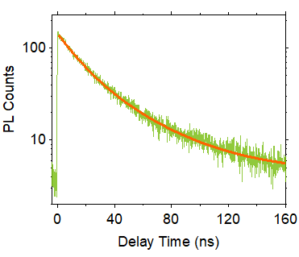
Supplementary Figure 9: PL decay curve of a K-K IX emission peaked at 1 eV. The PL spectrum of the same emitter is displayed in main Figure 4a. The decay curve is fitted by a biexponential decay equation, yielding τ₁ = 14.9±0.4 ns and τ₂ = 40.6±1.6 ns. Green curve: raw data. Orange curve: biexponential decay fit to the data.

Supplementary Note 8: Comparison between localized Γ-defect IX and moire trapped IX
In MoSe₂/WSe₂ HBL system, since the lattice mismatch of the two individual layer is as small as 0.1%, large moire unit cell can be formed when the two layers are angle-aligned. IXs trapped into such moire potential can form localized emissions, signatured by sharp PL lines at low temperature. Since moire trapping potential is shallow (typically at the scale of a few meV or tens of meV), such emission can be only obtained in the limit of weak excitation and < 30 K low temperature. Despite photon antibunching has been demonstrated in moire-trapped IX emissions, the stringent operation conditions arising from the shallow trapping potential, the unbridled emitter positioning, and the requirement of nearly identical lattice constants of two constituent layers have fundamentally hindered the future applications of such QEs. In contrast, the localization of Γ-defect IX reported in our work provides a general strategy that allows for site-controlled creation of robust, tunable, and bright QEs irrespective of lattice matching of the constituent materials. Without the restriction of perfect lattice match, we can unlock the freedom of selecting various 2D semiconductor monolayers to build IXs with desired emission energy.
The moire trapping effect commonly observed in MoSe₂/WSe₂ system has not been optically detected in any of the previous studies of MoS₂/WSe₂ system with small twist angle (main manuscript reference 17-19 and 24-25), perhaps due to the large lattice mismatch (3.8%). A recent study⁶ reports a moire-unit-cell length of 6.1 nm in angle-aligned MoS₂/WSe₂, which means thousands of moire cells are pumped together in each confocal PL measurement, leading to spectrum broadening. Nevertheless, at low excitation power (~ 1 nW), we very occasionally obtained sharp PL lines from MoS₂/WSe₂ K-K IX emission on nanopillars with hBN spacer layer. This feature is very similar to the sharp PL lines originated from moire-trapped IXs in MoSe₂/WSe₂ HBLs. Neither our measurements nor previous studies have detected such sharp PL lines in homogenous MoS₂/WSe₂ HBLs, suggesting that local strain could play a crucial role in breaking down the K-K IX emission into isolated narrow peaks. We were not able to systematically characterize these emitters due to their ultra-low occurrence rate (2 out of >100 measurements). Future effort of deterministically creation and careful characterization of such emitters are highly encouraged as they are promising for telecom O-band quantum light generation.

Supplementary Note 9: Band-structure calculations under various defect configurations
Supplementary Figure 10a and Supplementary Figure 10b show the band structures of MoS₂/WSe₂ HBL with a sulfur vacancy in the top and bottom sulfur layer, respectively. In both scenarios, the defect bands emerge ~0.4 eV below the CBM of MoS₂. On the other hand, the presence of a selenium vacancy gives rise to defect levels above the CBM of MoS₂, leaving the low-energy optical transitions unchanged (Supplementary Figure 10c). The electronic structure calculations have excluded Se vacancy as the origin of the large redshift of our defect-Γ transition. The first-principles DFT simulations presented in the main text and in supplementary note 9 do not consider many-electron effects, which are enhanced in 2D semiconductors and dominate optical.^{7,8} On the other hand, the self-energy correction and electron-hole binding energies are similar for both intrinsic and defect excitons.⁹ Therefore, our discussions of relative energies between excitons from defects and continuum bands are still valid.
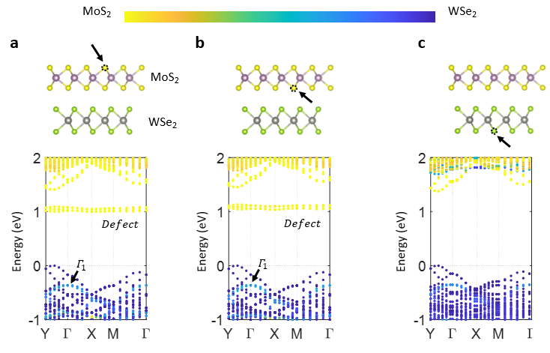
Supplementary Figure 10: Band structures of MoS₂-WSe₂ HBLs under different defect configurations. a, b,. HBL with s sulfur vacancy in the top and bottom sulfur layer, respectively; c, HBL with a selenium vacancy. The defect sites are outlined in the crystal lattice structures.
Supplementary Note 10: additional PLE data
HBL samples have strong PLE features near the WSe₂ band edge (~1.5 – 1.75 eV) but display relatively weak PLE in ~1.75 – 2 eV covering 2D band-edge excitons of MoS₂ and WSe₂ (Figure 4b and Supplementary Figure 11a). In contrast the hetero-trilayer (HTL) sample exhibits strong adsorption at both MoS₂ and WSe₂ band edges (Supplementary Figure 11b). We attribute this behavior to the fact that HBL and HTL samples have different Γ point compositions. MoS₂ only contributes to 31% of the HBL Γ point wavefunction (which is further reduced to 29% upon applying strain), whereas the percentage increased to 41% in an HTL (Figure 3a, 3b, 3d). With an increased MoS₂ component at Γ band edge, carriers populated by photoexcitation in MoS₂ absorption bands can be more efficiently transferred to Γ band, leading to the pronounced MoS₂-branch PLE features in HTL.
For Γ-defect IX emissions, HBL are coupled directly to the Au substrate except for the regions immediately above the nanopillars. As a result, only the excitons created in the 150 nm diameter nanopillar regions can contribute to the Γ-defect IX emissions while all the 2D intra-layer excitons created in the vicinity of nanopillars were essentially quenched by the Au substrate. At nanopillar sites, excitons resonantly pumped into the 1.5 – 1.7 eV energy states are trapped by the strain-and-defect induced potential wells before relaxing to the Γ-defect IX state, leading to the prominent absorption features. For K-K IX emissions on nanopillars, the hBN spacer layer placed between the HBL and gold-nanopillar substrate can minimize defect formation and suppress the quenching of the 2D intra-layer excitons. Therefore, 2D intra-layer excitons formed in homogenous HBL/hBN regions nigh the nanopillars could be funneled into the nearest nanopillar sites and contribute to the prominent PLE feature of the K-K IX emission in absence of defect states. The exciton pumped into the strain-induced localized states can now make only minor contribution to the K-K IX emission. Taken together, these findings indicate that resonant excitation into WSe₂ localized exciton states as well as quenching of 2D intra-layer excitons play a crucial role in defect-Γ IX quantum light emissions.

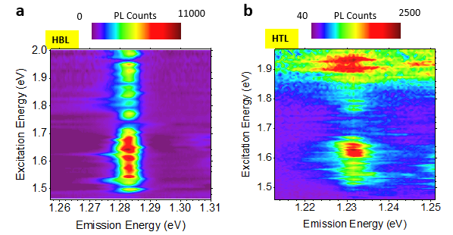
Supplementary Figure 11: two more sets of PLE intensity map data beyond the data presented in main Figure 4a and 4b. a, PLE map of another MoS₂/WSe₂ HBL; b, PLE map of a 2L MoS₂ / 1L WSe₂ (HTL).

Supplementary Note 11: Modeling TRPL of a QE under different laser repetition rates and two-photon correlation function $g$⁽²⁾.
To get a better insight into the exciton photoexcited dynamics, a nonlinear rate equation model for coupled K/-K exciton state in WSe₂ and Γ-defect IX is introduced. We used the model to fit the TRPL curves successfully reproducing the initial time uprising feature and yielding slow exciton transfer time ~5 ns to the defect state (see Supplementary Table II for accurate values). The fitting parameters were further validated by using them to simulate the two-photon correlation function presented in Fig. 2d. A good agreement was achieved (Supplementary Figure 13a) between our theory and experiment giving strong evidence towards validity of the proposed (Fig. 4d) electronic state model. Interestingly, fitting the long-time plateau of TRPL in Fig. 2b resulted in the extraction of additional 2 $μs$ decay timescale (see captions to Supplementary Table II). This timescale, indeed, well explains observed in Fig. 2d rise and fall of the correlation function side peaks, i.e., non-zero delay time bunching, and even better seen in a similar signal shown on $μs$ timescale (Supplementary Figure 13b). We attribute this feature to a dark defect shelving state receiving some portion of population from the Γ-defect IX on the timescale of 100 ns and returning the population back on the timescale of 2 $μs$. This observation suggests additional complexity of the defect electronic states, though not affecting purity of the emitted quantum photons.
Supplementary Table II Population decay and population transfer times (inverse rates) from data fit of TRPL data shown in Supplementary Figure 12 using our couped 2LS and 3LS model. The shelving ${τ_{12}=\frac{1}{k}}_{12}=150.77±0.11$ ns and de-shelving ${τ_{21}=\frac{1}{k}}_{21}=2000±75$ns times were extracted from the data for the 3.5 MHz repetition rate and were kept as fixed parameters while fitting the 6.5MHz and 11MHz date.
Repetition rate | $$τ_{1}=\frac{1}{k_{1}}$$ | $$τ_{12}=\frac{1}{k_{12}}$$ | $$τ_{x}=\frac{1}{k_{1}+k_{12}}$$ | $$τ_{2}=\frac{1}{k_{2}}$$
3.5 MHz | 5.98 ± 0.004 ns | 22.55 ± 0.004 ns | 4.73 ± 0.007 ns | 18.45 ± 0.01 ns
6.5 MHz | 7.90 ± 0.06 ns | 20.88 ± 0.04 ns | 5.73 ± 0.08 ns | 17.11 ± 0.14 ns
11 MHz | 8.53 ± 0.08 ns | 19.99 ± 0.05 ns | 5.99 ±0.11 ns | 16.18 ± 0.15 ns

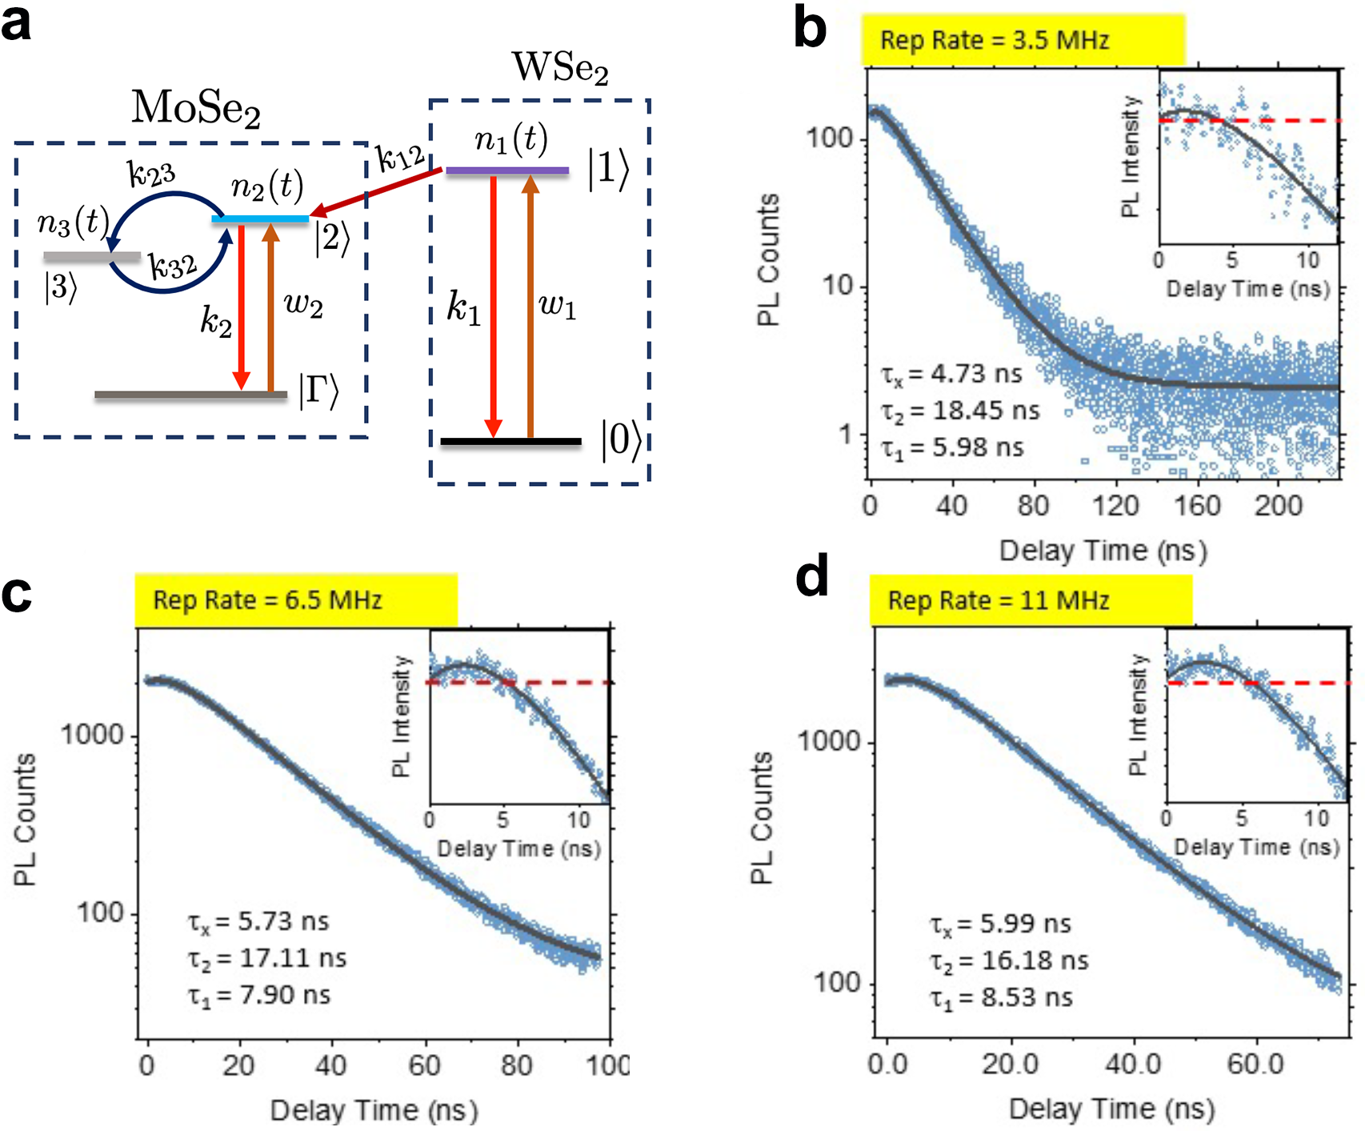Supplementary Figure 12: a. Adopted multilevel model for photoexcited dynamics with the details specified in the text. Panels, b, c, and d, display the TRPL of a QE (emission spectrum shown in Figure 2a) under optical excitation with pulse repetition rates 3.5 MHz, 6.5 MHz, and 11 MHz, respectively. Blue dots: experimental data, black line: theoretical fit using model in panel a with the extracted relaxation times given in Supplementary Table II. Insets: the first 12 ns of the PL decay. The red dashed lines are drawn to guide the eye. Notice that rising feature in the first few nanoseconds are more pronounced when the repetition rate is high.

Model: To understand the origin of the TRPL rising feature and fit the TRPL data, we used a multi-level model shown in Supplementary Figure 12a. Here, the interband exciton states at K/-K point of strained WSe₂ are represented as a two-level system (2LS) with the exciton vacuum $|0⟩$ and first excited state $|1⟩$. We allow optical excitation (population decay) of state $|1⟩$ with the rate w₁ (k₁). The IX states formed from a hole residing at the interlayer hybridization of the Γ valley and electron at MoS₂ defect states (see main Figure 1c and 3c) is modeled as a three-level system (3LS): the exciton vacuum $|Γ⟩$, and excited states $\left|2\right\rangle$ and $|3⟩$. Optical pumping (population decay) of state $|2⟩$ occurs with the rate w₂ (k₂). Furthermore, experimentally detected photon emission is due to the radiative decay of $\left|2\right\rangle$ to $|Γ⟩$. State $|3⟩$ is a dark shelving state that can accumulate and return back population of state $|2⟩$, with the rates k₂₃ and k₃₂, respectively. To model conversion of the WSe₂ K/-K interband exciton into the IX, we couple the 2LS and 3LS by allowing population transfer $\left|1\right\rangle → |2⟩$ with the rate k₁₂.
Assigning time-dependent populations of states $|1⟩$, $|2⟩$, and $|3⟩$, as $n_{1}\left(t\right)$, $n_{2}\left(t\right)$, and $n_{3}\left(t\right)$ respectively, we introduce the following set of nonlinear rate equations describing coupled population dynamics withing our multilevel system
${\dot{n}}_{1}= - k_{1}n_{1}-k_{12}n_{1}\left[1-n_{2}-n_{3}\right]+w_{1}\sum_{m}{A\left(t-\frac{m}{ν}\right)\left[1-n_{1}\right]}$, (1)
${\dot{n}}_{2}=- k_{2}n_{2}+k_{12}n_{1}\left[1-n_{2}-n_{3}\right]-k_{23}n_{2}+k_{32}n_{3 }+w_{2}\sum_{m}{A\left(t-\frac{m}{ν}\right)\left[1-n_{2}-n_{3}\right]}$, (2)
${\dot{n}}_{3}= {-k}_{32}n_{3}+k_{23}n_{2}$. (3)
Here, $A\left(t-\frac{m}{ν}\right)$ is a time dependent amplitude of the excitation pulses forming a train with repetition rate $ν$. The nonlinear terms in square brackets (Eqs. (1) and (2)) are state filling factors accounting for the Pauli exclusion principle and slowing down population dynamics if the corresponding states are occupied.
Equations (1) – (3) can be derived from the Lindblad equation
$\dot{ρ}=\sum_{\hat{C}}{\left({\hat{C}ρ\hat{C}}^{†}-\frac{1}{2}\left({\hat{C}}^{†}\hat{C }ρ+ρ {\hat{C}}^{†}\hat{C}\right)\right)}$, (4)
describing driven-dissipative dynamics of reduced density matrix, $ρ$, for our coupled 2LS - 3LS. Here, the sum runs over a set of the collapse operators, $\hat{C}$, giving rise to the elementary dissipative and incoherent excitation processes. Let us introduce ladder operators $b_{1}=\left|1\right\rangle \left\langle 0\right|$, $b_{2}=\left|2\right\rangle \left\langle Γ\right|$, and $b_{32}=\left|3\right\rangle \left\langle 2\right|$, describing annihilation of an excitation at the states $\left|1\right\rangle$, $\left|2\right\rangle$, and the excitation transfer from $\left|2\right\rangle$ to $\left|3\right\rangle$, respectively. In terms of the ladder operators, population decay (gain) of states $\left|1\right\rangle$ and $\left|2\right\rangle$ is given by the collapse operators ${\hat{C}}_{1}=\sqrt{k_{1}}b_{1}$ and ${\hat{C}}_{2}=\sqrt{k_{2}}b_{2}$ (${\hat{C}}_{p1}=\sqrt{{\sum_{m}{A\left(t-\frac{m}{ν}\right)}w}_{1 }}b_{1}^{†}$ and ${\hat{C}}_{p2}=\sqrt{{\sum_{m}{A\left(t-\frac{m}{ν}\right)}w}_{2}}b_{2}^{†}$), respectively. Furthermore, population transfer $\left|1\right\rangle →\left|2\right\rangle$ is subject to ${\hat{C}}_{12}=\sqrt{k_{12}}b_{2}^{†}b_{1}$ as well as $\left|2\right\rangle →\left|3\right\rangle$ and $\left|3\right\rangle →\left|2\right\rangle$ are due to ${\hat{C}}_{23}=\sqrt{k_{23}}b_{32}$ $and {\hat{C}}_{32}=\sqrt{k_{32}}b_{32}^{†}$, respectively.
Instead of solving Eqs. (1) – (3) directly, we integrated the Lindblad equation (4) using QuTiP computational package with implemented master equation solver.^{10,11} To account for the dissipation processed of interest, we supplied the solver with the set of collapse operators $\hat{C}=\left\{{{\hat{C}}_{1},{\hat{C}}_{2},\hat{C}}_{p_{1}},{\hat{C}}_{p_{2},}{\hat{C}}_{12}, {\hat{C}}_{23}, {\hat{C}}_{32}\right\}$ defined above.
Modeling of TRPL decay: Time decay of emissive state $\left|2\right\rangle$ determines the TRPL behavior. Therefore, the population was numerically evaluated as
$n_{2}\left(t\right)=tr\left\{ρ\left(t\right)b_{2}^{†}b_{2}\right\}$, (5)
with the initial condition for the density matrix $ρ\left(t=0\right)$ prepared by a train of 50 square pulses of 200 ps duration. The population gain rates were set to w₁=100 ps and w₂=400 ps.
Subsequently, fit of the experimental data shown in Supplementary Figure 12, was performed using our computational model. Extracted relaxation parameters are listed in Supplementary Table II.
Modeling of the two-photon correlation function: Experimentally measured histogram of two-photon coincidence events of delay time $τ$ under the excitation by a train of pulses of repetition rate $ν$ can be described by the integral
$g^{(2)}\left(τ\right)=ν\int_{0}^{1/ν}{G^{(2)}\left(t,τ\right)dt}$ , (6)
over a delay time between two subsequent excitation pulses. Equation (6) contains two-photon correlation function, $G^{(2)}\left(t,τ\right),$ which for the adopted multi-level system can be expressed as^{8,9}
$G^{(2)}\left(t,τ\right)=tr\{ρ {\hat{b}}_{2}^{†}\left(t\right){\hat{b}}_{2}^{†}\left(t+τ\right){\hat{b}}_{2}\left(t+τ\right){\hat{b}}_{2}\left(t\right)\}$. (7)
In Eq. (7), $ρ$ is the reduced density matrix of coupled 2LS – 3LS, ${\hat{b}}_{2}$ is introduced above ladder operators for the $\left|2\right\rangle →|Γ⟩$ transition resulting in the probed correlated photon emission. We have implemented quantum regression theorem^{12,13} into a QuTiP script to numerically calculate the two-photon correlation histogram using fit parameters from Supplementary Table II.
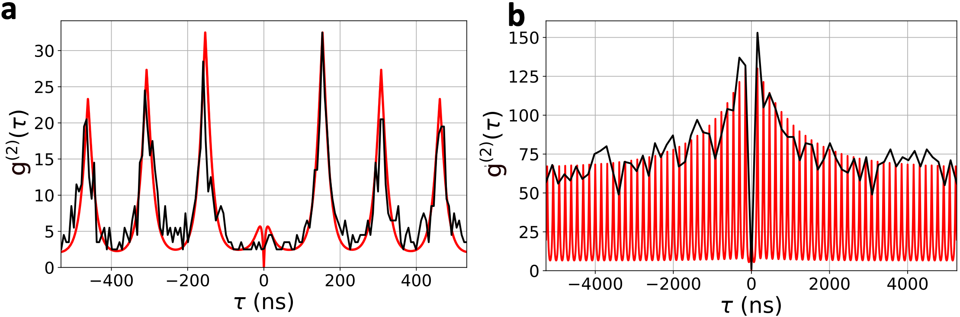
Supplementary Figure 13: Superimposed two-photon correlation functions measured experimentally (black line) and calculated using model (red line) in Supplementary Figure 12a for (a) 6 (see main Figure 2d) and (b) 69 delay times between pulses arriving with repetition rate of 6.5 GHz. For the experimental data showing timescale of 69 delay times, we integrated the overall coincident counts in each correlation function side peak as one data point, resulting in a line plot of 69 data points showing bunching behavior on ~2 $μs$ timescale.

Results of the calculations (red line) are shown in Supplementary Figure 13 demonstrating a good agreement with the experiment (black lines). Noteworthy, the model well reproduces photon bunching observed for the non-zero delay times of a few microseconds. According to the model, the observed bunching is due to the population shelving and deshelving by state $|3⟩$ on the scales of $τ_{23}=150$ ns and $τ_{32}=2 μs$, respectively.

Supplementary Note 12: A diagram of the optical measurement setup

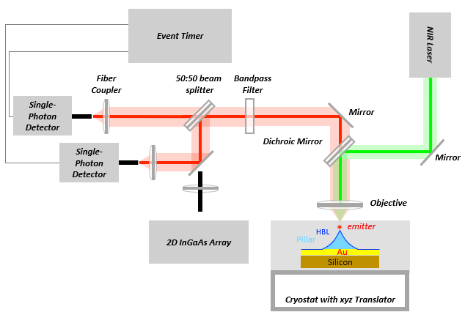
Supplementary Figure 14: An illustration of the optical measurement setup.
References of Supplementary Information:
- Castellanos-Gomez, A., Buscema, M., Molenaar, R., Singh, V., Janssen, L., Van Der Zant, H. S., & Steele, G. A. (2014). Deterministic transfer of two-dimensional materials by all-dry viscoelastic stamping. 2D Materials, 1(1), 011002.

Kunstmann, J. et al. Momentum-space indirect interlayer excitons in transition-metal dichalcogenide van der Waals heterostructures. Nature Physics 14, 801-805 (2018).

Solin, S. A., and A. K. Ramdas. "Raman spectrum of diamond." Physical Review B 1.4 (1970): 1687.

Li, Z., Lv, Y., Ren, L., Li, J., Kong, L., Zeng, Y., ... & Liu, Y. (2020). Efficient strain modulation of 2D materials via polymer encapsulation. Nature communications, 11(1), 1-8.

Tebyetekerwa, M., Zhang, J., Saji, S. E., Wibowo, A. A., Rahman, S., Truong, T. N., ... & Nguyen, H. T. (2021). Twist-driven wide freedom of indirect interlayer exciton emission in MoS2/WS2 heterobilayers. Cell Reports Physical Science, 2(8), 100509.

Karni, O., Barré, E., Pareek, V., Georgaras, J. D., Man, M. K., Sahoo, C., ... & Dani, K. M. (2022). Structure of the moiré exciton captured by imaging its electron and hole. Nature, 603(7900), 247-252.

Qiu, Diana Y., H. Felipe, and Steven G. Louie. "Optical spectrum of MoS 2: many-body effects and diversity of exciton states." Physical review letters 111.21 (2013): 216805.

Chernikov, Alexey, et al. "Exciton binding energy and nonhydrogenic Rydberg series in monolayer WS2." Physical review letters 113.7 (2014): 076802.

Refaely-Abramson, Sivan, et al. "Defect-induced modification of low-lying excitons and valley selectivity in monolayer transition metal dichalcogenides." Physical review letters 121.16 (2018): 167402.

Johansson, J.R. Nation P.D. and Nori, F. QuTiP 2: a Python framework for the dynamics of open quantum systems. Comp. Phys. Comm, 184, 1234 (2013).

Johansson, J.R., Nation, P.D. and Nori, F. QuTiP: An open-source Python framework for the dynamics of open quantum systems. Comp. Phys. Comm. 183, 1760–1772 (2012)

Loudon, R. The Quantum Theory of Light. (Oxford University Press, Oxford, 2000).

Zheng, Y., Kim, Y., Jones, A. C., Olinger, G., Bittner, E. R., Bachilo, S. M., Doorn, S. K., Weisman, R. B., Piryatinski, A., Htoon, H. Quantum Light Emission from Coupled Defect States in DNA-Functionalized Carbon Nanotubes, ACS Nano 15, 10406-10414 (2021).

