SUPPLEMENTARY MATERIAL
TRANSCRIPTOME DYSREGULATION IN HEPATOBLASTOMA: THE PIVOTAL ROLE OF NONCODING RNAS AND CHANGES IN LIPID METABOLISM

Maria Prates Rivas^{1*}, Talita Ferreira Marques Aguiar^{1,2*}, Edson Mario de Andrade^{3*}, Sara Ferreira Pires¹, Alexandre Defelicibus⁴, Bruna Barros⁴, Estela Novak⁵, Lilian Maria Cristofani⁵, Vicente Odone⁵, Monica Cypriano⁶, Silvia Regina Caminada de Toledo⁶, Isabela Werneck da Cunha⁷, Cecilia Maria Lima da Costa⁸, Dirce Maria Carraro⁴, Israel Tojal⁴, Tiago Antônio de Oliveira Mendes³, Ana Cristina Victorino Krepischi^{1**}

- Human Genome and Stem-Cell Research Center, Department of Genetics and Evolutionary Biology, Institute of Biosciences, University of São Paulo, São Paulo, Brazil.
- Columbia University Irving Medical Center, New York, NY, USA
- Department of Biochemistry and Molecular Biology, Federal University of Viçosa, Minas Gerais, Brazil
- International Center for Research, A. C. Camargo Cancer Center, São Paulo, Brazil.
- Pediatric Cancer Institute (ITACI) at the Pediatric Department, São Paulo University Medical School, São Paulo, Brazil.
- Department of Pediatrics, Adolescent and Child with Cancer Support Group (GRAACC), Federal University of São Paulo, São Paulo, Brazil.
- Department of Pathology, Rede D’OR-São Luiz, São Paulo, Brazil.
- Department of Pediatric Oncology, A. C. Camargo Cancer Center, São Paulo, Brazil.

*These authors contributed equally.

** Corresponding author:
Ana Cristina Victorino Krepischi
Human Genome and Stem-Cell Research Center, Department of Genetics and Evolutionary Biology - Institute of Biosciences, University of São Paulo, São Paulo, Brazil
Phone: 55 11 3091 7573
E-mail: ana.krepischi@ib.usp.br

Supplementary Figure S1. Principal Component Analysis (PCA) and clustering of HBL and control liver samples. The PCA analysis was applied to the differentially expressed genes (DEGs) (FDR <0.05 and log₂ fold-change). In A, the contribution in total variance of the first 10 dimensions (components) are represented (bars). The graph in B shows the ideal number of clusters (dashed vertical lines).
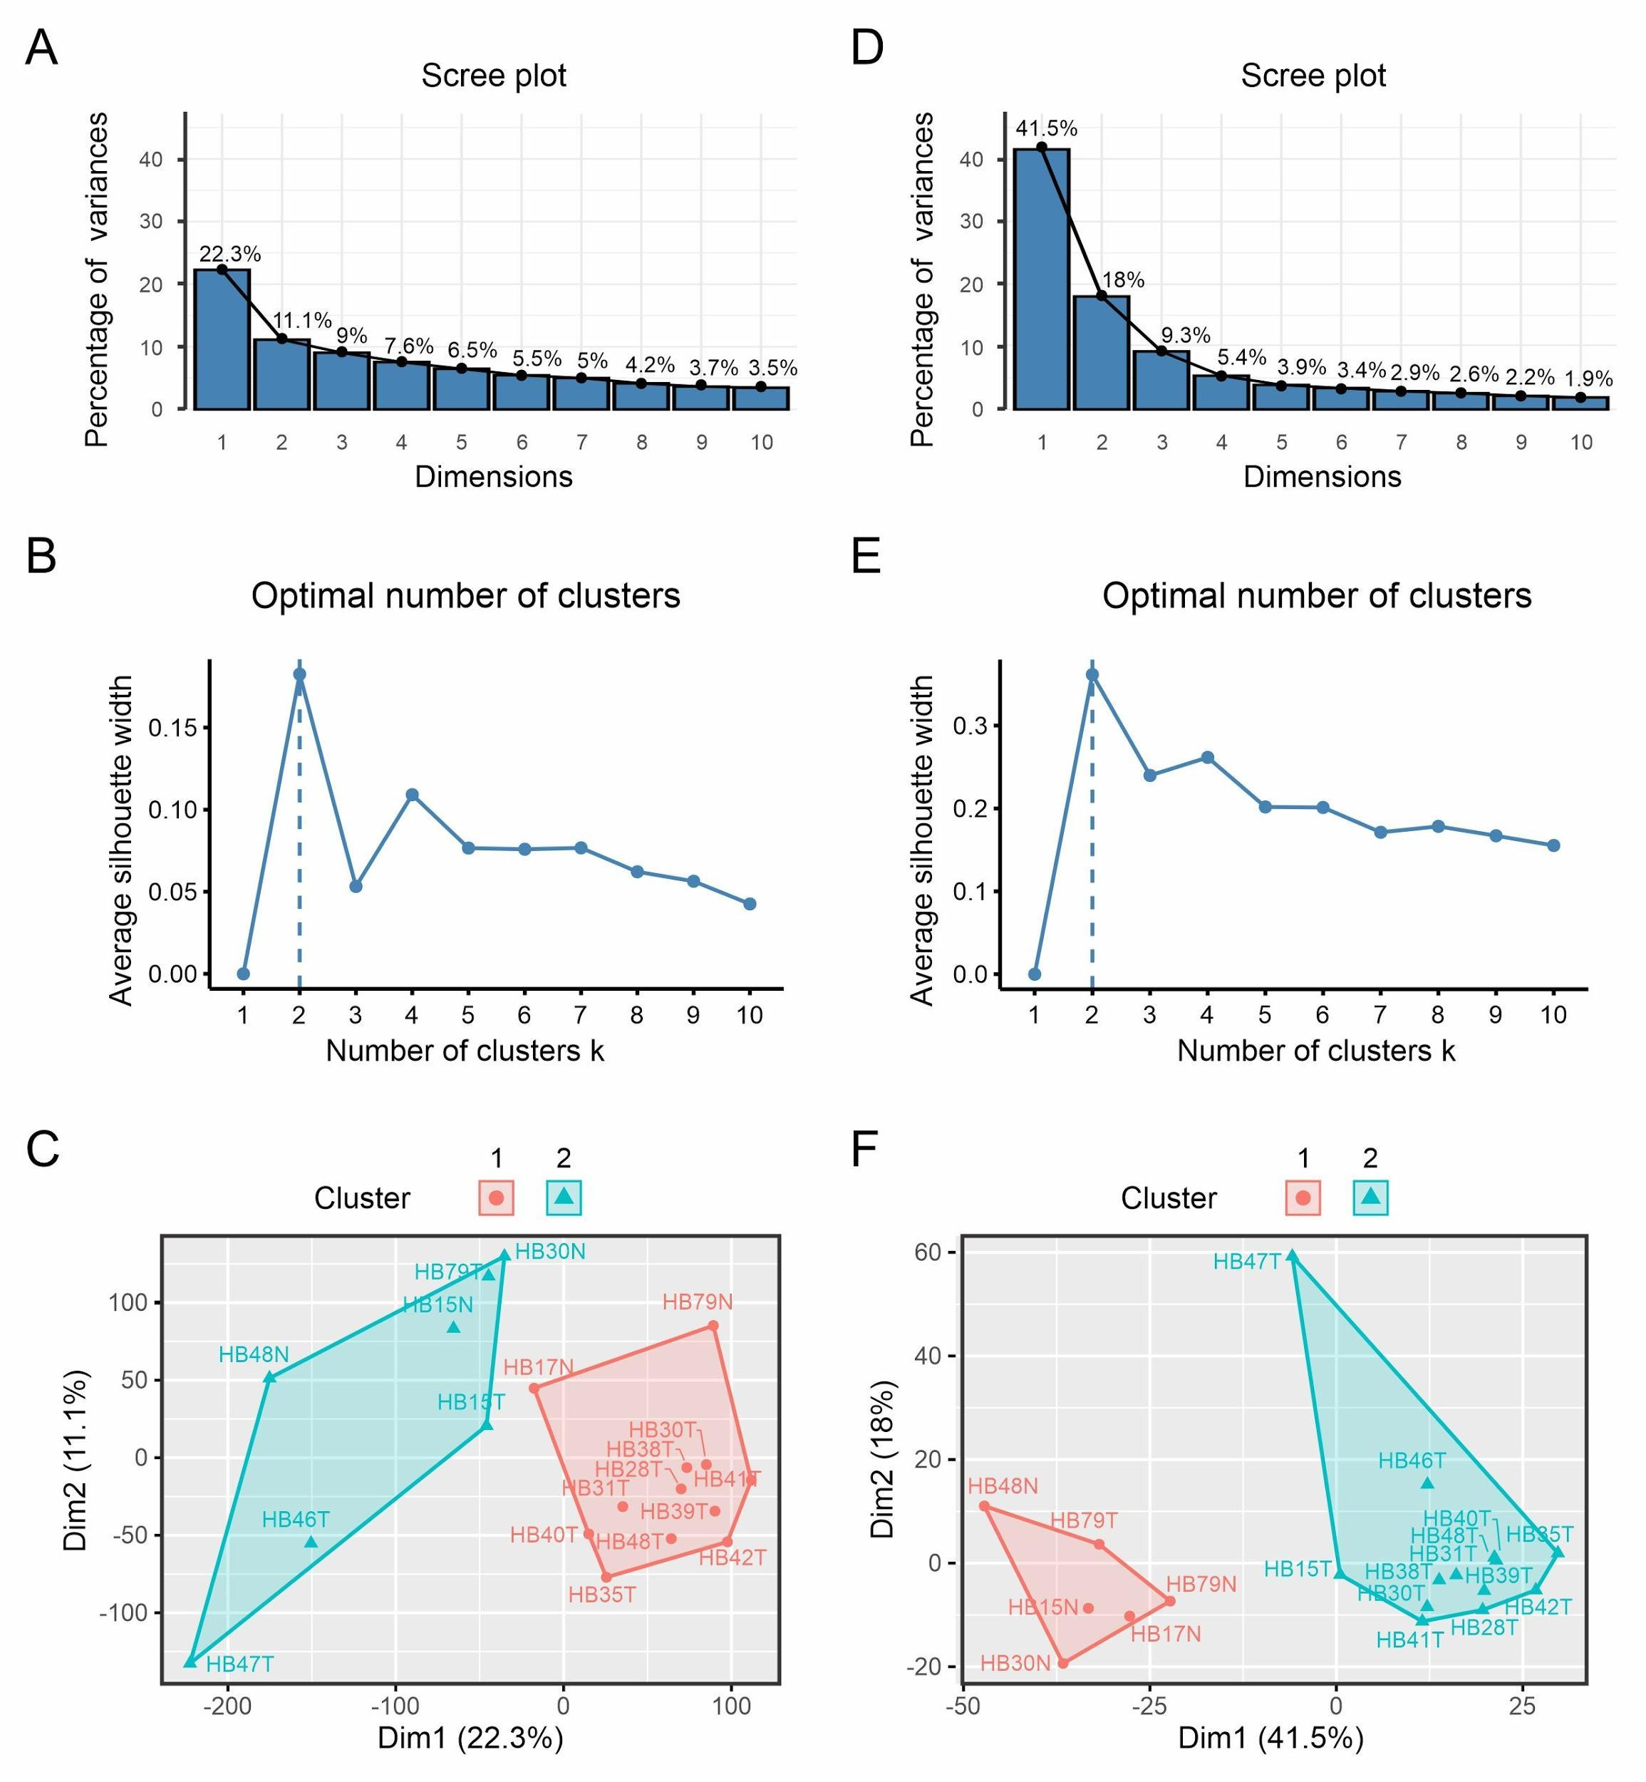

A
B

Supplementary Figure S2. Protein-protein interaction (PPI) network. The network represents the enriched biological processes in each cluster and all proteins that interact directly (A-G). Proteins with a degree of centrality (hub, bottleneck, or hub-bottleneck) were represented as larger dots. Down or upregulation of genes encoding proteins with centrality are shown in blue and red, respectively. The main network is shown in the center of the figure (H).

