Supplemental Information

Extracellular vesicles derived from glioblastoma promote proliferation and migration of neural progenitor cells via PI3K-Akt pathway

Jiabin Pan, Shiyang Sheng, Ling Ye, Yizhao Ma, Lisha Qiu, Zhaohuan Fan, Xiaohuan Xia, Yi Wang, Yunlong Huang, Jialin C. Zheng

Supplemental Materials
Supplementa Figure 1
Supplemental Figure 2
Supplemental Figure 3
Supplemental Figure 4
Supplemental Figure 5

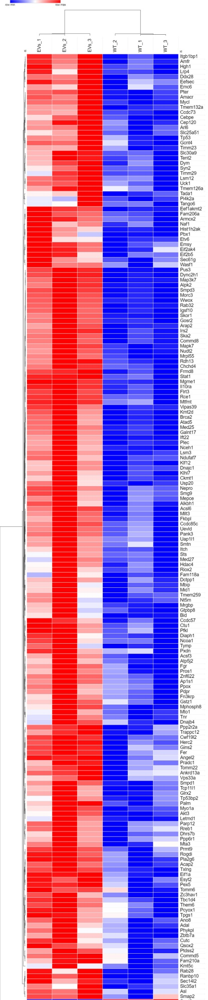
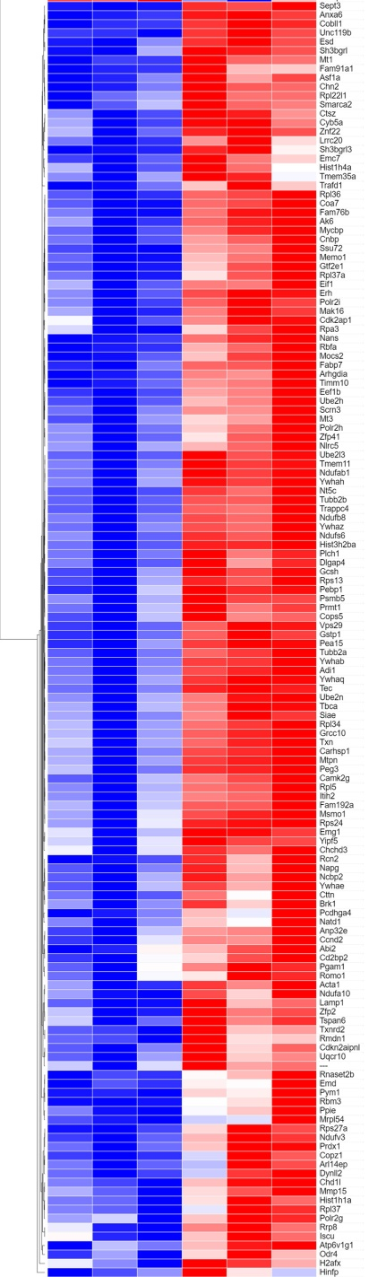

Supplementary Figure 1. Heatmap of differentially expressed proteins in U87 EVs-treated mNPCs versus control mNPCs.

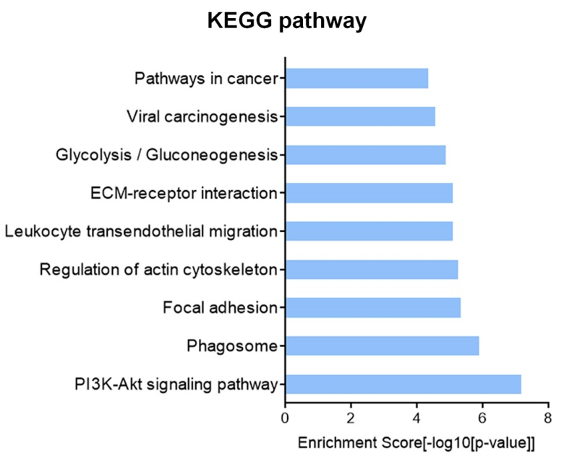
Supplementary Figure 2. KEGG analysis for top 100 abundantly expressed proteins in U87-derived EVs.

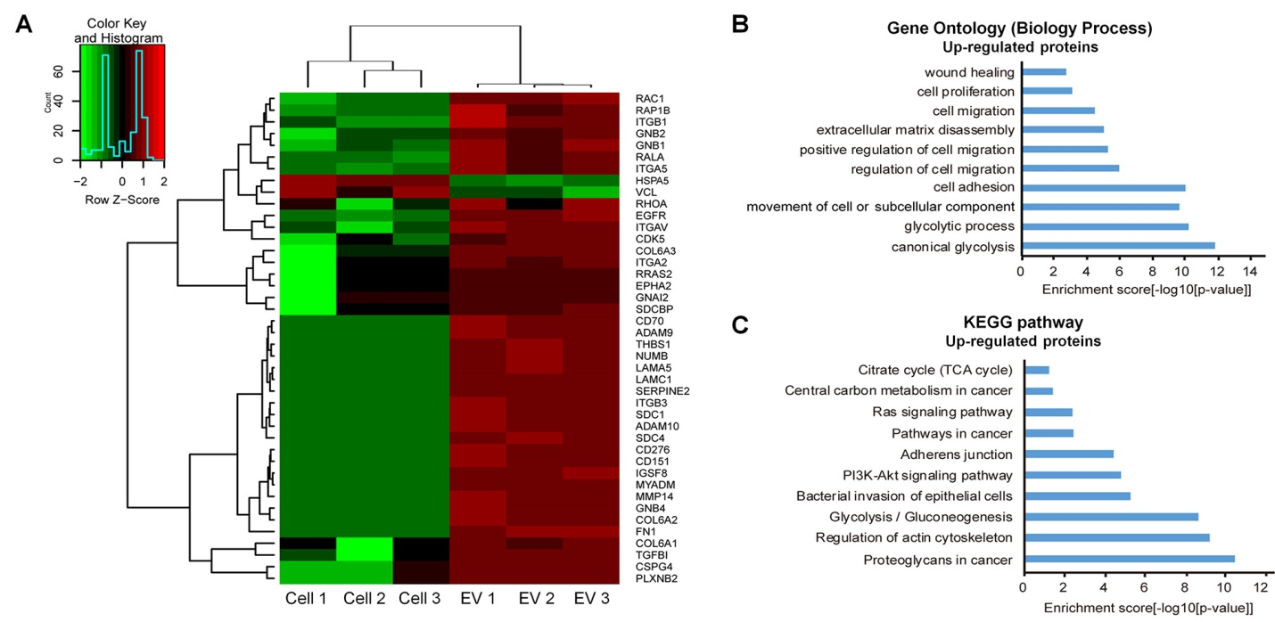
Supplementary Figure 3. Proteomic analysis of U87-derived EVs versus U87 cells. A. Heatmap and hierarchical clustering of differentially expressed proteins in U87-derived EVs versus U87 cells. B. Top 10 biology processes of upregulated proteins revealed by Gene Ontology analysis. C. Top 10 signaling pathways of upregulated proteins revealed by KEGG analysis.

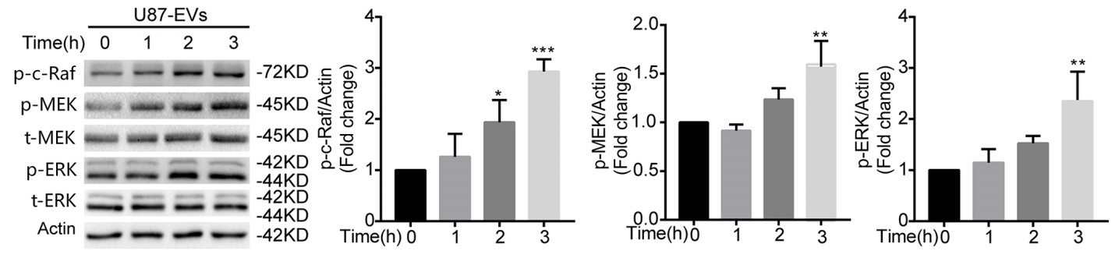
Supplementary Figure 4. Western-blot confirmation of upregulated ERK signaling pathway proteins in U87 EVs-treated mNPCs. p-c-Raf, p-MEK, and p-ERK were upregulated in U87 EVs-treated mNPCs compared with control mNPCs in a time-dependent manner.

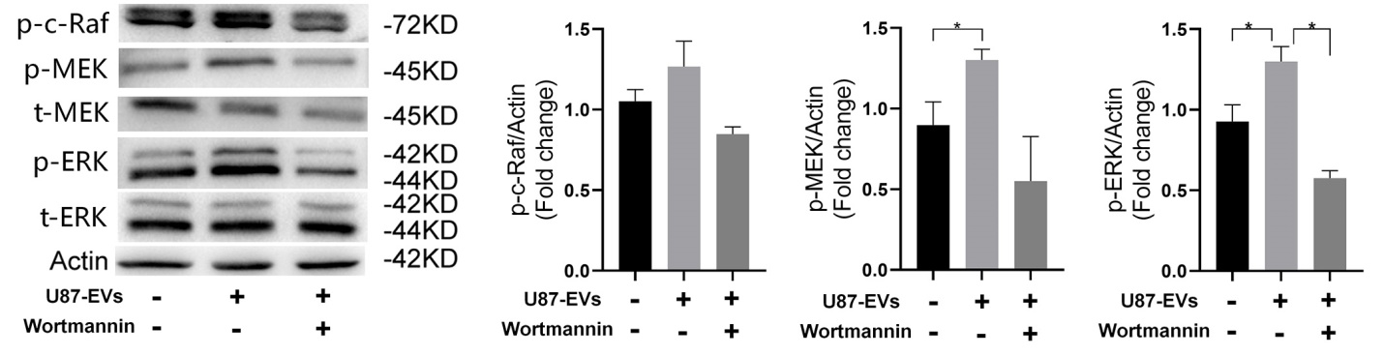
Supplementary Figure 5. PI3K inhibitor Wortamnnin lowered upregulated ERK pathway proteins in U87 EVs-treated mNPCs. Western-blot analysis revealed that PI3K inhibitor Wortamannin treatment lowered the protein levels of p-c-Raf, p-MEK, and p-ERK.

