Supporting Information

Polydopamine nanomedicine-enabled antioxidation against senescence

Jiamei Han¹, Jiao Wang¹, Hongwei Shi¹, Qian Li^{2,3}, Shibo Zhang¹, Hao Wu¹, Wenjun Li¹, Cheng Zhuang¹, Linhua Gan⁴, Wei Feng^{1*}, Yu Chen^{1*}, Holly M. Brown-Borg^{5*} and Robert Chunhua Zhao^{1,2*}

- School of Life Sciences, Shanghai University, Shanghai, China.

2. Institute of Basic Medical Sciences Chinese Academy of Medical Sciences, School of
Basic Medicine Peking Union Medical College, Center of Excellence in Tissue Engineering, Chinese Academy of Medical Sciences, Beijing Key Laboratory of New Drug Development and Clinical Trial of Stem Cell Therapy (BZ0381), Beijing, China.

3. Cell Energy Life Sciences Group Co. LTD, Qingdao, Shandong, China.

4. Department of Neurology and National Research Center for Aging and Medicine & National Center for Neurological Disorders, State Key Laboratory of Medical Neurobiology, Huashan Hospital, Fudan University, Shanghai, China.

5. Department of Biomedical Sciences, School of Medicine & Health Sciences, University of North Dakota, Grand Forks, ND, USA.

Corresponding Author E-mail: fengw@shu.edu.cn, chenyuedu@shu.edu.cn, holly.brown.borg@und.edu, zhaochunhua@vip.163.com.
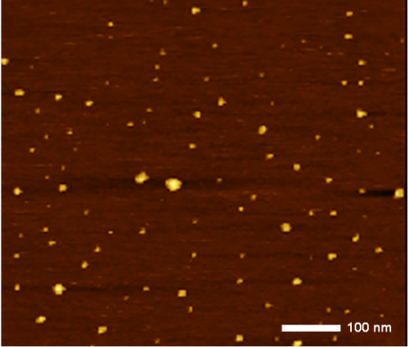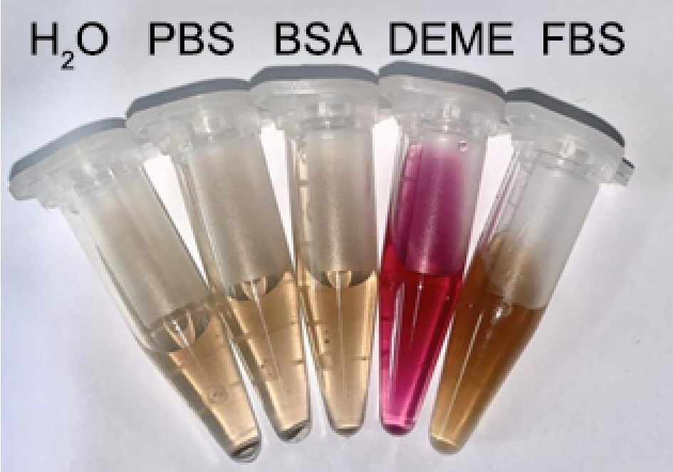
c
a
d
b
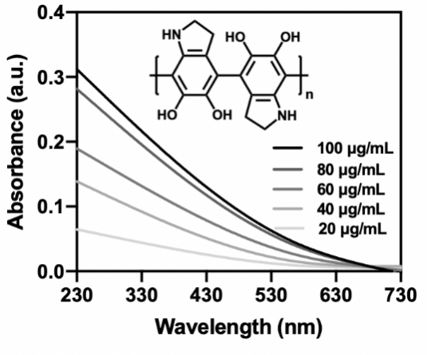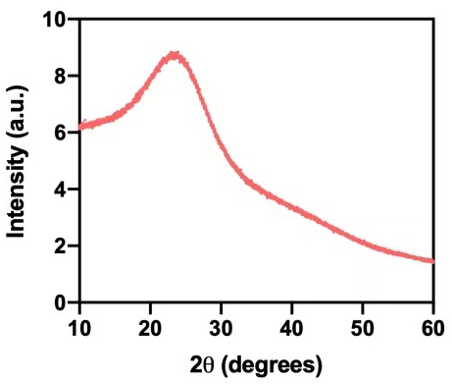
Supplementary Fig.1 Additional characterization of UPDA NPs. (a) A representative AFM image of UPDA NPs. The average diameter of the particles is estimated to be 3nm. (b) The appearance of UPDA NPs in different solutions. The particles are distributed evenly with no visible precipitates after 72 h. (c) The UV-Vis absorption spectra of UPDA NPs with different concentrations. The absorption band ranges from the ultraviolet region (100-400 nm) to the visible light region (400-700 nm). (d) The XRD pattern of the UPDA NPs. The diffraction peak exhibits a bread-like pattern indicating the amorphous nature of UPDA NPs.

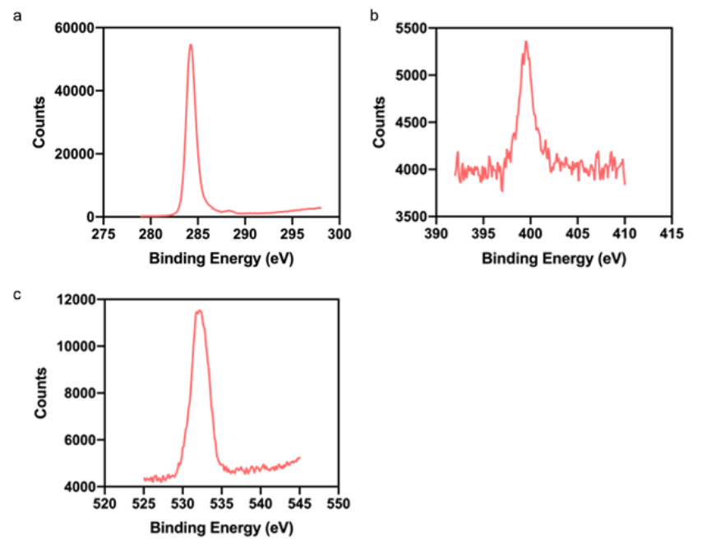

Supplementary Fig.2 C1s narrow-scan XPS spectra of UPDA NPs. The elements
C (a), N (b) and O (c) are identified.

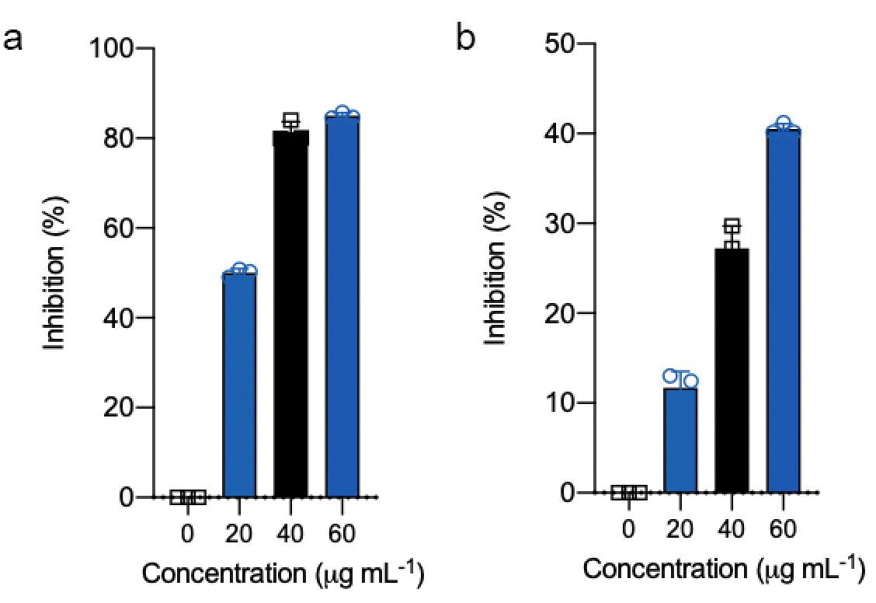
Supplementary Fig.3 Total antioxidant capacity of (a) UPDA NPs or (b) Trolox with different concentrations. The percentage of inhibition is shown by the decreased absorbance values of ABTS•⁺. The values were quantified from 3 independent replicates.

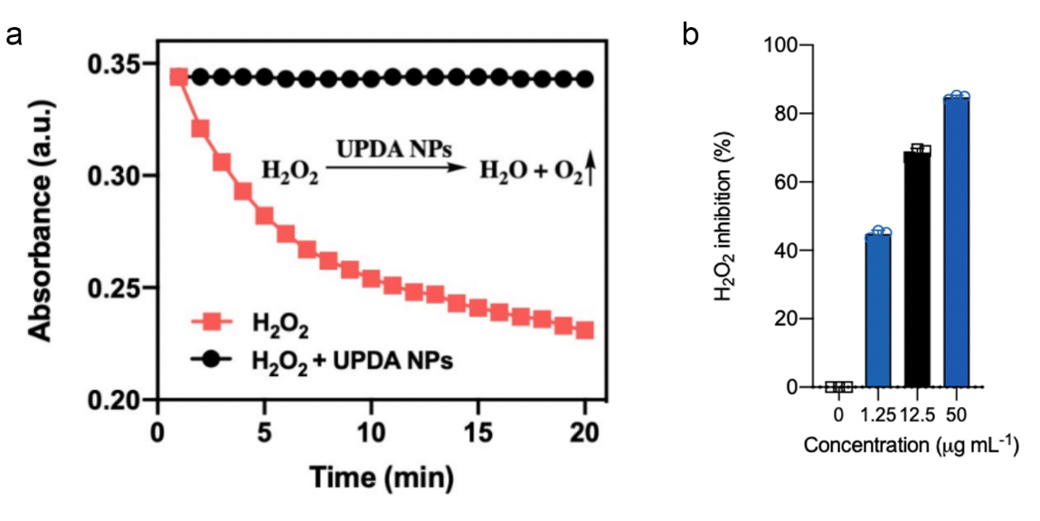
Supplementary Fig.4 The decomposition of H₂O₂ by UPDA NPs. (a) Absorbance curves of H₂O₂. The absorbance values at 240 nm were recorded over a 20-min time interval with (black) or without (red) the treatment of UPDA NPs. (b) H₂O₂ inhibition with different concentrations of UPDA NPs. The percentage of H₂O₂ inhibition is shown by the decreased absorbance values of Fe³⁺-OX complex. The values were quantified from 3 independent replicates.

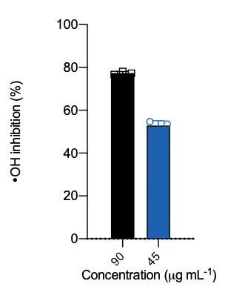
Supplementary Fig.5 Hydroxyl radical inhibition with two different concentrations of UPDA NPs. The percentage of hydroxyl radical inhibition is shown by the increased absorbance values of MB. The values were quantified from 3 independent replicates.

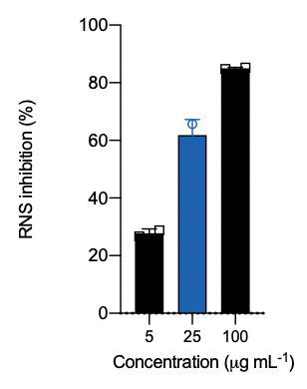
Supplementary Fig.6 RNS inhibition with different concentrations of UPDA NPs. The percentage of RNS inhibition is shown by the decreased absorbance values of DPPH•. The values were quantified from 2 independent replicates.

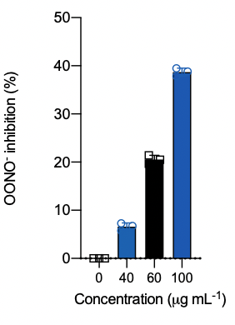
Supplementary Fig.7 OONO⁻ inhibition with different concentrations of UPDA NPs. The percentage of OONO⁻ inhibition is shown by the increased absorbance values of pyrogallol red. The values were quantified from 3 independent replicates.
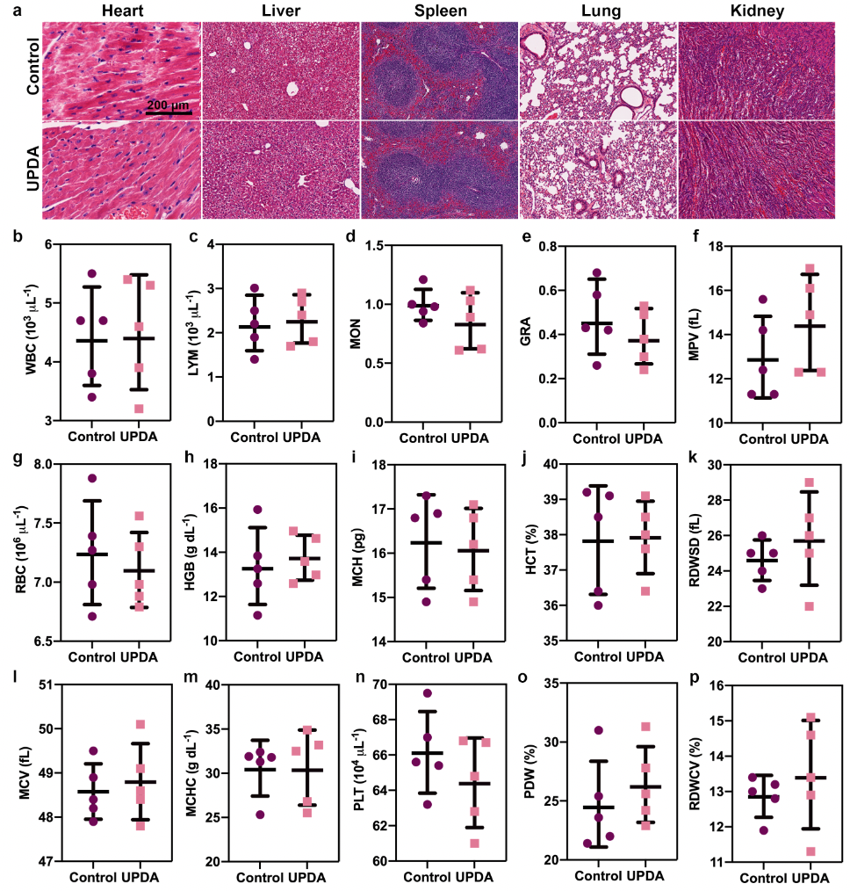
Supplementary Fig.8 Biosafety assessment of UPDA NPs in vivo. (a) H&E-stained tissue sections of major organs (heart, liver, spleen, lung, and kidney) obtained from mice receiving intravenous administration of PBS or UPDA NPs for 30 days. (b-p) Hematology parameters of mice described in (a). The values were quantified from 5 mice (n=5 for both groups) and are all not significant (p>0.05, using one-way ANOVA with Tukey’s post hoc test) between the control group and UPDA NPs-treated group.
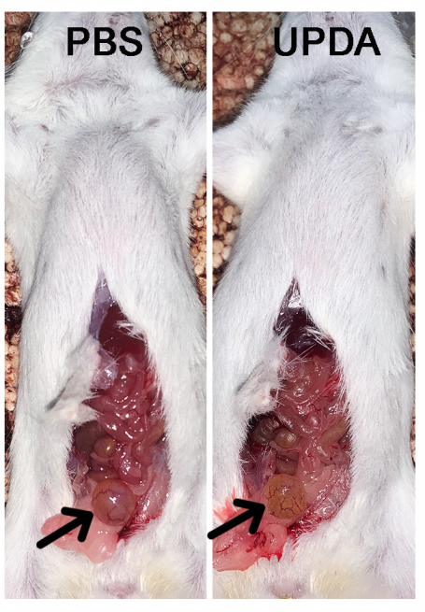
Supplementary Fig.9 Representative photographs of mouse bladders without or with the injection of UPDA NPs. Mice injected with PBS were regarded as the control group.

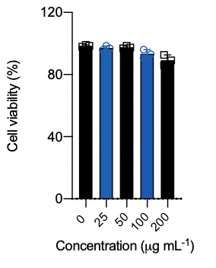
Supplementary Fig.10 Cell viabilities of 293T cells incubated with UPDA NPs of different concentrations. The values were quantified from 3 independent replicates.

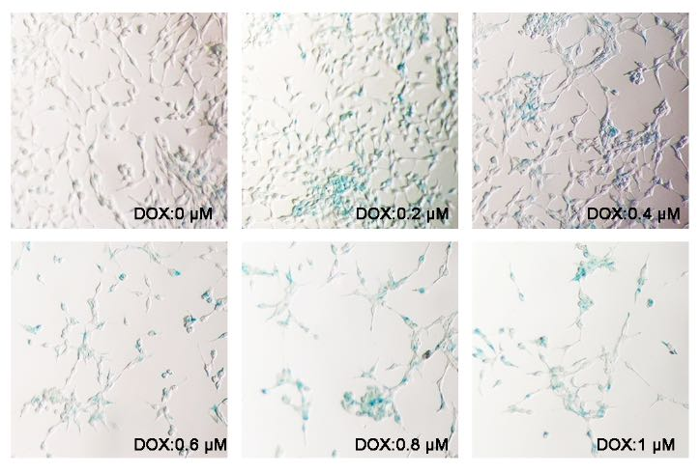
Supplementary Fig.11 Representative photographs of 293T cells incubated with different concentrations of DOX. The green/blue color derived from X-gal indicates the expression of SA-β-GAL.

