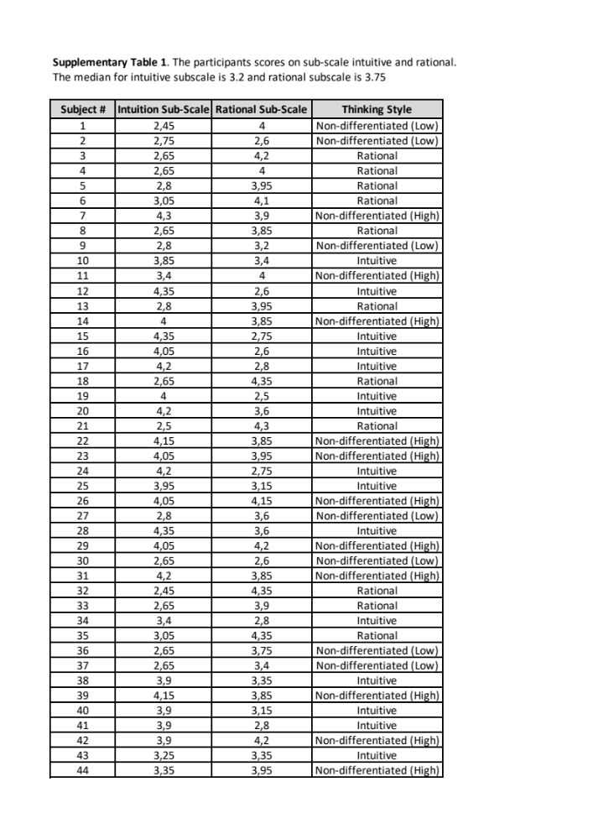

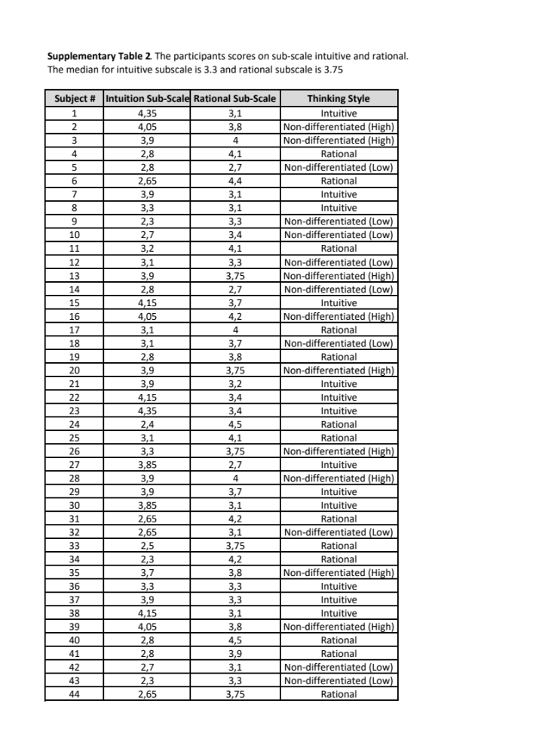

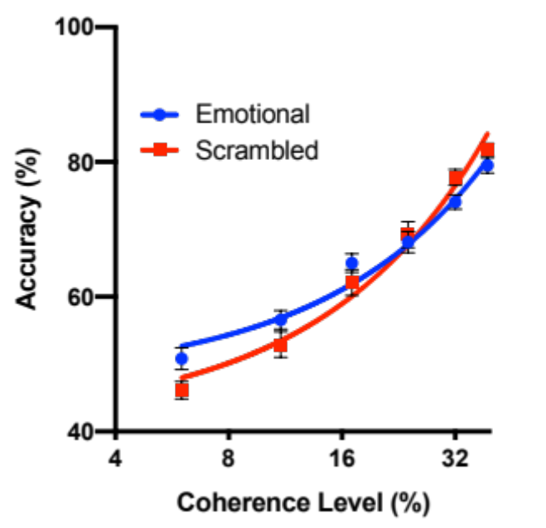

Supplementary Figure 1 | Decision accuracy was plotted for 26 non-differentiated thinkers. All error bars show ± 1 SEM.

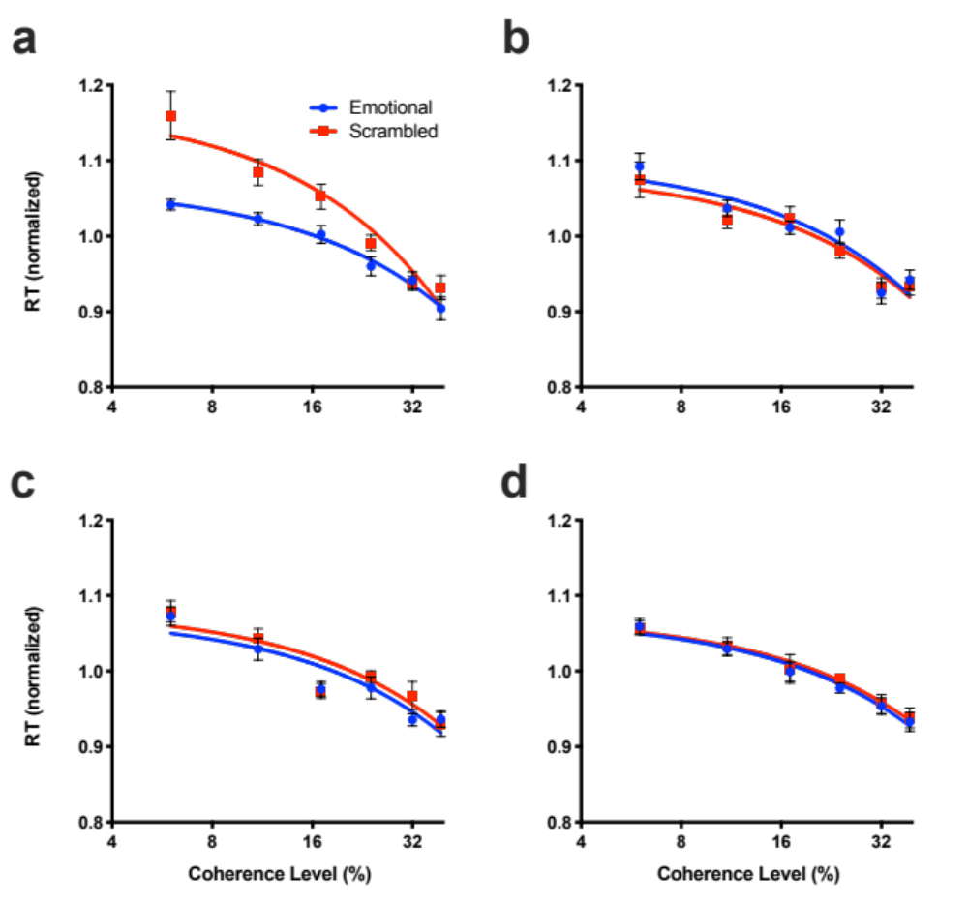

Supplementary Figure 2 | Reaction time (normalized) was plot for (a) the intuitive thinkers, (b) rational thinkers, (c) the non-differentiated thinkers who scored above median score in REI intuitive and rational sub-scale, and (d) the non-differentiated thinkers who scored below median score in REI intuitive and rational sub-scale. All error bars show ± 1 SEM.

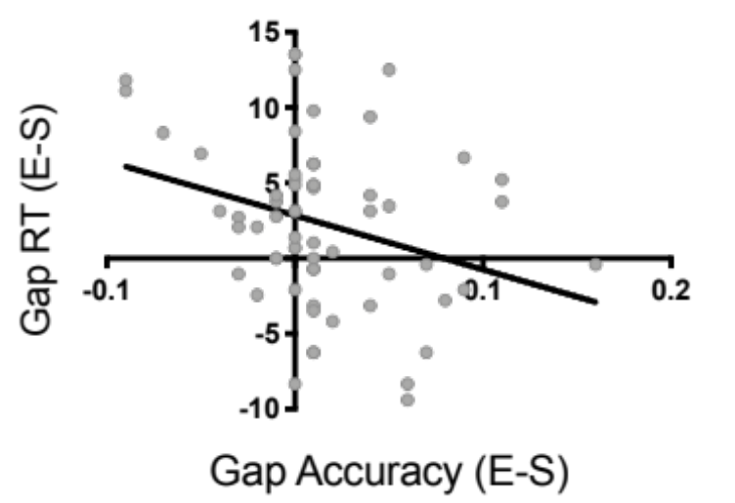

Supplementary Figure 3 | Decision accuracy and reaction time difference score between emotional and scrambled (E-S) condition, when collapsed across the first three lowest coherences (i.e, 6%, 11%, & 17%)conditions, was negatively correlated.

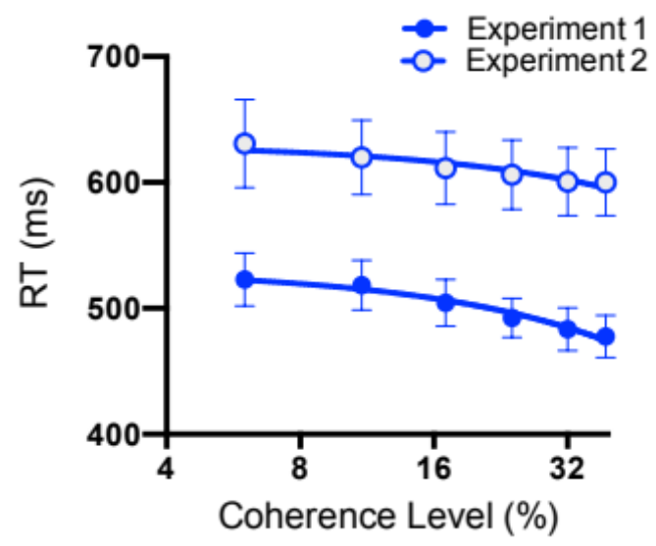

Supplementary Figure 4 | Reaction time (ms) in the experiment 2 –in which stimuli stayed on the screen until participants made responses– was longer relative to the experiment 1.

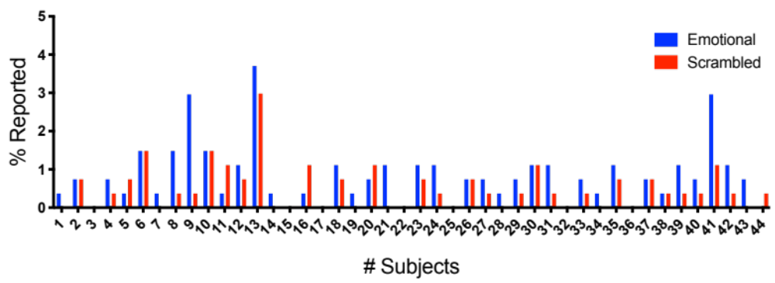

Supplementary Figure 5 | Incidental suppression breaks. The graph shows subjects’ individual reports of incidental suppression breaks. These trials were excluded from our main analysis. Prior to the experiment, subjects were instructed to press a certain key if they saw any sepia color, at or around the CFS image location. Here, most subjects reported below 5% of incidental suppression breaks.

