Pervasive Intronic Polyadenylation Serves as a Potential Source of Cancer Neoantigens
Xi Ren^{1,†}, Bin Zhang^{1,†}, Jia Li^{1,†}, Thamizhanban Manoharan^{3,4}, Beijia Liu³, Yang Yang Song¹, Shu Ye Tian⁵, Kar Tong Tan^{1,6}, Ling Wen Ding⁷, Ying Li¹, Omer An¹, Ming Li², Chan Shuo Wu¹, Yang Liu^{1,8}, Boon Heng Teo^{9,10}, Sze Jing Tang¹, Jinhua Lu^{9,10}, Yu Hui Hu⁵, Wei Chen⁵, Leilei Chen^{1,11}, Gloryn Chia^{3,4,*}, Henry Yang^{1,2,,*}

Supplementary Information

Supplementary figures S1-S13
Supplementary tables S1-S6

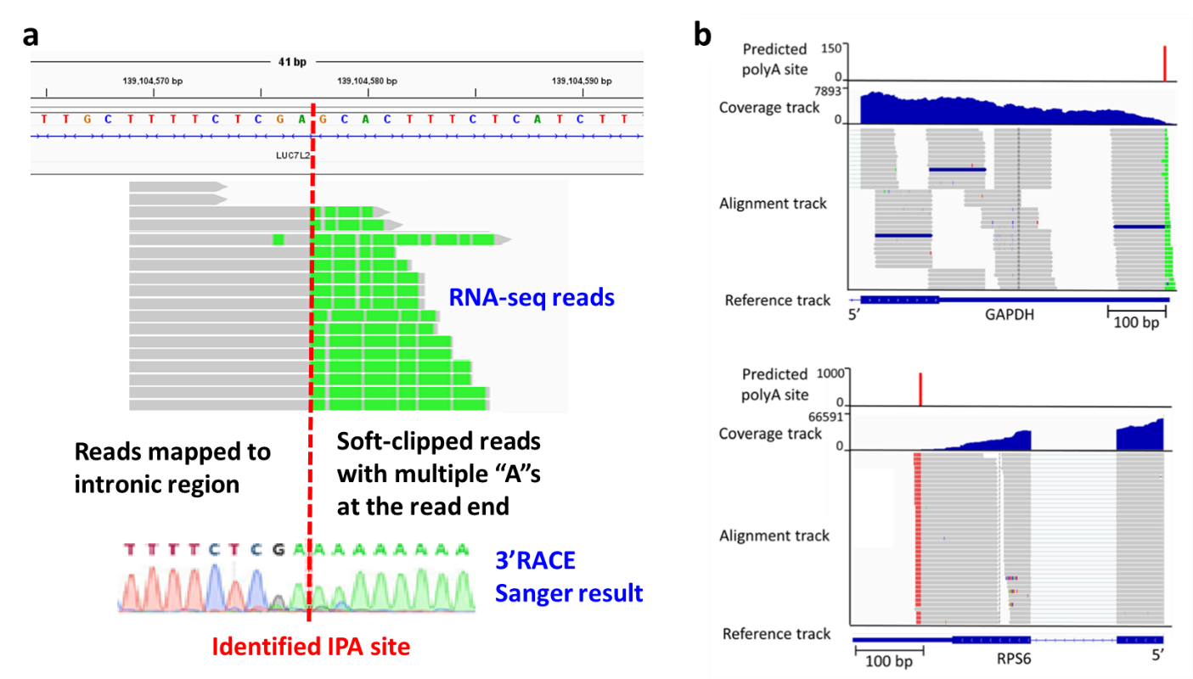

Supplementary Figure 1. Utilization of soft-clipped reads obtained from RNA-seq data mapping as polyA-spanning reads for identification of potential IPA/APA sites. a Schematic representation of PASRAM using soft-clipping reads with multiple adenosines or thymines at each read end to identify polyA-spanning reads and thus IPA/APA sites. b Two IGV plots illustrating soft-clipped reads as polyA-spanning reads for two PAS sites. In the alignment tracks, the soft-clipped reads ending with at least three adenosines were highlighted in green at the 3’ ends (top panel) while the 5’ part of the soft-clipped reads ending with at least three thymines were colored in red (bottom panel).
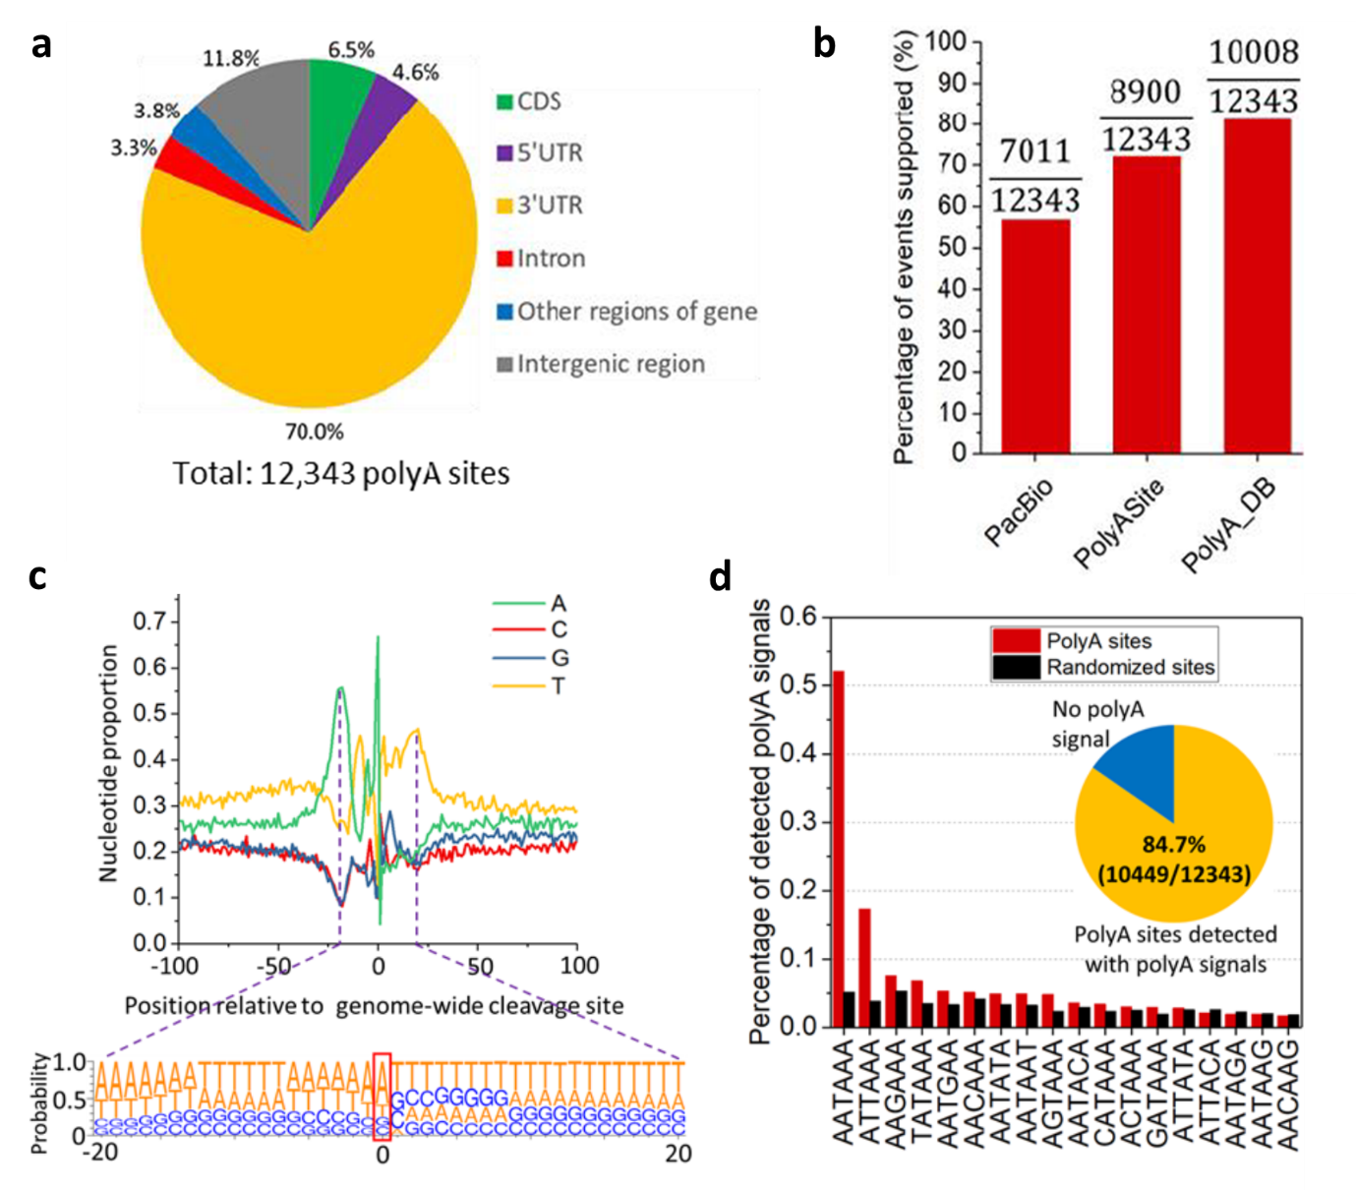
Supplementary Figure 2. Evaluation of PASRAM for genome-wide PAS prediction with MCF7 cell line. a Genome-wide distribution of the predicted PASs. b Percentage of 12,343 identified PASs supported by PacBio long-reads or annotated sites in PolyASite and PolyA_DB. c Genome-wide profiling of nucleotide compositions around the identified PASs. The red rectangle in the bottom panel highlights the nucleotide composition at the PASs. d Occurrences of the 18 polyA signals within 60 nt upstream of genome-wide PASs (red bars) compared to randomly generated sites (black bars). Inset: Overall detection rate of the polyA signals within 60 nt upstream of PASs.

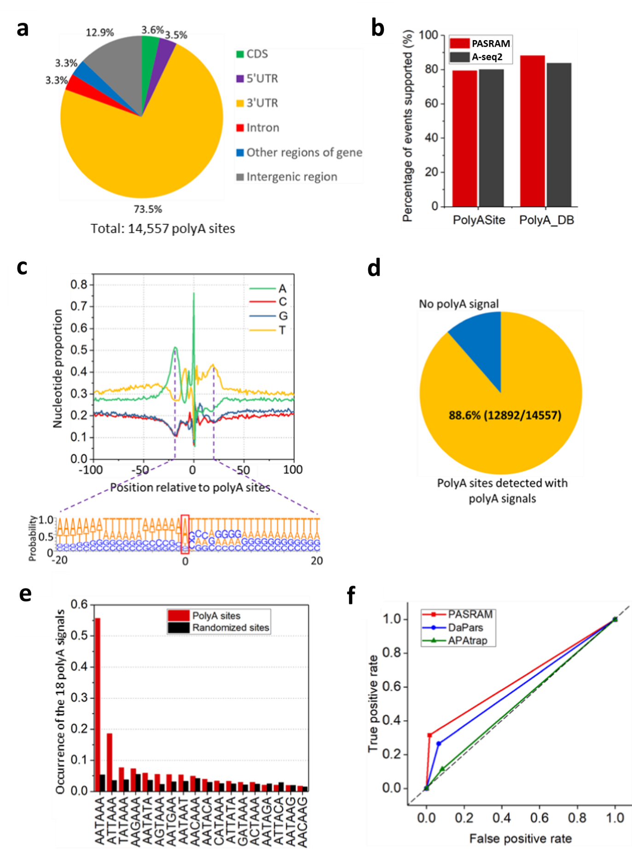
Supplementary Figure 3. Evaluation of PASRAM for PAS prediction with HEK293 cell line. a Genome-wide distribution of the predicted PASs. b Percentage of PASs identified by PASRAM (red bars) and A-seq2 (black bars) supported by the annotated sites from PolyASite and PolyA_DB. c Nucleotide compositions around the identified genome-wide PASs. Adenosine is the dominant nucleotide at the PASs highlighted with the red rectangle. d Overall detection rate of the polyA signals within 60 nt upstream of PASs. e Occurrences of the 18 known polyA signals within 60 nt upstream of genome-wide PASs (red bars) compared to randomly generated sites (black bars). f ROC curves of True Positive Rate over False Positive Rate for comparison of PASRAM with published methods (DaPars and APAtrap) capable of de novo PAS prediction. The predictions were based only on the standard parameter setup for all three methods.

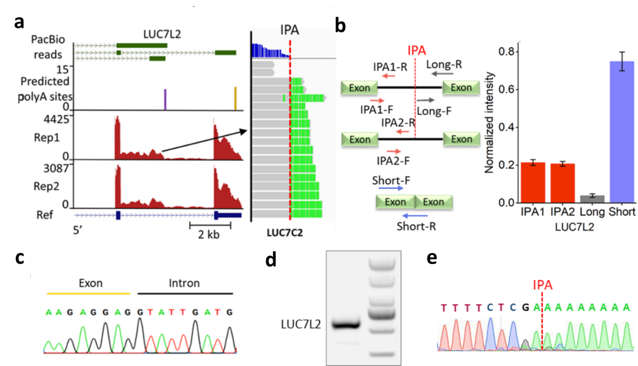
Supplementary Figure 4. Experimental validation of an identified IPA transcript with MCF7 cell line. a Genome browser screenshot of a predicted IPA site (depicted as the purple peak) in gene LUC7L2 together with corresponding PacBio long reads, two MCF7 RNA-seq biological replicates (left panel), and alignment track of a replicate highlighting soft-clipped reads with multiple adenosines at each read end (right panel). b RT-qPCR validation of the identified IPA transcript in LUC7L2 showing similar expression between two different locations (IPA1 & IPA2) of the IPA transcript but a significant drop of expression downstream of the IPA site (Long). Data were shown as mean ± SEM with n = 3. c Sanger sequencing result showing the crossing of the IPA transcript over the exon-intron junction upstream of the IPA site. d-e Gel image (d) and Sanger sequencing result (e) of 3’ RACE products for validation of the identified LUC7L2 IPA transcript by highlighting the presence of a polyA tail at the IPA site.

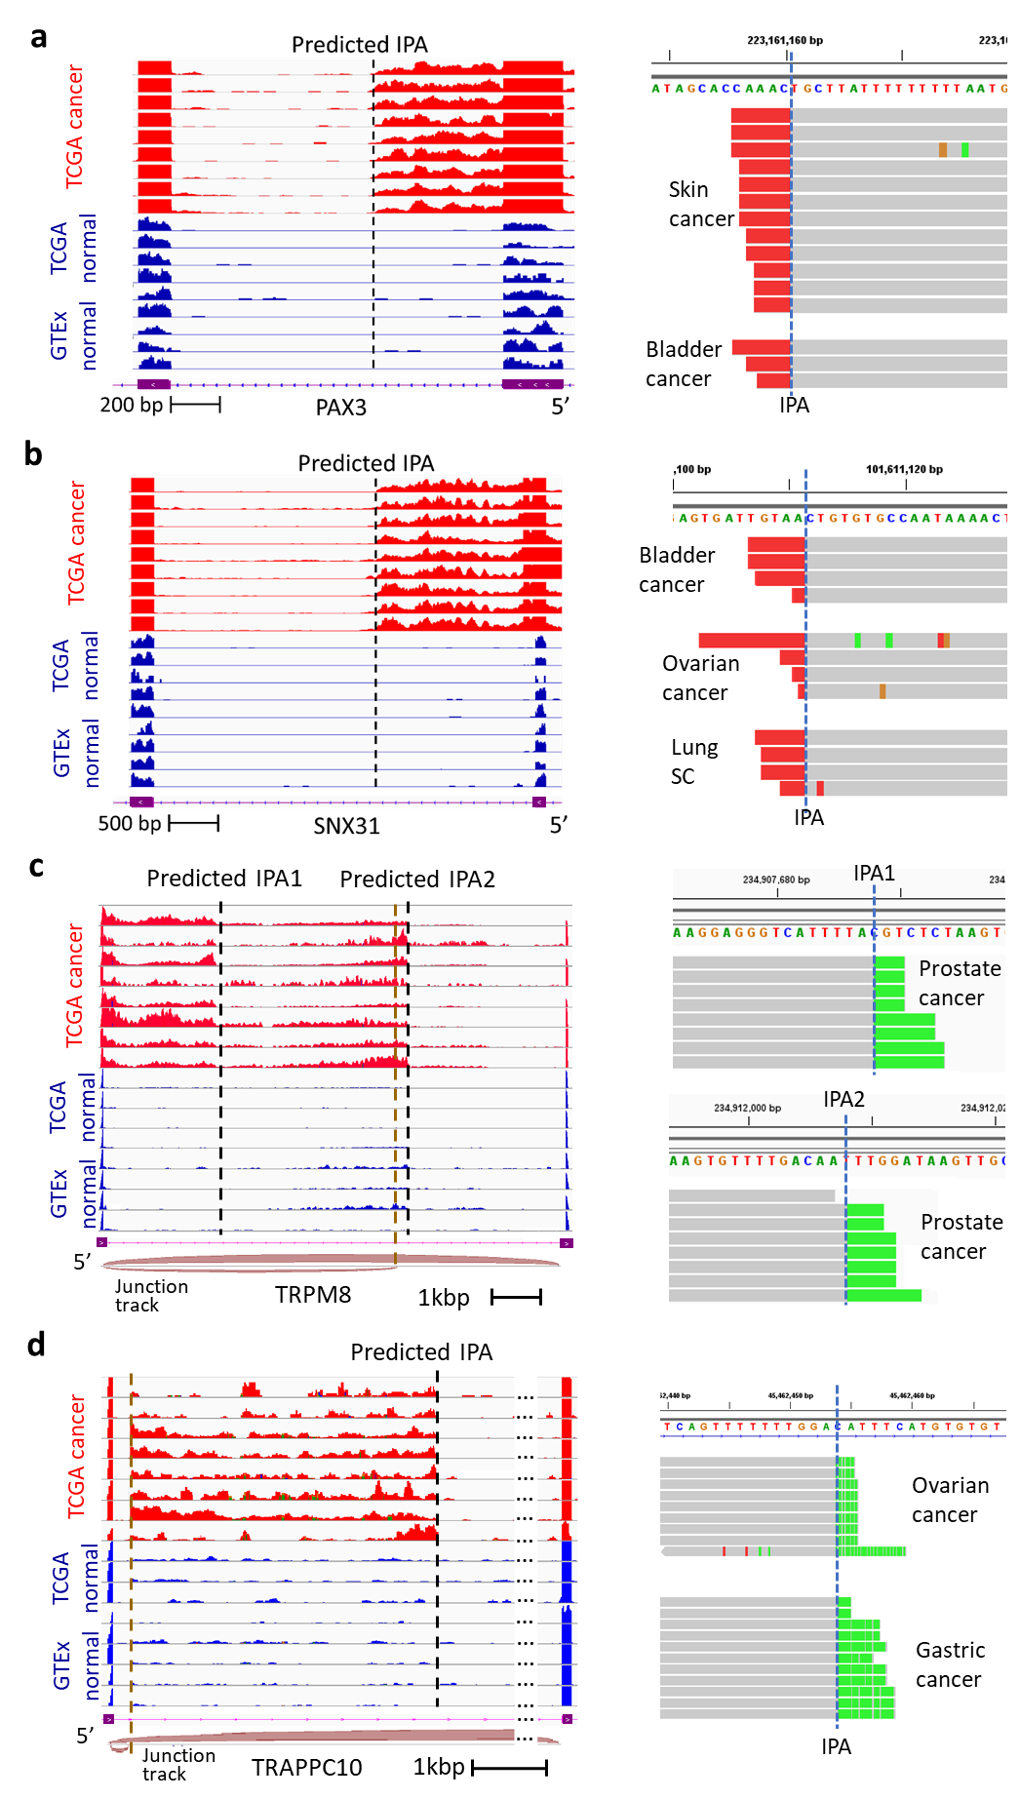
Supplementary Figure 5. Representative tumor-specific IPA transcripts depicted in IGV plots. a-d Four tumor-specific IPA events were highlighted in genes (a) PAX3, (b) SNX31, (c) TRPM8, and (d) TRAPPC10. In coverage tracks (left panel), tracks in red represented cancer samples, while those in blue were randomly selected normal samples. For alignment tracks (right panel), multiple adenosines at the 3’ ends of soft-clipped reads were depicted with green color, while red color represented multiple thymines at the 5’ ends of soft-clipped reads. In (c), two IPA sites were observed within the same intron while the second IPA transcript (IPA2) might be spliced. In (d), there was also an intronic splicing for the IPA transcript. The splicing events in (c) and (d) were highlighted by the respective junction tracks. The vertical dashed black lines stand for predicted IPA sites and the dashed taupe ones for splicing sites.
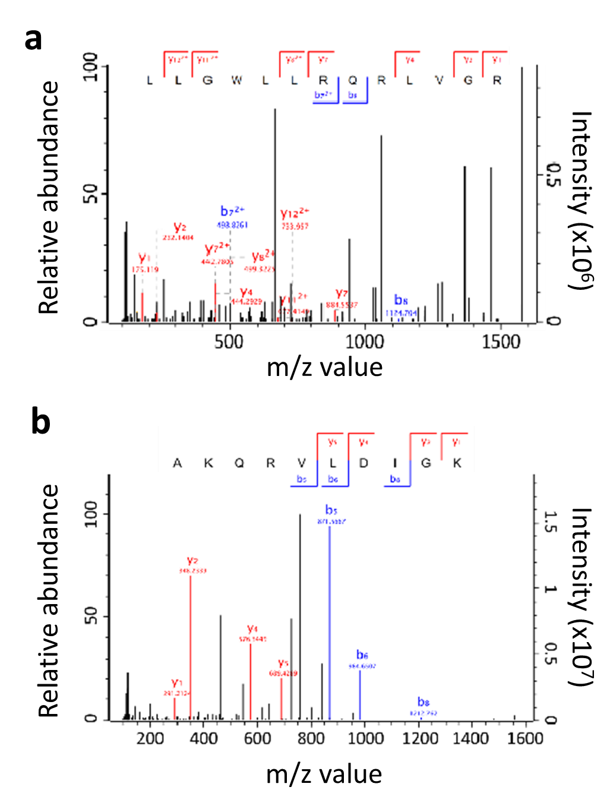
Supplementary Figure 6. Identification of IPA derived neoantigens in CPTAC a for gene CDCA8 in an ovarian cancer sample (FDR = 1.78e-4); b for gene GRHL2 in a breast cancer sample (FDR = 0.01).

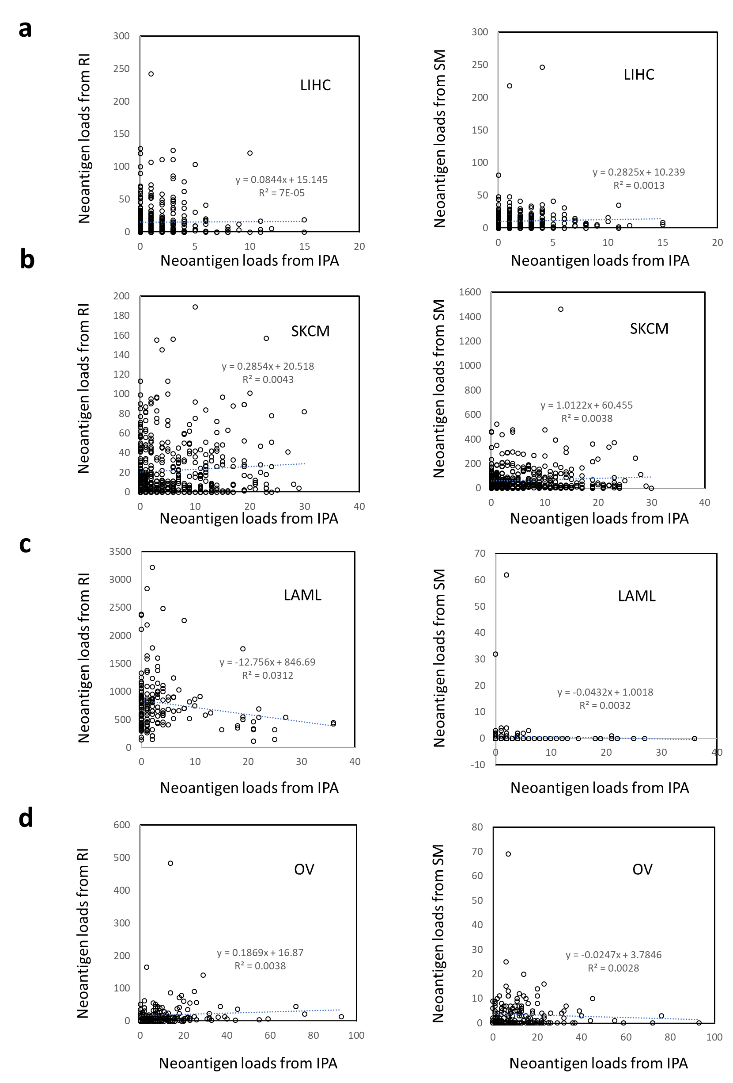
Supplementary Figure 7. Correlations of IPA neoantigen loads with those derived from RI and SM. a-d No correlations of IPA neoantigen loads with those derived from RI (left panel) and SM (right panel) across all patient samples in one of four representative cancers: liver cancer (a), melanoma (b), AML (c), and ovarian cancer (d). Blue dotted lines represented linear regression and the equations showed the regression results with R-squared values for the correlations. Each symbol represents a patient sample, and Pearson correlation coefficient (r) was used.

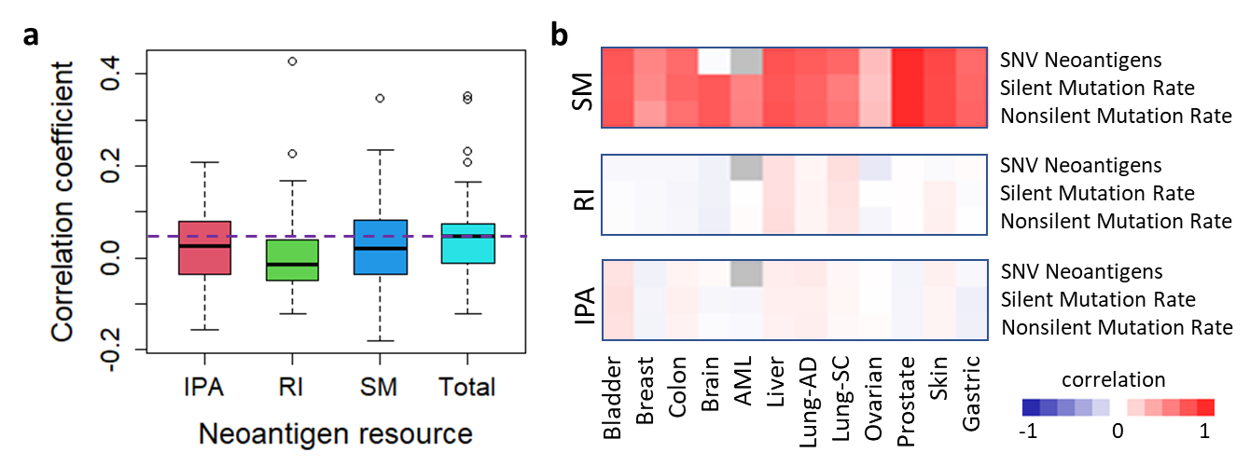
Supplementary Figure 8. Correlations of neoantigen loads with TIIC fractions as well as mutation related terms. a Correlations of the loads of different neoantigen resources (IPA, RI and SM) as well as their sum with immune responses over TCGA patient samples. “Total” stands for the sum of the neoantigen loads over the three resource. b Heatmaps illustrating the correlations of the loads of different neoantigens (IPA, RI and SM) with reported mutation-related neoantigens and mutation rates across tumor samples in each cancer type.
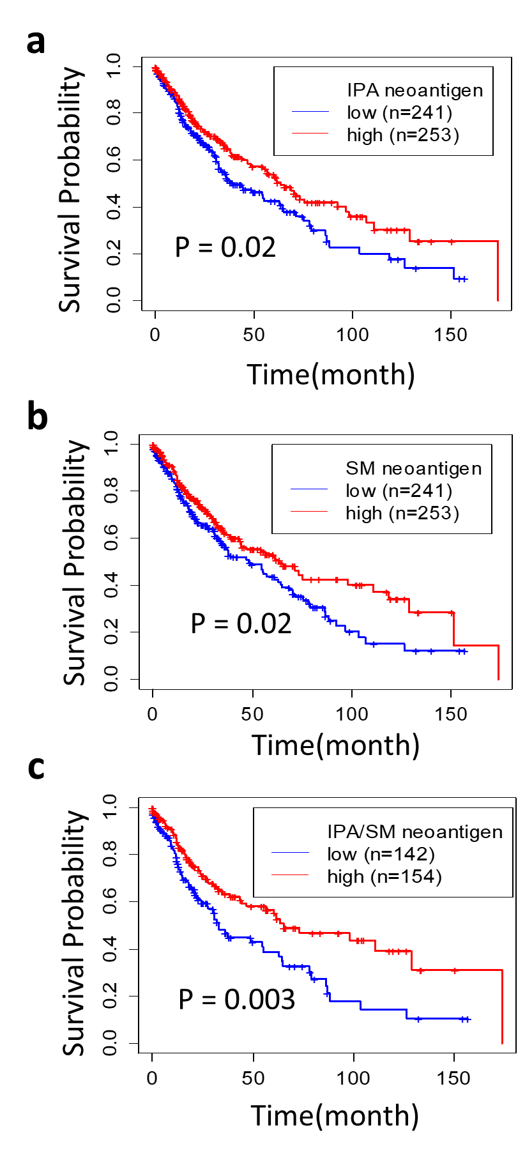
Supplementary Figure 9. Patient prognosis for TCGA lung squamous cell carcinoma cohort based on neoantigen loads. a-c Survival analysis stratified using (a) only IPA-derived neoantigen loads, or (b) only SM-derived neoantigen loads, or (c) both SM & IPA high vs low neoantigen loads (c). High and low load stratification was based on the median value.
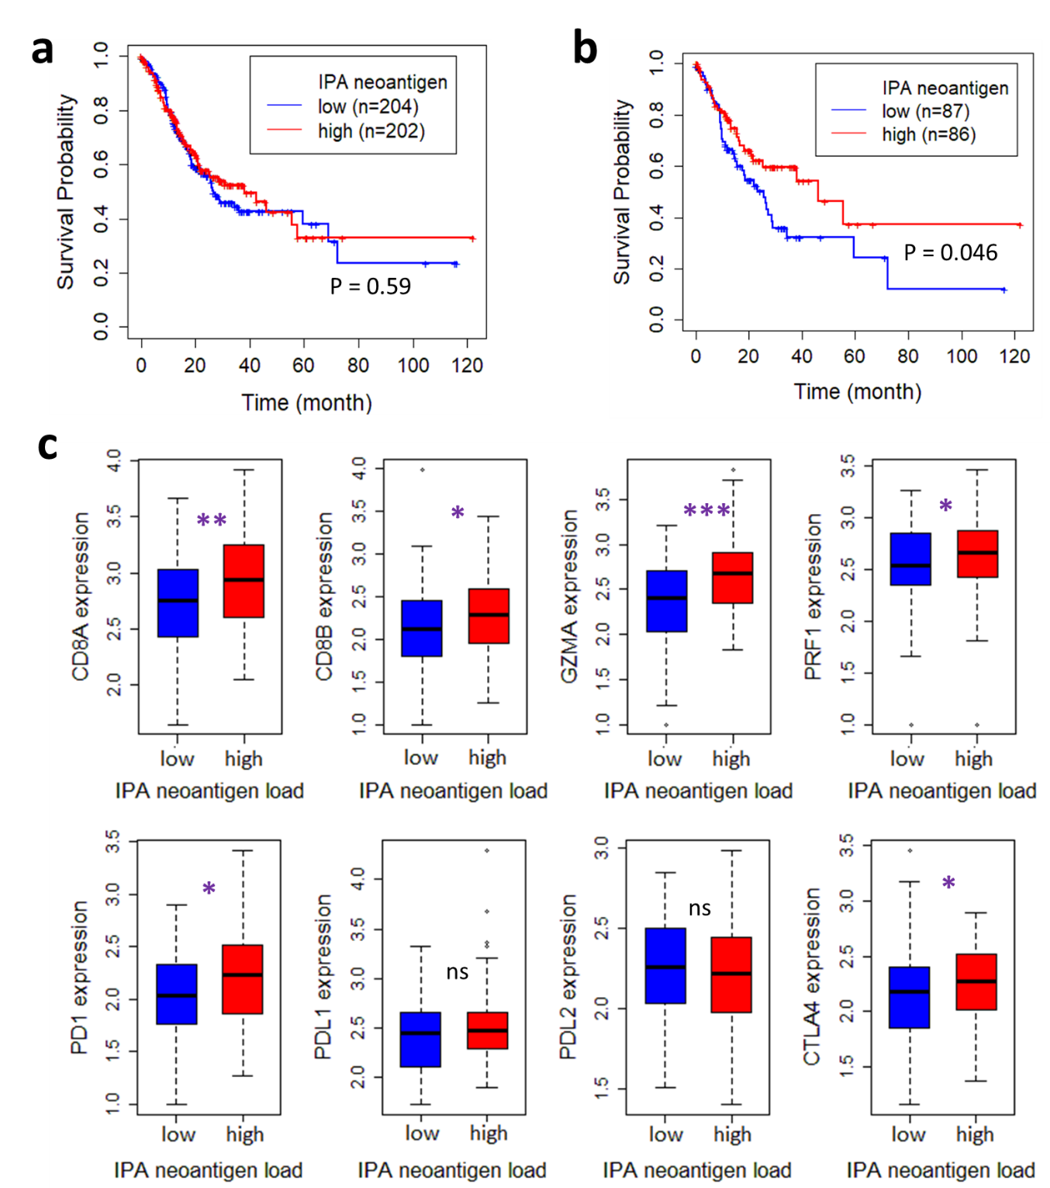
Supplementary Figure 10. Patient prognosis and expression differences based on IPA neoantigen loads for TCGA gastric cancer cohort. a-b Survival analysis stratified based on IPA-derived neoantigen loads (a) using all available samples or (b) using only samples with low SM-derived neoantigen loads. Median values were used for sample stratification into high and low IPA neoantigen groups. c Expression differences of T cell markers (top panel) as well as ICIs (bottom panel) for patients stratified in (b). *** stands for p<0.001, ** 0.001≤ p <0.01, * 0.01≤ p<0.05, ns p≥0.05.
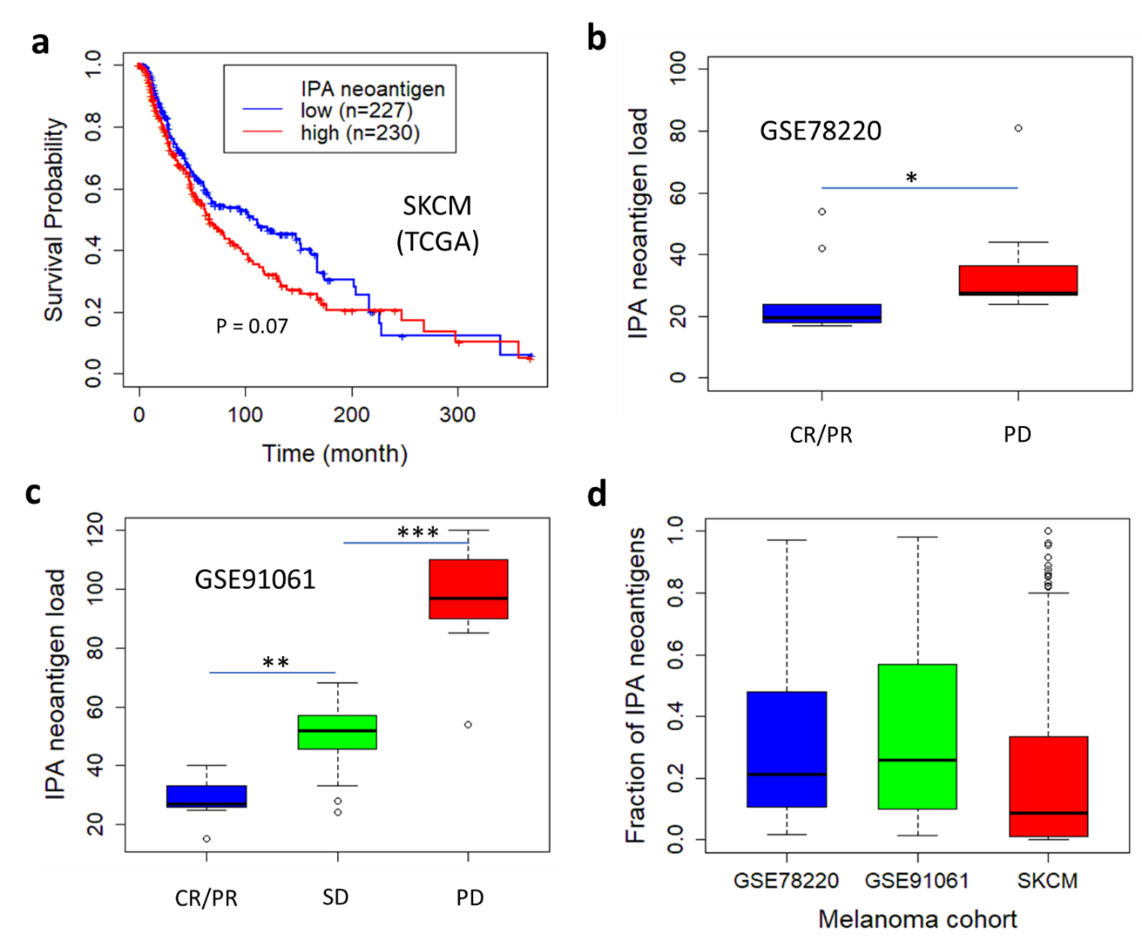
Supplementary Figure 11. Correlation of IPA neoantigen loads with clinical data in three melanoma cohorts. a Negative correlation of IPA-derived neoantigen loads with patient prognosis in TCGA melanoma cohort (SKCM). b-c Negative correlations between IPA-derived neoantigen loads and anti-PD1 ICI responses in both (b) GSE78220 and (c) GSE91061 datasets. Wilcoxon rank sum test was used with * for p<0.05 but ≥0.01, ** for p<0.01 but ≥0.001, and *** p<0.001. The response evaluation criteria were defined by RECIST guideline extracted from original studies: CR = complete response, PR = partial response, SD = stable disease, PD = progressive disease. d Fractions of IPA-derived neoantigen loads to the total pool of SM-, RI-, and IPA-derived neoantigen loads in the three melanoma cohorts (GSE78220, GSE91061 and TCGA-SKCM). Data were presented as median and IQR.
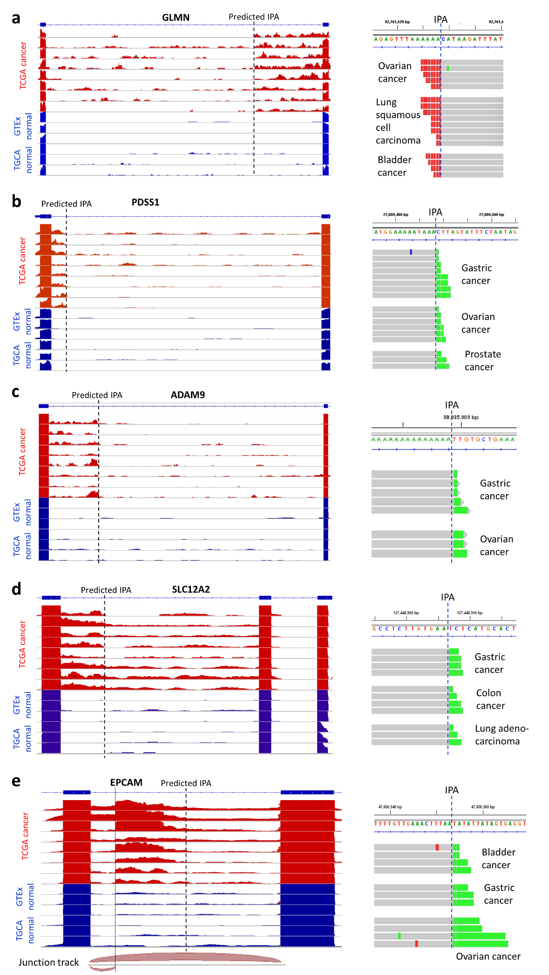
Supplementary Figure 12. Genome browser views showing five recurrent tumor-specific transcripts along with polyA-spanning reads. a-e The five IPA neoantigens associated with HLA-A*11:01 were derived from IPA transcripts in genes (a) GLMN, (b) PDSS1, (c) ADAM9, (d) SLC12A2, and (e) EPCAM. In coverage tracks (left panel), tracks in red represented cancer samples, while those in blue were randomly selected normal samples. For alignment tracks (right panel), multiple adenosines at the 3’ ends of soft-clipped reads were depicted with green color, while red color represented multiple thymines at the 5’ ends of soft-clipped reads. Intron retention events co-occurred with IPA in some samples, in particular for IPA events in (d) and (e). There was also an intronic splicing for (e) as highlighted with the junction track at the bottom of (e).
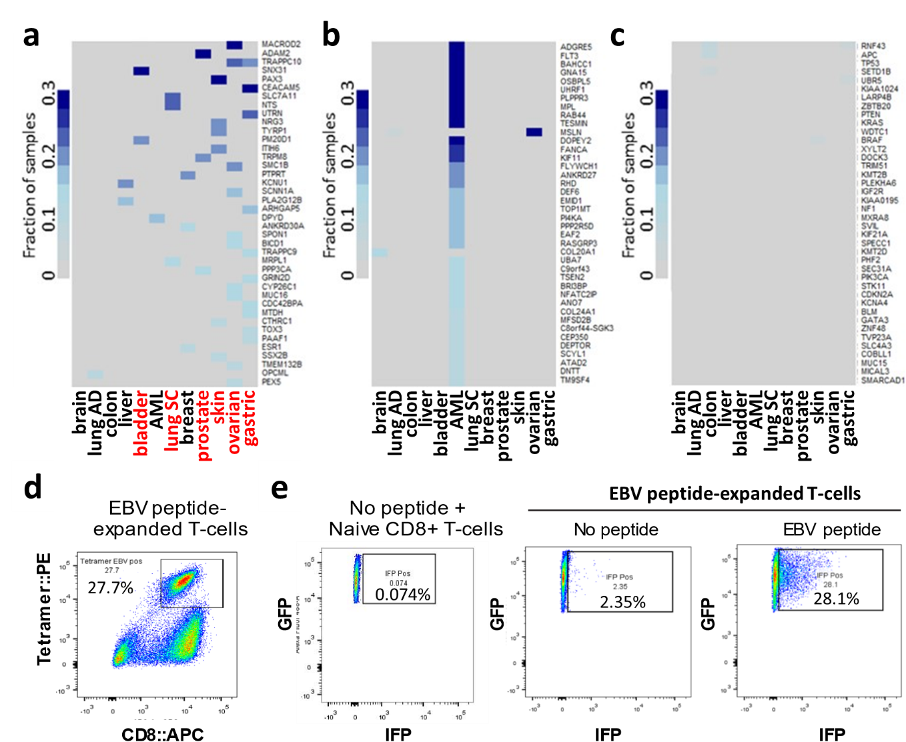
Supplementary Figure 13. Recurrent tumor-specific IPA neoantigens and positive control of EBV-antigen peptide for immunogenicity. a-c Heatmaps for top 40 recurrent cancer-specific neoantigens derived from (a) IPA, (b) RI, and (c) SM, respectively. For each TCGA cancer, the sample fraction of a recurrent neoantigen peptide (y-axis) was represented in the heatmaps. The six cancers with multiple recurrent IPA neoantigens in 10+ % of patients were highlighted in red. d Tetramer and anti-CD8 staining of EBV peptide-expanded T cells as positive control. e Flow cytometry profiling of the reporter cells after co-culture with naïve CD8+ T cells (left panel), with EBV peptide-expanded T cells in the absence (middle panel), or in the presence (right panel) of EBV antigen peptide. Cells were constitutively GFP positive. IFP expression indicated granzyme B-mediated cleavage of the reporter cell undergoing apoptosis.
Supplementary Table 1: List of a few published methods for PAS identification
Method | PolyA site identification | Using annotation | Utilizing RNA-seq data | Predicting within | APA quantification
APARENT [19] | Yes | No | No | Whole gene | No
DeeReCT-PolyA  [20] | Yes | No | No | Whole gene | No
QAPA  [21] | No | Yes | Yes | 3' UTR | Yes
APAlyzer [22] | No | Yes | Yes | Whole gene | Yes
DaPars  [23] | Yes | No | Yes | 3' UTR | Yes
APAtrap  [24] | Yes | No | Yes | 3' UTR | Yes

Supplementary Table 2: RNA-seq data applied to predict cancer-specific IPA transcripts and neoantigens for the 12 TCGA cancer types
Primary cancer samples (TCGA)
Cancer type | # of RNA-seq used | TCGA abbreviation | Note
Bladder | 414 | BLCA | Bladder Urothelial Carcinoma
Breast | 1142 | BRCA | Breast invasive carcinoma
Colon | 505 | COAD | Colon adenocarcinoma
Brain | 170 | GBM | Glioblastoma multiforme
AML | 179 | LAML | Acute Myeloid Leukemia
Liver | 374 | LIHC | Liver hepatocellular carcinoma
Lung AD | 542 | LUAD | Lung adenocarcinoma
Lung SC | 504 | LUSC | Lung squamous cell carcinoma
Ovarian | 430 | OV | Ovarian serous cystadenocarcinoma
Prostate | 506 | PRAD | Prostate adenocarcinoma
Skin | 472 | SKCM | Skin Cutaneous Melanoma
Gastric | 416 | STAD | Stomach adenocarcinoma
Total | 5654
Samples of healthy tissues (Normal samples)
Data source | # of RNA-seq used | Tissue types | Note
TCGA | 429 | 10 adjacent normal tissues | The Cancer Genome Atlas
TCGA | 313 | Other adjacent normal tissues | The Cancer Genome Atlas
GTEx | 9777 | 32 histological types | The Genotype-Tissue Expression
BLUEPRINT | 864 | 18 major blood lineage cell subtypes | Haemopoetic Epigenome
Total | 11383

Supplementary Table 3. Comparison of the total numbers of predicted cancer-specific transcripts from TCGA together with detected peptides and derived putative neoantigens from the three sources (IPA, RI and SM) that are supported by cancer proteome data of CPTAC (Only matched 38 breast cancer and 59 ovarian cancer samples with CPTAC were used and the results were obtained with FDR of 0.01)
Cancers | IPA |  |  | RI |  |  | SM
Cancers | Trans-cripts | Detected peptides | Neo-antigens | Trans-cripts | Detected peptides | Neo-antigens | Events | Detected peptides | Neo-antigens
Ovarian cancer | 2540 | 211 | 2 | 2726 | 594 | 9 | 3716 | 54 | 6
Breast cancer | 948 | 591 | 3 | 2172 | 1183 | 13 | 2819 | 148 | 17
Total | 3488 | 802 | 5 | 4898 | 1777 | 22 | 6535 | 202 | 23

Supplementary Table 4. List of ten synthesized peptides selected from recurrent IPA-derived neoantigens with strong binding to HLA-A*11:01 for immunogenicity testing
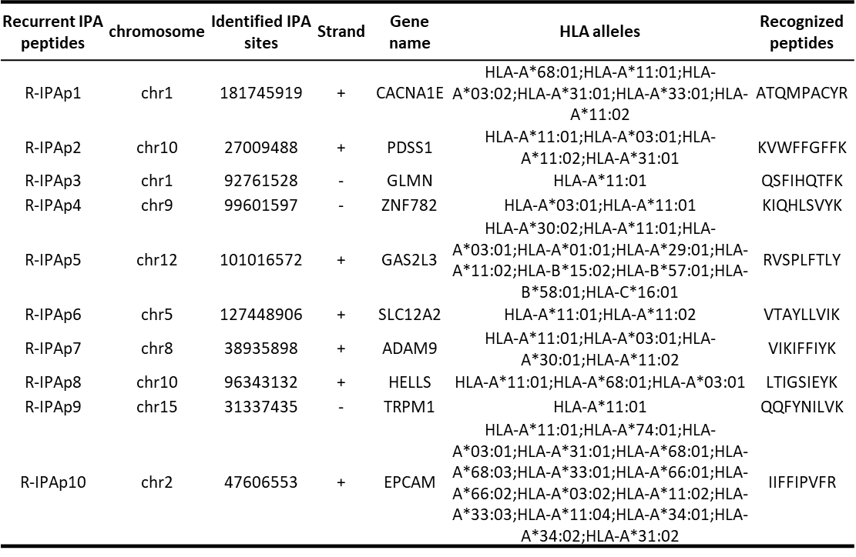

Supplementary Table 5. Sequences of primers used for RT-qPCR validation of IPA transcripts
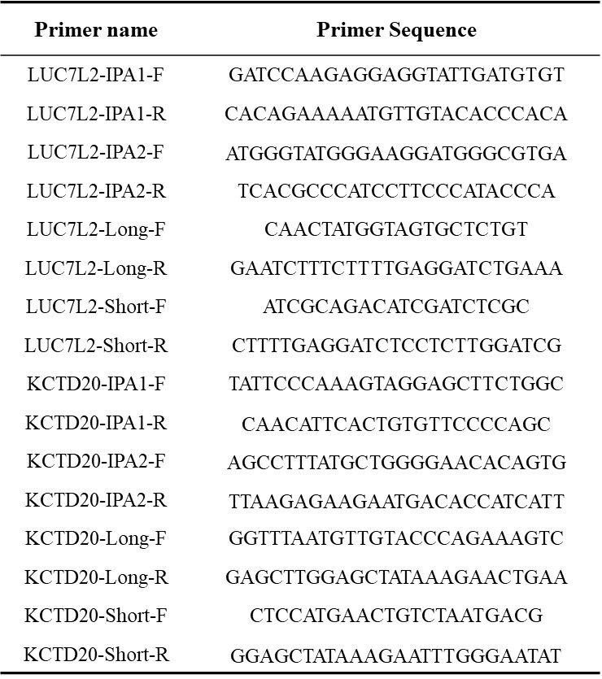

Supplementary Table 6. Sequences of primers used for 3’ RACE validation of IPA transcripts
Primer name | Primer sequence
Anchored oligo dT | GACCACGCGTATCGATGTCGACTTTTTTTTTTTTTTTTTTVN
Anchor-R | GACCACGCGTATCGATGTCGAC
LUC7L2-F | TCCTGCTAGGTGATGGAAGGT
KCDT20-F | TGGCATGGCGTAGATGTTTTC
ANKEF-F | CTGCCACCTGGGACTACTGT

