Supplementary Material
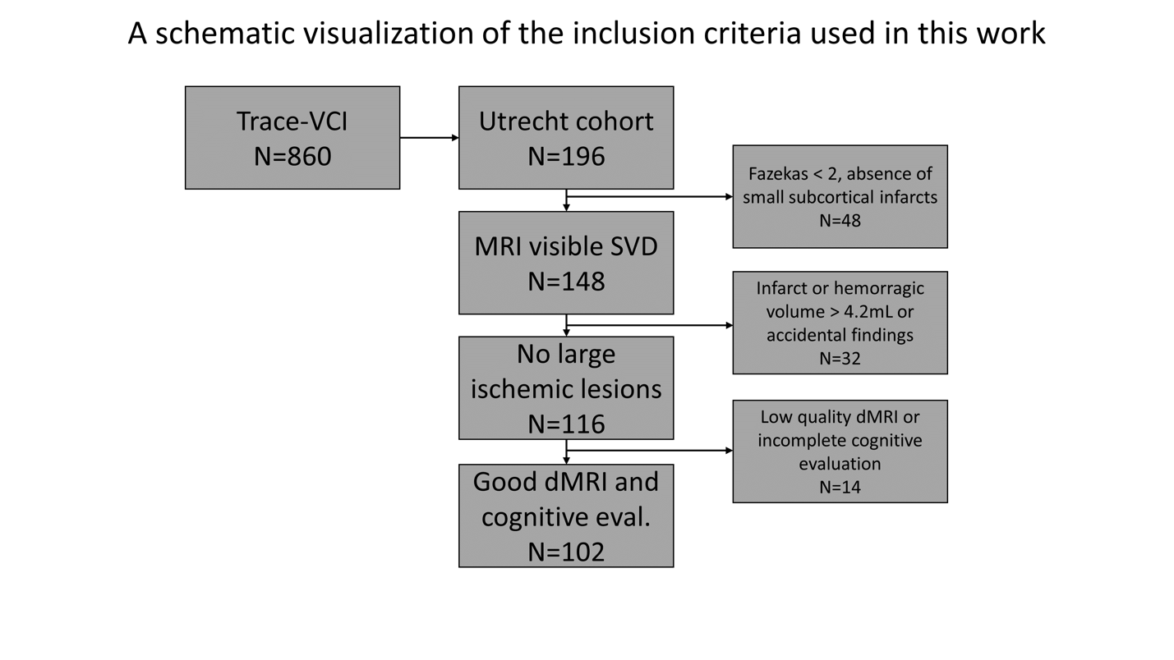
Figure S1: a visualization of the inclusion/exclusion criteria adopted in this work.

Table S1: A list of the tracts reconstructed by automated clustering method and their abbreviation used in the main text.
Abbreviation | Definition
AF | arcuate fasciculus
CB | cingulum bundle
EC | external capsule
EmC | extreme capsule
ILF | inferior longitudinal fasciculus
IoFF | inferior occipito-frontal fasciculus
MdLF | middle longitudinal fasciculus
PLIC | posterior limb of internal capsule
SLF-I-II-III | superior longitudinal fasciculus I-II-III
UF | uncinate fasciculus
CPC | cortico-ponto-cerebellar
ICP | inferior cerebellar peduncle
Intra-CBLM-I&P | intracerebellar input and Purkinje tract
Intra-CBLM-PaT | intracerebellar parallel tract
MCP | middle cerebellar peduncle
CC 1-7 | corpus callosum segments 1 to 7 (includes forceps)
CST | corticospinal tract
CR-F | corona-radiata-frontal
CR-P | corona-radiata-parietal
SF | striato-frontal
SO | striato-occipital
SP | striato-parietal
TF | thalamo-frontal
TO | thalamo-occipital
TP | thalamo-parietal
Sup-F | superficial-frontal
Sup-FP | superficial-frontal-parietal
Sup-O | superficial-occipital
Sup-OT | superficial-occipital-temporal
Sup-P | superficial-parietal
Sup-PO | superficial-parietal-occipital
Sup-PT | superficial-parietal-temporal
Sup-T | superficial-temporal

Table S2: average ± standard deviation of lesion and atrophy markers in the considered cohort.
Brain atrophy
Brain parenchymal fraction (BPF) [%] | 0.67 ± 0.04
Cortical thickness [mm] | 2.53 ± 0.13
Cerebrovascular lesions
WMH volume [% of ICV] | 3.4% ± 2.5%
Non-lacunar (sub)cortical infarcts | 26 (26%)
Lacunar infarcts | 50 (49%)
Microinfarcts | 4 (4%)
Intracerebral hemorrhages | 7 (7%)
Any microbleeds | 42 (41%)
Microstructural alterations
Mean diffusivity of WM [mm²/s] | (0.88 ± 0.05) x 10⁻³
Mean diffusivity of GM [mm²/s] | (1.07 ± 0.07) x 10⁻³
Peak-width mean diffusivity of WM [s/mm²/s] | (1.10 ± 0.35) x 10⁻³
Peak-width mean diffusivity of GM [s/mm²/s] | (1.80 ± 0.30) x 10⁻³
Fractional anisotropy of WM | 0.28 ± 0.02
Fractional anisotropy of GM | 0.13 ± 0.01

Table S3: Linear multivariate prediction (leave one out) using tract-specific imaging metrics. Bold indicates the best prediction for each domain
N=102 subjects |  | Processing speed |  |  | Memory
Model | Predictors | MAE | R² | Relevant tracts | MAE | R² | Relevant tracts
1 | Age + Sex + Education + WMH burden | 0,70 | 0,16 | Right CB  CC  Left CR-F  Left CST  Left/Right IOFF  Right MdLF  Right SF  Right SP  Right Sup-F  Right Sup-OT  Right Sup-PT  Left/Right TF | 0,78 | 0,12 | Left/Right CB  CC  Left/Right CR-F  Right CST  Right ILF  Right Sup-OT  Right Sup-PT  Right Sup-T  Left/Right TF
2 | Age + Sex + Education + MD | 0,63 | 0,27 | Left/Right CB  Left/Right CR-F  Left/Right CST  Right ILF  Left/Right SF  Left/Right SP  Left/Right Sup-P  Left/Right Sup-T  Right TF | 0,69 | 0,31 | Left/Right CB  CC  Left/Right ILF  Left MdLF  Left/Right Sup-OT  Left Sup-PT  Left/Right Sup-P  Left/Right Sup-T  Left/Right UF
3 | Age + Sex + Education + FA | 0,62 | 0,30 | Right CR-F  Left CST  Left/Right EmC  Left/Right ILF  Right ILF  Left MdLF  Right SLF-III  Left SLF-II  Left/Right Sup-FP  Left/Right Sup-PO  Left/Right Sup-P  Right TF  Right TP | 0,70 | 0,22 | Left EmC  Left Sup-PO  Right Sup-P  Left UF
4 | Age + Sex + Education + PWD | 0,67 | 0,21 | CC  Left/Right CR-F  Left/Right ILF  Right MdLF  Right SF  Left SP  Right Sup-OT  Left/Right Sup-PT  Right Sup-P  Left/Right Sup-T  Left TP | 0,70 | 0,28 | Left CB  Right CR-F  Right EmC  Left/Right ILF  Right IOFF  Right MdLF  Right SF  Right Sup-OT  Right Sup-PT  Left/Right Sup-T  Left TP  Left/Right UF
5 | Age + Sex + Education + Residuals | 0,63 | 0,25 | Right EmC | 0,67 | 0,28 | Right CST  Left/Right EmC  Left/Right MdLF
6 | Age + Sex + Education + CTH | 0,71 | 0,11 | CC  Right CR-F  Right CST  Left CBLM-I&P  Right SLF-III  Left SLF-II  Left TP | 0,75 | 0,18 | CC  Right CST  Left EmC  Left Sup-FP  Right Sup-F  Left Sup-PT  Left/Right Sup-T  Left/Right TP  Right UF

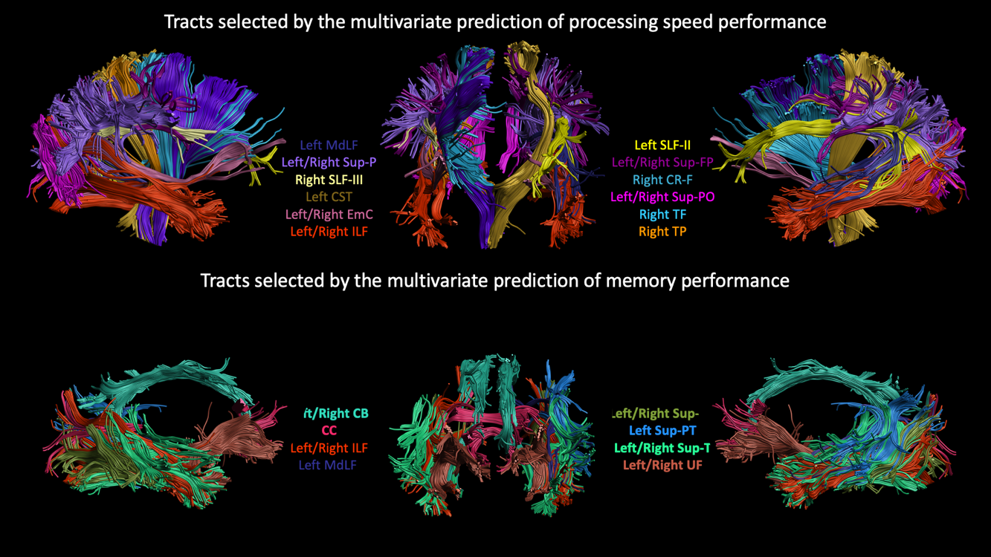
Figure S2: The tracts selected by the multivariate regression that best predicted processing speed (top) and memory performance (bottom) with leave-one-out cross validation.
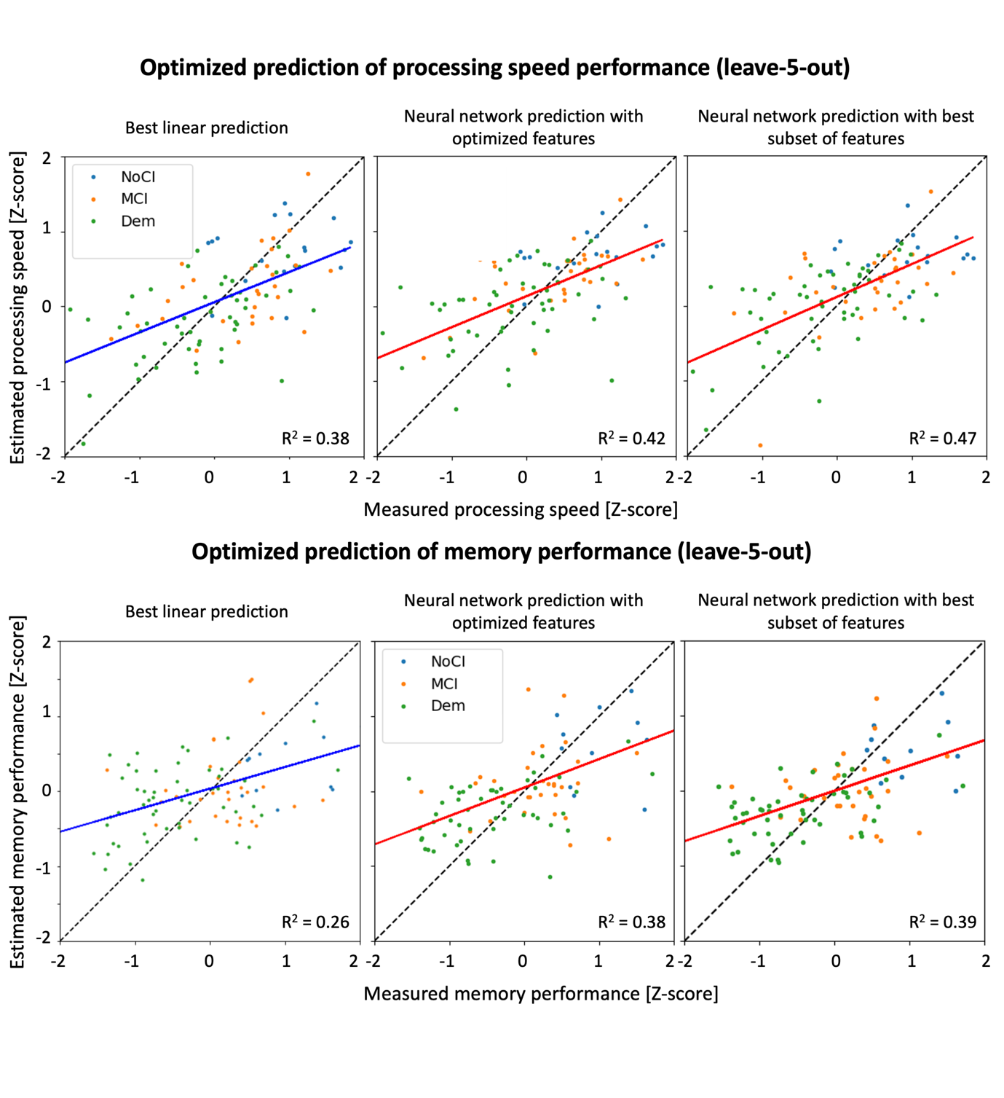
Figure S3: Scatter plots of measured and estimated processing speed (top) and memory performance (bottom) using the linear multivariate predictor (first column) and ANN (second and third column) with leave-5-out cross-validation. The solid line is the regression line, and is colored in blue for multivariate prediction (left), and in red for ANN prediction (middle and right). The colored dots represent each included patient and are colored encoded according to the clinical diagnosis: blue for no cognitive impairment (NoCI), orange for mild cognitive impairment (MCI), and green for patients with dementia (Dem). The best multivariate prediction (left) included demographics, lesion and atrophy markers and average MD in WM, and is compared to predictions with the neural network using all candidate metrics (middle), and the best subset (right).
Video S1: Subsequent axial slices (feet-head) of the spatial probability of each reconstructed white matter tract at the group level.
Video S2: Subsequent coronal slices (fronto-occipital) of the spatial probability of each reconstructed white matter tract at the group level.
Video S3: Subsequent sagittal slices (right-left) of the spatial probability of each reconstructed white matter tract at the group level.

