Extended Data
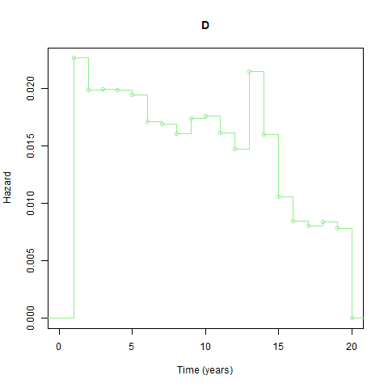
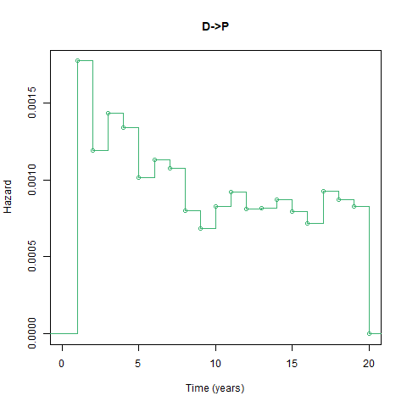
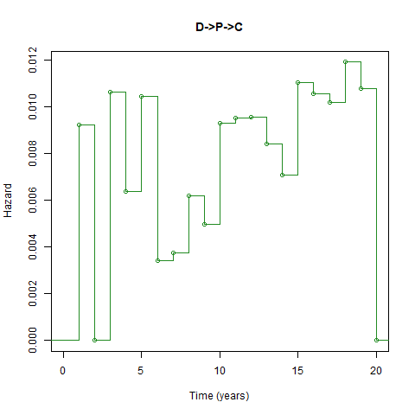
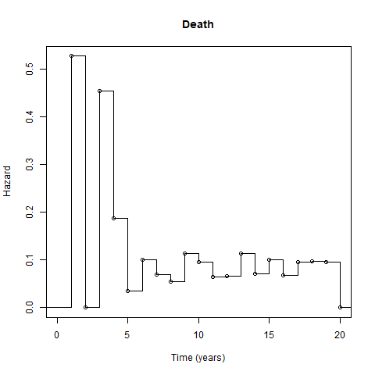
Extended Data Figure 1: Hazard plots for a 50 year old male in the 3rd WIMD quintile for trajectory OH/OD -> D -> P -> C

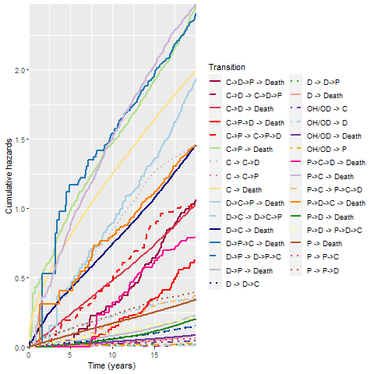
Extended Data Figure 2: Cumulative hazards for all transitions for a 50 year-old, male, in the 3rd WIMD quintile

Extended Data Figure 3: Cumulative incidence of mortality for triple combinations of disease for a 75-year-old, male, in the 3rd WIMD quintile
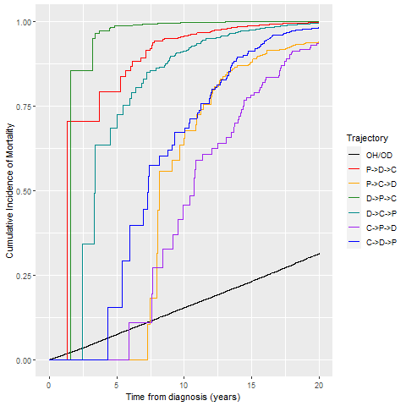

Extended Data Figure 4: Cumulative incidence of mortality for triple combinations of disease for a 50-year-old, female, in the 3rd WIMD quintile
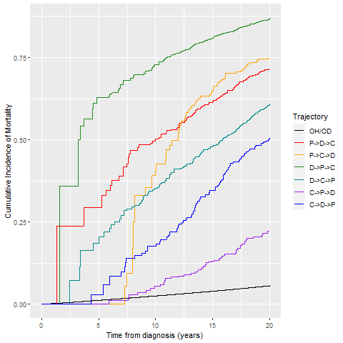

Extended Data Figure 5: Multi-state model illustrating the possible trajectories of disease in psychosis, diabetes, and CHF
