Supplemental material

Table S1 All the variables used to build machine learning model and their abbreviation
Variable class | Variable abbreviation | Variable explain
Sex | Sex_1 | Sex changed into TURE/FALSE in two variables in the model
Sex | Sex_2 | Sex changed into TURE/FALSE in two variables in the model
Gravidity | G_G1 | Gravidity changed into TRUE/FALSE for 7 variables
Gravidity | G_G2 | Gravidity changed into TRUE/FALSE for 7 variables
Gravidity | G_G3 | Gravidity changed into TRUE/FALSE for 7 variables
Gravidity | G_G4 | Gravidity changed into TRUE/FALSE for 7 variables
Gravidity | G_G5 | Gravidity changed into TRUE/FALSE for 7 variables
Gravidity | G_G6 | Gravidity changed into TRUE/FALSE for 7 variables
Gravidity | G_G7 | Gravidity changed into TRUE/FALSE for 7 variables
Parity | P_P1 | Parity changed into TRUE/FALSE for 3 variables
Parity | P_P2 | Parity changed into TRUE/FALSE for 3 variables
Parity | P_P3 | Parity changed into TRUE/FALSE for 3 variables
Gestational age | Gestational_age | Gestational age (weeks)
Delivery mode | Birth_way | 1for normal natural delivery; 2 for C-section
Apgar score | Apgar | Apgar score at birth
Birth weight | Birth_weight | Birth weight (g)
Weight at admission | admission_weight | Weight when admission
Age at admission | admission_age | Age when admission in days
Feeding type | Feeding_breast | Breast feeding
Feeding type | Feeding_formula | Formula feeding
Feeding type | Feeding_none | Not start feeding
Feeding type | Feeding_mixed | Formula and breast mixed feeding
Diagnose | Diag_ABO_hemolytic | ABO hemolytic / ABO incompatibility
Diagnose | Diag_RH_hemolytic | RH hemolytic/ RH incompatibility
Diagnose | Diag_BE | Bilirubin encephalopathy
Diagnose | Diag_anemia | anemia
Diagnose | Diag_premature | premature
Diagnose | Diag_sepsis | Sepsis
Diagnose | Diag_G6PD | G6PD deficiency
Diagnose | Diag_NEC | Necrotizing enterocolitis
Diagnose | Diag_PM | Purulent meningitis
Diagnose | Diag_HB | Hyperbilirabinemia without etiology
ET waiting time | Admission2ET | The time from admission to ET in hours
ET volume | ET_volume | ET volume (ml)
ET time | ET_time | ET length of time (minutes)
ET speed | et_speed | Calculate average speed by ET_volume/ET_time
ET artery | ET_artery_radial | Radial artery
ET artery | ET_artery_brachial | Brachial artery
ET artery | ET_artery_femoral | Femoral artery
ET artery | ET_artery_axillary | Axillary artery
ET artery | ET_artery_scalp | Scalp
ET artery | ET_artery_ulnar | Ulnar artery
ET vein | ET_vein_axillary | Axillary vein
ET vein | ET_vein_basilic | Basilic vein
ET vein | ET_vein_mediancubital | Mediancubital vein
ET vein | ET_vein_hand | Hand dorsal vein
ET vein | ET_vein_femoral | Femoral vein
ET vein | ET_vein_popliteal | Popliteal vein
ET vein | ET_vein_foot | Foot dorsal vein
Baby blood group | Baby_RH_positive | The RH、ABO blood type of baby were changed into TRUE/FALSE value in the model.
Baby blood group | Baby_RH_negative
Baby blood group | Baby_ABO_A
Baby blood group | Baby_ABO_B
Baby blood group | Baby_ABO_AB
Baby blood group | Baby_ABO_O
Father blood group | Father_RH_positive | The RH、ABO blood type of baby’s father were changed into TRUE/FALSE value in the model.
Father blood group | Father_RH_negative
Father blood group | Father_ABO_A
Father blood group | Father_ABO_B
Father blood group | Father_ABO_AB
Father blood group | Father_ABO_O
Mother blood group | Mother_RH_positive | The RH、ABO blood type of baby’s mother were changed into TRUE/FALSE value in the model.
Mother blood group | Mother_RH_negative
Mother blood group | Mother_ABO_A
Mother blood group | Mother_ABO_B
Mother blood group | Mother_ABO_AB
Mother blood group | Mother_ABO_O
TBIL at admission | TBIL_admission | Total bilirubin at admission measured by biochemistry
TBIL after ET | TBIL_ET | Total bilirubin after ET measured by biochemistry
IBIL at admission | IBIL_admission | Indirect bilirubin at admission measured by biochemistry
IBIL after ET | IBIL_ET | Indirect bilirubin after ET measured by biochemistry
DBIL at admission | DBIL_admission | Direct bilirubin at admission measured by biochemistry
DBIL after ET | DBIL_ET | Direct bilirubin after ET measured by biochemistry
TBIL_{bga} before ET | BG_TBIL_BET | Total bilirubin before ET measured by blood gas analyzer
TBIL_{bga} during ET | BG_TBIL_IET | Total bilirubin during ET (at time about half of volume exchanged ) measured by blood gas analyzer
TBIL_{bga} after ET | BG_TBIL_AET | Total bilirubin after ET measured by blood gas analyzer
Bilirubin exchange rate | Bil_exchange_rate | Calculate by (BG_TBIL_BET – BG_TBIL_AET)/BG_TBIL_BET
pH | PH_BET | pH level before ET
Serum bicarbonate | HCO3_BET | Serum bicarbonate before ET
Serum glucose | BG_BET | Serum glucose before ET
Serum potassium | BK_BET | Serum potassium before ET
Serum calcium | BCa_BET | Serum calcium before ET
Serum sodium | Bna_BET | Serum sodium before ET
Hemoglobin | HGB_BET | Hemoglobin before ET
White cell count | WC_BET | White cell count before ET
Platelet count | PLT_BET | Platelet count before ET

Table S1 The AUC performance of 5 models in prediction 7 adverse events during exchange transfusion.
 | hypokalemia | hyperglycemia | Top-up transfusion | hypocalcemia | hyponatremia | thrombocytopenia | acidosis | Average in 7 tasks
XGB | 0.761 | 0.750 | 0.646 | 0.823 | 0.616 | 0.708 | 0.697 | 0.714429
Logistic Regression | 0.526 | 0.303 | 0.664 | 0.700 | 0.530 | 0.700 | 0.402 | 0.546429
GaussianNB | 0.532 | 0.440 | 0.561 | 0.712 | 0.576 | 0.490 | 0.573 | 0.554857
Kneighbors | 0.518 | 0.433 | 0.421 | 0.674 | 0.486 | 0.603 | 0.425 | 0.508571
RandomForest | 0.802 | 0.659 | 0.537 | 0.811 | 0.601 | 0.629 | 0.691 | 0.675714
Average of 5 models | 0.6278 | 0.517 | 0.5658 | 0.744 | 0.5618 | 0.626 | 0.5576 | 0.6

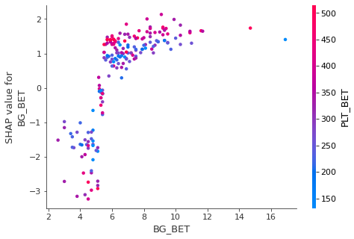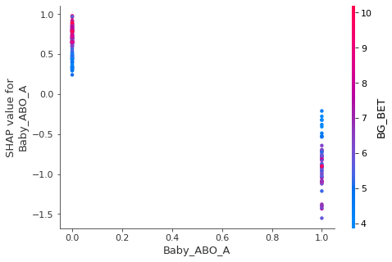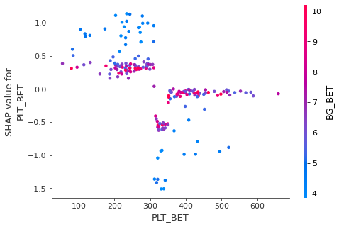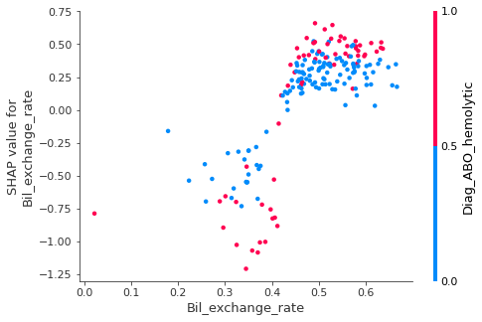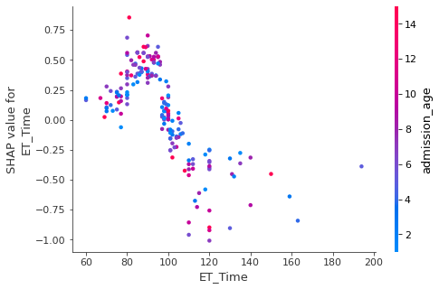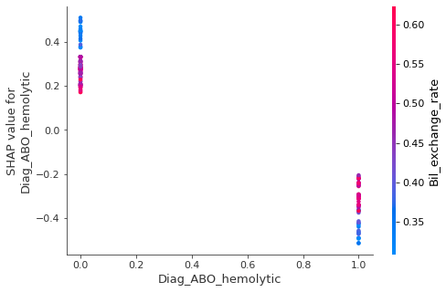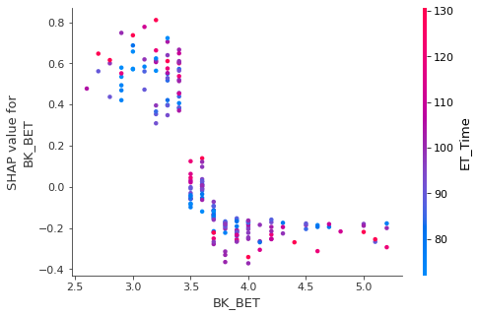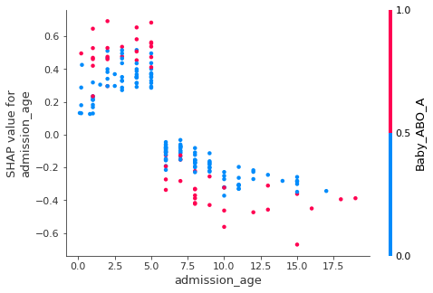
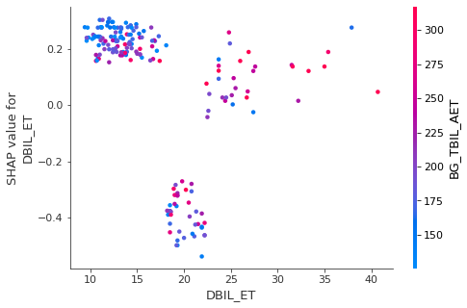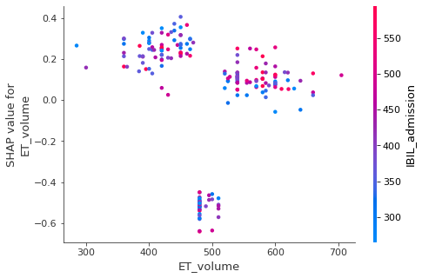
Figure S1 Top 10 important factors associated with hyperglycemia during ET

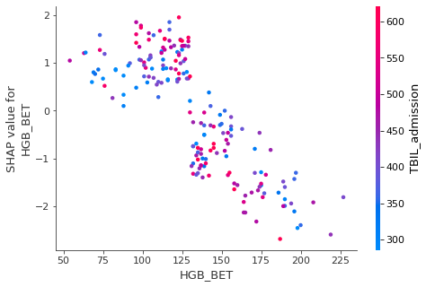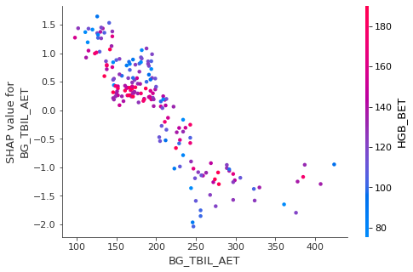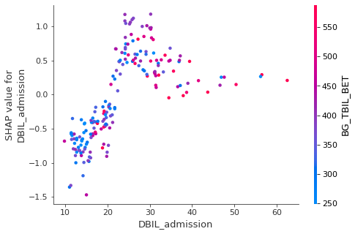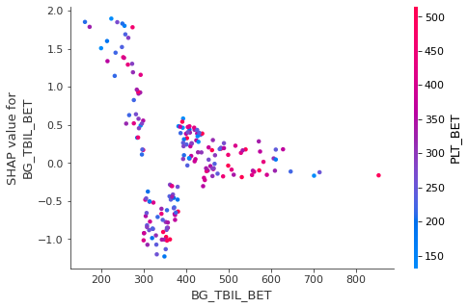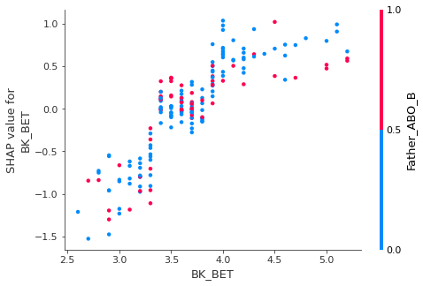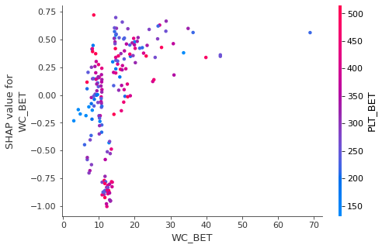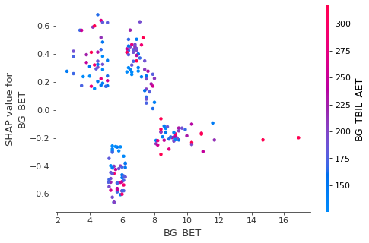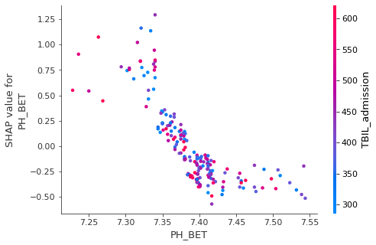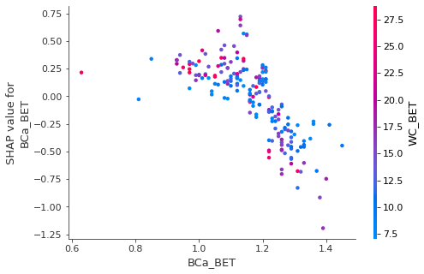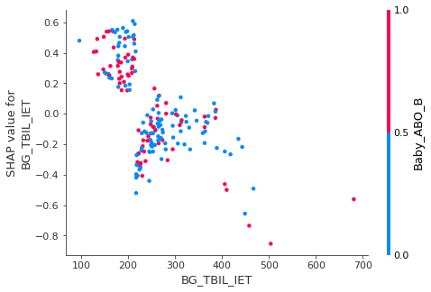
Figure S2 Top 10 important factors associated with top-up transfusion after ET

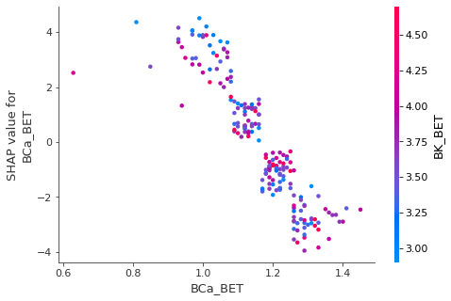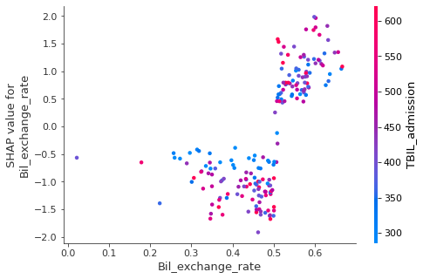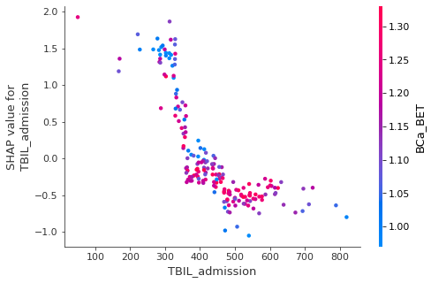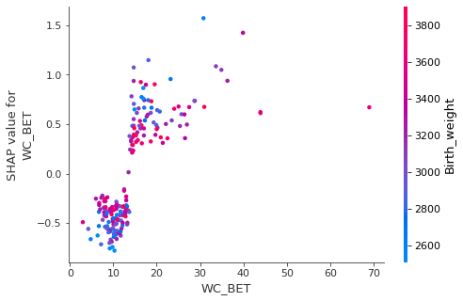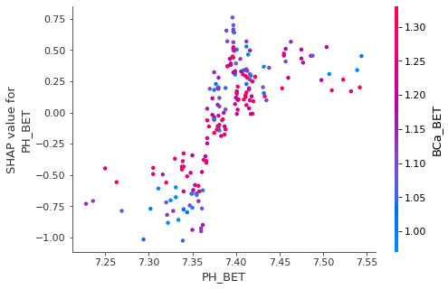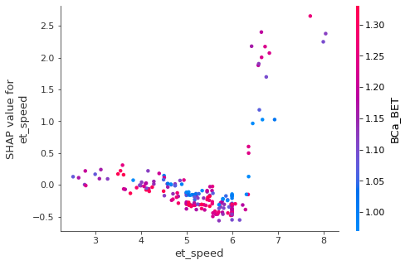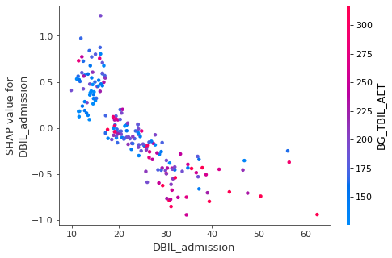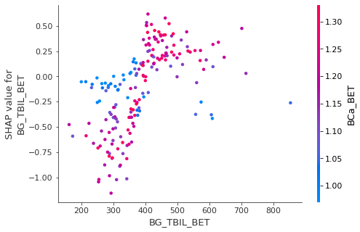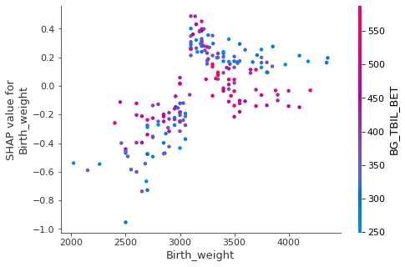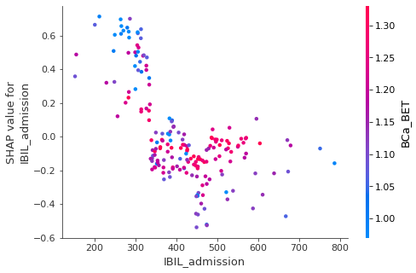
Figure S3 Top 10 important factors associated with hypercalcemia during ET

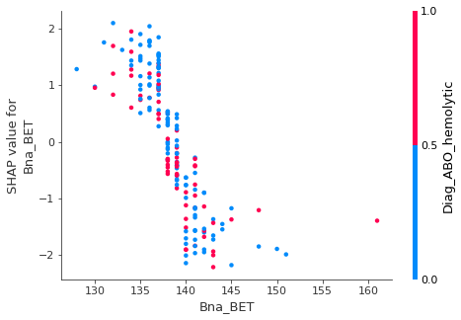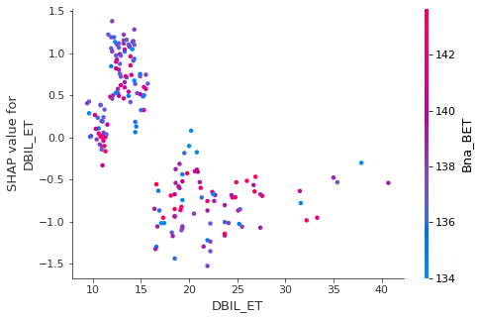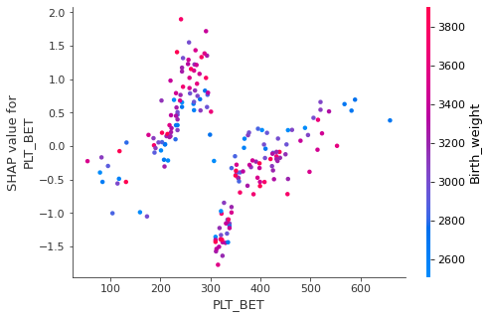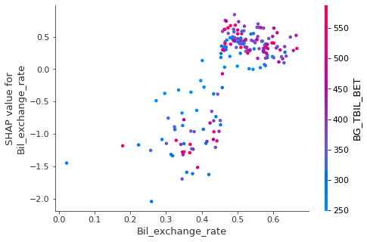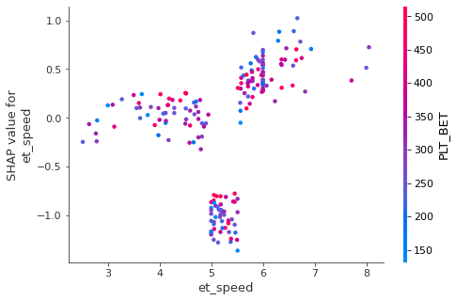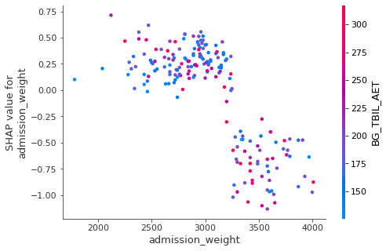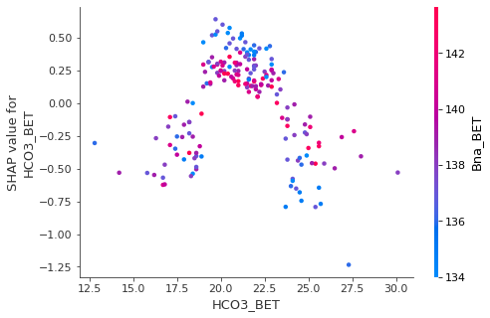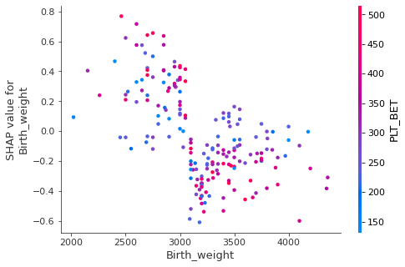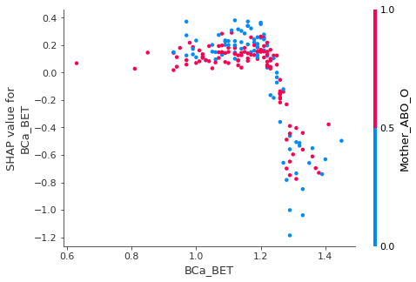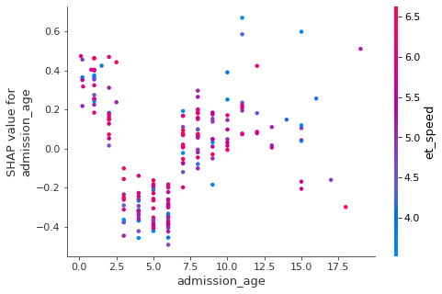
Figure S4 Top 10 important factors associated with hyponatremia during ET

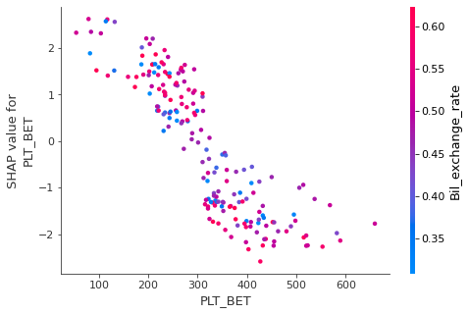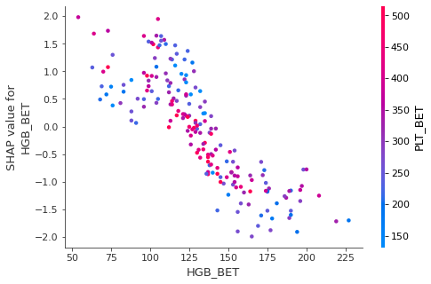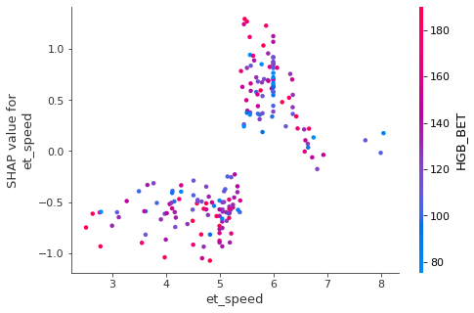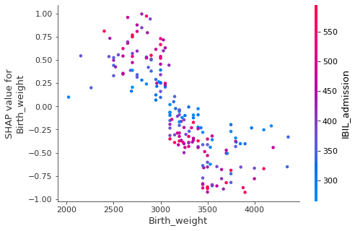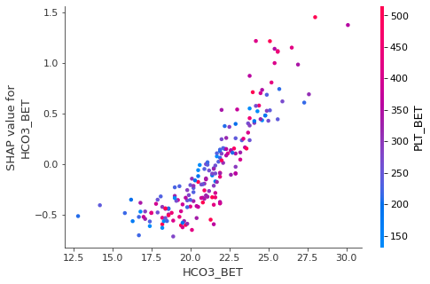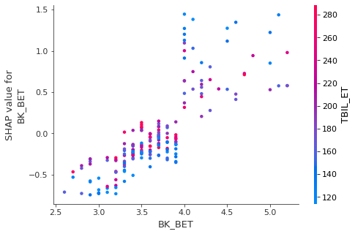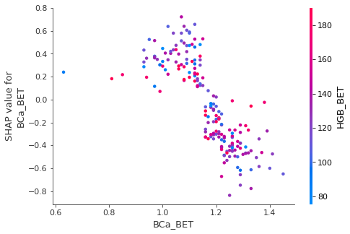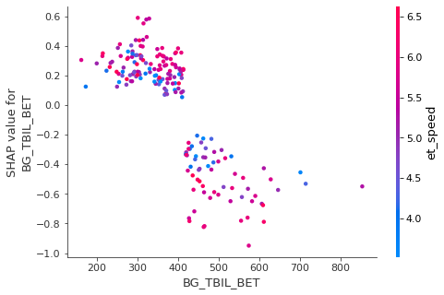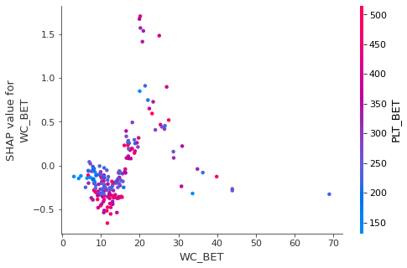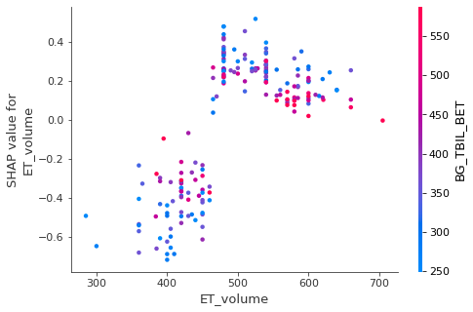
Figure S5 Top 10 important factors associated with thrombocytopenia during ET

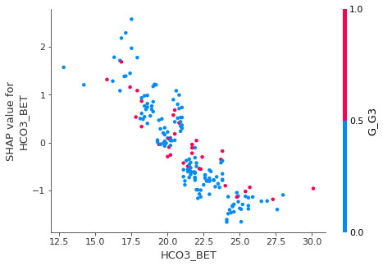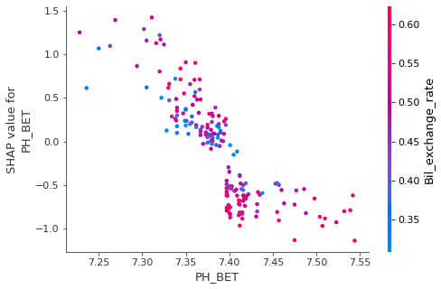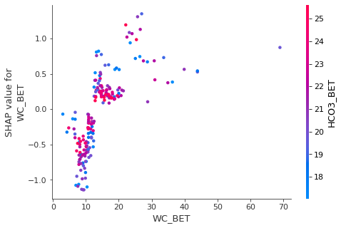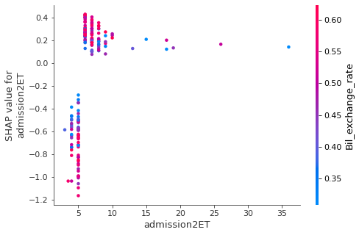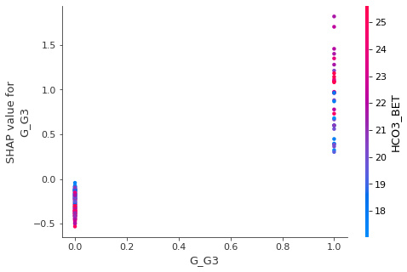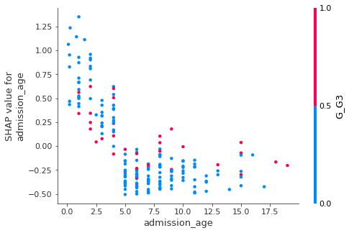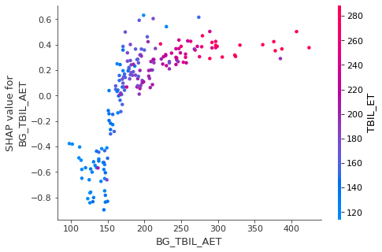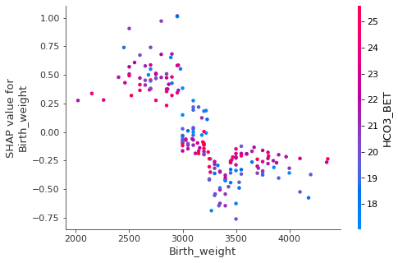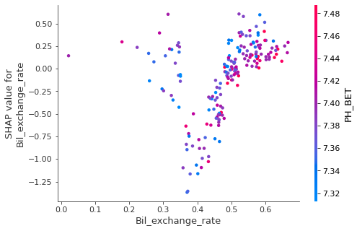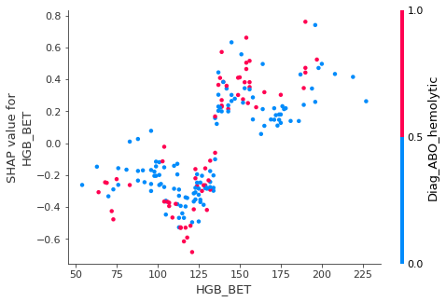
Figure S6 Top 10 important factors associated with metabolic acidosis during ET

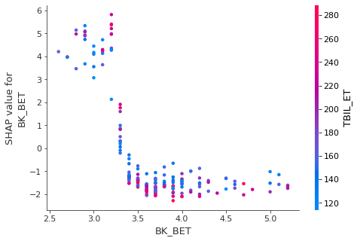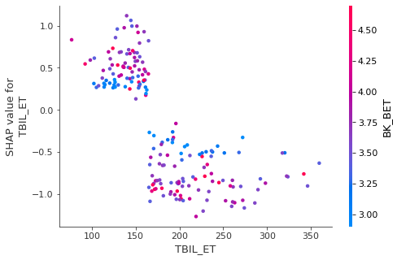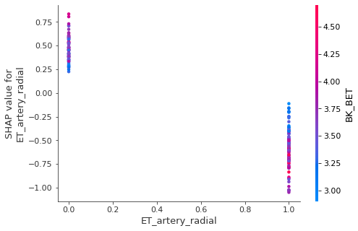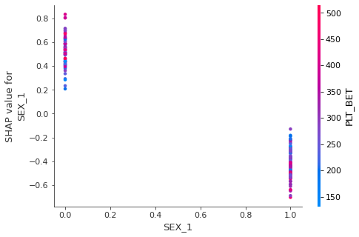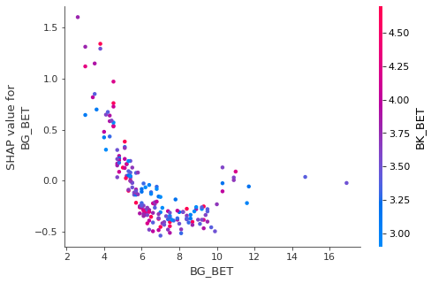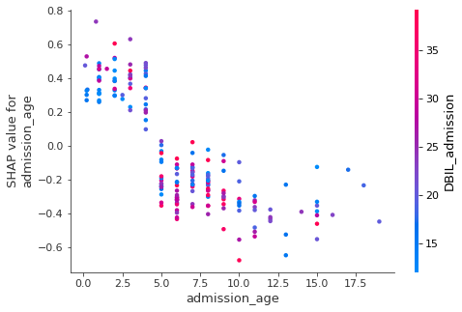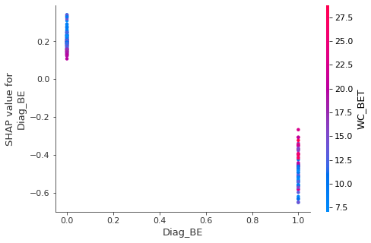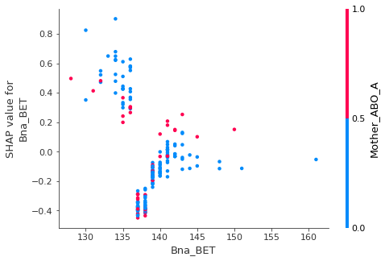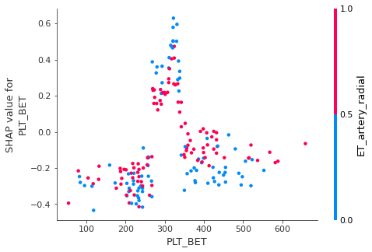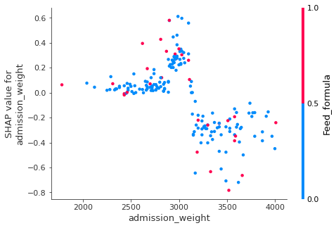
Figure S7 Top 10 important factors associated with hypokalemia during ET

