Supplementary Information

“Shear stress activates P2X4 receptor currents via triggering Cx43 hemichannels in atrial myocytes: possible role on atrial adaptation to pressure overload” Cell Mol Life Sci
Joon-Chul Kim^{1,2}, Long Nguyen Hoang Do¹, Qui Anh Le¹, Tran Nguyet Trinh¹, Luong Phuong Kim¹, Sun-Hee Woo (correspondence)¹
¹Laboratory of Pathophysiology, College of Pharmacy, Chungnam National University, 99 Daehak-ro, Yuseong-gu, Daejeon 34134, South Korea; ²NEXEL Co. Ltd., 55, Magokdong-ro, Gangseo-gu, Seoul 07802, South Korea

Supplemental Methods

Cell isolation
Atrial myocytes were enzymatically isolated from male Sprague-Dawley rats (200–300 g), TAC- and sham-rats, and from control and Cx43 cKO mice using retrograde Langendorff perfusion method. This study conforms with the Guiding Principles for the Care and Use of Experimental Animals published by the Korean Food and Drug Administration and Animal and Plant Quarantine Agency in South Korea. The experimental protocols were approved by the Animal Care and Use Committees of the Chungnam National University, South Korea (No. CNU-00992). Rats or mice were deeply anesthetized with sodium pentobarbital (150 mg/kg, i.p.), the chest cavity was opened, and hearts were excised. The excised hearts from rats and mice were retrogradely perfused at 7-12 ml/min and 1 ml/min, respectively, through the aorta (at 36.5°C), first for 3 min with Ca²⁺-free Tyrode's solution composed of (in mM) 137 NaCl, 5.4 KCl, 10 HEPES, 1 MgCl₂, and 10 glucose, pH 7.3, and then with Ca²⁺-free Tyrode's solution containing collagenase (1.4 mg/mL; Type A (EC 3.4.24.3), Roche) and protease (0.14 mg/L, Type XIV (EC 3.4.24.31), Sigma, St. Louis, MO, USA) for 12 min; and finally with Tyrode's solution containing 0.2 mM CaCl₂ for 5 min. The atria of the digested hearts were then cut into several sections and subjected to gentle agitation to dissociate the cells. The freshly dissociated cells were stored at room temperature in Tyrode's solution containing 0.2 mM CaCl₂.

Western blotting
To examine expression levels of P2X4R, Cx43, atrial natriuretic peptide (ANP) and phosphorylated Cx43 at S368 in atrial muscles Western blotting was performed. Tissues or cells without or with interventions (e.g., siRNA transfection, TAC and sham) were dissolved in a SDS lysis buffer (10 mM Tris-HCl, pH 7.4, 1% (w/v) SDS, 1 mM phenylmethanesulfonyl fluoride, 1 mM Na₃VO₄) and complete protease inhibitor mixture (Roche Molecular Biochemicals) for 20 min at 60°C, and then triturated several times by passing through a 1-ml syringe and centrifuged at 16,000 g for 15 min. Protein concentrations were measured by Bradford protein assay (Bio-Rad, Hercules, CA, USA). Approximately 15-30 μg of total proteins were run on 10% SDS-polyacrylamide gel. The proteins were transferred onto a nitrocellulose membrane, and the blots were sequentially probed with primary and secondary antibodies (anti-P2X4R: rabbit polyclonal, 1:150, intracellular epitope, a.a. 370-388 of rat P2X4R, APR-002, Alomone labs; anti-Cx43, rabbit polyclonal, 1:500, intracellular epitope at a.a. 233-382 of human Cx43, sc-9059, Santa Cruz Biotechnology Inc.; anti-phospho-Cx43, rabbit polyclonal, 1:1000, intracellular epitope at amino acid residues surrounding the phosphoserine 368 of rat connexin 43, 48-3000, Invitrogen.; anti-ANP, sc-18811, Santa cruz, 1:500; anti-GAPDH, mouse monoclonal, 1:1000, epitope of rabbit muscle GAPDH, ab8245, Abcam) using standard western blot protocol. All blots were imaged and quantified using a Chemi-luminescence Bioimaging Instrument (CHEBI) (Cellgenetek, South Korea).

Measurement of membrane currents
Membrane currents were recorded using the whole-cell configuration of the patch-clamp technique using an EPC7 amplifier (HEKA Elektronik, Germany). The patch pipettes were made of glass capillaries (Kimble Glass Inc., Vineland, NJ, USA) to have resistance of ∼3 MΩ when filled with the internal solutions. The normal Tyrode's solutions composed of (in mM) 137 NaCl, 5.4 KCl, 10 HEPES, 1 MgCl₂, and 10 glucose, 2 CaCl₂ (pH 7.4) was used for cellular equilibrium and formation of the giga-seal. Before applying shear, conditioning pulses from −80 mV to −10 mV were continuously applied to the cells in order to maintain the sarcoplasmic reticulum Ca²⁺ load. Measurement of I_{S,Cs} was generally carried out 7~8 min after rupture of the membrane in the external solutions containing (mM) 137 CsCl, 10 HEPES, 1 MgCl₂, 10 glucose, 2 CaCl₂ (pH = 7.4), with ~4 min intervals. Puffing solutions to apply shear stress contained 2 mM Ca²⁺ or zero Ca²⁺ (with 1 mM EGTA) as described in the figures and legends. Cs⁺-rich pipette solutions contained (in mM) 137 CsCl, 10 HEPES, 5 MgATP, 1 MgCl₂ with the pH adjusted to 7.2. For K⁺-rich internal solution, 137 mM CsCl was replaced with equimolar KCl (Figure 1). To measure I_{S,NMDG} internal and external CsCl were replaced with equimolar NMDG-Cl. In some experiments, anti-Cx43 antibodies (monoclonal, mouse, MiliporeSigma, C8093, 1:2000) and scramble were dialyzed into atrial myocytes. Similarly, anti-P2X4R antibodies (Rabbit polyclonal, 1:1000 dilution, epitope: intracellular, a.a. 370-388 of rat P2X4R; APR-002, Alomone labs, Jerusalem, Israel) or anti-P2X5R antibodies (Rabbit polyclonal, 1:1000 dilution, epitope: extracellular, a.a. 299-311 of rat P2X5R; APR-027, Alomone labs) with and without blocking antigenic peptides were added to the pipette solutions. Generation of the voltage-clamp protocol and acquisition of the data were carried out using pClamp software (v9.0, Molecular Devices, Foster City, CA, USA) via an A/D converter (Digitata 1440, Molecular Devices). The current signals were filtered (10 kHz) and analyzed using Clampfit 10.3 software and OriginPro 8.1 SR1 software (OriginLab Corporation, Northampton, MA, USA). The experiments were performed at room temperature (22–25°C).

Knockdown (KD) of Cx43 in HL-1 cells
HL-1 atrial cell line was obtained from Dr. W. C. Claycomb (Louisiana State University Health Science Center, USA). HL-1 cells were grown onto a matrix of gelatin (0.02%, Difco) plus fibronectin (12.5 µg/mL, Sigma), in Claycomb medium (JRH Biosciences) supplemented with 10% fetal bovine serum (Sigma), 2 mM L-glutamine (Life Technologies, Carlsbad, CA), 0.1 mM norepinephrine (Sigma), and 100 U/mL penicillin-streptomycin (Life Technologies). Cells were maintained at 37°C in a humidified atmosphere containing 5% CO₂. To suppress the expression of Cx43, HL-1 cells were transfected with siRNAs (300 nM) specifically targeting Cx43 (sc-35091, Santa Cruz Biotechnology Inc.) or control siRNA (siRNA control, sc-37007) for 6 h at 37°C using Lipofectamine-2000 (Life Technologies; siRNA:lipofectamine = 1:1) in accordance with the manufacturer's instructions. HL-1 cells were pre-incubated in serum- and antibiotic-free medium for 30 min before transfection. The cells were used for the experimental measurements after 48 h of culture. The KD of target protein expression was confirmed by using RT-PCR and western blotting.

Application of shear stress in a field of atrial cells
Isolated rat atrial cell or HL-1 cells were attached to cover slip (diameter: 25 mm) coated with fibronectin (12.5 µg/mL) plus gelatin (0.02%) solutions in advance for shear application in a field of cells. Shear stress of about 4 dyn/cm² were applied as a laminar flow for 20, 40, or 50 min in our own chamber to examine the effects of shear stress on gene and protein expressions.

Polymerase chain reaction (PCR)
For genotyping of Cx43 cKO mice, tails cut were added to solutions containing 25 mM NaOH and 0.2 mM EDTA which was subjected for reverse transcriptase PCR according to the manufacture’s protocol (The Jackson Laboratory). The sample was placed in thermocycler at 98 °C for 1 hour first. Then the temperature was lowered to 15°C. The mixture was continuously put in 75 μl of 40 mM Tris HCl (pH 5.5) solutions and then centrifuged at 4000 rpm for 3 minutes. Supernatant was taken to measure DNA concentrations and then were made as an aliquot for PCR with the Cx43 primer (Tabel below). The general PCR was carried out according to the instruction from PrimerScriptTM RT-PCR kit (Cat# RR014A, Takara Bio Inc.) using 5-μg-DNA sample with the primers in a total volume of 20 μl. The samples were initially denatured at 94 °C for 5 min followed by 30 cycles of 94°C for 30 s, 52°C for 30 s, and 72°C for 60 s, and a 7-min final extension at 72°C. The amplified products (10 μl each) were separated by electrophoresis on 1% agarose gels and stained with ethidium bromide.
Real-time PCR (RT-PCR) was performed to measure expression changes by shear stress. Total RNA from HL-1 cells was extracted using the TRIzol™ reagent (Ambicon, 15596026). cDNA was synthesized from total RNA using PrimeScript™ 1st strand cDNA Synthesis Kit, Cat #6110A, Takara Bio Inc., following the manufacturer's instructions. The RNA samples were denatured at 65 °C for 5 min to get cDNA. The general PCR conditions of cDNA was conducted using Luna Universal qPCR mix, M3003G from Biolabs and primer’s sequences as described in Supplemental Table 1, each primer in a total volume of 20 μl. The samples were initially denatured at 94°C for 5 min followed by 40 cycles of 94°C for 30 s, 54.3°C for 30 s, and 72°C for 1 min, and a 7-min final extension at 72°C by using Mic qPCR machine from Bio molecular system. The results were analyzed relative quantification using $∆∆$Ct method by software micPCR v2.10.1

Transverse aortic constriction (TAC) in rats and echocardiography
All animal procedures were reviewed by the Institutional Animal Care and Use Committee and approved. To induce aortic pressure overload TAC procedure was performed on 6 weeks old male Sprague-Dawley rats as previously reported.¹⁹ Briefly, rats were anaesthetized with sodium pentobarbital (45 mg/kg; i.p.). Trachea was connected to a rodent ventilator (Model 683, Harvard Apparatus) with an intubation. A horizontal incision at the jugulum was used to display the transversal aorta. Constriction of the transverse aorta was induced using a 23 G spacer and a 5-0 black silk suture. Sham operated animals underwent the same surgical procedure but without aortic constriction.
For in vivo cardiac phenotyping 5 weeks after TAC intervention, we performed transthoracic echocardiography (S-Sharp, S-Sharp Corporation, New Taipei City, Taiwan) of the left ventricle and atrium using a 20 MHz probe. To induce anesthesia prior to echocardiography we used 3% isoflurane, which was maintained at 1.5% in oxygen. Left atrial (LA) and left ventricular (LV) images were obtained by 2-D guided B-mode and M-mode parasternal long axis, respectively. Body temperature and the surface electrocardiogran were monitored throughout echocardiography procedures. The LA fractional shortening (FS) was calculated by the equation: FS = [LA inner diameter at diastole (LAID,d) – LAID at systole (LAID,s)]/LAID,d] × 100%. All images were analyzed by Prospect software (S-Sharp Corporation).

Reagents
Reagents used to make Tyrode's solutions, and carbenoxolone (CBX), probenecid, LaCl₃ and suramin were purchased from Sigma-Aldrich. 9-phenanthrol (9-PT), TAT-Gap19, Gap19, iso-PPADS (pyridoxalphosphate-6-azophenyl-2’,5’-disulfonic acid), and 5-BDBD (5-(3-Bromophenyl)-1,3-dihydro-2H-benzofuro[3,2-e]-1,4-diazepin-2-one) were supplied by Tocris Bioscience (Avonmouth, Bristol, BS11 9QD). PSB-12054 (N-(Benzyloxycarbonyl) phenoxazine) was from Glixx Laboratories Inc.
Supplemental figures
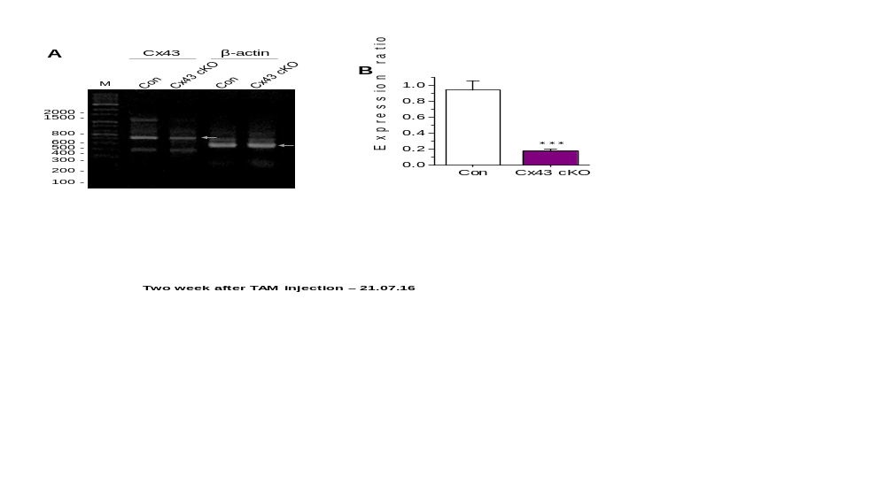

Fig. S1 Genotyping result in Cx43 conditional knockout (cKO) mice. A, Reverse transcriptase-PCR result on mRNA expression for Cx43 and β-actin in control and Cx43 cKO mice. B, comparison of mean Cx43 mRNA expression normalized to β-actin expression in control (3 mice) and Cx43 cKO mice (3 mice; ***P < 0.001).

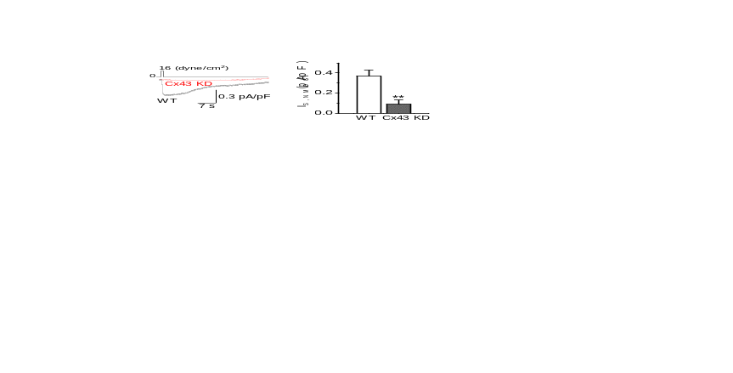

Fig. S2 Major role of Cx43 in shear-induced NMDG⁺ current (I_{S,NMDG}) in HL-1 atrial cells. Representative I_{S,NMDG} recorded in wild-type (WT) and CX43-specific siRNA-introduced (Cx43 KD) HL-1 cells (left) and comparison of mean I_{S,NMDG} between WT and Cx43 KD HL-1 cells (right). One-way repeated measures ANOVA-Bonferroni test was used. **P < 0.01 (five batches). The siRNA treatment produced about 80%-null in Cx43 expression and in I_{S,NMDG} in these cells.

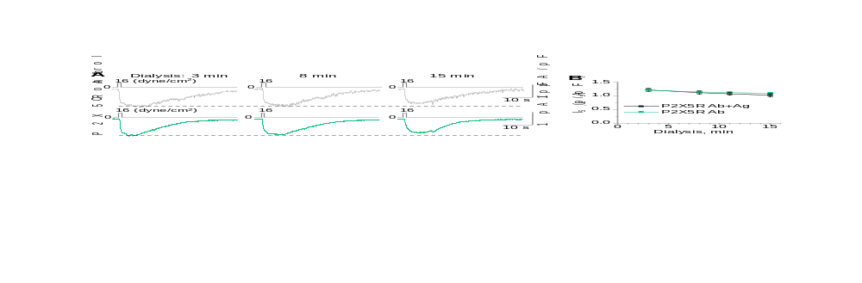

Fig. S3 P2X5R does not contribute to atrial I_{S,Cs}. A, Representative currents show I_{S,Cs} measured following different dialysis duration in the same cells with anti-P2X5R antibodies (Ab; 400 ng/ml) with or without its antigenic peptides (Ag). B, Plots of means of peak I_{S,Cs} versus dialysis durations (Ab+Ag, n = 8; Ab, n = 8). **P < 0.01 vs. “P2X5R Ab+Ag”. Results show no significant changes in I_{S,Cs} by the introduction of anti-P2X5R antibodies into the rat atrial myocytes.
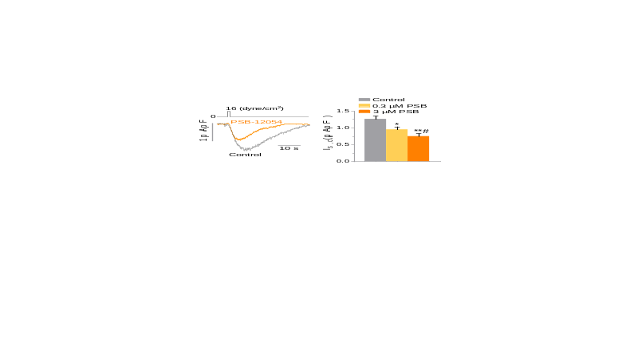

Fig. S4 P2X4R partly contributes to atrial I_{S,Cs}. I_{S,Cs} measured in the absence and presence of the P2X4R inhibitor PSB-12054 in a representative rat atrial cell (left). Mean I_{S,Cs} in control and 0.3- (n = 7) and 3-µM PSB-12054 (n = 8) (right). *P < 0.05, **P < 0.01 vs. Control. #P < 0.05 vs. 0.3 µM PSB-12054 (paired t-test).

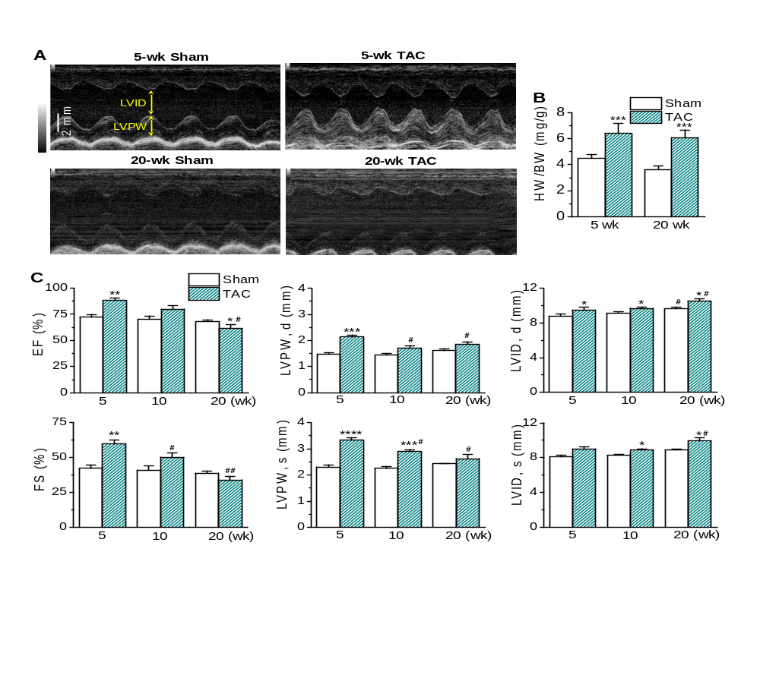
Fig. S5 Ventricular morphology and function following 5-week- and 20-week-TAC in rats. A, Echocardiography images measured in M-mode from left ventricle (LV) of 5-week (wk)-sham and -TAC rats and LV of 20-wk-sham and TAC rats. Width: 947 ms. B, Comparison of the ratio of heart weight (HW) to body weight (BW) shows significant increase in the HW/BW in 5-wk- (13 rats) and 20-wk-TAC rats (15 rats) compared with their age-matched sham group (5-wk, 10 rats; 20-wk. 12 rats). ***P < 0.001 vs. Sham. C, Comparisons of mean values of ejection fraction (EF), fractional shortening (FS), LV posterior wall thickness at diastole (LVPW,d) and systole (LVPW,s), LV inner diameter at diastole (LVID,d) and systole (LVID,s) measured from echocardiography at 5-wk-, 10-wk- (sham, 10 rat; TAC, 6 rats), and 20-wk-sham and TAC rats. *P < 0.05, **P < 0.01, ***P < 0.001, ****P < 0.0001 vs. Sham. #P < 0.05 vs. 5-wk TAC.
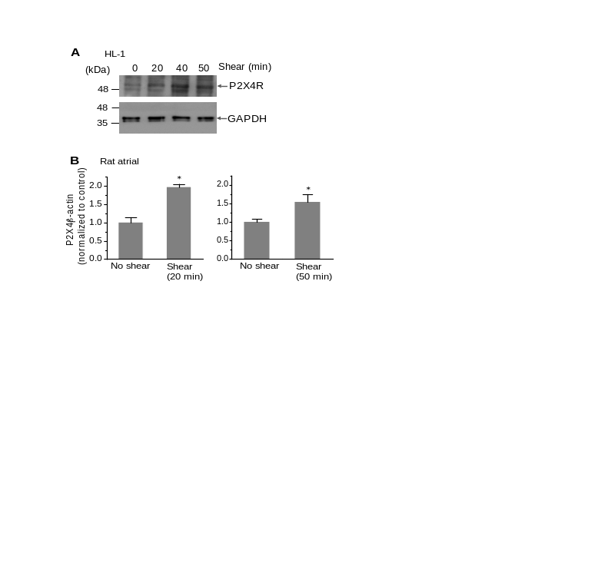

Fig. S6 Shear-stress-induced increase in P2X4R expression in atrial cells. A, Western blotting result shows laminar shear (~4 dyn/cm²)-dependent increase in P2X4R protein expression in HL-1 adult atrial cell line. B, Real time-PCR results show shear (~4 dyn/cm²)-dependent increase in P2X4R gene expression in rat atrial myocytes (3 batches for each graph). *P<0.05 vs. “No shear”.

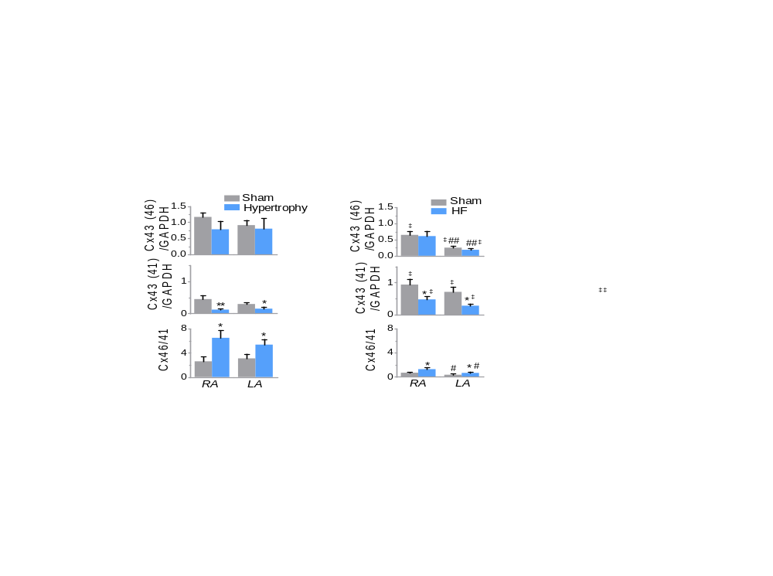

Fig. S7 Alterations of Cx43 phosphorylation status by progressive PO in RA and LA muscles. B and D, The changes in protein expression at 5-week-sham and TAC (“hypertrophy”) rats (left) and 20-week-sham and TAC (“HF”) rats (right) were normalized to GAPDH bands shown in Fig. 5E (same preparations) and are summarized by bar graphs. Results on comparison of the level of GAPDH-normalized Cx43 band intensity show that the intensities of the 41 kDa band was significantly reduced by PO in RA- and LA-muscles with no changes in the intensities of the 46-kDa-bands, thereby resulting in increases in the 46/41-kDa ratio under PO Blots are representative of 3 independent experiments (rats). *P<0.05, **P<0.01 vs. sham. #P<0.05, ##P<0.01 vs. sham, RA. ‡P<0.05 vs. corresponding 5-wk group (two-way ANOVA with repeated measures).

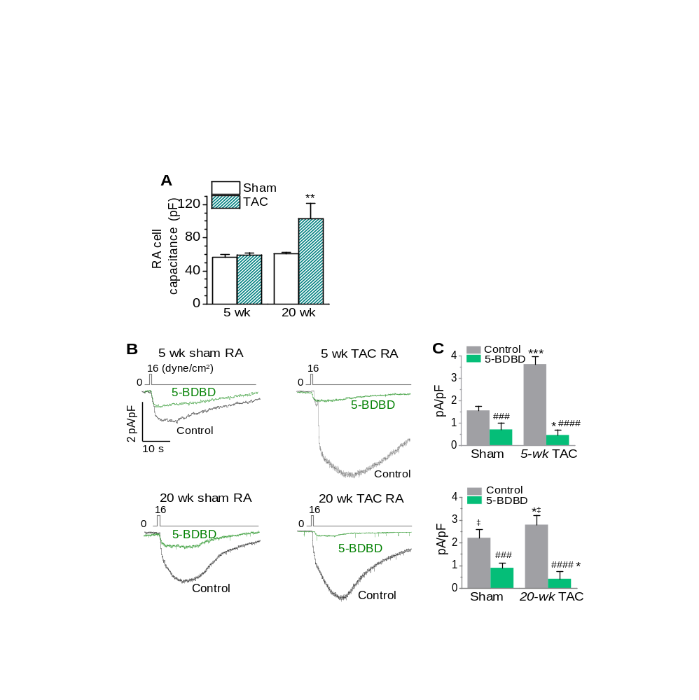

Fig. S8 Alterations of rat RA I_{S,Cs} and P2X4R current component of the I_{S,Cs} by progressive pressure overload. A, Cell capacitance measured in RA cells from sham and TAC rats at 5 weeks (3 sham rats, 10 cells; 3 TAC rats 11 cells) and 20 weeks (2 sham rats, 8 cells; 2 TAC rats 9 cells) following surgery. **P < 0.01 vs. sham. Representative I_{S,Cs} (B) and their mean peak values (C) obtained under the control solutions and after treatment of 5-BDBD (10 μM) in RA myocytes isolated from 5-week-sham (5 cells from 2 rats) and -TAC rats (9 cells from 2 rats) as well as 20-week-sham (6 cells from 2 rats) and -TAC rats (7 cells from 2 rats), showing significant increase in I_{S,Cs} and 5-BDBD-sensitive currents after 5-week-TAC and a reversal of such effects after 20-week-TAC. *P < 0.05, ***P < 0.001 vs sham. ###P < 0.001, ####P < 0.0001 vs. each control. ‡P < 0.05 vs. 5-wk rat, control.
Supplemental Table 1.

PCR primer sequences
Gene | Sense | Anti-sense
Cx43 | 5’-GCTTCTGGGTCCTTCAGATC-3’ | 5’- AGACACCAAGGACACCACCA-3’
P2RX4 | 5′-GGGTATCCAGATCAAGTGG-3′ | 5′-CTCTAGAGTGACAGACGCA-3′
β-actin | 5′-GGAATCCTGTGGCATCCATG-3’ | 5′-CGTACTCCTGCTTGCTGATCC-3′

