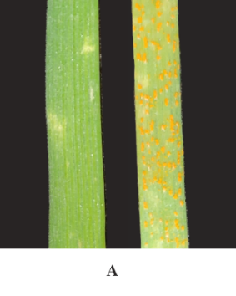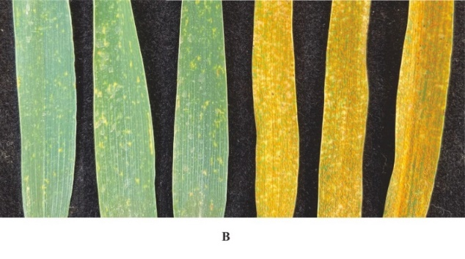
Figure S1 Stripe rust reactions of Zhongmai 175 and Avocet S
A. Seedling reactions of Zhongmai 175 (left, IT = 0;) and Avocet S (right, IT = 4) to PST race CYR32 at 14 dpi (days post inoculation). B. Adult plant responses of Zhongmai 175 (IT = 0;, Maximum DS = 2%) and Avocet S (IT = 4, Maximum DS = 100%) to mixed PST races (CYR32, CYR33 and CYR34) in the field.

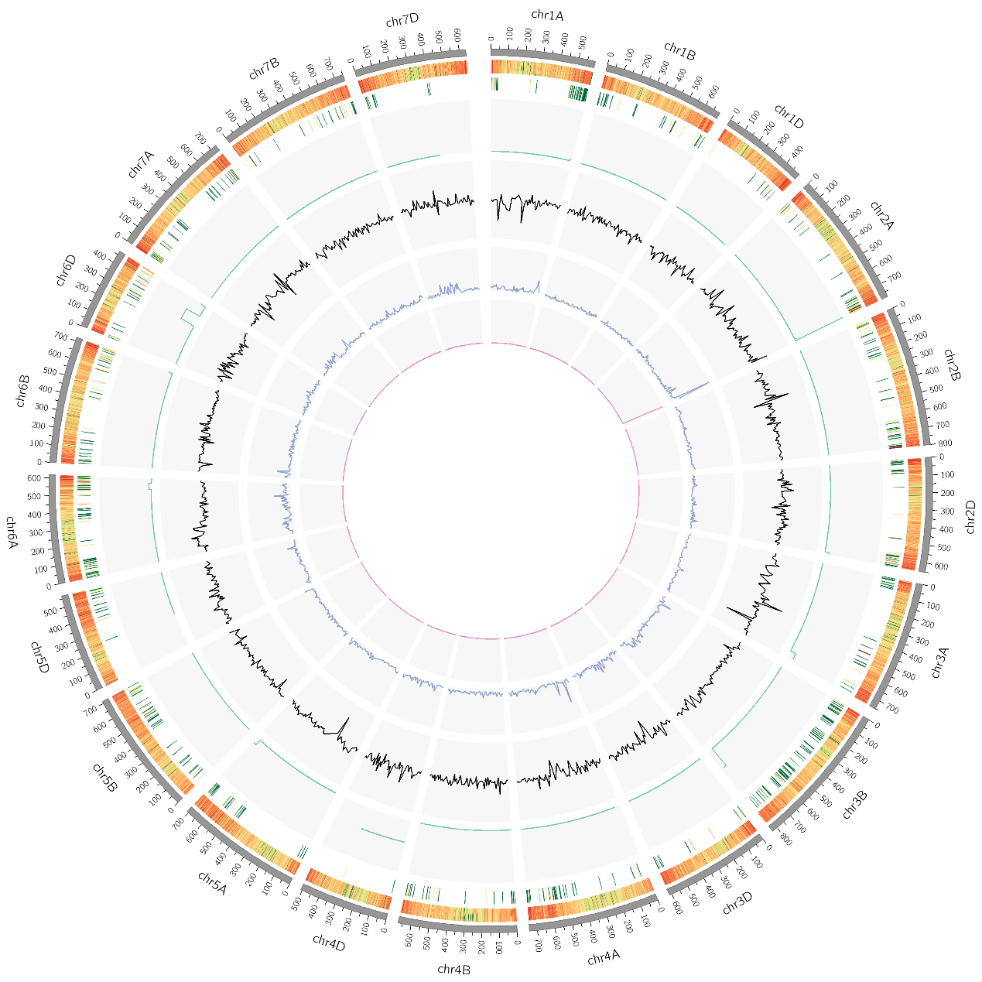
Figure S2 Overview of BSR-seq analyses
From the inside track to outside are: 1) Fitted ED^4 value; 2) G’ value; 3) ∆SNP-index; 4) varBScore; 5) SNP density; 6) Gene density; 7) Chromosome scale plate. A significant peak of fitted ED^4 value at the proximal end of chromosome 2AL indicates large differences between R and S pools.

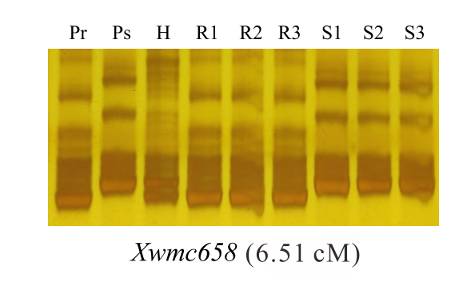
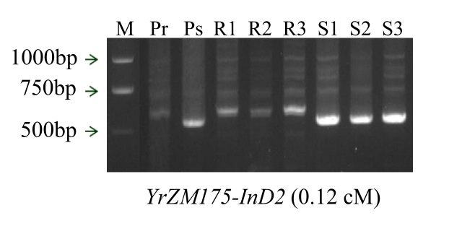
Figure S3 Analysis of markers Xwmc658 (upper) and YrZM175-InD2 (lower) linked to YrZM175
Pr: Resistant parent; Ps: Susceptible parent; R1–R3: Resistant F₂ plants; S1–S3: Susceptible F₂ plants. M: Marker.

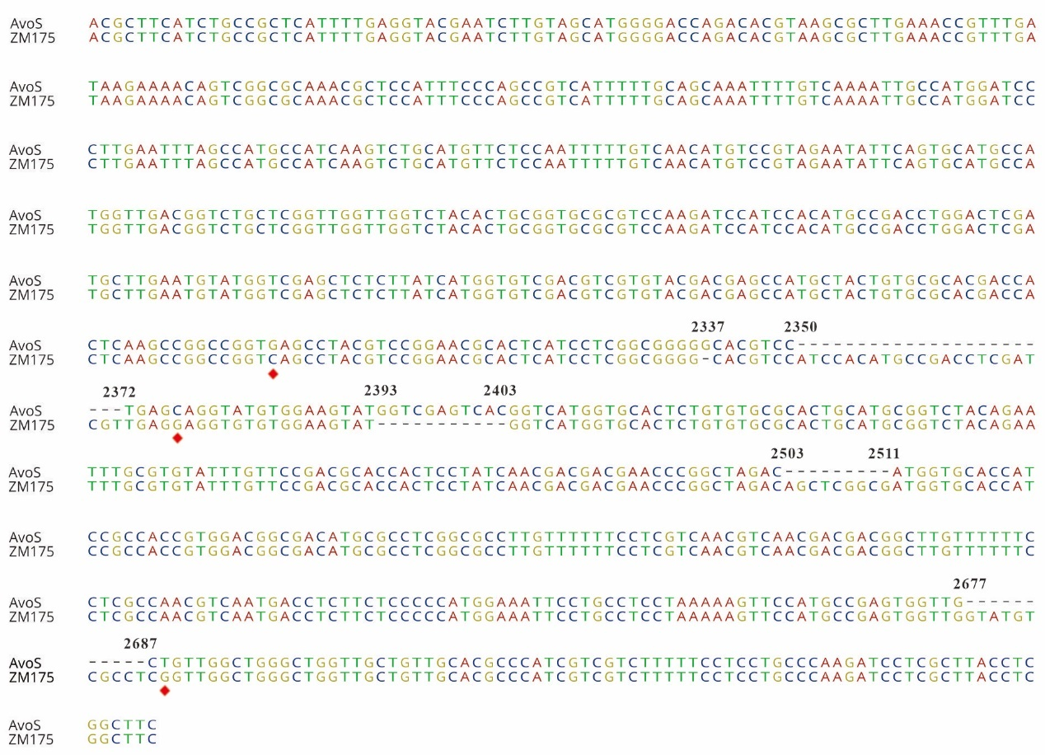
Figure S4 Sequence variations in the 857-bp presumed promoter sequence of gene TRITD2Bv1G265970 in Zhongmai 175 and Avocet S
Red rhombi: SNP; Numbers: indicate start and end position of base pair insertions and deletions. AvoS: Avocet S; ZM175: Zhongmai 175.

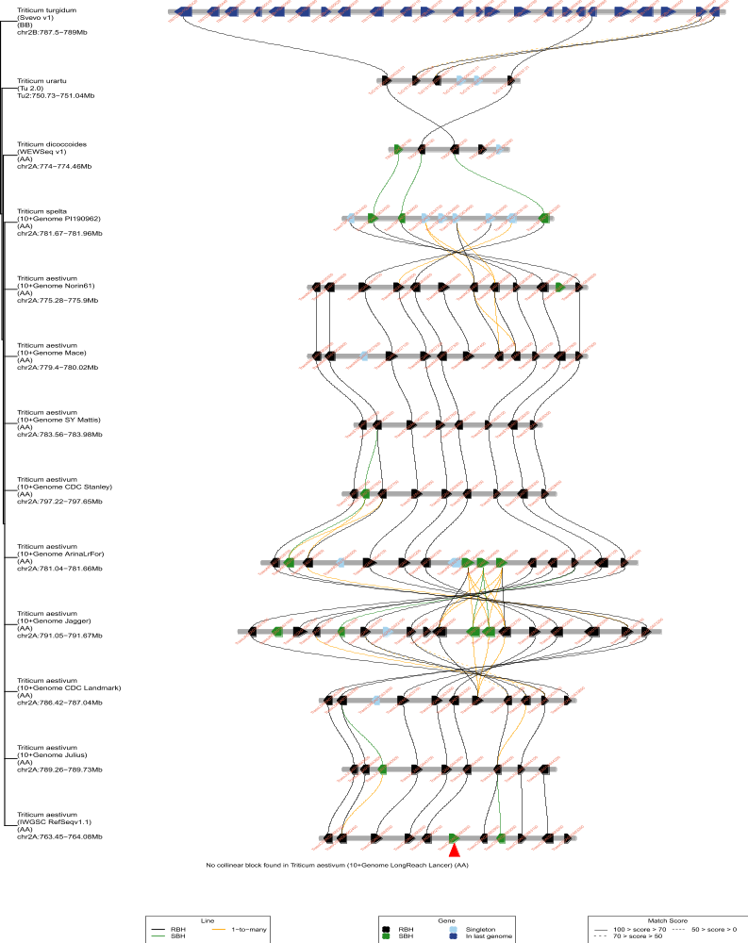
Figure S5 Collinearity analysis of TraesCS2A02G562800 and 636.4 kb interval in Chinese Spring RefSeq v1.0 with other wheat and related species according to the TGT website (http://wheat.cau.edu.cn/TGT/)
The 636.4-kb fine mapping interval showed a close collinearity with 10+ Genome varieties. However, most of the wild relatives had inversions or duplications and deletions of genes compared to Chinese Spring v1.0. Red arrowhead indicates TraesCS2A02G562800.

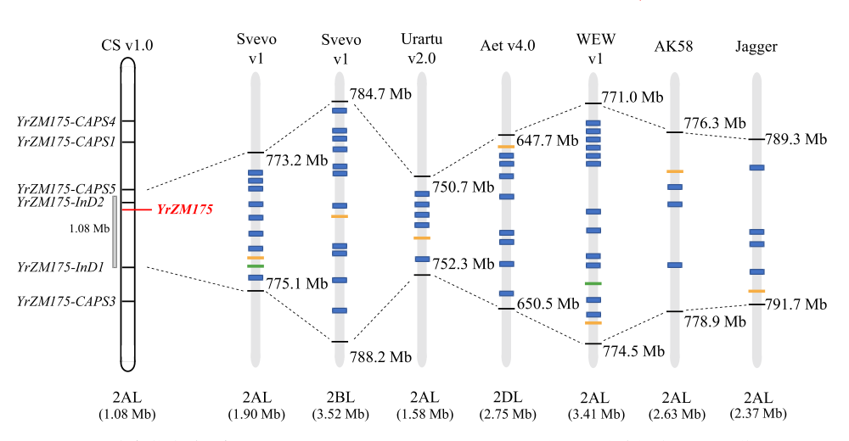
Figure S6 Collinearity analysis of the target genomic interval on chromosome arm 2AL in Chinese Spring RefSeq v1.0 among five Triticum species
Collinear interval of five Triticum species flanked by YrZM175-CAPS5 and YrZM175-InD1 marked as black lines. Blue rectangles show putative disease resistance genes within the genomic region. Orange bars indicate the position of YrZM175-InD2 in the target interval of five species. Green bars on chromosome arm 2AL of Svevo and WEW (T. dicoccoides) indicate the polymorphic SNPs with a genetic distance of 0.12 cM from YrZM175. CS: Chinese Spring; Aet: Ae. tauschii; WEW: T. dicoccoides; AK58: T. aestivum cv. Aikang 58

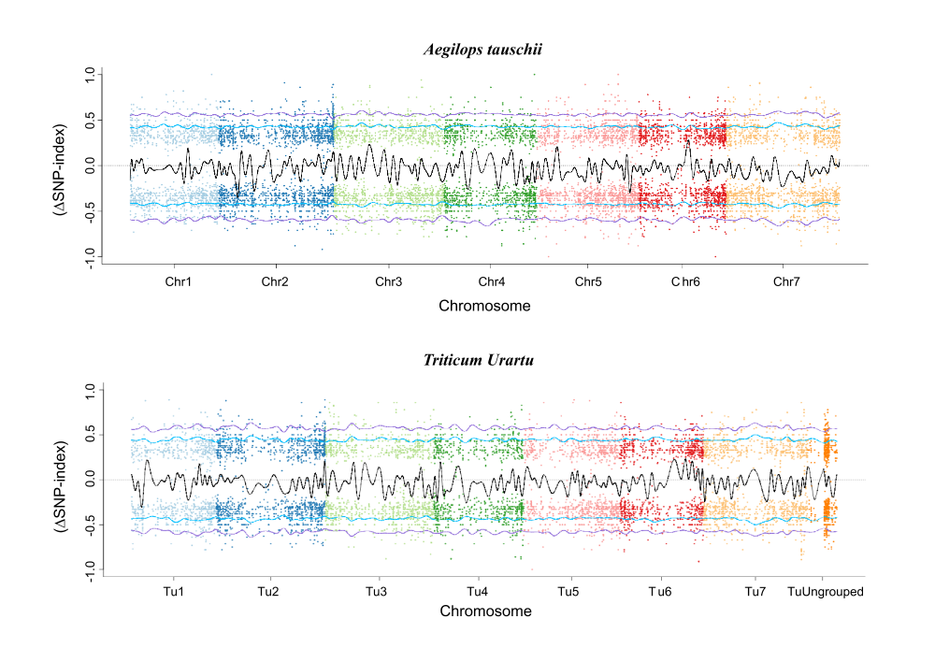
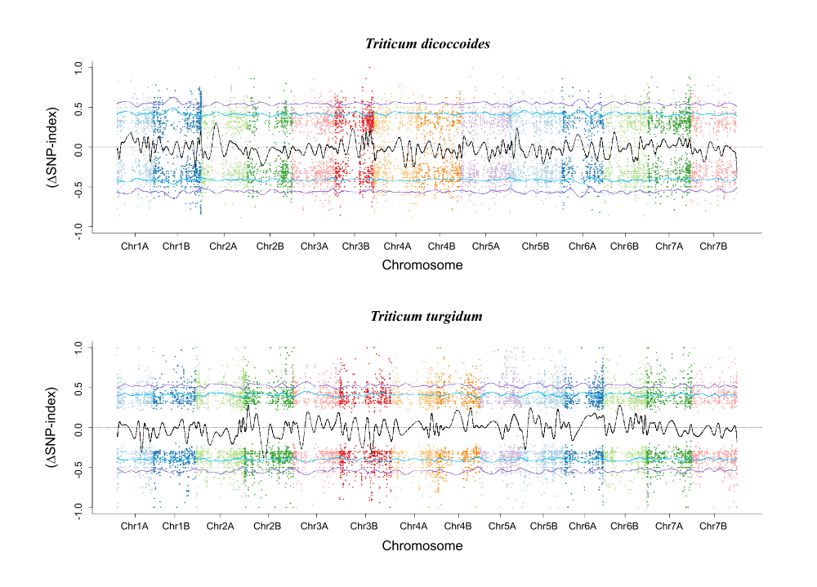
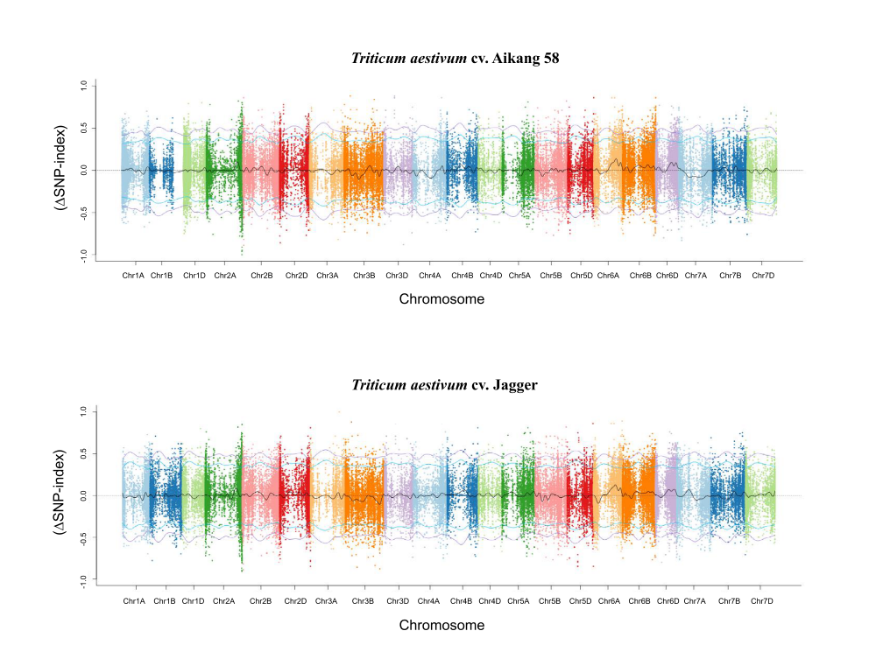
Figure S7 Manhattan plots from BSR-seq analysis of genome sequences from Ae. tauschii, T. urartu, T. dicoccoides, T. turgidum, and T. aestivum cv. Aikang 58 and Jagger
Red arrowheads indicate single peak on homoeologous group 2 chromosomes.

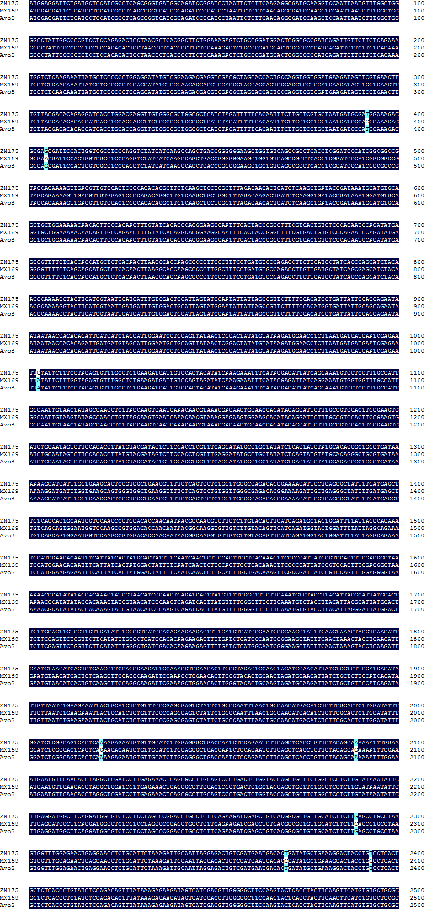
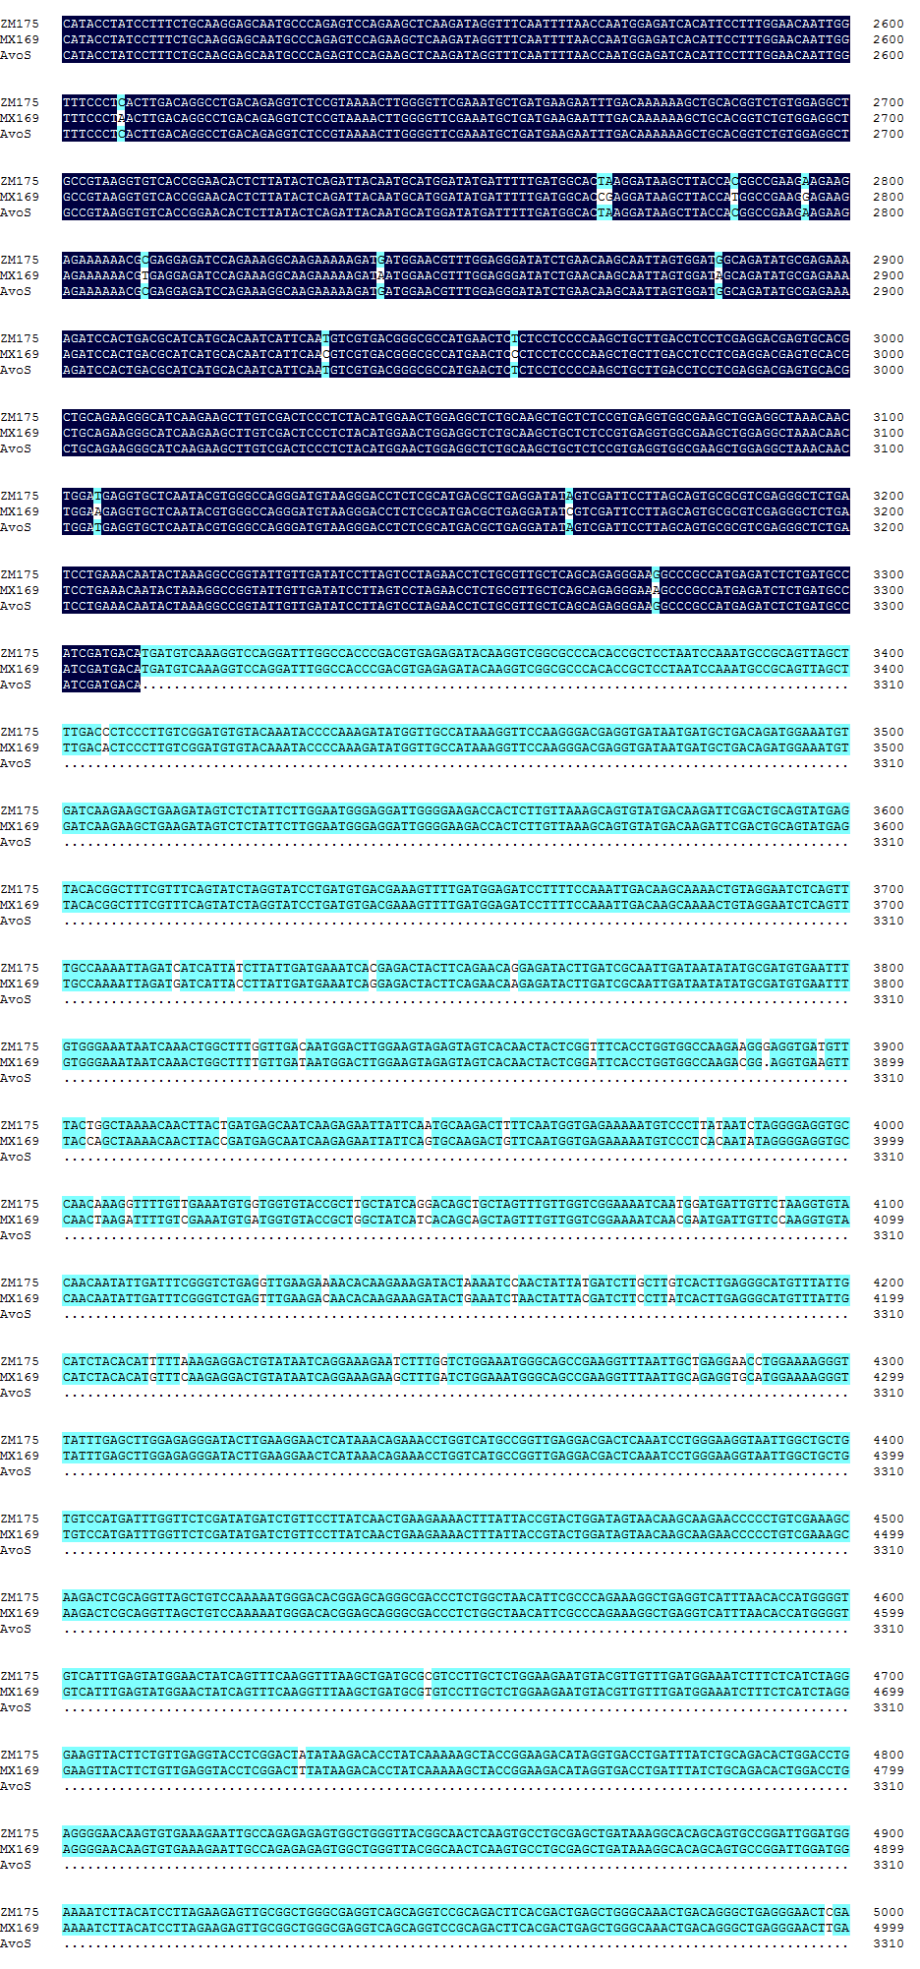
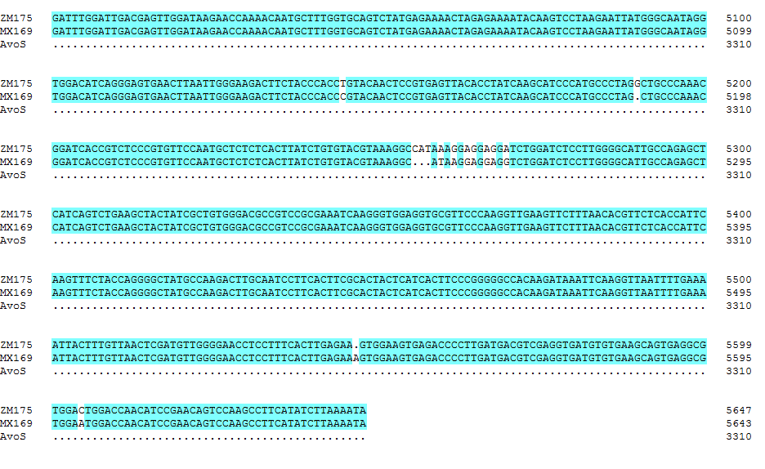
Figure S8 The sequence of CDS domain of TRITD2Bv1G264480 in Zhongmai 175, Avocet S and Mingxian 169
The CDS sequence of TRITD2Bv1G264480 in Zhongmai 175, Mingxian 169 and Avocet S are 5,647 bp, 5,643 bp and 3,310 bp, respectively. Numbers on the right are base pair positions. ZM175: Zhongmai 175; MX169: Mingxian 169; AvoS: Avocet S.

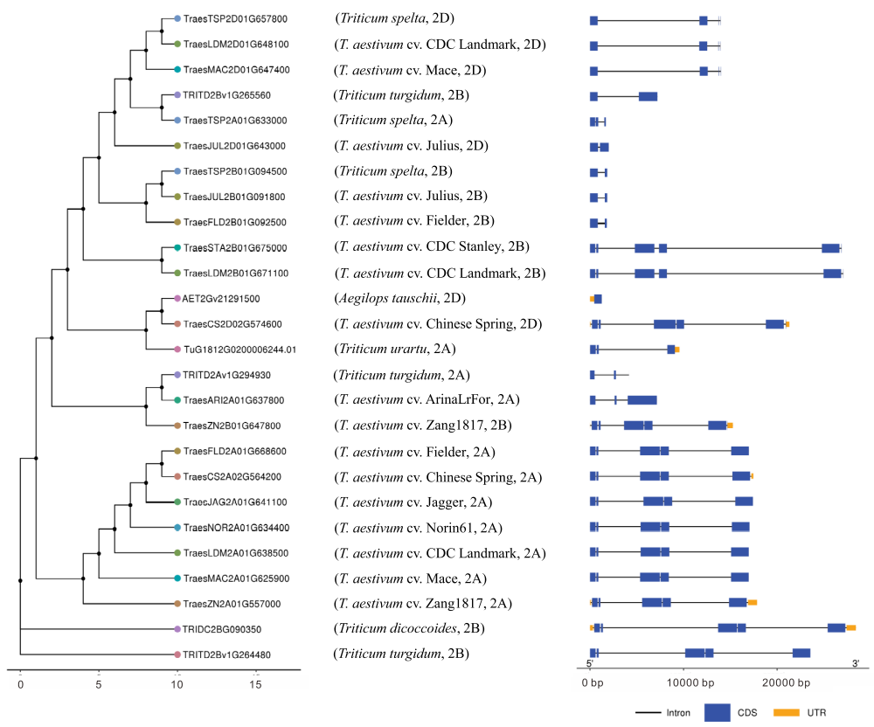
Figure S9 Phylogenetic analysis of TRITD2Bv1G264480 in Triticum species
Line and numbers on the lower left indicate branch length. Line and numbers at the lower right indicate ORF sequence length; 5’ to 3’ is from left to right.

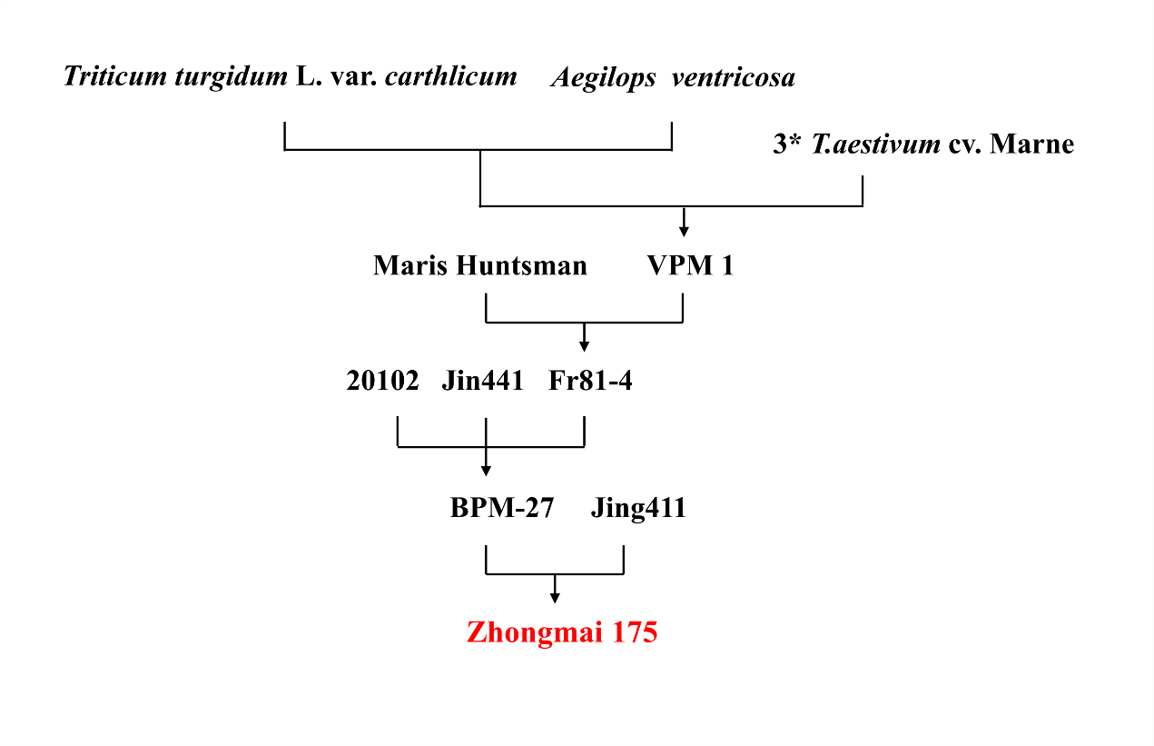
Figure S10 Pedigree of Zhongmai 175

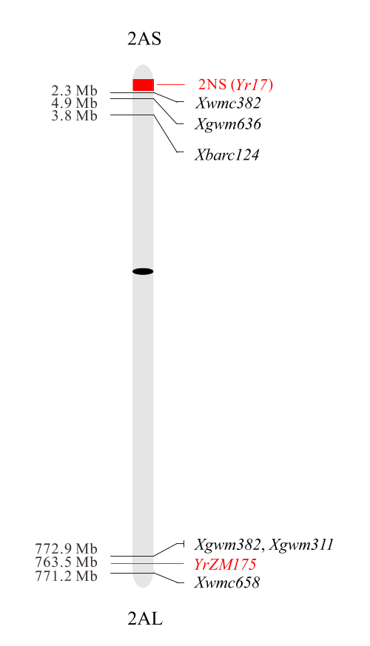
Figure S11 Physical positions of YrZM175 and 2NS translocated segment carrying Yr17 on chromosome 2A
Numbers on the left indicate physical positions of SSR markers and Yr genes. Black oval indicates the centromere.

Table S1 Information of polymorphic sites on chromosome arm 2AL between resistant (R) and susceptible (S) pools based on BSR-seq
Variation type | Physical positionª | R pool^{b} | S pool | ∆SNP-index
SNP | 473,399,277 | G | A | 1
SNP | 762,505,806 | G | A | 1
SNP | 762,505,828 | C | T | -1
SNP | 762,505,860 | A | G | -1
SNP | 762,643,085 | A | G | 1
SNP | 765,439,494 | C | T | 1
SNP | 767,353,577 | G | C | 1
SNP | 768,526,538 | T | C | 1
SNP | 768,526,564 | C | T | -1
SNP | 768,526,574 | A | G | -1
SNP | 768,526,583 | T | C | -1
SNP | 768,526,613 | G | C | -1
SNP | 768,526,653 | G | A | -1
ª Physical positions referring to Chinese Spring genome RefSeq v1.0 (IWGSC 2018).
^{b} The base pair type of R and S pools at each SNP position

Table S2 Information of molecular markers flanking YrZM175
Marker name | Primer sequence (5′–3′)ª | Product size (bp) | Endonuclease or STS
CAPS587 | F: AATGCGTCAACAAGTGCTTG  R: AATGGCGTAAGAGAAGACCG | 534 | NheI
CAPS6 | F: ATAACGAGGTCGACGCTAGCAC  R: CCTGTATCTGCTTCCACTTCTCCT | 908 | EcoRI
YrZM175-CAPS1 | F: AACACTTGTCTCCGTACTGCC  R: AACGTCTGCACTGGGTTTCT | 448 | EagI
YrZM175-CAPS2 | F: AACATAGAGTTGTCTGACGGGC  R: AACGTCCAAGTGCCAGAAAG | 645 | BsrI
YrZM175-CAPS3 | F: AGGCCACTCTTCAAATGATG  R: AACTAACTCGCTGGTGTTGG | 821 | BspEI
YrZM175-CAPS4 | F: AATTCCTCACAGCTCTCACG  R: AACCGTGCAAGTATAGGGAG | 837 | SbfI
YrZM175-CAPS5 | F: GCAATATCTTTAGGCACCGC  R: TTACGCATTATTTCTCACACGG | 636 | HhaI
YrZM175-InD1 | F: GCTGGCCAAATATGTACACTTG  R: CCAAGATGACAGGAAGCATAAC | 753/689^{b} | STS
YrZM175-InD2 | F: ATGAAGGAAATGCCAGCAGTTC  R: TACAGCGACTAGGAAACAGTCAC | 593/523^{c} | STS
ª F: forward primer; R: reverse primer
^{b} 753/689: PCR products in Zhongmai 175 and Avocet S are 753 and 689 bp, respectively.
^{c} 593/523: PCR products in Zhongmai 175 and Avocet S are 593 and 523 bp, respectively.

Table S3 Information of six putative disease resistance genes in the 1.5-Mb target genomic region
Gene IDª | Length  (bp) | Start position  (Mb) | Gene annotation^{b}
TraesCS2A02G560600 | 6,251 | 762,756,758 | CC-NBS-LRR
TraesCS2A02G560700 | 4,832 | 762,770,075 | NBS-LRR
TraesCS2A02G560900 | 5,711 | 762,799,764 | NBS-LRR
TraesCS2A02G561100 | 1,838 | 762,984,122 | NBS-LRR
TraesCS2A02G562800 | 3,341 | 763,867,757 | receptor-like protein kinase
TraesCS2A02G563200 | 11,668 | 764,052,639 | NBS-LRR
ª Sequences were downloaded from Chinese Spring genome RefSeq v1.0 (IWGSC 2018).
^{b} Gene annotations according to Chinese Spring genome RefSeq v1.0 (IWGSC 2018).

Table S4 Information of gene-specific primers used for isolating six putative disease resistance genes in the 1.5-Mb target genomic region
Gene IDª | Primer sequence (5′–3′)^{b} | Product size (bp)
TraesCS2A02G560600 | F1: GCCGCTGTGAACATGATATG  R1: ATGAGCCTTCCTTTCCATCC | 689
TraesCS2A02G560600 | F2: TACGCTGCCCACTAGATACCT  R2: TATCGCAACCAGAGCCTTTC | 925
TraesCS2A02G560600 | F3: ACGGCGGCAACTAACTTCAG  R3: GCTGCTTTGTCTAGAAACCACGT | 903
TraesCS2A02G560600 | F4: GCGAGAACATACTTGGGTCTT  R4: CTGCACTTTCACCTTCATCTG | 721
TraesCS2A02G560600 | F5: AGTGACCTACAGCATCTCTGC  R5: CCGTATTGTCCACATAGTCATG | 765
TraesCS2A02G560600 | F6: CGATCTTCCGGTTTTACCTTTAC  R6: CTTGCATAGTCTTGACAAGTTGC | 1,206
TraesCS2A02G560600 | F7: GGCAGTTAGTGGTGGATATGTG  R7: CCTTCTATCTCATTGGCTTTGTC | 688
TraesCS2A02G560600 | F8: ATGGCAAGCTAAGCATACGTG  R8: GCATACATCTACTCACTCCGTTC | 933
TraesCS2A02G560600 | F9: CGGAAAACTCCGTAACATGTAC  R9: CCGCAACTAGAAACAACATAGCT | 782
TraesCS2A02G560700 | F1: GGTTGACTCCTGTAGCTTGTTAGT  R1: TCGAGATCTTGCTCCTGTGAG | 992
TraesCS2A02G560700 | F2: CGACTTACGCAGTGCTAATTGT  R2: TCAACACCACCAAATCCATC | 716
TraesCS2A02G560700 | F3: GCAGTCTTTCAAGTCAGATGGAG  R3: CAAATACTGACAGCCAACATCG | 1,105
TraesCS2A02G560700 | F4: ATTAACTGTGGCGGTTGCAT  R4: CGATTCTATACTTGGCAAGTTTG | 1,089
TraesCS2A02G560700 | F5: GGAAAGCAGATATTGTAATGGAAT  R5: CGAACAACATCTGATTTCAATTCT | 1,218
TraesCS2A02G560700 | F6: TGCTCCCTCACCGAATTTAG  R6: ACGGCACCACTAGTACATCTACA | 893
TraesCS2A02G560700 | F7: GCCTCACTTGAAATTGAAGGATT  R7: ACAGATGCAGATGTTGTGCTC | 1,030
TraesCS2A02G560900 | F1: ATACTCCTGCTCCTCCTCCTGT  R1: CGAGCTTCATATGTGGAAAGAT | 1,206
TraesCS2A02G560900 | F2: ATGTTGGTTCTTCCTGGAAGG  R2: CCGCTCTCCAACTTTAATACACT | 1,053
TraesCS2A02G560900 | F3: TGATTGCAGGACAAAAGTAGC  R3: CCAGGATAATTCTCAGAACTCTG | 1,271
 | F4: CCGTCTGGAATTTCTTTAAGTCT  R4: GCCTACAAACGAATGCATCC | 1,164
 | F5: GGATTTTCATATTATGCTGGGC  R5: AAGCTCTAGGCAACTGGGAAC | 1,142
 | F6: TCCATCGTCTCTCCAAAGTCTC  R6: TTACCTATCTGCACCCGTAATG | 983
TraesCS2A02G561100 | F1: GCATAATTATTGCTAGCTGGCT  R1: TCTTAGAAAGGTCACGCTGG | 977
TraesCS2A02G561100 | F2: AGCTAGCGAAGGTGATGAGATC  R2: ATGCTTAACATGCGTCCCAA | 724
TraesCS2A02G561100 | F3: AGCGATGATTTGGATTCTCTC  R3: GCCTACGCAAAAGTTTAGTACAG | 885
TraesCS2A02G561100 | F4: GTGGTGTTCCGATTCAAGATG  R4: GGCTAGAACTGTCAGGGATAGA | 1,126
TraesCS2A02G562800 | F1: ATCGGCACCTCCTCGGATAA  R1: AGAACTGAAGATGGTCTACATTGCA | 1,907
 | F2: GGAGGAGAAGATGCTGGTGTA  R2: CCTATTGGAGTGCGTGCTCA | 1,649
TraesCS2A02G563200 | F1: ACCTCAAGCAAGGAATGGAC  R1: CAAACTTCAAATGTGGATCAGAT | 1,062
TraesCS2A02G563200 | F2: ACGCGTACGTGCATGTTACTAC  R2: AAAGCTCCAGCTAGCTCCTG | 1,143
TraesCS2A02G563200 | F3: CGTAAGCATTAGCCCCCACTAT  R3: CGTTAGGAAAGGAGCGTAACTT | 1,336
TraesCS2A02G563200 | F4: ACATTACAGGCACCATGGCT  R4: TAAGCGGTGAAACCTGCGTT | 1,218
TraesCS2A02G563200 | F5: CAAGTGTCCAGCCAGAATCTC  R5: GATTTACGCCTGGTGTCAAATAG | 1,142
TraesCS2A02G563200 | F6: CGACGAATTTGACGGTATGGTT  R6: TAGCGGCGTTGCTCTTCTACT | 880
TraesCS2A02G563200 | F7: TGATAGGGACAGCCTTGCGT  R7: ATACGTTCTCGCGAGACGGA | 826
TraesCS2A02G563200 | F8: ACGGGGTCTGCTAGAGATGCT  R8: ATATCTGCCCCAGCGTCTTGT | 1027
ª Gene sequences were downloaded from Chinese Spring genome sequences RefSeq v1.0 (IWGSC 2018).
^{b} F: forward primer; R: reverse primer

Table S5 Information of gene-specific primers used to get the sequence of TRITD2Bv1G265970 in Zhongmai 175 and Avocet S
Gene IDª | Primer sequence (5′–3′)^{b} | Product size (bp)
TRITD2Bv1G265970 | F1: TTGGTTTACACGTGCACGGT  R1: ATATAAGGAGGAGGCAGGGCA | 556
TRITD2Bv1G265970 | F2: ACAACCACCATCTGCGCATT  R2: CCTCACCAAGTCACTTACTCTGC | 873
TRITD2Bv1G265970 | F3: ATAAGCTGTTGAGGCCCTTCTC  R3: TACGCGCTACAATACACGGTTC | 944
TRITD2Bv1G265970 | F4: TGCACTCTAGCGGATCCTCTAC  R4: GTTCGTGCACATATTTCCCTTG | 895
TRITD2Bv1G265970 | F5: CGCTATCTTATCAATCGTGTTCC  R5: CCAACGTACACAACCATCATTG | 1,003
TRITD2Bv1G265970 | F6: ACATGGTACCGAACAAGCGT  R6: CTTGCATAGTCTTGACAAGTTGC | 991
TRITD2Bv1G265970 | F7: TGACCAGACACAGGAAAGAGC  R7: CCTTCTATCTCATTGGCTTTGTC | 1,078
TRITD2Bv1G265970 | F8: ATATCCTTGCGGGTGTGCTC  R8: GTGCCGTCATAGAACTGATAGC | 952
TRITD2Bv1G265970 | F9: AACAACCCACGAGCTTGACC  R9: TTCACCTTTCTGATCGCATCTC | 903
TRITD2Bv1G265970 | F10: AGTGATGCGCCATTTACCATT  R10: TACATTATGCGCTGCCATTTC | 428
TRITD2Bv1G265970 | F11: CCGCCTTACTAACTACGTGCAAC  R11: TTAATCCGGCAAGGGCACTC | 1,072
ª Gene sequences were downloaded from durum wheat Svevo genome sequences (Maccaferri et al. 2019).
^{b} F: forward primer; R: reverse primer

Table S6 Information of gene-specific primers used to get the promoter sequences of TRITD2Bv1G265970 in Zhongmai 175 and Avocet S
Gene IDª | Primer sequence (5′–3′)^{b} | Product size (bp)
TRITD2Bv1G265970 | F1: AATGTGTGCGTGTGTGCGTC  R1: CGCGCTTAGTGAGCTAAACACTT | 1,263
TRITD2Bv1G265970 | F2: CCGATTTTACACAAAGGAACACTG  R2: TTTGACACACTGAGACGGAGACTC | 902
TRITD2Bv1G265970 | F3: ATCGATCACCTGGTCGGAGAAT  R3: ATACACGACGTCGACACCATGAT | 959
TRITD2Bv1G265970 | F4: CGCCACACTAATTATACGAAAAGC  R4: TATACCAGCGTCCTGTTCCCAT | 960
ª Gene sequences were downloaded from durum wheat Svevo genome sequences (Maccaferri et al. 2019).
^{b} F: forward primer; R: reverse primer

Table S7 Information of 11 putative disease resistance genes in the 3.52-Mb collinear genomic region of Triticum turgidum
Gene IDª | Length  (bp) | Start position  (Mb) | Gene annotation^{b}
TRITD2Bv1G258820 | 3,633 | 772,510,233 | receptor-like protein kinase
TRITD2Bv1G264400 | 4,316 | 784,644,246 | NBS-LRR
TRITD2Bv1G264440 | 6,703 | 784,851,480 | Leucine-rich repeat domain superfamily
TRITD2Bv1G264470 | 1,960 | 784,915,832 | Leucine-rich repeat domain superfamily
TRITD2Bv1G264480 | 23,559 | 784,919,981 | NBS-LRR
TRITD2Bv1G264520 | 2,387 | 785,033,612 | Protein kinase domain
TRITD2Bv1G265130 | 23,382 | 786,349,523 | Protein kinase domain
TRITD2Bv1G265560 | 7,208 | 787,696,298 | NBS-LRR
TRITD2Bv1G265630 | 2,140 | 787,792,775 | Leucine-rich repeat domain superfamily
TRITD2Bv1G265730 | 1,869 | 788,194,974 | Protein kinase domain
TRITD2Bv1G265750 | 6,529 | 788,247,406 | NBS-LRR
ª Sequences were downloaded from durum wheat Svevo genome sequences (Maccaferri et al. 2019).
^{b} Gene annotations according to durum wheat Svevo genome (Maccaferri et al. 2019).

Table S8 Information of gene-specific primers used to get the sequence of TRITD2Bv1G264470 and TRITD2Bv1G264480 in Zhongmai 175 and Mingxian 169
Gene IDª | Primer sequence (5′–3′)^{b} | Product size (bp)
TRITD2Bv1G264470 | F1: GCCTGATCATAAGAGCTGATGTGTT  R1: TAGGGCTAGCGTCTCCAACTG | 1,034
TRITD2Bv1G264470 | F2: TTGACAAAGAACGTGGTCCCT  R2: TCCGCTCAGATATTTCAGTCCAT | 971
TRITD2Bv1G264480 | F1: TATGGTGGGGTGACAGCTGGT  R1: TTCAGGGGACTCCACAACGTT | 838
TRITD2Bv1G264480 | F2: ATAACGAGGTCGACGCTAGCAC  R2: CCTGTATCTGCTTCCACTTCTCCT | 887
TRITD2Bv1G264480 | F3: GGCTGTGAAGATGATTGTCCAGT  R3: CAAGAGTGCGAAGTGATGTCATGTT | 923
TRITD2Bv1G264480 | F4: GTCTTCATATTTGGGCTGATCGAC  R4: CGCAGAAACCTATCTTGAGCTTC | 804
TRITD2Bv1G264480 | F5: CATTCTGCTGCGCCATACCTA  R5: ACCTTGTATCTCTCACGTCGGGT | 830
TRITD2Bv1G264480 | F6: TATATACGGGCGCCATGAACTCT  R6: CGCATATAGTGAGGGACATTTTTC | 1,011
TRITD2Bv1G264480 | F7: CGCTCAGTTTGCCAAAATTAGATC  R7: TACATTCTTCCAGAGCAAGGACG | 943
TRITD2Bv1G264480 | F8: GTCGAAGGTTTAATTGCAGAGGTG  R8: TATGAGGAGGTTCCCCAACATG | 1,241
TRITD2Bv1G264480 | F9: ATTAGCAGAGAGAGTGGCTGGGT  R9: ACGATATGAAGGCTTGGACTGTTG | 775
ª Gene sequences were downloaded from durum wheat Svevo genome sequences (Maccaferri et al. 2019).
^{b} F: forward primer; R: reverse primer

Table S9 Reaction patterns to 7 PST races at the seedling stage among Zhongmai 175, VPM1, Chinese 166 and Jimai 22
PST races | Zhongmai 175  (with YrZM175 and Yr17)ª | VPM1  (with Yr17) | Chinese 166  (with Yr1) | Jimai 22  (with YrJ22) | Mingxian 169^{b}
CYR27 | 2- | 4 | 4 | 0 | 4
CYR29 | 0; | 4 | 0; | 0; | 4
CYR31 | 3 | 3 | 2+ | 4 | 4
CYR32 | 0; | 3 | 4 | 0; | 4
CYR33 | 0; | 4 | 2+ | 0 | 4
Su-3 | 0; | 0; | 0; | 1 | 4
V26 | 0; | 0; | 4 | 0; | 4
ª Seedling infection types of Zhongmai 175 and VPM1 referred Lu et al. (2016), and seedling infection types of Chinese 166 and Jimai 22 referred Chen et al. (2016).
^{b} Mingxian 169 was used as a susceptible control

