Supplementary Information

Supplementary Table S1. Sequencing statistics for libraries provided by Macrogen Inc.
 | Total read bases (bp) | Total reads | GC(%) | AT(%) | Q20(%) | Q30(%)
Library1 | 3,361,376,960 | 33,280,960 | 38.78 | 61.22 | 98.78 | 95.95
Library2 | 3,859,031,432 | 38,208,232 | 38.64 | 61.36 | 98.86 | 96.11
Library3 | 4,314,873,722 | 42,721,522 | 38.71 | 61.29 | 98.92 | 96.24
Library4 | 4,561,187,472 | 45,160,272 | 38.76 | 61.24 | 98.87 | 96.15
Library5 | 4,578,651,988 | 45,333,188 | 38.63 | 61.37 | 98.9 | 96.21
Library6 | 3,813,115,822 | 37,753,622 | 39.25 | 60.75 | 98.94 | 96.32
Library7 | 3,880,280,014 | 38,418,614 | 38.33 | 61.67 | 98.84 | 96.07
Library8 | 4,259,695,402 | 42,175,202 | 38.98 | 61.02 | 98.84 | 96.12
Library9 | 5,476,862,562 | 54,226,362 | 39.09 | 60.91 | 98.85 | 96.09
Library10 | 5,016,965,526 | 49,672,926 | 38.75 | 61.25 | 98.84 | 96.07
Library11 | 4,180,695,626 | 41,393,026 | 38.03 | 61.97 | 98.84 | 96.07
Library12 | 4,183,320,414 | 41,419,014 | 39.07 | 60.93 | 98.92 | 96.27
Library13 | 3,750,845,686 | 37,137,086 | 39.55 | 60.45 | 98.94 | 96.35
Library14 | 4,421,791,716 | 43,780,116 | 38.77 | 61.23 | 98.89 | 96.15
Library15 | 5,199,690,080 | 51,482,080 | 38.57 | 61.43 | 98.83 | 96.02
Library16 | 4,534,732,340 | 44,898,340 | 39.03 | 60.97 | 98.84 | 96.05
Average | 4,337,069,798 | 42,941,285.13 | 38.81 | 61.19 | 98.87 | 96.14
SD | 561,085,273.58 | 5,555,299.74 | 0.36 | 0.36 | 0.05 | 0.11
Total | 69,393,116,762 | 687,060,562

Supplementary Table S2. Coverage statistics.
Libraries | Mean Read Depth | Total number of bases mapped | Depth of Coverage | Total number of covered bases | Coverage breadth (%)
Library1 | 17.69 | 2,243,870,263 | 7.22 | 126,861,950 | 40.82
Library2 | 20.00 | 2,533,477,425 | 8.15 | 126,698,918 | 40.76
Library3 | 20.63 | 2,896,794,769 | 9.32 | 140,424,176 | 45.18
Library4 | 22.89 | 2,975,010,965 | 9.57 | 129,983,211 | 41.82
Library5 | 21.25 | 2,805,784,670 | 9.03 | 132,044,257 | 42.48
Library6 | 20.47 | 2,216,844,694 | 7.13 | 108,293,392 | 34.84
Library7 | 20.12 | 2,646,586,303 | 8.52 | 131,539,684 | 42.32
Library8 | 20.80 | 2,530,133,003 | 8.14 | 121,646,153 | 39.14
Library9 | 24.57 | 2,863,398,353 | 9.21 | 116,563,228 | 37.50
Library10 | 22.52 | 2,946,733,038 | 9.48 | 130,844,846 | 42.10
Library11 | 19.83 | 2,799,871,434 | 9.01 | 141,179,880 | 45.42
Library12 | 21.22 | 2,606,269,257 | 8.39 | 122,800,661 | 39.51
Library13 | 20.75 | 2,331,678,758 | 7.50 | 112,365,376 | 36.15
Library14 | 21.25 | 2,741,405,563 | 8.82 | 129,021,444 | 41.51
Library15 | 24.24 | 3,244,688,673 | 10.44 | 133,832,240 | 43.06
Library16 | 21.34 | 2,518,205,118 | 8.10 | 118,017,982 | 37.97
Total |  | 42,900,752,286 | 138.03
Average | 21.22 | 2,681,297,017.88 | 8.63 |  | 40.66
SD | 1.70 | 282,173,683.51 | 0.91 |  | 2.99

Supplementary Table S3. The figures and tables referred to gene enrichment categories.
Enriched Groups | Figure S7 | Figure S8 | Figure S9 | Figure S11 | Figure S12 | Figure S13 | Figure S15 | Figure S16 | Figure S17 | Table S4
Ciliary activity | ✓ | ✓ |  | ✓ | ✓ |  |  | ✓ |  | ✓
Energy metabolism (OXPHOS) |  |  |  |  |  |  | ✓ | ✓ | ✓ | ✓
Gene expression regulation | ✓ | ✓ |  | ✓ | ✓ |  | ✓ | ✓ | ✓ | ✓
Negative regulation of gene expression | ✓ |  |  |  |  |  |  |  |  | ✓
Protein metabolism | ✓ |  | ✓ | ✓ | ✓ | ✓ | ✓ | ✓ | ✓ | ✓
Protein catabolic processes |  |  |  |  |  |  |  |  |  | ✓
Nucleotide metabolism | ✓ |  | ✓ | ✓ |  |  | ✓ | ✓ |  | ✓
DNA repair | ✓ |  |  | ✓ |  |  | ✓ |  |  | ✓

Supplementary Figure S1. Second level functional annotation of assembled contigs based on GO for biological process, molecular function and cellular component categories.

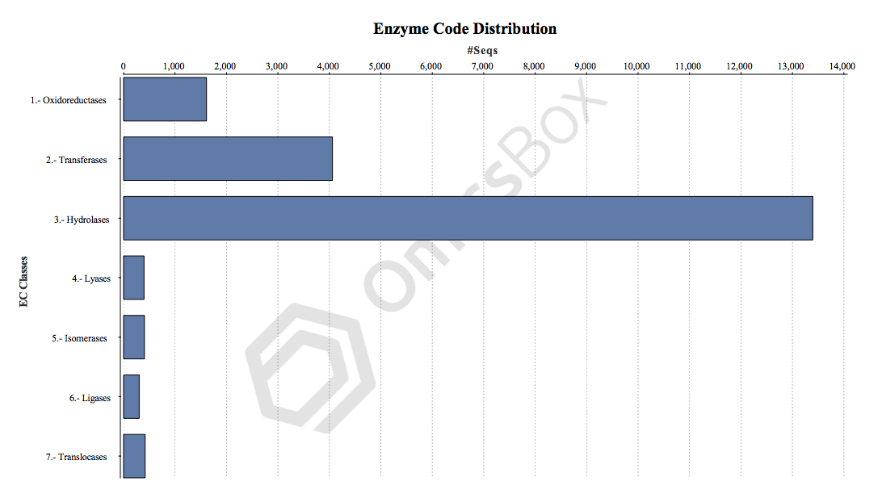
Supplementary Figure S2. KEGG ontology distribution of enzymes.

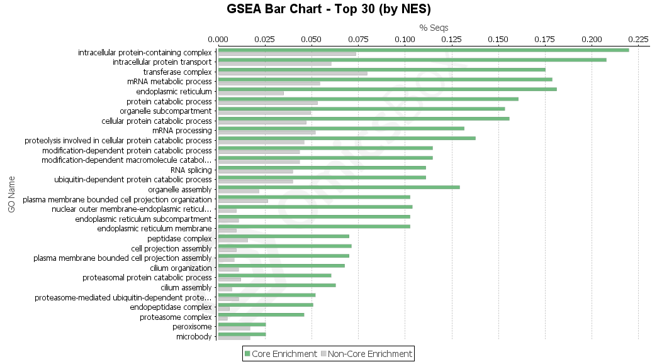

Supplementary Figure S6. GO terms enrcihed in salinity increase.

Supplementary Figure S7. Summarization of the enriched GOs for salinity increase, biological processes having FDR < 0.25 were summarized to 19 main nodes by REVIGO.

Supplementary Figure S8. Summarization of the enriched GOs for salinity increase, cellular components having FDR < 0.25 were summarized to 11 main nodes by REVIGO.

Supplementary Figure S9. Summarization of the enriched GOs for salinity increase, molecular functions having FDR < 0.25 were summarized to 20 main nodes by REVIGO.

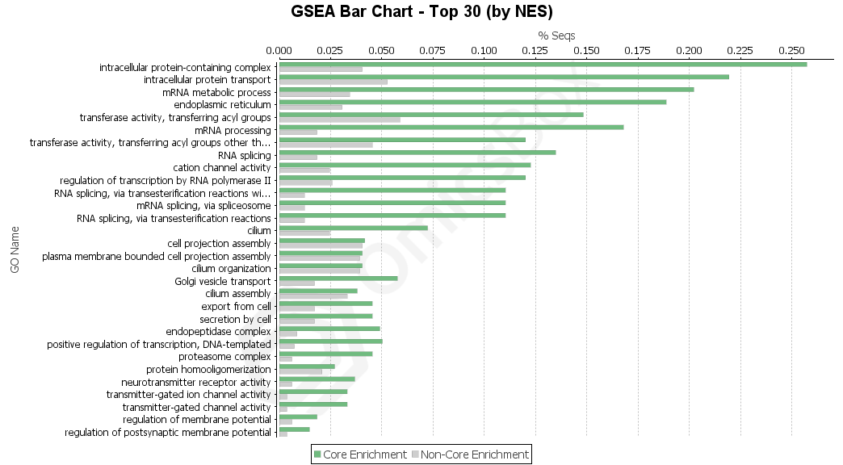

Supplementary Figure S10. GO terms enrcihed in high salinity acclimation.

Supplementary Figure S11. Summarization of the enriched GOs for high salinity acclimation, biological processes having FDR < 0.25 were summarized to 11 main nodes by REVIGO.

Supplementary Figure S12. Summarization of the enriched GOs for high salinity acclimation, cellular components having FDR < 0.25 were summarized to 8 main nodes by REVIGO.

Supplementary Figure S13. Summarization of the enriched GOs for high salinity acclimation, molecular functions having FDR < 0.25 were summarized to 14 main nodes by REVIGO.

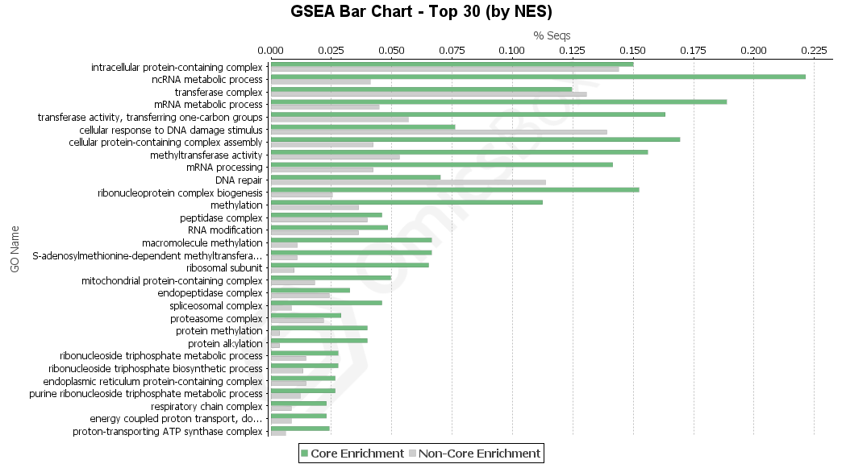

Supplementary Figure S14. GO terms enrcihed in salinity decrease.

Supplementary Figure S15. Summarization of the enriched GOs for salinity decrease, biological processes having FDR < 0.25 were summarized to 18 main nodes by REVIGO.

Supplementary Figure S16. Summarization of the enriched GOs for salinity decrease, cellular components having FDR < 0.25 were summarized to 7 main nodes by REVIGO.

Supplementary Figure S17. Summarization of the enriched GOs for salinity decrease, molecular functions having FDR < 0.25 were summarized to 15 main nodes by REVIGO.

