Table 2. Regulation of contigs that were related to metabolism. In the legend, green and red colors represent downregulation and upregulation with higher color intensity denoting greater log-fold change.
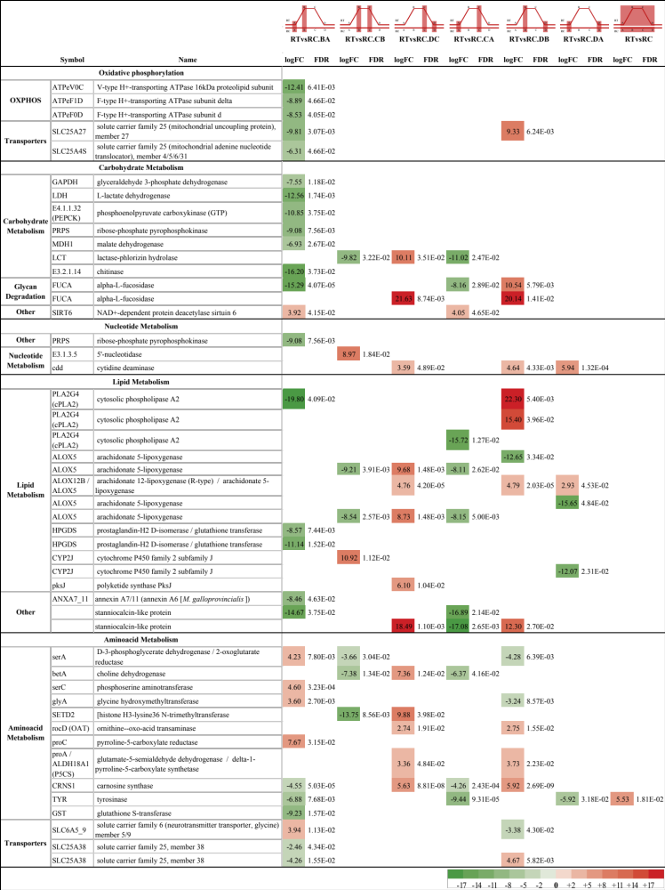

Table 3. Regulation of contigs of protein turnover, GPCRs, cillium, antioxidant response and DNA damage. In the legend, green and red colors represent downregulation and upregulation with higher color intensity denoting greater log-fold change.
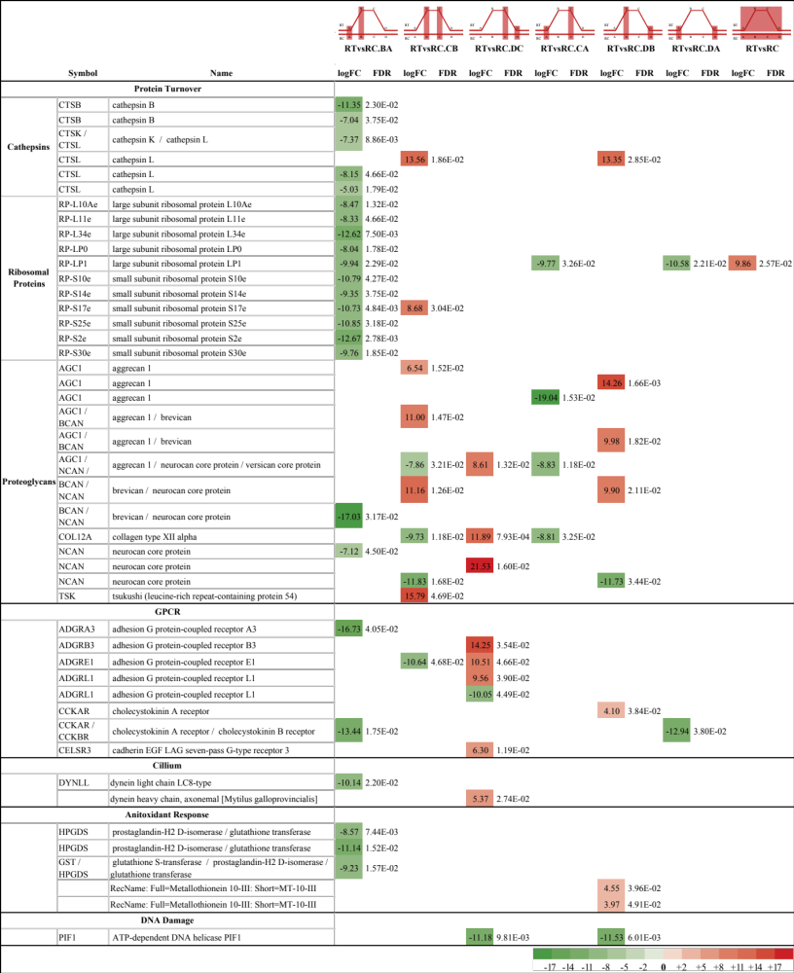

Table 4. Regulation of contigs of ion channels and transporters. In the legend, green and red colors represent downregulation and upregulation with higher color intensity denoting greater log-fold change.
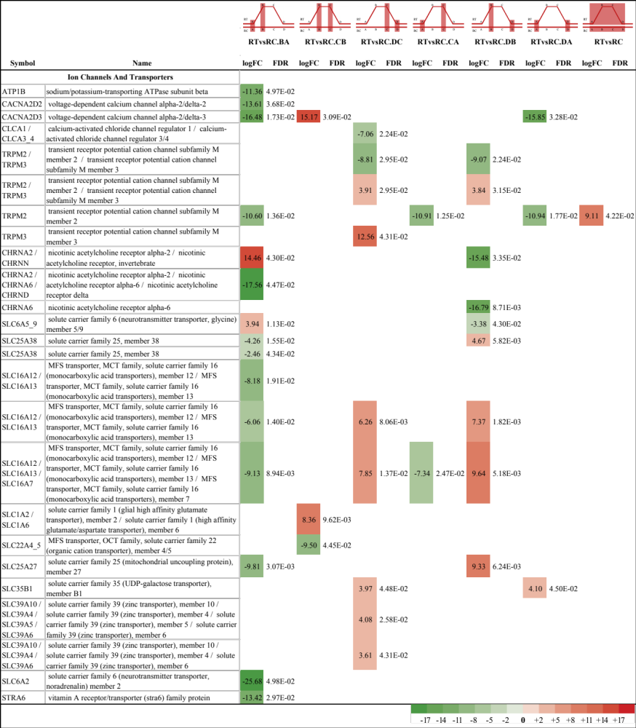

Table 5. Regulation of contigs of apoptosis and TLRs. In the legend, green and red colors represent downregulation and upregulation with higher color intensity denoting greater log-fold change.
