Supplemental Materials
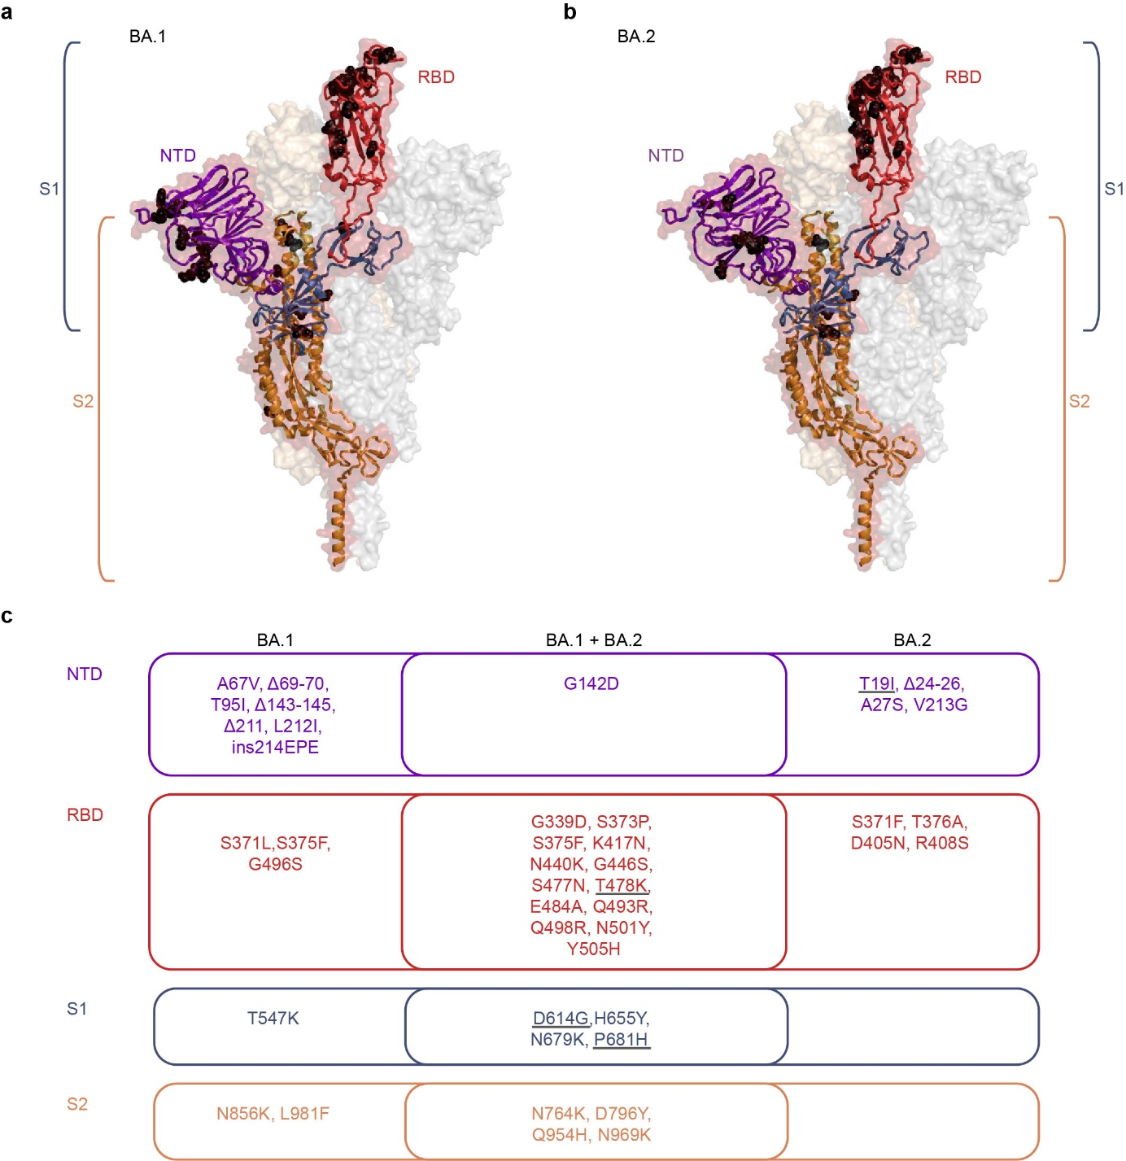
Supplementary Figure 1| Structural analysis of mutations present in Omicron BA.1 and BA.2 sublineages.
a, b, Cartoon representation of one monomer of the spike protein (side view) combined with a semi-transparent surface representation of the trimeric spike in its up-conformation (PDB 7KRR, ¹). The three protomers are colored in red, grey, and bright orange. The S1 subunit is colored blue in the single protomer, with the RBD highlighted in red and the NTD highlighted in purple. S2 is colored in orange. The black spheres indicate the mutations present in sub-lineages BA.1 (a) and BA.2 (b). The structures were generated with PyMol (https://pymol.org). c, Venn diagram illustrating the BA.1 and BA.2 sub-lineage-specific and shared mutations, colored according to the regions highlighted in panels a and b. The grey underlines indicate mutations present in the Delta variant. RBD, Receptor-binding domain; NTD, N-terminal domain; S1, Subunit 1; S2, Subunit 2.
1. Zhang, J., et al. Structural impact on SARS-CoV-2 spike protein by D614G substitution. Science 372, 525-530 (2021).
Supplementary Table 1| Description of cohorts
 | Vaccinees  (3 mRNA vaccinations) | WT convalescent + 3 mRNA vaccinations | WT primary infection | Omicron BA1 primary infection ª | Omicron BA2 primary infection ^{b} | Omicron breakthrough infections ^{c}
N | 15 | 9 | 11 | 17 | 7 | 11
Median age in years [range] | 39 [23-59] | 42 [27-60] | 33 [19-52] | 39 [4-64] | 34 [24 - 58] | 26 [20 - 43]
Male sex (% of N) | 2 (13) | 3 (33) | 9 (82) | 6 (35) | 3 (42) | 6 (55)
“Early” samples in dpo/dpv [range] | 26 [15-38] | 24 [14-28] | 18 [10-25] | 35 [16-57] | 27 [19 - 33] | 21 [13 - 32]
“Late” samples in dpo/dpv [range] | 106 [79-133] | / | 215 [168-272] | / | / | /
dpo, days post onset of symptoms; dpv, days post vaccination; WT, wildtype.
ª PCR confirmed sub-lineage: n = 3; date of infection and NT are indicative of a BA.1 infection
^{b} PCR confirmed sub-lineage: n = 1; date of infection and NT are indicative of a BA.2 infection
^{c} For exposure history see Supplementary Table 2

Supplementary Table 2| Exposure history of Omicron breakthrough patients
Sample | Age | Sex | dpo (serum sample) | Infection prior to vaccination | Vaccination |  |  | Omicron-Infection
 |  |  |  |  | 1st vaccination | 2nd vaccination | 3rd vaccination | dpv | Sub-lineageª
1 | 26 | m | 21 | N | Moderna | Moderna | Moderna | 27 | BA.1
2 | 22 | m | 21 | N | Pfizer | Pfizer | Pfizer | 34 | BA.1
3 | 25 | f | 21 | N | Moderna | Moderna | N | 212 | BA.1
4 | 43 | m | 13 | N | Pfizer | Pfizer | N | 123 | BA.1
5 | 39 | f | 15 | N | Pfizer | Pfizer | Moderna | 144 | BA.1
6 | 37 | f | 23 | N | Pfizer | Pfizer | Pfizer | 44 | BA.1
7 | 32 | f | 18 | N | Pfizer | Pfizer | Moderna | 141 | BA.1
8 | 29 | m | 22 | Y | Astra | Astra | Pfizer | 34 | BA.1
9 | 20 | m | 20 | Y | Pfizer | Pfizer | N | 104 | BA.1
10 | 22 | m | 16 | Y | J & J | Pfizer | N | 61 | BA.1
11 | 25 | f | 32 | N | Pfizer | Pfizer | N | 84 | BA.2
dpo, days post onset of symptoms; dpv, days post vaccination; J&J, Johnson&Johnson
ª BA.1: not confirmed, but infection date before end of January 2022, BA.2: PCR-confirmed

