Electronic Supplementary Information
Table. S-1. Pesticides selected for validation study along with their MRL

Sr.no | Compounds | Classes | Chemical formula | MRLs  mg/kg | Structure | Endocrine Disruptor Effects
1 | Lindane | Organochlorine | C₆H₆Cl₆ | 0.01 | 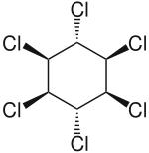 | ¹Reduction of oestrous cycles and luteal progesterone concentrations. Increase of insulin and estradiol blood serum concentrations, decrease thyroxine concentrations. Competitive binding to AR, ER and PR
2 | Heptachlor | Organochlorine | C₁₀H₅C_{l7} | 0.01 | 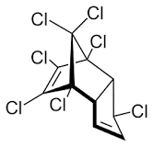 | ²Binding to cellular estrogen and androgen receptors
3 | Chlorpyrifos | Organophosphorus | C₉H₁₁C_{l3}NO₃PS | 0.01 | 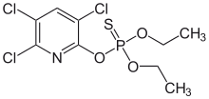 | ¹Antagonist to androgen activity
4 | Triadimenol | Triazoles | C₁₄H₁₈ClN₃O₂ | 0.3 | 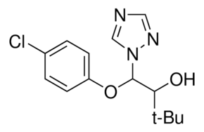 | ³Estrogenic effect, inhibition of aromatase activity,  decrease of estrogens production and increase  androgens availability
5 | Heptachlor exoepoxide A | Organochlorine | C₁₀H₅Cl₇O | 0.01 | 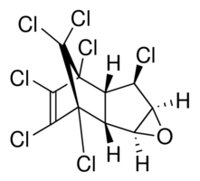 | ²Binding to cellular estrogen and androgen  receptors
6 | Heptachlor endoepoxide B | Organochlorine | C₁₀H₅Cl₇O | 0.01 | 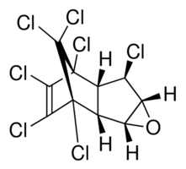 | ²Binding to cellular estrogen and androgen  receptors
7 | α-Endosulfan | Organochlorine | C₉H₆Cl₆O₃S | 0.05 | 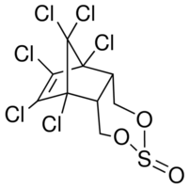 | ⁴Competitive binding to androgen receptors, estrogenic effect, stimulation of estrogen receptor production, inhibition of aromatase activity
8 | β-Endosulfan | Organochlorine | C₉H₆Cl₆O₃S | 0.05 | 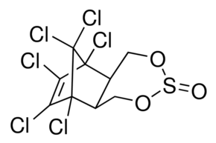 | ⁴Competitive binding to androgen receptors, estrogenic effect, stimulation of estrogen receptor production, inhibition of aromatase activity
9 | Endosulfan sulfate | Organochlorine | C₉H₆Cl₆O₄S | 0.05 | 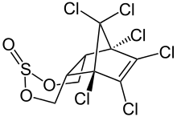 | ⁴Competitive binding to androgen receptors, estrogenic effect, stimulation of estrogen receptor production, inhibition of aromatase activity
10 | Bifenthrin | Pyrethroid | C₂₃H₂₂ClF3O₂ | 0.3 | 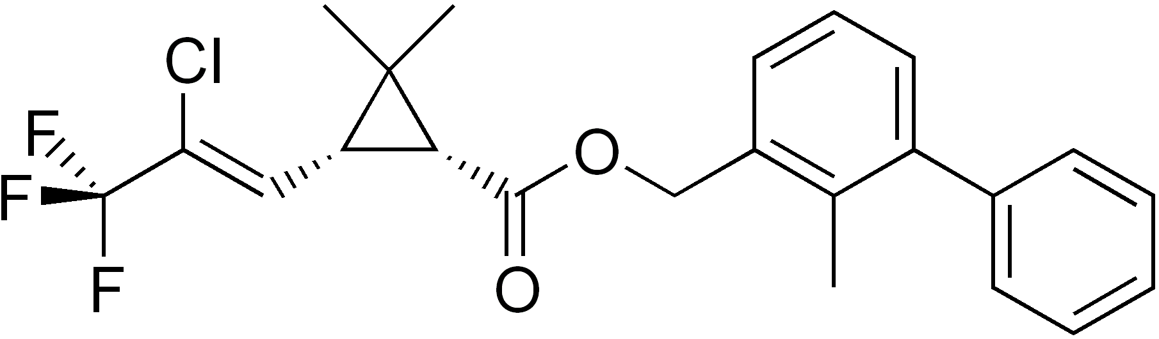 | ⁵hormone signaling of the endocrine−nervous−reproductive system communication in trophoblast cells  Enantiospecific binding to ER
11 | Cypermethrin | Pyrethroid | C₂₂H₁₉Cl₂NO₃ | 0.5 | 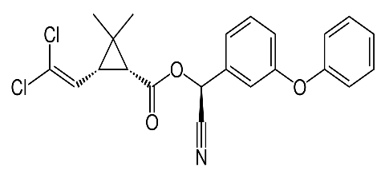 | ⁴Estrogenic effect
12 | λ-cyhalothrin | Pyrethroid | C₂₃H₁₉ClF₃NO₃ | 0.3 | 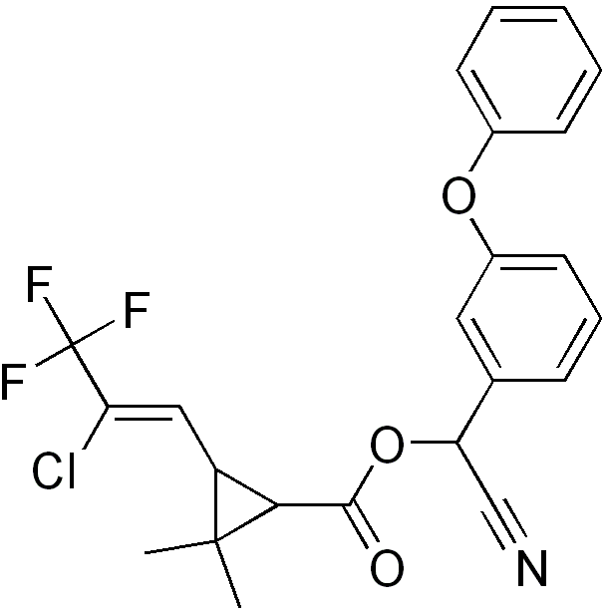 | ⁶Inhibited thyroid hormone production
13 | Deltamethrin | Pyrethroid | C₂₂H₁₉Br₂NO₃ | 0.4 | 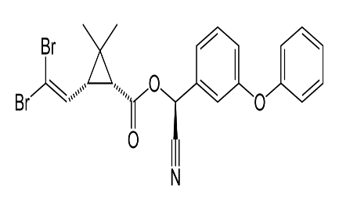 | ⁶Weak estrogenic activity
¹Rawlings NC, Cook SJ, Waldbillig D. Effects of the pesticides carbofuran; chlorpyrifos; dimethoate; lindane; triallate; trifluralin; 2;4-D; and pentachlorophenol on the metabolic endocrine and reproductive endocrine system in ewes. J. Toxicol. Environ. Health A. 1998; 54:21–36.
²Oduma, J.A.; Wango, E.O.; Oduor-Okelo, D.; Makawiti, D.W.; Odongo, H. In vivo and In vitro effects of graded doses of the pesticide heptachlor on female sex steroid production in rats. Comp.
Biochem. Physiol. C Pharmacol. Toxicol. Endocrinol. 1995, 111, 191-196
³Trosken, E.E.; Scholz, K.; Lutz, R.W.; Volkel, W.; Zarn, J.A.; Lutz, W.K. Comparative assessment of the inhibition of recombinant human CYP19 (aromatase) by azoles used in
agriculture and as drugs for humans. Endocr. Res. 2004, 30, 387-394.
⁴Beard AB, Rawlings NC. Thyroid function and effects on reproduction in ewes exposed to the organochlorine pesticides lindane or pentachlorophenol (PCP) from conception. J. Toxicol. Environ. Health A. 1999;58: 509–530.
⁵Zhao, M., Zhang, Y., Zhuang, S., Zhang, Q., Lu, C., & Liu, W. (2014). Disruption of the Hormonal Network and the Enantioselectivity of Bifenthrin in Trophoblast: Maternal–Fetal Health Risk of Chiral Pesticides. Environmental Science & Technology, 48(14), 8109–8116. doi:10.1021/es501903b
⁶Sugiyama S, Shimada N, Miyoshi H, Yamauchi K (2005) Detection of thyroid system-disrupting chemicals using in vitro and in vivo screening assays in Xenopus laevis Toxicol Sci. 88(2):367-74.

Table S-2. Collection points and origin of the samples
Sample Code | Market | Growing Area
PwFm 1-3 | Pir wadai, Fruit Market Islamabad | Swabi, Mansehra, Huzro
KpFm 1-3 | Khana Pull, Fruit Market Islamabad | Hari pur, Kaghan, Sawabi
JbRs 1-3 | Jummah Bazar, Rawalpindi Stadium | Mansehra, Gilgit, Huzro
BkWm 1-3 | Barakho Wednesday Market Islamabad | Multan, Sawat, Rawat
AbSm 1-3 | Abpara, SundayMarket Islamabad | Sawabi, Huzro, Sawat
G9Sm 1-3 | G9 Sunday Market Islamabad | Islamabad(local), Chak Shahzad, Sawat
C-20m 1-3 | Chungi no.20, Rawalpindi | Adiyala Road, Haripur, Sawabi
C-22m 1-3 | Chungi no.22, Rawalpindi | Northern Area Sawat, Abbottabad

Table.S-3 GC-MSD method parameters for selected pesticides in brinjal and cauliflower
Pesticides | RT | Target ion | Q₁ | Q₂
Lindane | 6.7 | 181 | 183 | 219
Heptachlor | 8.4 | 272 | 100 | 274
Chlorpyrifos | 9.6 | 197 | 199 | 314
Heptachlor exo-epoxide B | 10.4 | 353 | 355 | 351
Heptachlor epoxide A | 10.5 | 237 | 135 | 81
Triadimenol | 10.9 | 112 | 128 | 168
α-Endosulfan | 11.3 | 241 | 195 | 239
β-Endosulfan | 12.6 | 195 | 237 | 207
Endosulfan sulfate | 13.4 | 272 | 274 | 229
Bifenthrin | 14.5 | 181 | 165 | 166
λ-Cyhalothrin | 15.3 | 181 | 197 | 208
α-cypermethrin | 16.6 | 181 | 163 | 165
Deltamethrin | 18.1 | 181 | 253 | 251

Table.S-4 Linearity of the calibration curve for selected pesticides in cauliflower and brinjal
Pesticides | Linearity
Pesticides | Solvent | Cauliflower (MMS) | Brinjal (MMS)
Lindane | 0.955 | 0.990 | 0.971
Heptachlor | 0.956 | 0.950 | 0.987
Chlorpyrifos | 0.912 | 0.999 | 0.915
Heptachlor-endoepoxide B | 0.952 | 0.936 | 0.988
Heptachlor-exoepoxide A | 0.948 | 0.999 | 0.986
Triadimenol | 0.953 | 0.977 | 0.980
α-Endosulfan | 0.952 | 0.997 | 0.984
β-Endosulfan | 0.952 | 0.999 | 0.984
Endosulfan sulfate | 0.951 | 0.992 | 0.987
Bifenthrin | 0.954 | 0.919 | 0.996
λ-Cyhalothrin | 0.947 | 0.988 | 0.988
Cypermethrin | 0.956 | 0.993 | 0.981
Deltamethrin | 0.959 | 0.974 | 0.972

Table.S-5 Method recovery for selected pesticides at 1×MRL, 2×MRL and 4×MRL spiking levels in cauliflower and brinjal

Pesticides | Cauliflower |  |  | Brinjal
Pesticides | Average %Recovery (RSD) |  |  | Average %Recovery (RSD)
Pesticides | (1×MRL) | (2×MRL) | (4×MRL) | (1×MRL) | (2×MRL) | (4×MRL)
Lindane | 94(20.6) | 93.4(18.1) | 100.6(6.0) | 70(15.0) | 92.1(20.7) | 99.7(10.3)
Heptachlor | 90.1(17.0) | 97.4(19.1) | 108.7(4.0) | 81.7(11) | 85.8(12.9) | 73.8(18.3)
Chlorpyrifos | 88.9(20.9) | 73.8(18.3) | 84.2(23) | 92.6(29.2) | 89.8(11.6) | 75.6(8.4)
Heptachlor-endoepoxide B | 86.3(26.4) | 88.8(20.0) | 93.8(11.1) | 87(17.0) | 91.4(17.9) | 74.6(21.5)
Heptachlor-exoepoxide A | 70.7(12.0) | 94.9(18.5) | 109.5(9.0) | 68.1(13.0) | 70.4(1.4) | 91.0(18.8)
Triadimenol | 99.5(21.0) | 81.7(22.2) | 89.0(16) | 96.7(21.7) | 75.4(12.9) | 94.2(7.2)
α-Endosulfan | 96.0(18.9) | 106(18.8) | 107(13.9) | 76.8(2.9) | 73.0(2.8) | 85.6(7.6)
β-Endosulfan | 83.7(7.4) | 73.6(10.5) | 76.1(4.3) | 83.9(13.6) | 89.2(5.6) | 77.8(20.3)
Endosulfan sulfate | 91.8(24.5) | 137.1(23) | 109 (13.1) | 55.7(26.3) | 89.8(14.9) | 94.2(19.7)
Bifenthrin | 115.2(3.3) | 117.9(6.6) | 108.8(16) | 65.8(7.2) | 76.3(7.4) | 96.8(10.5)
λ-Cyhalothrin | 76.4(14.4). | 105(14.4) | 114.8(4.3) | 127.2(15.5) | 94.5(9.8) | 83.2(22.0)
α-Cypermethrin | 66.5(11.8) | 104(22.4) | 117.0(1.7) | 78.8(6.5) | 95.5(4.5) | 73.6(2.7)
Deltamethrin | 76.5(1.6) | 72.1(11.6) | 89.4(13.7) | 78.4(4.0) | 94.6(4.2) | 83.1(14.5)

