Study of Nonlinear Optical Responses of Phytochemicals of Clitoria ternatea by Quantum Mechanical Approach and Investigation of their anti-Alzheimer activity with In-Silico Approach
Shradha Lakhera¹, Kamal Devlal¹, Meenakshi Rana^{1*}‬, Ismail Celik²
¹Department of Physics, School of Sciences, Uttarakhand Open University,
Haldwani, 263139, Uttarakhand, India
²Department of Pharmaceutical Chemistry, Faculty of Pharmacy, Erciyes University, Kayseri 38039, Turkey

SD 1. Active phytochemicals of Clitoria Ternatea plant with their PubChem IDs, chemical formulae, and 3D structures.
Phytochemical name | Chemical formula | PubChem ID | 3D structure
Cinnamic acid | C₉H₈O₂ | 444539 | 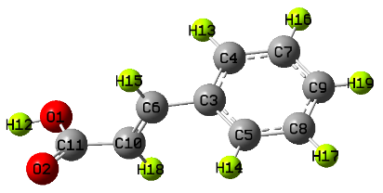
Clitorin | C₃₃H₄₀O₁₉ | 11592917 | 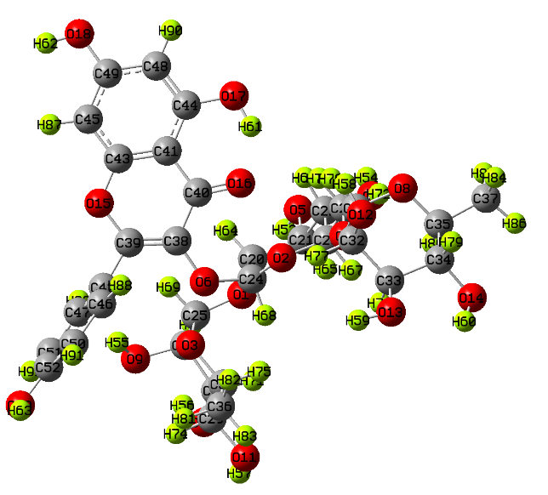
Delphindin-3,5-diglucoside | C₂₇H₃₁O₁₇⁺ | 10100906 | 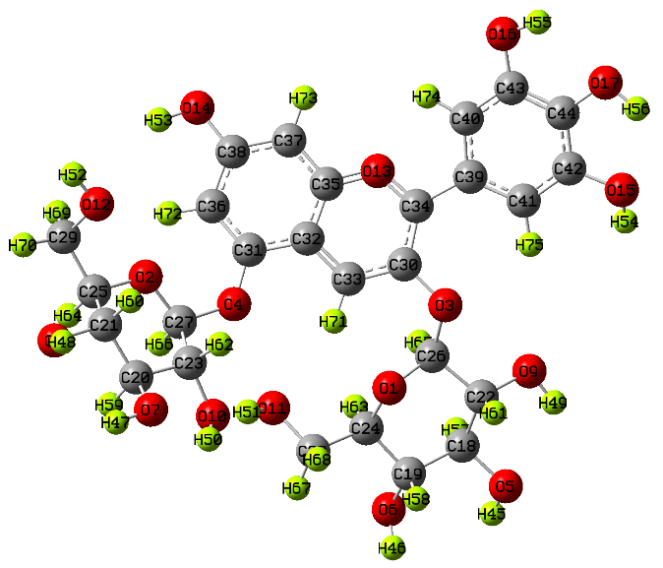
Flavanol 3-O-D-glucoside | C₁₅H₁₄O₂ | 11953828 | 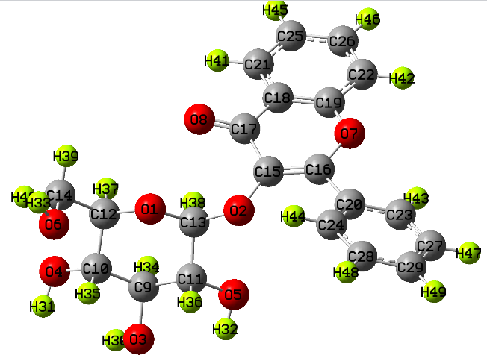
Genistein | C₁₅H₁₀O₅ | 5280961 | 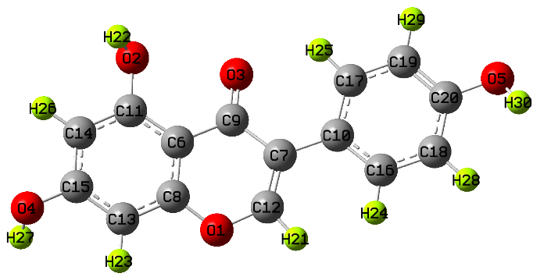
Kaempferol | C₁₅H₁₀O₆ | 5280863 | 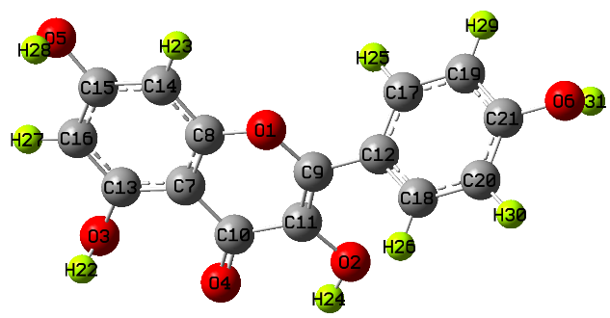
Kaempferol-3,7-diglucoside | C₂₇H₃₀O₁₆ | 6325460 | 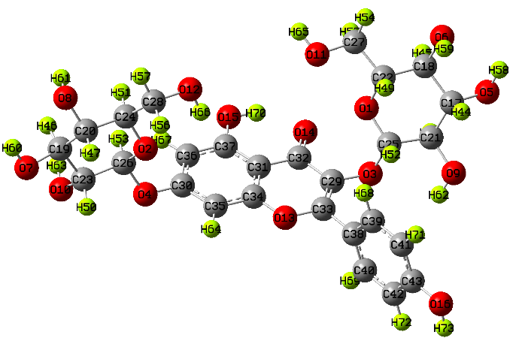
Linolenic acid | C₁₈H₃₀O₂ | 5280934 | 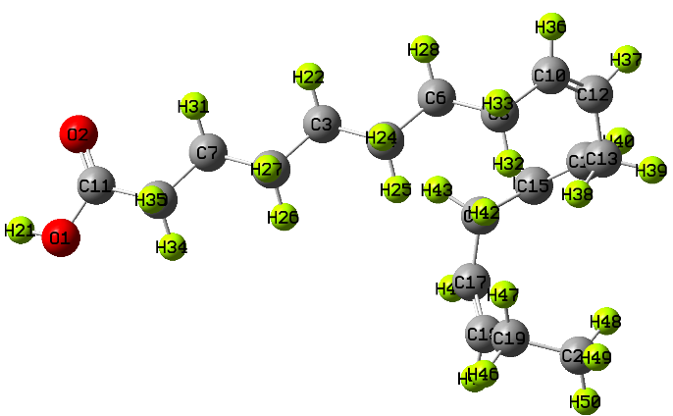
Oleic acid | C₁₈H₃₄O₂ | 445639 | 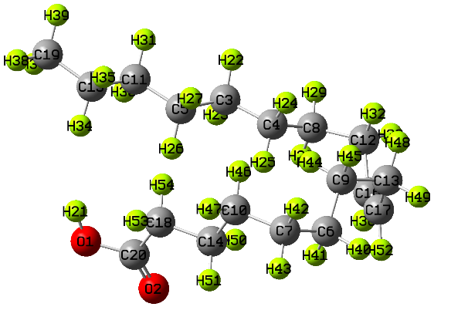
Palmitic acid | C₁₆H₃₂O₂ | 985 | 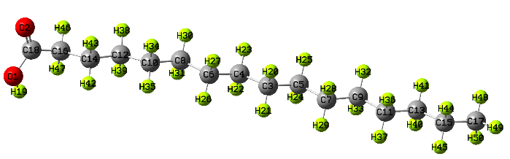
Taraxerol | C₃₀H₅₀O | 92097 | 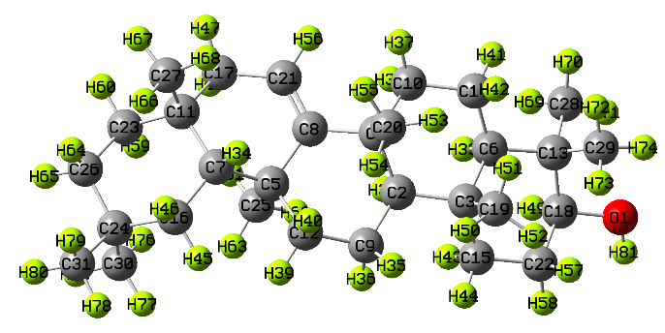
Taraxeron | C₃₀H₄₈O | 392170 | 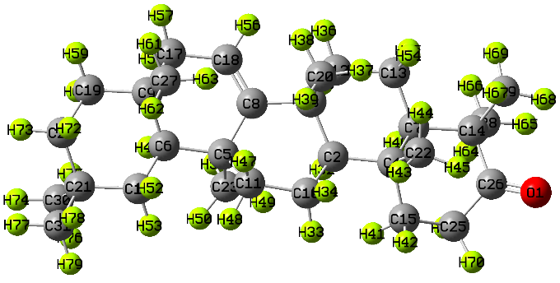

SD 2. Dipole moment of the active phytochemicals of Clitoria Ternatea plant.

Dipole moment
Cinnamic Acid | 2.68
Clitorin | 10.28
Delphinidin 3,5-diglucoside | 6.41
Flavonol 3-O-D-glucoside | 2.17
Genistein | 5.32
Kaempferol | 6.15
Linolenic acid | 1.74
Oleic acid | 4.64
Taraxerol | 1.69
Taraxerone | 3.35

SD 3. Bond lengths associated to Clitorin molecule.
Bond | Bond Length | Bond | Bond Length | Bond | Bond Length
18O – 62H | 0.970 | 52C – 50C | 1.388 | 34C – 79H | 1.096
18O – 49C | 1.361 | 50C – 91H | 1.085 | 34C – 14O | 1.432
49C – 45C | 1.398 | 50C – 46C | 1.397 | 14O – 60H | 0.978
45C – 87H | 1.084 | 46C – 88H | 1.089 | 34C – 35C | 1.535
45C – 43C | 1.393 | 42C – 46C | 1.403 | 31C – 8O | 1.428
43C – 41C | 1.382 | 38C – 6O | 1.387 | 8O – 35C | 1.435
41C – 44C | 1.399 | 6O – 24C | 1.449 | 35C – 80H | 1.098
44C – 48C | 1.379 | 24C – 2O | 1.408 | 35C – 37C | 1.522
48C – 90H | 1.087 | 2O – 23C | 1.422 | 37C – 85H | 1.095
44C – 17O | 1.371 | 23C – 67H | 1.096 | 37C – 84H | 1.094
17O – 61H | 0.984 | 23C – 28C | 1.533 | 37C – 86H | 1.092
43C – 15O | 1.368 | 73H – 28C | 1.095 | 22C – 66H | 1.092
15O – 39C | 1.393 | 72H – 28C | 1.093 | 22C – 7O | 1.432
39C – 38C | 1.349 | 28C – 4O | 1.430 | 7O – 54H | 0.978
38C – 40C | 1.478 | 4O – 31C | 1.419 | 22C – 21C | 1.520
40C – 16O | 1.227 | 31C – 76H | 1.097 | 21C – 65H | 1.098
40C – 41C | 1.449 | 31C – 32C | 1.543 | 21C – 5O | 1.444
39C – 42C | 1.476 | 32C – 77H | 1.096 | 5O – 53H | 0.974
42C – 47C | 1.399 | 32C – 12O | 1.435 | 24C – 68H | 1.087
47C – 89H | 1.085 | 12O – 58H | 0.973 | 24C – 20C | 1.566
47C – 51C | 1.401 | 32C – 33C | 1.536 | 21C – 20C | 1.535
51C – 92H | 1.087 | 33C – 13O | 1.437 | 20C – 64H | 1.095
51C – 52C | 1.391 | 13O – 59H | 0.973 | 20C – 1O | 1.461
52C – 19O | 1.363 | 33C – 78H | 1.097 | 1O – 25C | 1.426
19O – 63H | 0.972 | 33C – 34C | 1.535 | 25C – 69H | 1.096
25C – 26C | 1.55289 | 26C – 9O | 1.43977 | 9O – 55H | 0.974
26C – 70H | 1.09520 | 26C – 27C | 1.54372 | 27C – 71H | 1.096
27C – 10O | 1.43666 | 10O – 56H | 0.97492 | 27C – 29C | 1.538
29C – 74H | 1.09580 | 29C – 11O | 1.42861 | 11O – 57H | 0.977
29C – 30C | 1.52241 | 30C – 75H | 1.09768 | 30C – 36C | 1.523
36C – 81H | 1.09379 | 36C – 82H | 1.09693 | 36C – 83H | 1.092
30C – 3O | 1.43284 | 3O – 25C | 1.42206

SD 4. Bond angles associated to Clitorin molecule.

Bond | Bond Angle | Bond | Bond Angle | Bond | Bond Angle
62H – 18O – 49C | 109.39485 | 20C – 1O – 25C | 115.53 | 22C – 21C – 20C | 112.90
61H – 17O – 44C | 107.58336 | 69H – 25C – 1O | 108.85 | 21C – 5O – 53H | 106.329
90H – 48C – 44C | 120.11 | 25C – 26C – 27C | 110.19 | 59H – 13O – 33C | 106.88
87H – 45C – 43C | 119.26 | 27C – 10O – 56H | 107.32 | 58H – 12O – 32C | 108.26
16O – 40H – 38C | 125.57 | 29C – 27C – 10O | 108.35 | 60H – 14O – 34C | 104.37
38C – 39C – 15O | 125.23 | 29C – 11O – 57H | 104.78 | 84H – 37C – 86H | 109.14
44C – 41C – 43C | 121.66 | 11O – 29C – 74H | 107.65 | 80H – 35C – 8O | 109.51
43C – 15O – 39C | 118.97 | 74H – 29C – 30C | 110.85 | 28C – 23C – 22C | 109.41
41C – 40C – 16O | 114.27 | 75H – 30C – 3O | 110.31 | 22C – 7O – 54H | 104.91
40C – 38C – 39C | 115.03 | 1O – 25C – 3O | 112.20 | 22C – 21C – 5O | 107.79
38C – 6O – 24C | 120.26 | 30C – 36C – 82H | 110.28 | 65H – 21C – 5O | 105.36
39C – 42C – 47C | 122.86 | 30C – 36C – 81H | 111.35 | 38C – 6O – 24C | 120.26
46C – 42C – 47C | 118.91 | 30C – 36C – 83H | 111.68 | 24C – 2O – 23C | 118.51
52C – 19O – 63H | 108.87 | 48C – 44C – 41C | 119.88 | 23C – 28C – 4O | 108.47
52C – 50C – 91H | 121.42 | 40C – 38C – 39C | 115.03 | 4O – 31C – 32C | 108.39
4O – 31C – 8O | 111.55 | 12O – 32C – 77H | 106.71

SD 5. Charge distribution of the 92 atoms of Clitorin molecule.

Atom | Charge | Atom | Charge | Atom | Charge
1O | -0.513024 | 32C | 0.044468 | 63H | 0.373684
2O | -0.457361 | 33C | 0.032591 | 64H | 0.205562
3O | -0.442441 | 34C | 0.097645 | 65H | 0.197736
4O | -0.484202 | 35C | 0.034943 | 66H | 0.206723
5O | -0.603467 | 36C | -0.498395 | 67H | 0.190828
6O | -0.491412 | 37C | -0.509606 | 68H | 0.220633
7O | -0.601545 | 38C | 0.318382 | 69H | 0.179064
8O | -0.461010 | 39C | 0.014599 | 70H | 0.189416
9O | -0.590528 | 40C | 0.383402 | 71H | 0.195221
10O | -0.617990 | 41C | -0.296689 | 72H | 0.215407
11O | -0.603398 | 42C | -0.030980 | 73H | 0.187632
12O | -0.575133 | 43C | 0.357219 | 74H | 0.179012
13O | -0.611295 | 44C | 0.349060 | 75H | 0.188062
14O | -0.609616 | 45C | -0.222582 | 76H | 0.171349
15O | -0.488467 | 46C | -0.047105 | 77H | 0.169033
16O | -0.494213 | 47C | -0.038667 | 78H | 0.200541
17O | -0.594949 | 48C | -0.189541 | 79H | 0.188701
18O | -0.588994 | 49C | 0.331279 | 80H | 0.192422
19O | -0.593071 | 50C | -0.194555 | 81H | 0.181086
20C | -0.013213 | 51C | -0.176780 | 82H | 0.198659
21C | 0.003147 | 52C | 0.271424 | 83H | 0.200406
22C | 0.043801 | 53H | 0.378420 | 84H | 0.176218
23C | 0.040390 | 54H | 0.382220 | 85H | 0.182809
24C | 0.295802 | 55H | 0.376698 | 86H | 0.197693
25C | 0.166247 | 56H | 0.383982 | 87H | 0.173688
26C | 0.002399 | 57H | 0.382469 | 88H | 0.167005
27C | 0.081459 | 58H | 0.361786 | 89H | 0.143594
28C | -0.074966 | 59H | 0.366626 | 90H | 0.197689
29C | 0.110164 | 60H | 0.378367 | 91H | 0.162990
30C | -0.020076 | 61H | 0.397958 | 92H | 0.174165
31C | 0.163531 | 62H | 0.377766 | 92H | 0.174165

SD 6. Frontier molecular orbitals of the Clitorin molecule. All values are in eV and S is in eV⁻¹.
S No. | Molecular property | Values
1. | HOMO | -6.597
2. | LUMO | -2.254
3. | Energy gap (ΔE) | 4.343
4. | Ionization potential (IP) | 6.597
5. | Electron affinity (EA) | 2.254
6. | Chemical potential (CP) | -4.425
7. | Electronegativity (χ) | 4.425
8. | Hardness (η) | 2.171
9. | Softness (S) | 0.4606

SD 7. Computational Raman modes of Clitorin showing modes with maximum frequency and their corresponding Raman intensities. (Vibrational modes: ν-symmetric stretching, α-asymmetric stretching, δ-torsional bending.)

S. No. | Modes | Frequency  (cm⁻¹) | Raman activity | Raman intensity
1. | δ_{CH} | 855.17 | 11.9229 | 1808.13
2. | δ_{CH} | 1283.56 | 2.9216 | 161.77
3. | ν_{CC} | 1679.64 | 202.5361 | 5412.76
4. | ν_{CO} | 1771.92 | 165.592 | 3798.18
5. | α_{CH} | 2991.83 | 251.4471 | 1037.4
6. | α_{CH} | 3148.3 | 97.7441 | 331.105
7. | ν_{OH} | 3397.76 | 106.5315 | 264.83
8. | νo_{H} | 3667.34 | 84.2118 | 150.48
9. | ν_{CH} | 2997.67 | 295.4502 | 1209.95

SD 8. UV-Vis absorption data of Clitorin molecule with transition levels and oscillator strength (f).
Absorption | Theoretical
Absorption | Transition | λ (nm) | E (eV) | (f)
Absorption | S₀ →S₁ | 341.82 | 3.6272 | 0.0048
Absorption | S₀ → S₂ | 327.83 | 3.7819 | 0.0666
Absorption | S₀ → S₃ | 299.42 | 4.1408 | 0.0085

SD 9. Binding affinity of the considered phytochemicals docked with BACE1 (PDB ID: 4B05) target protein.

Binding affinity (Kcal/mol)
CINNAMIC ACID | -5.8
Clitorin | -10.4
Delphinidin 3,5-diglucoside | -10.2
Flavonol 3-O-D-glucoside | -9
genistein | -7.9
kaempferol | -7.9
Kaempferol 3,7-diglucoside | -9.3
linolenic acid | -5.8
octadeca-9,12-dienoic acid | -4.9
oleic acid | -5.7
palmitic acid | -4.8
Taraxerol | -10.7
Taraxerone | -10.6

SD 10. Hydrogen bonds, hydrophobic and dipole moment of Clitorin, Delphinidin 3,5-diglucoside, Taraxerol and Taraxeron when docked with BACE1 (PDB ID: 4B05) target protein.

Ligand | Binding Affinity | Hydrogen bonds | Hydrophobic bonds | Dipole moment
Clitorin | -10.4 | 7 | 6 | 3.62 Debye
Delphinidin 3,5-diglucoside | 10.2 | 7 | 4 | 2.47 Debye
Taraxerol | -10.7 | 0 | 1 | 1.76 Debye
Taraxeron | -10.6 | 0 | 1 | 3.48 Debye

SD 11. Interaction details of the best pose of Clitorin bonded with BACE1: 4B05.
Protein | Binding affinity  (kcal/mol) | Hydrogen-bonded interaction (donor: acceptor, distance in A)  [Type of bond]
4BO5 | -10.4 | A:TRP76:HE1 - :UNL1:O, 1.82031  [Conventional Hydrogen Bond]  A:THR231:HG1 - :UNL1:O Yes, 2.63925  [Conventional Hydrogen Bond]  UNL1:H - A:GLY34:O, 2.77071  [Conventional Hydrogen Bond]  UNL1:H - A:GLY230:O, 1.99419  [Conventional Hydrogen Bond]  UNL1:H - A:LYS107:O, 2.26541  [Conventional Hydrogen Bond]  :UNL1:H - A:ASN37:OD1, 2.36007  [Conventional Hydrogen Bond]  UNL1:H - A:GLN73:OE1, 2.05099  [Conventional Hydrogen Bond]

