Search Strategy of Meta-analaysis
((Ascorbic Acid (Mesh)) OR (Acid, Ascorbic) OR (L-Ascorbic Acid) OR (Acid, L-Ascorbic) OR (L Ascorbic Acid) OR (Vitamin C) OR (Hybrin) OR (Magnorbin) OR (Sodium Ascorbate) OR (Ascorbate, Sodium) OR (Ascorbic Acid, Monosodium Salt) OR (Ferrous Ascorbate) OR (Ascorbate, Ferrous) OR (Magnesium Ascorbate) OR (Ascorbate, Magnesium) OR (Magnesium di-L-Ascorbate) OR (Magnesium di L Ascorbate) OR (di-L-Ascorbate, Magnesium) OR (Magnesium Ascorbicum)) AND ((Prostate Neoplasms (Mesh)) OR (Neoplasms, Prostate) OR (Neoplasm, Prostate) OR (Prostate Neoplasm) OR (Neoplasms, Prostatic) OR (Neoplasm, Prostatic) OR (Prostatic Neoplasm) OR (Prostate Cancer) OR (Cancer, Prostate) OR (Cancers, Prostate) OR (Prostate Cancers) OR (Cancer of the Prostate) OR (Prostatic Cancer) OR (Cancer, Prostatic) OR (Cancers, Prostatic) OR (Prostatic Cancers) OR (Cancer of Prostate))

Supplementary Figure.1 The flow chart of articles included in meta-analysis
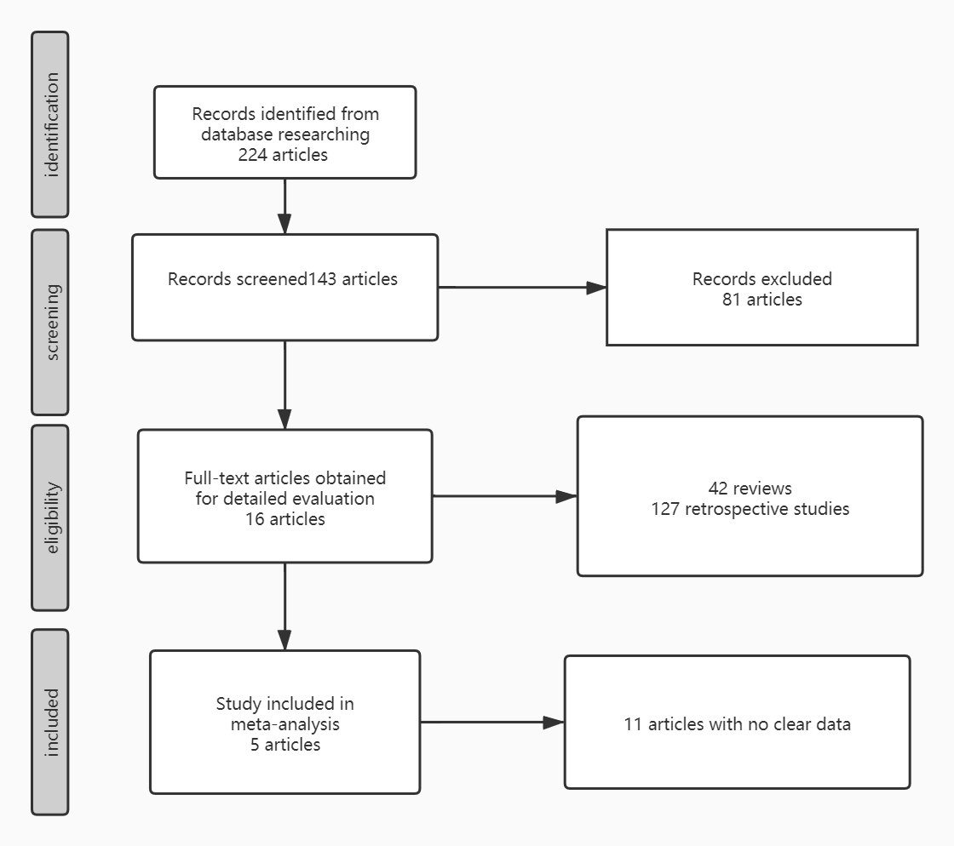

Supplementary Figure.2 The quality assessment results of included articles in meta-analysis

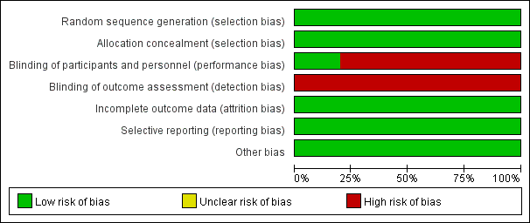

Supplementary Figure.3 Heterogeneity Analysis of Meta-analysis
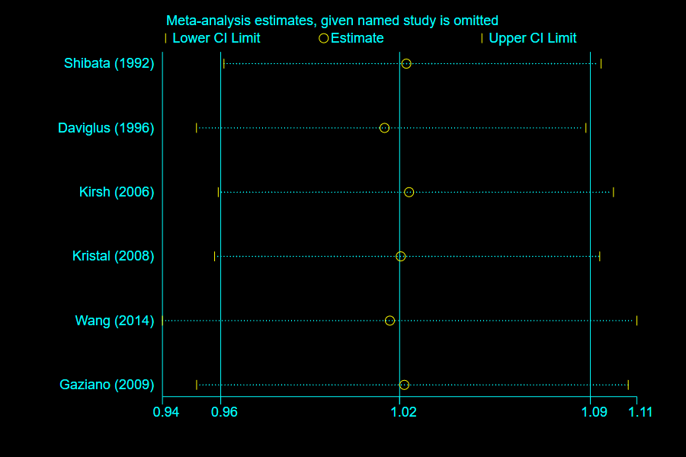
Supplementary Table 1. Lead SNPs identified in the genome-wide meta-analysis of plasma vitamin C
Chromosome | Position | SNP | Beta | se | effect  allele | other  allele | eaf | P value | Nearest gene | PRACTICAL outcome |  | FINNGEN outcome
 |  |  |  |  |  |  |  |  |  | Beta | SE | Beta | SE
1 | 2330190 | rs6693447 | 0.039 | 0.006 | T | G | 0.551 | 6.25×${10}^{-10}$ | RER1 | -0.0031 | 0.0085 | -0.0127 | 0.0213
2 | 220031255 | rs13028225 | 0.102 | 0.009 | T | C | 0.857 | 2.38×${10}^{-30}$ | SLC23A3
5 | 138715502 | rs33972313 | 0.36 | 0.018 | C | T | 0.968 | 4.61×${10}^{-90}$ | SLC23A1 | -0.0108 | 0.0232 | -0.0537 | 0.0731
5 | 176799992 | rs10051765 | 0.039 | 0.007 | C | T | 0.342 | 3.61×${10}^{-9}$ | RGS14 | 0.0062 | 0.0091 | 0.0073 | 0.0218
6 | 52725787 | rs7740812 | 0.038 | 0.006 | G | A | 0.594 | 1.88×${10}^{-9}$ | GSTA5 | 0.0054 | 0.016 | 0.0437 | 0.0242
11 | 61570783 | rs174547 | 0.036 | 0.007 | C | T | 0.328 | 3.84×${10}^{-8}$ | FADS1 | -0.0029 | 0.0085 | -0.0161 | 0.0216
12 | 96249111 | rs117885456 | 0.078 | 0.012 | A | G | 0.087 | 1.70×${10}^{-11}$ | SNRPF | -0.0144 | 0.017 | 0.0073 | 0.0381
12 | 102093459 | rs2559850 | 0.058 | 0.006 | A | G | 0.598 | 6.30×${10}^{-20}$ | CHPT1 | 0.0037 | 0.0088 | -0.0034 | 0.0217
14 | 105253581 | rs10136000 | 0.040 | 0.007 | A | G | 0.283 | 1.33×${10}^{-8}$ | AKT1 | 0.0014 | 0.0092 | -0.0203 | 0.0235
16 | 79740541 | rs56738967 | 0.041 | 0.007 | C | G | 0.321 | 7.62×${10}^{-10}$ | MAF | -0.0063 | 0.0087 | 0.0053 | 0.0231
17 | 59456589 | rs9895661 | 0.063 | 0.008 | T | C | 0.817 | 1.05×${10}^{-14}$ | BCAS3 | -0.0182 | 0.0108 | 0.0161 | 0.0275

Supplementary Figure.4 Scatter plot of genetic association with prostate cancer and genetic association with the plasma vitamin C levels using data from FinnGen and PRACTICAL
A. Result of FinnGen
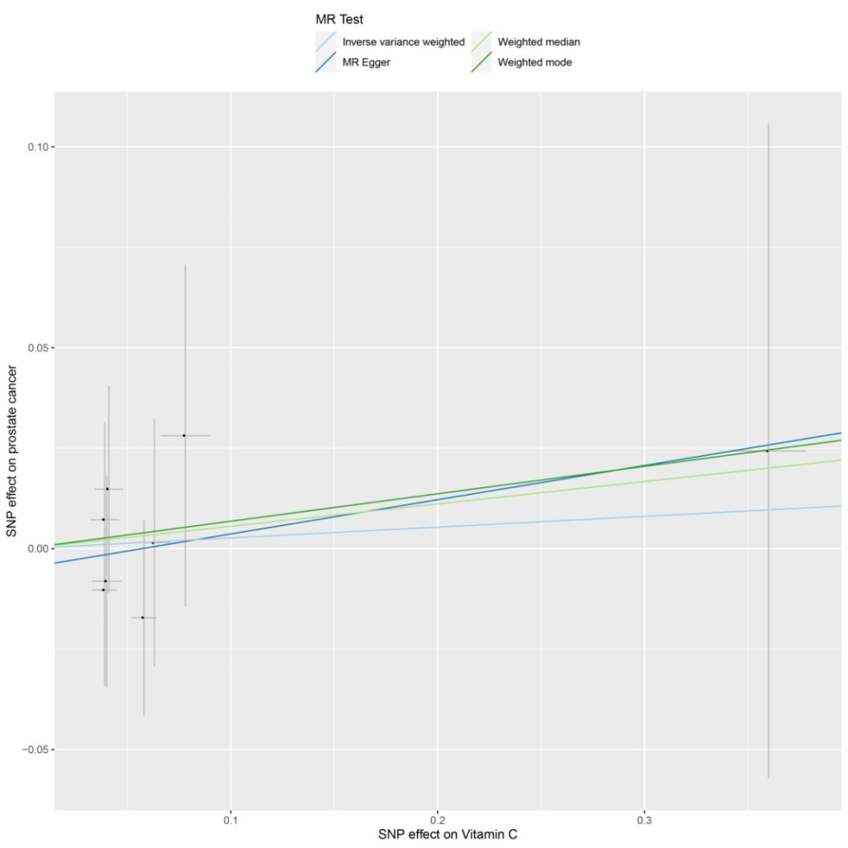
B. Result of and PRACTICAL
