The Effect of Acute PM2.5 Exposure on Lung Function in Children: A Systematic Review and Meta-Analysis
Additional File
Yueming Zhang, Ziyao Guo, Qinyuan Li, Yan Zhao, Zhili Wang, Zhengxiu Luo*

Table of Contents

Table A1. Search Strategies

Description of Newcastle Ottawa Scale

Table A2. Newcastle Ottawa Scale study quality assessment
Figure A1. Funnel plot of changes in PEF (L/min) estimates associated with a 10µg/m³ increases in PM2.5

Figure A2. Funnel plot of changes in FVC (L) estimates associated with a 10µg/m³ increases in PM2.5

Figure A3. Funnel plot of changes in FEV1 (L) estimates associated with a 10µg/m³ increases in PM2.5

Table A1. Search Strategies

Additional Table 1. Search Strategies used in PUBMED, EMBASE to identify studies examining the relationship between exposure to PM2.5 and Lung function in children. PUBMED searches used MeSH terms and EMBASE searches used Emtree terms .
Search queries for PUBMED
1 | (PM2.5[Title/Abstract]) OR (Ultrafine Fibers[Title/Abstract])) OR (Ultrafine Fiber[Title/Abstract])) OR (Fiber, Ultrafine[Title/Abstract])) OR (Airborne Particulate Matter[Title/Abstract])) OR (Particulate Matter, Airborne[Title/Abstract])) OR (Air Pollutants, Particulate[Title/Abstract])) OR (Particulate Air Pollutants[Title/Abstract])) OR (Ambient Particulate Matter[Title/Abstract])) OR (Particulate Matter, Ambient[Title/Abstract])) OR (Ultrafine Particulate Matter[Title/Abstract])) OR (Particulate Matter, Ultrafine[Title/Abstract])) OR (Ultrafine Particles[Title/Abstract])) OR (Particles, Ultrafine[Title/Abstract])) OR (Ultrafine Particle[Title/Abstract])) OR (Particle, Ultrafine[Title/Abstract])) OR ("Particulate Matter"[Mesh])
2 | AND(children[Title/Abstract]) OR ("Child"[Mesh])
3 | AND (Function Test, Respiratory[Title/Abstract]) OR (Function Tests, Respiratory[Title/Abstract])) OR (Test, Respiratory Function[Title/Abstract])) OR (Tests, Respiratory Function[Title/Abstract])) OR (Pulmonary Function Tests[Title/Abstract])) OR (Function Test, Pulmonary[Title/Abstract])) OR (Function Tests, Pulmonary[Title/Abstract])) OR (Test, Pulmonary Function[Title/Abstract])) OR (Tests, Pulmonary Function[Title/Abstract])) OR (Lung Function Tests[Title/Abstract])) OR (Function Test, Lung[Title/Abstract])) OR (Function Tests, Lung[Title/Abstract])) OR (Lung Function Test[Title/Abstract])) OR (Test, Lung Function[Title/Abstract])) OR (Tests, Lung Function[Title/Abstract])) OR (Pulmonary Function Test[Title/Abstract])) OR ("Respiratory Function Tests"[Mesh])

Search queries for EMBASE
1 | (pm2.5:ab,ti OR 'ultrafine fibers':ab,ti OR 'ultrafine fiber':ab,ti OR 'fiber, ultrafine':ab,ti OR 'airborne?particulate matter':ab,ti OR 'particulate matter, airborne':ab,ti OR 'air pollutants, particulate':ab,ti OR 'particulate air pollutants':ab,ti OR 'ambient?particulate matter':ab,ti OR 'particulate matter, ambient':ab,ti OR 'ultrafine?particulate matter':ab,ti OR 'particulate matter, ultrafine':ab,ti OR 'ultrafine particles':ab,ti OR 'particles, ultrafine':ab,ti OR 'ultrafine particle':ab,ti OR 'particle, ultrafine':ab,ti OR particulate matter 2.5'/exp)
2 | AND (children OR child'/exp)
3 | AND(function test, respiratory':ab,ti OR 'test, respiratory function':ab,ti OR 'tests, respiratory function':ab,ti OR 'pulmonary function tests':ab,ti OR 'function test, pulmonary':ab,ti OR 'function tests, pulmonary':ab,ti OR 'test, pulmonary function':ab,ti OR 'tests, pulmonary function':ab,ti OR 'lung function?tests':ab,ti OR 'function test, lung':ab,ti OR 'function tests, lung':ab,ti OR 'test,?lung function':ab,ti OR 'tests,?lung function':ab,ti OR 'pulmonary function test':ab,ti OR lung function test'/exp)

Table A2. Newcastle Ottawa Scale study quality assessment
Newcastle – Ottawa Quality Assessment Scale Cohort Studies
Note: A study can be awarded a maximum of one star for each numbered item within the Selection and Outcome categories. A maximum of two stars can be given for Comparability

Selection

- Representativeness of the exposed cohort
a) truly representative of the average _______________ (describe) in the community
b) somewhat representative of the average ______________ in the community
c) selected group of users eg nurses, volunteers
d) no description of the derivation of the cohort

2) Selection of the non-exposed cohort
a) drawn from the same community as the exposed cohort
b) drawn from a different source
c) no description of the derivation of the non-exposed cohort

3) Ascertainment of exposure
a) secure record (eg surgical records)
b) structured interview
c) written self-report
d) no description

4) Demonstration that outcome of interest was not present at start of study
a) yes
b) no

Comparability

1) Comparability of cohorts on the basis of the design or analysis
a) study controls for _____________ (select the most important factor)
b) study controls for any additional factor (This criteria could be modified to indicate specific
control for a second important factor.)

Outcome

1) Assessment of outcome
a) independent blind assessment
b) record linkage
c) self-report
d) no description

2) Was follow-up long enough for outcomes to occur
a) yes (select an adequate follow up period for outcome of interest)
b) no

3) Adequacy of follow up of cohorts
a) complete follow up - all subjects accounted for
b) subjects lost to follow up unlikely to introduce bias - small number lost – > 80%
or description provided of those lost
c) follow up rate < 80% and no description of those lost
d) no statement

Newcastle – Ottawa Quality Assessment Scale Summary Categorization
Thresholds for converting the Newcastle-Ottawa scales to AHRQ standards (good, fair, and poor):

Good quality: 3 or 4 stars in selection domain AND 1 or 2 stars in comparability domain AND 2 or 3 stars in outcome/exposure domain

Fair quality: 2 stars in selection domain AND 1 or 2 stars in comparability domain AND 2 or 3 stars in outcome/exposure domain

Poor quality: 0 or 1 star in selection domain OR 0 stars in comparability domain OR 0 or 1 stars in outcome/exposure domain

Newcastle Ottawa Scale study quality assessment

Author | Representative | Non-Exposed | Exposure | Outcome not present | Control for confounding_{a} | Outcome | Follow up | Adequate Follow up_{b} | Score_{c} | Overall Quality_{d}
Lu Ma/2008 | 1 | 1 | 1 | 1 | 2 | 1 | 1 | 0 | 8 | Good
Bing-Yu Chen/2010 | 1 | 1 | 1 | 1 | 2 | 1 | 1 | 0 | 8 | Good
Shin Yamazaki/2011 | 0 | 1 | 1 | 1 | 2 | 1 | 1 | 1 | 8 | Good
Ludmilla/2012 | 1 | 1 | 1 | 1 | 2 | 1 | 1 | 1 | 9 | Good
Ludmilla/2014 | 0 | 1 | 1 | 1 | 2 | 1 | 1 | 1 | 8 | Good
Masanari/2016 | 0 | 1 | 1 | 1 | 2 | 1 | 1 | 1 | 8 | Good
Dandan Xu/2018 | 1 | 1 | 1 | 1 | 1 | 1 | 1 | 0 | 7 | Fair
Liu Weiyan/2019 | 1 | 1 | 1 | 1 | 1 | 1 | 1 | 1 | 8 | Good
Dandan Xu/2020 | 1 | 1 | 1 | 1 | 2 | 1 | 1 | 0 | 8 | Good
YANG Xiao Yan/2020 | 0 | 1 | 1 | 1 | 1 | 1 | 1 | 0 | 6 | Fair
WU Xingbin/2020 | 1 | 1 | 1 | 1 | 1 | 1 | 1 | 0 | 7 | Fair

*All categories were scored based on the Newcastle Ottawa Scale (NOS) with the exception of the category ―Control for confounding, see Supplemental Materials, Newcastle Ottawa Scale Assessment Score Cohort Studies. Studies may appear more than once in separate analyses.
_{a}Adjustment for confounding considered: i)asthma status, asthmatic medicinal usage, passive smoking (excluded or adjusted) ii)environmental parameters such as temperature and humidity, and iii)individual factors such as age, gender, BMI, height, weight.
_{b}Adequate follow-up defined as >80%
_{c}The summary score for each study was calculated by summing the scores from each category
_{d}Studies were categorized for overall study quality based on the Newcastle Ottawa Scale categorization, see Supplemental Materials, Newcastle Ottawa Scale Summary Categorization

Figure A1. Funnel plot of changes in PEF (L/min) estimates associated with a 10µg/m³ increases in PM2.5

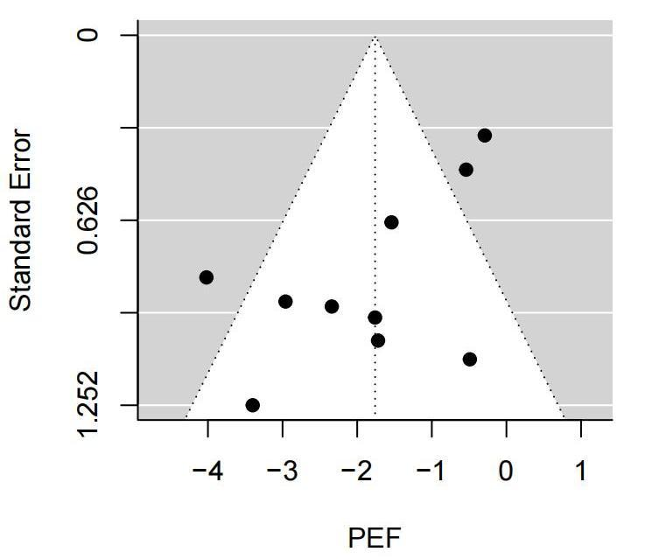

Figure A2. Funnel plot of changes in FVC (L) estimates associated with a 10µg/m³ increases in PM2.5

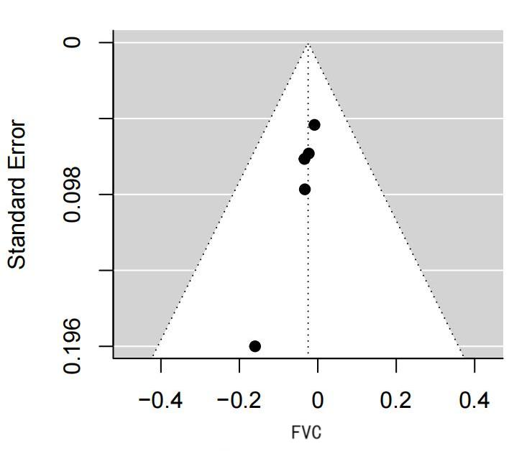

Figure A3. Funnel plot of changes in FEV1 (L) estimates associated with a 10µg/m³ increases in PM2.5

