Additional File 1: Meshing Details
The meshing process was carried out using Fluent 20R2 meshing (ANSYS, Canonsburg, Pennsylvania, USA) where the domain was discretized into poly-hexcore elements. Ten and five inflation layers were implemented on the walls of the cannula and the vasculature respectively; thereby maintaining a y+ value of less than five for each simulation. This ensured accurate resolution of the viscous sublayer. A mesh containing 604,007 elements was created (Figure 1) and was verified with a mesh convergence study using a finer mesh containing 1,411,774 elements. Results showed less than 5% variation in flow rates at the BCA, LCCA and LSCA outlets and also the pressures at the aortic valve and cannula inlet surfaces. To ensure mesh convergence was achieved within the main trunk of the aorta, planes were cut through cross-sections of the aortic arch, descending aorta and abdominal aorta. The area-averaged velocity was computed for each plane and these results also showed less than 5% variation between the two meshes. All generated meshes were of high quality and had no elements that had a skewness value above 0.9 and an orthogonal quality value below 0.2.
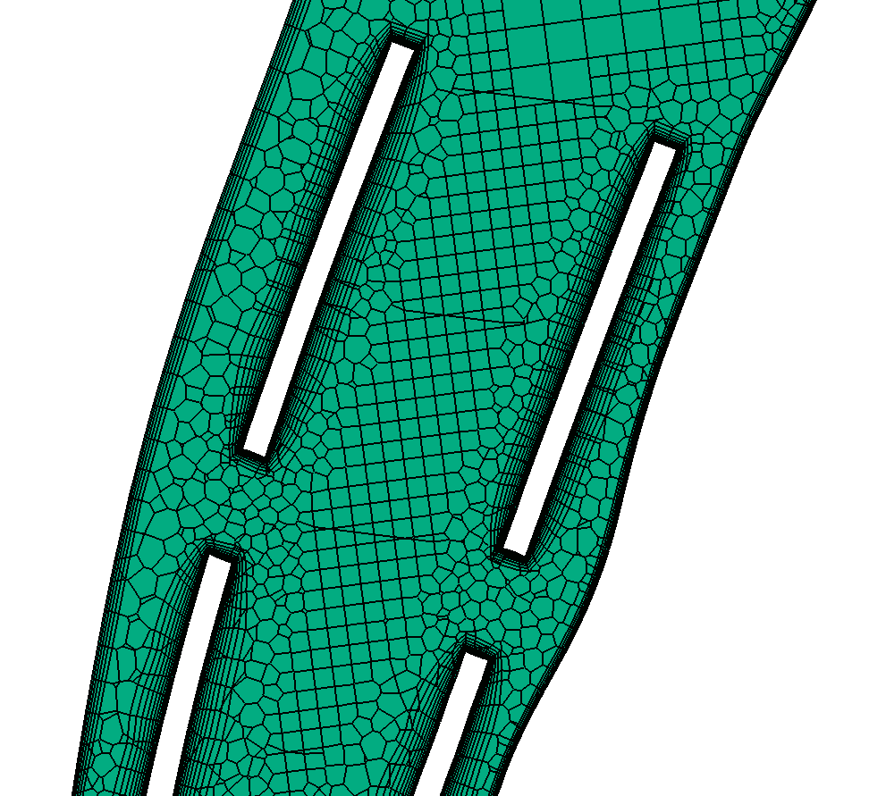
Figure 1: Meshed region of the arterial cannula in position 1, clearly depicting the poly-hexcore elements and inflation layers.

