CARE CHECKLIST

Title

Glanzmann’s Thrombasthenia during Pregnancy: Case Report and Literature Review

Key Words

Glanzmann thromboasthenia; postpartum haemorrhage; pregnancy; recombinant FVIIa; case report

Abstract

Glanzmann's thrombasthenia is an uncommon congenital disease due to an anomaly qualitative or quantitative of the glycoprotein complex GPIIb / IIIA with the consequence of a defective platelet aggregation. Hemorrhages in pregnant women with this bleeding disorder can be severe and may require aggressive treatment with a combined therapy including platelet concentrates, anti-fibrinolytics and rFVIIa. A scheduled plan for obstetric and haematological management should be set in advance.

Close clinical observation, laboratory monitoring and immediate access to pro-haemostatic therapies are essential, leading to lower rates of postpartum hemorrhage.

A 35 year-old white woman with Glanzmann’s thrombasthenia was followed during pregnancy. A multidisciplinary meeting including gynaecologists, obstetrics, haematologists and anaesthesiologists was arranged for the management of unexpected antepartum haemorrhages, method of delivery and postpartum care. The primary aim of this case report was to evaluate the management of thrombasthenia of Glanzmann during pregnancy, with particular emphasis on the current management of the hemorrhages and the method of delivery, in order to ensure optimal maternal and fetal outcomes.

Introduction

Glanzmann's thrombasthenia is a congenital disease due to an anomaly qualitative or quantitative of the glycoprotein complex: GPIIb / IIIA with the consequence of a defective platelet aggregation. [1] It is a rare condition with a general incidence rate of approximately 1 in a million with higher occurrence in groups with consanguinity. [2]

Pregnancy in women with thromboasthenia is often marked by several hemorrhages of different origins, especially in the immediate post-partum period.

The aim of this case report was to describe the management of this bleeding disorder during pregnancy, with particular emphasis on the current management of the hemorrhages and the method of delivery.

Patient information

A 35 year-old white woman with Glanzmann’s thrombasthenia was followed during her first gestation. The patient was known to have Glanzmann's thrombasthenia since early childhood following severe spontaneous epistaxis requiring blood transfusions. She reported a lifelong history of bleeding episodes, including menorrhagia, gingival bleeding and spontaneous epistaxis. Pregnancy remained uneventful, except for an episode of hematuria tackled within 24 hours; there were no other bleeding episodes throughout pregnancy. Growth scans performed at 33 and 37 weeks of gestation showed a normal growth profile.

Clinical Findings

The patient was hospitalized for planned induction of labour at 39 weeks and a complete blood count test was performed. Maternal platelet count was normal, as expected in Glanzmann’s thrombasthenia. Haemoglobin value was 9.9 g/dL. During physical examination there were no bleeding episodes. Bishop score was zero.

Timeline

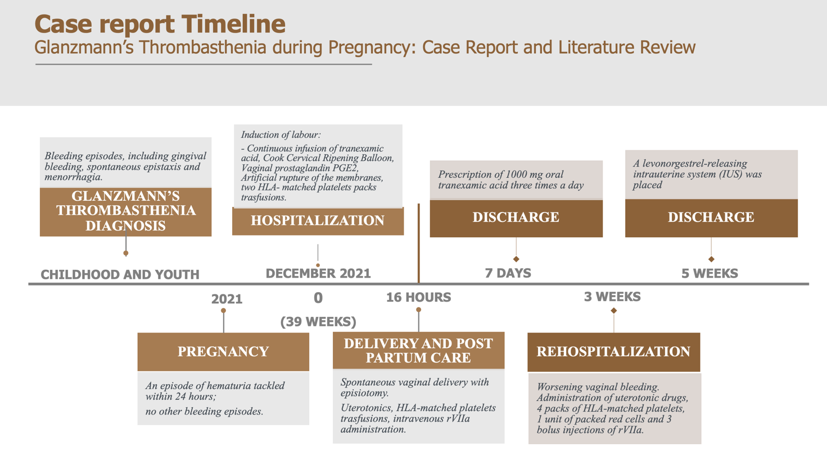

Diagnostic Assessment

A multidisciplinary meeting including gynaecologists, obstetrics, haematologists and anaesthesiologists was arranged for the management of unexpected antepartum haemorrhages, method of delivery and postpartum care. The safest approach of delivery was deemed to be a planned induction of labour at 39 weeks.

Therapeutic Intervention

Induction of labour was performed following a continuous infusion of tranexamic acid. Considered the low Bishop score (0), a Cook Cervical Ripening Balloon was placed. It was removed after 12 hours, in order to continue with vaginal prostaglandin PGE2 and artificial rupture of the membranes. One pack of HLA- matched platelets was transfused during the induction and another one before the delivery. A spontaneous vaginal delivery was attained after 16 hours. The newborn had Apgar score of 9 and 10 at 1 and 5 min, respectively; birth weight was 2800 g.

Prophylactic administration of uterotonics and another pack of HLA-matched platelets were administered to the patient. Placenta and membranes were entirely delivered and an episiotomy was sutured. Emergency treatment with intravenous rVIIa (Novo- seven®) was administered after delivery following the presence of vaginal bleeding. A vaginal pack was placed and removed after 24 hours.

Follow-up and Outcomes

The patient was kept under close supervision for the next 2 hours in the labour room and then transferred to an intensive care unit for a 24 hour- multiparameter monitoring. She mantained hemodynamic stability during the whole stay in the ICU. The post-partum hemoglobin level after 12 hours was 6.8 g/dL, therefore 2 units of packed red cells were transfused to the patient. Mechanical thromboprophylaxis with compressive stockings was performed and a daily pack of HLA-matched platelets was infused for the following five postpartum days.

The patient was discharged on post-operative day 7. A two-week course of 1000 mg oral tranexamic acid three times a day was prescribed. After three postpartum weeks the patient experienced worsening vaginal bleeding, requiring an immediate hospitalization. Ultrasound scan detected remaining clots over the isthmic and cervical region of the uterus. Therefore, uterotonic drugs, 4 packs of HLA-matched platelets, 1 unit of packed red cells and 3 bolus injections of rVIIa (Novo- seven®) were administered to the patient during the following 10 days. Finally, a levonorgestrel-releasing intrauterine system (IUS) was placed and the patient was discharged.

Discussion

Glanzmann's thrombasthenia is a rare disease characterized by the absence or severely decreased platelet aggregation due to a quantitative or qualitative deficit of GPIIB / IIIA complexes at the platelet surface membrane. [1] This condition is characterized by an haemorrhagic mucocutaneous diathesis due to prolonged bleeding time. Laboratory parameters include normal platelet counts, morphology, prothrombin time (PT), and activated thromboplastin times (aPTT). In contrast, PFA-100 test shows prolonged closure times. [3,4]. Flow cytometry, evaluating platelet structure and function, provides the definitive diagnosis.[5] Epistaxis, easy bruising, purpura, gingival bleeding and menorrhagia are the most common clinical symptoms. [6] Epistaxis is often a cause of severe bleeding in childhood. Menorrhagia may be critical, resulting in anaemia, and it is usually associated with excessive bleeding at the menarche.[7] Other common clinical features include bleeding from the urinary and gastrointestinal tracts, surgical procedures and traumatic events. [8]

Depending on laboratory parameters, Glanzmann's thrombasthenia is classified into the following variants: type 1 variants (<5% GPIIb-IIIa expression) which is related to severe bleeding, type 2 (5-20% expression of GPIIb-IIIa) and qualitative GT variants in which the bleeding phenotype may be less severe. [6] Haemostatic management is associated with the severity of clinical manifestations. Currently, the main treatment remains supportive.

Local bleeding can be managed using various methods, including compression, use of tranexamic acid or topical thrombin applied to superficial wounds. Epistaxis is managed by cauterization or nasal packing, while menorrhagia may be managed with tranexamic acid and hormone therapy. [7] When local measures and antifibrinolytics fail to control bleeding, the first line of treatment for severe haemorrhage is platelet transfusion. [9] Platelet transfusions are usually effective in controlling haemorrhages, but there is a risk of alloimmunisation by HLA antigens or the specific missing GPs leading to transfusion refractoriness. Approximately 15-30% of individuals become refractory to transfusion and a significant percentage develops antibodies against GP IIb-IIIa or HLA. [10,11] In Glanzmann patients who are refractory to platelet transfusions recombinant FVIIa is licensed for use. [9,12] In the near future bone marrow transplant and gene therapy technology may guarantee an effective option to cure this otherwise lifelong disease. [13,14]

Pregnancy and delivery should be managed in collaboration between haemophilia, anesthesia, neonatology and obstetric units. Glanzmann's thrombasthenia is characterized by an increased percentage of primary and secondary post-partum hemorrages. [15,16]

The risk of significant antenatal bleeding is low. Conversely, intra-partum and postpartum bleeding are common and frequently severe justifying measures such as active management of the third stage of labour with uterotonics drugs, as emphasized in current guidelines. [9,12] Concerning vaginal delivery, recent guidelines support the use of rFVIIa combined with tranexamic acid. This practice avoids the use of platelets transfusions and the related risk of developing maternal antiplatelet antibodies that may cross the placenta, resulting in neonatal alloimmune thrombocytopenia and subsequent severe bleeding. Consequently, it is currently recommended monitoring maternal alloantibody titre during pregnancy as a routine screening, in order to prevent and minimize adverse foetal outcomes. [12]

The administration of rFVIIa in patients suffering from Glanzmann thrombasthenia was described as a successful treatment in several cases [17,18] and there are case reports confirming the efficacy of recombinant factor VIIa in the treatment of massive postpartum haemorrhage refractory to other treatments. [19] There are no clear data related to dosing schedules, but 90 lg/kg infused as close to delivery as possible, followed by further 2- hourly infusions for a maximum of three to four doses or until haemostasis is clinically secure, is a reasonable approach. [9] If bleeding occurs despite this treatment, HLA-selected platelets should be infused. [12] HLA- matched platelets transfusion is suggested as an alternative to rFVIIa for vaginal delivery and as first-line prophylaxis against PPH after caesarean section. [9,12] According to individual variations in platelet recovery, an algorithm for correction of hemostasis during delivery in Glanzmann's thrombasthenia is available. [20] Postpartum haemorrhage is unpredictable and may occur within 1-2 weeks after delivery; the median time to secondary PPH is 10 days after delivery, irrespective of whether prophylaxis is given at the time of delivery. This confirms that each patient requires individual assessment, planning and close observation after delivery; therefore, anti-fibrinolytic therapy should be administered for at least 2 weeks, even after apparently uncomplicated deliveries without signs of bleeding manifestations.

Currently, the mode of delivery is not related to maternal bleeding risk. [15] In case of increased risk of neonatal bleeding, due to inherited alloimmune thrombocytopenia , ventouse extraction and forceps deliveries are contraindicated. [9,12]

Regional anaesthesia in patients with platelet dysfunction should be avoided because haemostasis cannot be maneged. If there is comorbidity that makes the risk of general anaesthesia high, a management plan should be settled in advance between the haematologist and anaesthetist in case a caesarean section becomes necessary. Caesarean section may reduce the risk of PPH, providing an improved uterine evacuation, but late PPH remains a possible complication. [9,12]

Our case and review of literature confirm that postpartum hemorrhage in pregnant women with Glanzmann's thrombasthenia can be severe and may require aggressive treatment with a combined therapy comprising platelet concentrates, anti-fibrinolytics and rFVIIa. [12]

A scheduled plan for obstetric and haematological management should be set in advance.

Pregnancy, delivery and postpartum care should be managed by a multi-disciplinary team in a specialized center with clinical expertise in bleeding disorders.

Close clinical observation, laboratory monitoring and immediate access to pro-haemostatic therapies are essential, leading to lower rates of postpartum hemorrhage. However, further systematic descriptions of deliveries are necessary, in order to guarantee optimal maternal and fetal outcomes.

Patient Perspective

According to the clinical stability, the patient was satisfied with the treatment received, showing compliance and experiencing minimal predictable complications.

Informed consent

Written informed consent was obtained from the patient for publication of this case report.

Reference list

- Nurden AT, Fiore M, Nurden P, Pillois X. Glanzmann thrombasthenia: a review of ITGA2B and ITGB3 defects with emphasis on variants, phenotypic variability, and mouse models. Blood. 2011;118(23):5996–6005. doi:10.1182/blood-2011-07-365635
- Poon MC, Di Minno G, d’Oiron R, Zotz R. New insights into the treatment of Glanzmann thrombasthenia. Transfus Med Rev. 2016;30(2):92–99. doi:10.1016/j.tmrv.2016.01.001
- Buyukasik, Y., Karakus, S., Goker, H., Haznedaroglu, I.C., Ozatli, D., Sayinalp, N., Ozcebe, O.I., Dundar, S.V. & Kirazli, S. (2002) Rational use of the PFA-100 device for screening of platelet function disorders and von Willebrand disease. Blood Coagulation and Fibrinolysis, 13, 349– 353.
- Harrison, P., Robinson, M., Liesner, R., Khair, K., Cohen, H., Mackie, I. & Machin, S. (2002a) The PFA-100: a potential rapid screening tool for the assessment of platelet dysfunction. Clinical and Laboratory Haematology, 24, 225– 232.
- Kottke-Marchant K, Corcoran G. The lab- oratory diagnosis of platelet disorders. Arch Pathol Lab Med 2002; 126: 133–46.
- George JN, Caen JP, Nurden AT. Glanz- mann’s thrombasthenia: the spectrum of clinical disease. Blood 1990; 75: 1383–95.
- Markovitch, O., Ellis, M., Holzinger, M., Goldberger, S. & Beyth, Y. (1998) Severe juvenile vaginal bleeding due to Glanzmann’s thrombasthenia: case report and review of the literature. American Journal of Hematology, 57, 225–227
- Bellucci S, Caen JP. Molecular basis of Glanzmann's Thrombasthenia and current strategies in treatment. Blood Reviews. 2002;16:193–202.
- Alamelu J, Liesner R. Modern management of severe platelet function disorders. Br J Haematol 2010; 149: 813–23.
- Laursen B and Jacobsen S. Transfusion problems in patients with Glanzmann’s thrombasthenia. Eur J Haematol 1992; 49: 143–144.
- Santoro C, Rago A, Biondo F et al. Preva- lence of allo-immunization anti-HLA and anti-integrin alphaIIbbeta3 in Glanzmann Thromboasthenia patients. Haemophilia 2010; 16: 805–12.
- Bolton-Maggs PH, Chalmers EA, Collins PW, Harrison P, Kitchen S, Liesner RJ, Minford A, Mumford AD, Parapia LA, Perry DJ, Watson SP, Wilde JT, Williams MD; UKHCDO. A review of inherited platelet disorders with guidelines for their management on behalf of the UKHCDO. Br J Haematol. 2006 Dec;135(5):603-33. doi: 10.1111/j.1365-2141.2006.06343.x. PMID: 17107346.
- McColl, M.D. & Gibson, B.E. (1997) Sibling allogeneic bone marrow transplantation in a patient with type I Glanzmann's thrombasthenia. British Journal of Haematology, 99, 58– 60.
- Mathews N, Rivard GE, Bonnefoy A. Glanzmann Thrombasthenia: Perspectives from Clinical Practice on Accurate Diagnosis and Optimal Treatment Strategies. J Blood Med. 2021 Jun 11;12:449-463. doi: 10.2147/JBM.S271744. PMID: 34149292; PMCID: PMC8205616.
- Siddiq S, Clark A, Mumford A. A systematic review of the management and outcomes of pregnancy in Glanzmann thrombasthenia. Haemophilia. 2011 Sep;17(5):e858-69. doi: 10.1111/j.1365-2516.2011.02516.x. Epub 2011 Apr 4. PMID: 21457404.
- Sherer DM, Lerner R. Glanzmann's thrombasthenia in pregnancy: a case and review of the literature. Am J Perinatol. 1999;16(6):297-301. doi: 10.1055/s-2007-993875. PMID: 10586983.
- Roberts HR, Monroe DM, White GC. The use of recombinant factor VIIa in the treatment of bleeding disorders. Blood 2004;104:3858-64.
- Kale A, Bayhan G, Yalinkaya A, et al. The use of recombinant factor VIIa in a primigravida with Glanzmann’s thrombasthenia during delivery. J Perinat Med 2004; 32: 456–458.
- Ahonen J, Jokela R. Recombinant Factor VIIa for life threatening postpartum haemorrhage. Br J Anaesth 2005;94:592-5.
- Bell JA, Savidge GF. Glanzmann's thrombasthenia proposed optimal management during surgery and delivery. Clin Appl Thromb Hemost. 2003 Apr;9(2):167-70. doi: 10.1177/107602960300900213. PMID: 12812388.

