Extended Figures and Tables
Identification and preclinical development of kinetin as a safe error-prone SARS-CoV-2 antiviral and anti-inflammatory therapy

Thiago Moreno L. Souza^{1,2,*#}, Vagner D. Pinho³, Cristina F. Setin⁴; Carolina Q. Sacramento^{1,2}, Rodrigo Marcon⁴, Natalia Fintelman-Rodrigues^{1,2}, Melina Heller⁴, Jairo R. Temerozo^{1,5,6}, André C. Ferreira^{1,2,7}, Mayara Mattos^{1,2}, Patrícia B. Momo³, Suelen S. G. Dias¹, João Gesto^{1,2}, Filipe Pereira-Dutra¹, João Viola⁸, Dumith C. Bou-Habib^{5,6}, Patrícia T. Bozza¹, Anderson R. Aguillón³, Jarbas Siqueira-Junior⁴, Sergio Macedo-Junior⁴, Edineia L. Andrade⁴,; Guilherme P. Fadanni⁴; Sara E. Tolouei⁴; Francine B. Potrich⁴; Adara A. Santos⁴, Naiani F. Marques⁴; João B. Calixto^{4,*,#}, Jaime A. Rabi^{3,}*,#
#These authors contributed equally to this work

1 – Laboratório de Imunofarmacologia, Oswaldo Cruz Institute, Fundação Oswaldo Cruz (Fiocruz), Rio de Janeiro, RJ, Brazil.
2 - National Institute for Science and Technology on Innovation in Diseases of Neglected Populations (INCT/IDPN), Center for Technological Development in Health (CDTS), Fiocruz, Rio de Janeiro, RJ, Brazil.
3 - Microbiológica Química e Farmacêutuca, Doutor Nicanor, 238 Inhaúma, Rio de Janeiro, RJ, Brazil.
4- Centro de Inovação e Ensaios Pre-clinicos and National Institute for Science and Technology on Innovation in Medicines and Identification of New Therapeutics Targets (INCT-INOVAMED). Avenida Luiz Boiteux Piazza, 1302 Cachoeira do Bom Jesus, 88056-000 Florianópolis, SC Brazil.
5 – National Institute for Science and Technology on Neuroimmunomodulation (INCT/NIM), Oswaldo Cruz Institut, Fiocruz, Rio de Janeiro, RJ, Brazil.
6 – Laboratory on Thymus Research, Oswaldo Cruz Institute, Fiocruz, Rio de Janeiro, RJ, Brazil.
7 - Universidade Iguaçu, Nova Iguaçu, RJ, Brazil.
8 - Program of Immunology and Tumor Biology, Brazilian National Cancer Institute (INCA), Rua André Cavalcanti 37, 5th floor, Centro, Rio de Janeiro, Brazil;

*Correspondent authors: Thiago Moreno L. Souza (thiago.moreno@fiocruz.br), João B. Calixto (joao.calixto@cienp.org.br ), Jaime A. Rabi (jrabi@microbiologica.ind.br).

A | MB-905
B | MB-906
C | MB-711
D | MB-801

Extended Figure 1 – Chemical structures of the original compounds used in this investigation

A
B

Extended Figure 2. The anti-coronavirus activity of compound MB-905 requires the engagement of the enzyme adenine phosphoribosyl transferase (APRT). (A) HuH-7 cells, at density of 5 x 10⁴ cells/well in 96-well plates, were infected with SARS-CoV-2, at MOI of 0.1 for 1h at 37 °C, treated with indicated concentrations of MB-905, in the presence or absence of 10 µM of adenine, or with its 9-tetrahydopyranyl derivative (MB-906). After 48h, cell-monolayers were lysed, total RNA extracted and viral RNA synthesis was quantified by detection of sub-genomic RNA at region of the gene N by real time RT-PCR. (B) Calu-3 cells (human type II pneumocytes), at density of 5 x 10⁴ cells/well in 96-well plates, were infected with SARS-CoV-2, at MOI of 0.5 for 1h at 37 °C treated with indicated concentrations of MB-905, in the presence or absence of 10 µM of adenine, or with MB-906. After 48-72h, cell supernatants were harvested and infectious viral titers in the culture supernatant were measured by PFU/mL in Vero cells (B). The data represent means ± SEM of at least three independent experiments performed with three technical replicates per experiment.

Extended Table 1 - In vitro Pharmacological parameters of MB 905 and related compounds in inhibiting SARS-CoV-2 virus replication in Calu-3 cells.

 | Single treatment |  |  |  | Daily treatment
Compounds | EC₅₀ | EC₉₀ | CC₅₀ | SI | EC₅₀ | EC₉₀ | CC₅₀ | SI
Compounds | [µM] | [µM] | [µM] | SI | [µM] | [µM] | [µM] | SI
Remdesivir | 0.15 ± 0.03 | 0.4 ± 0.1 | 350 ± 50 | 2.300 | 0.01 ± 0.003 | 0.2 ± 0.01 | 330 ± 40 | 3,3000
MK-4482 | 0.72 ± 0.12 | 3.4 ± 0.5 | 58 ± 18 | 80 | 0.02 ± 0.008 | 8.6 ± 0.2 | 58 ± 18 | 2,900
MB-905 | 0.31 ± 0.05 | 2.8 ± 0.3 | 620 ± 80 | 2.000 | 0.03 ± 0.004 | 2.1 ± 0.3 | 538 ± 64 | 17,933
MB-711 | 1.1 ± 0.03 | 9.2 ± 0.1 | 562 ± 46 | 510 | 0.01 ± 0.008 | 3.8 ± 0.3 | 580 ± 72 | 58,000
MB-801 | 0.18 ± 0.02 | 7.2 ± 0.5 | 550 ±32 | 3.055 | 0.02 ± 0.003 | 3.7 ± 0.2 | 530 ± 65 | 26,500
SI – Selectivity index = CC₅₀/EC₅₀

Extended figure 3 – MB-905 induces transitions and transversion in the SARS-CoV-2 genome. (A) Huh-7 cells at density of 2 x 10⁶ cells were infected at MOI of 0.1 for 1h at 37 ºC and treated with MB-905 at 0.5 μM, initially. These subsequent passages with virus supernatant occurred for three months period and covered the MB-905 concentrations from 0.5 to 9 µM. (B) Calu-3 cells at density of 2 x 10⁶ cells were infected at MOI of 0.1 for 1h at 37 ºC and treated with MB-905 or molnupiravir at 5 μM. The subsequent passages with viral supernatant were performed 4 times with the same dose of 5 μM. For both panels, cells were monitored daily up to the observation of cytophatic effects (CPE). Virus was recovered from the culture supernatant, tittered and used in a next round of infection in the presence of higher drug concentration. As a control, SARS-CoV-2 was also passaged in the absence of treatments to monitor genetic drifts associated with culture. At each passage, total RNA was extracted from culture supernatant, by Qiamp viral RNA, and 4.2 ng was used for libraries construction using the MGIEasy RNA Library Prep Set. All libraries were constructed through RNA‐fragmentation (250 bp), followed by reverse‐transcription and second‐strand synthesis. After purification with MGIEasy DNA Clean Beads, libraries were quantified and loaded onto the flow cells (MGI-2000). Mega 7.0 software was used for alignment and base statistics. Samples were run in quadruplicates. Only sequences with quality score phread above Q36 were considered. Average coverage was above 10,000-fold. (A) The evolutionary history of the sequencing passages was inferred by using the Maximum Likelihood method and Kimura-2 parameter model, with 1,000 boostraps. The phylogenetic tree is rooted by Wuhan-01 index case (#EPI_ISL_402125, black line), MB-905-associated sequences are in red and control sequences (virus yield in the absence of drug) are in green. Sequences are deposited on GISAID, under accession code # EPI_ISL_1023783-EPI_ISL_1023845. (B) Mutations were assigned according to the Snpeff Version 5.1 (https://pcingola.github.io/SnpEff/) at the Usegalaxy platform (https://usegalaxy.org/) and heatmaps created with Prism GraphPad version 9.0.

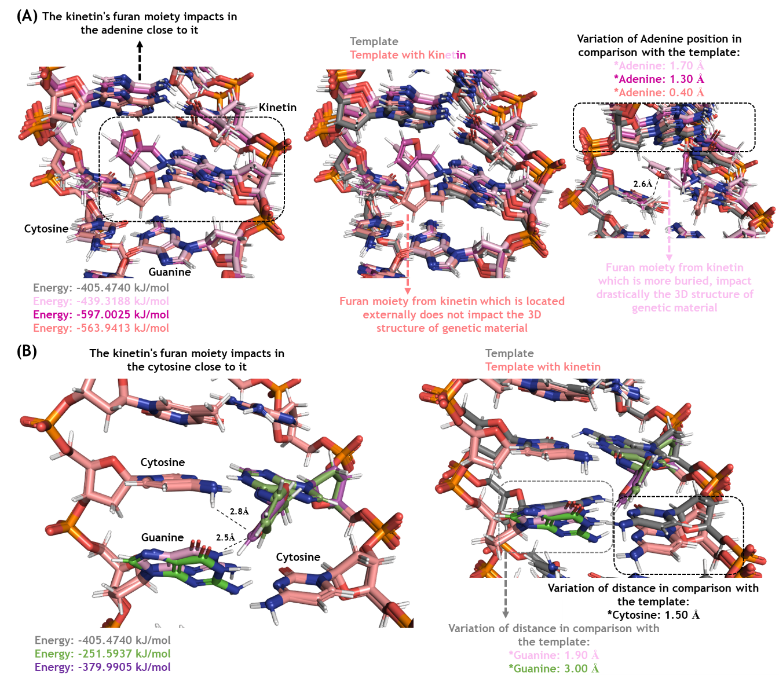
Extended Figure 4 - Molecular model of promiscuous pairing of tautomeric kinetin. A) Three conformations in which furfuryl from kinetin affects double-strand conformation with neighbor A. This model is in line with a possible steric hindrance of the RNA polymerase. B) Three conformations in which furfuryl from kinetin affects double-strand conformation with neighbor C and G. This model is in line with error-prone mechanism

Extended Table 2 – Pharmacological parameters for MB905 and control RdRp inhibitors alone and in combination with SARS-CoV-2 nsp14 inhibitors in Calu-3 cells

 | EC50 |  | EC90 |  | EC99
Drug | mean | SEM | mean | SEM | mean | SEM
Tenofovir | 4.3 | 2.1 | ND | ND | ND | ND
RDV | 0.09 | 0.002 | 0.4 | 0.03 | 1.1 | 0.2
Favipiravir | 7.8 | 1.2 | ND | ND | ND | ND
MK-4482 | 0.8 | 0.03 | 7 | 0.4 | 9 | 0.7
MB905 | 0.3 | 0.02 | 8 | 1.2 | ND | ND
DTG | 5.3 | 1.2 | ND | ND | ND | ND
RTG | 4.8 | 1.4 | ND | ND | ND | ND
Pibrentasvir | 0.7 | 0.2 | 4.2 | 0.6 | 19 | 2
Ombitasvir | 0.4 | 0.05 | 3.3 | 0.5 | 18 | 3
Daclatasvir | 0.7 | 0.08 | 3.8 | 1.2 | ND | ND
Tenofovir + DTG (5μM) | 0.5 | 0.03 | 7 | 1.2 | 9.8 | 0.2
RDV+DTG (5μM) | 0.09 | 0.004 | 0.4 | 0.03 | 0.9 | 0.2
Favipiravir + DTG (5μM) | 0.15 | 0.07 | 8 | 1.3 | 9.8 | 0.2
MK-4482 + DTG (5μM) | 0.03 | 0.004 | 8 | 1.2 | 9 | 0.7
MB905 + DTG (5μM) | 0.06 | 0.004 | 5 | 0.9 | 8.7 | 0.5
Tenofovir + RTG (5μM) | 0.4 | 0.02 | 8 | 1.5 | 9.5 | 0.1
RDV+RTG (5μM) | 0.08 | 0.002 | 0.5 | 0.08 | 1.2 | 0.1
Favipiravir + RTG (5μM) | 0.16 | 0.07 | 6 | 1.6 | 9.2 | 0.3
MK-4482 + RTG (5μM) | 0.01 | 0.002 | 7 | 1.4 | 9.1 | 0.5
MB905 + RTG (5μM) | 0.05 | 0.002 | 6 | 0.6 | 8.5 | 0.2
Tenofovir + Pibrentasvir (0.1μM) | 0.5 | 0.05 | 8 | 1.5 | ND | ND
RDV + Pibrentasvir (0.1μM) | 0.008 | 0.0009 | 0.07 | 0.03 | 0.3 | 0.09
Favipiravir + Pibrentasvir (0.1μM) | 0.5 | 0.03 | 8 | 0.5 | ND | ND
MK-4482 + Pibrentasvir (0.1μM) | 5.4 | 0.3 | 7 | 0.3 | 7.8 | 0.5
MB905 + Pibrentasvir (0.1μM) | 6.4 | 0.9 | 8 | 0.4 | ND | ND
Tenofovir + Ombitasvir (0,1μM) | 0.8 | 0.07 | 7 | 1.6 | 8.9 | 0.4
RDV + Ombitasvir (0.1μM) | 0.08 | 0.003 | 0.01 | 0.05 | 0.5 | 0.2
Favipiravir + Ombitasvir (0.1μM) | 0.15 | 0.04 | 8 | 0.4 | 9.5 | 0.4
MK-4482 + Ombitasvir (0.1μM) | 0.13 | 0.02 | 4 | 0.5 | 7.8 | 0.6
MB905 + Ombitasvir (0.1μM) | 0.3 | 0.04 | 8 | 1.3 | ND | ND
Tenofovir + Dacltasvir (0.5μM) | 0.01 | 0.004 | 6 | 1.2 | 7.5 | 0.5
RDV + Dacltasvir (0.5μM) | 0.008 | 0.0006 | 0.1 | 0.06 | 0.5 | 0.1
Favipiravir + Dacltasvir (0.5μM) | 0.12 | 0.05 | 8 | 0.5 | ND | ND
MK-4482 + Dacltasvir (0.5μM) | 0.02 | 0.008 | 3 | 0.4 | 8.1 | 0.3
MB905 + Dacltasvir (0.5μM) | 0.4 | 0.03 | 4 | 0.4 | 8.8 | 0.2

Extended Table 3: Mutagenicity results of MB-905 tested in the Ames test strains TA 97a, TA 98, TA100, TA102 and TA 1535. The test was performed in the absence and presence of the metabolic activation system (8% of S9 in the mixture with required co-factors.
Treatments | Concentration  (µg/mL) | TA 97a |  | TA 98 |  | TA 100 |  | TA 102 |  | TA 1535
Treatments | Concentration  (µg/mL) | -S9 | +S9 | -S9 | +S9 | -S9 | +S9 | -S9 | +S9 | -S9 | +S9
MB-905 | 8 | - | - | - | - | - | - | - | - | - | -
MB-905 | 40 | - | - | - | - | - | - | - | - | - | -
MB-905 | 200 | - | - | - | - | - | - | - | - | - | -
MB-905 | 1,000 | - | - | - | - | - | - | - | - | - | -
MB-905 | 5,000 | - | - | - | - | - | - | - | - | - | -
Positive Control | # | + | + | + | + | + | + | + | + | + | +
(-S9) = absence of the metabolic activation system; (+S9) = presence of the metabolic activation system; (-) = negative test; (+) = positive test. # Positive controls = 4-nitroquinoline-N-oxide (4NQO) 0.5 µg/plate: TA97a, TA98 and TA102 (-S9); sodium azide (AZS) 1.5 µg/plate: TA100 and TA 1535 (-S9); 2-aminofluorene (2-AF) 50 µg/plate: TA97a, TA98 and TA100 (+S9); 2-aminoanthracene (2-AA): 2.5 and 5 µg/plate: TA 1535 and TA102, respectively (+S9). Each group represents triplicate experiments.

Extended Table 4: Incidence of micronucleated polychromatic erythrocytes (MNPCE) and the ratio of polychromatic erythrocytes (PCE) to normochromatic erythrocytes in mice treated with MB-905.
Group | Dose  (mg/Kg) | Route | MNPCE/4,000 PCE  (Mean ± S.D.) | Ratio PCE/NCE  (Mean ± S.D.)
Negative Control | 0 | p.o. | 10.10 ± 4.89 | 1.33 ± 0.18
MB-905 | 32 | p.o. | 8.50 ± 4.50 | 1.26 ± 0.20
MB-905 | 125 | p.o. | 8.50 ± 3.81 | 1.43 ± 0.24
MB-905 | 500 | p.o. | 9.00 ± 2.45 | 1.26 ± 0.12
Positive Control  (Cyclophosphamide) | 25 | i.p. | 16.20 ± 6.03* | 1.44 ± 0.29
PCE = polychromatic erythrocytes; NCE = normochromatic erythrocytes; Ratio PCE/NCE means the cytotoxicity of compounds. MNPCE = micronucleated polychromatic erythrocytes evaluated in 4000 cells; *p<0.05, significantly different from the negative control by Kruskal-Wallis test. p.o. = per os; i.p. = intraperitoneal. Negative control: 5% Tween 80 and 95% PEG 400 (polyethylene glycol 400). Data were expressed as mean ± SD (standard deviation). (n = 10).

