Case 1 of surgery only group (during surgery)
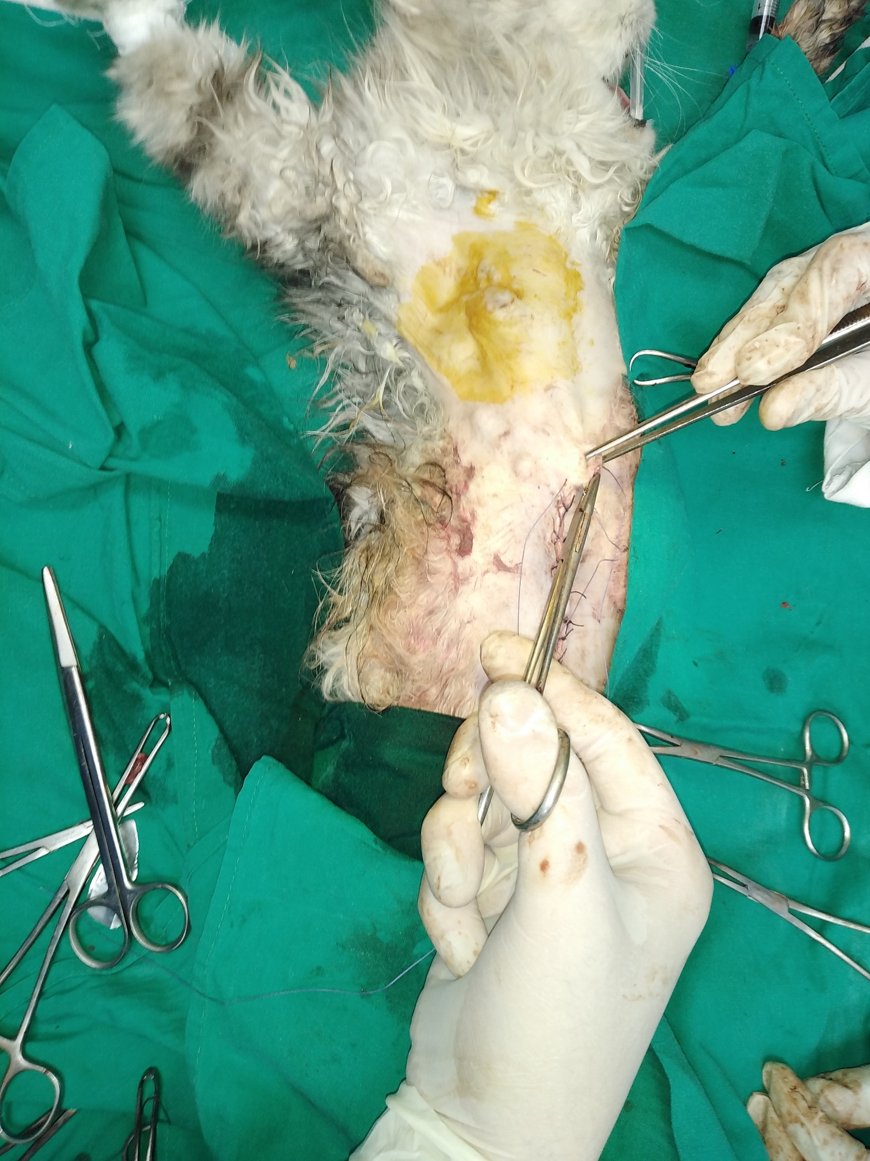
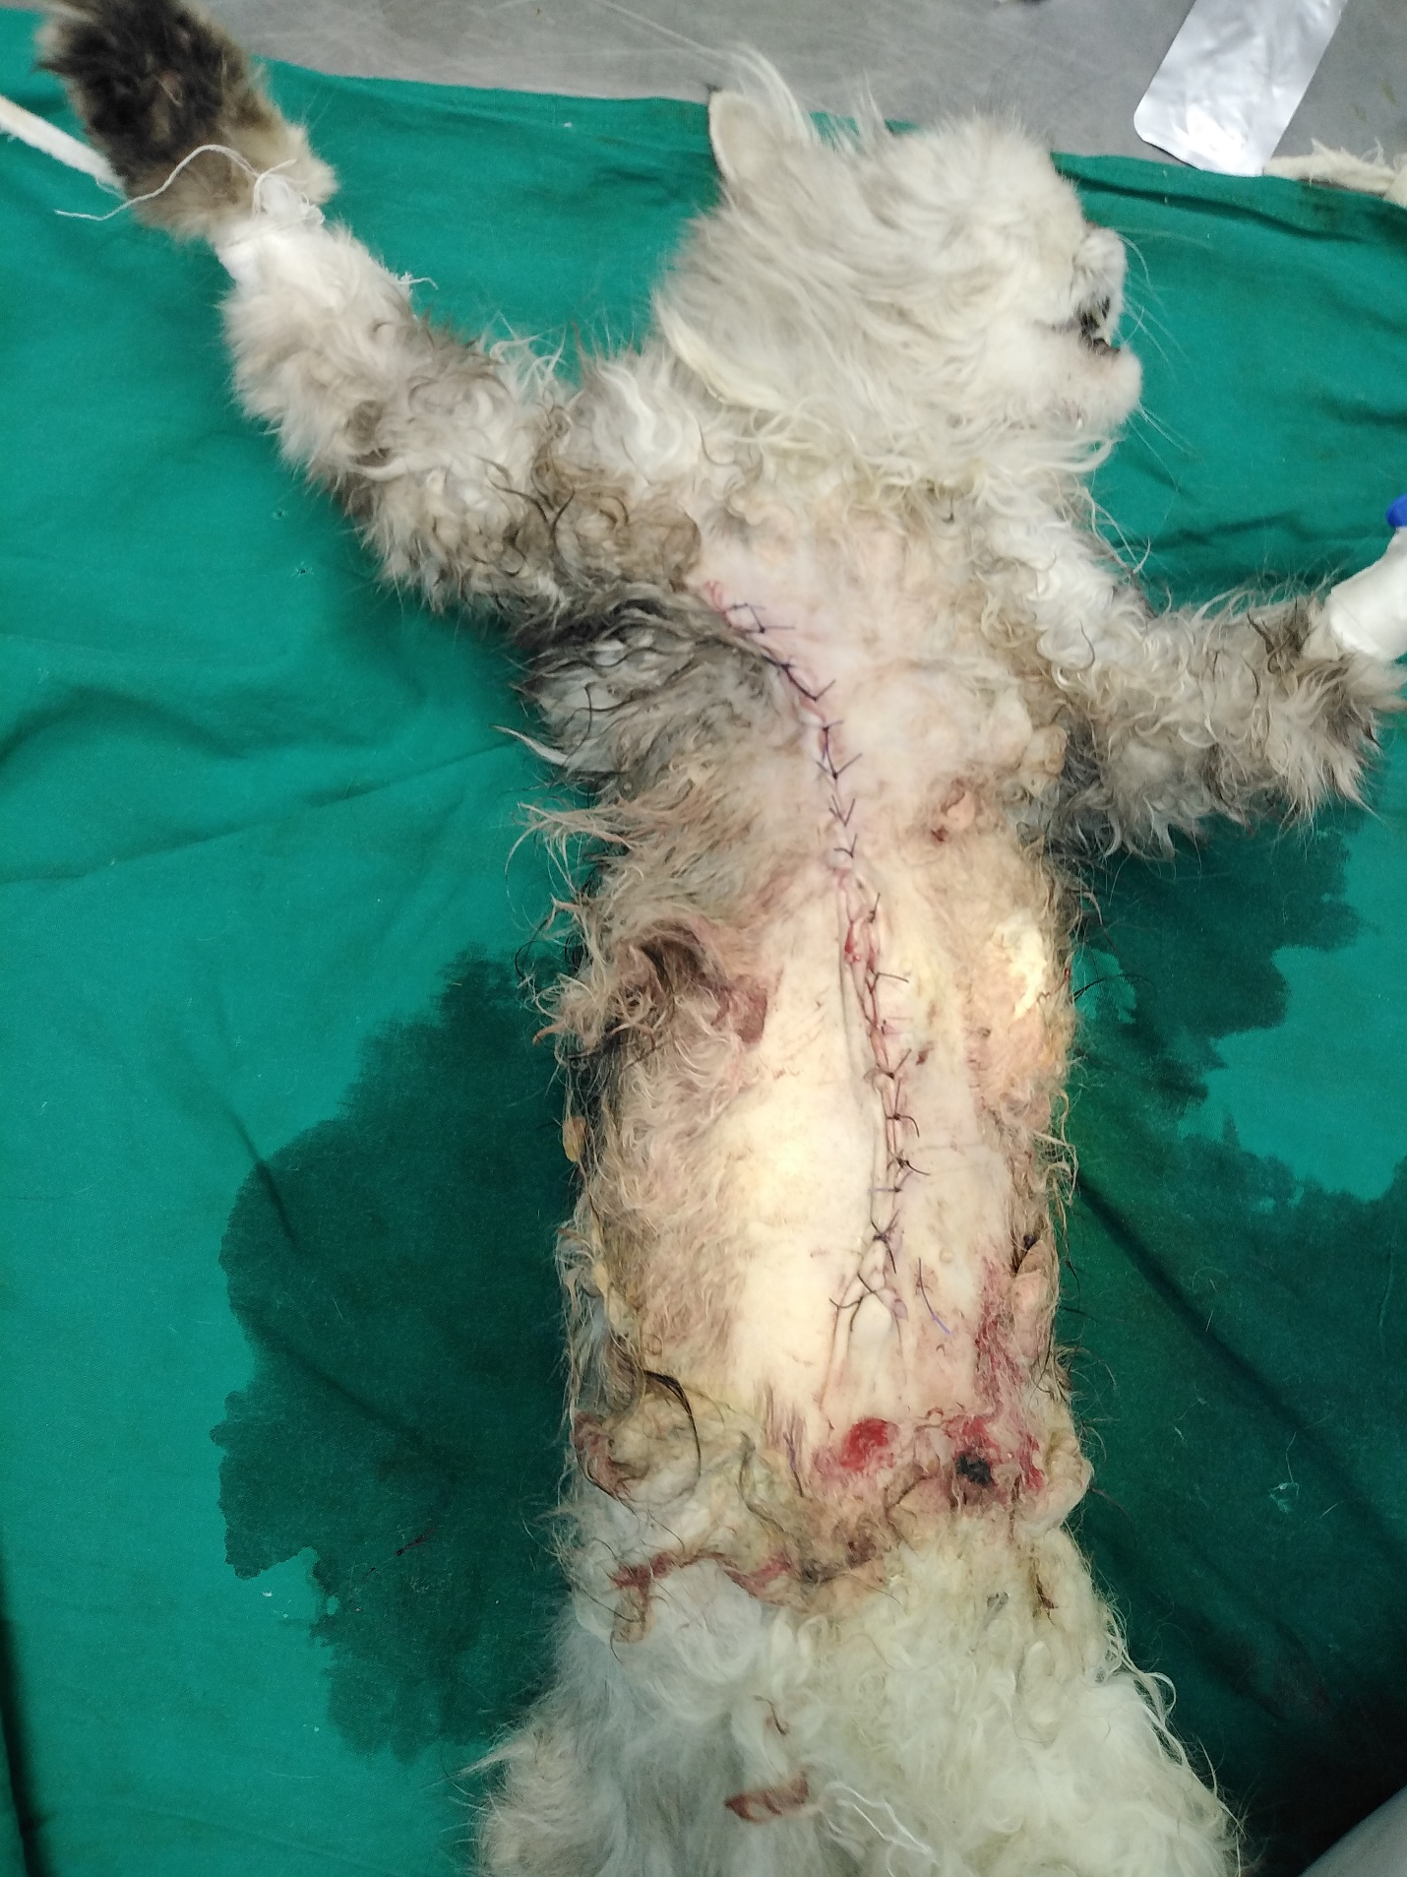

Case 1 of surgery only group (after 1.5 month of surgery)
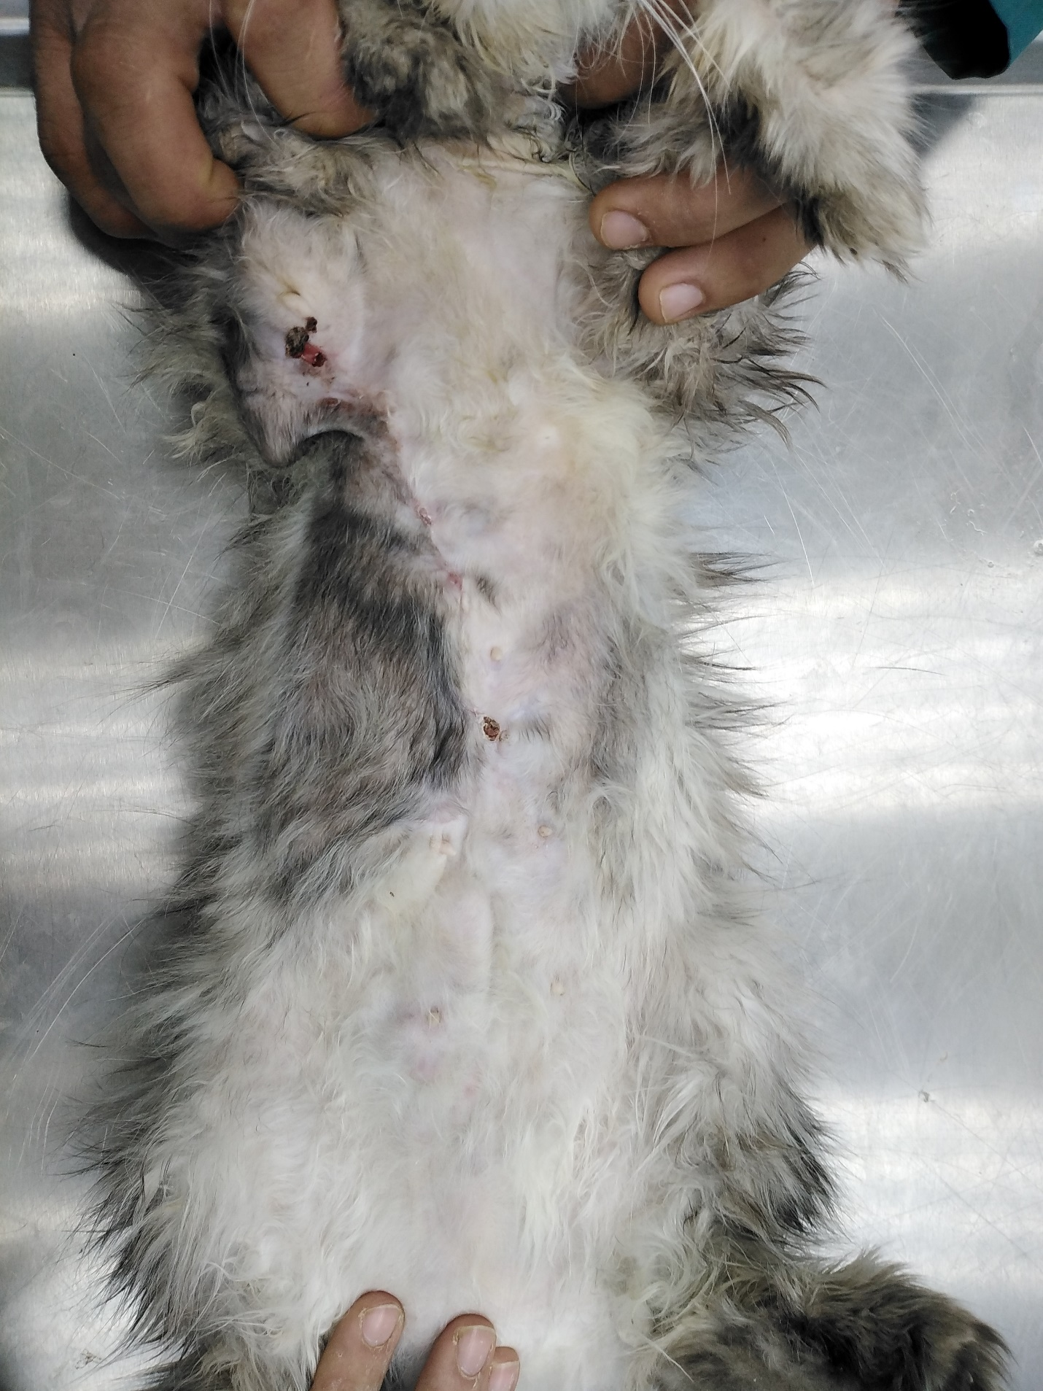
Case 2 of surgery only group (before surgery)
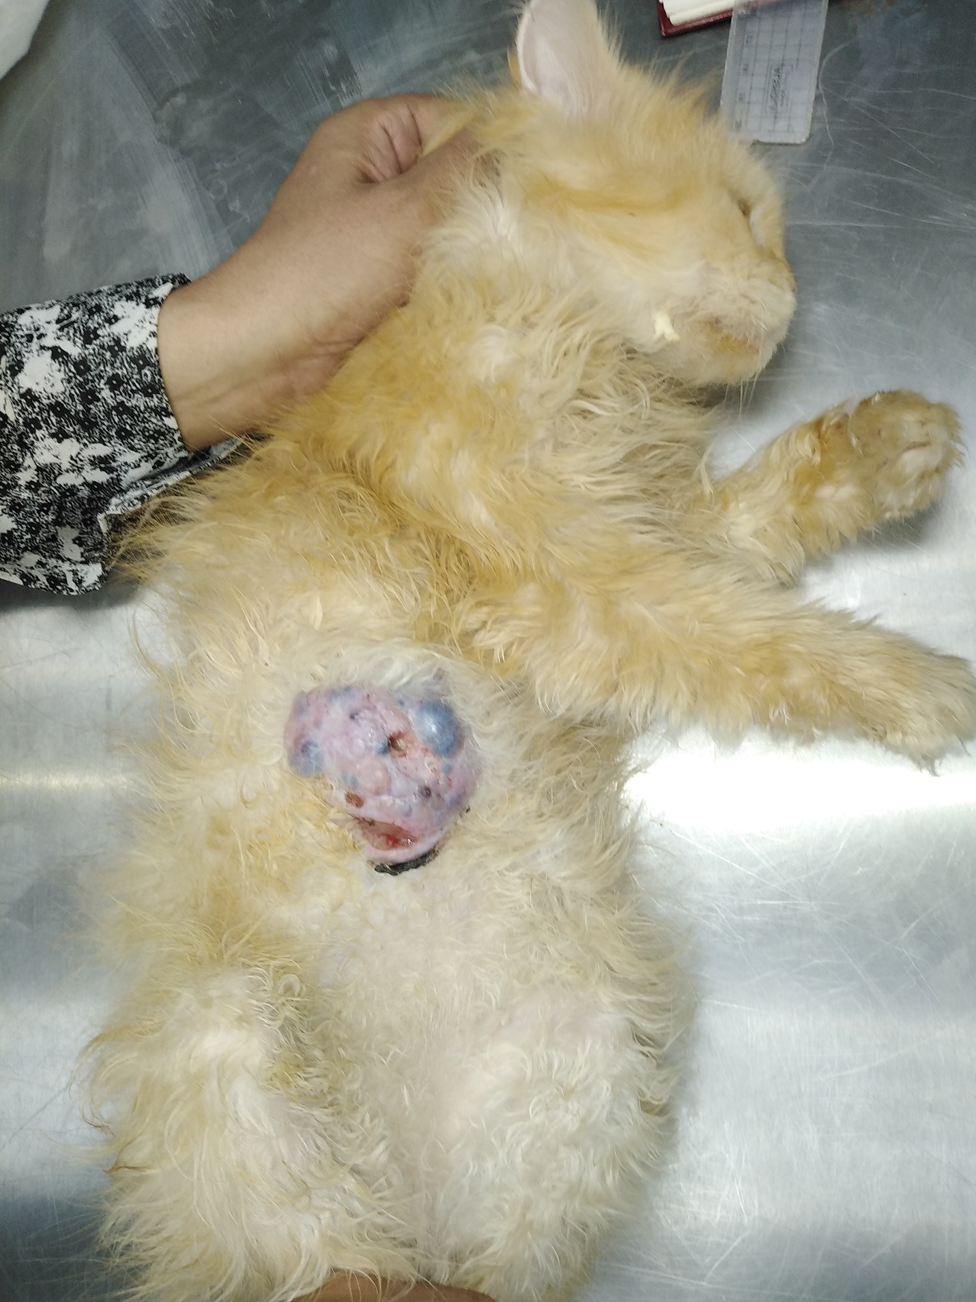
Case 2 of surgery only group (after 2 weeks of surgery)
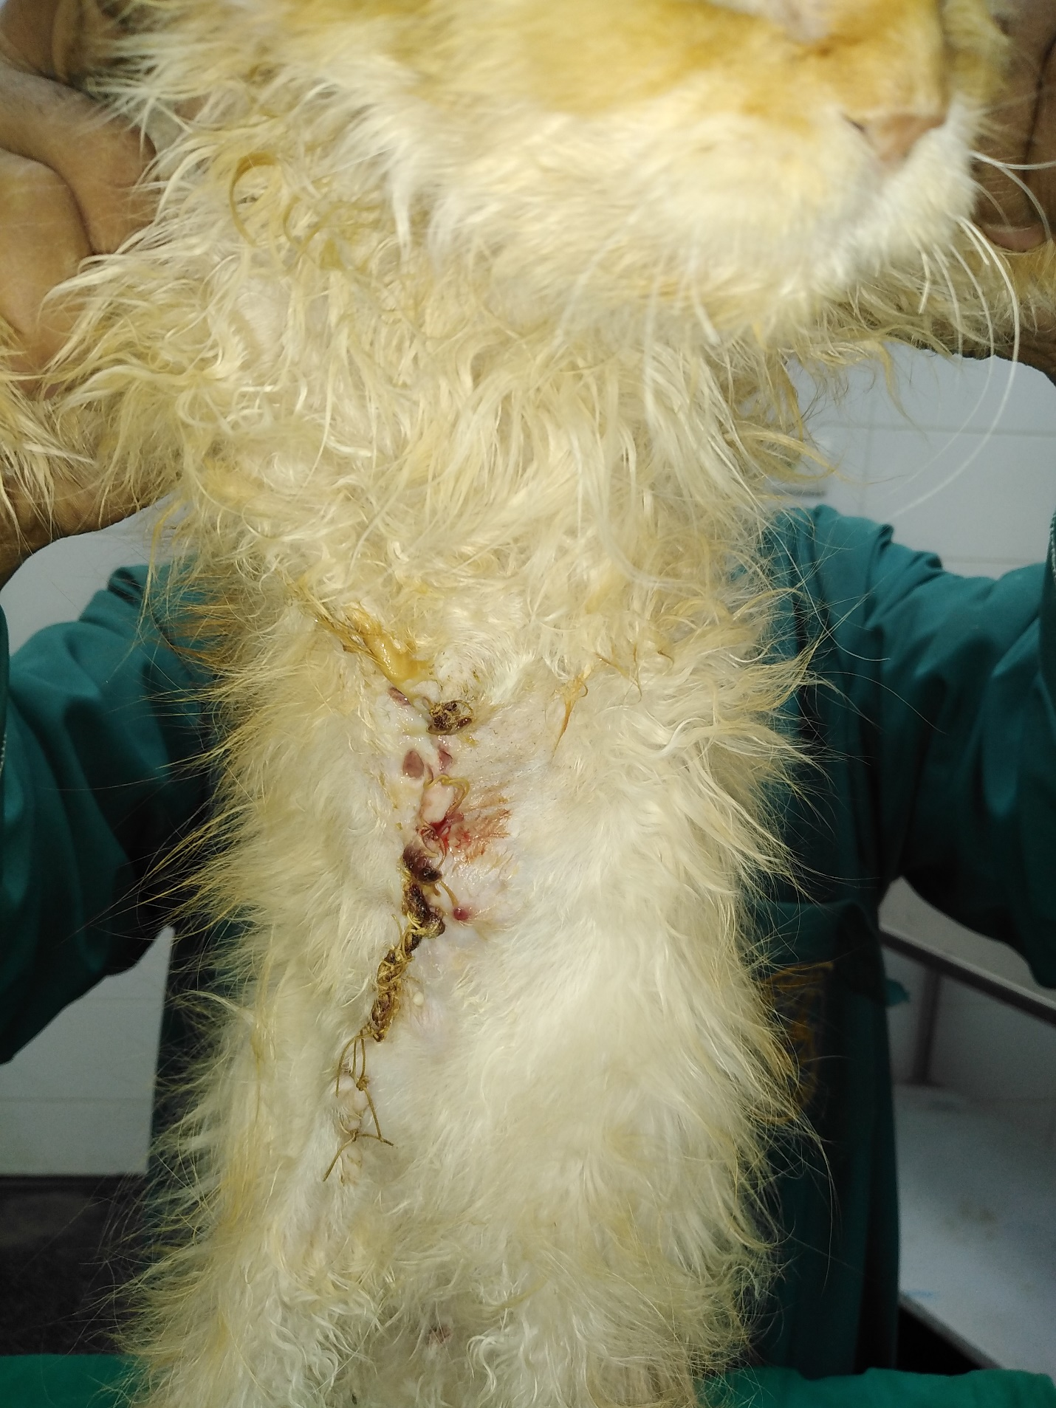
Case 3 of surgery only group (directly after surgery)
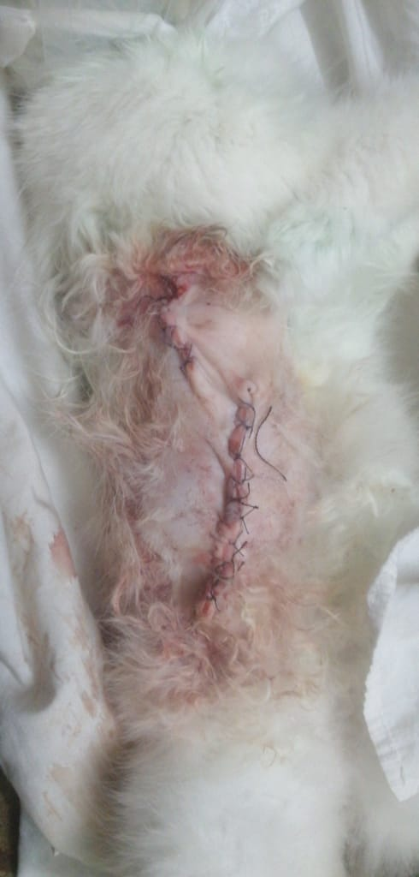

Case 3 of surgery only group (after 1.5 month of surgery)
