Case 1 of combination group (after 1 month of surgery)
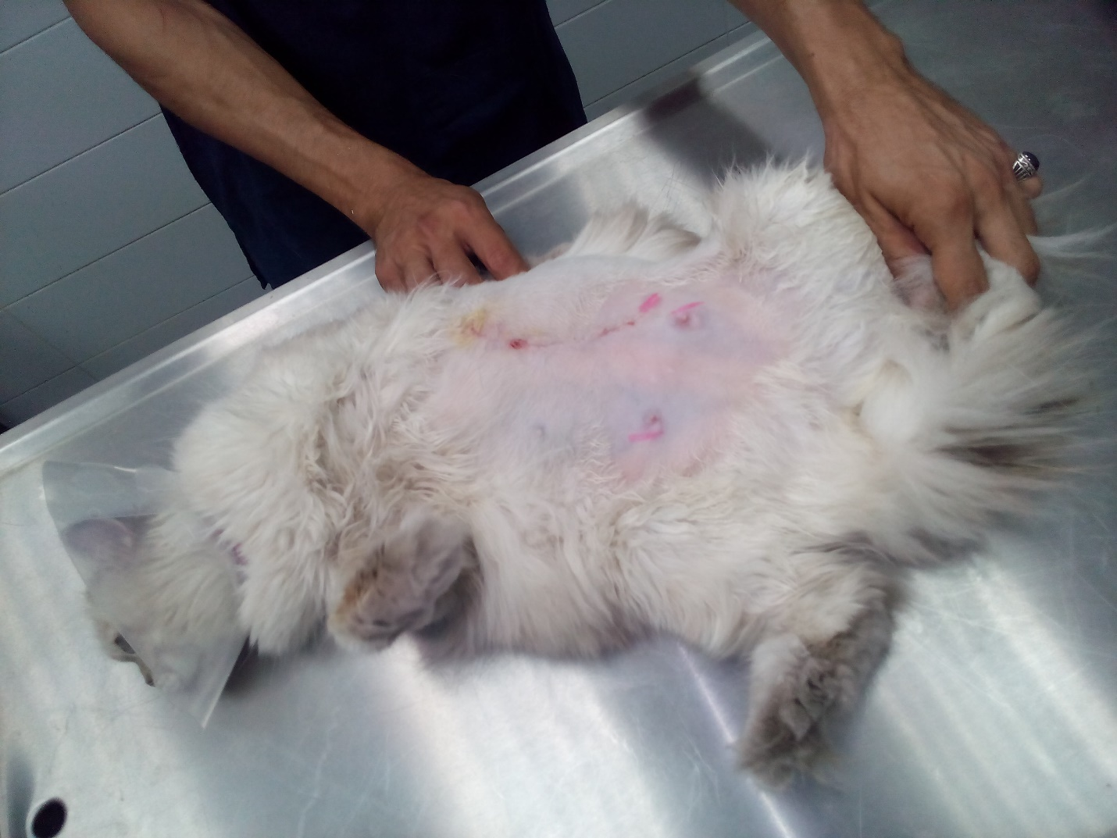
Case 2 of combination group (before surgery)
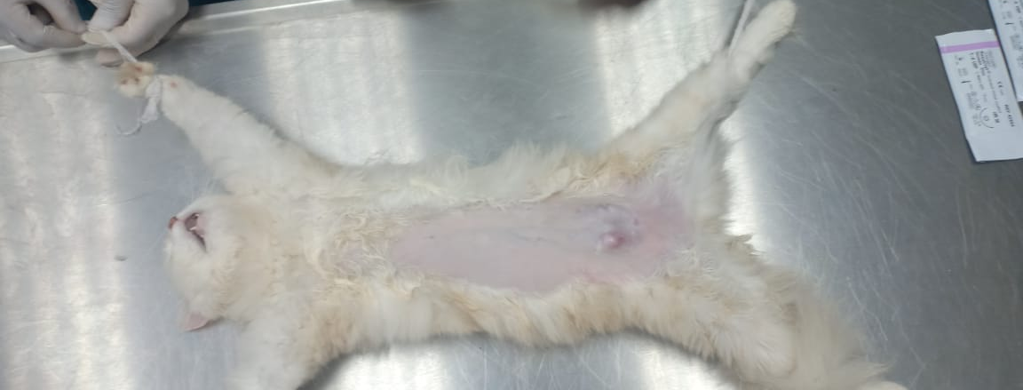

Case 2 of combination group (during surgery and application of PPTT)
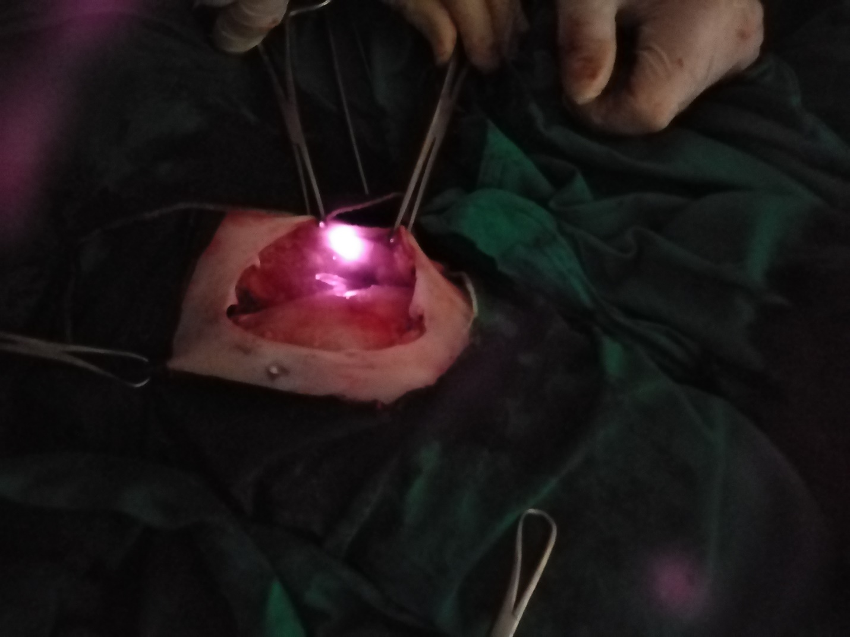

Case 2 of combination group (after 3 months of surgery)
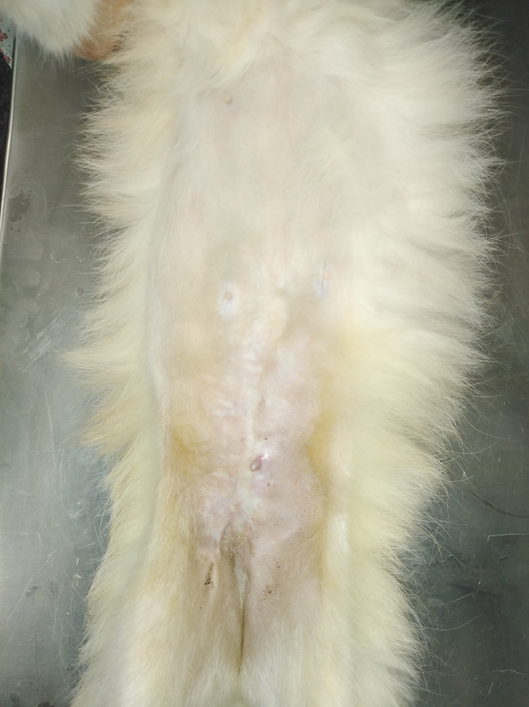
Case 3 of combination group (after 1 month of surgery)
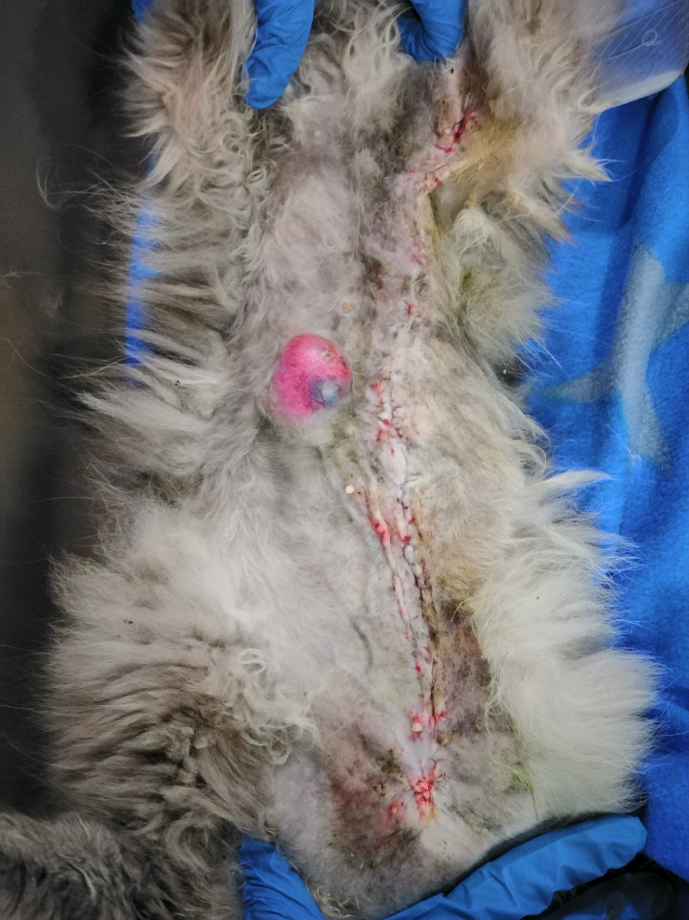
Case 4 of combination group (before surgery)
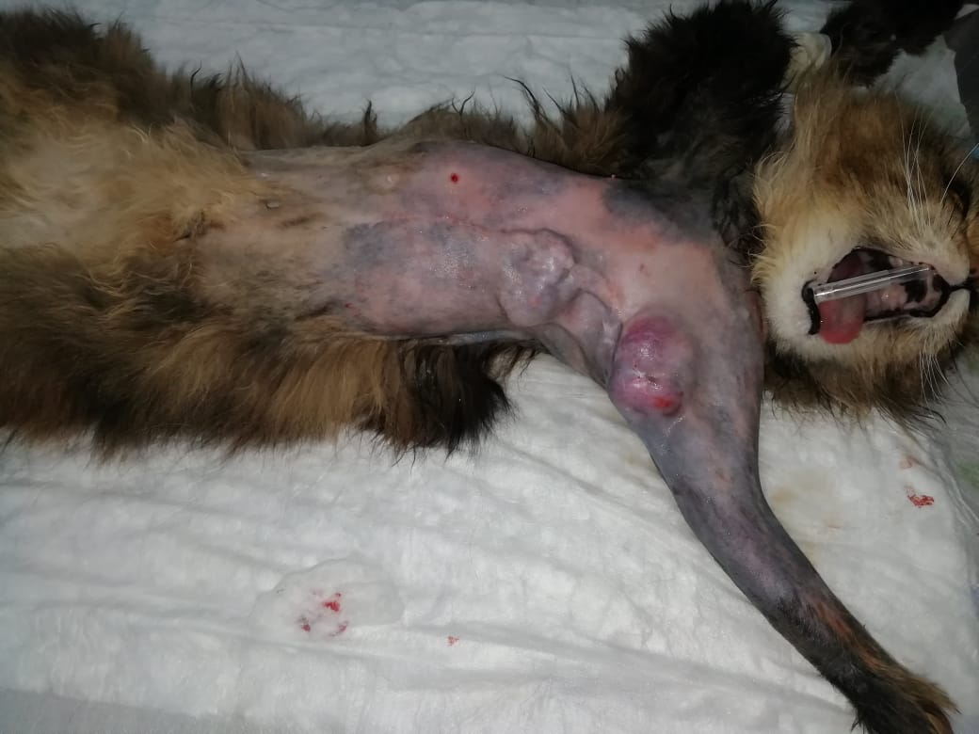

Case 4 of combination group (0.75 month after surgery)
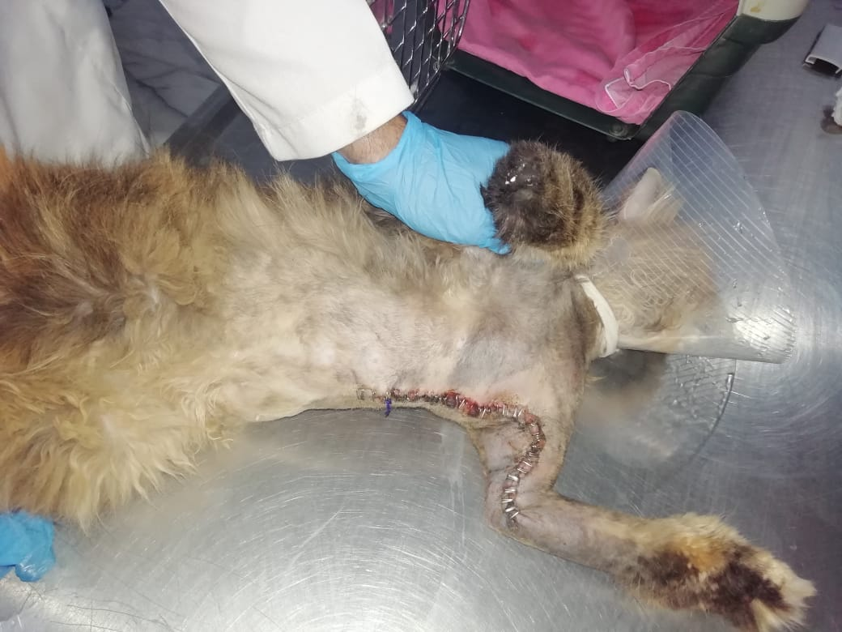

Case 5 of combination group (after 0.5 month of surgery)
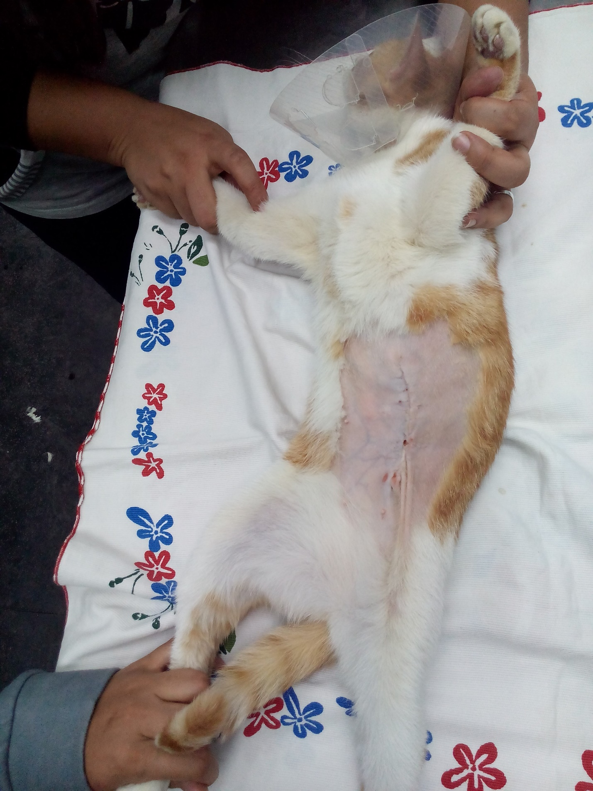

Case 6 of combination group (before surgery)
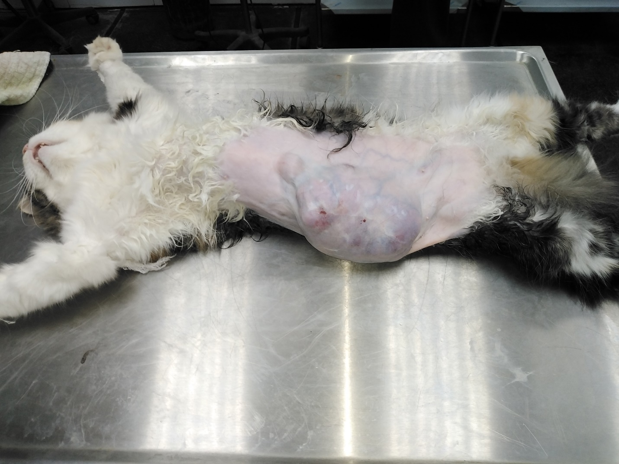

Case 6 of combination group (after surgery)
