The origin of transparent and non-transparent white pumice: A case study of the 52ka Maninjau caldera forming eruption, Indonesia
Indranova Suhendro¹, Atsushi Toramaru¹, Agung Harijoko^{2,3}, Haryo Edi Wibowo^{2,3}
¹Department of Earth and Planetary Sciences, Graduate School of Science, Kyushu University, Nishiku, 744, Motooka, Fukuoka, 819-0395, Japan
²Department of Geological Engineering, Faculty of Engineering, Universitas Gadjah Mada, Jl. Grafika no.2, Yogyakarta, Indonesia
³Centre for Disaster Studies, Universitas Gadjah Mada, Jl. Mahoni C-16, Bulaksumur, Yogyakarta, Indonesia
Corresponding author: Indranova Suhendro (indranovasuhendro10@gmail.com)

Supplementary material
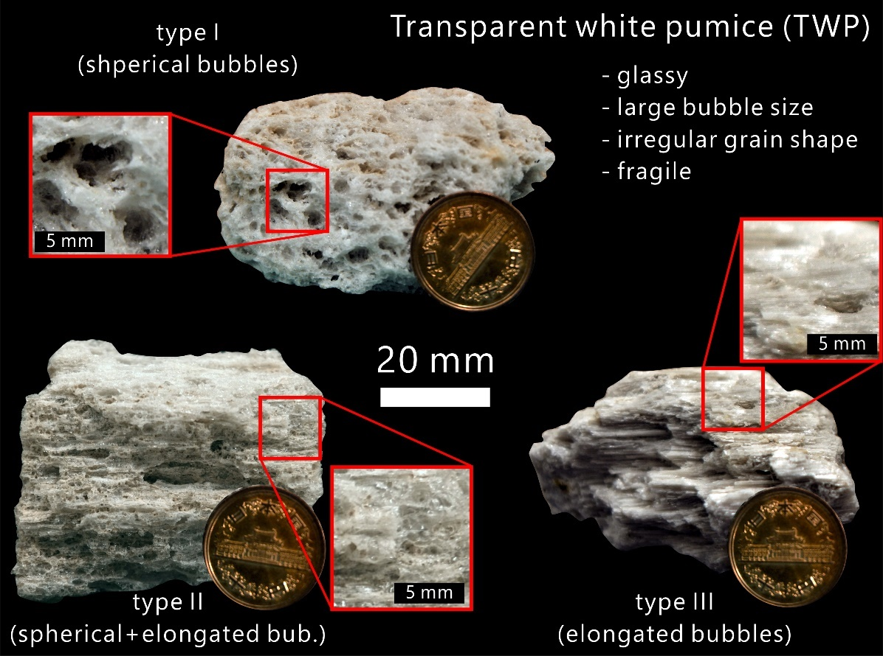
- Transparent and non-transparent pumices: how different?

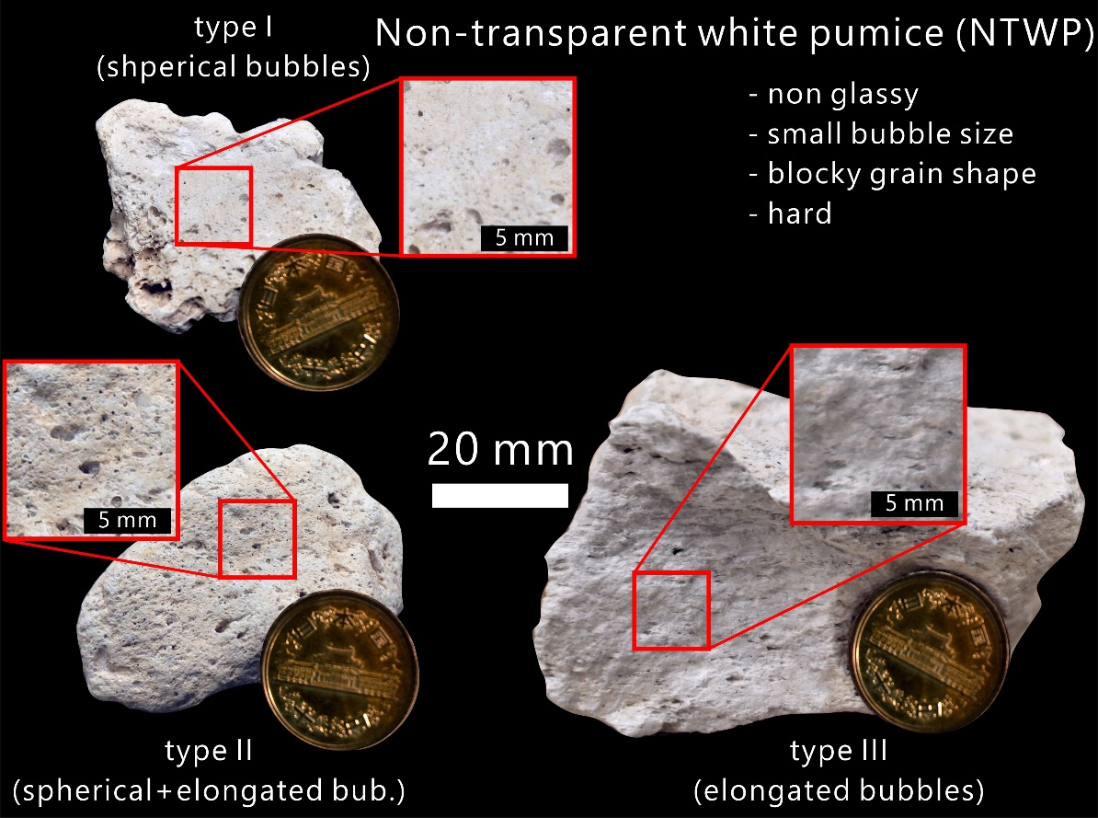

Figure 1S. Representative sample images of transparent white pumice (TWP, upper image) and non-transparent white pumice (NTWP, lower image). TWP is typically glass-like, dominated in large vesicles, having irregular grain shape, and fragile. Conversely, NTWP is apparently non-glassy, lack of large vesicles, blocky in grain shape, and hard
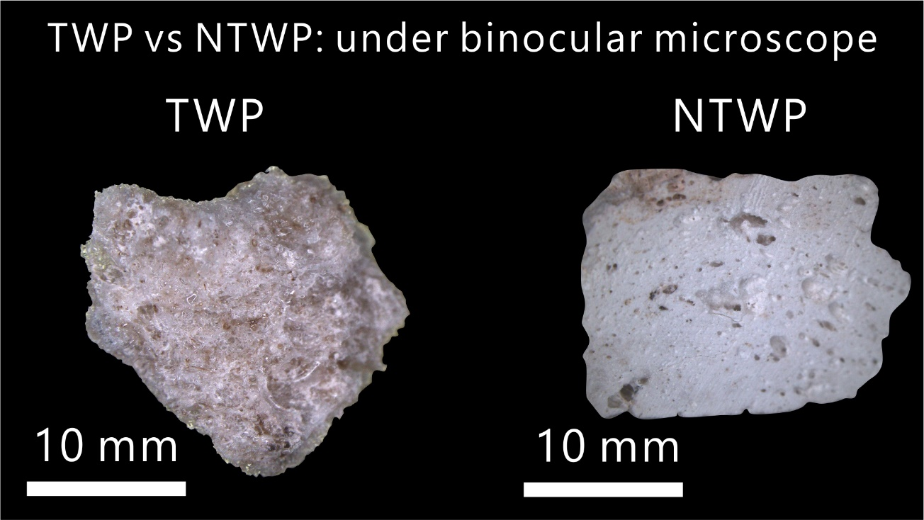

Figure 2S. Representative selected image of TWP and NTWP under the transmitted light from binocular microscope.
- Componentry result
Table 1DR. Componentry of deposits from the 52ka Maninjau caldera forming eruption
Location, unit | Number of counted grains  (2 - >32 mm) | Transparent white pumice |  |  | Non-transparent white pumice |  |  | Grey pumice  (%) | Banded pumice  (%) | Lithic  (%) | Free crystal  (%)
Location, unit | Number of counted grains  (2 - >32 mm) | TWP  I  (%) | TWP II  (%) | TWP III  (%) | NTWP I  (%) | NTWP II  (%) | NTWP III  (%)
1 (E),  unit 1 | 992 | 0 | 1.8 | 75.1 | 0 | 0 | 21.8 | 0 | 0 | 1.8 | 0.1
2 (E),  unit 1 | 1350 | 0 | 2.2 | 75.4 | 0 | 0 | 20.9 | 0 | 0 | 2.0 | 0.1
17 (E),  unit 2 | 2558 | 33.6 | 50.9 | 1.6 | 0 | 0 | 8.5 | 0 | 0 | 4.1 | 1.1
16 (N), unit 2 | 2374 | 19.6 | 39.1 | 22.6 | 0 | 0 | 10.6 | 0 | 0 | 6.2 | 1.7
11 (E), unit 3 | 3923 | 25.2 | 49.7 | 3.0 | 0 | 0 | 7.5 | 3.9 | 0.9 | 9.6 | 1.1
15 (N), unit 3 | 2477 | 1.6 | 17.9 | 29.6 | 0 | 1.3 | 25.9 | 6.1 | 3.9 | 12.7 | 0.8
6 (E), unit 4 | 4598 | 8.9 | 8.5 | 9.6 | 0 | 0 | 34.0 | 3.9 | 10.3 | 23.6 | 1.1
22 (S), unit 4 | 7794 | 3.2 | 13.1 | 8.5 | 1.7 | 3.2 | 40.6 | 5.7 | 3.6 | 23.5 | 0.3
12 (W), unit 4 | 8751 | 0.11 | 2.0 | 3.7 | 0 | 0.16 | 47.4 | 4.6 | 16.5 | 21.0 | 1.2
13 (W), unit 4 | 6096 | 2.0 | 2.8 | 6.4 | 0.8 | 3.3 | 41.1 | 2.0 | 11.8 | 26.9 | 2.8
14 (W), unit 4 | 6179 | 0.1 | 3.4 | 5.6 | 6.0 | 2.1 | 50.5 | 3.1 | 4.9 | 18.1 | 0.8

- Obtaining 2D-bubble size distribution (BSD)
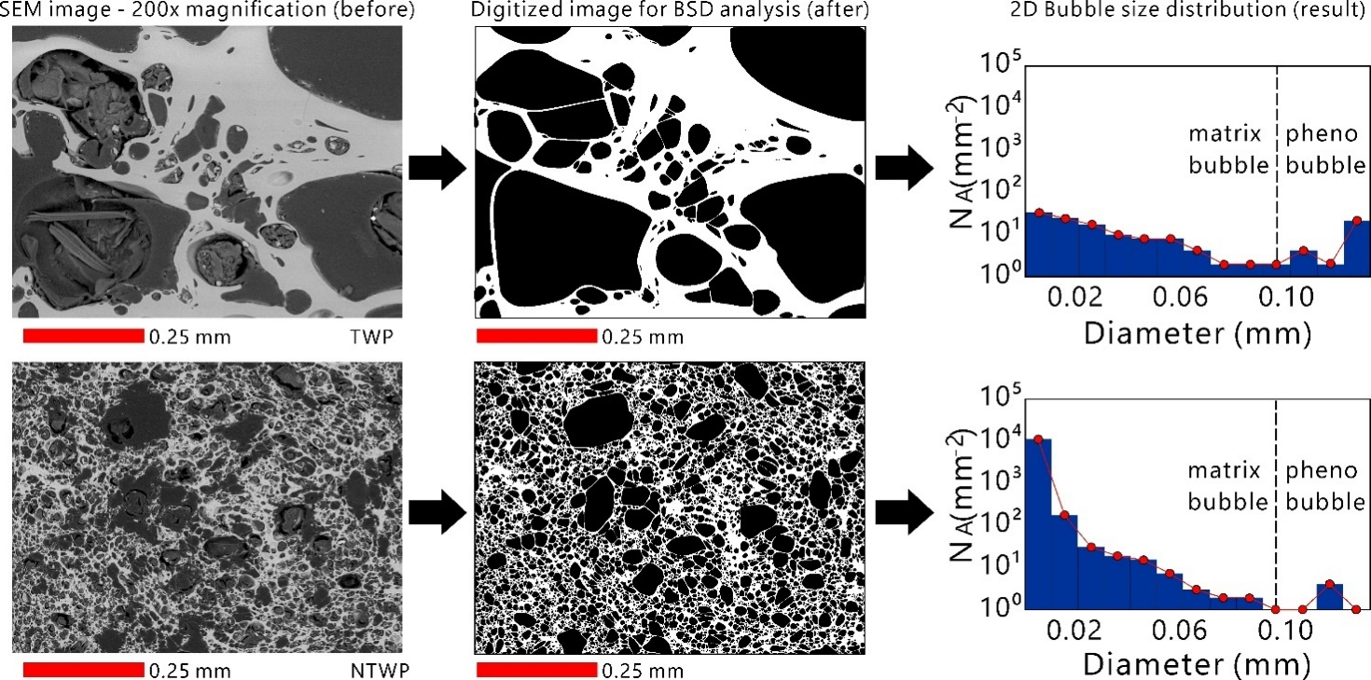

Figure 3S. 200x image magnification was chosen as it is capable to identify the smallest size of pheno-bubble and largest size of matrix-bubble. Next, we digitize the observed vesicles and make corrections for coalesced bubbles by manually separating the vesicle bodies. Correcting each bubble morphologies from bubble coalescence is highly important in order to represent the actual distribution value of the bubble size, before the bubble coalescence occur. Upper image is the example of TWP, while lower image is the example of NTWP. Hereafter, the digitized images were processed by using Image-J software to obtain the area of vesicle. The results were plotted as number density (N_{A}) curves, forming 2D-bubble size distribution (BSD).

- Obtaining pheno-bubble number density (PBND)
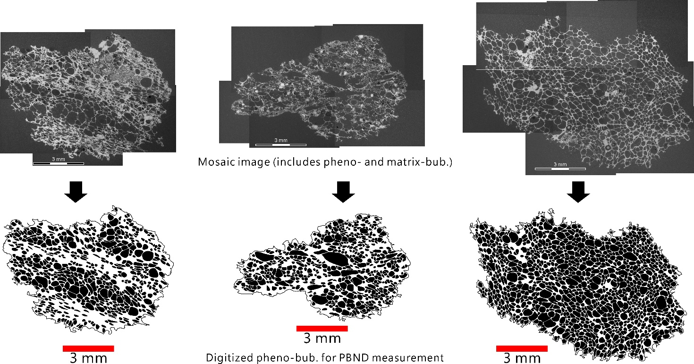

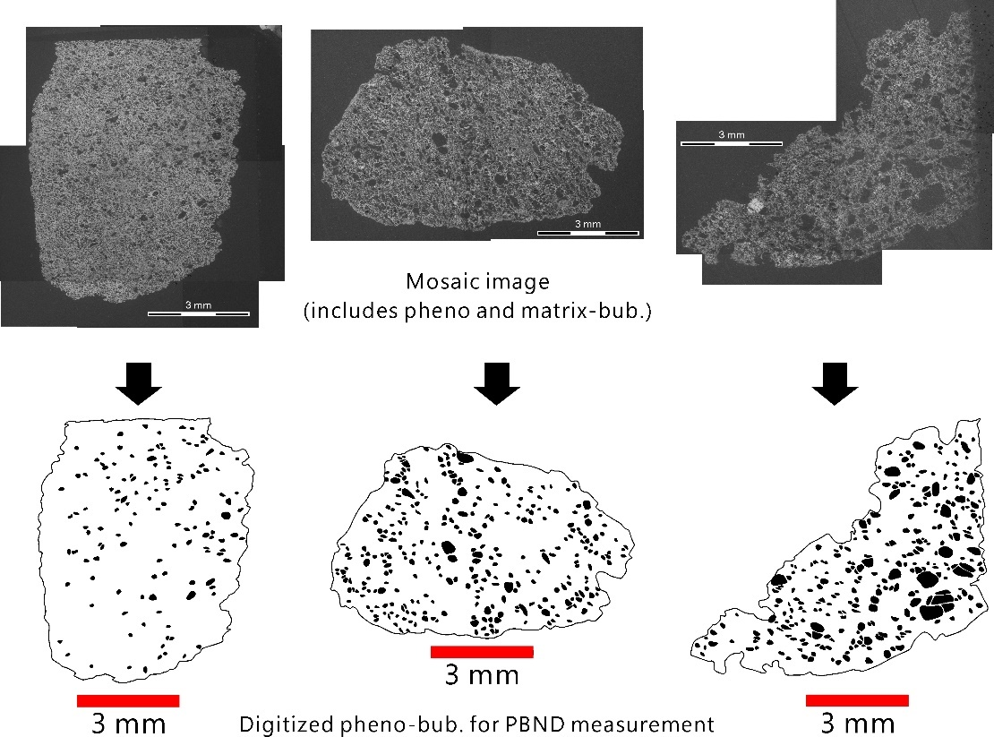

Figure 4S. Selected images of TWP (upper) and NTWP (lower) for PBND measurement. Mosaic image was chosen for PBND measurement. Based on our BSDs data, we quantitatively describe pheno-bubble as bubbles larger than 0.1 mm in diameter. Here, we manually digitize all bubbles which correspond to pheno-bubble (>0.1 mm diameter, about 0.01 mm²). We also make corrections for coalesced bubbles by manually separating the vesicle bodies. Hereafter, the digitized images were processed by using Image-J software to obtain the number and diameter of vesicle. The results were used in order to obtain the 3D-PBND value ($N_{v}$). $PBND (N_{v})=(N_{ap}/d_{p}$) x $(1/1-φ_{bv}$), where $N_{ap}$ is number density per unit area of pheno-bubble, $d_{p}$ is the average pheno-bubble size, $φ_{bv}$ is bulk vesicularity.
- Obtaining matrix-bubble number density
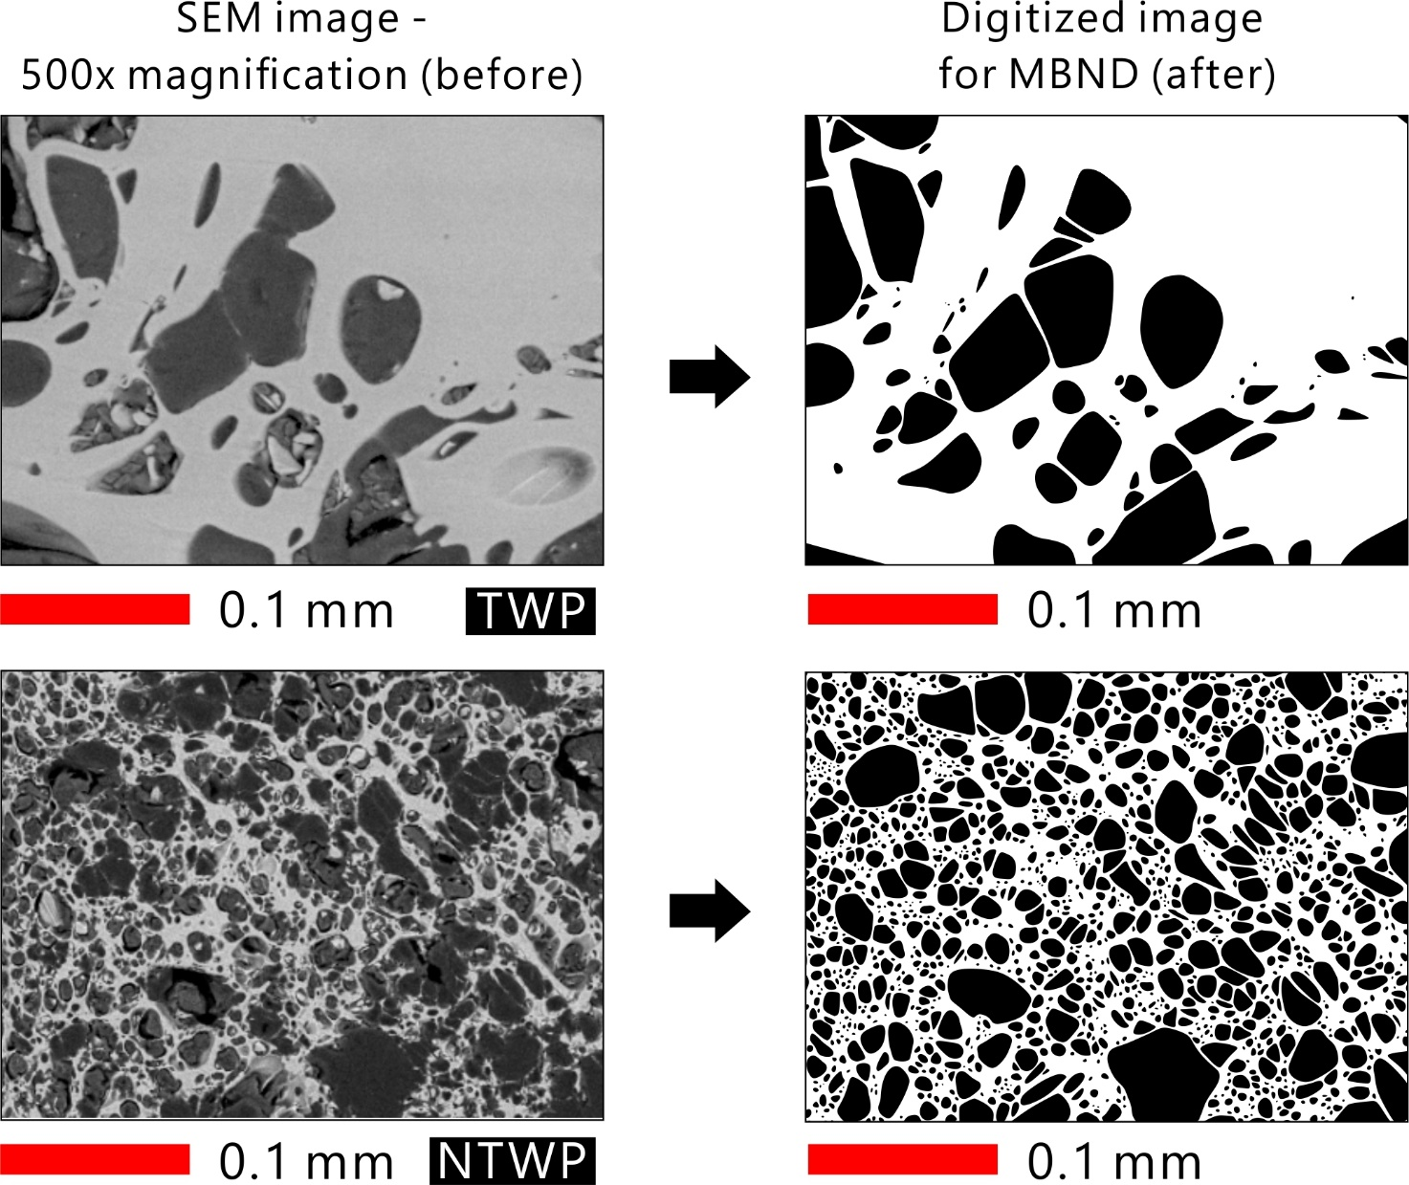

Figure 5S. Selected images of TWP (upper) and NTWP (lower) for MBND measurement. Phenobubble-free image with 500x image magnification was chosen for MBND measurement. We manually digitize all bubbles and make corrections for coalesced bubbles by manually separating the vesicle bodies. Hereafter, the digitized images were processed by using Image-J software to obtain the number and diameter of vesicle. The results were used in order to obtain the 3D-MBND value ($N_{v}$). $MBND (N_{v})=(N_{am}/d_{m}$) x $(1/1-φ_{mv}$), where $N_{am}$ is number density per unit area of matrix-bubble, $d_{m}$ is the average matrix-bubble size, $φ_{mv}$ is groundmass or matrix vesicularity.

- Textural data of transparent white pumice (TWP)
Table 2S. Textural parameters of TWP (number of samples = 45)
Location, unit, pumice type | Bulk density (gr/cm³) | Bulk vesicularity  (%) | Pheno-bubble |  |  | Matrix-bubble |  |  | Phenocryst  Content (%)
Location, unit, pumice type | Bulk density (gr/cm³) | Bulk vesicularity  (%) | Average diameter (mm) | Fraction  (%) | Nv  (m⁻³) | Average diameter (mm) | Fraction  (%) | Nv  (mm⁻³) | Phenocryst  Content (%)
2 (E), unit 1  TWP II | 0.83 | 60.5 | 0.30 | 56.5 | 1.8x10¹¹ | 0.04 | 4.0 | 7.5x10¹¹ | 0
2 (E), unit 1  TWP II | 0.60 | 70.5 | 0.27 | 54.9 | 1.6x10¹¹ | 0.035 | 6.6 | 1.3x10¹² | 7.9
2 (E), unit 1  TWP II | 0.56 | 75.3 | 0.28 | 70.0 | 1.4x10¹¹ | 0.037 | 5.3 | 1.4x10¹² | 18.2
2 (E), unit 1  TWP III | 1.12 | 48.2 | 0.23 | 42.6 | 1.2x10¹¹ | 0.022 | 12.4 | 5.8x10¹³ | 0
2 (E), unit 1  TWP III | 0.92 | 58.1 | 0.24 | 61.6 | 2.0x10¹¹ | 0.035 | 8.4 | 1.8x10¹³ | 21.0
2 (E), unit 1  TWP III | 0.77 | 67.0 | 0.23 | 45.6 | 1.4x10¹¹ | 0.021 | 29.4 | 2.0x10¹⁴ | 23.6
16 (N), unit 2  TWP I | 0.84 | 62.0 | 0.29 | 58.2 | 1.9x10¹¹ | 0.039 | 3.8 | 7.8x10¹¹ | 0
16 (N), unit 2  TWP I | 0.56 | 76.0 | 0.30 | 71.0 | 1.8x10¹¹ | 0.041 | 5.0 | 6.9x10¹¹ | 0
16 (N), unit 2  TWP I | 0.46 | 80.3 | 0.30 | 76.5 | 2.5x10¹¹ | 0.042 | 4.5 | 5.2x10¹¹ | 0
16 (N), unit 2  TWP III | 1.07 | 51.0 | 0.29 | 48.0 | 1.8x10¹¹ | 0.039 | 3.0 | 7.0x10¹¹ | 0
16 (N), unit 2  TWP III | 0.77 | 61.1 | 0.22 | 48.4 | 1.8x10¹¹ | 0.025 | 15.6 | 4.3x10¹³ | 8.0
16 (N), unit 2  TWP III | 0.66 | 68.0 | 0.26 | 62.0 | 2.5x10¹¹ | 0.031 | 8.0 | 1.0x10¹² | 0
11 (E), unit 3  TWP II | 0.75 | 69.6 | 0.32 | 73.8 | 2.0x10¹¹ | 0.042 | 4.3 | 4.9x10¹¹ | 0
11 (E), unit 3  TWP II | 0.55 | 75.1 | 0.30 | 77.0 | 2.5x10¹¹ | 0.042 | 5.0 | 8.2x10¹¹ | 0
11 (E), unit 3  TWP II | 0.42 | 81.9 | 0.31 | 73.0 | 1.4x10¹¹ | 0.040 | 9.0 | 1.2x10¹² | 0
11 (E), unit 3  TWP III | 1.06 | 52.0 | 0.28 | 48.5 | 1.6x10¹¹ | 0.038 | 3.5 | 6.8x10¹¹ | 0
11 (E), unit 3  TWP III | 0.86 | 62.1 | 0.25 | 62.0 | 1.9x10¹¹ | 0.031 | 3.1 | 1.1x10¹² | 0
11 (E), unit 3  TWP III | 0.61 | 70.3 | 0.26 | 56.6 | 1.4x10¹¹ | 0.025 | 13.7 | 4.1x10¹³ | 0
15 (N), unit 3  TWP II | 0.82 | 58.4 | 0.18 | 38.3 | 1.8x10¹¹ | 0.009 | 20.1 | 8.2x10¹⁴ | 0
15 (N), unit 3  TWP II | 0.67 | 64.2 | 0.21 | 47.2 | 1.8x10¹¹ | 0.028 | 17.0 | 6.0x10¹² | 0
15 (N), unit 3  TWP II | 0.6 | 70.0 | 0.28 | 64.8 | 1.9x10¹¹ | 0.028 | 5.2 | 2.3x10¹² | 0
15 (N), unit 3  TWP III | 1.08 | 50.6 | 0.17 | 24.5 | 1.3x10¹¹ | 0.006 | 21.5 | 1.7x10¹⁵ | 0
15 (N), unit 3  TWP III | 0.74 | 63.7 | 0.19 | 33.1 | 1.5x10¹¹ | 0.016 | 30.6 | 2.3x10¹⁴ | 4.3
15 (N), unit 3  TWP III | 0.65 | 66.0 | 0.21 | 36.2 | 1.5x10¹¹ | 0.023 | 29.8 | 4.3x10¹³ | 0.2
22 (S), unit 4  TWP I | 0.74 | 68.0 | 0.28 | 24.5 | 1.3x10¹¹ | 0.039 | 5.0 | 9.6x10¹¹ | 11.3
22 (S), unit 4  TWP I | 0.57 | 75.0 | 0.30 | 33.1 | 1.5x10¹¹ | 0.040 | 5.0 | 8.5x10¹¹ | 30.6
22 (S), unit 4  TWP I | 0.40 | 83.0 | 0.34 | 36.2 | 1.5x10¹¹ | 0.040 | 8.3 | 1.3x10¹² | 0
22 (S), unit 4  TWP II | 0.79 | 62.0 | 0.29 | 65.0 | 1.3x10¹¹ | 0.027 | 8.0 | 6.1x10¹² | 2.3
22 (S), unit 4  TWP II | 0.49 | 78.5 | 0.28 | 62.3 | 1.4x10¹¹ | 0.029 | 16.2 | 1.1x10¹³ | 8.3
22 (S), unit 4  TWP II | 0.47 | 81.5 | 0.32 | 72.3 | 1.5x10¹¹ | 0.036 | 9.2 | 1.1x10¹² | 0
22 (S), unit 4  TWP III | 1.18 | 48.9 | 0.17 | 28.2 | 1.5x10¹¹ | 0.005 | 20.7 | 2.9x10¹⁵ | 0.5
22 (S), unit 4  TWP III | 0.75 | 63.7 | 0.21 | 43.8 | 1.6x10¹¹ | 0.020 | 19.9 | 6.4x10¹³ | 1.2
22 (S), unit 4  TWP III | 0.68 | 68.0 | 0.23 | 59.4 | 1.8x10¹¹ | 0.021 | 8.6 | 3.0x10¹³ | 5.2
12 (W), unit 4  TWP III | 0.94 | 54.9 | 0.19 | 33.5 | 1.3x10¹¹ | 0.006 | 21.4 | 4.3x10¹⁵ | 0.6
12 (W), unit 4  TWP III | 0.62 | 67.0 | 0.26 | 59.6 | 1.4x10¹¹ | 0.023 | 7.4 | 7.2x10¹³ | 2.5
12 (W), unit 4  TWP III | 0.49 | 75.0 | 0.23 | 54.3 | 1.6x10¹¹ | 0.035 | 12.8 | 2.5x10¹³ | 0
13 (W), unit 4  TWP II | 0.81 | 62.0 | 0.23 | 58.2 | 1.8x10¹¹ | 0.033 | 3.8 | 3.5x10¹² | 0
13 (W), unit 4  TWP II | 0.57 | 70.1 | 0.25 | 49.8 | 1.4x10¹¹ | 0.021 | 20.2 | 9.8x10¹³ | 0
13 (W), unit 4  TWP II | 0.41 | 83.0 | 0.32 | 79.2 | 2.1x10¹¹ | 0.037 | 5.8 | 1.5x10¹² | 0
13 (W), unit 4  TWP III | 0.97 | 55.1 | 0.23 | 47.4 | 1.1x10¹¹ | 0.015 | 7.7 | 4.0x10¹⁴ | 0
13 (W), unit 4  TWP III | 0.67 | 68.0 | 0.23 | 51.7 | 1.7x10¹¹ | 0.019 | 16.3 | 9.0x10¹³ | 0
13 (W), unit 4  TWP III | 0.58 | 71.0 | 0.25 | 68.2 | 1.8x10¹¹ | 0.036 | 6.8 | 1.4x10¹³ | 1.3
14 (W), unit 4  TWP III | 0.82 | 59.0 | 0.21 | 43.9 | 1.6x10¹¹ | 0.028 | 15.1 | 3.5x10¹³ | 0
14 (W), unit 4  TWP III | 0.67 | 65.3 | 0.19 | 41.3 | 1.7x10¹¹ | 0.020 | 23.7 | 1.1x10¹⁴ | 0
14 (W), unit 4  TWP III | 0.40 | 80.5 | 0.29 | 62.0 | 1.6x10¹¹ | 0.042 | 18.0 | 1.2x10¹² | 0

- Textural data of non-transparent white pumice (NTWP)
Table 3S. Textural parameters of NTWP (number of samples = 39)
Location, unit, pumice type | Bulk density (gr/cm³) | Bulk vesicularity  (%) | Pheno-bubble |  |  | Matrix-bubble |  |  | Phenocryst  Content (%)
Location, unit, pumice type | Bulk density (gr/cm³) | Bulk vesicularity  (%) | Average diameter (mm) | Fraction  (%) | Nv  (m⁻³) | Average diameter (mm) | Fraction  (%) | Nv  (mm⁻³) | Phenocryst  Content (%)
2 (E), unit 1  NTWPIII | 1.01 | 54.7 | 0.19 | 24.3 | 9.9x10¹⁰ | 0.0035 | 30.4 | 1.3x10¹⁶ | 27.3
2 (E), unit 1  NTWPIII | 0.83 | 61.5 | 0.20 | 21.5 | 8.7x10¹⁰ | 0.0036 | 40.0 | 2.0x10¹⁶ | 1.5
2 (E), unit 1  NTWPIII | 0.71 | 68.0 | 0.18 | 28.1 | 1.3x10¹⁰ | 0.0044 | 39.9 | 1.1x10¹⁶ | 2.2
16 (N), unit 2  NTWPIII | 0.92 | 56.9 | 0.17 | 26.8 | 1.7x10¹¹ | 0.0038 | 28.1 | 9.7x10¹⁵ | 3.9
16 (N), unit 2  NTWPIII | 0.87 | 61.0 | 0.16 | 17.1 | 1.3x10¹¹ | 0.0039 | 47.9 | 1.6x10¹⁶ | 0
16 (N), unit 2  NTWPIII | 0.66 | 67.0 | 0.19 | 31.5 | 1.6x10¹¹ | 0.0039 | 35.5 | 6.6x10¹⁵ | 0.2
17 (N), unit 2  NTWPIII | 0.92 | 58.0 | 0.18 | 24.1 | 1.2x10¹¹ | 0.0044 | 33.9 | 1.1x10¹⁶ | 5.1
17 (N), unit 2  NTWPIII | 0.77 | 60.1 | 0.18 | 18.7 | 1.0x10¹¹ | 0.0033 | 41.4 | 2.2x10¹⁶ | 0
17 (N), unit 2  NTWPIII | 0.59 | 70.3 | 0.19 | 22.7 | 1.6x10¹¹ | 0.0053 | 47.6 | 7.6x10¹⁵ | 0
11 (E), unit 3  NTWPIII | 0.90 | 59.8 | 0.15 | 8.4 | 7.4x10¹⁰ | 0.0038 | 51.4 | 2.7x10¹⁶ | 0
11 (E), unit 3  NTWPIII | 0.79 | 64.9 | 0.15 | 15.2 | 1.4x10¹¹ | 0.0040 | 49.7 | 1.8x10¹⁶ | 0
11 (E), unit 3  NTWPIII | 0.61 | 67.0 | 0.19 | 25.7 | 1.6x10¹¹ | 0.0041 | 41.3 | 1.5x10¹⁶ | 0
15 (N), unit 3  NTWPIII | 0.92 | 54.3 | 0.17 | 11.7 | 8.3x10¹⁰ | 0.0040 | 42.6 | 2.1x10¹⁶ | 0
15 (N), unit 3  NTWPIII | 0.79 | 61.0 | 0.19 | 11.3 | 5.5x10¹⁰ | 0.0040 | 49.7 | 2.6x10¹⁶ | 6.2
15 (N), unit 3  NTWPIII | 0.58 | 71.4 | 0.17 | 13.7 | 1.2x10¹¹ | 0.0043 | 57.7 | 1.5x10¹⁶ | 0
6 (E), unit 4  NTWPIII | 0.96 | 55.0 | 0.23 | 26.0 | 5.9x10¹⁰ | 0.0029 | 29.0 | 2.1x10¹⁶ | 4.6
6 (E), unit 4  NTWPIII | 0.81 | 63.0 | 0.20 | 8.7 | 3.5x10¹⁰ | 0.0032 | 54.3 | 2.8x10¹⁶ | 2.1
6 (E), unit 4  NTWPIII | 0.63 | 67.4 | 0.21 | 18.5 | 7.8x10¹⁰ | 0.0033 | 48.5 | 1.6x10¹⁶ | 0
22 (S), unit 4  NTWPI | 0.48 | 75.0 | 0.17 | 13.1 | 1.2x10¹¹ | 0.0051 | 57.9 | 1.0x10¹⁶ | 12.3
22 (S), unit 4  NTWPI | 0.39 | 82.6 | 0.22 | 30.2 | 1.7x10¹¹ | 0.0045 | 52.4 | 1.2x10¹⁶ | 6.1
22 (S), unit 4  NTWPI | 0.29 | 87.9 | 0.22 | 23.0 | 1.8x10¹¹ | 0.0054 | 64.9 | 1.1x10¹⁶ | 3.8
22 (S), unit 4  NTWPII | 0.82 | 59.7 | 0.20 | 19.9 | 8.4x10¹⁰ | 0.0044 | 39.8 | 1.8x10¹⁶ | 0
22 (S), unit 4  NTWPII | 0.65 | 65.0 | 0.19 | 11.4 | 6.4x10¹⁰ | 0.0062 | 53.6 | 1.5x10¹⁶ | 0.8
22 (S), unit 4  NTWPII | 0.59 | 69.0 | 0.22 | 18.3 | 7.4x10¹⁰ | 0.0058 | 50.7 | 1.4x10¹⁶ | 9.6
22 (S), unit 4  NTWPIII | 0.91 | 54.5 | 0.18 | 9.1 | 4.6x10¹⁰ | 0.0031 | 45.4 | 3.4x10¹⁶ | 4.6
22 (S), unit 4  NTWPIII | 0.72 | 64.0 | 0.19 | 14.1 | 7.4x10¹⁰ | 0.0031 | 49.9 | 3.7x10¹⁶ | 2.2
22 (S), unit 4  NTWPIII | 0.68 | 69.0 | 0.18 | 12.5 | 9.0x10¹⁰ | 0.0034 | 56.5 | 3.6x10¹⁶ | 2.2
12 (W), unit 4  NTWPIII | 0.97 | 54.1 | 0.18 | 15.9 | 7.1x10¹⁰ | 0.0028 | 38.2 | 3.2x10¹⁶ | 7.4
12 (W), unit 4  NTWPIII | 0.68 | 63.0 | 0.17 | 10.8 | 6.8x10¹⁰ | 0.0025 | 52.2 | 8.2x10¹⁶ | 15.8
12 (W), unit 4  NTWPIII | 0.57 | 69.0 | 0.17 | 18.9 | 1.6x10¹¹ | 0.0041 | 50.1 | 2.2x10¹⁶ | 16.6
13 (W), unit 4  NTWPIII | 0.93 | 58.4 | 0.13 | 4.6 | 5.2x10¹⁰ | 0.0025 | 53.8 | 8.9x10¹⁶ | 0
13 (W), unit 4  NTWPIII | 0.72 | 62.0 | 0.14 | 12.6 | 1.5x10¹¹ | 0.0036 | 49.4 | 2.5x10¹⁶ | 0
13 (W), unit 4  NTWPIII | 0.58 | 72.0 | 0.17 | 19.0 | 1.5x10¹¹ | 0.0036 | 51.0 | 2.5x10¹⁶ | 1.5
14 (W), unit 4  NTWPII | 0.87 | 59.6 | 0.18 | 13.4 | 1.2x10¹¹ | 0.0053 | 46.2 | 6.2x10¹⁵ | 0
14 (W), unit 4  NTWPII | 0.64 | 67.0 | 0.19 | 14.6 | 8.2x10¹⁰ | 0.0056 | 51.6 | 7.2x10¹⁵ | 0
14 (W), unit 4  NTWPII | 0.51 | 73.0 | 0.20 | 21.4 | 1.2x10¹¹ | 0.0058 | 55.6 | 6.0x10¹⁵ | 2.0
14 (W), unit 4  NTWPIII | 0.98 | 52.3 | 0.18 | 21.5 | 1.0x10¹¹ | 0.0028 | 30.5 | 2.6x10¹⁶ | 6.5
14 (W), unit 4  NTWPIII | 0.63 | 66.0 | 0.18 | 19.2 | 1.3x10¹¹ | 0.0035 | 48.3 | 1.8x10¹⁶ | 0
14 (W), unit 4  NTWPIII | 0.57 | 70.1 | 0.19 | 28.4 | 1.6x10¹¹ | 0.0042 | 41.6 | 1.3x10¹⁶ | 0

