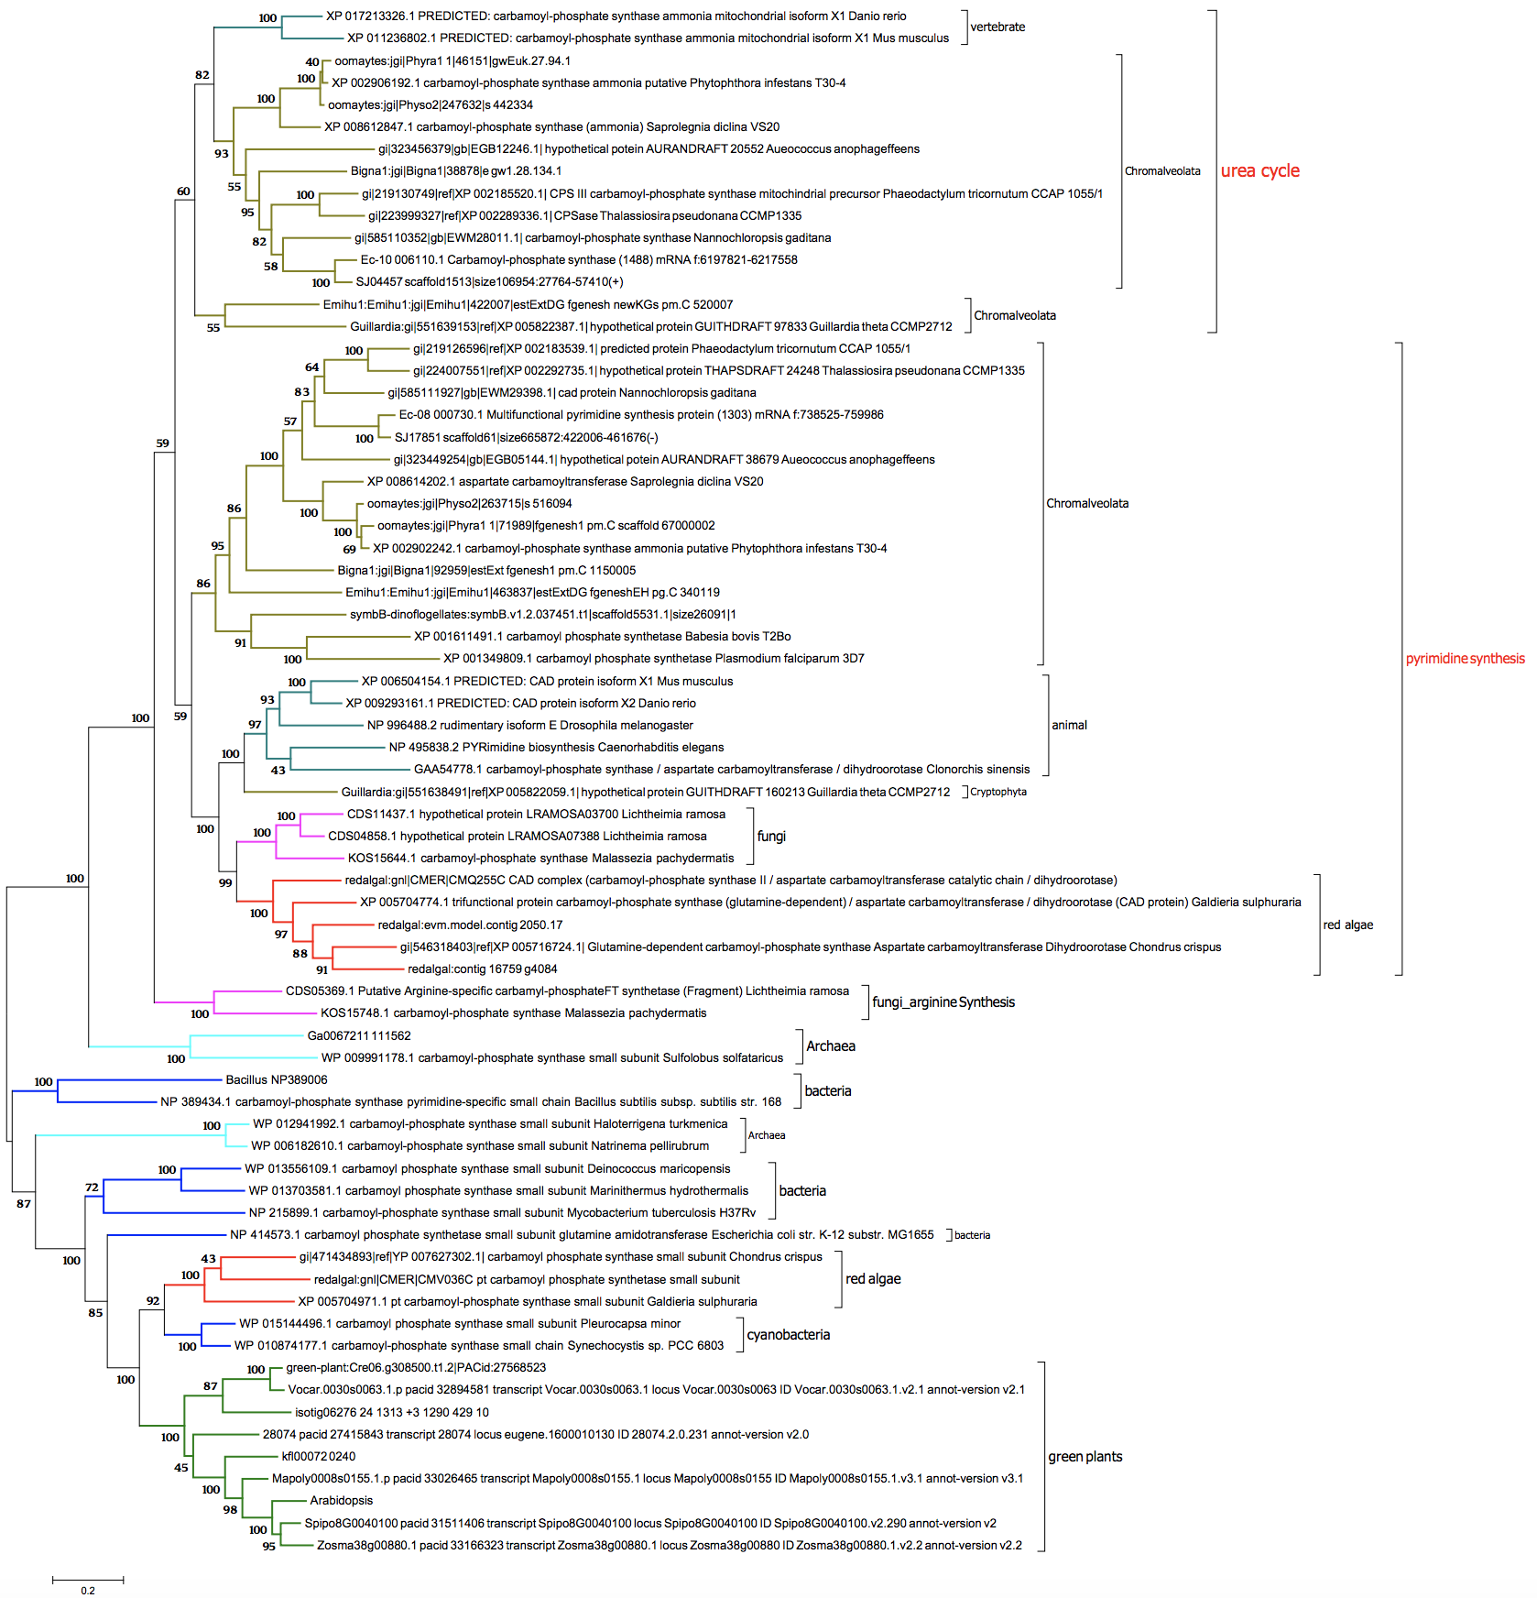
Figure S1. ML tree of CPS constituting of carA and carB subunits.
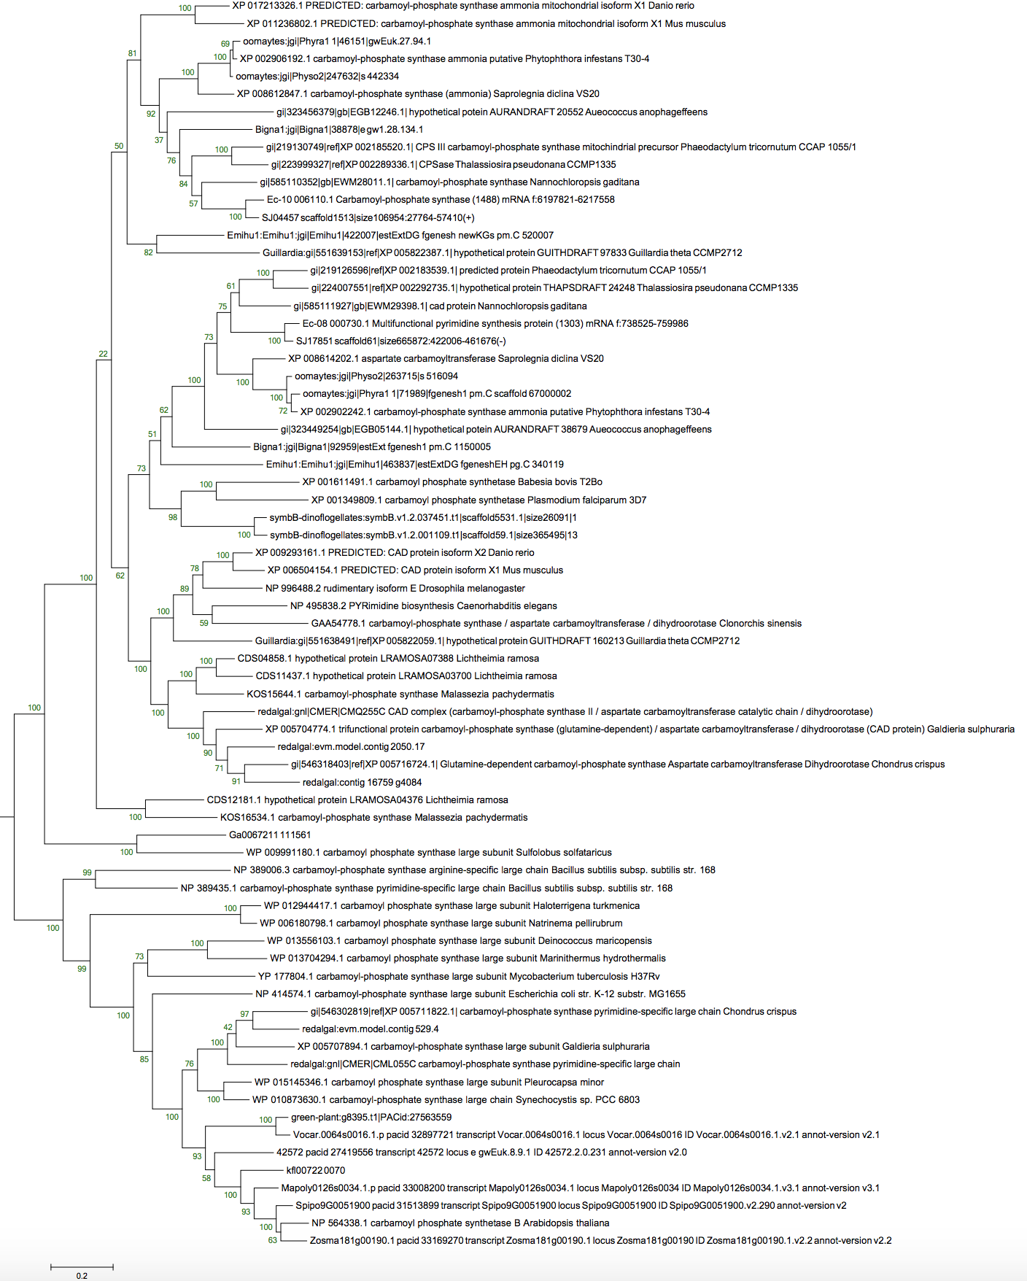
Figure S2. phylogenetic ML tree of CPS protein sequences constituting of carB subunit.

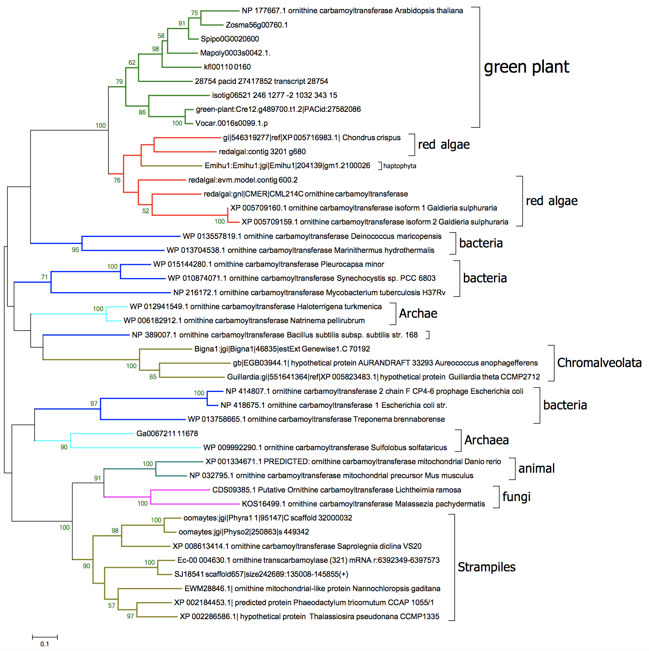
Figure S3. ML tree of OTC.

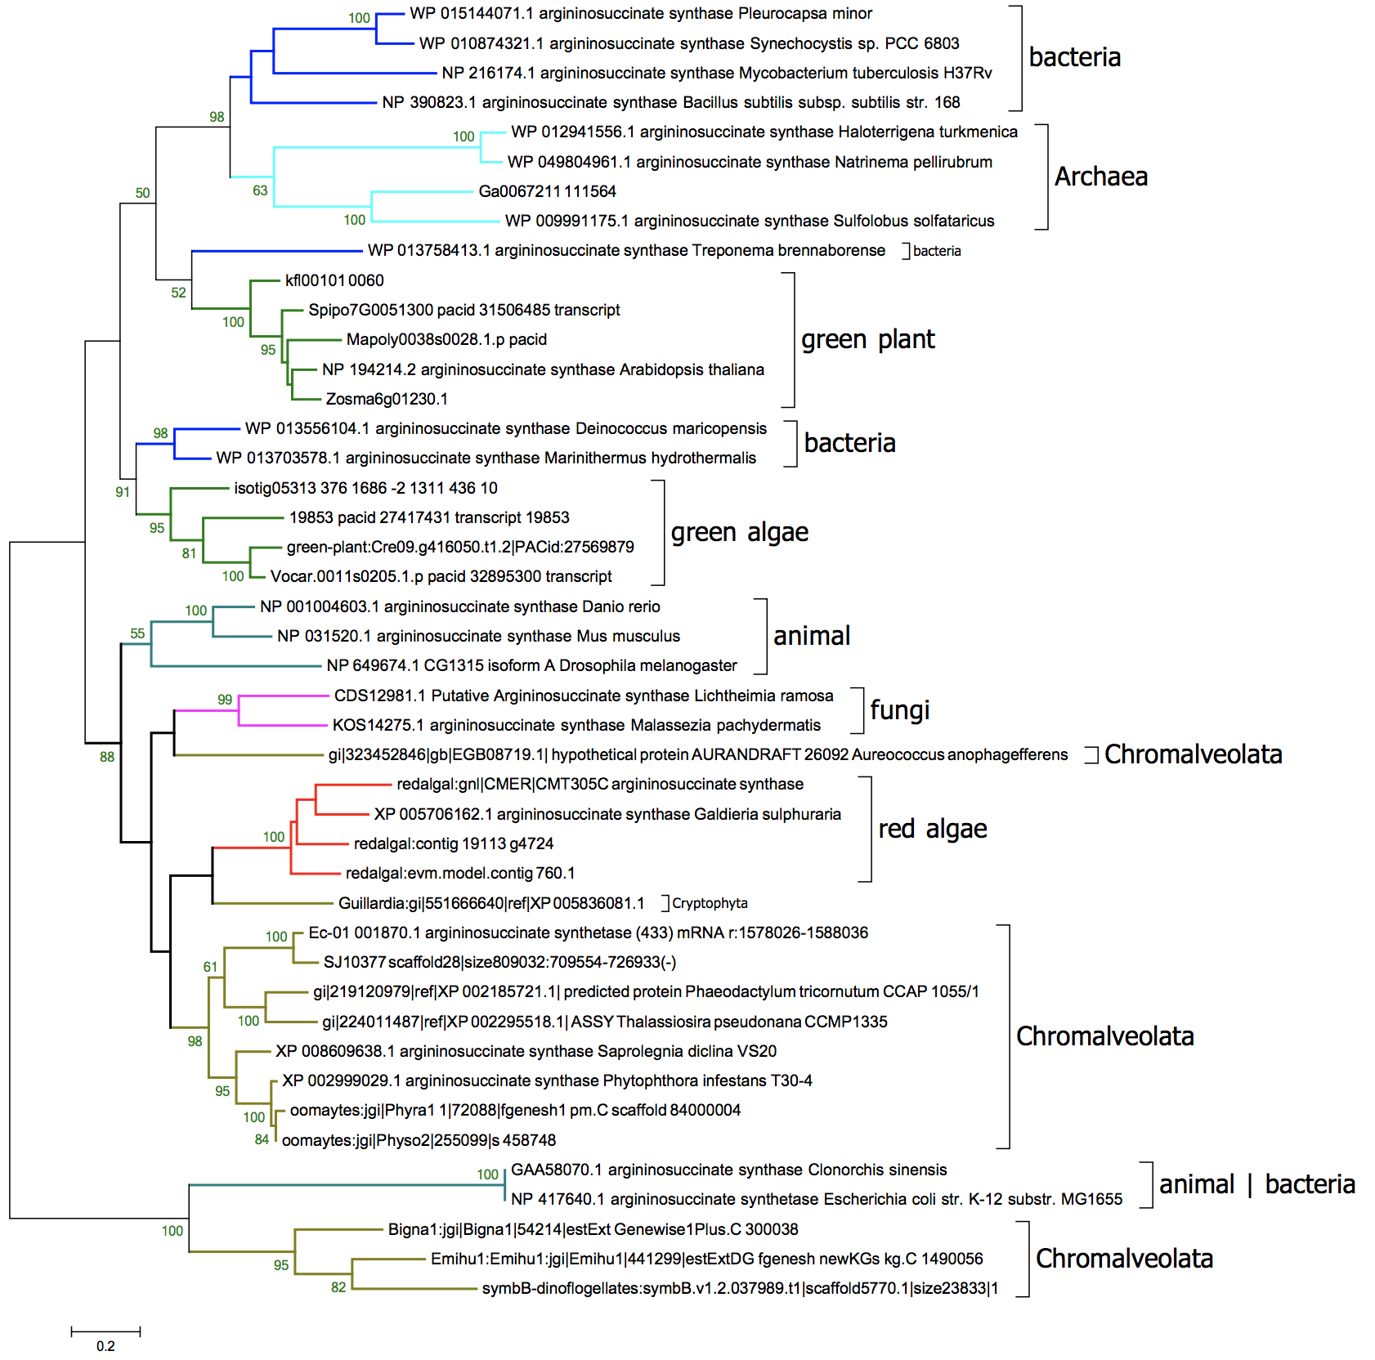
Figure S4. ML tree of ASS.
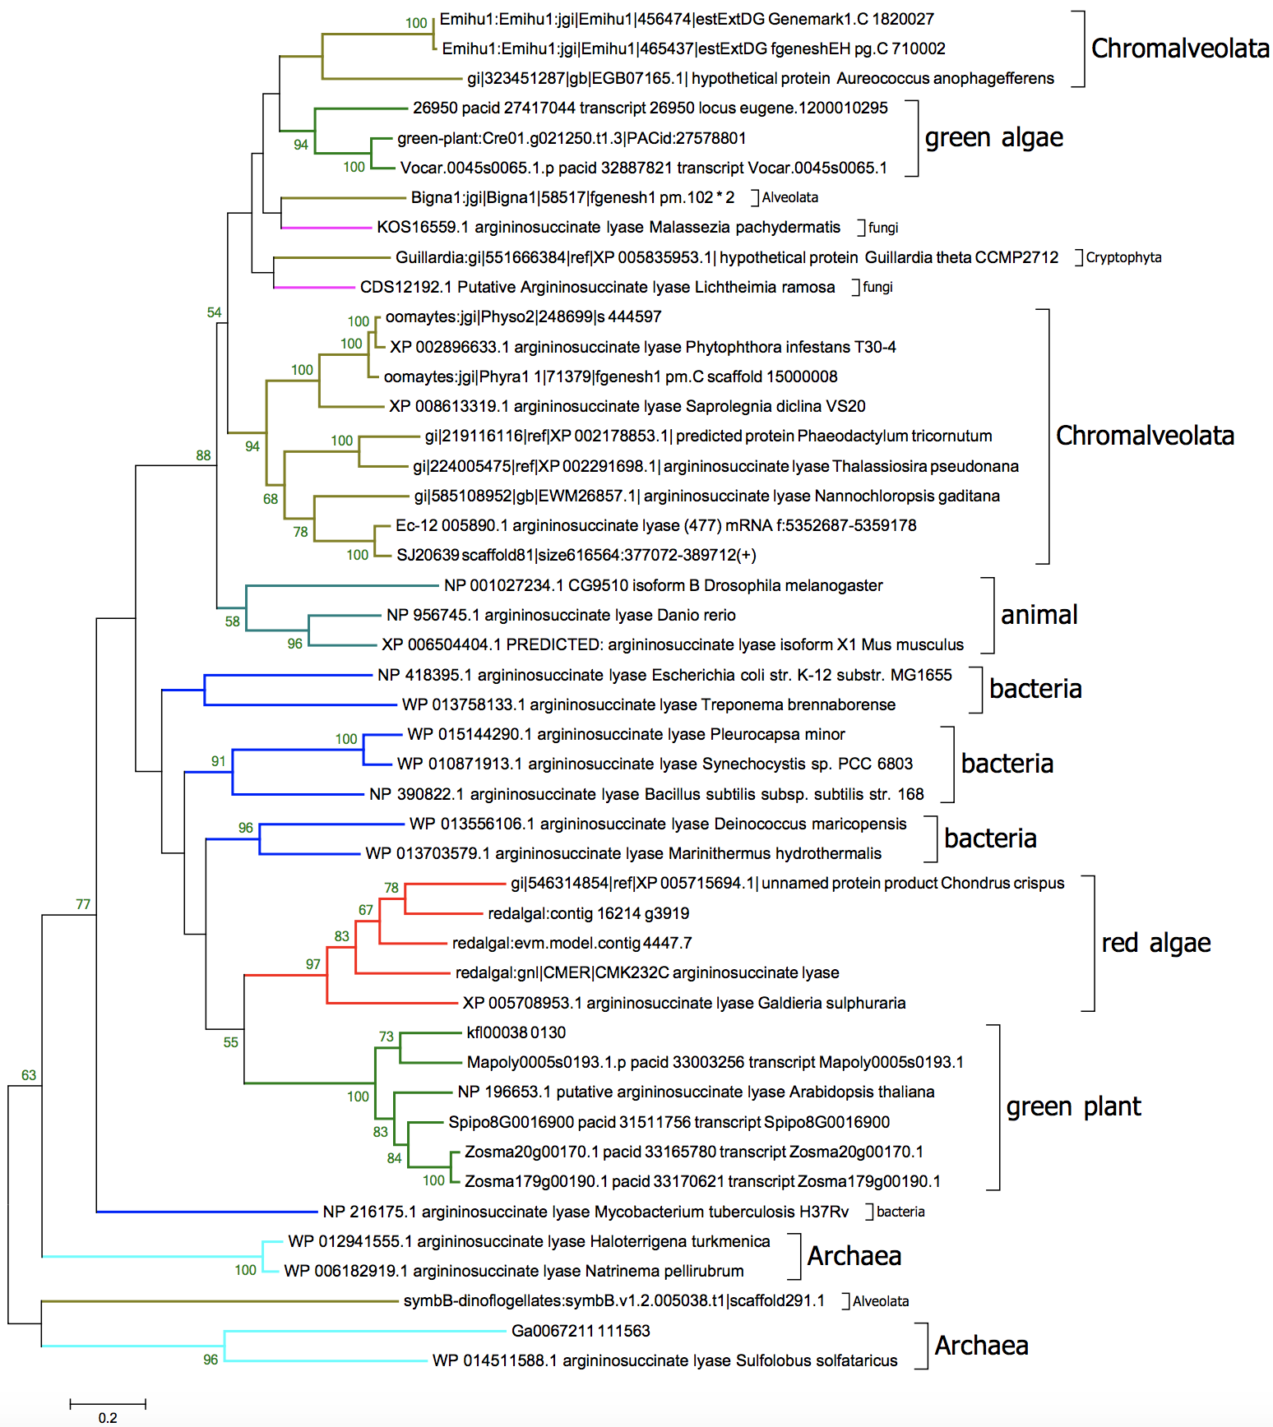
Figure S5. ML tree of ASL.

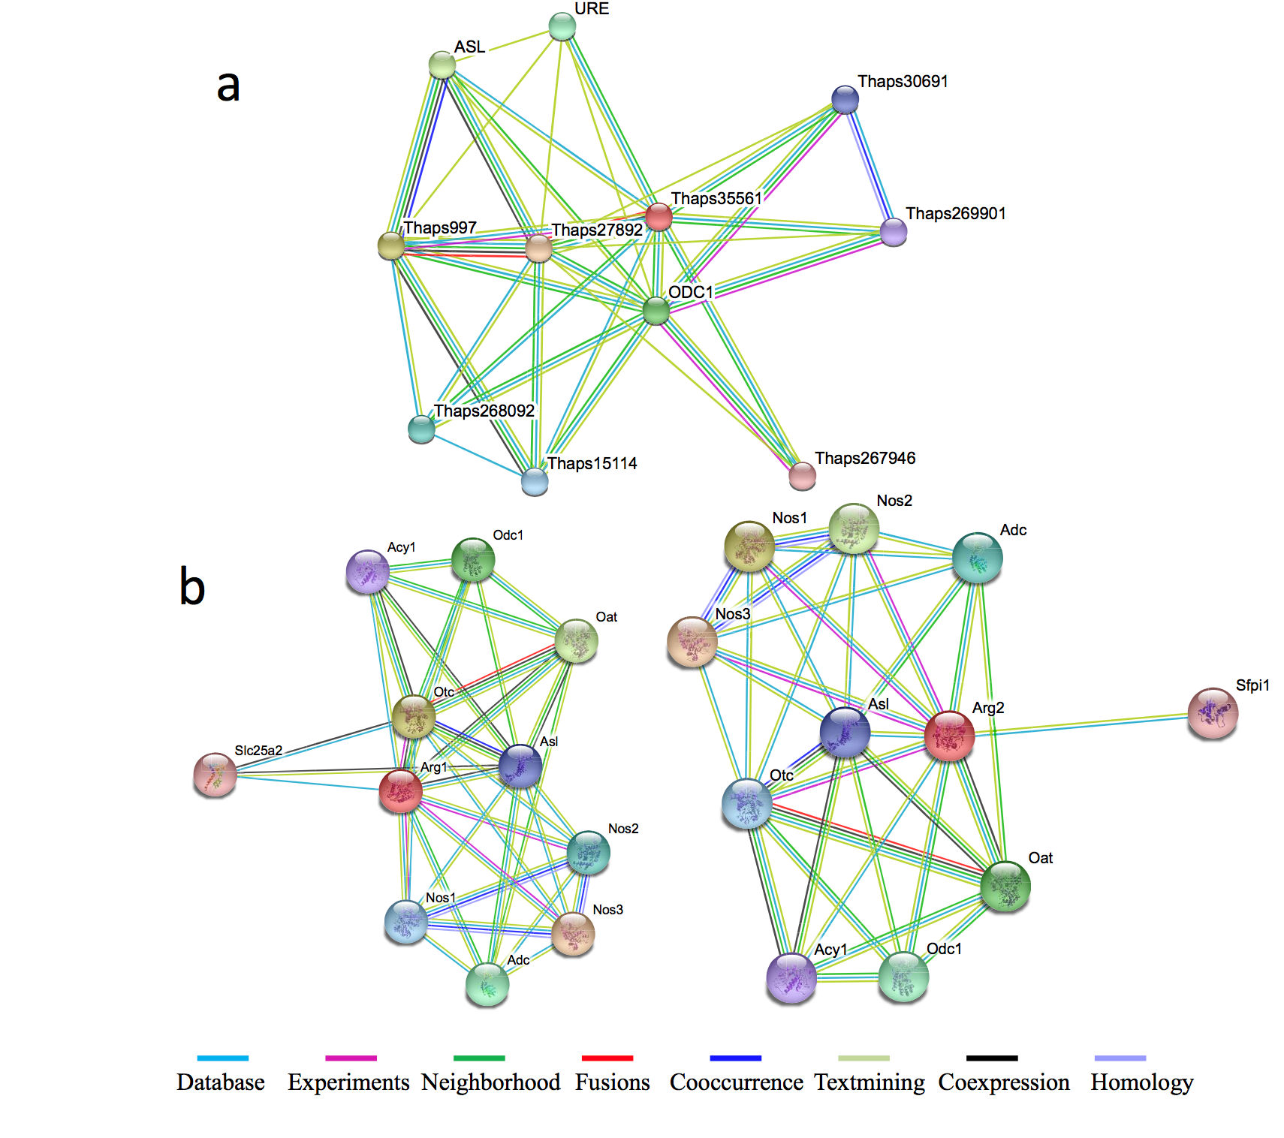
Figure S6. protein-protein interaction network of Thalassiosira preudonana and Mus musculus.

