Figure S1. Relative expression of activating B cell surface markers on activated naïve DNA tetramer-binding B cells.
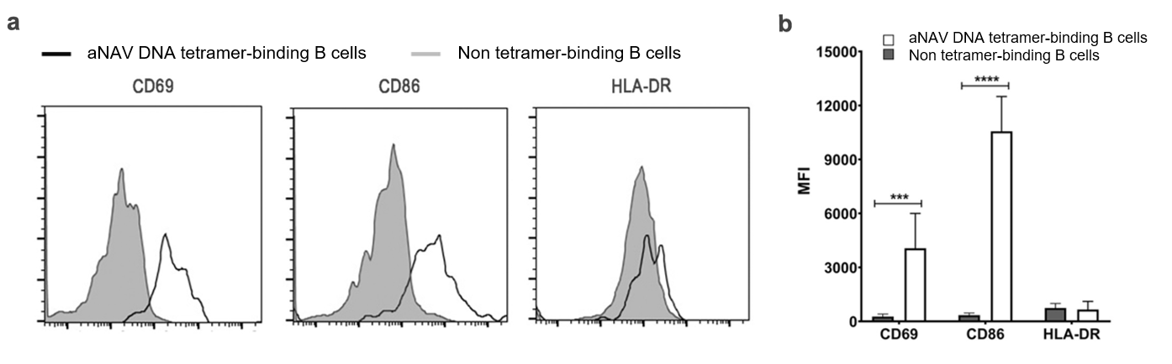
(a) aNAV DNA tetramer-binding B cells overexpressed CD69 and CD86 compared to non-tetramer-binding B cells. (b) Mean fluorescent intensity (MFI) of CD69, CD86 and HLA-DR on B cells of SLE patients (n = 3). Bars represent median with interquartile range. p values were determined by the Mann-Whitney U-test: *p < 0.05; **p < 0.01; ***p < 0.001; ****p < 0.0001.

