Prediction of Inflammatory Bowel Diseases using Genetic Risk Score in Asian populations
Shifteh Abedian^{1, 2}, Sunny H. Wong³, Suzanne Van Sommeren⁴, Atsushi Takahashi⁵, Jae Hee Cheon⁶, Ajit sood⁷, Homayoon Vahedi², Keiko Yamazaki⁸, Won Ho Kim⁶, Thelma B K⁹, Nasser E Daryani¹⁰, Michiaki Kubo⁸, Suk-KyunYang¹¹, Rupa Banerjee¹², International IBD Genetics Consortium¹³, Reza Malekzadeh², Rinse K. Weersma⁴, Siew C. Ng³, Behrooz Z. Alizadeh¹

¹Department of Epidemiology, University of Groningen and University Medical Center Groningen, Groningen, the Netherlands.
²Digestive Disease Research Center, Digestive Disease Research Institute, Tehran University of Medical Sciences, Tehran, Iran.
³Department of Medicine and Therapeutics, Institute of Digestive Disease, State Key Laboratory of Digestive Disease, LKS Institute of Health Science, the Chinese University of Hong Kong.
⁴Department of Gastroenterology and Hepatology, University of Groningen and University Medical Center Groningen, Groningen, the Netherlands.
⁵Laboratory for Statistical Analysis, RIKEN, Yokohama, Japan.
⁶Department of Internal Medicine and Institute of Gastroenterology, Yonsei University College of Medicine, Seoul, Republic of Korea.
⁷Department of Medicine, Dayanand Medical college and Hospital, Ludhiana, India.
⁸Division of Genomic Epidemiology and Clinical Trials, Clinical Trials Research Center, Nihon University School of Medicine, Tokyo, Japan.
⁹Department of Genetics, University of Delhi South Campus, New Delhi, India.
¹⁰Department of Gastroenterology, Emam Hospital, Tehran, Iran.
¹¹Department of Gastroenterology and Hepatology, Asan Medical Center, University of Ulsan College of Medicine, Seoul, Korea.
¹²Department of Gastroenterology ,Asian Institute of Gastroenterology, Hyderabad, India.
¹³A full list of members and affiliations appears in the Supplementary Note.

Correspondence to:
Shifteh Abedian, MD, PhD (s.abedian@umcg.nl)
Department of Epidemiology
University Medical Center Groningen
Groningen, The Netherlands

Supplementary Text and Figures
Overview of contents
- Supplementary Text S1: Cohorts Information, p (3)
- Supplementary Tables S1: Demographic and clinical characteristics of the sample, p (4)
- Supplementary Figure S1: Map depicting the origin of the samples p (5)
- Supplementary Figures S2: GRS of IBD in EA countries p (6)
- Supplementary Figures S3: GRS of CD in EA countries p (7)
- Supplementary Figures S4: GRS of UC in EA countries p (8)
- Supplementary Figures S5: GRS of IBD in Indo-Iranian countries p (9)
- Supplementary Figures S6: GRS of CD in Indo-Iranian countries p (10)
- Supplementary Figures S7: GRS of UC in Indo-Iranian countries p (11)
- Supplementary Note: Members of the International IBD Genetics Consortium p (12- 15)

Supplementary Text S1: Cohorts information
In brief, the IBD patients and controls were recruited from the following sources: Japan (Institute of Medical Science, University of Tokyo, RIKEN Yokohama Institute and Japan Bio bank), Korea (Yonsei University College of Medicine and Asan Medical Centre, Seoul), Hong Kong China (Chinese University of Hong Kong), Iran ((DDRI: Digestive Disease Research Institute, (Department of Gastroenterology, Imam hospital)), Tehran University of Medical Science) and India (Department of Medicine, Dayanand Medical college and hospital, Ludhiana, India.

 | Japan |  | Korea |  | China |  | India |  | Iran
 | CD(n=1312) | UC(n=723) | CD(n=201) | UC(n=230) | CD(n=154) | UC(n=144) | CD (n=184) | UC (1237) | CD (151) | UC (397)
Sex (female) | 393 (30.0%) | 372 (51.5%) | 82 (40.8%) | 133 (57.8%) | 42 (27.3%) | 66 (45.8%) | 80 44%) | 560 (45%) | 71 (47%) | 219 (55%)
Age of diagnosis | 24.8 ± 10.2 | 34.2 ± 15.1 | 25.8 ± 10.8 | 38.4 ± 12.3 | 32.6 ± 13.7 | 40.2 ± 13.0 | 6.60 ±14.37 | 34.28 ± 12.46 | 38.37 ± 12.82 | 39.10 ± 13.21
Smoker | 29.8% | 26.7% | 11.1% | 9.8% | 28.7% | 22.5% | 5% | .03% | .15% | .07%
Family history | 0.55% | 0.83% | 3.0% | 4.9% | 4.0% | 4.2% | .22% | .05% | .08% | .27%
Disease Location  - L1  - L2  - L3 | 419  168  486 |  | 17  6  40 |  | 30  27  82 |  | 5  14  17 |  | 22  32  12
Disease Behavior  - B1  - B2  - B3  - B2+B3 | 287  485  313  0 |  | 15  12  36  0 |  | 57  45  25  21 |  |  | 25  10  2  1 |  | 18  10  4  2
Surgery | 605 |  | 47 |  | 52 |  | 14 |  | 9
Disease Extent  - E1  - E2  - E3 |  | 116  259  335 |  | 16  56  51 |  | 42  43  57 |  | 51  617  180 | 46  35  55
Colectomy |  | 44 |  | 8 |  | 4 |  | 31 |  | 14

Supplementary Table S1: Demographic and clinical characteristics of the sample

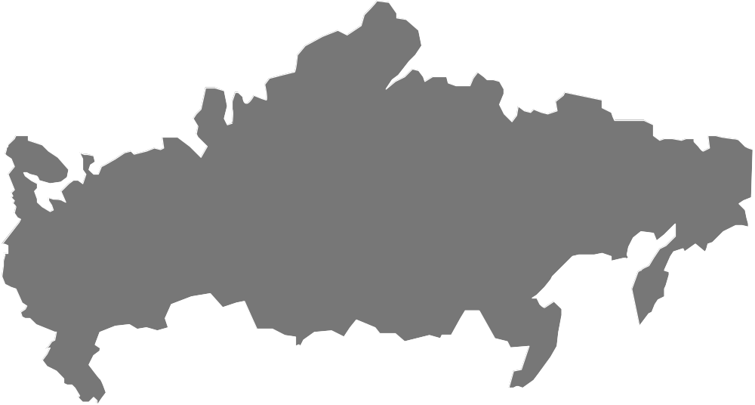
Japan
1,312/723 CD/UC
3,282controls
Korea
201/230 CD/UC
114 controls
China
155/143CD/UC
235 controls
Iran
151/397 CD/UC
342 controls
India
184/1,237 CD/UC
992 controls
Total Populations 9,698
2,003 Crohn’s Disease
2,730 Ulcerative colitis
4,965 Healthy controls
Supplementary Figure S1. Map depicting the origin of the samples in the East and Central Asian cohort

Supplementary Figures S2: GRS of IBD in EA populations
Japan Korea China
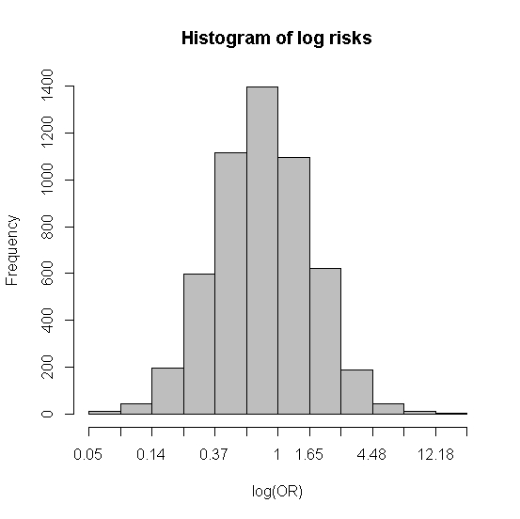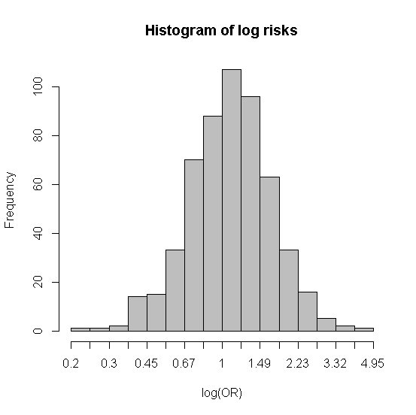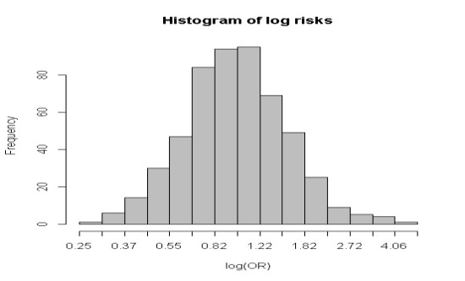
a: Distribution of predicted risk
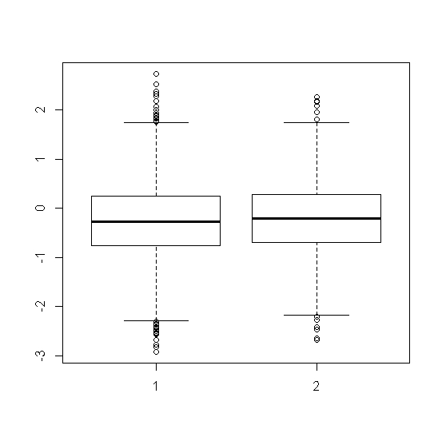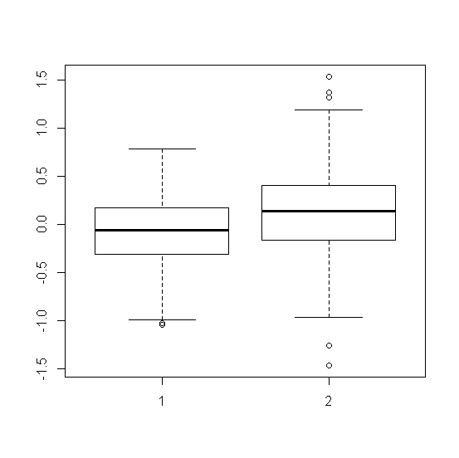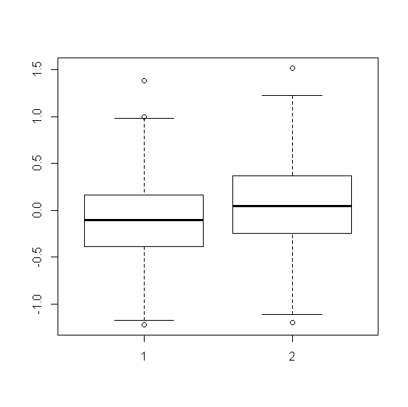
b: Distribution of predicted risk in cases and controls
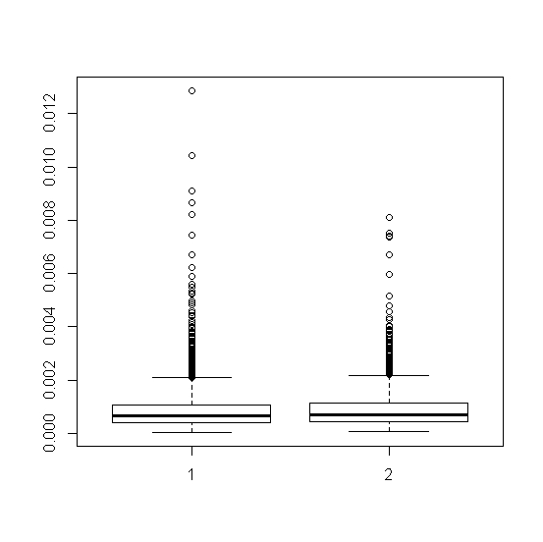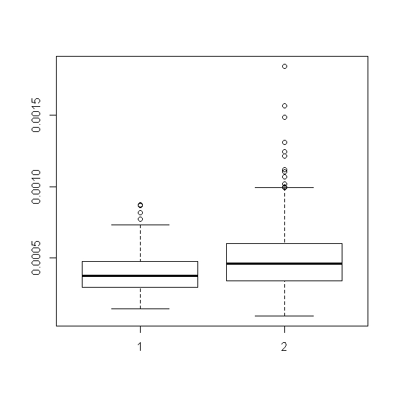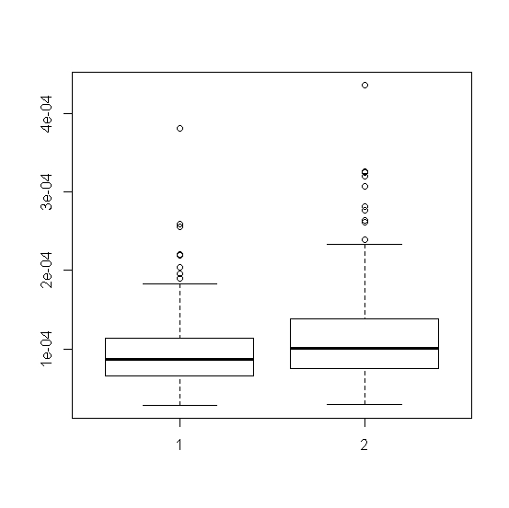
c: Distribution of estimated Posterior Probability
Supplementary Figures S3: GRS of CD in EA populations
Japan Korea China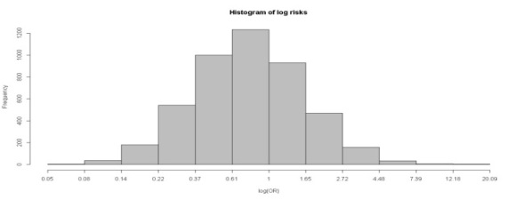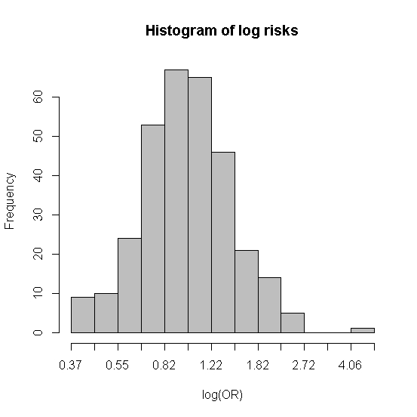 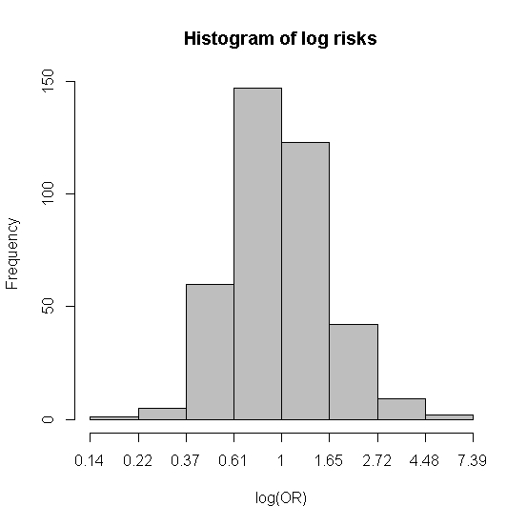
a: Distribution of predicted risk
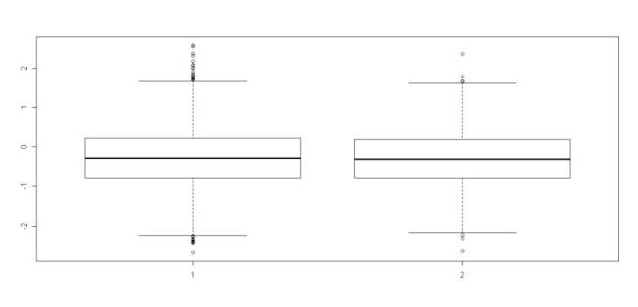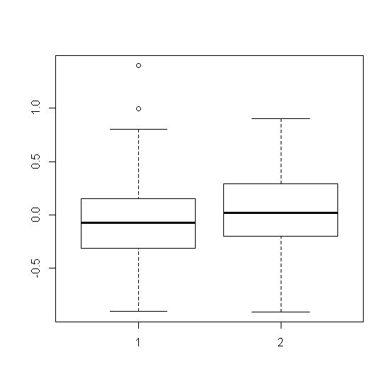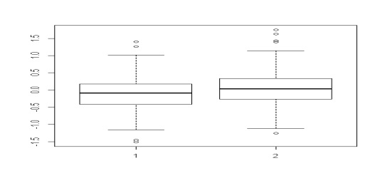

b: Distribution of predicted risk in cases and controls
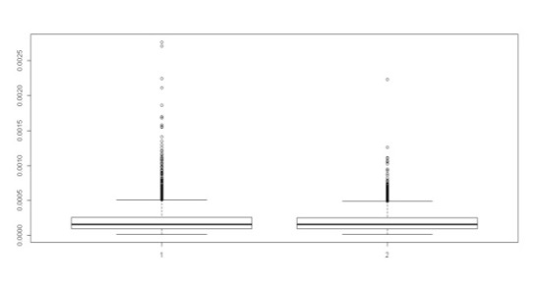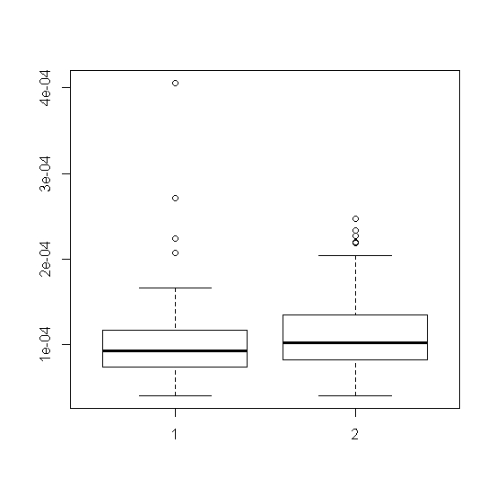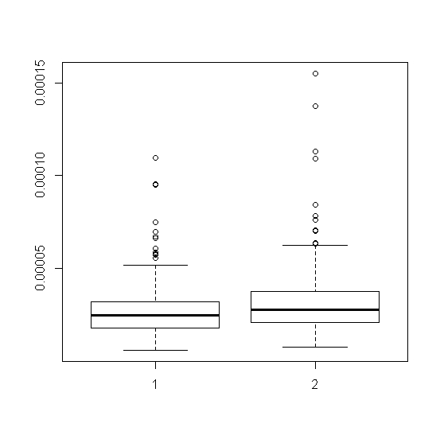
c: Distribution of estimated Posterior Probability
Supplementary Figures S4: GRS of UC in EA populations
Japan Korea china
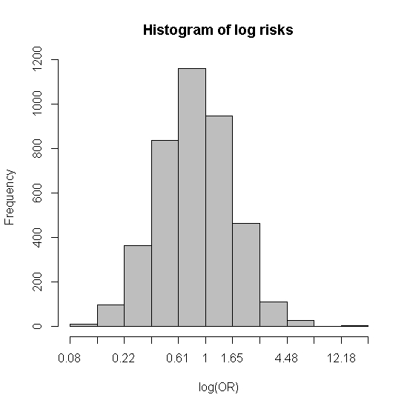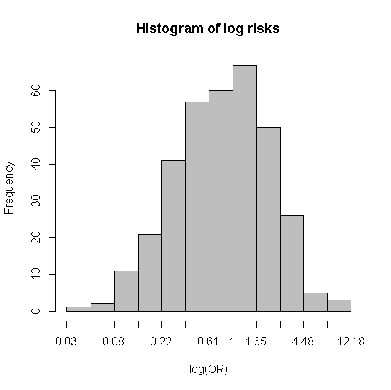 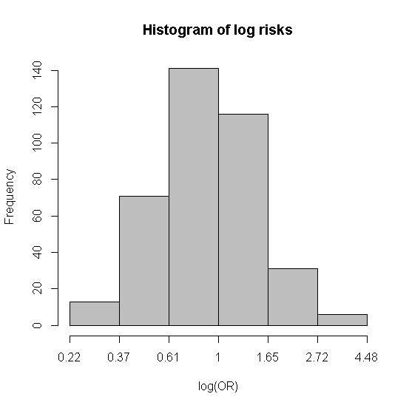 a: Distribution of predicted risk
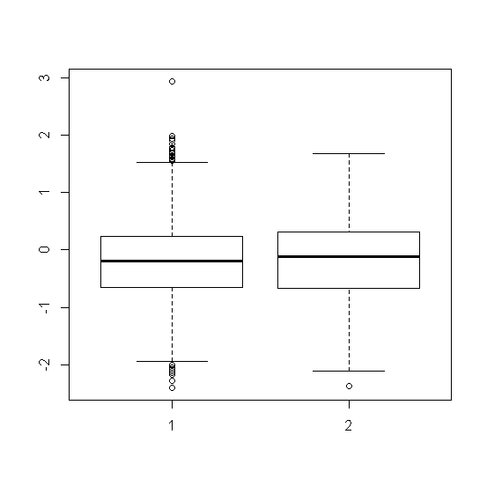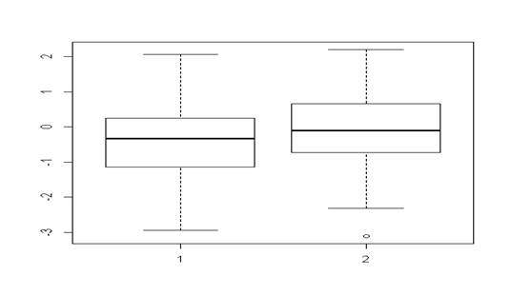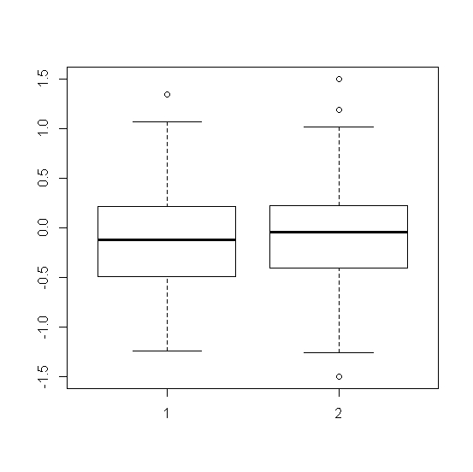
b: Distribution of predicted risk in cases and controls
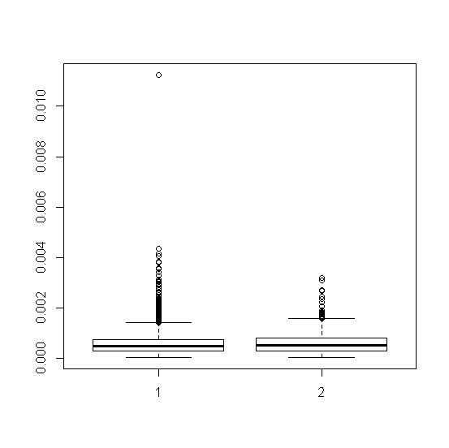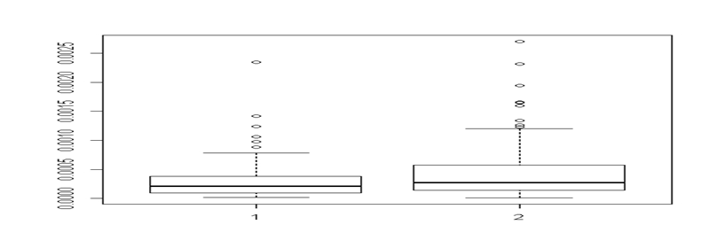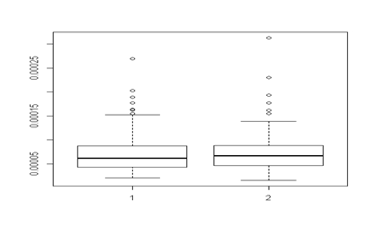
c: Distribution of estimated Posterior Probability
Supplementary Figures S5: GRS of IBD in Indo- Iranian populations
India Iran
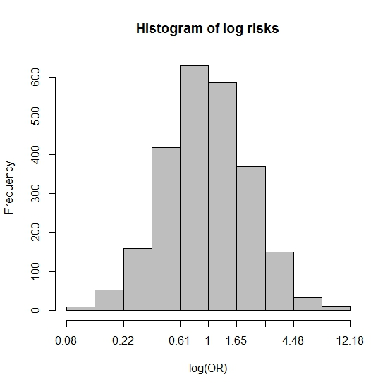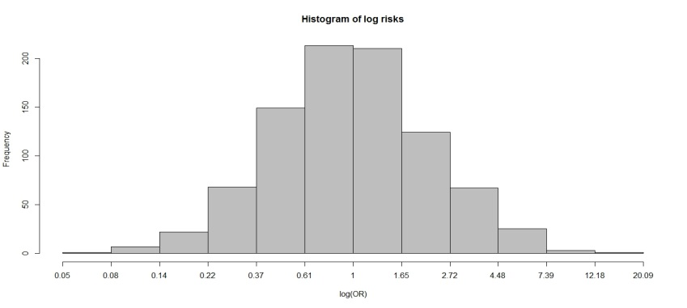
a: Distribution of predicted risk
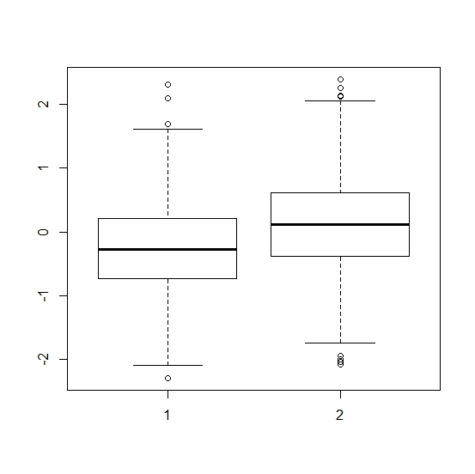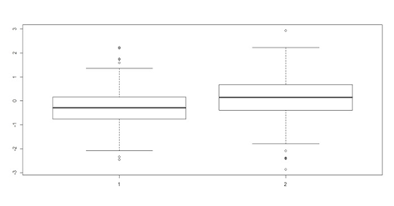
b: Distribution of predicted risk in cases and controls
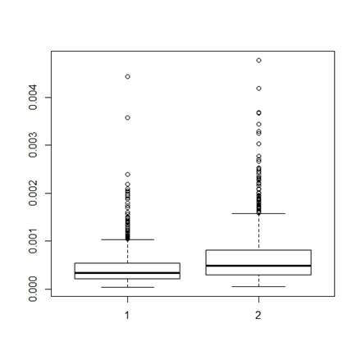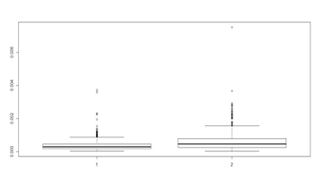
c: Distribution of estimated Posterior Probability
Supplementary Figures S6: GRS of CD in Indo- Iranian populations
India Iran
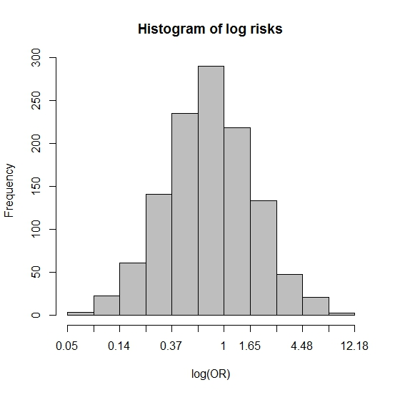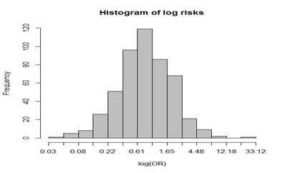
a: Distribution of predicted risk
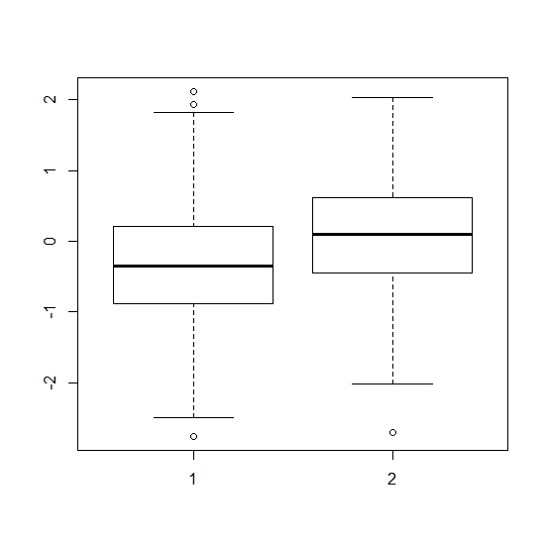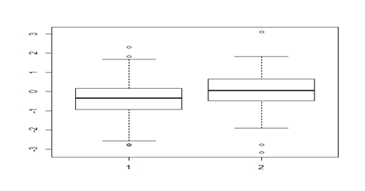
b: Distribution of predicted risk in cases and controls
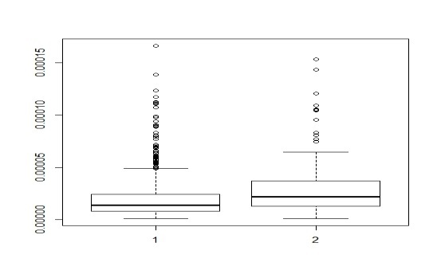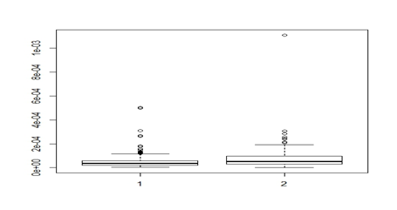
c: Distribution of estimated Posterior Probability
Supplementary Figures S6: GRS of UC in Indo- Iranian populations
India Iran
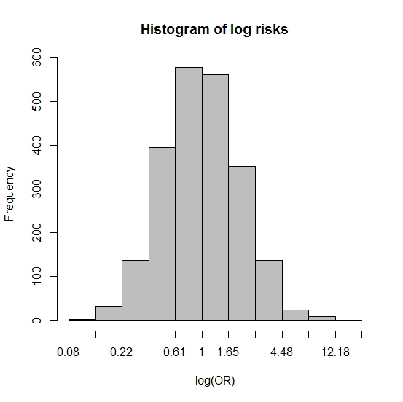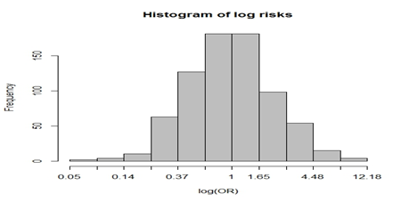
a: Distribution of predicted risk
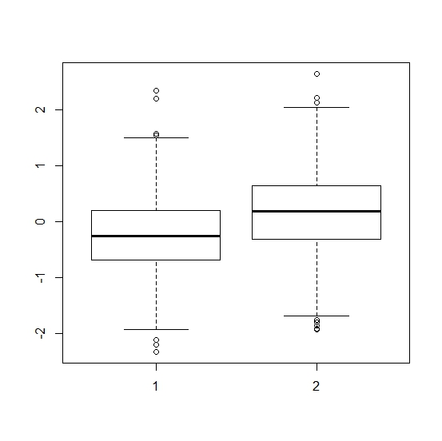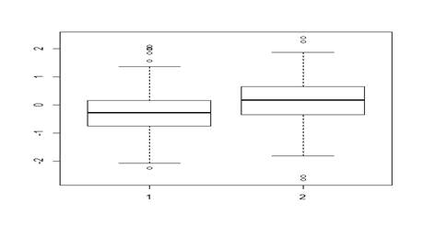
b: Distribution of predicted risk in cases and controls
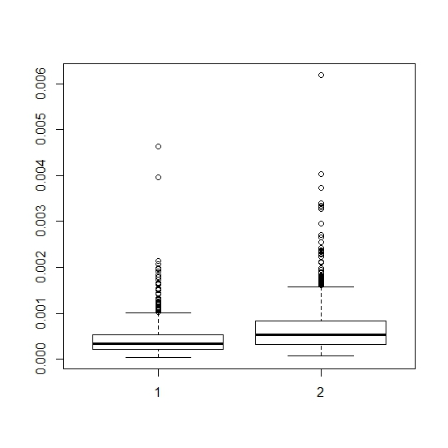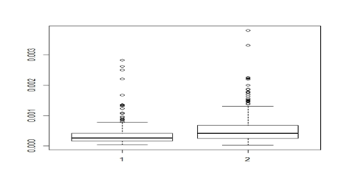
c: Distribution of estimated Posterior Probability

Supplementary Note:
Member of International IBD Genetic Consortium:
Shifteh Abedian^{9,26}, Clara Abraham²⁷, Jean-Paul Achkar^{28,29}, Tariq Ahmad³⁰, Rudi Alberts², Behrooz Alizadeh²³, Leila Amininejad^{31,32}, Ashwin N Ananthakrishnan^{33,34}, Vibeke Andersen^{35,36}, Carl A Anderson¹, Jane M Andrews³⁷, Vito Annese^{38,39}, Guy Aumais^{40,41}, Leonard Baidoo⁴², Robert N Baldassano⁴³, Tobias Balschun⁴⁴, Peter A Bampton⁴⁵, Murray Barclay⁴⁶, Jeffrey C Barrett¹, Theodore M Bayless⁴⁷, Johannes Bethge⁴⁸, Claire Bewshea³⁰, Joshua C Bis⁴⁹, Alain Bitton⁵⁰, Thelma BK¹⁶, Gabrielle Boucher⁵¹, Oliver Brain⁵², Stephan Brand⁵³, Steven R Brant⁴⁷, Carsten Büning⁵⁴, Jae Hee Cheon¹⁰, Angela Chew^{55,56}, Judy H Cho⁵⁷, Isabelle Cleynen⁵⁸, Ariella Cohain⁵⁹, Rachel Cooney⁶⁰, Anthony Croft⁶¹, Mark J Daly^{4,62}, Mauro D'Amato⁶³, Silvio Danese⁶⁴, Naser Ebrahim Daryani^{12,65}, Dirk De Jong⁶⁶, Katrina M de Lange¹, Martine De Vos⁶⁷, Goda Denapiene⁶⁸, Lee A Denson⁶⁹, Kathy L Devaney³³, Olivier Dewit⁷⁰, Renata D'Inca⁷¹, Hazel E Drummond⁷², Marla Dubinsky⁷³, Richard H Duerr^{42,74}, Cathryn Edwards⁷⁵, David Ellinghaus⁴⁴, Motohiro Esaki⁷⁶, Jonah Essers^{77,78}, Lynnette R Ferguson⁷⁹, Eleonora A Festen², Philip Fleshner⁸⁰, Tim Florin⁸¹, Denis Franchimont^{31,32}, Andre Franke⁴⁴, Karin Fransen³, Yuta Fuyuno¹³, Richard Gearry^{46,82}, Michel Georges^{83,84}, Christian Gieger⁸⁵, Jürgen Glas⁵⁰, Philippe Goyette⁵¹, Todd Green^{62,77}, Anne M Griffiths⁸⁶, Stephen L Guthery⁸⁷, Hakon Hakonarson⁴³, Jonas Halfvarson^{88,89}, Katherine Hanigan⁶¹, Talin Haritunians⁸⁰, Ailsa Hart¹⁴, Chris Hawkey⁹⁰, Nicholas K Hayward⁹¹, Matija Hedl²⁷, Paul Henderson⁹², Georgina L Hold⁹³, Xinli Hu⁹⁴, Hailiang Huang^{4,62}, Ken Y Hui⁵⁷, Marcin Imielinski⁴³, Andrew Ippoliti⁸⁰, Omid Jazayeri³, Laimas Jonaitis⁹⁵, Luke Jostins⁸, Garima Juyal¹⁶, Ramesh Chandra Juyal¹⁵, Rahul Kalla⁷², Tom H Karlsen^{96,97,98}, Takaaki Kawaguchi⁹⁹, Nicholas A Kennedy⁷², Mohammed Azam Khan¹⁸, Won Ho Kim¹⁰, Takanari Kitazono⁷⁶, Gediminas Kiudelis⁹⁵, Michiaki Kubo¹³, Subra Kugathasan¹⁰⁰, Limas Kupcinskas¹⁰¹, Christopher A Lamb¹⁰², Anna Latiano³⁸, Debby Laukens⁶⁷, Ian C Lawrance⁵⁶, James C Lee⁷, Charlie W Lees⁷², Marcis Leja¹⁰³, Nina Lewis⁹⁰, Johan Van Limbergen⁸⁶, Paolo Lionetti¹⁰⁴, Jimmy Z Liu¹, Edouard Louis¹⁰⁵, Yang Luo¹, Gillian Mahy¹⁰⁶, Masoud Mohammad Malekzadeh^{9,26}, Reza Malekzadeh^{9,26}, John Mansfield¹⁰⁷, Suzie Marriott³⁰, Dunecan Massey⁷, Christopher G Mathew¹⁰⁸, Toshiyuki Matsui¹⁰⁹, Dermot PB McGovern⁸⁰, Vandana Midha¹⁹, Raquel Milgrom¹¹⁰, Samaneh Mirzaei^{9,26}, Mitja Mitrovic^{3,111}, Grant W Montgomery⁹¹, Satoshi Motoya¹¹², Craig Mowat¹¹³, William G Newman¹⁸, Aylwin Ng^{33,114}, Siew C Ng⁵, Sok Meng Evelyn Ng²⁷, Susanna Nikolaus⁴⁸, Elaine R Nimmo⁷², Kaida Ning²⁷, Markus Nöthen¹¹⁵, Ioannis Oikonomou²⁷, Timothy R Orchard²⁰, Orazio Palmieri³⁸, Miles Parkes⁷, Anne Phillips¹¹³, Cyriel Y Ponsioen¹¹⁶, Urõs Potocnik^{111,117}, Hossein Poustchi^{9,26}, Natalie J Prescott¹⁰⁸, Deborah D Proctor²⁷, Graham Radford-Smith^{61,118}, Jean- Francois Rahier¹¹⁹, Soumya Raychaudhuri⁹⁴, Miguel Regueiro⁴², Florian Rieder²⁸, John D Rioux^{41,51}, Stephan Ripke^{4,62}, Rebecca Roberts⁴⁶, Richard K Russell¹²⁰, Jeremy D Sanderson¹²¹, Miquel Sans¹²², Jack Satsangi⁷², Eric E Schadt⁵⁹ Stefan Schreiber^{44,48}, L Philip Schumm¹²³, Regan Scott⁴², Mark Seielstad^{124,125}, Tejas Shah¹, Yashoda Sharma²⁷, Mark S Silverberg¹¹⁰, Alison Simmons⁵², Lisa A Simms⁶¹, Abhey Singh³⁰, Jurgita Skieceviciene⁹⁵, Ajit Sood¹²⁶, Sarah L Spain¹⁰⁸, A. Hillary Steinhart¹¹⁰, Joanne M Stempak¹¹⁰, Laura Stronati¹²⁷, Joseph JY Sung⁵, Yasuo Suzuki¹²⁸, Jurgita Sventoraityte¹⁰¹, Atsushi Takahashi⁶, Masakazu Takazoe¹²⁹, Hiroki Tanaka¹¹², Stephan R Targan⁸⁰, Kirstin M Taylor¹²¹, Anje ter Velde¹¹⁶, Emilie Theatre^{83,84}, Leif Torkvist¹³⁰, Mark Tremelling¹³¹, Holm H Uhlig¹³², Homayon Vahedi^{9,26}, Andrea van der Meulen¹³³, Suzanne van Sommeren², Eric Vasiliauskas⁸⁰, Nicholas T Ventham⁷², Severine Vermeire^{58,134}, Hein W Verspaget¹³³, Thomas Walters^{86,135}, Kai Wang⁴³, Ming-Hsi Wang^{28,47}, Rinse K Weersma², Zhi Wei¹³⁶, David Whiteman⁹¹, Cisca Wijmenga³, David C Wilson^{92,120}, Juliane Winkelmann^{137,138}, Ramnik J Xavier^{33,62}, Tetsuhiro Yamada⁹⁹, Keiko Yamazaki¹³, Sebastian Zeissig⁴⁸, Bin Zhang⁵⁹, Clarence K Zhang¹³⁹, Hu Zhang^{140,141}, Wei Zhang²⁷, Hongyu Zhao¹³⁹, Zhen Z Zhao⁹¹, Australia and New Zealand IBDGC, Belgium IBD Genetics Consortium, Italian Group for IBD Genetic Consortium, NIDDK Inflammatory Bowel Disease Genetics Consortium, United Kingdom IBDGC, Wellcome Trust Case Control Consortium, Quebec IBD Genetics Consortium
1Wellcome Trust Sanger Institute, Hinxton, UK. ²Department of Gastroenterology and Hepatology, University Medical Center Groningen, Groningen, The Netherlands. 3Department of Genetics, University Medical Center Groningen, Groningen, The Netherlands. ⁴Analytic and Translational Genetics Unit, Massachusetts General Hospital, Harvard Medical School, Boston, Massachusetts, USA. ⁵Department of Medicine and Therapeutics, Institute of Digestive Disease, Chinese University of Hong Kong, Hong Kong. ⁶Laboratory for Statistical Analysis, Center for Integrative Medical Sciences, Riken, Yokohama, Japan. ⁷Inflammatory Bowel Disease Research Group, Addenbrooke's Hospital, Cambridge, UK. ⁸Wellcome Trust Centre for Human Genetics, University of Oxford, Headington, UK. ⁹Digestive Disease Research Institute, Shariati Hospital, Tehran, Iran. ¹⁰Yonsei University College of Medicine, Seoul, Korea. ¹¹Icahn School of Medicine, Mount Sinai New York, New York, USA. ¹²Department of Gastroenterology, Emam Hospital, Tehran, Iran. ¹³Laboratory for Genotyping Development, Center for Integrative Medical Sciences, Riken, Yokohama, Japan. ¹⁴IBD Unit, St Mark's Hospital, Harrow, Middlesex, UK. ¹⁵National Institute of Immunology, Aruna Asaf Ali Road, New Delhi, India. ¹⁶Department of Genetics, University of Delhi South Campus, New Delhi, India. 17Welcome Trust Center for Human Genetics, Oxford U.K. and Department of Biostatistics, University of Liverpool, Liverpool, UK. ¹⁸Manchester Centre for Genomic Medicine, University of Manchester and Central Manchester University Hospitals NHS Foundation Trust, Manchester, UK. ¹⁹Department of Medicine, Dayanand Medical College and Hospital, Ludhiana, India. ²⁰St Mary's Hospital, London, UK. ²¹Asan Medical Center, University of Ulsan College Medicine, Seoul, Korea. ²²A list of members and affiliations appears in the Supplementary Note. ²³Department of Epidemiology, University Medical Center Groningen, Groningen, The Netherlands. ²⁴These authors contributed equally to this work. ²⁵These authors jointly supervised this work. 26Digestive Disease Research Institute, Tehran University of Medical Sciences, Tehran Iran. ²⁷Section of Digestive Diseases, Department of Internal Medicine, Yale School of Medicine, New Haven, Connecticut, USA. ²⁸Department of Gastroenterology and Hepatology, Digestive Disease Institute, Cleveland Clinic, Cleveland, Ohio, USA. 29Department of Pathobiology, Lerner Research Institute, Cleveland Clinic, Cleveland, Ohio, USA. ³⁰Peninsula College of Medicine and Dentistry, Exeter, UK. ³¹Department of Gastroenterology, Erasmus Hospital, Brussels, Belgium. ³²Department of Gastroenterology, Free University of Brussels, Brussels, Belgium. ³³Gastroenterology Unit, Massachusetts General Hospital, Harvard Medical School, Boston, Massachusetts, USA. ³⁴Division of Medical Sciences, Harvard Medical School, Boston, Massachusetts, USA. ³⁵Medical Department, Viborg Regional Hospital, Viborg, Denmark. ³⁶Organ Center, Hospital of Southern Jutland Aabenraa, Aabenraa, Denmark. ³⁷Inflammatory Bowel Disease Service, Department of Gastroenterology and Hepatology, Royal Adelaide Hospital, Adelaide, Australia. ³⁸Unit of Gastroenterology, Istituto di Ricovero e Cura a Carattere Scientifico-Casa Sollievo della Sofferenza (IRCCS-CSS) Hospital, San Giovanni Rotondo, Italy. ³⁹Strutture Organizzative Dipartimentali (SOD) Gastroenterologia 2, Azienda Ospedaliero Universitaria (AOU) Careggi, Florence, Italy. ⁴⁰Department of Gastroenterology, Hôpital Maisonneuve-Rosemont, Montréal, Québec, Canada. 41Faculté de Médecine, Université de Montréal, Montréal, Québec, Canada. ⁴²Division of Gastroenterology, Hepatology and Nutrition, Department of Medicine, University of Pittsburgh School of Medicine, Pittsburgh, Pennsylvania, USA. ⁴³Center for Applied Genomics, The Children's Hospital of Philadelphia, Philadelphia, Pennsylvania, USA. 44Institute of Clinical Molecular Biology, Christian-Albrechts-University, Kiel, Germany. 45Department of Gastroenterology and Hepatology, Flinders Medical Centre and School of Medicine, Flinders University, Adelaide, Australia. ⁴⁶Department of Medicine, University of Otago, Christchurch, New Zealand. ⁴⁷Meyerhoff Inflammatory Bowel Disease Center, Department of medicine, Johns Hopkins University School of Medicine, Baltimore, Maryland, USA. ⁴⁸Department for General Internal Medicine, Christian- Albrechts-University, Kiel, Germany. ⁴⁹Cardiovascular Health Research Unit, University of Washington, Seattle, Washington, USA. ⁵⁰Division of Gastroenterology, Royal Victoria Hospital, Montréal, Québec, Canada. ⁵¹Research Center, Montreal Heart Institute, Montréal, Québec, Canada. ⁵²Translational Gastroenterology Unit, John Radcliffe Hospital, Oxford, UK. ⁵³Department of Medicine II, Ludwig-Maximilians-University Hospital Munich-Grosshadern, Munich, Germany. ⁵⁴Department of Gastroenterology, Campus Charité Mitte, Universitatsmedizin Berlin, Berlin, Germany. ⁵⁵IBD unit, Fremantle Hospital, Fremantle, Australia. ⁵⁶School of Medicine and Pharmacology, University of Western Australia, Fremantle, Australia. ⁵⁷Department of Genetics, Yale School of Medicine, NewHaven, Connecticut, USA. ⁵⁸Department of Clinical and experimental medicine, Translational Research in GastroIntestinal Disorders (TARGID), Katholieke Universiteit (KU) Leuven, Leuven, Belgium. ⁵⁹Department of Genetics and Genomic Sciences, Mount Sinai School of Medicine, New York, New York, USA. 60Department of Gastroenterology, Sandwell and West Birmingham Hospitals NHS Trust, Birmingham, UK. ⁶¹Inflammatory Bowel Diseases, Genetics and Computational Biology, Queensland Institute of Medical Research, Brisbane, Australia. ⁶²Broad Institute of MIT and Harvard, Cambridge, Massachusetts, USA. ⁶³Department of Biosciences and Nutrition, Karolinska Institutet, Stockholm, Sweden. ⁶⁴IBD Center, Department of Gastroenterology, Istituto Clinico Humanitas, Milan, Italy. ⁶⁵Department of Gastroenterology, Tehran University of Medical Sciences, Tehran, Iran. ⁶⁶Department of Gastroenterology and Hepatology, Radboud University Nijmegen Medical Centre, Nijmegen, The Netherlands. ⁶⁷Department of Hepatology and Gastroenterology, Ghent University Hospital, Ghent, Belgium. ⁶⁸Center of hepatology, Gastroenterology and Dietetics, Vilnius University, Vilnius, Lithuania. ⁶⁹Pediatric Gastroenterology, Cincinnati Children's Hospital Medical Center, Cincinnati, Ohio, USA. ⁷⁰Department of Gastroenterology, Université Catholique de Louvain (UCL) Cliniques Universitaires Saint- Luc, Brussels, Belgium. ⁷¹Division of Gastroenterology, University Hospital Padua, Padua, Italy. ⁷²Gastrointestinal Unit, Centre for Genomic and Experimental Medicine, Institute of Genetics and Molecular Medicine, University of Edinburgh, Edinburgh, UK. 73Department of Pediatrics, Cedars Sinai Medical Center, Los Angeles, California, USA. 74Department of Human Genetics, University of Pittsburgh Graduate School of Public Health, Pittsburgh, Pennsylvania, USA. ⁷⁵Department of Gastroenterology, Torbay Hospital, Torbay, Devon, UK. ⁷⁶Department of Medicine and Clinical Science, Graduate School of Medical Sciences, Kyushu University, Fukuoka, Japan. ⁷⁷Center for Human Genetic Research, Massachusetts General Hospital, Harvard Medical School, Boston, Massachusetts, USA. ⁷⁸Pediatrics, Harvard Medical School, Boston, Massachusetts, USA. 79Faculty of Medical & Health Sciences, School of Medical Sciences, The University of Auckland, Auckland, New Zealand. ⁸⁰F.Widjaja Foundation Inflammatory Bowel and Immunobiology Research Institute, Cedars-Sinai Medical Center, Los Angeles, California, USA. ⁸¹Department of Gastroenterology, Mater Health Services, Brisbane, Australia. 82Department of Gastroenterology, Christchurch Hospital, Christchurch, New Zealand. 83Unit of Animal Genomics, Groupe Interdisciplinaire de Génoprotéomique Appliquée (GIGA-R) Research Center, University of Liege, Liege, Belgium. ⁸⁴Faculty of Veterinary Medicine, University of Liege, Liege, Belgium. ⁸⁵Institute of Genetic Epidemiology, Helmholtz Zentrum München - German Research Center for Environmental Health, Neuherberg, Germany. ⁸⁶Division of Pediatric Gastroenterology, Hepatology and Nutrition, Hospital for Sick Children, Toronto, Ontario, Canada. ⁸⁷Department of Pediatrics, University of Utah School of Medicine, Salt Lake City, Utah, USA. 88Department of Medicine, Örebro University Hospital, Örebro, Sweden. ⁸⁹School of Health and Medical Sciences, Örebro University, Örebro, Sweden. ⁹⁰Nottingham Digestive Diseases Centre, Queens Medical Centre, Nottingham, UK. ⁹¹Molecular Epidemiology, Genetics and Computational Biology, Queensland Institute of Medical Research, Brisbane, Australia. ⁹²Child Life and Health, University of Edinburgh, Edinburgh, Scotland, UK. ⁹³Gastrointestinal Research Group, Division of Applied Medicine, University of Aberdeen, Aberdeen, UK. ⁹⁴Division of Rheumatology Immunology and Allergy, Brigham and Women's Hospital, Boston, Massachusetts, USA. ⁹⁵Academy of Medicine, Lithuanian University of Health Sciences, Kaunas, Lithuania. ⁹⁶Research Institute of Internal Medicine, Department of Transplantation Medicine, Division of Cancer, Surgery and Transplantation, Oslo University Hospital Rikshospitalet, Oslo, Norway. ⁹⁷Norwegian PSC Research Center, Department of Transplantation Medicine, Division of Cancer, Surgery and Transplantation, Oslo University Hospital Rikshospitalet, Oslo, Norway. ⁹⁸K.G. Jebsen Inflammation Research Centre, Institute of Clinical Medicine, University of Oslo, Oslo, Norway. ⁹⁹IBD center, Tokyo Yamate Medical Center, Tokyo, Japan. ¹⁰⁰Department of Pediatrics, Emory University School of Medicine, Atlanta, Georgia, USA. ¹⁰¹Department of Gastroenterology, Kaunas University of Medicine, Kaunas, Lithuania. ¹⁰²Institute of Cellular Medicine, Newcastle University, Newcastle- upon-Tyne, UK. ¹⁰³Faculty of medicine, University of Latvia, Riga, Latvia. ¹⁰⁴Dipartimento di Neuroscienze, Psicologia, Area del Farmaco e Salute del Bambino (NEUROFARBA), Università di Firenze Strutture Organizzative Dipartimentali (SOD) Gastroenterologia e Nutrizione Ospedale pediatrico Meyer, Firenze, Italy. ¹⁰⁵Division of Gastroenterology, Centre Hospitalier Universitaire (CHU) de Liège, Liege, Belgium. ¹⁰⁶Department of Gastroenterology, The Townsville Hospital, Townsville, Australia. ¹⁰⁷Department of Gastroenterology & Hepatology, Royal Victoria Infirmary, Newcastle-upon-Tyne, UK. 108Department of Medical and Molecular Genetics, King's College London School of Medicine, Guy's Hospital, London, UK. ¹⁰⁹Department of Gastroenterology, Fukuoka University Chikushi Hospital, Fukuoka, Japan. ¹¹⁰Inflammatory Bowel Disease Centre, Mount Sinai Hospital, Toronto, Ontario, Canada. ¹¹¹Center for Human Molecular Genetics and Pharmacogenomics, Faculty of Medicine, University of Maribor, Maribor, Slovenia. ¹¹²Department of Gastroenterology, Sapporo-Kosei General Hospital, Sapporo, Japan. ¹¹³Department of Medicine, Ninewells Hospital and Medical School, Dundee, UK. 114Center for Computational and Integrative Biology, Massachusetts General Hospital, Harvard Medical School, Boston, Massachusetts, USA. ¹¹⁵Department of Genomics Life &Brain Center, University Hospital Bonn, Bonn, Germany. ¹¹⁶Department of Gastroenterology, Academic Medical Center, Amsterdam, The Netherlands. ¹¹⁷Faculty for Chemistry and Chemical Engineering, University of Maribor, Maribor, Slovenia. 118Department of Gastroenterology, Royal Brisbane and Womens Hospital, Brisbane, Australia. ¹¹⁹Department of Gastroenterology, Université Catholique de Louvain (UCL) Centre Hospitalier Universitaire (CHU) Mont-Godinne, Mont-Godinne, Belgium. 120Paediatric Gastroenterology and Nutrition, Royal Hospital for Sick Children, Edinburgh, UK. ¹²¹Department of Gastroenterology, St Thomas Hospital, London, UK. ¹²²Department of Digestive Diseases, Hospital Quiron Teknon, Barcelona, Spain. ¹²³Department of Public Health Sciences, University of Chicago, Chicago, Illinois, USA. ¹²⁴Human Genetics, Genome Institute of Singapore, Singapore. ¹²⁵Institute for Human Genetics, University of California, San Francisco, San Francisco, California, USA. ¹²⁶Department of Gastroenterology, Dayanand Medical College and Hospital, Ludhiana, India. 127Department of Biology of Radiations and Human Health, Agenzia nazionale per le nuove tecnologie l'energia e lo sviluppo economico sostenibile (ENEA), Rome, Italy. 128Department of Internal Medicine, Faculty of Medicine, Toho University, Chiba, Japan. 129Department of Medicine, Division of Gastroenterology, Tokyo Yamate Medical Center, Tokyo, Japan. ¹³⁰Department of Clinical Science Intervention and Technology, Karolinska Institutet, Stockholm, Sweden. ¹³¹Gastroenterology & General Medicine, Norfolk and Norwich University Hospital, Norwich, UK. ¹³²Translational Gastroenterology Unit, Nuffield Department of Clinical Medicine and Children's Hospital, John Radcliffe Hospital, Oxford, UK. ¹³³Department of Gastroenterology, Leiden University Medical Center, Leiden, The Netherlands. ¹³⁴Division of Gastroenterology, University Hospital Gasthuisberg, Leuven, Belgium. ¹³⁵Faculty of medicine, University of Toronto, Toronto, Ontario, Canada. ¹³⁶Department of Computer Science, New Jersey Institute of Technology, Newark, New Jersey, USA. ¹³⁷Institute of Human Genetics, Technische Universität München, Munich, Germany. ¹³⁸Department of Neurology, Technische Universität München, Munich, Germany. ¹³⁹Department of Biostatistics, School of Public Health, Yale University, NewHaven, Connecticut, USA. ¹⁴⁰Department of Gastroenterology, West China Hospital, Chengdu, Sichuan, China. ¹⁴¹State Key Laboratory of Biotherapy, Sichuan University West China University of Medical Sciences (WCUMS), Chengdu, Sichuan, China.

