Supplementary material to “Screening for anti-neoplastic enzyme producing halophilic bacterial extract and their antioxidant activity due to carotenoid synthesis”
Deepalaxmi Rathakrishnan¹, *Arun Kumar Gopalan²
^{1&2}PG & Research Department of Microbiology, Hindusthan College of Arts and Science, Coimbatore,
Tamil Nadu, India
*Corresponding author
Mailing address: PG & Research Department of Microbiology, Hindusthan College of Arts and Science, Coimbatore, Tamil Nadu, India
Mobile: +919894989909
E-mail address: arun0613@gmail.com

Number of pages : 12

Number of figure : 1

Number of tables : 2

Fig S1 Phylogenetic tree

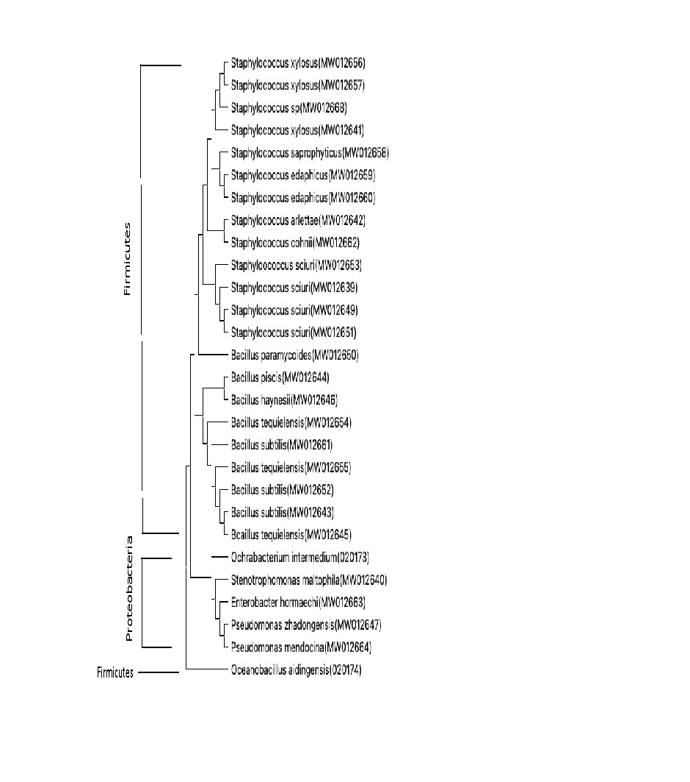
Phylogenetic relationships of both halophilic and halotolerant bacteria isolated from different geographical locations along with their gene accession numbers have been constructed. Based on partial 16S rRNA gene sequences, a phylogenetic tree was generated using the neighbor-joining method using MEGA 11 software, derived from 1,000 resamplings. The bacteria isolated belonged to phylum firmicutes and proteobacteria

Table S1 Some molecular structures of carotenoids from LC-MS/MS profile

Carotenoids | Molecular formula | Chemical structure | Biological activity
Zeaxanthin | C₄₀H₅₆0₂ | 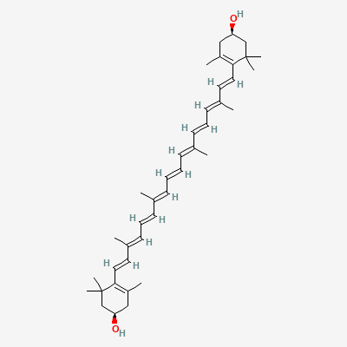 | Reduces age related macular degenearation, glaucoma and cataracts
Neoxanthin | C₄₀H₅₆0₄ | 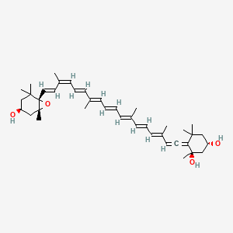 | Precursor of phytohormone, Abscisic acid
Beta-Carotene | C₄₀H₅₆ | 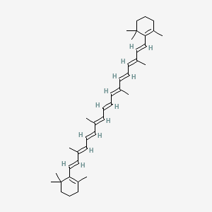 | Provitamin A supply, correcting growth and sight.
Lutein | C₄₀H₅₆0₂ | 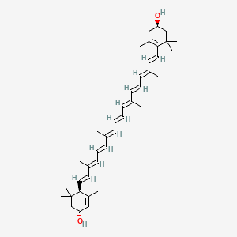 | Light filter, protects eye tissues from sunlight damage.
Violaxanthin | C₄₀H₅₆0₄ | 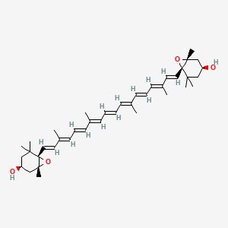 | Anti-proliferative activity on MCF-7 breast cancer cell lines
Astaxanthin | C₄₀H₅₆0₄ | 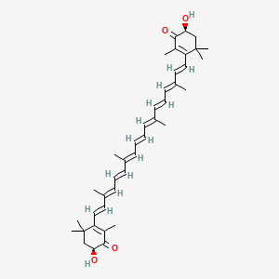 | Helps to activate white blood cells, reduces inflammation, protects from UV damage, supports cognitive health.
Canthaxanthin | C₄₀H₅₂0₂ | 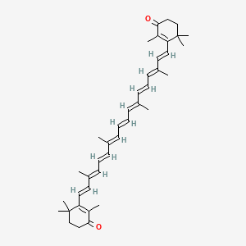 | Natural skin tanning agent, prevent liver damage from lipoperoxidation.

Image source : https://pubchem.ncbi.nlm.nih.gov/compound

Table S2 Potential applications of identified compounds using GC-MS analysis

Isolate | Compound Name | Potential known Applications | References
 | Benzeneethanamine | Neuroprotection | Martin
 | Phthalocyaninato iron | Catalysts in oxidation reaction | Brown
AD11 | Thiazolo[4,5-d]pyrimidines | Immune-modulators, Corticotropin Releasing Factor (CRF) receptor antagonists, anti-Parkinson's, anti-oxidant, antiviral, anticancer, antibacterial, antifungal, analgesic, anti-inflammatory agents including COX inhibitors, chemokines antagonists and Fractalkine receptor antagonists, anti-inflammatory and analgesic activities | Kuppast, Blokhina,  Singh
 | Acetic acid, 2 (2-Phenoxy)-ethyl ester | Anti-inflammatory, Anticancer and analgesic activity | Fokom,  Barclay, Nacoba
 | Phthalocyanine manganese | Catalyst for water oxidation | Mousazade
 | 2-Morpholin-4-yl-1,5-diphenyl-7-p-tolylimino-5- trifluoromethyl-1,5,6,7-tetrahydro- [1,2,4]triazolo[1,5- c]pyrimidine-8-carbonitrile | Antibiotic, Anticancer, Analgesic, Emulsifier, Insecticidal, Fungicide | McGuire
 | 1-(2-Benzyloxy-1-phenylethyl)-3,4-piperidinediol | Iminosugar inhibitor
AD14 | Thiophene, 3-methyl-5-octadecyl-2-pentadecyl | Anti-inflammatory, Anti-cancer activity, Antimicrobial, Antioxidant | Mishra,  Deep, Archna
 | 9,10-anthracenedione, 1-amino-4-[(9,10-dihydro- 9,10-dioxo-1-anthracenyl)amino] | Anticancer | Zhang, Hua,
 | Pyridine-3-carboxamide, 4-methoxy-N-(3,5- dichlorophenyl) | Anti-inflammatory,Anticancer, Anti Irritant, Collagen reducer, Food additive | Coban
 | Benzenaminium, 4-carboxy-N,N,N-trimethyl-, hydroxide, inner salt | Anticancer activity | Fadda
 | 2-Methyl-4-phenoxy-5,6-diphenyl-2H-pyridazin-3- one | Anti-feedant, Neuroprotective | Gevorkyan
AD23 | Glutaric acid, 2-methylpent-3-yl 2,2,3,4,4,4- hexafluorobutyl ester | Cognition enhancing, Polymer production | Marques
 | Estra-1,3,5(10)-trien-17-one, 2,3,4- tris[(trimethylsilyl)oxy] | Anti-Cancer activity | Maltais
 | N-Methyl-N-{4-[4-(4-nitro-1,2,5-oxadiazol-3-yl)- 1,2,5-oxadiazol-3-yl]-1,2,5-oxadiazol-3- yl}acetamide | Pesticidal, Pharmaceuticals, Antioxidant | Caruso,  Dhanasekaran
 | l-Proline, n-heptafluorobutyryl-, isobutyl ester | Anti-Pneumonial, anti-aging | Kaul
 | Silane, dimethyl(4-phenylphenoxy)heptadecyloxy | Dental applications | Lung
AD28 | Silane, diethylhexadecyloxypentadecyloxy | Dental applications | Matinlinna,  Nihei
 | 4-Methyl-2,4-bis(p-hydroxyphenyl)pent-1-ene, 2TMS derivative | Estrogenic activity, Hepatocellular carcinoma biomarkers | Bannaga, Stavropoulos
 | Phthalazine 1-phenyl | AntiCancer, Anti-cholinesterases, Anti- Alzheimer’s, Antiangiogenic | El-Helby,  Eckroat, El-Sayed

References

Archna, Archna, Pathania S, Chawla PA (2020) Thiophene-based derivatives as anticancer agents: An overview on decade’s work. Bioorganic Chemistry 101:104026
Bannaga AS, Tyagi H, Daulton E, et al (2021) Exploratory Study Using Urinary Volatile Organic Compounds for the Detection of Hepatocellular Carcinoma. Molecules 26.:

Barclay J (1866) Injection of Acetic Acid in Cancer. BMJ 2:512–512
Blokhina SV, Sharapova AV, Ol’khovich MV, et al (2021) Synthesis and antifungal activity of new hybrids thiazolo[4,5-d]pyrimidines with (1H-1,2,4)triazole. Bioorganic & Medicinal Chemistry Letters 40:127944
Brown ES, Robinson JR, McCoy AM, McGaff RW (2011) Efficient catalytic cycloalkane oxidation employing a “helmet” phthalocyaninato iron(iii) complex. Dalton Transactions 40:5921

Coban M, Morrison J, Freeman W, et al (2020) Targeting Tmprss2, S-protein:Ace2, and 3CLpro for Synergetic Inhibitory Engagement

Deep A, Narasimhan B, Aggarwal S, et al (2016) Thiophene Scaffold as Prospective Central Nervous System Agent: A Review. Central Nervous System Agents in Medicinal Chemistry 16:158–164

Dhanasekaran D, Thajuddin N, Panneerselvam A, Others (2008) An antifungal compound: 4′ phenyl-1-napthyl--phenyl acetamide from Streptomyces sp. DPTB16. Facta Universitatis Ser Med Biol 15:7–12
Eckroat TJ, Manross DL, Cowan SC (2020) Merged Tacrine-Based, Multitarget-Directed Acetylcholinesterase Inhibitors 2015–Present: Synthesis and Biological Activity. Int J Mol Sci 21:5965
El-Helby A-GA, Sakr H, Ayyad RRA, et al (2018) Design, Synthesis, In Vitro Anti-cancer Activity, ADMET Profile and Molecular Docking of Novel Triazolo[3,4-a]phthalazine Derivatives Targeting VEGFR-2 Enzyme. Anti-Cancer Agents in Medicinal Chemistry 18:1184–1196
El-Sayed NF, El-Hussieny M, Ewies EF, et al (2020) New phosphazine and phosphazide derivatives as multifunctional ligands targeting acetylcholinesterase and β-Amyloid aggregation for treatment of Alzheimer’s disease. Bioorg Chem 95:103499
Fadda AA, Tawfik EH, Abdel‐Motaal M, Selim YA (2021) Synthesis of novel cyanine dyes as antitumor agents. Archiv der Pharmazie 354:2000186
Fokom-Domgue J, Combescure C, Fokom-Defo V, et al (2015) Performance of alternative strategies for primary cervical cancer screening in sub-Saharan Africa: systematic review and meta-analysis of diagnostic test accuracy studies. BMJ h3084
Gevorkyan AA, Kazaryan PI, Avakyan SV, Simonyan ÉS (1989) Scission of oxiranes by acid anhydrides to unsaturated alcohol esters. Chem Heterocycl Compd 25:254–257
Hua D, Lou K, Battina S, et al (2006) Syntheses, Molecular Targets and Antitumor Activities of Novel Triptycene Bisquinones and 1,4-Anthracenedione Analogs. Anti-Cancer Agents in Medicinal Chemistry 6:303–318
Kaul S, Sharma SS, Mehta IK (2008) Free radical scavenging potential of L-proline: evidence from in vitro assays. Amino Acids 34:315–320
Kuppast B, Fahmy H (2016) Thiazolo[4,5-d]pyrimidines as a privileged scaffold in drug discovery. European Journal of Medicinal Chemistry 113:198–213
Lung CYK, Matinlinna JP (2012) Aspects of silane coupling agents and surface conditioning in dentistry: an overview. Dent Mater 28:467–477
Maltais R, Perreault M, Roy J, Poirier D (2020) Minor chemical modifications of the aminosteroid derivative RM-581 lead to major impact on its anticancer activity, metabolic stability and aqueous solubility. Eur J Med Chem 188:111990

Marques F de O, de Oliveira Marques F, Hagen MEK, et al (2003) Glutaric acid induces oxidative stress in brain of young rats. Brain Research 964:153–158
Martin LL, Lee GE, Lee TBK, et al (1994) Synthesis, Resolution, and SAR of (.+-.)-2-Amino-N-methyl-.alpha.-(3-methyl-2-thienyl)benzeneethanamine and Related Analogs as Noncompetitive NMDA Antagonists with Neuroprotective Properties. Journal of Medicinal Chemistry 37:3008–3015
McGuire RG, Dimitroglou DA (1999) Evaluation of Shellac and Sucrose Ester Fruit Coating Formulations that Support Biological Control of Post-harvest Grapefruit Decay. Biocontrol Science and Technology 9:53–65
Mishra R, Kumar N, Mishra I, Sachan N (2020) A Review on Anticancer Activities of Thiophene and Its Analogs. Mini-Reviews in Medicinal Chemistry 20:1944–1965
Mousazade Y, Najafpour MM, Bagheri R, et al (2019) A manganese(ii) phthalocyanine under water-oxidation reaction: new findings. Dalton Transactions 48:12147–12158
Nagoba BS, Selkar SP, Wadher BJ, Gandhi RC (2013) Acetic acid treatment of pseudomonal wound infections – A review. Journal of Infection and Public Health 6:410–415
Nihei T (2016) Dental applications for silane coupling agents. J Oral Sci 58:151–155
Singh B, Guru SK, Kour S, et al (2013) Synthesis, antiproliferative and apoptosis-inducing activity of thiazolo[5,4-d]pyrimidines. European Journal of Medicinal Chemistry 70:864–874
Stavropoulos G, van Munster K, Ferrandino G, et al (2021) Liver Impairment-The Potential Application of Volatile Organic Compounds in Hepatology. Metabolites 11.:

