Table 3 List of compounds identified from the samples using GC-MS
Isolate | Compound Name | RT | Molecular formula | Molecular structure
 | Benzeneethanamine | 9.44 | C₂₇H₄₉NO | 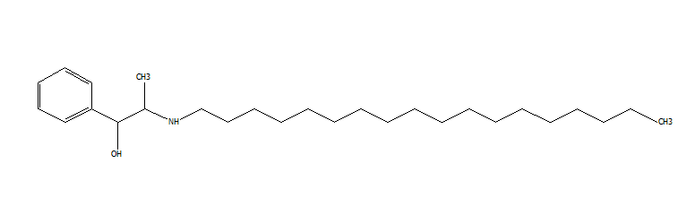
 | Phthalocyaninatoiron | 13.85 | C₃₂H₁₆FeN₈ | 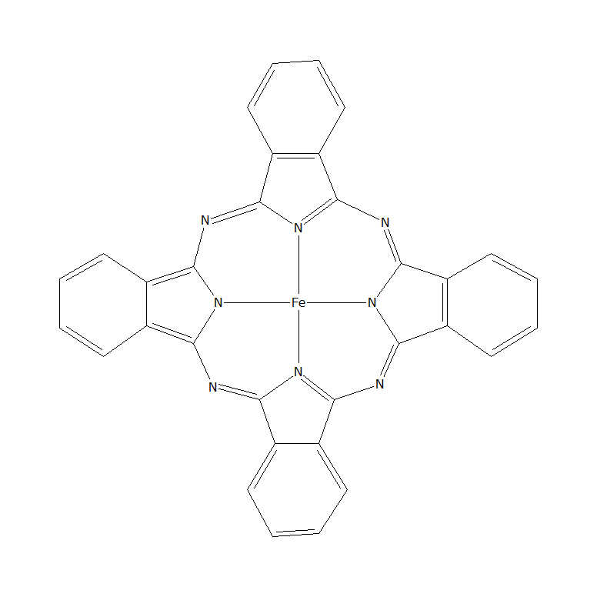
AD11 | Thiazolo[5,4-d]thiazole 2,5,di-2-pyridinyl | 9.54 | C₁₄H₈N₄S₂ | 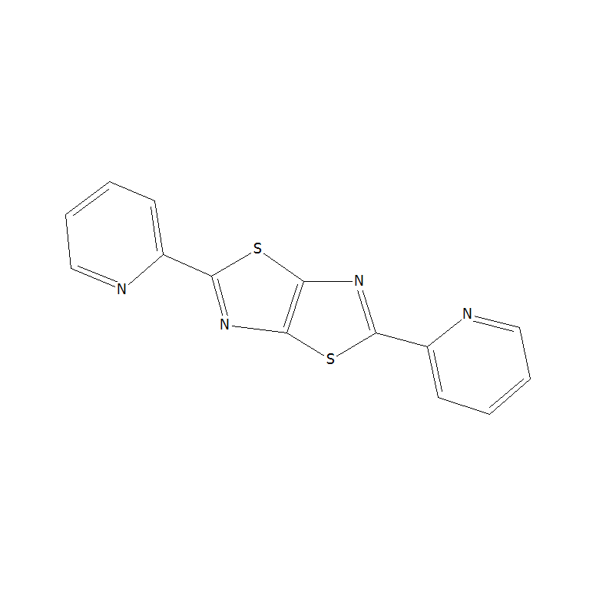
 | Acetic acid, 2 (2-Phenoxy)-ethyl ester | 6.32 | C₁₄H₁O₆ | 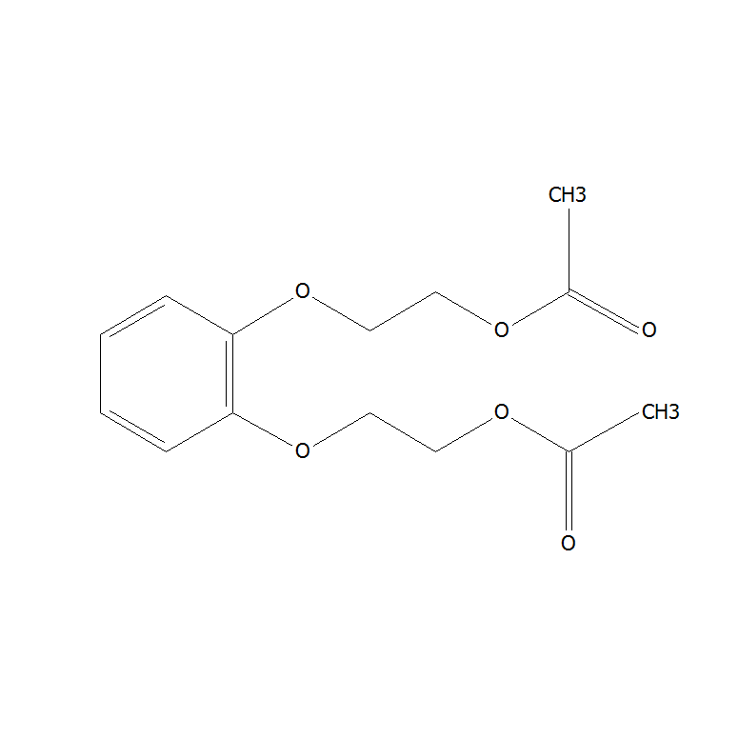
 | Phthalocyanine manganese | 13.85 | C₃₂H₁₆FeN₈ | 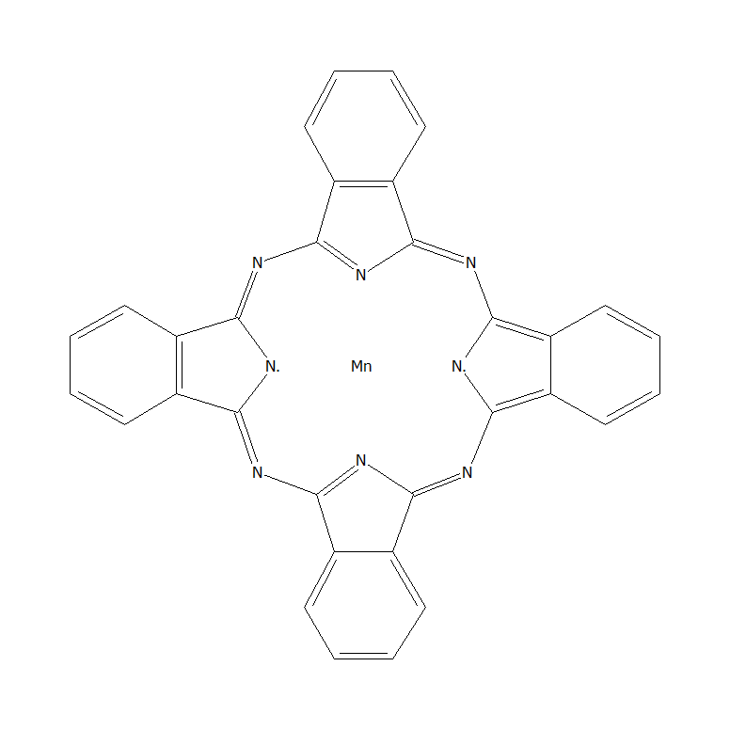
 | 2-Morpholin-4-yl-1,5-diphenyl-7-p-tolylimino-5- trifluoromethyl-1,5,6,7-tetrahydro- [1,2,4]triazolo[1,5- c]pyrimidine-8-carbonitrile | 25.84 | C₃₀H₂₆F₃N₇O | 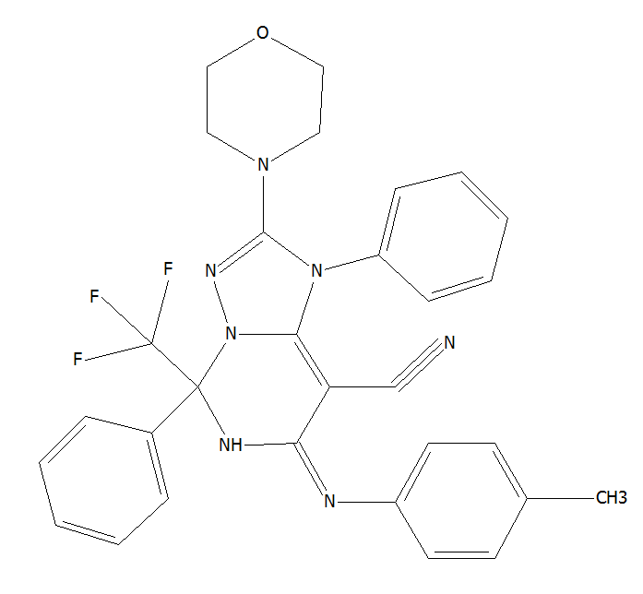
AD14 | 1-(2-Benzyloxy-1-phenylethyl)-3,4-piperidinediol | 4.136 | C₂₀H₂₅NO₃ | 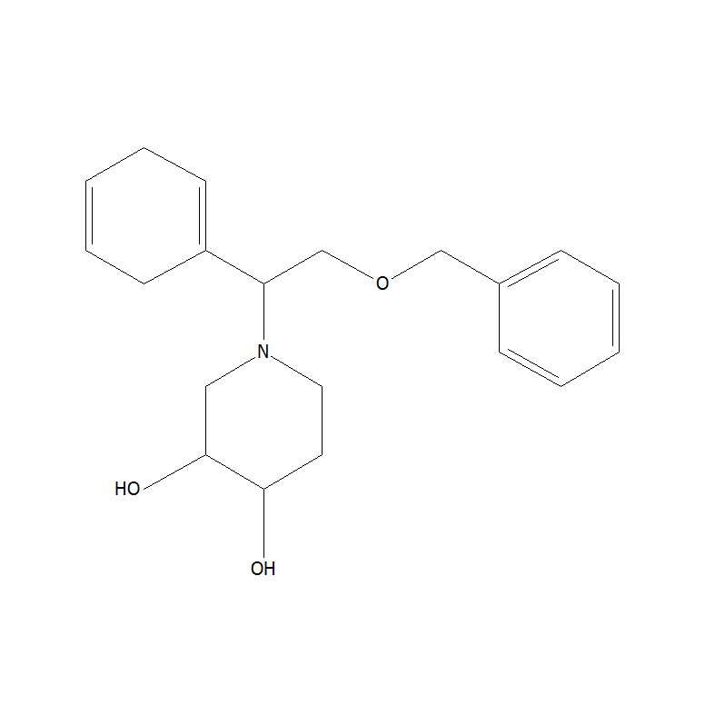
 | Thiophene, 3-methyl-5-octadecyl-2-pentadecyl | 9.48 | C₃₈H₇₂S | 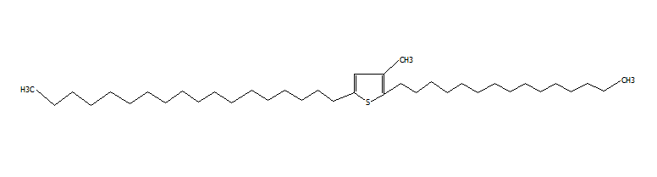
 | 9,10-anthracenedione, 1-amino-4-[(9,10-dihydro- 9,10-dioxo-1-anthracenyl)amino] | 18.37 | C₃₈H₁₆N₂O₄ | 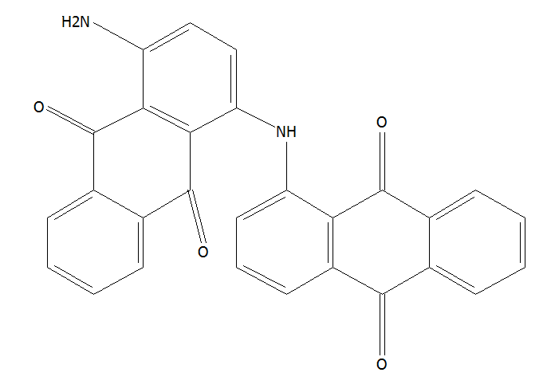
 | Pyridine-3-carboxamide, 4-methoxy-N-(3,5- dichlorophenyl) | 9.55 | C₁₃H₁₀C₁₂N₂O₂ | 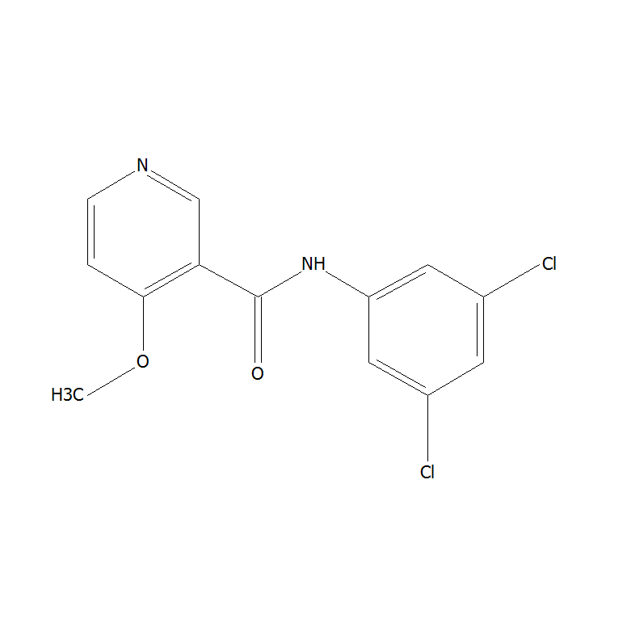
 | Benzenaminium, 4-carboxy-N,N,N-trimethyl-, hydroxide, inner salt | 4.18 | C₁₀H₁₃NO₂ | 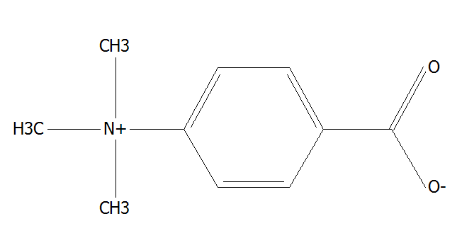
 | 2-Methyl-4-phenoxy-5,6-diphenyl-2H-pyridazin-3- one | 11.64 | C₂₃H₁₈N₂O₂ | 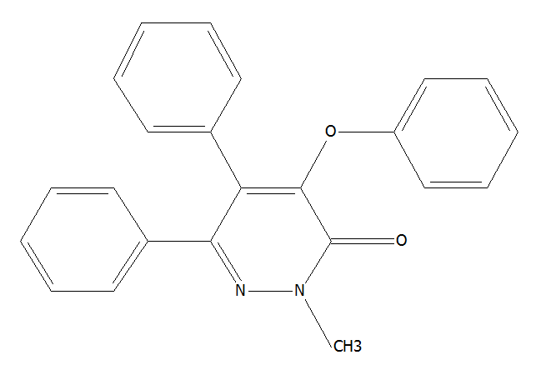
AD23 | Glutaric acid, 2-methylpent-3-yl 2,2,3,4,4,4- hexafluorobutyl ester | 31.00 | C₁₅H₂₂F₆O₄ | 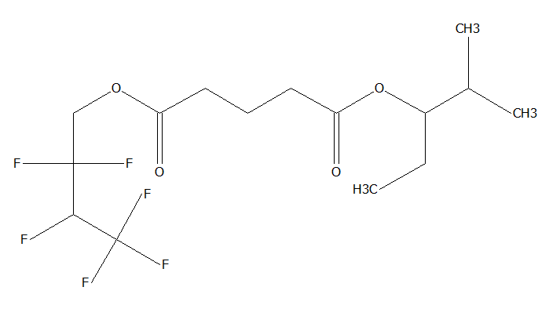
 | Estra-1,3,5(10)-trien-17-one, 2,3,4- tris[(trimethylsilyl)oxy] | 28.65 | C₂₇H₄₆O₄Si₃ | 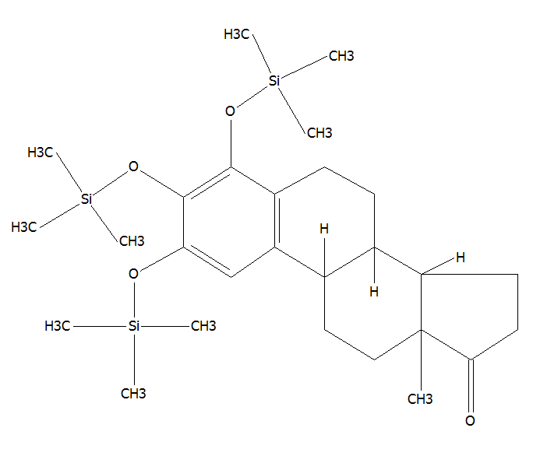
 | N-Methyl-N-{4-[4-(4-nitro-1,2,5-oxadiazol-3-yl)- 1,2,5-oxadiazol-3-yl]-1,2,5-oxadiazol-3- yl}acetamide | 7.12 | C₉H₆N₈O₆ | 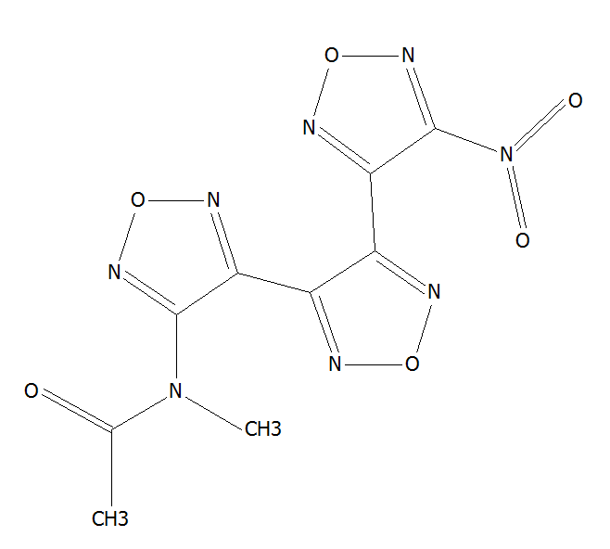
 | l-Proline, n-heptafluorobutyryl-, isobutyl ester | 10.55 | C₁₃H₁₆F₇NO₃ | 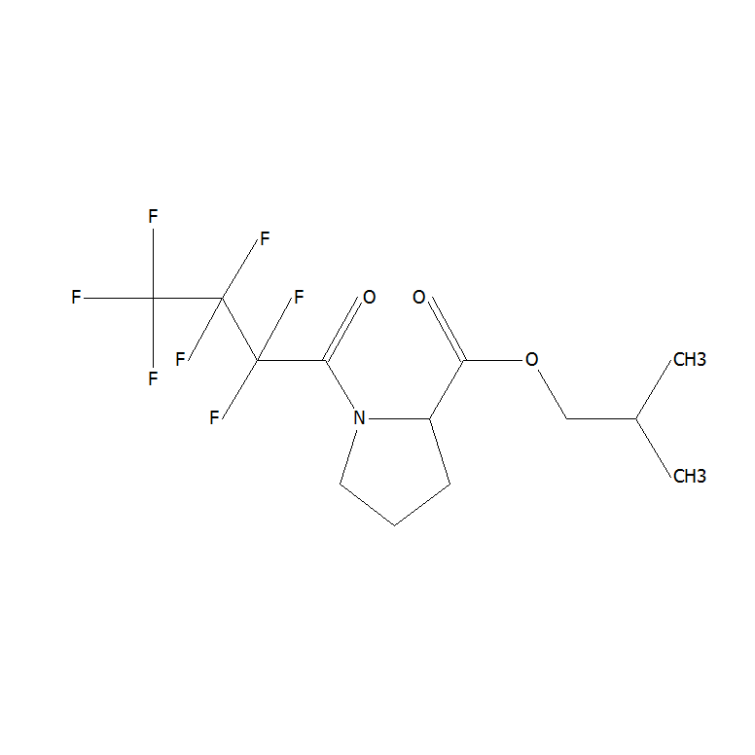
 | Silane, dimethyl(4-phenylphenoxy)heptadecyloxy | 11.49 | C₃₁H₅₀O₂Si | 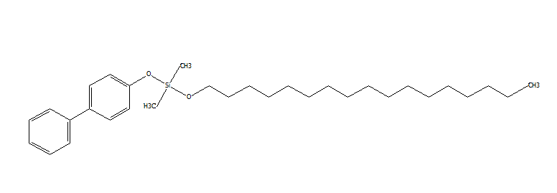
AD28 | Silane, diethylhexadecyloxypentadecyloxy | 11.58 | C₃₅H₇₄O₂Si | 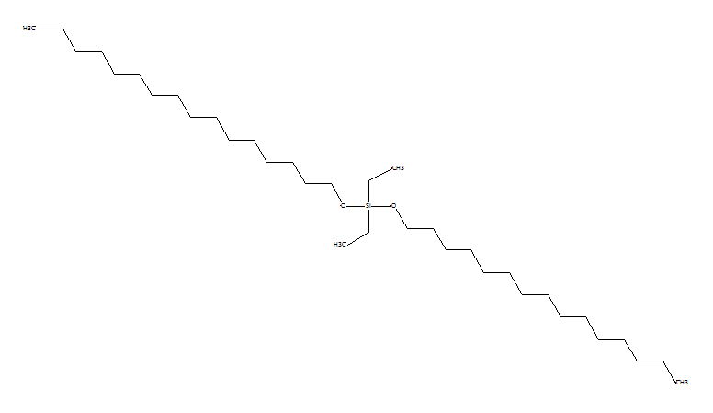
 | 4-Methyl-2,4-bis(p-hydroxyphenyl)pent-1-ene, 2TMS derivative | 37.99 | C₂₄H₃₆O₂Si₂ | 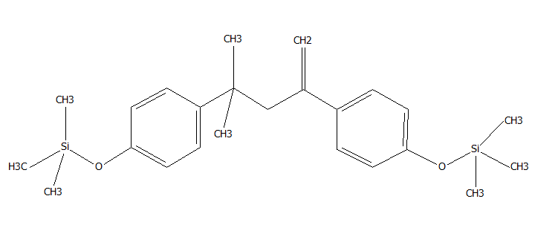
 | Phthalazine 1-phenyl | 29.68 | C₁₄H₁₀N₂ | 