Supplementary Information

Carbohydrate ProLectin-M, a Galectin-3 Antagonist that Blocks SARS-CoV-2 Activity
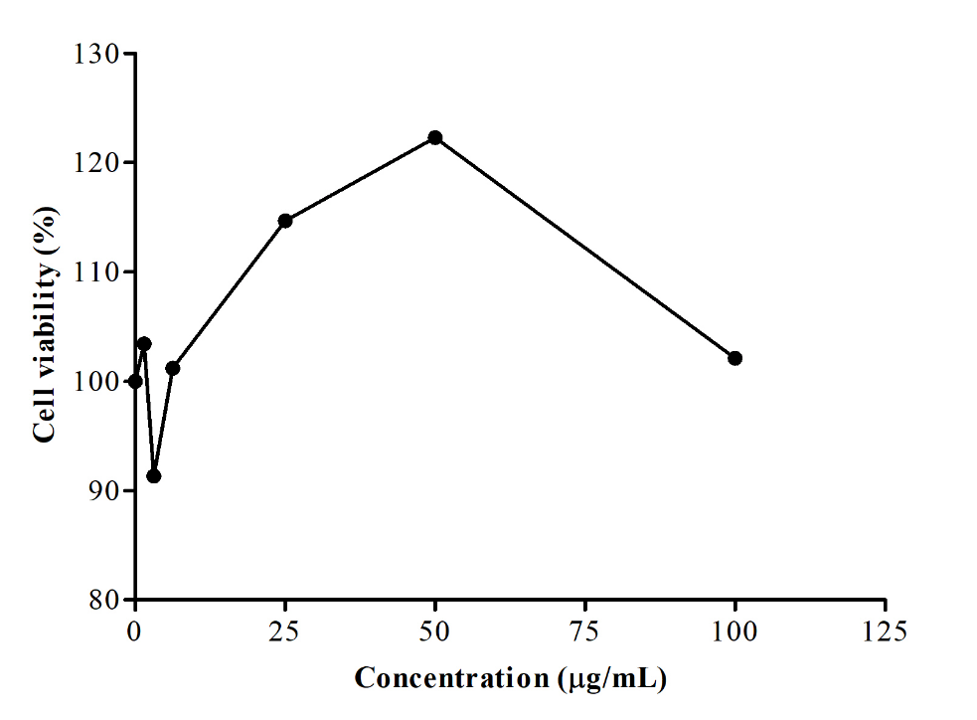
Supplementary Fig. 1: Cytotoxic effect of PL-M on Vero cells.
No cytotoxic effect observed by PL-M on Vero cells. PL-M increased the percent of viable cells: CC₅₀ = >100 µg/mL. All data represent the mean ± SD of triplicate experiments.
