Supplementary Information

Targeted degradation of IKZF2 for cancer immunotherapy
Compounds Synthesis and Characterization
Starting materials, reagents, and solvents were obtained from commercial sources with purity >95% unless otherwise noted and used as received. THF, Et₂O, DMF, DCM, 1,4-dioxane, and DMF were anhydrous grade. Analytical LC/MS was conducted using a Waters Classic AcQuity UPLC with UV detection at 214 and 254 nm and an electrospray mode (ESI) coupled with a Waters SQ single quad mass detector. High resolution mass spectra (HRMS) were recorded on a Waters Xevo G2XS QToF. All analyses were carried out in positive ion mode. Sodium Cesium Iodide was used as calibration standard. A Biotage Initiator Sixty or a Biotage Initiator Plus Sixty was used for microwave heating. Purification of intermediates and final products was carried out on normal phase using an ISCO CombiFlash system and prepacked SiO₂ cartridges eluted with optimized gradients of either heptane-ethyl acetate mixture occasionally with NEt₃ modifier as described. Preparative high pressure liquid chromatography (HPLC) was performed on Waters auto purification systems. HPLC separation was performed at 75 mL/min flow rate with the indicated gradient within 3.5 min with an initial hold of 10 s, using either NH₄OH or formic acid modifier as described. Columns were Xbridge C18 5μm 30 mm x 50 mm or Sunfire C18 5μm 30 mm x 50 mm. All target compounds had purity of >95% as established by analytical HPLC, unless otherwise noted. NMR spectra were recorded on a Bruker Ultrashield AV400 (Avance 400 MHz) plus instrument. Chemical shifts (δ) are reported in parts per million (ppm) relative to deuterated solvent as the internal standard (CDCl₃ 7.26 ppm, DMSO-d₆ 2.50 ppm), and coupling constants (J) are in hertz (Hz).

Scheme 1: Synthesis of 3-(5-cyclopropyl-1-oxoisoindolin-2-yl)piperidine-2,6-dione (3)
Step 1. methyl 2-(bromomethyl)-4-cyclopropylbenzoate (Int-2). Methyl 4-cyclopropyl-2-methylbenzoate (Int-1) was made according to procedure described in J. Med. Chem. 2015, 58, 512−516. To a stirred solution of methyl methyl 4-cyclopropyl-2-methylbenzoate (Int-1) (1.1 g, 0.92 mmol) in CCl₄ (20 mL) were added AIBN (100 mg, 0.63 mmol) and NBS (1.54 g, 8.67 mmol) under nitrogen atmosphere. The reaction mixture was stirred for 16 hours at 70 ºC. The reaction mxiture was diluted with water at 0 ºC and extracted with EtOAc (2x10 mL). Combined organic layers were dried over Na₂SO₄, filtered, and concentrated under reduced pressure. The crude methyl 2-(bromomethyl)-4-cyclopropylbenzoate (Int-2) (~800 mg) was immediately used in the next step.
Step 2. 3-(5-cyclopropyl-1-oxoisoindolin-2-yl)piperidine-2,6-dione (3). To a stirred solution of crude methyl 2-(bromomethyl)-4-cyclopropylbenzoate (Int-2) (800 mg, assumed 2.97 mmol) in DMF (10 mL) was added Et₃N (0.83 mL, 5.9 mmol) and 3-aminopiperidine-2,6-dione hydrochloride (730 mg, 4.45 mmol). The reaction mixture was stirred for 15 hours at 50 ºC. The reaction mixture was diluted with at water 0 ºC and extracted with EtOAc (2x10 mL), were dried over Na₂SO₄, filtered, and concentrated under reduced pressure. The crude product was purified by silica gel column chromatography, eluting with 70-100% EtOAc in hexane, to afford 3-(5-cyclopropyl-1-oxoisoindolin-2-yl)piperidine-2,6-dione (3) (5 mg, 0.02 mmol, 6% yield) as a grey solid. ¹H NMR (400 MHz, DMSO-d₆) δ ppm 10.96 (s, 1H), 7.58 (d, J = 8.0 Hz, 1H), 7.28 (s, 1H), 7.22 (d, J = 8.2 Hz, 1H), 5.09 (dd, J = 13.3, 5.2 Hz, 1H), 4.38 (d, J = 17.1 Hz, 1H), 4.26 (d, J = 17.1 Hz, 1H), 2.91 (ddd, J = 17.0, 13.5, 5.3 Hz, 1H), 2.63 – 2.55 (m, 1H), 2.38 (qd, J = 13.2, 4.4 Hz, 1H), 2.10 – 2.03 (m, 1H), 2.02 – 1.93 (m, 1H), 1.08 – 1.00 (m, 2H), 0.83 – 0.73 (m, 2H).¹³C NMR (101 MHz, DMSO-d₆) δ ppm 172.90, 171.10, 168.08, 148.54, 142.48, 128.98, 125.41, 122.76, 119.94, 51.51, 46.98, 31.22, 22.50, 15.53, 10.34. HRMS (m/z): [M+H]⁺ calcd for C₁₆H₁₆N₂O₃ 285.1234; found 285.1245.

¹H NMR (400 MHz, DMSO-d₆) - 3-(5-cyclopropyl-1-oxoisoindolin-2-yl)piperidine-2,6-dione (3)
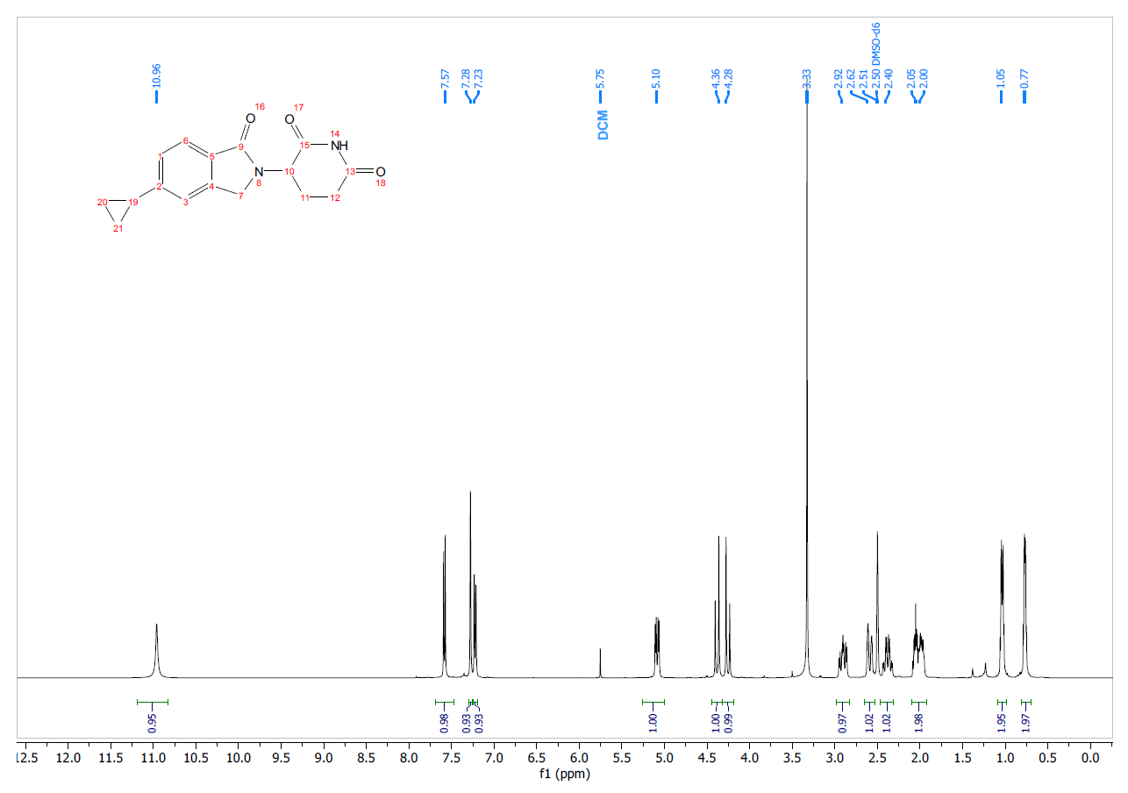
¹³C NMR (101 MHz, DMSO-d₆) - 3-(5-cyclopropyl-1-oxoisoindolin-2-yl)piperidine-2,6-dione (3)
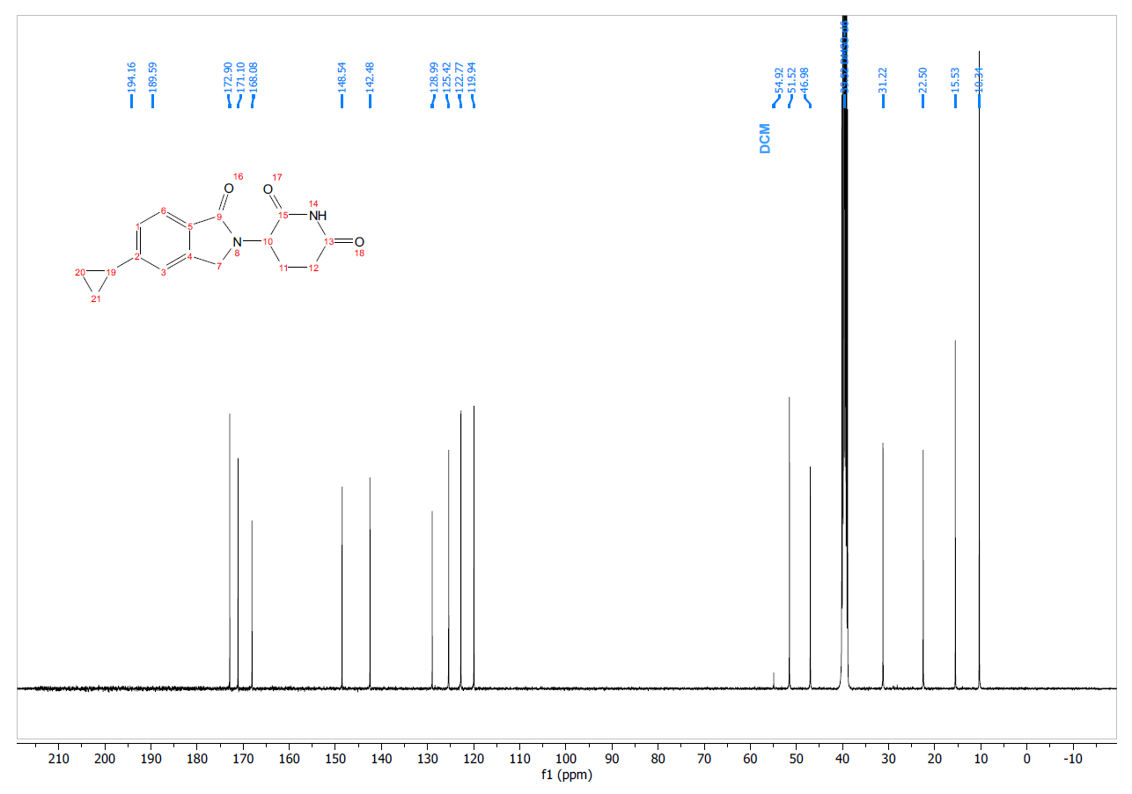
Scheme 2: Synthesis of 3-(1-oxo-5-phenylisoindolin-2-yl)piperidine-2,6-dione (4)
Step 1. methyl 3-methyl-[1,1'-biphenyl]-4-carboxylate (Int-4). A mixture of methyl 4-bromo-2-methylbenzoate (Int-3) (300 mg, 1.31 mmol), phenylboronic acid (190 mg, 1.57 mmol), K₂CO₃ (380 mg, 2.79 mmol), and water (1.5 mL) in PhMe:MeOH (10 mL, v/v =4:1) was degassed with argon for 5 min. Pd(PPh₃)₂Cl₂ (48 mg, 0.069 mmol) was added and the reaction mixture was stirred for 16 hours at 90 º C. Reaction mixture was diluted with water and extracted with EtOAc. Organic layer was separated and washed with brine. The organic layer was dried over Na₂SO₄, filtered, and concentrated under reduced pressure. The crude compound was purified by silica gel column chromatography, eluting with 2.5 % EtOAc in hexane to afford methyl 3-methyl-[1,1'-biphenyl]-4-carboxylate (Int-4) (0.21 g, 0.92 mmol, 72% yield) as a white solid. The analytical data matched the one reported in Molecules 2013, 18, 11683-11704.
Step 2. methyl 3-(bromomethyl)-[1,1'-biphenyl]-4-carboxylate (Int-5). To a stirred solution of methyl 3-methyl-[1,1'-biphenyl]-4-carboxylate (Int-4) (0.21 g, 0.92 mmol) in CCl₄ (10 mL) were added AIBN (15 mg, 0.09 mmol) and NBS (0.18 g, 1.01 mmol) under nitrogen atmosphere. The reaction mixture was stirred for 16 hours at 70 ºC. The reaction mixture was concentrated under reduced pressure diluted with cold water and extracted with DCM. The separated organic layer was washed with brine, dried over Na₂SO₄, filtered, and concentrated under reduced pressure. The crude product was purified by silica gel column chromatography, eluting with 2.5 % EtOAc in hexane, to afford methyl 3-(bromomethyl)-[1,1'-biphenyl]-4-carboxylate (Int-5) (0.18 g, 0. 59 mmol, 64% yield) as a white solid. The product was used in the next step immediately.
Step 3. 3-(1-oxo-5-phenylisoindolin-2-yl)piperidine-2,6-dione (4). To a stirred solution of methyl 3-(bromomethyl)-[1,1'-biphenyl]-4-carboxylate (Int-5) (180 mg, 0.59 mmol) in DMF (10 mL) was added K₂CO₃ (160 mg, 1.18 mmol) and 3-aminopiperidine-2,6-dione hydrochloride (150 mg, 0.88 mmol). The reaction mixture was stirred for 16 h at 70 ºC. The reaction mixture was concentrated under reduced pressure, diluted with cold water, and extracted with DCM. The separated organic layer and washed with brine, dried over Na₂SO₄ and then concentrated under reduced pressure. The crude product was washed with EtOAc (20 mL) and dried under high vacuum for 1 hour to afford 3-(1-oxo-5-phenylisoindolin-2-yl)piperidine-2,6-dione (4) (42.5 mg, 0.13 mmol, 22% yield) as a grey solid. ¹H NMR (400 MHz, DMSO-d₆) δ ppm 10.99 (s, 1H), 7.90 (s, 1H), 7.81 (s, 2H), 7.74 (d, J = 7.5 Hz, 2H), 7.51 (t, J = 7.5 Hz, 2H), 7.43 (t, J = 7.3 Hz, 1H), 5.15 (dd, J = 13.2, 5.2 Hz, 1H), 4.52 (d, J = 17.4 Hz, 1H), 4.40 (d, J = 17.1 Hz, 1H), 2.93 (ddd, J = 18.1, 13.4, 5.4 Hz, 1H), 2.70 – 2.56 (m, 1H), 2.46 – 2.36 (m, 1H), 2.18 – 1.81 (m, 1H). ¹³C NMR (101 MHz, DMSO-d₆) δ ppm 172.90, 171.06, 167.88, 143.73, 142.96, 139.54, 130.70, 129.10, 128.17, 127.17, 126.81, 123.45, 121.91, 51.65, 47.28, 31.24, 22.49. HRMS (m/z): [M+H]⁺ calcd for C₁₉H₁₇N₂O₃ 321.1234; found 321.1282.

¹H NMR (400 MHz, DMSO-d₆) - 3-(1-oxo-5-phenylisoindolin-2-yl)piperidine-2,6-dione (4)
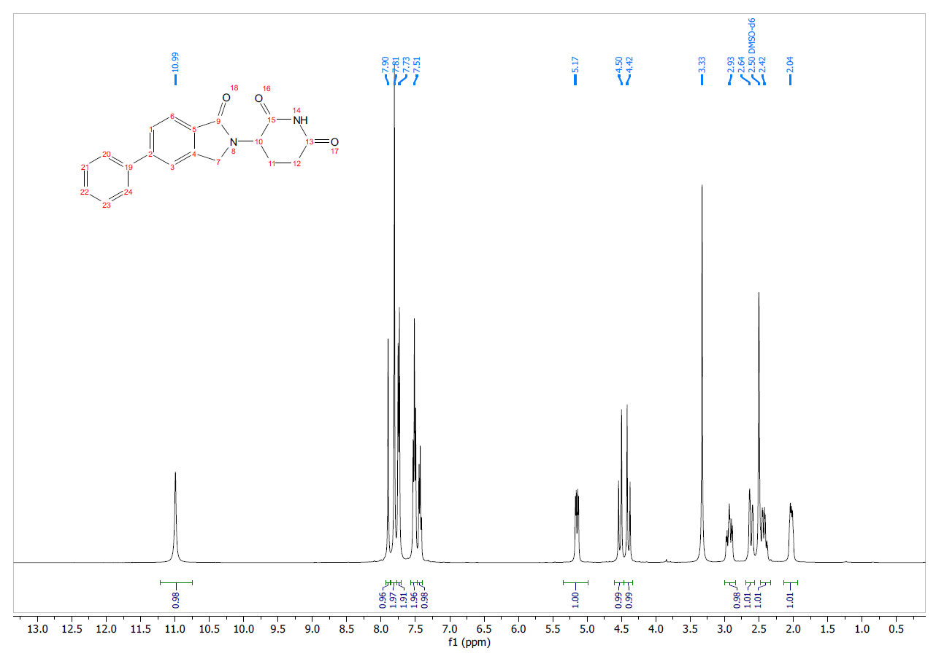

¹³C NMR (101 MHz, DMSO-d₆) - 3-(1-oxo-5-phenylisoindolin-2-yl)piperidine-2,6-dione (4)
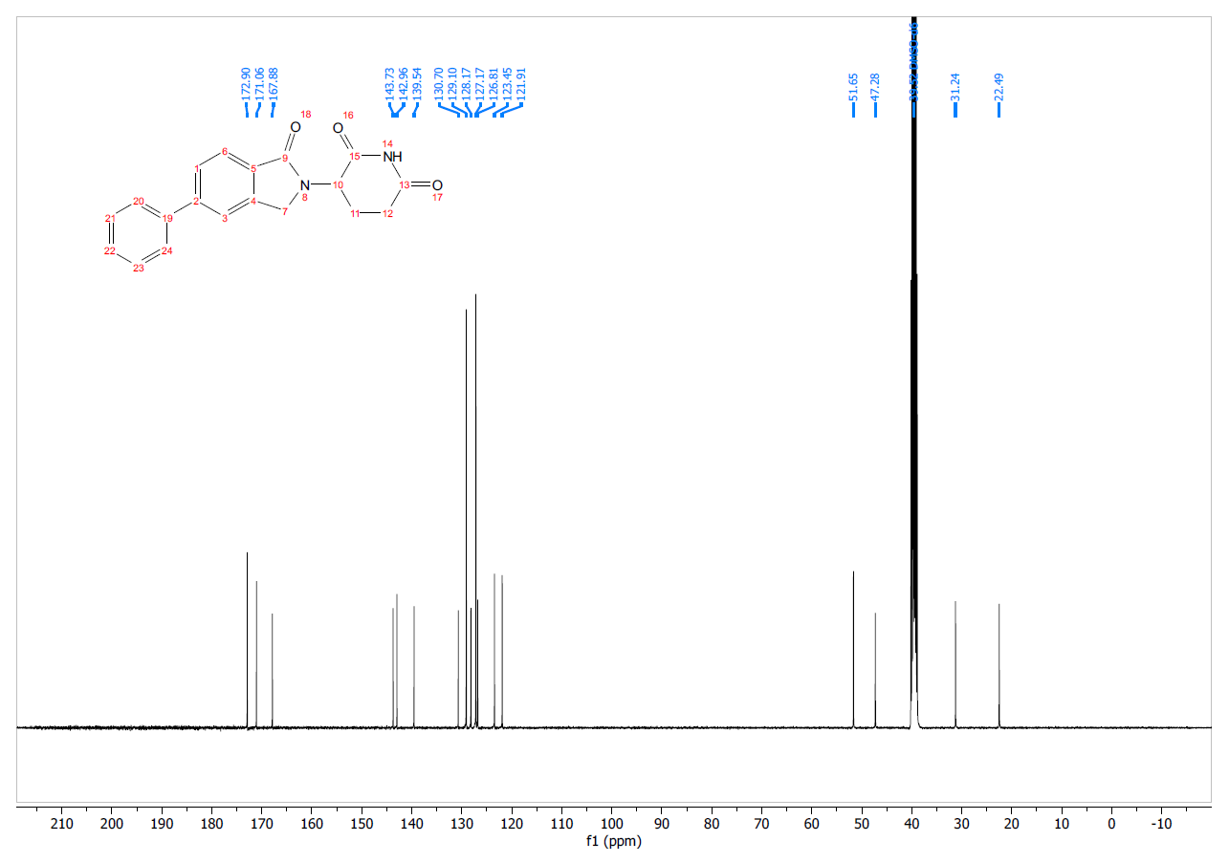

Scheme 3: Synthesis of 3-(5-cyclohexyl-1-oxoisoindolin-2-yl)piperidine-2,6-dione (5)
Step 1. 3-(5-bromo-1-oxoisoindolin-2-yl)piperidine-2,6-dione (Int-7). Intermediate methyl 4-bromo-2-(bromomethyl)benzoate (Int-6) was prepared as reported in U.S. Patent Application US 2009/0142297. To a stirred solution of methyl 4-bromo-2-(bromomethyl)benzoate (Int-6) (15.0 g, 48.7 mmol) in DMF (150 mL) was added 3-aminopiperidine-2,6-dione hydrochloride (6.90 g, 53.6 mmol) and K₂CO₃ (20.2 g, 146 mmol). The resulting mixture was heated at 70 °C for 16 hours after which time the reaction mixture was cooled to rt and then concentrated to dryness. To the resulting residue, water was added and the mixture stirred at rt for 30 min. The resultant solid was filtered and washed with Et₂O and EtOAc. The solid was dried under vacuum filtration to afford 3-(5-bromo-1-oxoisoindolin-2-yl)piperidine-2,6-dione (Int-7) (10.6 g, 32.9 mmol, 67% yield) as a gray solid. MS (ESI) m/z 323.0 [M+H]⁺. ¹H NMR (400 MHz, DMSO-d₆) δ ppm 10.99 (s, 1H), 7.91-7.88 (m, 1H), 7.72 (dd, J = 8.1, 1.6 Hz, 1H), 7.67 (d, J = 8.0 Hz, 1H), 5.11 (dd, J = 13.3, 5.1 Hz, 1H), 4.47 (d, J = 17.7 Hz, 1H), 4.34 (d, J = 17.7 Hz, 1H), 2.98-2.83 (m, 1H), 2.65-2.55 (m, 1H), 2.45-2.29 (m, 1H), 2.01 (dtd, J = 12.7, 5.3, 2.3 Hz, 1H).
Step 2. 3-(5-(cyclohex-1-en-1-yl)-1-oxoisoindolin-2-yl)piperidine-2,6-dione (Int-8). A stirred solution of 3-(5-bromo-1-oxoisoindolin-2-yl)piperidine-2,6-dione (Int-7) (0.15 g, 0.464 mmol) in DMF (4.0 mL) was purged with argon for 5 min. Next, 2-(cyclohex-1-en-1-yl)-4,4,5,5-tetramethyl-1,3,2-dioxaborolane (0.125 g, 0.603 mmol), K₃PO₄ (0.197 g, 0.928 mmol), and Pd(dppf)Cl₂•DCM (19 mg, 0.023 mmol) were added sequentially and the reaction mixture was purged with argon for additional 5 min in a seal tube. Reaction mixture was stirred at 90°C for 16 hours. The reaction mixture was concentrated under reduced pressure and purified by column chromatography, eluting with 10% MeOH in DCM, to afford 3-(5-cyclohexyl-1-oxoisoindolin-2-yl)piperidine-2,6-dione (Int-8) (90 mg, 0.28 mmol, 59 % yield) as a brown solid. MS (ESI) m/z 325.0 [M+H]⁺.
Step 3. 3-(5-cyclohexyl-1-oxoisoindolin-2-yl)piperidine-2,6-dione (5). To a stirred solution of 3-(5-(cyclohex-1-en-1-yl)-1-oxoisoindolin-2-yl)piperidine-2,6-dione (Int-8) (45 mg, 0.14 mmol) in THF:DMF (5.5 mL, v/v = 10:1) was added Pd/C (5 mg). The reaction mixture was stirred under atmosphere of H₂ (1 atm, balloon) at room temperature for 3 h. The reaction mixture was filtered through a bed of Celite® and the filtrate was concentrated under reduced pressure. The crude product was purified by reverse phase HPLC (20-65% MeCN in H₂O + 0.02% TFA) to afford 3-(5-cyclohexyl-1-oxoisoindolin-2-yl)piperidine-2,6-dione (5) (14 mg, 0.042 mmol, 30% yield) as a white solid. MS (ESI) m/z 327.0 [M+H]⁺. ¹H NMR (400 MHz, DMSO-d₆) δ ppm 10.97 (s, 1H), 7.63 (d, J = 7.8 Hz, 1H), 7.46 (s, 1H), 7.40 – 7.34 (m, 1H), 5.10 (dd, J = 13.3, 5.1 Hz, 1H), 4.41 (d, J = 17.1 Hz, 1H), 4.28 (d, J = 17.1 Hz, 1H), 2.91 (ddd, J = 17.1, 13.6, 5.4 Hz, 1H), 2.71 – 2.55 (m, 2H), 2.39 (qd, J = 13.3, 4.5 Hz, 1H), 2.04 – 1.94 (m, 1H), 1.85 – 1.77 (m, 4H), 1.75 – 1.67 (m, 1H), 1.53 – 1.32 (m, 4H), 1.31 – 1.19 (m, 1H). ¹³C NMR (101 MHz, DMSO-d₆) δ ppm 172.89, 171.10, 168.06, 151.91, 142.43, 129.57, 126.82, 122.88, 121.61, 51.51, 47.08, 44.12, 33.90, 31.22, 26.27, 25.52, 22.52. HRMS (m/z): [M+H]⁺ calcd for C₁₉H₂₃N₂O₃ 327.1703; found 327.1761.

¹H NMR (400 MHz, DMSO-d₆) - 3-(5-cyclohexyl-1-oxoisoindolin-2-yl)piperidine-2,6-dione (5)
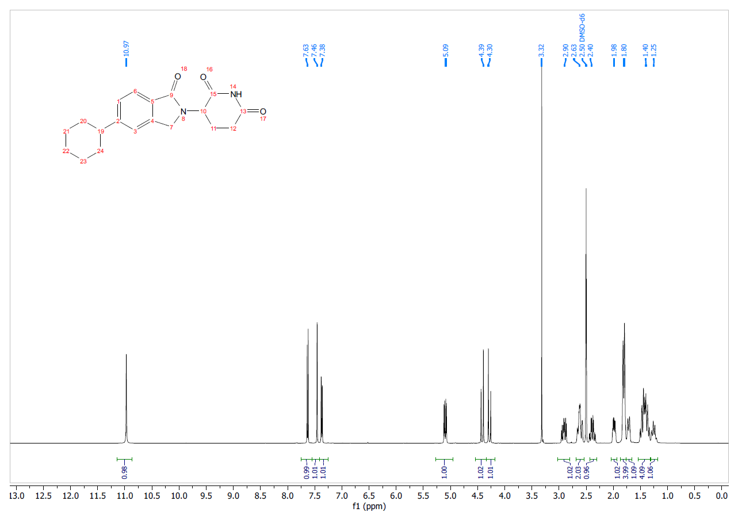
¹³C NMR (101 MHz, DMSO-d₆) - 3-(5-cyclohexyl-1-oxoisoindolin-2-yl)piperidine-2,6-dione (5)
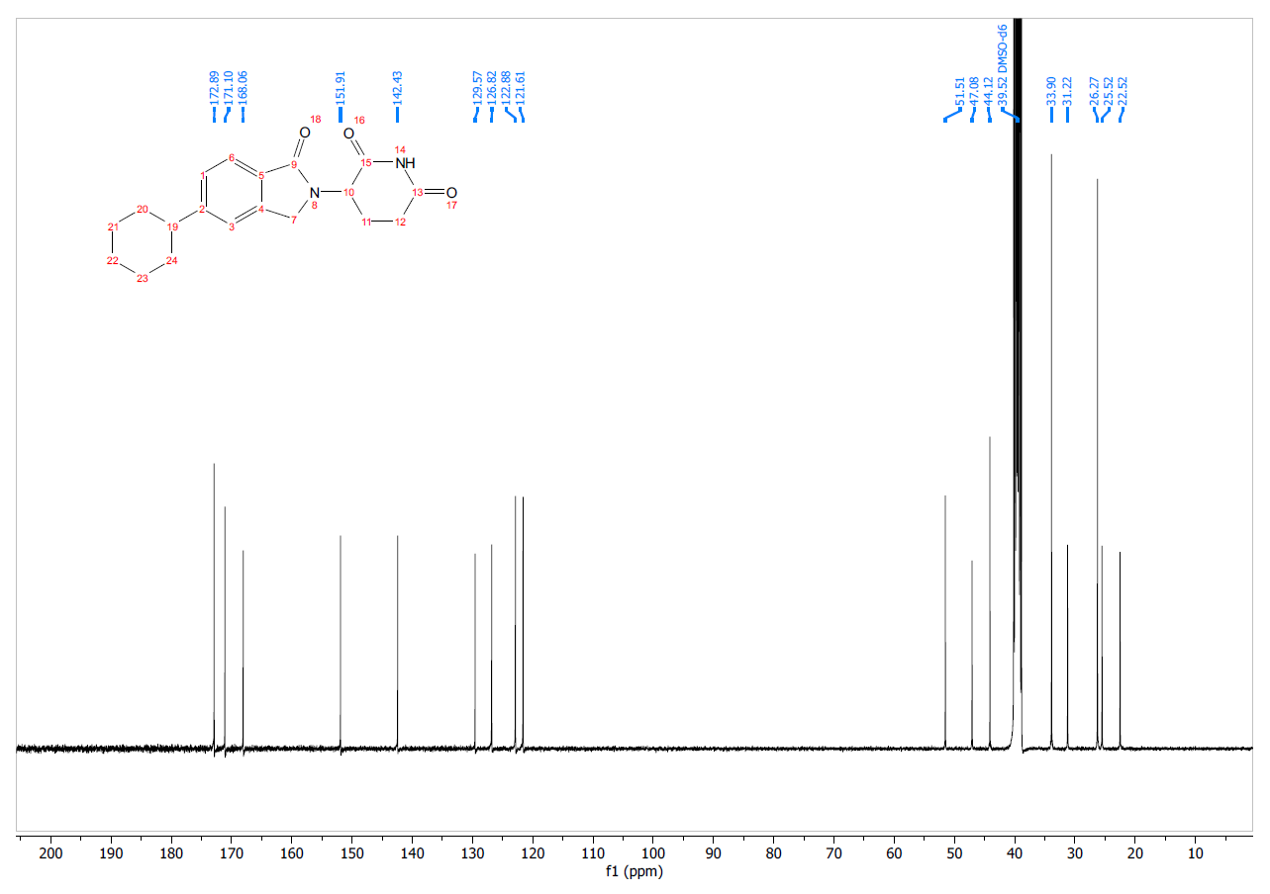

Scheme 4: Synthesis of 3-(1-oxo-5-(piperidin-4-yl)isoindolin-2-yl)piperidine-2,6-dione (6)
Step 1. tert-Butyl-4-(2-(2,6-dioxopiperidin-3-yl)-1-oxoisoindolin-5-yl)-3,6-dihydropyridine-1(2H)-carboxylate (Int-9). A solution of 3-(5-bromo-1-oxoisoindolin-2-yl)piperidine-2,6-dione (Int-7) (1.80 g, 5.60 mmol) in DMF (10 mL) in a sealed tube was purged with argon for 5 min prior to addition of 3,6-dihydro-2H-pyridine-1-tert-butoxycarbonyl-4-boronic acid pinacol ester (2.20 g, 7.20 mmol), K₃PO₄ (1.42 g, 6.69 mmol) and Pd(dppf)Cl₂•DCM (227 mg, 0.28 mmol). The reaction mixture was purged with argon for additional 5 min and then heated at 90 °C for 16 hours. The reaction mixture was cooled to rt and then concentrated under reduced pressure. Water was added to the residue which was then extracted with EtOAc. The organic layer was washed with brine, dried over Na₂SO₄, filtered, and concentrated under a reduced pressure. The crude product was purified by silica gel chromatography, eluting with 70-80% of EtOAc in hexanes, to afford tert-Butyl-4-(2-(2,6-dioxopiperidin-3-yl)-1-oxoisoindolin-5-yl)-3,6-dihydropyridine-1(2H)-carboxylate (Int-9) (1.0 g, 2.4 mmol, 42% yield) as a light brown solid. MS (ESI) m/z 426.3 [M+H]⁺.
Step 2. tert-Butyl 4-(2-(2,6-dioxopiperidin-3-yl)-1-oxoisoindolin-5-yl)piperidine-1-carboxylate (Int-10). To a stirred solution of tert-Butyl-4-(2-(2,6-dioxopiperidin-3-yl)-1-oxoisoindolin-5-yl)-3,6-dihydropyridine-1(2H)-carboxylate (Int-9) (1.00 g, 2.35 mmol) in DMF (20 mL) was added 10% Pd/C (150 mg) and the mixture was stirred under a hydrogen atmosphere (1 atm, balloon) at rt for 6 hours. The reaction mixture was then filtered through a bed of Celite®. The filtrate was concentrated under reduced pressure to afford tert-Butyl 4-(2-(2,6-dioxopiperidin-3-yl)-1-oxoisoindolin-5-yl)piperidine-1-carboxylate (Int-10) (0.850 g, 1.97 mmol, 84% yield) as an off-white solid. MS (ESI) m/z 372.3 [M-tBu+H]⁺. ¹H NMR (400 MHz, CDCl₃) δ ppm 8.40 (s, 1H), 7.81 (d, J = 7.9 Hz, 1H), 7.32 (d, J = 8.0 Hz, 1H), 7.29 (s, 1H), 5.22 (dd, J = 13.3, 5.1 Hz, 1H), 4.46 (d, J = 16.0 Hz, 1H), 4.31 (d, J = 16.1 Hz, 1H), 4.27 (d, J = 16.2 Hz, 2H), 2.97-2.67 (m, 5H), 2.41-2.26 (m, 1H), 2.23-2.13 (m, 1H), 1.83 (d, J = 12.6 Hz, 2H), 1.71-1.55 (m, 2H), 1.48 (s, 9H).
Step 3. 3-(1-oxo-5-(piperidin-4-yl)isoindolin-2-yl)piperidine-2,6-dione hydrochloride (6). To a stirred solution of tert-Butyl 4-(2-(2,6-dioxopiperidin-3-yl)-1-oxoisoindolin-5-yl)piperidine-1-carboxylate (Int-10) (0.85 g, 2.0 mmol) in 1,4-dioxane (10 mL) was added 4M HCl in 1,4-dioxane (5.0 mL). The reaction mixture was then stirred at rt for 2 hours. The reaction mixture was concentrated under reduced pressure and the solid was washed with Et₂O (x3) to afford 3-(1-oxo-5-(piperidin-4-yl)isoindolin-2-yl)piperidine-2,6-dione (6) (0.65 g, 1.8 mmol, 90% yield, hydrochloride salt) as an off-white solid. MS (ESI) m/z 328.3 [M+H]⁺. ¹H NMR (400 MHz, DMSO-d₆) δ ppm 10.99 (s, 1H), 9.28 (s, 1H), 7.70 (d, J = 7.8 Hz, 1H), 7.46 (s, 1H), 7.39 (d, J = 8.0 Hz, 1H), 5.74 (s, 1H), 5.11 (dd, J = 13.3, 5.2 Hz, 1H), 4.46 (d, J = 17.3 Hz, 1H), 4.32 (d, J = 17.3 Hz, 1H), 3.36 (d, J = 11.5 Hz, 2H), 3.10-2.86 (m, 4H), 2.61 (d, J = 14.8 Hz, 1H), 2.39 (qd, J = 13.2, 4.3 Hz, 1H), 2.14-1.79 (m, 5H). δ 10.98 (s, 1H), 9.22 – 8.95 (m, 2H), 7.70 (d, J = 7.9 Hz, 1H), 7.46 (s, 1H), 7.38 (d, J = 7.9 Hz, 1H), 5.11 (dd, J = 13.4, 5.1 Hz, 1H), 4.45 (d, J = 17.2 Hz, 1H), 4.31 (d, J = 17.3 Hz, 1H), 3.38 (s, 1H), 3.06 – 2.85 (m, 4H), 2.67 – 2.55 (m, 1H), 2.39 (qd, J = 13.2, 4.6 Hz, 1H), 2.10 – 1.86 (m, 5H). ¹³C NMR (101 MHz, DMSO-d₆) δ ppm 172.89, 171.05, 167.88, 148.91, 142.65, 130.22, 126.68, 123.23, 121.60, 51.57, 47.17, 43.37, 31.22, 29.31, 29.24, 22.51. HRMS (m/z): [M+H]⁺ calcd for C₁₈H₂₂N₃O₃ 328.1656; found 328.1702.

¹H NMR (400 MHz, DMSO-d₆) - 3-(1-oxo-5-(piperidin-4-yl)isoindolin-2-yl)piperidine-2,6-dione (6)
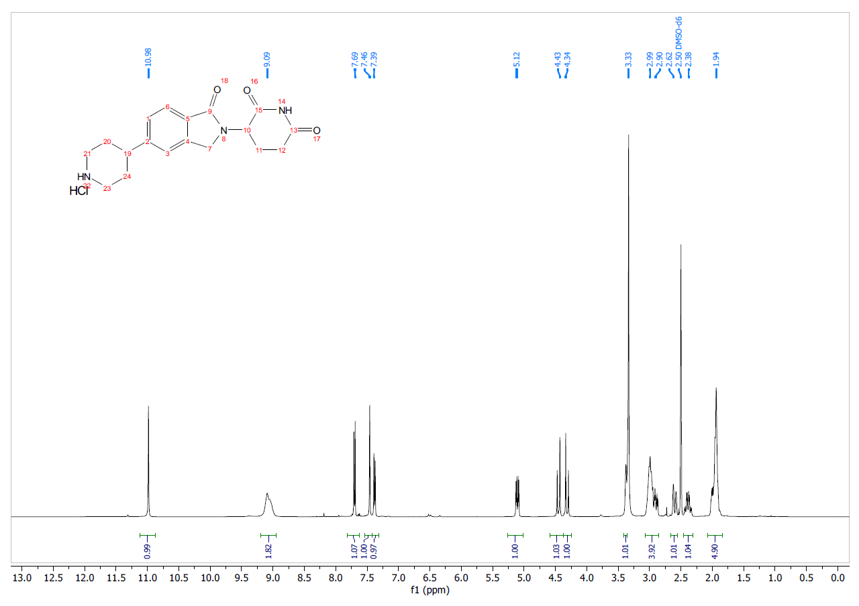
¹³C NMR (101 MHz, DMSO-d₆) - 3-(1-oxo-5-(piperidin-4-yl)isoindolin-2-yl)piperidine-2,6-dione (6)
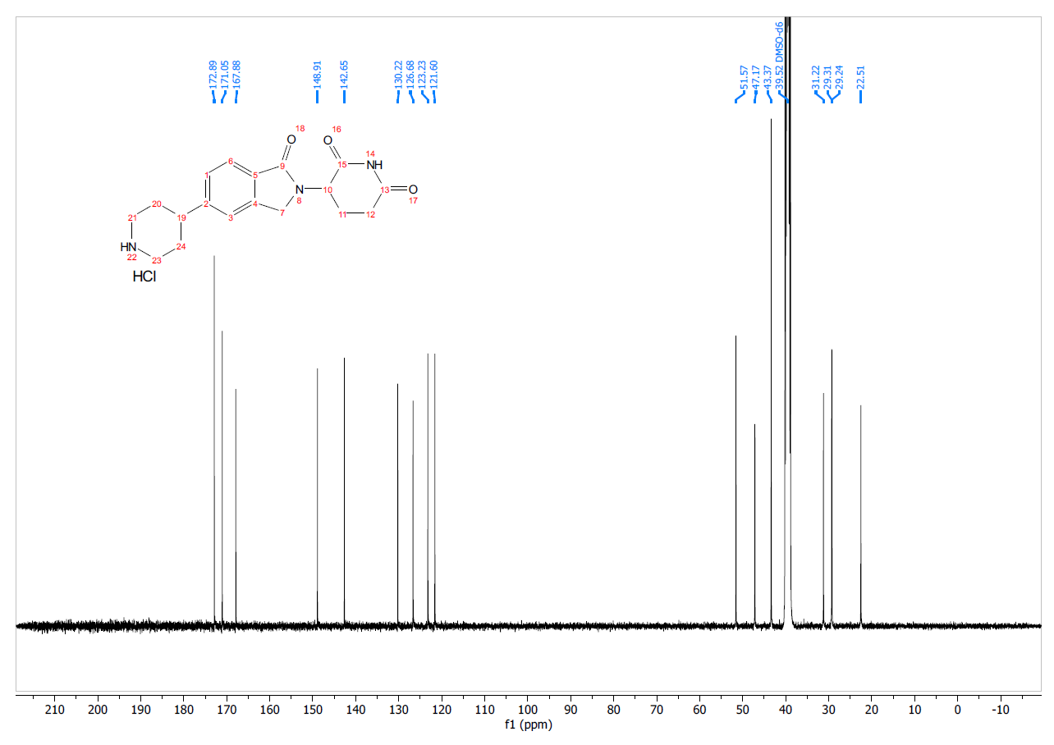
Scheme 5: Synthesis of 3-(5-(1-benzylpiperidin-4-yl)-1-oxoisoindolin-2-yl)piperidine-2,6-dione (7) (DKY709)
To a stirred solution of 3-(1-oxo-5-(piperidin-4-yl)isoindolin-2-yl)piperidine-2,6-dione hydrochloride (6) (450 mg, 1.20 mmol) and benzaldehyde (157 mg, 1.5 mmol) in a mixture of DMF:DCM (v/v =1:1, 10 mL), was added NaBH(OAc)₃ (0.78 g, 3.7 mmol) in a single portion. The reaction mixture was stirred at rt for 16 hours. The reaction mixture was then concentrated under reduced pressure, diluted with DCM and aq. NaHCO₃ solution, and extracted with DCM (x3). The combined organic layers were dried over Na₂SO₄, filtered, and concentrated under reduced pressure affording a light brown solid. The solid was then purified by column chromatography, eluting with 0-10% NEt₃ in EtOAc, affording 3-(5-(1-benzylpiperidin-4-yl)-1-oxoisoindolin-2-yl)piperidine-2,6-dione (7, DKY709) (210 mg, 0.50 mmol, 42% yield) as a white solid. MS (ESI) m/z 418.2 [M+H]⁺. ¹H NMR (400 MHz, DMSO-d₆) δ ppm 10.98 (s, 1H), 7.64 (d, J = 7.9 Hz, 1H), 7.50 (s, 1H), 7.40 (d, J = 7.9 Hz, 1H), 7.33 (d, J = 4.4 Hz, 4H), 7.29 – 7.23 (m, 1H), 5.10 (dd, J = 13.3, 5.1 Hz, 1H), 4.42 (d, J = 17.2 Hz, 1H), 4.28 (d, J = 17.2 Hz, 1H), 3.51 (s, 2H), 2.99 – 2.84 (m, 3H), 2.71-2.56 (m, 2H), 2.46 – 2.31 (m, 1H), 2.16 – 1.94 (m, 3H), 1.84 – 1.64 (m, 4H). ¹³C NMR (151 MHz, DMSO-d₆) δ ppm 172.86, 171.06, 168.00, 150.62, 142.44, 138.54, 129.73, 128.79, 128.12, 126.89, 126.82, 122.88, 121.70, 62.38, 53.49, 51.52, 47.08, 42.17, 33.05, 31.20, 22.49. HRMS (m/z): [M+H]⁺ calcd for C₂₅H₂₈N₃O₃ 418.2125; found 418.2121.

¹H NMR (400 MHz, DMSO-d₆) - 3-(5-(1-benzylpiperidin-4-yl)-1-oxoisoindolin-2-yl)piperidine-2,6-dione (7)
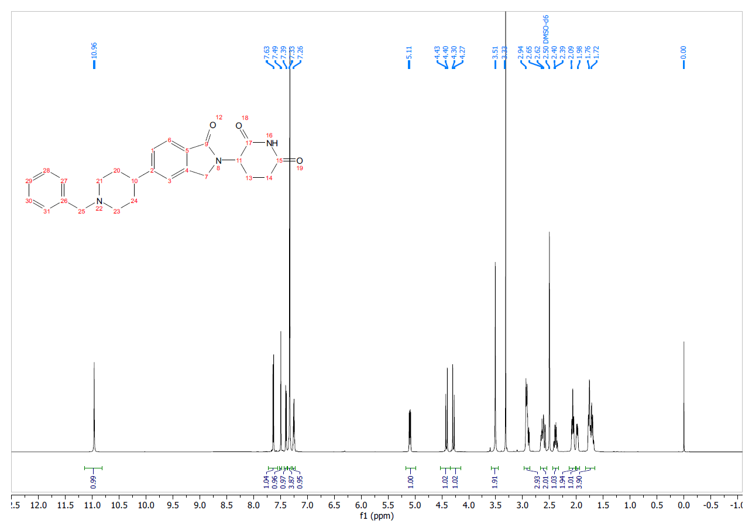
¹³C NMR (101 MHz, DMSO-d₆) - 3-(5-(1-benzylpiperidin-4-yl)-1-oxoisoindolin-2-yl)piperidine-2,6-dione (7)
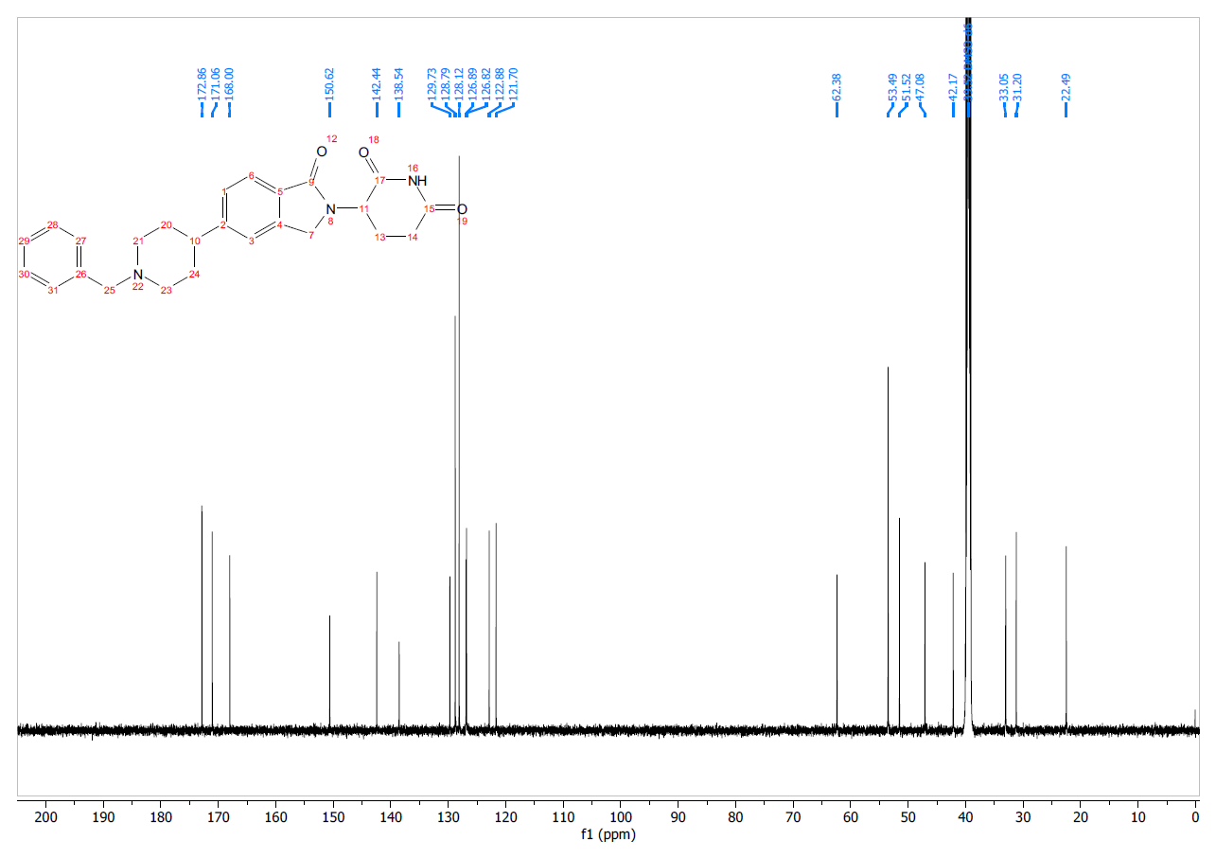
Scheme 6: 4-((14-((4-(benzo[d]thiazol-5-ylamino)-6-(tert-butylsulfonyl)quinolin-7-yl)oxy)-3,6,9,12-tetraoxatetradecyl)amino)-2-(2,6-dioxopiperidin-3-yl)isoindoline-1,3-dione formate salt (probe 1)
tert-butyl (14-bromo-3,6,9,12-tetraoxatetradecyl)(tert-butoxycarbonyl)carbamate (Int-12). Step 1. Cs₂CO₃ (3.50 g, 10.7 mmol) was added to a room temperature solution of NH(Boc)₂ (1.89 g, 8.53 mmol) in acetone (30 mL). A solution of Int-1 (2.58 g, 6.57 mmol) in acetone (70 mL) was added to the reaction mixture followed by addition of NaI (1.00 g, 6.67 mmol). The reaction mixture was heated at 45 °C overnight. The reaction mixture was filtered and the residue washed with acetone. The filtrate was filtered through a small plug of celite, washed with acetone and concentrated to dryness affording a white residue. The product was purified by column chromatography, eluting with 0-35% acetone/heptane to give tert-butyl (tert-butoxycarbonyl)(14-hydroxy-3,6,9,12-tetraoxatetradecyl)carbamate (1.97 g, 69% yield) as a clear colorless oil. MS m/z 455.5 [M+Na]+. ¹H NMR (400 MHz, CDCl₃) δ ppm 3.77 - 3.82 (m, 2 H) 3.72 - 3.75 (m, 2 H) 3.65 - 3.70 (m, 8 H) 3.59 - 3.64 (m, 8 H) 1.51 (s, 18 H).

Step 2. A solution of tert-butyl (tert-butoxycarbonyl)(14-hydroxy-3,6,9,12-tetraoxatetradecyl)carbamate (1.97 g, 4.50 mmol) and PPh₃ (1.40 g, 5.34 mmol) in DCM (40 mL) was cooled to 5-10 °C with a water bath, then a solution of CBr₄ (1.71 g, 5.16 mmol) in DCM (10 mL) was added dropwise with an addition funnel over 15 min. The reaction mixture was then allowed to stir and warm up to RT over 30 min. The crude reaction mixture was concentrated to dryness and the resulting residue was purified by column chromatography, eluting with 0-45% EtOAc/heptane to afford tert-butyl (14-bromo-3,6,9,12-tetraoxatetradecyl)(tert-butoxycarbonyl)carbamate (Int-12) (1.34 g, 60% yield) as a clear colorless oil. MS m/z 519.4 [(M+2H)+H₂O]+. ¹H NMR (400 MHz, CDCl₃) δ ppm 3.77 - 3.84 (m, 4H), 3.67 - 3.69 (m, 4H), 3.64 - 3.67 (m, 4H), 3.60 - 3.64 (m, 6H), 3.48 (t, J = 6.36 Hz, 2 H), 1.51 (s, 18H).

Step 3. Tert-butyl (14-((4-(benzo[d]thiazol-5-ylamino)-6-(tert-butylsulfonyl)quinolin-7-yl)oxy)-3,6,9,12-tetraoxatetradecyl)(tert-butoxycarbonyl)carbamate (Int-14). Int-12 (126 mg, 0.252 mmol) was added to a room temperature suspension of Int-13 (76 mg, 0.180 mmol) and Cs₂CO₃ (120 mg, 0.368 mmol) in DMF (2 mL). NaI (25 mg, 0.167 mmol) was added and the reaction mixture heated at 70 °C for 2 hours. The reaction mixture was then diluted with DCM (10 mL), filtered through celite and the pad washed with DCM. The filtrate was concentrated to dryness and the resulting residue was purified by column chromatography, eluting with 1-15% MeOH/EtOAc to afford tert-butyl (14-((4-(benzo[d]thiazol-5-ylamino)-6-(tert-butylsulfonyl)quinolin-7-yl)oxy)-3,6,9,12-tetraoxatetradecyl)(tert-butoxycarbonyl)carbamate (Int-14) as a yellow amorphous solid (75 mg, 34% yield, 70% purity). The material was used in the next step without further purification. MS m/z 833.6 [M+H]+.
Step 4. 4-((14-((4-(benzo[d]thiazol-5-ylamino)-6-(tert-butylsulfonyl)quinolin-7-yl)oxy)-3,6,9,12-tetraoxatetradecyl)amino)-2-(2,6-dioxopiperidin-3-yl)isoindoline-1,3-dione formate salt (probe 1). Int-14 (81 mg, 0.068 mmol, 70% purity) was dissolved in DCM (1 mL). TFA (0.3 mL, 3.89 mmol) was added at room temperature. The reaction mixture was stirred for 15 min then concentrated to dryness. Toluene (1 mL) was added to the residue then concentrated to dryness. The resulting orange oil was dried under high vacuum overnight. The residue was dissolved in DMA (0.6 mL) followed by addition of DIPEA (0.1 mL, 0.573 mmol). Commercially available Int-15 (26 mg, 0.094 mmol) was added and the reaction mixture heated at 110 °C for 12 hours. The reaction mixture was cooled to room temperature and partitioned between EtOAc (10 mL) and water (2 mL). The organic layer was washed with water (2 mL) and brine. The organic layer was dried over Na₂SO₄, filtered and concentrated to dryness. The residue was dissolved in DMSO (3 mL) and purified by reverse phase HPLC (MeCN/H₂O with formic acid modifier) to afford 4-((14-((4-(benzo[d]thiazol-5-ylamino)-6-(tert-butylsulfonyl)quinolin-7-yl)oxy)-3,6,9,12-tetraoxatetradecyl)amino)-2-(2,6-dioxopiperidin-3-yl)isoindoline-1,3-dione formate salt (probe 1) (7.8 mg, 12% yield) as a yellow solid. ¹H NMR (400 MHz, DMSO-d6) δ ppm 11.13 (s, 1H), 9.79 (br s, 1H), 9.44 (s, 1H), 8.96 (s, 1H), 8.48 (br d, J = 4.77 Hz, 1H), 8.21 (d, J = 8.53 Hz, 1H), 8.03 (s, 1H), 7.51 - 7.60 (m, 2H), 7.46 (s, 1H), 7.12 (d, J = 8.53 Hz, 1H), 7.02 (d, J = 7.03 Hz, 1H), 6.88 (br d, J = 4.77 Hz, 1H), 6.60 (br t, J = 5.65 Hz, 1H), 5.05 (dd, J = 12.80, 5.27 Hz, 1H), 4.28 - 4.38 (m, 2H), 3.78 - 3.85 (m, 2H), 3.58 - 3.64 (m, 4H), 3.49 - 3.57 (m, 10H), 3.40 - 3.48 (m, 3H), 2.81 - 2.94 (m, 1H), 2.52 - 2.63 (m, 2H) (part of DMSO peak), 1.96 - 2.08 (m, 1H), 1.33 (s, 9H). HRMS (m/z): [M+H]+ calcd for C₄₃H₄₉N₆O₁₁S₂ 889.2901; found 889.2921.

¹H NMR (400 MHz, DMSO-d₆) - 4-((14-((4-(benzo[d]thiazol-5-ylamino)-6-(tert-butylsulfonyl)quinolin-7-yl)oxy)-3,6,9,12-tetraoxatetradecyl)amino)-2-(2,6-dioxopiperidin-3-yl)isoindoline-1,3-dione formate salt (probe 1)
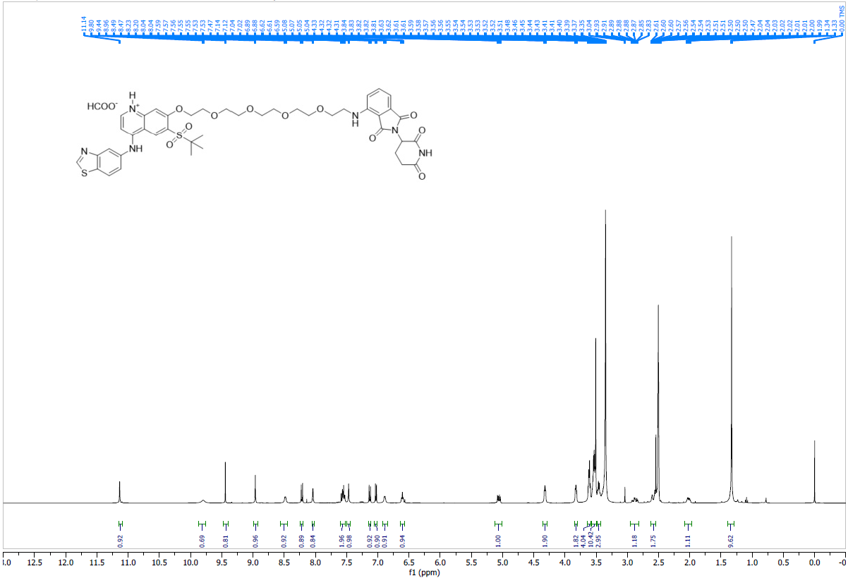

Supplementary Table 1 | Sample conditions for 2.5 µM DKY709 TMT quantitative proteomics profiling in Jurkat cell line at 16 hours

TMT Labeling Channel | Cell Line | Compound Treatment | Time Point (hours)
126 | Jurkat | DMSO_R1 | 16
129C | Jurkat | DMSO_R2 | 16
132N | Jurkat | DMSO_R3 | 16
128N | Jurkat | 2.5 µM DKY709 | 16
131N | Jurkat | 2.5 µM DKY709 | 16
133C | Jurkat | 2.5 µM DKY709 | 16

Supplementary Fig. 2 | Biophysical and structural characterization of IKZF2 zinc finger recruitment to CRBN by DKY709. a, SPR analysis of the binding of DKY709 to the DDB1:CRBN complex for a 2X dilution series from 0.002-1 μM DKY709. b, 1:1 interaction modelling of SPR data, resulting in a K_{D} of 18 ± 6 nM (N = 2). c, Omit map for DKY709 from the DDB1:CRBN:DKY709 complex contoured at 1.0 sigma.
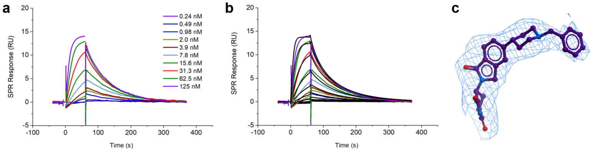

Supplementary Table 2 | Data collection and refinement statistics for CRBN/DDB1/DKY709/IKZF2(ZF2).
 | CRBNΔ40/DDB1ΔBPB/IKZF2-ZF2
Wavelength | 1
Resolution range | 48.88 - 3.15 (3.263 - 3.15)*
Space group | P 61 2 2
Unit cell | 180.892 180.892 555.884 90 90 120
Total reflections | 1554398 (151578)
Unique reflections | 93684 (9197)
Multiplicity | 16.6 (16.5)
Completeness (%) | 99.94 (100.00)
Mean I/sigma(I) | 13.37 (1.39)
Wilson B-factor | 88.38
R-merge | 0.2532 (2.189)
R-meas | 0.2613 (2.258)
R-pim | 0.06405 (0.5513)
CC1/2 | 0.998 (0.516)
CC* | 1 (0.825)
Reflections used in refinement | 93673 (9197)
Reflections used for R-free | 4704 (491)
R-work** | 0.2079 (0.3677)
R-free | 0.2404 (0.4131)
CC(work) | 0.945 (0.691)
CC(free) | 0.926 (0.531)
Number of non-hydrogen atoms | 19495
macromolecules | 19355
ligands | 121
solvent | 19
Protein residues | 2456
RMS(bonds) | 0.007
RMS(angles) | 0.95
Ramachandran favored (%) | 93.61
Ramachandran allowed (%) | 5.86
Ramachandran outliers (%) | 0.53
Rotamer outliers (%) | 0.05
Clashscore | 6.40
Average B-factor | 117.18
macromolecules | 117.16
ligands | 123.87
solvent | 90.92
Number of TLS groups | 16
*Values in parentheses are for highest-resolution shell. A single crystal was used for this structure.
**R_{work} and R_{free} were calculated from the working and test reflection sets, respectively. The test set contained 5% of the total reflections available.

Supplementary Fig. 3 | Representative gating strategy for flow cytometry data. a, Gating of expanded Tregs for Fig. 3b. b, Gating of responder Teff cells for Fig. 3c c, Gating of CD8+ Teff cells for Extended Fig. 3b. d, Gating of tumor-infiltrating T regs in hCD4-humanized mice for Fig. 4b and 4d. e, Gating of CD3+ T cells in cynomolgus monkey PBMC for Fig. 4e, 4g and 4h.
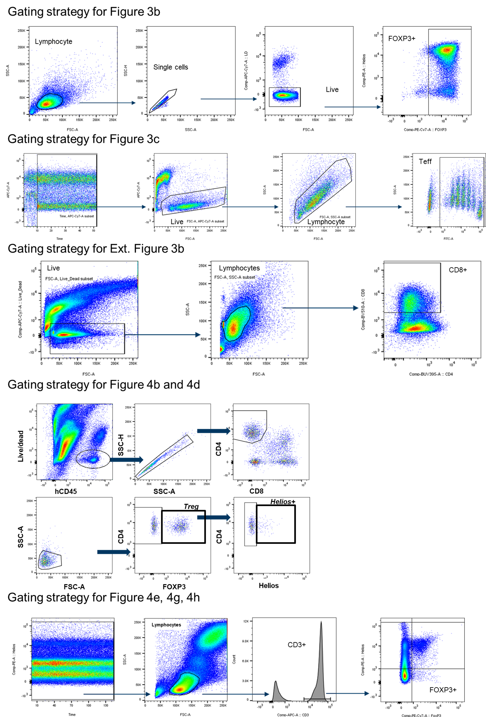

Bouzide, Abderrahim; Gilles Sauvé. Org. Lett. 2002, 4, 2329-2332.
Amino-quinolines as kinase inhibitors. WO 2012/122011 A2, 2012.

