An inter-order comparison of copepod fatty acid composition and biosynthesis in response to a long-chain PUFA-deficient diet along a temperature gradient

Robyn Sahota^{1,*}, Jens Boyen¹, Ilias Semmouri², Samuel Bodé³ and Marleen De Troch¹

¹ Marine Biology, Department of Biology, Ghent University, Krijgslaan 281-S8, 9000 Ghent, Belgium
² Laboratory of Environmental Toxicology and Aquatic Ecology, Faculty of Bioscience Engineering, Ghent University, Coupure Links 653-F, 9000 Ghent, Belgium
³ Isotope Bioscience Laboratory (ISOFYS), Ghent University, Coupure Links 653, 9000 Ghent, Belgium

*Corresponding author: robyn.sahota@ugent.be

Supplementary information

Table S1 Mean relative FA (%) composition ± standard deviation (n = 4) of D. tertiolecta feed used in P. littoralis and T. longicornis experiments detected by GC-MS
 | D. tertiolecta
FA | P. littoralis feed | T. longicornis feed
14:0 | 0.187 ± 0.025 | 0.209 ± 0.057
15:0 | 0.066 ± 0.041 | 0.061 ± 0.023
16:0 | 15.267 ± 0.171 | 16.764 ± 3.036
16:1n-7 | 0.219 ± 0.044 | 3.356 ± 0.563
16:1n-9 | 3.186 ± 0.072 | 3.355 ± 0.564
16:2n-7 | 0.958 ± 0.198 | 1.192 ± 0.398
16:3n-4 | 4.084 ± 0.282 | n.d.
16:4n-1 | 1.113 ± 0.292 | n.d.
16:4n-3 | 18.499 ± 0.147 | 16.786 ± 0.931
17:1+16:2n-4 | 0.074 ± 0.057 | n.d.
18:0 | 0.317 ± 0.031 | 0.535 ± 0.217
18:1n-7 | 0.679 ± 0.057 | 5.719 ± 0.362
18:1n-9 | 4.488 ± 0.588 | 5.368 ± 0.775
18:2n-6 | 5.216 ± 0.447 | 5.309 ± 0.365
18:3n-3 | 40.658 ± 0.858 | 36.799 ± 3.607
18:3n-6 | 3.884 ± 0.245 | 3.493 ± 0.213
18:4n-3 | 1.088 ± 0.174 | 0.938 ± 0.086

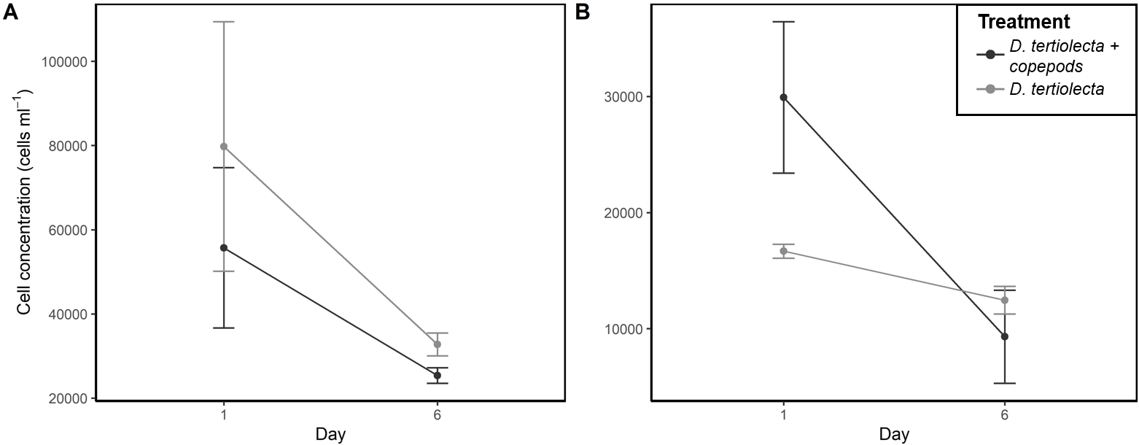
Fig. S1 Cell concentrations (cells mL ⁻¹) of D. tertiolecta in (A) P. littoralis and (B) T. longicornis experiments at 14°C with (‘black’) and without (‘grey’) copepods added

Table S2 Model parameters, outputs and smoothing parameter interactions for carbon assimilation into the consumer FAs. The parametric coefficient interaction of species and temperature was highly significant in all FA models (p <0.001); therefore, the values are not reported here
¹³C FA | Family | Link | Transformation | R² | Deviance explained (%) | Smoothing  termsª | p^{b}
14:0 | gamma | log | -- | 0.682 | 95.1 | T:SP | <0.001 | ***
 |  |  |  |  |  | T:ST | 0.039 | *
16:0 | gamma | log | -- | 0.829 | 95.7 | T:SP | <0.001 | ***
 |  |  |  |  |  | T:ST | 0.201
16:1ω9 | gamma | log | + 1 | 0.632 | 95.5 | T:SP | 0.978
 |  |  |  |  |  | T:ST | <0.001 | ***
18:0 | gamma | log | -- | 0.868 | 95.8 | T:SP | <0.001 | ***
 |  |  |  |  |  | T:ST | 0.390
18:1ω11 | gamma | log | -- | 0.730 | 93.1 | T:SP | <0.001 | ***
 |  |  |  |  |  | T:ST | 0.022 | *
18:3ω3 | gaussian | identity | -- | 0.915 | 93.7 | T:SP | <0.001 | ***
 |  |  |  |  |  | T:ST | 0.018 | *
20:5ω3 | gamma | log | + 1 | 0.874 | 91.6 | T:SP | 0.936
 |  |  |  |  |  | T:ST | <0.001 | ***
22:6ω3 | gamma | log | -- | 0.219 | 68.0 | T:SP | 0.018 | *
 |  |  |  |  |  | T:ST | 0.021 | *
ªT = temperature, S = species, P = P. littoralis, T = T. longicornis
^{b}Significance codes: 0.001 ‘***’, 0.01 ‘**’, 0.05 ‘*’

Table S3 Multiple comparisons of means, Tukey contrasts, on GLM survival plot factors (Fig. 1). Notation: ‘Species name’. ‘temperature treatment’, adjusted p-values reported, single-step method
Linear hypothesis | Estimate | Std. Error | z value | Pr (>|z|)
T. longicornis.11 - P. littoralis.11 == 0 | -1.66 | 0.69 | -2.417 | 0.2949
P. littoralis.14 - P. littoralis.11 == 0 | -0.56 | 0.76 | -0.73 | 0.9992
T. longicornis.14 - P. littoralis.11 == 0 | -2.71 | 0.65 | -4.158 | <0.01
P. littoralis.17 - P. littoralis.11 == 0 | -0.42 | 0.78 | -0.544 | 0.9999
T. longicornis.17 - P. littoralis.11 == 0 | -2.68 | 0.65 | -4.098 | <0.01
P. littoralis.20 - P. littoralis.11 == 0 | -0.42 | 0.78 | -0.544 | 0.9999
T. longicornis.20 - P. littoralis.11 == 0 | -3.36 | 0.65 | -5.183 | <0.01
P. littoralis.23 - P. littoralis.11 == 0 | -0.42 | 0.78 | -0.544 | 0.9999
T. longicornis.23 - P. littoralis.11 == 0 | -4.53 | 0.67 | -6.786 | <0.01
P. littoralis.14 - T. longicornis.11 == 0 | 1.10 | 0.57 | 1.925 | 0.6297
T. longicornis.14 - T. longicornis.11 == 0 | -1.06 | 0.41 | -2.561 | 0.2188
P. littoralis.17 - T. longicornis.11 == 0 | 1.23 | 0.59 | 2.073 | 0.5229
T. longicornis.17 - T. longicornis.11 == 0 | -1.02 | 0.41 | -2.468 | 0.2663
P. littoralis.20 - T. longicornis.11 == 0 | 1.23 | 0.59 | 2.073 | 0.5224
T. longicornis.20 - T. longicornis.11 == 0 | -1.71 | 0.41 | -4.196 | <0.01
P. littoralis.23 - T. longicornis.11 == 0 | 1.23 | 0.59 | 2.073 | 0.5234
T. longicornis.23 - T. longicornis.11 == 0 | -2.88 | 0.44 | -6.589 | <0.01
T. longicornis.14 - P. littoralis.14 == 0 | -2.16 | 0.53 | -4.059 | <0.01
P. littoralis.17 - P. littoralis.14 == 0 | 0.13 | 0.68 | 0.195 | 1
T. longicornis.17 - P. littoralis.14 == 0 | -2.12 | 0.53 | -3.985 | <0.01
P. littoralis.20 - P. littoralis.14 == 0 | 0.13 | 0.68 | 0.195 | 1
T. longicornis.20 - P. littoralis.14 == 0 | -2.81 | 0.53 | -5.328 | <0.01
P. littoralis.23 - P. littoralis.14 == 0 | 0.13 | 0.68 | 0.195 | 1
T. longicornis.23 - P. littoralis.14 == 0 | -3.98 | 0.55 | -7.229 | <0.01
P. littoralis.17 - T. longicornis.14 == 0 | 2.29 | 0.56 | 4.114 | <0.01
T. longicornis.17 - T. longicornis.14 == 0 | 0.04 | 0.36 | 0.102 | 1
P. littoralis.20 - T. longicornis.14 == 0 | 2.29 | 0.56 | 4.114 | <0.01
T. longicornis.20 - T. longicornis.14 == 0 | -0.65 | 0.35 | -1.861 | 0.674
P. littoralis.23 - T. longicornis.14 == 0 | 2.29 | 0.56 | 4.114 | <0.01
T. longicornis.17 - P. littoralis.17 == 0 | -2.25 | 0.56 | -4.044 | <0.01
P. littoralis.20 - P. littoralis.17 == 0 | 0.00 | 0.70 | 0 | <0.01
T. longicornis.20 - P. littoralis.17 == 0 | -2.94 | 0.55 | -5.324 | 1
P. littoralis.23 - P. littoralis.17 == 0 | 0.00 | 0.70 | 0 | <0.01
T. longicornis.23 - P. littoralis.17 == 0 | -4.11 | 0.57 | -7.154 | 1
P. littoralis.20 - T. longicornis.17 == 0 | 2.25 | 0.56 | 4.044 | <0.01
T. longicornis.20 - T. longicornis.17 == 0 | -0.69 | 0.35 | -1.96 | <0.01
P. littoralis.23 - T. longicornis.17 == 0 | 2.25 | 0.56 | 4.044 | 0.604
T. longicornis.23 - T. longicornis.17 == 0 | -1.86 | 0.38 | -4.831 | <0.01
T. longicornis.20 - P. littoralis.20 == 0 | -2.94 | 0.55 | -5.324 | <0.01
P. littoralis.23 - P. littoralis.20 == 0 | 0.00 | 0.70 | 0 | <0.01
T. longicornis.23 - P. littoralis.20 == 0 | -4.11 | 0.57 | -7.154 | 1
P. littoralis.23 - T. longicornis.20 == 0 | 2.94 | 0.55 | 5.324 | <0.01
T. longicornis.23 - T. longicornis.20 == 0 | -1.17 | 0.38 | -3.107 | <0.01
T. longicornis.23 - P. littoralis.23 == 0 | -4.11 | 0.57 | -7.154 | 0.0535

Table S4 Mean absolute FA (ng individual ⁻¹) composition ± standard deviation (n = 4) in P. littoralis and T. longicornis from the field and at a range of temperatures (11, 14, 17, 20, 23˚C) fed a LC-PUFA deficient diet. Values indicated by ‘n.d.’ are not detected by GC-MS, below detection limits
FA |  |  | Temperature (˚C)
FA | Field | 11 |  | 14 | 17 | 20 | 23
P. littoralis
14:0 | 10.22 ± 0.6 | 5.95 ± 1.4 |  | 6.48 ± 0.19 | 5.73 ± 0.39 | 4.71 ± 0.94 | 5.62 ± 0.45
15:0 | 2.45 ± 0.13 | 1.55 ± 0.33 |  | 1.76 ± 0.1 | 1.47 ± 0.13 | 1.2 ± 0.25 | 1.72 ± 0.31
16:0 | 98.97 ± 7.34 | 69.78 ± 13.32 |  | 74.74 ± 1.57 | 68.61 ± 4.26 | 57.41 ± 11.33 | 68.72 ± 3.5
16:1ω5 | 71.12 ± 81.53 | 95.84 ± 31.22 |  | 84.78 ± 13.84 | 77.11 ± 9.68 | 65.82 ± 19.77 | 66.83 ± 6.71
16:1ω7 | 132.82 ± 9.6 | 77.82 ± 18.03 |  | 84.17 ± 2.41 | 74.47 ± 7.12 | 59.29 ± 14.01 | 69.78 ± 3.73
16:1ω9 | 1.76 ± 0.41 | 0.87 ± 0.31 |  | 1.36 ± 0.2 | 1.02 ± 0.14 | 0.6 ± 0.23 | 1.62 ± 0.5
16:2ω7 | 0.95 ± 0.27 | 0.43 ± 0.09 |  | 0.47 ± 0.04 | 0.33 ± 0.05 | 0.32 ± 0.11 | 0.32 ± 0.03
16:3ω4 | 5.18 ± 0.52 | 2.8 ± 0.65 |  | 2.98 ± 0.16 | 2.59 ± 0.25 | 2.11 ± 0.71 | 2.48 ± 0.13
16:4ω1 | 9.21 ± 0.72 | 5.33 ± 1.76 |  | 5.97 ± 0.49 | 5.47 ± 0.48 | 4.45 ± 1.07 | 5.5 ± 0.38
16:4ω3 | 0.45 ± 0.23 | 0.4 ± 0.17 |  | n.d. | 0.47 ± 0.2 | n.d. | 0.35 ± 0.2
17:1+16:2ω4 | 11.42 ± 0.84 | 6.79 ± 1.32 |  | 7.56 ± 0.21 | 6.5 ± 0.39 | 5.14 ± 1.22 | 6.15 ± 0.51
18:0 | 11.23 ± 0.99 | 10.14 ± 1.37 |  | 11.14 ± 0.43 | 10.44 ± 0.34 | 9.66 ± 1.47 | 10.51 ± 0.54
18:1ω7 | 35.85 ± 4.69 | 27.35 ± 5.91 |  | 28.79 ± 0.73 | 27.25 ± 2.1 | 21.76 ± 4.97 | 26.38 ± 1.57
18:1ω9 | 4.45 ± 0.42 | 3.33 ± 0.59 |  | 3.45 ± 0.16 | 3.09 ± 0.19 | 2.67 ± 0.61 | 3.59 ± 0.38
18:2ω6 | 2.08 ± 0.17 | 1.46 ± 0.16 |  | 1.47 ± 0.08 | 1.37 ± 0.15 | 1.16 ± 0.24 | 1.56 ± 0.14
18:3ω3 | 1.55 ± 0.16 | 1.2 ± 0.21 |  | 1.76 ± 0.36 | 1.33 ± 0.19 | 0.98 ± 0.32 | 3.64 ± 0.47
18:3ω6 | 1.44 ± 0.12 | 1.07 ± 0.19 |  | 1.15 ± 0.08 | 0.99 ± 0.06 | 0.78 ± 0.15 | 1.16 ± 0.06
18:4ω3 | 7.06 ± 0.59 | 4.43 ± 0.99 |  | 4.56 ± 0.1 | 4.19 ± 0.32 | 3.42 ± 0.86 | 4.04 ± 0.33
20:0 | 0.22 ± 0.03 | 0.31 ± 0.06 |  | 0.36 ± 0.05 | 0.34 ± 0.05 | 0.28 ± 0.01 | 0.37 ± 0.04
20:1ω9 | 0.27 ± 0.12 | 0.11 ± 0.06 |  | 0.21 ± 0.06 | 0.15 ± 0.05 | 0.12 ± 0.04 | 0.2 ± 0.08
20:3ω6 | 0.25 ± 0.09 | 0.28 ± 0.13 |  | 0.31 ± 0.03 | 0.28 ± 0.08 | 0.2 ± 0.07 | 0.33 ± 0.03
20:4ω3 | 2.01 ± 0.25 | 1.4 ± 0.37 |  | 1.46 ± 0.07 | 1.3 ± 0.17 | 1.17 ± 0.31 | 1.3 ± 0.22
20:4ω6 | 2.79 ± 0.24 | 2.31 ± 0.29 |  | 2.42 ± 0.16 | 2.31 ± 0.14 | 2 ± 0.24 | 2.48 ± 0.18
20:5ω3 | 136.25 ± 12.05 | 95.83 ± 16.19 |  | 101.3 ± 2.38 | 92.71 ± 5.99 | 75.78 ± 15.03 | 87.44 ± 5.95
22:0 | 2.62 ± 0.33 | 2.57 ± 0.56 |  | 3.04 ± 0.11 | 2.95 ± 0.24 | 2.54 ± 0.44 | 3 ± 0.27
22:5ω3 | 5.64 ± 0.56 | 4.09 ± 1.04 |  | 4.48 ± 0.23 | 4.26 ± 0.36 | 3.84 ± 0.69 | 4.4 ± 0.33
22:6ω3 | 46.84 ± 3.27 | 42.02 ± 4.67 |  | 43.63 ± 1 | 41.72 ± 1.9 | 36.11 ± 5.05 | 39.08 ± 2.27
24:1ω9 | 2.28 ± 0.35 | 1.44 ± 0.31 |  | 1.62 ± 0.34 | 1.64 ± 0.24 | 1.09 ± 0.36 | 1.27 ± 0.22
T. longicornis
14:0 | 29.48 ± 3.02 | 11.71 ± 4.58 |  | 8.71 ± 3.21 | 5.55 ± 3.31 | 5 ± 2.51 | 9.58 ± 2.19
15:0 | 6.42 ± 0.75 | 2.65 ± 1.23 |  | 1.84 ± 0.66 | 1.33 ± 0.62 | 1.51 ± 0.87 | 2.5 ± 0.51
16:0 | 133.28 ± 12.01 | 94.21 ± 21.52 |  | 77.97 ± 18.94 | 58.98 ± 22.1 | 56.66 ± 15.1 | 101.38 ± 13.08
16:1ω5 | 11.26 ± 18.4 | n.d. |  | 10.39 ± 7.64 | 1.88 ± 1.86 | 1.21 ± 1.07 | 0.35 ± 0.03
16:1ω7 | 29.01 ± 4.54 | 10.69 ± 6.63 |  | 6.62 ± 3.41 | 4.43 ± 3.06 | 5.17 ± 3.29 | 10.41 ± 2.91
16:1ω9 | 3.12 ± 0.59 | 1.65 ± 0.99 |  | 0.93 ± 0.44 | 0.71 ± 0.4 | 2.45 ± 4.1 | 4.84 ± 4.97
16:2ω7 | 1.39 ± 0.24 | 0.58 ± 0.46 |  | 0.42 ± 0.17 | 0.33 ± 0.24 | 0.34 ± 0.1 | 2.01 ± 0.67
16:3ω4 | 8.01 ± 0.65 | 2.14 ± 1.56 |  | n.d. | n.d. | n.d. | 1.16 ± 1.11
16:4ω1 | 6.16 ± 0.73 | 2.67 ± 1.19 |  | n.d. | n.d. | n.d. | 2.14 ± 0.63
16:4ω3 | 1.45 ± 0.05 | 2.4 ± 1.4 |  | 1.39 ± 0.75 | 0.88 ± 0.65 | 0.64 ± 0.21 | 1.33 ± 0.33
17:1+16:2ω4 | 6.08 ± 0.89 | 2.32 ± 1.54 |  | 1.41 ± 0.83 | 0.79 ± 0.6 | 0.38 ± 0.17 | 1.69 ± 0.54
18:0 | 14.12 ± 6.36 | 10.77 ± 2.37 |  | 9.84 ± 2.05 | 9.5 ± 2.21 | 10.22 ± 1.37 | 18.96 ± 0.84
18:1ω7 | 28.1 ± 3.21 | 17.06 ± 6.05 |  | 10.44 ± 3.23 | 9.33 ± 5.38 | 7.87 ± 4.52 | 17.49 ± 2.97
18:1ω9 | 2.41 ± 0.98 | 2.05 ± 1.13 |  | 1.33 ± 0.61 | 1.03 ± 0.56 | 0.9 ± 0.25 | 2.61 ± 0.87
18:2ω6 | 2.31 ± 0.95 | 2.59 ± 1 |  | 1.59 ± 0.69 | 1.08 ± 0.59 | 0.86 ± 0.44 | 2.45 ± 0.57
18:3ω3 | 1.75 ± 0.58 | 24.01 ± 8.34 |  | 16.06 ± 8.57 | 11.91 ± 5.08 | 7.7 ± 3.48 | 17.36 ± 2.42
18:3ω6 | 0.54 ± 0.18 | 2.55 ± 0.8 |  | 1.49 ± 1.02 | 1.06 ± 0.47 | 0.58 ± 0.23 | 1.54 ± 0.32
18:4ω3 | 11.07 ± 2.05 | 4.59 ± 3.55 |  | 2.66 ± 1.3 | 2.29 ± 1.59 | 1.36 ± 0.71 | 2.66 ± 1.1
20:0 | 0.31 ± 0.06 | 0.19 ± 0.16 |  | n.d. | n.d. | n.d. | n.d.
20:1ω9 | 0.73 ± 0.32 | 1.49 ± 0.31 |  | 0.9 ± 0.32 | 0.58 ± 0.29 | 0.38 ± 0.11 | 1.25 ± 0.02
20:3ω6 | 0.25 ± 0.03 | 0.25 ± 0.11 |  | n.d. | 0.17 ± 0.05 | 0.23 ± 0.08 | 0.33 ± 0.02
20:4ω3 | 1.62 ± 0.27 | 0.68 ± 0.48 |  | n.d. | n.d. | n.d. | 0.66 ± 0.03
20:4ω6 | 4.64 ± 0.39 | 2.74 ± 1.3 |  | 1.46 ± 0.44 | 2.36 ± 3.01 | 1.27 ± 0.82 | 10.44 ± 0.75
20:5ω3 | 211.66 ± 19.4 | 101.33 ± 33.33 |  | 77.82 ± 27.41 | 49.84 ± 27.67 | 46.45 ± 22.76 | 96.26 ± 27.15
22:0 | 0.36 ± 0.16 | 0.31 ± 0.1 |  | n.d. | 0.25 ± 0.05 | 0.33 ± 0.03 | 0.44 ± 0.11
22:5ω3 | 6.97 ± 0.68 | 3.29 ± 0.91 |  | 2.38 ± 0.66 | 1.68 ± 0.77 | 1.47 ± 0.52 | 2.76 ± 0.87
22:6ω3 | 221.16 ± 18.32 | 165.48 ± 24.7 |  | 141.43 ± 31.04 | 106.2 ± 41.25 | 94.14 ± 32.78 | 155.61 ± 13.41
24:1ω9 | 9.92 ± 1.69 | 10.05 ± 1.84 |  | 9.86 ± 2.68 | 7.67 ± 3.64 | 7.28 ± 2.97 | 13.63 ± 2.35
Table S5 Mean relative FA (%) composition ± standard deviation (n = 4) in P. littoralis and T. longicornis from the field and at a range of temperatures (11, 14, 17, 20, 23 ˚C) fed a LC-PUFA deficient diet. Values indicated by ‘n.d.’ are not detected by GC-MS, below detection limits
FA |  |  | Temperature (˚C)
FA | Field | 11 |  | 14 | 17 | 20 | 23
P. littoralis
14:0 | 1.692 ± 0.205 | 1.267 ± 0.17 |  | 1.346 ± 0.052 | 1.302 ± 0.046 | 1.286 ± 0.13 | 1.338 ± 0.076
15:0 | 0.406 ± 0.046 | 0.33 ± 0.039 |  | 0.365 ± 0.023 | 0.333 ± 0.015 | 0.328 ± 0.037 | 0.412 ± 0.084
16:0 | 16.402 ± 2.232 | 14.908 ± 1.304 |  | 15.52 ± 0.543 | 15.592 ± 0.337 | 15.677 ± 1.339 | 16.374 ± 0.164
16:1ω5 | 11.095 ± 12.713 | 20.644 ± 7.188 |  | 17.56 ± 2.496 | 17.518 ± 1.79 | 18.362 ± 6.872 | 15.9 ± 0.914
16:1ω7 | 22.012 ± 2.976 | 16.586 ± 2.321 |  | 17.482 ± 0.815 | 16.903 ± 0.832 | 16.127 ± 2.121 | 16.629 ± 0.486
16:1ω9 | 0.293 ± 0.082 | 0.183 ± 0.047 |  | 0.283 ± 0.043 | 0.232 ± 0.034 | 0.165 ± 0.054 | 0.383 ± 0.103
16:2ω7 | 0.159 ± 0.053 | 0.093 ± 0.014 |  | 0.098 ± 0.007 | 0.075 ± 0.012 | 0.087 ± 0.018 | 0.078 ± 0.01
16:3ω4 | 0.858 ± 0.134 | 0.594 ± 0.065 |  | 0.619 ± 0.033 | 0.587 ± 0.023 | 0.567 ± 0.134 | 0.592 ± 0.011
16:4ω1 | 1.526 ± 0.2 | 1.12 ± 0.24 |  | 1.239 ± 0.098 | 1.242 ± 0.038 | 1.21 ± 0.162 | 1.309 ± 0.027
16:4ω3 | 0.074 ± 0.039 | n.d. |  | n.d. | 0.109 ± 0.049 | n.d. | 0.086 ± 0.054
17:1+16:2ω4 | 1.894 ± 0.262 | 1.451 ± 0.151 |  | 1.57 ± 0.026 | 1.479 ± 0.044 | 1.398 ± 0.17 | 1.464 ± 0.053
18:0 | 1.862 ± 0.273 | 2.178 ± 0.108 |  | 2.313 ± 0.088 | 2.376 ± 0.105 | 2.65 ± 0.04 | 2.507 ± 0.123
18:1ω7 | 5.953 ± 1.119 | 5.826 ± 0.593 |  | 5.977 ± 0.177 | 6.203 ± 0.502 | 5.915 ± 0.483 | 6.285 ± 0.143
18:1ω9 | 0.738 ± 0.111 | 0.719 ± 0.132 |  | 0.716 ± 0.035 | 0.703 ± 0.031 | 0.725 ± 0.053 | 0.854 ± 0.054
18:2ω6 | 0.346 ± 0.05 | 0.315 ± 0.043 |  | 0.305 ± 0.016 | 0.31 ± 0.019 | 0.317 ± 0.027 | 0.371 ± 0.013
18:3ω3 | 0.256 ± 0.038 | 0.265 ± 0.086 |  | 0.366 ± 0.076 | 0.302 ± 0.05 | 0.264 ± 0.049 | 0.871 ± 0.133
18:3ω6 | 0.238 ± 0.027 | 0.23 ± 0.022 |  | 0.238 ± 0.019 | 0.224 ± 0.005 | 0.213 ± 0.022 | 0.276 ± 0.019
18:4ω3 | 1.17 ± 0.17 | 0.945 ± 0.122 |  | 0.947 ± 0.014 | 0.951 ± 0.026 | 0.931 ± 0.145 | 0.961 ± 0.029
20:0 | 0.036 ± 0.004 | 0.068 ± 0.01 |  | 0.075 ± 0.012 | 0.078 ± 0.009 | 0.079 ± 0.014 | 0.089 ± 0.015
20:1ω9 | 0.044 ± 0.021 | 0.024 ± 0.017 |  | 0.044 ± 0.011 | 0.033 ± 0.01 | 0.032 ± 0.009 | 0.046 ± 0.018
20:3ω6 | 0.04 ± 0.013 | 0.059 ± 0.02 |  | 0.065 ± 0.006 | 0.064 ± 0.02 | 0.056 ± 0.015 | 0.078 ± 0.005
20:4ω3 | 0.334 ± 0.061 | 0.298 ± 0.049 |  | 0.302 ± 0.019 | 0.296 ± 0.027 | 0.318 ± 0.051 | 0.31 ± 0.04
20:4ω6 | 0.463 ± 0.068 | 0.496 ± 0.027 |  | 0.502 ± 0.031 | 0.526 ± 0.03 | 0.551 ± 0.023 | 0.594 ± 0.057
20:5ω3 | 22.598 ± 3.426 | 20.54 ± 1.828 |  | 21.032 ± 0.679 | 21.064 ± 0.282 | 20.693 ± 1.794 | 20.818 ± 0.241
22:0 | 0.435 ± 0.078 | 0.547 ± 0.061 |  | 0.63 ± 0.023 | 0.672 ± 0.064 | 0.696 ± 0.051 | 0.715 ± 0.055
22:5ω3 | 0.936 ± 0.146 | 0.867 ± 0.118 |  | 0.93 ± 0.059 | 0.967 ± 0.027 | 1.053 ± 0.106 | 1.047 ± 0.041
22:6ω3 | 7.762 ± 1.027 | 9.051 ± 0.608 |  | 9.058 ± 0.322 | 9.487 ± 0.175 | 9.921 ± 0.412 | 9.31 ± 0.098
24:1ω9 | 0.38 ± 0.082 | 0.309 ± 0.05 |  | 0.335 ± 0.068 | 0.372 ± 0.042 | 0.294 ± 0.065 | 0.304 ± 0.052
T. longicornis
14:0 | 3.905 ± 0.164 | 2.378 ± 0.272 |  | 2.174 ± 0.344 | 1.903 ± 0.316 | 1.863 ± 0.464 | 1.975 ± 0.163
15:0 | 0.85 ± 0.06 | 0.533 ± 0.099 |  | 0.463 ± 0.068 | 0.481 ± 0.114 | 0.551 ± 0.204 | 0.517 ± 0.03
16:0 | 17.671 ± 0.721 | 19.651 ± 0.642 |  | 20.097 ± 0.741 | 21.318 ± 1.463 | 22.728 ± 2.241 | 21.063 ± 0.383
16:1ω5 | 1.6 ± 2.628 | n.d. |  | 2.898 ± 2.326 | 0.703 ± 0.724 | 0.414 ± 0.27 | 0.074 ± 0.018
16:1ω7 | 3.836 ± 0.389 | 2.079 ± 0.696 |  | 1.582 ± 0.573 | 1.497 ± 0.425 | 1.924 ± 0.871 | 2.139 ± 0.288
16:1ω9 | 0.413 ± 0.058 | 0.324 ± 0.114 |  | 0.225 ± 0.075 | 0.286 ± 0.229 | 0.899 ± 1.456 | 1.092 ± 1.193
16:2ω7 | 0.184 ± 0.021 | 0.109 ± 0.055 |  | 0.12 ± 0.07 | 0.106 ± 0.049 | 0.151 ± 0.077 | 0.411 ± 0.078
16:3ω4 | 1.062 ± 0.02 | 0.408 ± 0.176 |  | n.d. | n.d. | n.d. | 0.226 ± 0.198
16:4ω1 | 0.816 ± 0.049 | 0.537 ± 0.093 |  | n.d. | n.d. | n.d. | 0.439 ± 0.067
16:4ω3 | 0.193 ± 0.013 | 0.47 ± 0.146 |  | 0.338 ± 0.143 | 0.29 ± 0.111 | 0.26 ± 0.072 | 0.273 ± 0.028
17:1+16:2ω4 | 0.804 ± 0.076 | 0.447 ± 0.175 |  | 0.332 ± 0.152 | 0.261 ± 0.095 | 0.149 ± 0.042 | 0.345 ± 0.062
18:0 | 1.867 ± 0.812 | 2.251 ± 0.184 |  | 2.581 ± 0.407 | 3.611 ± 0.93 | 4.278 ± 1.122 | 3.963 ± 0.409
18:1ω7 | 3.723 ± 0.25 | 3.482 ± 0.334 |  | 2.653 ± 0.178 | 3.141 ± 0.901 | 2.888 ± 0.745 | 3.623 ± 0.084
18:1ω9 | 0.319 ± 0.125 | 0.404 ± 0.109 |  | 0.329 ± 0.115 | 0.395 ± 0.258 | 0.359 ± 0.027 | 0.533 ± 0.103
18:2ω6 | 0.305 ± 0.12 | 0.524 ± 0.063 |  | 0.401 ± 0.115 | 0.388 ± 0.135 | 0.351 ± 0.164 | 0.504 ± 0.044
18:3ω3 | 0.232 ± 0.073 | 4.906 ± 0.637 |  | 4.105 ± 1.647 | 4.41 ± 1.436 | 3.581 ± 2.958 | 3.603 ± 0.028
18:3ω6 | 0.071 ± 0.022 | 0.524 ± 0.073 |  | 0.379 ± 0.206 | 0.388 ± 0.113 | 0.262 ± 0.187 | 0.319 ± 0.02
18:4ω3 | 1.463 ± 0.207 | 0.871 ± 0.408 |  | 0.641 ± 0.206 | 0.967 ± 0.967 | 0.51 ± 0.111 | 0.541 ± 0.15
20:0 | 0.04 ± 0.007 | 0.036 ± 0.02 |  | n.d. | n.d. | n.d. | n.d.
20:1ω9 | 0.097 ± 0.041 | 0.324 ± 0.107 |  | 0.232 ± 0.053 | 0.216 ± 0.115 | 0.171 ± 0.106 | 0.262 ± 0.043
20:3ω6 | 0.033 ± 0.004 | 0.051 ± 0.018 |  | n.d. | 0.064 ± 0.016 | 0.104 ± 0.069 | 0.069 ± 0.006
20:4ω3 | 0.215 ± 0.025 | 0.131 ± 0.053 |  | n.d. | n.d. | n.d. | 0.139 ± 0.026
20:4ω6 | 0.615 ± 0.027 | 0.552 ± 0.116 |  | 0.37 ± 0.024 | 0.651 ± 0.586 | 0.519 ± 0.324 | 2.178 ± 0.164
20:5ω3 | 28.054 ± 0.79 | 20.775 ± 1.153 |  | 19.489 ± 2.459 | 16.933 ± 3.009 | 17.334 ± 3.514 | 19.772 ± 2.726
22:0 | 0.048 ± 0.021 | 0.064 ± 0.004 |  | n.d. | 0.098 ± 0.028 | 0.141 ± 0.052 | 0.09 ± 0.01
22:5ω3 | 0.925 ± 0.065 | 0.681 ± 0.058 |  | 0.607 ± 0.049 | 0.591 ± 0.036 | 0.573 ± 0.036 | 0.566 ± 0.098
22:6ω3 | 29.348 ± 1.436 | 34.995 ± 3.533 |  | 36.695 ± 2.367 | 37.965 ± 3.609 | 36.852 ± 3.292 | 32.435 ± 1.988
24:1ω9 | 1.313 ± 0.162 | 2.122 ± 0.293 |  | 2.534 ± 0.216 | 2.681 ± 0.153 | 2.792 ± 0.257 | 2.822 ± 0.072

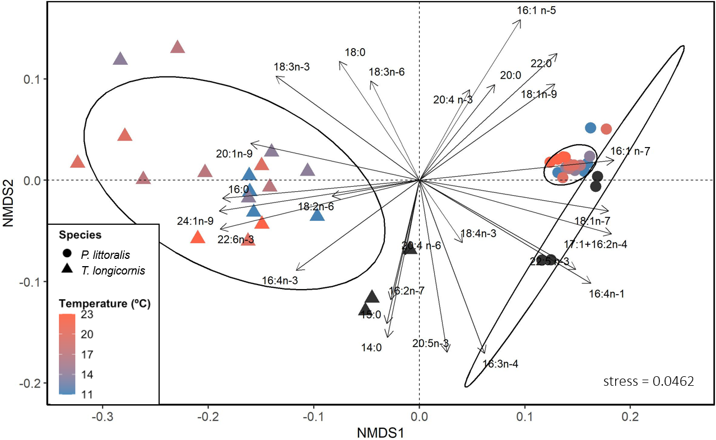
Fig. S2 NMDS of cube-root transformed relative FA composition between T. longicornis and P. littoralis copepods from the field and experimental samples exposed to a range of temperatures. Ellipses determined by hierarchical clustering, displaying a 95% confidence interval. The ‘black’ symbols indicate field samples

Table S6 SIMPER output contrasting experimental and field T. longicornis and P. littoralis. Listed are the FAs contributing to 75% of the differences for the sake of brevity
FA | Avg. | SD | Ratio | Avg. T. longicornis | Avg. P. littoralis | Cumulative sum
Contrast: Field T. longicornis vs. Field P. littoralis
16:1ω7 | 0.03767 | 0.004183 | 9.005 | 1.9567 | 4.6837 | 0.2011
22:6ω3 | 0.036399 | 0.002845 | 12.792 | 5.4163 | 2.7814 | 0.3954
16:1ω5 | 0.030904 | 0.025746 | 1.2 | 0.9025 | 2.4938 | 0.5604
14:0 | 0.009348 | 0.001103 | 8.476 | 1.9758 | 1.2991 | 0.6103
20:5ω3 | 0.007634 | 0.004593 | 1.662 | 5.2963 | 4.7434 | 0.6511
24:1ω9 | 0.00733 | 0.001203 | 6.094 | 1.1442 | 0.6138 | 0.6902
18:1ω7 | 0.00695 | 0.002982 | 2.33 | 1.9287 | 2.4316 | 0.7273
17:1+16:2ω4 | 0.006598 | 0.001304 | 5.062 | 0.896 | 1.3735 | 0.7626
Contrast: Experimental T. longicornis vs. Experimental P. littoralis
16:1ω5 | 0.047487 | 0.011196 | 4.2416 | 0.7754 | 4.2153 | 0.1839
22:6ω3 | 0.04073 | 0.004652 | 8.7548 | 6.0077 | 3.0594 | 0.3417
16:1ω7 | 0.038121 | 0.004484 | 8.5025 | 1.3269 | 4.0884 | 0.4894
18:3ω3 | 0.019085 | 0.005799 | 3.291 | 2.0068 | 0.6208 | 0.5633
24:1ω9 | 0.014246 | 0.001725 | 8.2568 | 1.598 | 0.5658 | 0.6185
18:1ω7 | 0.009695 | 0.002732 | 3.5489 | 1.7535 | 2.4564 | 0.656
17:1+16:2ω4 | 0.009392 | 0.002095 | 4.4829 | 0.5333 | 1.2124 | 0.6924
16:4ω1 | 0.008932 | 0.00452 | 1.9762 | 0.4615 | 1.1045 | 0.727
16:0 | 0.008654 | 0.002992 | 2.8919 | 4.5751 | 3.9498 | 0.7606

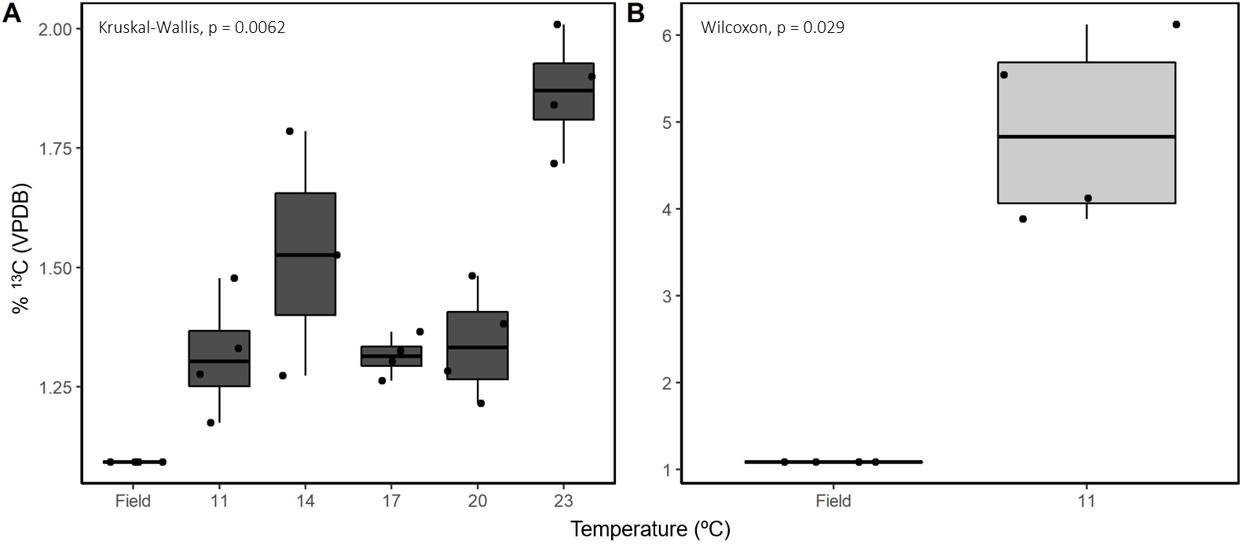
Fig. S3 ¹³C (%) VPDB stable isotope values for (A) P. littoralis and (B) T. longicornis in field and experimental samples

Table S7 Carbon assimilation into FAs (ng individual ⁻¹) in P. littoralis and T. longicornis at 11, 14, 17, 20, and 23°C
FA | Temperature (˚C)
FA | 11 | 14 | 17 | 20 | 23
P. littoralis
14:0 | 0.002 ± 0.001 | 0.008 ± 0.002 | 0.003 ± 0.000 | 0.002 ± 0.001 | 0.019 ± 0.014
15:0 | n.d. | n.d. | n.d. | n.d. | n.d.
16:0 | 0.269 ± 0.146 | 0.589 ± 0.217 | 0.332 ± 0.130 | 0.310 ± 0.071 | 2.103 ± 0.313
16:1ω9 | 0.016 ± 0.019 | 0.067 ± 0.018 | 0.023 ± 0.011 | 0.015 ± 0.006 | 0.104 ± 0.038
16:2ω4 | n.d. | n.d. | n.d. | n.d. | n.d.
18:0 | 0.014 ± 0.009 | 0.030 ± 0.009 | 0.021 ± 0.007 | 0.021 ± 0.004 | 0.105 ± 0.047
18:1ω11 | 0.036 ± 0.015 | 0.099 ± 0.016 | 0.045 ± 0.016 | 0.034 ± 0.007 | 0.265 ± 0.080
18:1ω9t | n.d. | <0.001 | n.d. | n.d. | n.d.
18:3ω3 | 0.211 ± 0.176 | 0.524 ± 0.283 | 0.255 ± 0.116 | 0.174 ± 0.122 | 1.891 ± 0.371
20:1 | n.d. | 0.005 ± 0.011 | n.d. | n.d. | 0.028 ± 0.034
20:5ω3 | 0.015 ± 0.011 | 0.022 ± 0.000 | 0.020 ± 0.001 | 0.016 ± 0.003 | 0.033 ± 0.008
22:6ω3 | 0.009 ± 0.001 | 0.012 ± 0.005 | 0.009 ± 0.000 | 0.008 ± 0.001 | 0.030 ± 0.019
T. longicornis
14:0 | 0.251 ± 0.119 | 0.123 ± 0.111 | 0.204 ± 0.060 | 0.133 ± 0.100 | 0.074 ± 0.148
15:0 | 0.011 ± 0.023 | n.d. | n.d. | n.d. | n.d.
16:0 | 28.74 ± 4.414 | 21.33 ± 7.863 | 25.45 ± 5.538 | 18.64 ± 4.409 | 13.47 ± 12.26
16:1ω9 | 0.400 ± 0.211 | 0.166 ± 0.134 | 0.588 ± 0.874 | 0.106 ± 0.125 | 0.136 ± 0.272
16:2ω4 | n.d. | n.d. | n.d. | n.d. | n.d.
18:0 | 1.664 ± 0.385 | 1.247 ± 0.418 | 1.842 ± 0.215 | 1.899 ± 0.654 | 1.249 ± 0.971
18:1ω11 | 0.718 ± 0.182 | 0.343 ± 0.237 | 0.320 ± 0.133 | 0.139 ± 0.094 | 0.064 ± 0.128
18:1ω9t | n.d. | n.d. | n.d. | n.d. | n.d.
18:3ω3 | 15.57 ± 5.475 | 10.92 ± 5.932 | 9.433 ± 3.812 | 5.998 ± 2.664 | 3.168 ± 6.337
20:1 | 0.540 ± 0.623 | 0.146 ± 0.135 | 0.037 ± 0.075 | n.d. | n.d.
20:5ω3 | 0.226 ± 0.117 | 0.107 ± 0.056 | 0.104 ± 0.069 | 0.079 ± 0.053 | 0.030 ± 0.060
22:6ω3 | 0.161 ± 0.043 | 0.117 ± 0.076 | 0.088 ± 0.062 | 0.126 ± 0.185 | 0.012 ± 0.025

