Supporting Information

Multivalent Binding Kinetics Resolved by Fluorescence Proximity Sensing
Clemens Schulte¹; Alice Soldà²; Sebastian Spänig³, Nathan Adams⁴, Ivana Bekić⁴, Werner Streicher⁴; Dominik Heider³, Ralf Strasser²; Hans Michael Maric¹*
*Correspondence to hans.maric@virchow.uni-wuerzburg.de

¹Rudolf Virchow Center; Center for Integrative and Translational Bioimaging; University of Wuerzburg; Josef-Schneider-Str. 2, Germany, 97080 Wuerzburg, Germany
²Dynamic Biosensors GmbH Germany, Lochhamer Strasse 15, 82152 Martinsried/Planegg, Germany
³Department of Bioinformatics, Faculty of Mathematics and Computer Science, Philipps-University of Marburg, Hans-Meerwein-Strasse 6, 35043 Marburg, Germany
⁴Nanotemper Technologies GmbH, Flößergasse 4, 81369 Munich, Germany

Outline
Supporting Methods p. 2-9
Supporting Figures p. 10-17
Supporting Tables p. 18-23
Supporting References p. 24

Supporting Methods
Unless otherwise stated, amino acids and reagents were purchased from either Iris Biotech or Carl Roth. All solvents were purchased from commercial sources and used without further purification.

Automated Solid-Phase Peptide Synthesis
µSPOT peptide arrays (Dikmans et al., 2006) were synthesized using a MultiPep RSi robot (CEM GmbH, Kamp-Lindford, Germany) on in-house produced, acid-labile, amino-functionalized, cellulose membrane discs containing 9-fluorenylmethyloxycarbonyl-β-alanine (Fmoc-β-Ala) linkers (average loading: 130 nmol/disc – 4 mm diameter). Synthesis was initiated by Fmoc deprotection using 20% piperidine (pip) in dimethylformamide (DMF) followed by washing with DMF and ethanol (EtOH). Peptide chain elongation was achieved using a coupling solution consisting of preactivated amino acids (aas, 0.5 M) with ethyl 2-cyano-2-(hydroxyimino)acetate (oxyma, 1 M) and N,N′-diisopropylcarbodiimide (DIC, 1 M) in DMF (1:1:1, aa:oxyma:DIC). Couplings were carried out for 3×30 min, followed by capping (4% acetic anhydride in DMF) and washes with DMF and EtOH. Synthesis was finalized by deprotection with 20% pip in DMF (2×4 µL/disc for 10 min each), followed by washing with DMF and EtOH. Dried discs were transferred to 96 deep-well blocks and treated, while shaking, with sidechain deprotection solution, consisting of 90% trifluoracetic acid (TFA), 2% dichloromethane (DCM), 5% H₂O and 3% triisopropylsilane (TIPS) (150 µL/well) for 1.5 h at room temperature (rt). Afterwards, the deprotection solution was removed, and the discs were solubilized overnight (ON) at rt, while shaking, using a solvation mixture containing 88.5% TFA, 4% trifluoromethanesulfonic acid (TFMSA), 5% H₂O and 2.5% TIPS (250 µL/well). The resulting peptide-cellulose conjugates (PCCs) were precipitated with ice-cold ether (0.7 mL/well) and spun down at 2000×g for 10 min at 4 °C, followed by two additional washes of the formed pellet with ice-cold ether. The resulting pellets were dissolved in DMSO (250 µL/well) to give final stocks. PCC solutions were mixed 2:1 with saline-sodium citrate (SSC) buffer (150 mM NaCl, 15 mM trisodium citrate, pH 7.0) and transferred to a 384-well plate. For transfer of the PCC solutions to white coated CelluSpot blank slides (76×26 mm, Intavis AG), a SlideSpotter (CEM GmbH) was used. After completion of the printing procedure, slides were left to dry ON.

Preparative Peptide Synthesis
Standard solid-phase peptide synthesis with Fmoc chemistry was applied, shortly, 2-chlorotrityl resin (1.6 mmol/g) was swollen in dry DCM with 2 eq. of N,N-Diisopropylethylamine (DIEA). Then, the desired aa (1eq) and the orthogonally protected Boc-Gly-OH (1eq) were loaded. Boc-Gly-OH reduces resin loading in order to prevent aggregation of the elongating peptide chain. After ON reaction, the resin was capped with MeOH and washed with DCM and DMF. Deprotection and conjugation cycles followed, where 20% pip solution in DMF was used to deprotect, and after washes, the peptide chain was elongated by adding aa (4eq.) with oxyma (4eq.) and DIC (4eq.). Coupling efficiency was monitored by measuring the absorption of the dibenzofulvene–pip adduct after deprotection. The peptides were cleaved from the resin using a cocktail of 90.5% TFA, 4% H₂O, 3% TIPS 5% thioanisole, 2.5% 1,2-Dithiothreitol for 2 h at rt. The peptides were precipitated and washed twice with ice-cold ether, then purified with high-performance liquid chromatography (HPLC), and analyzed by liquid chromatography-mass spectrometry (LCMS) (Supplementary Table 3).
Unmodified peptides synthesized in 2 µmol scale were bought from Intavis Peptide Services (SKU: 90.215) with a free N-terminal amino end and C-terminal amide group and were used for FPS and BLI measurements without further purification. Crude peptide purity was assessed by LC-MS similar to preparatively synthesized peptides (Supplementary Table 4).

Preparation of Mouse Tissue Lysates
Whole mouse brains were obtained from C57BL/6J mice at >4 weeks of age and immediately flash-frozen in liquid N₂. Before lysis, whole mouse brains were weighed and cut into four pieces along the horizontal and vertical axis. To prepare one lysate, two diagonally opposite pieces were transferred into a 1.5 mL reaction tube (Sarsted). Lysis was carried out on ice in 500 µL HEPES lysis buffer (20 mM HEPES, 100 mM KCH₃COO,40 mM KCl, 5 mM MgCl₂, 5 mM DTT, 1 mM PMS, 5 mM EDTA, 1% Triton X-100, 1% complete EDTA-free protease inhibitor cocktail (Roche) (all v/v)), by hand crushing the brain material with a hand pestle in a 1.5 mL reaction tube. Lysis was completed by 1 min sonification on ice with a Sartorius Labsonic M Sonificator at 20% amplitude with care to avoid heating the suspensions. Finally, Lysates were centrifuged for 15 min at 17,200×g and 4 °C. The SN was subsequently collected, transferred to a new 1.5 mL reaction tube, flash-frozen in liquid N₂ and stored at -80 °C until use.

Microarray Binding Assay
µSPOT slides were blocked by incubation with 2.5 mL 5% (w/v) blotting grade milkpowder (MP, Carl Roth) in PBS for 60 min at ~70 revolutions per minute (rpm) and RT. Afterwards, slides were incubated with 0.8% (v/v) mouse brain lysate 5% MP in 1 × PBS for 15 min before slides were washed with 3×2.5 mL 1×PBS for 1 min. To label native geph for detection, the slides were incubated with 2.5 mL of a 1:5,000 diluted primary antibody (anti-gephyrin (3B11, SynapticSystems) in 5% MP in 1×PBS for 15 min, after which the slides were washed with 3×2.5 mL 1×PBS for 1 min. Afterwards, the slides were incubated with a secondary HRP-coupled Anti-mouse antibody (31430, Invitrogen) in 5% MP in 1×PBS for 15 min, after which the slides were washed with 3×2.5 mL 1×PBS for 1 min. Peptide binding was detected through chemiluminescent detection (Lowest Sensitivity, 30s exposure time) after application of 200 µL of SuperSignal West Femto Maximum Sensitive Substrate (Thermo Scientific) per slide using a c400 imaging system (Azure).
For on-chip peptide competition, native geph was preincubated with the indicated peptides in 5% MP in PBS for 30 min on ice before being put on an array slide.
Binding intensities were evaluated using FIJI including the Microarray Profile addon (OptiNav). After background subtraction of the mean greyscale value of the microarray surface surrounding the spots, raw greyscale intensities for each position were obtained for the left and right sides of the internal duplicate on each microarray slide. The standard deviation (STDEV) between both sides was obtained using formula (1).
$$STDEV=\sqrt{\frac{\sum{(x-\overline{x})}}{n}}$$ | (1)
with
$$n$$ | The total number of data points
$$\overline{x}$$ | The mean intensity value

Afterwards, the raw intensities of all spots of interest were summed and normalized to the summed intensity of the condition without competitor peptide.

Protein Expression and Purification
GephE (gephyrin P2 splice variant residues 318–736) was expressed in Escherichia coli and purified in a two-step purification as described earlier (Kim et al., 2006, Schrader et al., 2004). Concisely, the protein was purified using via Intein-tag (Chitin beads, New England BioLabs), and after self-cleavage the protein could be obtained by size-exclusion chromatography (SEC) column (HiLoad 16/600 Superdex 200pg, GE Healthcare) on an ÄKTA explorer system (GE Healthcare). His-tagged gephE was produced similarly with the exception of purification on IMAC coloumns before SEC purification.

Temperature Related Intensity Change (TRIC) Assays
For the TRIC assay, 16-point affinity measurements with each peptide against a target complex in duplicates were performed on the Dianthus NT.23PicoDuo. The experiment was performed in a single Dianthus 384-microwell plate using an assay buffer of 1× PBS, 2 mM reduced L-Glutathione and 0.1 % Pluronic® F-127, pH 7.4. Target protein and tracer peptide was diluted to 40 nM gephE and 20 nM NN1D-Cy5 in assay buffer and incubated on ice for one hour to create the target complex. All peptides were first pre-diluted to 2 mM in assay buffer and subsequently, a 16 point, 1:1 dilution series of each peptide was performed with an electronic multichannel pipette to a final volume of 10 µl directly in the Dianthus plate. Afterward, each dilution was mixed with 10 µl target complex, resulting in 16-point dilutions series of the peptides with a final concentration from 1 mM to 30.52 nM in the assay with 20 nM gephE and 10 nM NN1D-Cy5. The plate was centrifuged for 30 sec at 1000 ×g and incubated at 25 °C for 30 min. The final measurement of the plate was performed at 25 °C where the fluorescence signal of the samples was measured for 1 sec with the IR-laser off and for 5 sec on, resulting in TRIC traces where the detected fluorescence values are displayed as the relative fluorescence over time and under influence of the IR-laser induced heating and normalized to a value of one. For further analysis of the assay, the fluorescent signal is again normalized by dividing the fluorescence values after IR laser activation with the fluorescence values prior to the activation giving the normalized fluorescence F_{norm} in ‰. For a competitions assay of this kind, the affinity is evaluated by K_{i} values which are obtained by applying a Hill-fit to a plot of F_{norm} vs. ligand concentration to determine an EC₅₀ value (Formula 2 and 3).
The affinity of the tracer peptide to gephE was determined in the same assay buffer as the TRIC experiments were performed. gephE was diluted to 1000 nM and subsequently a 16-point dilution series of the protein was performed directly in a Dianthus plate in triplicate to a final volume of 10 µL. The gephE dilutions were mixed directly with 10 µL 2 nM NN1D-Cy5 to a final volume of 20 µL at 1 nM NN1D-Cy5 with protein concentration between 500 and 0.015 nM. The samples were subject to the same Dianthus parameters as above but analysed with a K_{D} fit for later use in the determination of K_{i} values.

$$K_{i}=\frac{K_{D}}{2-γ}∙\left(\frac{{EC}_{50}}{\frac{{\left[T\right]}_{t}}{γ}-\frac{K_{D}}{2-γ}-\frac{{\left[C\right]}_{t}}{2}}-γ\right)$$ | (2)
with
$$γ=\frac{{\left[T\right]}_{t}+{\left[C\right]}_{t}+K_{D}-\sqrt{{{(\left[T\right]}_{t}+{\left[C\right]}_{t}+K_{D})}^{2}-4{\left[T\right]}_{t}{\left[C\right]}_{t}}}{2{\left[C\right]}_{t}}$$ | (3)
and
$${\left[T\right]}_{t}$$ | Final concentration of the target protein (gephE)
$${\left[C\right]}_{t}$$ | Final concentration of fluorescent tracer peptide (NN1D-Cy5) that is in competition with unlabelled peptide ligand in the assay
$$K_{D}$$ | The determined K_{D} between the fluorescent tracer and the target protein from a direct binding affinity measurement
$${EC}_{50}$$ | The EC₅₀ obtained from the above-described competition assay between the unlabelled peptide ligand with the target complex

Isothermal titration calorimetry (ITC)
ITC measurements were performed using an ITC200 (MicroCal) at 25 °C and 1000 rpm stirring. PBS pH 7.4 was used as the standard solvent. Specifically, 40 μL of a solution 200 μM of dimeric, or 100 µM of tetrameric compounds was titrated into the 200 μL sample cell containing 20 μM GephE. In each experiment, a volume of 2.5 μL of ligand was added, resulting in 15 injections and a final molar ratio between 1:0.5 (tetrameric compounds) and 1:1 (dimeric compounds). The dissociation constant (K_{D}) and stoichiometry (N) were obtained by data analysis using NITPIC, SEDPHAT, and GUSSI (Brautigam et al., 2016). Measurements were conducted three times for each probe and are given as mean values with the resulting standard deviations.

Biolayer interferometry (BLI)
BLI measurements were carried out using the ForteBio Octet RED96 system. The chamber temperature was kept constant at 25 °C with a plate agitation speed of 1000 rpm. Briefly, Ni-NTA-coated biosensors were dipped into 200 µL of a 200 nM His-GephE solution (in a kinetic buffer (KB): 1×PBS with 0.1% (w/v) BSA, 0.05% (v/v) Tween20, 2 mM GSH) for protein immobilization. The loaded sensors were moved to solutions containing various concentrations (200 – 0.781 nM) of dimeric, tetrameric and octameric peptides solubilized in KB to obtain the association curve. After the 180-300s association step, the sensors were moved to KB to obtain the dissociation curve. A buffer only condition with a loaded biosensor was used as a reference for background subtraction. The association and dissociation curve were fitted with the ForteBio Biosystems Data Analysis HT Software (local fitting algorithm, 1:1 model).

Preparation of Protein-DNA Conjugates
GephE was covalently coupled via its primary amines to the 5’end of ssDNA (cNL-A48, ligand strand) (coupling kit HK-NHS-1, Dynamic Biosensors, Martinsried, DE). The protein-DNA conjugate was purified from the free protein and free DNA using the proFIRE® system (Dynamic Biosensors, Martinsried, DE) (Wiener et al., 2020, Reinking and Stingele, 2021). The purification gives a good first impression of the status of the protein after conjugation and can be used as quality control of the protein sample to be immobilized onto the surface (for the chromatogram, see Supplementary Figure 11). The embedded Data Viewer software provides protein-DNA conjugate purity and concentration based on the chromatogram. The yield of the gephE-DNA (1:1 ratio) is sufficient for approximately 300 chip functionalizations, considering a chip density of 100% and a ligand concentration of 100 nM). After liquid nitrogen freezing, the conjugates were stored at a concentration of 500 nM in PE40 buffer (10 mM Na₂HPO₄/NaH₂PO₄, 40 mM NaCl, 0.05 % Tween20, 50 µM EDTA, 50 µM EGTA) at −80 °C and were freshly thawed before each experiment.

Chip Functionalization
All switchSENSE experiments were performed on a dual-color heliX⁺ instrument using a standard heliX Adapter Biochip (ADP-48-2-0, Dynamic Biosensors, Martinsried, DE), in which single-stranded DNA (anchor strands) are covalently attached to the chip surface. Each chip is equipped with 2 gold electrodes (or spots), with different DNA anchor strands. Herein, we used spot 1 as measurement spot with the conjugated target protein (gephE-DNA) and spot 2 as real time referencing (only DNA), in order to monitor possible unspecific binding of the peptides on the anchor DNA and/or gold electrodes. Firstly, the conjugate gephE-DNA (ligand strand) was preincubated with the complementary ssDNA carrying the Gb fluorophore (adapter strand), for 20min at RT upon shacking (600rpm). Secondly, the whole ligand construct was immobilized on the biochip via hybridization of complementary anchor strand (for a schematic representation, see Supplementary Figure 12). The chip was regenerated and freshly functionalized before each measurement series. For chip regeneration, the double stranded DNA nanolevers were denatured by disrupting the hydrogen bonds between base pairs using a high-pH regeneration solution (HK-REG-1, Dynamic Biosensors). The conjugate is washed away while the covalently attached single-stranded nanolevers remained on the surface and could be reused for a new functionalization step. Using FPS mode, a DNA-based biochip can be regenerated up to 50 times.

Fluorescence Proximity Sensing (FPS) Mode – switchSENSE interaction analysis
Interaction analysis was performed in fluorescence proximity sensing (FPS) mode with a constant voltage of -0.4 V applied, which forces the surface-tethered DNA into a fixed angle. When the protein analyte binds to the DNA target, it affects the average distance of the fluorescent label from the fluorescence-quenching gold surface. Besides the change in DNA orientation, a change in close proximity to the fluorescent dye or direct interaction of the protein with the fluorescent dye lead to measurable changes in the fluorescence intensity. In the FPS measurements, the series of peptides were being flushed at specified concentrations over the two electrodes of the biochip. When the peptide reaches the target protein (gephE) present in spot 1, we observed an increase in the fluorescence signal on the timescale of seconds. Hence, the concentration jump itself may be considered instantaneous, and the time dependence of the fluorescence signal directly reflects the protein-peptide kinetics. After flushing out the peptide and replacing the bulk solution with pure buffer, only dissociation can take place. During measurements the sample tray containing the protein/peptide samples was set to 25°C, as well as the experiment temperature on the biochip. Peptide samples were diluted and measured in PE140 buffer (10 mM Na₂HPO₄/NaH₂PO₄, 140 mM NaCl, 0.05 % Tween20, 50 µM EDTA, 50 µM EGTA). Flow rate for association and dissociation reactions was set to 200 μL/min. The green LED power was set to 4. Experiment design, workflow and data analysis were performed with the heliOS software from Dynamic Biosensors. The association and dissociation rates (k_{on} and k_{off}), dissociation constants (K_{D}) and the respective error values were derived from a global single exponential fit model, upon double referencing correction (blank and real-time).

Machine Learning
We employed Snakemake v6.9.1 using Python v3.8.5 to develop the machine learning workflow (Köster and Rahmann, 2012). First, we removed all sequences with no available K_{D} values, on-, or off-rates. Moreover, we used the median values for duplicated sequences, i.e., repeated measurements. Afterward, we log-square-transformed K_{D} and k_{off} to retain issues with floating-point arithmetic. Specifically, we applied the FunctionTransformer from scikit-learn v1.0 using $log(x)²$, with $log$ being the natural logarithm (Pedregosa et al., 2011). We encoded the peptides using the amino acid composition (AAC) (Spänig and Heider, 2019) and the linker sequence through the one-hot encoding. Thus, we introduced three binary representations to transform the linker into a machine-readable format and assigned the actual linker (J) to $[1,0]$ and the spacer (O) to $[0,1]$. Since the model requires a fixed-length input, we also introduced gaps, denoted as $[0,0]$.
The AAC encoding counts the number of all amino acids concerning the total sequence length:
$f(t)=\frac{N(t)}{N}$ (Chen et al., 2018).
$N(t)$ denotes the number of amino acids $t$, $N$ refers to the peptide length, and $f(t)$, finally, is the composition of $t$ (Chen et al., 2018). The resulting matrix $X$ contains 79 peptides represented by 20 proteinogenic amino acids and a binary vector of length 14, thus, 34 features. Note that we removed all AAC features with zero variance before model training.
Afterward, we used the Random Forest Regressor with default arguments. We verified the model employing leave-one-out cross-validation (LOOCV), i.e., we trained $k$ models using $k-1$ peptides to predict the $k$-th peptide. For model evaluation, we computed the correlation coefficient $R²$, which is defined as
$R²=1-\frac{\sum_{i=1}^{n}{}(y_{i}-\hat{y_{i}})²}{\sum_{i=1}^{n}{}(y_{i}-\underline{y})²}$.
Specifically, $y_{i}$ is the $i$-th observed K_{D} value, on-, or off-rate, $\hat{y_{i}}$ is the $i$-th predicted K_{D} value, on-, or off-rate, and $\underline{y}$ is the average K_{D} value, on-, or off-rate. To score the correlation between the association level and K_{D} values, on- and off-rates, we utilized Pearson's product-moment correlation coefficient:
$Pearson R=\frac{\sum_{i=1}^{n}{}(x_{i}-\underline{x})(y_{i}-\underline{y})}{\sqrt{\sum_{i=1}^{n}{}(x_{i}-\underline{x})²}\sqrt{\sum_{i=1}^{n}{}(y_{i}-\underline{y})²}}$.
We used the implementations provided by the scikit-learn library. Finally, we conducted a 1000-fold bootstrapping for the total $R²$ and confidence interval (CI) calculation.

Supplementary Figures
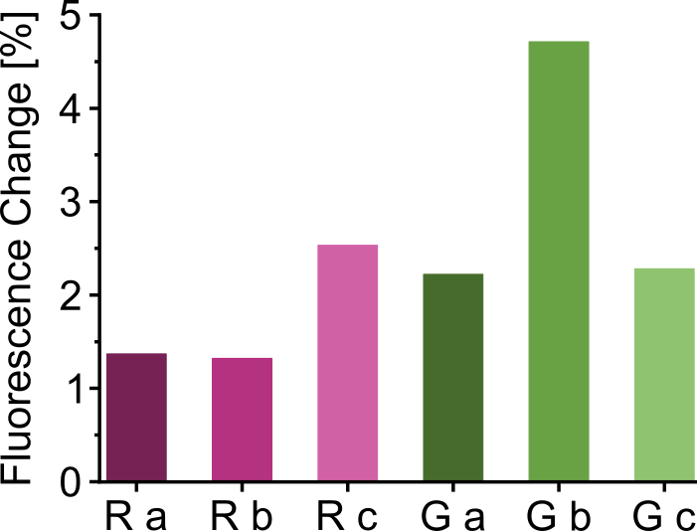
Supplementary figure 1: Systematic dye scouting with red (R) and green (G) dyes revealed that green dye b (Gb, Dynamic Biosensors GmbH, DE) provided the highest fluorescence signal amplitude among all tested dyes. Signal amplitudes were determined in measurements with a purified, dimeric geph-binding peptide ((YSIVGSYPR)2pegKC) at a concentration of 0.1 µM.
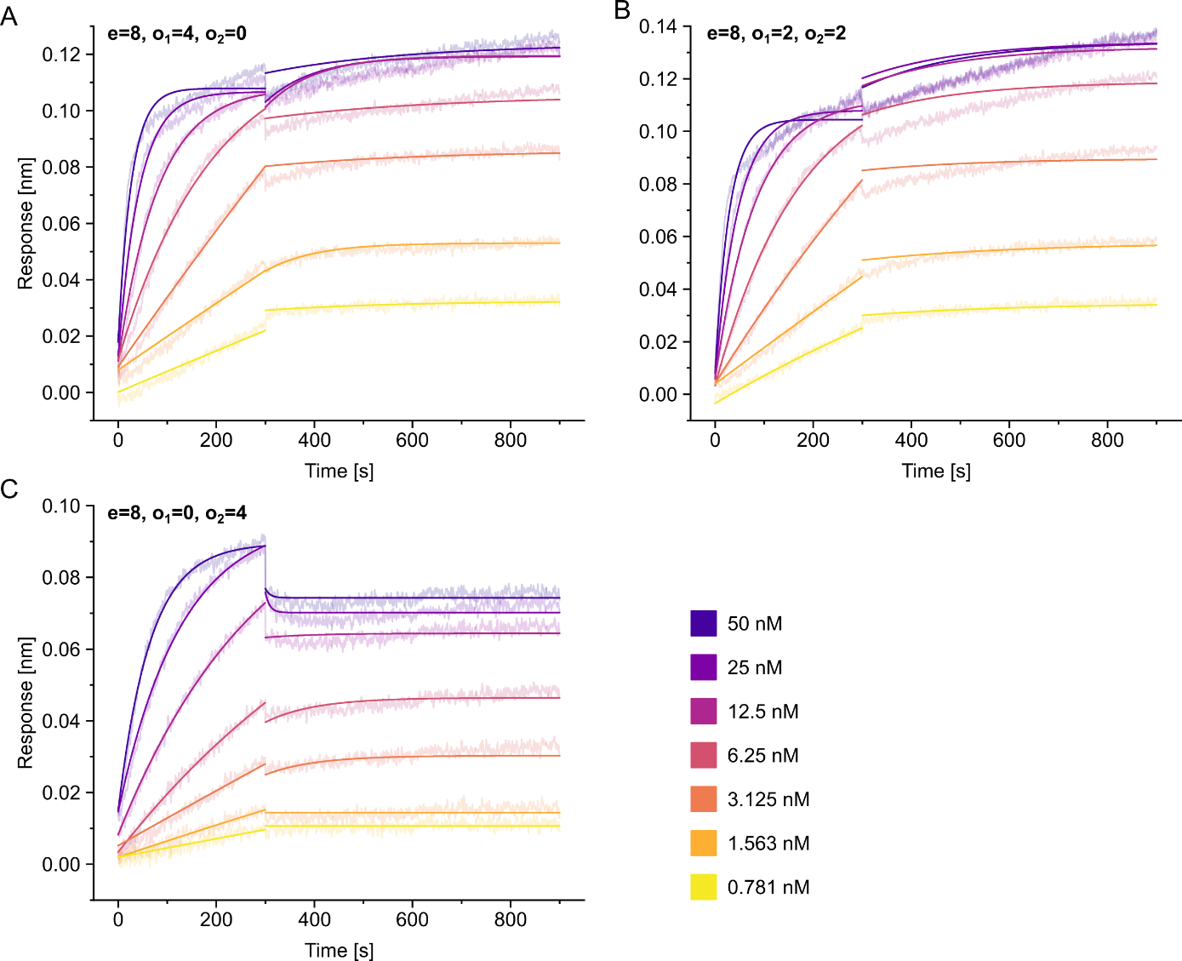
Supplementary Figure 2: BLI measurements of purified tetrameric peptides with 8mer epitopes and varying linker architecture. Tetrameric peptides with varying architecture (A-C) were subjected to BLI measurements at the indicated concentrations. Note that no off-rate could be determined for any of the tested tetramers.
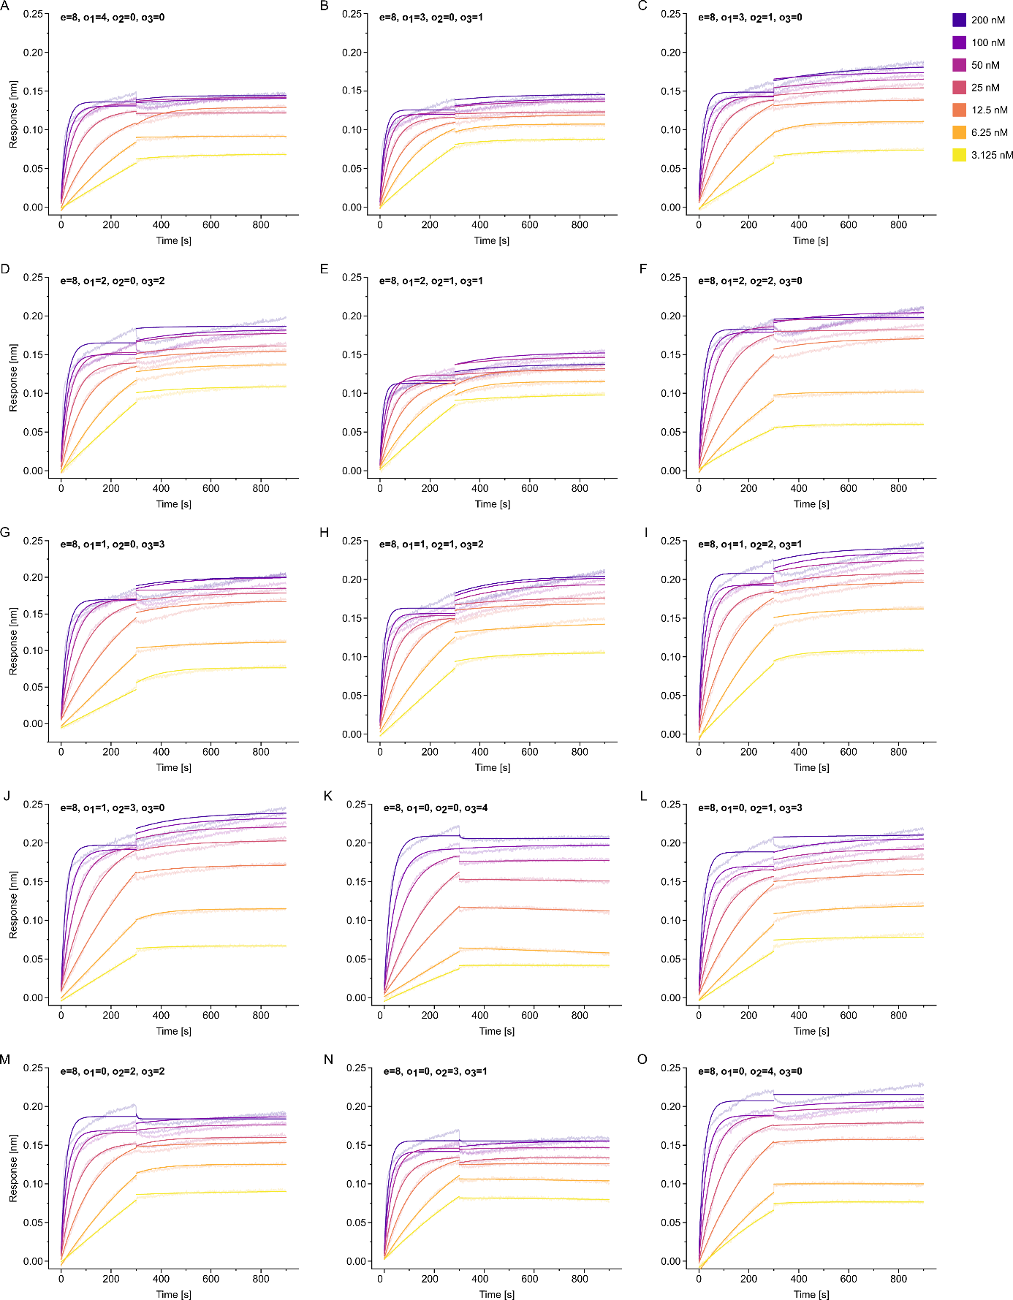
Supplementary Figure 3: BLI measurements of octameric peptides with 8mer epitopes and varying linker architecture. Octameric peptides with varying architecture (A-O) were subjected to BLI measurements at the indicated concentrations. Note that no off-rate could be determined for any of the tested octamers.

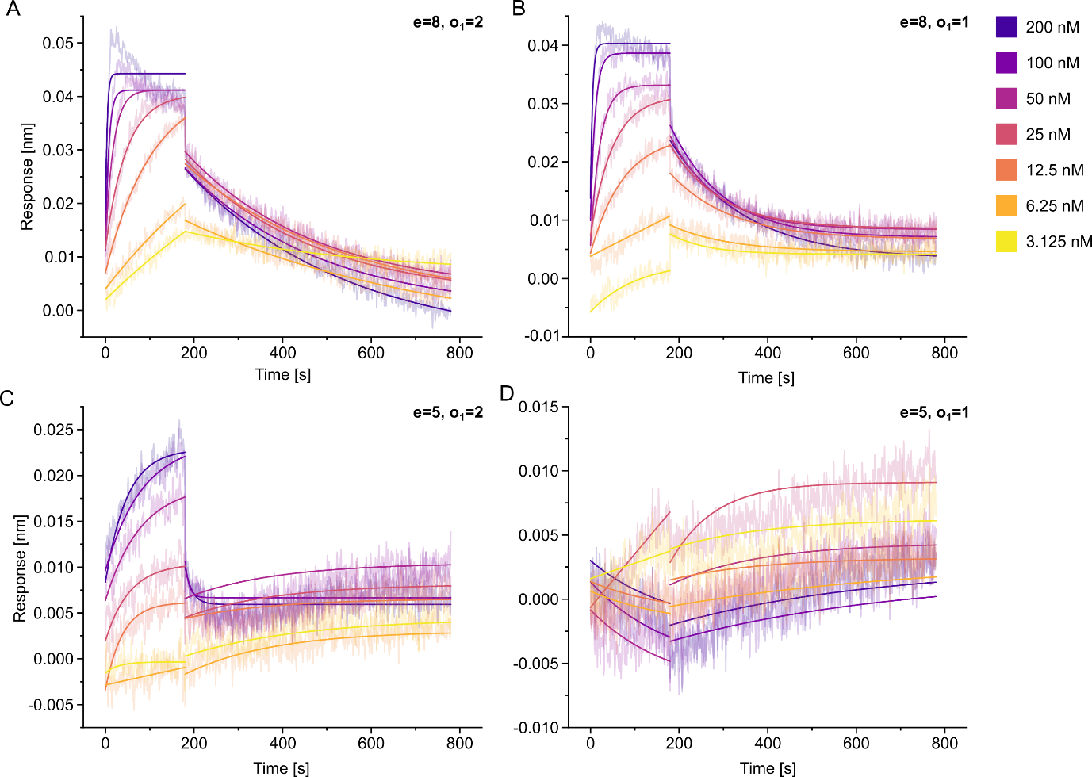
Supplementary Figure 4: BLI measurements of purified dimeric peptides with varying epitope and linker length. Dimeric peptides with varying epitope and linker length (A-D) were subjected to BLI measurements at the indicated concentrations. Note that for the smallest peptide tested (D), due to poor signal-to-noise ratio, no on- or off-rate could be determined.
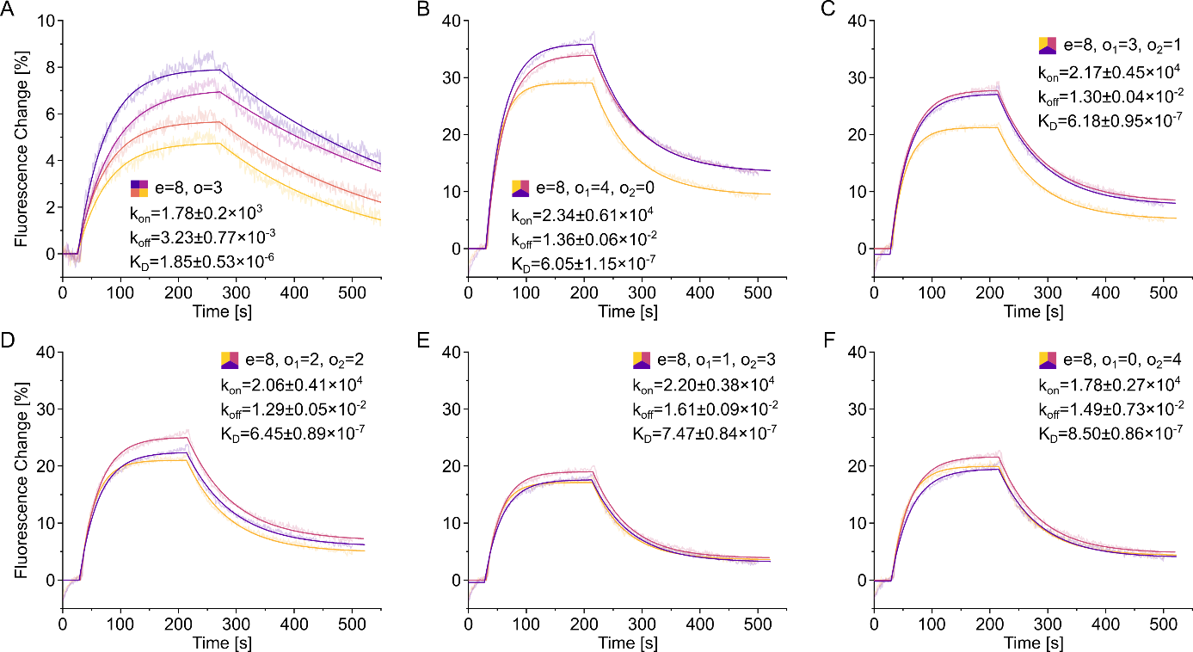
Supplementary figure 5: High intra-synthesis reproducibility of k_{on}, k_{off}, and K_{D} values of unmodified peptides determined in FPS. To determine the intra-synthesis reproducibility of our assay setup, selected independently synthesized dimeric and tetrameric compounds were measured concentration of 1 μM. Dynamic K_{D} values and the corresponding k_{on} and k_{off} values are represented as mean with the corresponding standard deviations. The dimeric peptide was synthesized and measured as n=4, the tetrameric compounds as n=3.

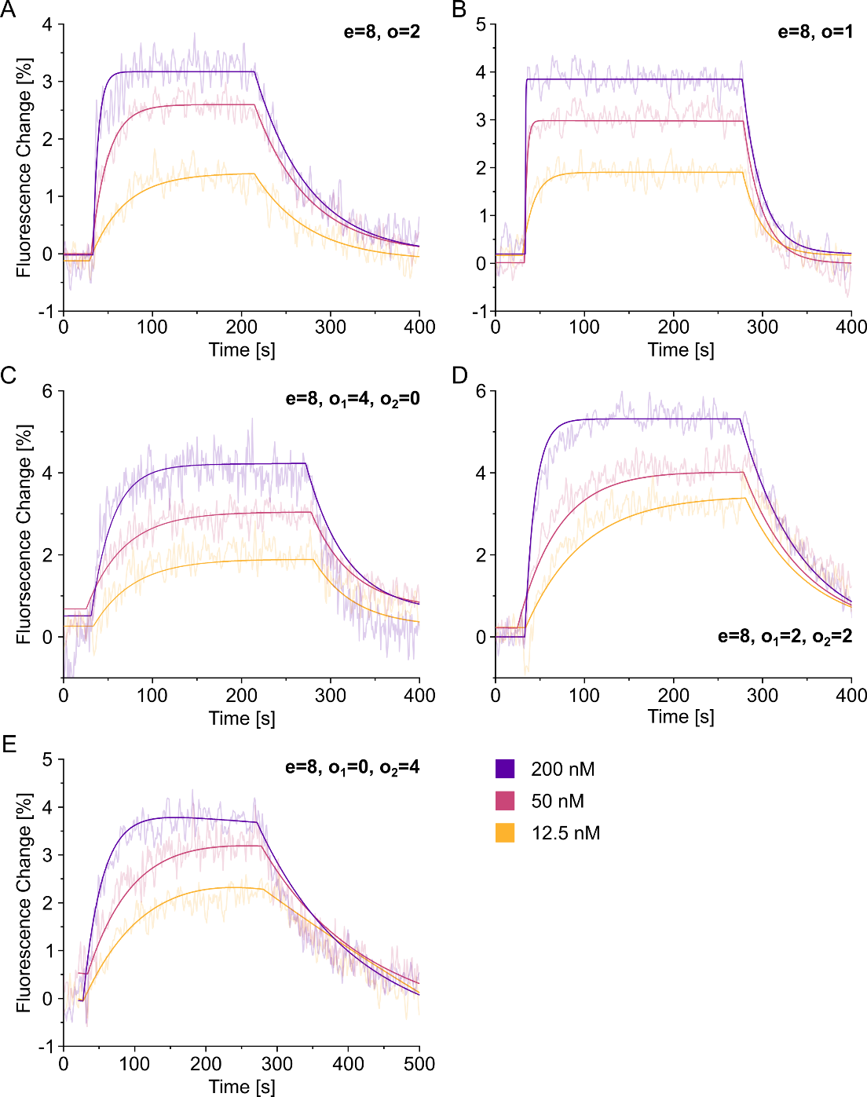
Supplementary figure 6: Affinity determination of purified dimeric and tetrameric peptides in FPS. Dimeric (A-B) and tetrameric (C-E) compounds were subjected to FPS measurements at the indicated concentrations in the nanomolar range.
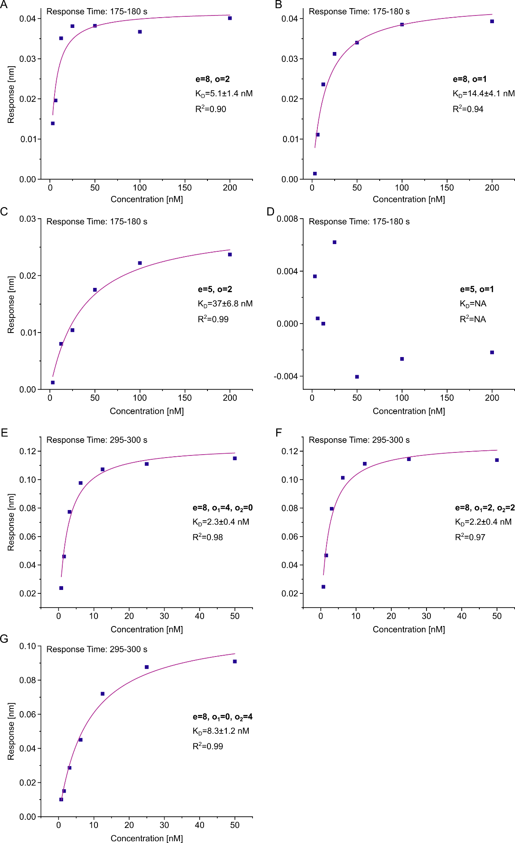
Supplementary figure 7: Affinity determination of purified dimeric and tetrameric peptides in BLI. Steady-state responses from BLI sensograms (see supplementary figure 2 and 4) of the indicated peptides were plotted against the corresponding concentration and fit to determine the apparent K_{D} values.

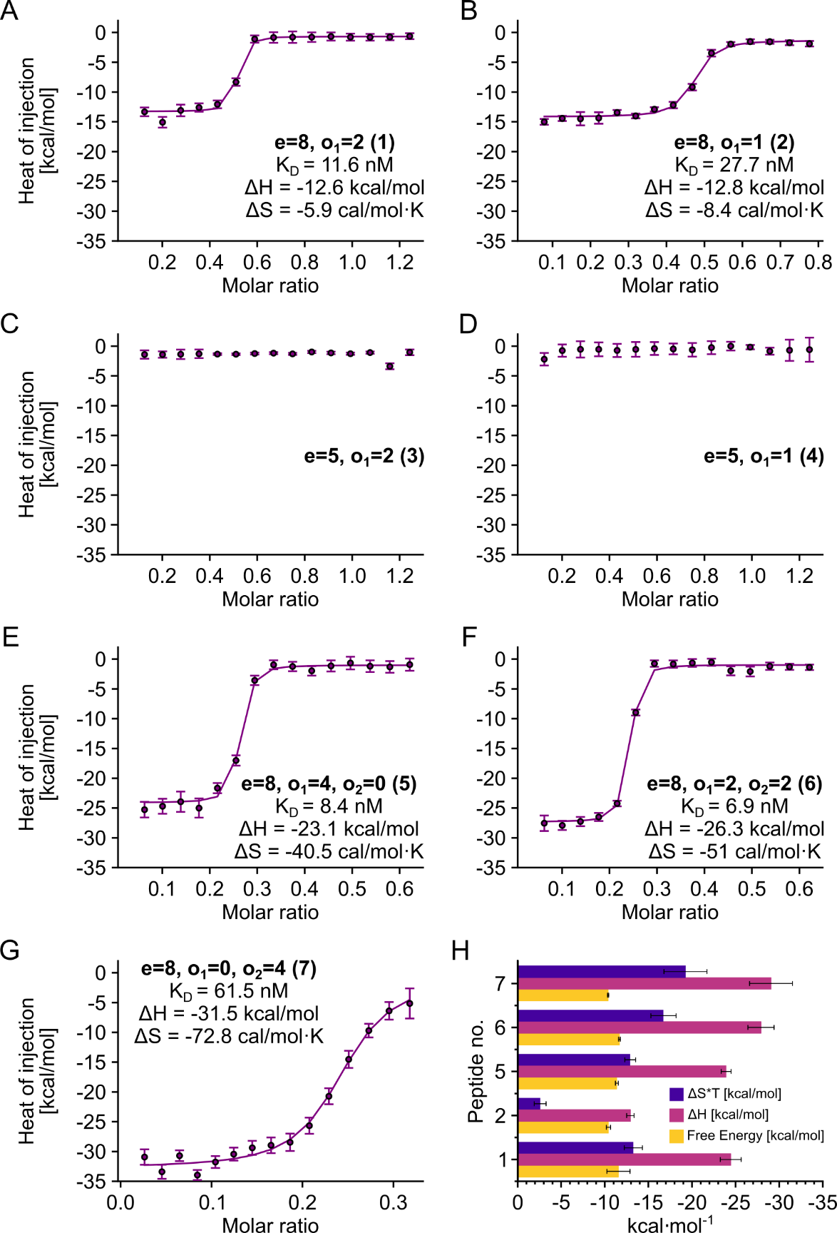
Supplementary Figure 8: representative binding isotherms of GephE titrated with purified dimeric and tetrameric peptides. (A-D) Integrated molar heat release obtained from titrating recombinant GephE with different dimeric peptides using the ITC method. (E-G) Integrated molar heat release obtained from titrating recombinant GephE with different tetrameric peptides using the ITC method. (H) Different contributions of the binding enthalpy and entropy to the overall free energy. Enthalpy, entropy and free energy bar graphs are averages and the corresponding standard deviations of three ITC measurements for (A)-(F) and two ITC measurements for (G).

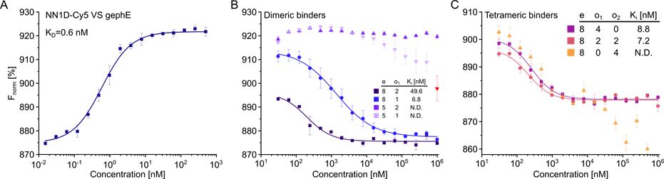
Supplementary Figure 9: Quasi label-free affinity determination of purified dimeric and tetrameric peptides in Dianthus. (A) Titration of gephE against a high affinity geph binding peptide with Cy5 (NN1D-Cy5) as a fluorescent tracer. (B) Displacement assay with dimeric peptides with verying epitope length and linker architecture against a gephE – NN1D-Cy5 complex. (C) Displacement assay with tetrameric peptides with varying linker architecture against a gephE – NN1D-Cy5 complex. Values are presented as mean of n=2 measurements and the corresponding standard deviations.

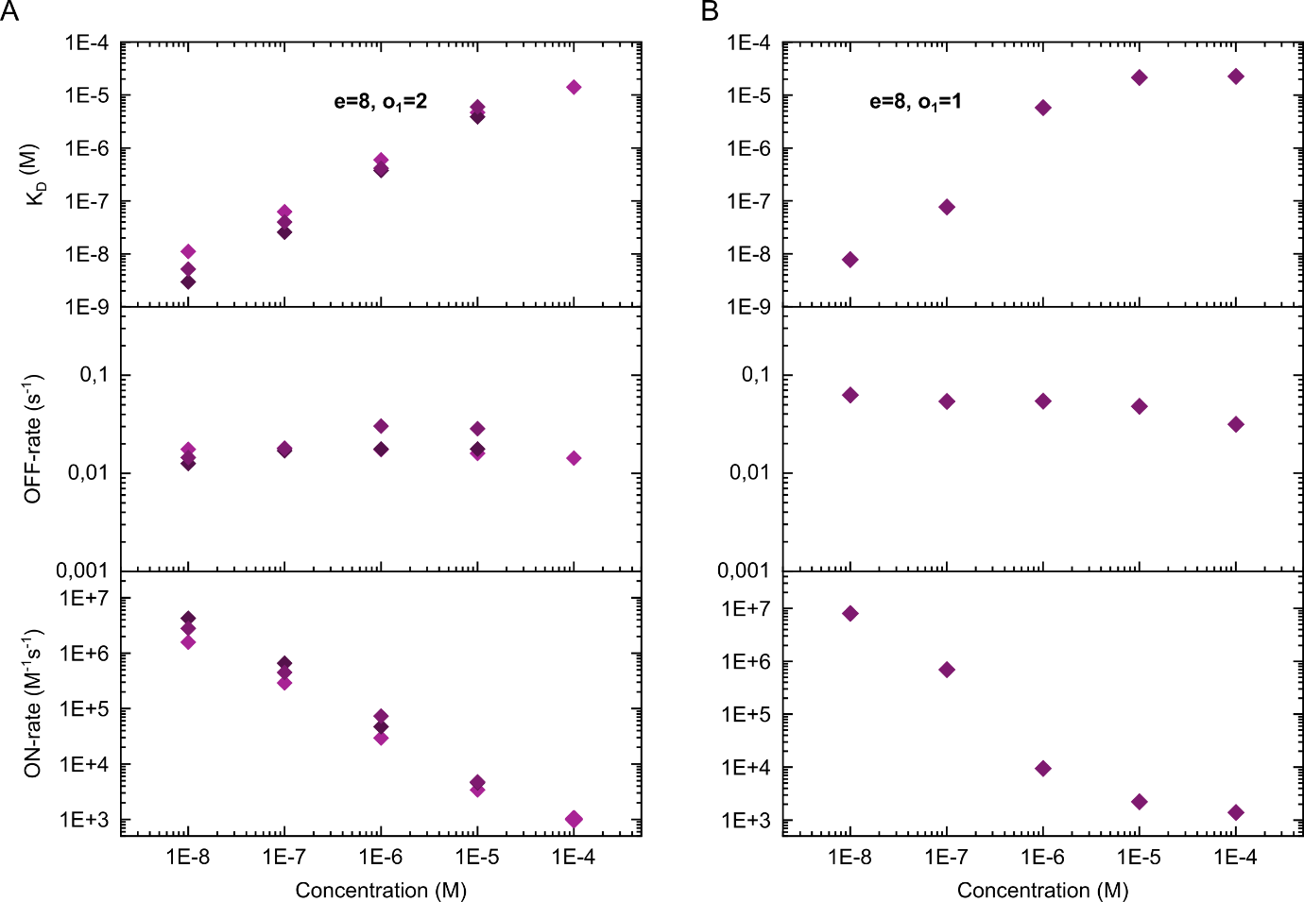
Supplementary figure 10: Determined on-rates are dependent on the peptide concentration. Obtained on-, off-rates and K_{D} values at varying peptide concentrations of two dimeric peptides with an 8mer binding epitope (e) and a linker length two (A) or one (B) PEG building blocks.

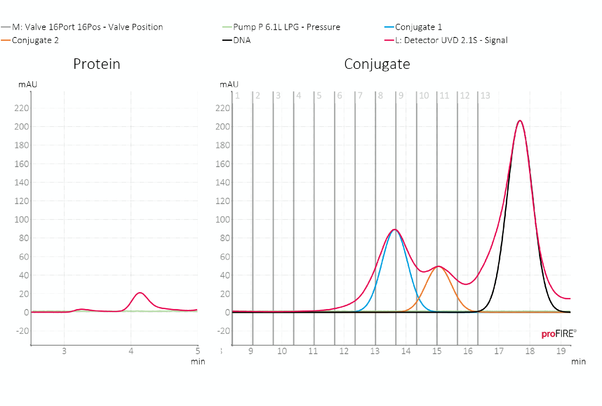
Supplementary figure 11: proFIRE® purification chromatogram of GephE conjugated to a 48mer oligonucleotide. Conjugate peak 1 (blue line) shows a single population of a 48mer labelled protein with a 1:1 ratio. Conjugate peak 2 (orange line) shows a higher molecular weight, assuming a 2:1 ratio. The third peak (black line) is the excess of free DNA. Only peak 1 was used for the peptide screening.

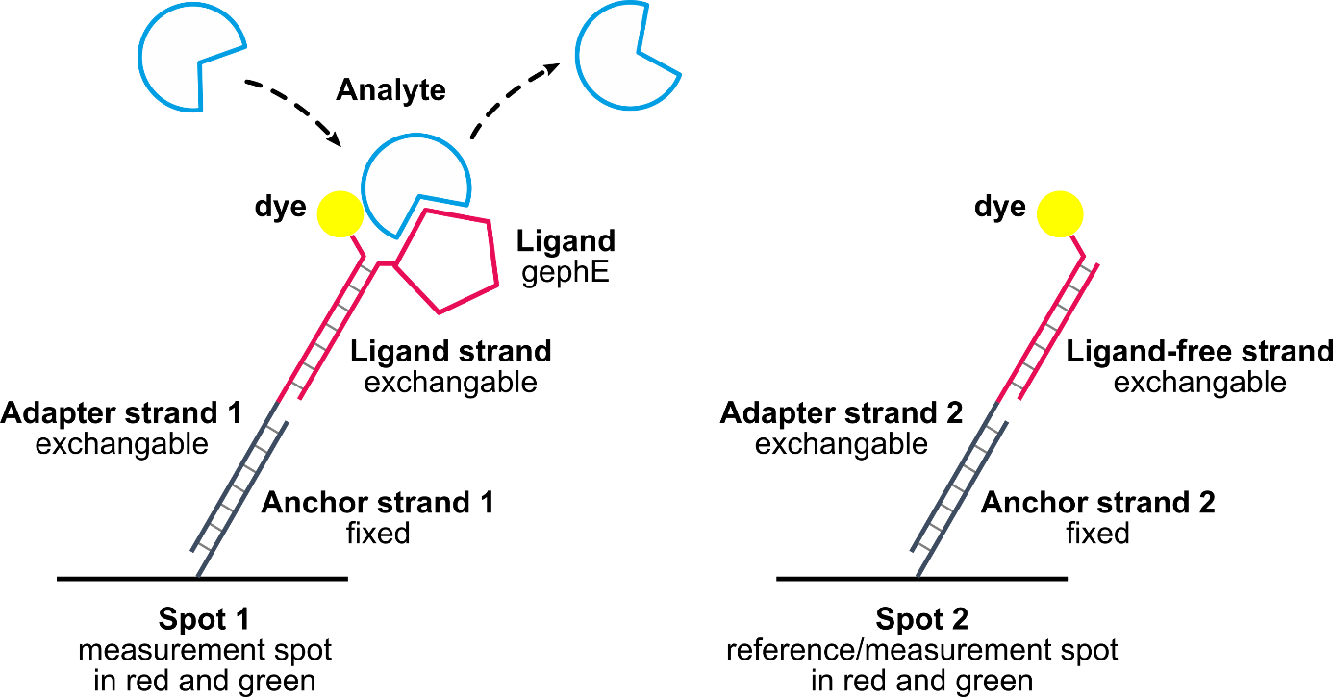
Supplementary figure 12: Layout of the heliX® adapter biochip.

Supplementary Tables
Supplementary Table 1: Complete overview of dimeric, tetrameric and octameric peptides measured in FPS. Peptide sequences are given alongside the on-, off-rate and K_{D} value and corresponding STDEV obtained at peptide concentrations of 1 µM.
Peptide | Sequence | kon (M-1s-1) | STDEV | koff (s-1) | STDEV | KD (M) | STDEV | Association Level
GlyRβ_DIM_008_8_3P_WT001 | FSIVGSLPOOOJ | 1.63E+03 | 6.00E+01 | 4.42E-03 | 1.00E-04 | 2.71E-06 | 1.20E-07 | 4.43
GlyRβ_DIM_008_8_3P_WT002 | FSIVGSLPOOOJ | 1.91E+03 | 6.00E+01 | 3.39E-03 | 7.00E-05 | 1.77E-06 | 7.00E-08 | 5.49
GlyRβ_DIM_008_8_3P_WT004 | FSIVGSLPOOOJ | 1.54E+03 | 5.00E+01 | 2.51E-03 | 5.00E-05 | 1.63E-06 | 6.00E-08 | 6.85
GlyRβ_DIM_008_8_3P_WT005 | FSIVGSLPOOOJ | 2.05E+03 | 6.00E+01 | 2.59E-03 | 5.00E-05 | 1.27E-06 | 5.00E-08 | 8.04
GlyRβ_DIM_001 | SDLRSNDFSIOOOJ | 0.00E+00 | 0.00E+00 | 0.00E+00 | 0.00E+00 | 0.00E+00 | 0.00E+00 | 0.00E+00
GlyRβ_DIM_002 | DLRSNDFSIVOOOJ | 3.59E+03 | 5.10E+02 | 1.10E-02 | 9.00E-04 | 3.07E-06 | 5.00E-07 | 1
GlyRβ_DIM_003 | LRSNDFSIVGOOOJ | 0.00E+00 | 0.00E+00 | 0.00E+00 | 0.00E+00 | 0.00E+00 | 0.00E+00 | 0.00E+00
GlyRβ_DIM_004 | RSNDFSIVGSOOOJ | 0.00E+00 | 0.00E+00 | 0.00E+00 | 0.00E+00 | 0.00E+00 | 0.00E+00 | 0.00E+00
GlyRβ_DIM_005* | SNDFSIVGSLOOOJ | 1.02E+04 | 3.10E+03 | 3.06E-02 | 3.60E-03 | 3.01E-06 | 9.90E-07 | 0.109
GlyRβ_DIM_006 | NDFSIVGSLPOOOJ | 6.35E+03 | 1.27E+03 | 1.98E-02 | 1.80E-03 | 3.12E-06 | 6.90E-07 | 1.04
GlyRβ_DIM_007 | DFSIVGSLPROOOJ | 5.15E+03 | 9.30E+02 | 1.39E-02 | 1.30E-03 | 2.71E-06 | 5.50E-07 | 1.11
GlyRβ_DIM_008 | FSIVGSLPRDOOOJ | 2.04E+03 | 2.20E+02 | 1.01E-02 | 6.00E-04 | 4.97E-06 | 6.00E-07 | 2.49
GlyRβ_DIM_009 | SIVGSLPRDFOOOJ | 0.00E+00 | 0.00E+00 | 0.00E+00 | 0.00E+00 | 0.00E+00 | 0.00E+00 | 0.00E+00
GlyRβ_DIM_010 | IVGSLPRDFEOOOJ | 0.00E+00 | 0.00E+00 | 0.00E+00 | 0.00E+00 | 0.00E+00 | 0.00E+00 | 0.00E+00
GlyRβ_DIM_008_10_3P | FSIVGSLPRDOOOJ | 3.30E+03 | 2.10E+02 | 9.22E-03 | 3.50E-04 | 2.79E-06 | 2.10E-07 | 3.07
GlyRβ_DIM_008_10_2P | FSIVGSLPRDOOJ | 4.06E+03 | 3.30E+02 | 1.03E-02 | 5.00E-04 | 2.53E-06 | 2.40E-07 | 2.37
GlyRβ_DIM_008_10_1P | FSIVGSLPRDOJ | 4.48E+03 | 3.60E+02 | 1.12E-02 | 5.00E-04 | 2.49E-06 | 2.30E-07 | 2.31
GlyRβ_DIM_008_10_0P | FSIVGSLPRDJ | 0.00E+00 | 0.00E+00 | 0.00E+00 | 0.00E+00 | 0.00E+00 | 0.00E+00 | 0.00E+00
GlyRβ_DIM_008_9_3P | FSIVGSLPROOOJ | 3.11E+03 | 2.90E+02 | 1.25E-02 | 6.00E-04 | 4.03E-06 | 4.30E-07 | 2.17
GlyRβ_DIM_008_9_2P | FSIVGSLPROOJ | 3.97E+03 | 3.80E+02 | 1.23E-02 | 6.00E-04 | 3.11E-06 | 3.40E-07 | 2.04
GlyRβ_DIM_008_9_1P | FSIVGSLPROJ | 3.38E+03 | 1.49E+03 | 1.61E-02 | 7.00E-04 | 4.76E-06 | 3.10E-07 | 1.31
GlyRβ_DIM_008_9_0P | FSIVGSLPRJ | 0.00E+00 | 0.00E+00 | 0.00E+00 | 0.00E+00 | 0.00E+00 | 0.00E+00 | 0.00E+00
GlyRβ_DIM_008_8_3P | FSIVGSLPOOOJ | 1.48E+03 | 2.10E+02 | 1.26E-02 | 8.00E-04 | 8.46E-06 | 1.31E-06 | 2.01
GlyRβ_DIM_008_8_2P | FSIVGSLPOOJ | 3.08E+03 | 2.80E+02 | 1.01E-02 | 5.00E-04 | 3.29E-06 | 3.50E-07 | 2.36
GlyRβ_DIM_008_8_1P | FSIVGSLPOJ | 1.77E+03 | 7.40E+02 | 1.71E-02 | 1.40E-03 | 9.66E-06 | 6.40E-07 | 1.31
GlyRβ_DIM_008_8_0P | FSIVGSLPJ | 0.00E+00 | 0.00E+00 | 0.00E+00 | 0.00E+00 | 0.00E+00 | 0.00E+00 | 0.00E+00
GlyRβ_DIM_008_7_3P | FSIVGSLOOOJ | 2.16E+03 | 2.50E+02 | 1.08E-02 | 7.00E-04 | 4.99E-06 | 6.50E-07 | 1.39
GlyRβ_DIM_008_7_2P | FSIVGSLOOJ | 0.00E+00 | 0.00E+00 | 0.00E+00 | 0.00E+00 | 0.00E+00 | 0.00E+00 | 0.00E+00
GlyRβ_DIM_008_7_1P | FSIVGSLOJ | 0.00E+00 | 0.00E+00 | 0.00E+00 | 0.00E+00 | 0.00E+00 | 0.00E+00 | 0.00E+00
GlyRβ_DIM_008_7_0P | FSIVGSLJ | 0.00E+00 | 0.00E+00 | 0.00E+00 | 0.00E+00 | 0.00E+00 | 0.00E+00 | 0.00E+00
GlyRβ_DIM_008_6_3P | FSIVGSOOOJ | 2.66E+03 | 6.10E+02 | 1.74E-02 | 1.70E-03 | 6.53E-06 | 1.64E-06 | 1.3
GlyRβ_DIM_008_6_2P | FSIVGSOOJ | 2.13E+03 | 6.70E+02 | 1.89E-02 | 2.30E-03 | 8.89E-06 | 3.02E-06 | 1.1
GlyRβ_DIM_008_6_1P | FSIVGSOJ | 0.00E+00 | 0.00E+00 | 0.00E+00 | 0.00E+00 | 0.00E+00 | 0.00E+00 | 0.00E+00
GlyRβ_DIM_008_6_0P | FSIVGSJ | 0.00E+00 | 0.00E+00 | 0.00E+00 | 0.00E+00 | 0.00E+00 | 0.00E+00 | 0.00E+00
GlyRβ_DIM_008_5_3P | FSIVGOOOJ | 0.00E+00 | 0.00E+00 | 0.00E+00 | 0.00E+00 | 0.00E+00 | 0.00E+00 | 0.00E+00
GlyRβ_DIM_008_5_2P | FSIVGOOJ | 1.63E+03 | 4.80E+02 | 1.92E-02 | 1.90E-03 | 1.18E-05 | 3.70E-06 | 1.2
GlyRβ_DIM_008_5_1P | FSIVGOJ | 0.00E+00 | 0.00E+00 | 0.00E+00 | 0.00E+00 | 0.00E+00 | 0.00E+00 | 0.00E+00
GlyRβ_DIM_008_5_0P | FSIVGJ | 0.00E+00 | 0.00E+00 | 0.00E+00 | 0.00E+00 | 0.00E+00 | 0.00E+00 | 0.00E+00
GlyRβ_DIM_008_4_3P | FSIVOOOJ | 0.00E+00 | 0.00E+00 | 0.00E+00 | 0.00E+00 | 0.00E+00 | 0.00E+00 | 0.00E+00
GlyRβ_DIM_008_4_2P | FSIVOOJ | 0.00E+00 | 0.00E+00 | 0.00E+00 | 0.00E+00 | 0.00E+00 | 0.00E+00 | 0.00E+00
GlyRβ_DIM_008_4_1P | FSIVOJ | 2.88E+03 | 5.60E+02 | 1.41E-02 | 1.60E-03 | 1.41E-05 | 1.60E-06 | 1.1
GlyRβ_DIM_008_4_0P | FSIVJ | 0.00E+00 | 0.00E+00 | 0.00E+00 | 0.00E+00 | 0.00E+00 | 0.00E+00 | 0.00E+00
GlyRβ_DIM_008_10_3P_Ala001 | ASIVGSLPRDOOOJ | 0.00E+00 | 0.00E+00 | 0.00E+00 | 0.00E+00 | 0.00E+00 | 0.00E+00 | 0.00E+00
GlyRβ_DIM_008_10_3P_Ala002 | FAIVGSLPRDOOOJ | 0.00E+00 | 0.00E+00 | 0.00E+00 | 0.00E+00 | 0.00E+00 | 0.00E+00 | 0.00E+00
GlyRβ_DIM_008_10_3P_Ala003 | FSAVGSLPRDOOOJ | 0.00E+00 | 0.00E+00 | 0.00E+00 | 0.00E+00 | 0.00E+00 | 0.00E+00 | 0.00E+00
GlyRβ_DIM_008_10_3P_Ala004 | FSIAGSLPRDOOOJ | 0.00E+00 | 0.00E+00 | 0.00E+00 | 0.00E+00 | 0.00E+00 | 0.00E+00 | 0.00E+00
GlyRβ_DIM_008_10_3P_Ala005 | FSIVASLPRDOOOJ | 1.45E+03 | 6.20E+02 | 2.77E-02 | 3.00E-03 | 1.91E-05 | 8.40E-06 | 0.892
GlyRβ_DIM_008_10_3P_Ala006 | FSIVGALPRDOOOJ | 1.62E+03 | 8.20E+02 | 2.86E-02 | 3.80E-03 | 1.76E-05 | 9.20E-06 | 1.42
GlyRβ_DIM_008_10_3P_Ala007 | FSIVGSAPRDOOOJ | 1.30E+03 | 5.90E+02 | 2.99E-02 | 3.00E-03 | 2.29E-05 | 1.06E-05 | 1.3
GlyRβ_DIM_008_10_3P_Ala008 | FSIVGSLARDOOOJ | 2.59E+03 | 2.43E+03 | 4.80E-02 | 7.60E-03 | 1.85E-05 | 1.06E-05 | 1.2
GlyRβ_DIM_008_10_3P_FP001 | YSIVGSLPRDOOOJ | 1.72E+03 | 5.00E+01 | 2.19E-03 | 4.00E-05 | 1.27E-06 | 4.00E-08 | 7.53
GlyRβ_DIM_008_10_3P_FP002 | WSIVGSLPRDOOOJ | 2.05E+03 | 8.00E+01 | 3.62E-03 | 9.00E-05 | 1.76E-06 | 8.00E-08 | 4.18
GlyRβ_DIM_008_10_3P_FP003 | FGIVGSLPRDOOOJ | 0.00E+00 | 0.00E+00 | 0.00E+00 | 0.00E+00 | 0.00E+00 | 0.00E+00 | 0.00E+00
GlyRβ_DIM_008_10_3P_FP004 | FTIVGSLPRDOOOJ | 9.20E+03 | 1.43E+03 | 1.59E-02 | 1.10E-03 | 1.73E-06 | 2.90E-07 | 1.39
GlyRβ_DIM_008_10_3P_FP005 | FWIVGSLPRDOOOJ | 0.00E+00 | 0.00E+00 | 0.00E+00 | 0.00E+00 | 0.00E+00 | 0.00E+00 | 0.00E+00
GlyRβ_DIM_008_10_3P_FP006 | FSLVGSLPRDOOOJ | 2.87E+03 | 3.00E+02 | 1.43E-02 | 7.00E-04 | 5.00E-06 | 5.80E-07 | 2.32
GlyRβ_DIM_008_10_3P_FP007 | FSVVGSLPRDOOOJ | 5.15E+03 | 7.60E+02 | 1.67E-02 | 1.20E-03 | 3.24E-06 | 5.30E-07 | 1.27
GlyRβ_DIM_008_10_3P_FP008 | FSMVGSLPRDOOOJ | 3.65E+03 | 3.90E+02 | 1.37E-02 | 8.00E-04 | 3.74E-06 | 4.50E-07 | 1.97
GlyRβ_DIM_008_10_3P_FP009 | FSIIGSLPRDOOOJ | 3.84E+03 | 3.70E+02 | 1.29E-02 | 7.00E-04 | 3.37E-06 | 3.60E-07 | 2.44
GlyRβ_DIM_008_10_3P_FP010 | FSIWGSLPRDOOOJ | 0.00E+00 | 0.00E+00 | 0.00E+00 | 0.00E+00 | 0.00E+00 | 0.00E+00 | 0.00E+00
GlyRß_QUAD_008_4-0_1 | FSIVGSLPOOOOJJ | 3.23E+04 | 7.00E+02 | 1.43E-02 | 2.00E-04 | 4.43E-07 | 1.20E-08 | 31
GlyRß_QUAD_008_3-1_1 | FSIVGSLPOOOJOJ | 2.81E+04 | 8.00E+02 | 1.36E-02 | 3.00E-04 | 4.84E-07 | 1.70E-08 | 23
GlyRß_QUAD_008_2-2_1 | FSIVGSLPOOJOOJ | 2.63E+04 | 8.00E+02 | 1.37E-02 | 3.00E-04 | 5.21E-07 | 1.80E-08 | 22.8
GlyRß_QUAD_008_1-3_1 | FSIVGSLPOJOOOJ | 2.72E+04 | 1.10E+03 | 1.72E-02 | 4.00E-04 | 6.32E-07 | 2.80E-08 | 18.8
GlyRß_QUAD_008_0-4_1 | FSIVGSLPJOOOOJ | 2.14E+04 | 8.00E+02 | 1.59E-02 | 3.00E-04 | 7.43E-07 | 3.10E-08 | 21.5
GlyRß_QUAD_008_4-0_2 | FSIVGSLPOOOOJJ | 1.90E+04 | 5.00E+02 | 1.29E-02 | 3.00E-04 | 6.79E-07 | 2.30E-08 | 37.5
GlyRß_QUAD_008_3-1_2 | FSIVGSLPOOOJOJ | 1.86E+04 | 5.00E+02 | 1.27E-02 | 2.00E-04 | 6.83E-07 | 2.40E-08 | 30.8
GlyRß_QUAD_008_2-2_2 | FSIVGSLPOOJOOJ | 1.83E+04 | 6.00E+02 | 1.26E-02 | 3.00E-04 | 6.89E-07 | 2.70E-08 | 27.7
GlyRß_QUAD_008_1-3_2 | FSIVGSLPOJOOOJ | 2.07E+04 | 9.00E+02 | 1.61E-02 | 4.00E-04 | 7.78E-07 | 3.90E-08 | 21.1
GlyRß_QUAD_008_0-4_2 | FSIVGSLPJOOOOJ | 1.71E+04 | 6.00E+02 | 1.46E-02 | 3.00E-04 | 8.54E-07 | 3.50E-08 | 23.6
GlyRß_QUAD_008_4-0_3 | FSIVGSLPOOOOJJ | 1.96E+04 | 6.00E+02 | 1.36E-02 | 3.00E-04 | 6.94E-07 | 2.70E-08 | 40.2
GlyRß_QUAD_008_3-1_3 | FSIVGSLPOOOJOJ | 1.85E+04 | 6.00E+02 | 1.27E-02 | 3.00E-04 | 6.86E-07 | 3.10E-08 | 28
GlyRß_QUAD_008_2-2_3 | FSIVGSLPOOJOOJ | 1.72E+04 | 6.00E+02 | 1.25E-02 | 3.00E-04 | 7.27E-07 | 3.10E-08 | 25.2
GlyRß_QUAD_008_1-3_3 | FSIVGSLPOJOOOJ | 1.82E+04 | 8.00E+02 | 1.51E-02 | 3.00E-04 | 8.30E-07 | 3.90E-08 | 20.1
GlyRß_QUAD_008_0-4_3 | FSIVGSLPJOOOOJ | 1.49E+04 | 6.00E+02 | 1.42E-02 | 3.00E-04 | 9.53E-07 | 4.60E-08 | 21.8
GlyRß_QUAD_007_4-0 | FSIVGSLOOOOJJ | 1.78E+04 | 2.90E+03 | 2.02E-02 | 1.30E-03 | 1.13E-06 | 2.00E-07 | 9.3
GlyRß_QUAD_007_3-1 | FSIVGSLOOOJOJ | 1.74E+04 | 3.20E+03 | 2.38E-02 | 1.50E-03 | 1.37E-06 | 2.60E-07 | 7.54
GlyRß_QUAD_007_2-2 | FSIVGSLOOJOOJ | 6.78E+03 | 6.10E+02 | 1.14E-02 | 4.00E-04 | 1.68E-06 | 1.60E-07 | 17
GlyRß_QUAD_007_1-3 | FSIVGSLOJOOOJ | 9.18E+03 | 7.70E+02 | 1.01E-02 | 4.00E-04 | 1.10E-06 | 1.00E-07 | 12.1
GlyRß_QUAD_007_0-4 | FSIVGSLJOOOOJ | 1.47E+04 | 2.20E+03 | 1.06E-02 | 1.10E-03 | 7.21E-07 | 1.29E-07 | 5.55
GlyRß_QUAD_006_4-0 | FSIVGSOOOOJJ | 2.03E+04 | 3.10E+03 | 1.49E-02 | 1.10E-03 | 7.34E-07 | 1.25E-07 | 7.09
GlyRß_QUAD_006_3-1 | FSIVGSOOOJOJ | 8.93E+03 | 1.43E+03 | 9.09E-03 | 8.10E-04 | 1.02E-06 | 1.90E-07 | 7.91
GlyRß_QUAD_006_2-2 | FSIVGSOOJOOJ | 2.35E+04 | 3.50E+03 | 1.23E-02 | 1.30E-03 | 5.23E-07 | 9.60E-08 | 4.77
GlyRß_QUAD_006_1-3 | FSIVGSOJOOOJ | 7.55E+03 | 7.90E+02 | 1.02E-02 | 5.00E-04 | 1.35E-06 | 1.60E-07 | 11.9
GlyRß_QUAD_006_0-4 | FSIVGSJOOOOJ | 2.14E+04 | 1.80E+03 | 7.64E-03 | 6.30E-04 | 3.57E-07 | 4.20E-08 | 7.39
GlyRß_QUAD_005_4-0 | FSIVGOOOOJJ | 1.78E+03 | 2.42E+03 | 1.98E-03 | 1.69E-03 | 1.11E-06 | 1.79E-06 | 4.91
GlyRß_QUAD_005_3-1 | FSIVGOOOJOJ | 1.07E+04 | 3.80E+03 | 1.78E-03 | 2.05E-03 | 1.66E-07 | 1.99E-07 | 2.83
GlyRß_QUAD_005_2-2 | FSIVGOOJOOJ | 6.55E+03 | 5.81E+03 | 1.98E-03 | 2.83E-03 | 3.02E-07 | 5.09E-07 | 2.05
GlyRß_QUAD_005_1-3 | FSIVGOJOOOJ | 7.43E+03 | 4.99E+03 | 1.42E-03 | 3.21E-03 | 1.91E-07 | 4.50E-07 | 1.67
GlyRß_QUAD_005_0-4 | FSIVGJOOOOJ | 8.20E+03 | 1.78E+03 | 3.77E-03 | 1.27E-03 | 4.60E-07 | 1.84E-07 | 4.04
GlyRß_OCT_008_4-0-0 | FSIVGSLPOOOOJJJ | 1.03E+05 | 6.00E+03 | 9.21E-03 | 2.00E-04 | 8.94E-08 | 5.30E-09 | 11.4
GlyRß_OCT_008_3-0-1 | FSIVGSLPOOOJJOJ | 7.35E+04 | 4.40E+03 | 7.70E-03 | 1.70E-04 | 1.05E-07 | 7.00E-09 | 7.6
GlyRß_OCT_008_3-1-0 | FSIVGSLPOOOJOJJ | 4.69E+04 | 2.90E+03 | 7.45E-03 | 2.00E-04 | 1.59E-07 | 1.10E-08 | 6.47
GlyRß_OCT_008_2-0-2 | FSIVGSLPOOJJOOJ | 4.49E+04 | 2.40E+03 | 8.04E-03 | 1.90E-04 | 1.79E-07 | 1.00E-08 | 8.03
GlyRß_OCT_008_2-1-1 | FSIVGSLPOOJOJOJ | 3.83E+04 | 2.40E+03 | 8.19E-03 | 2.20E-04 | 2.14E-07 | 1.40E-08 | 6.41
GlyRß_OCT_008_2-2-0 | FSIVGSLPOOJOOJJ | 3.67E+04 | 9.00E+02 | 6.75E-03 | 1.30E-04 | 1.84E-07 | 6.00E-09 | 19.4
GlyRß_OCT_008_1-0-3 | FSIVGSLPOJJOOOJ | 2.80E+04 | 8.00E+02 | 6.11E-03 | 1.20E-04 | 2.18E-07 | 8.00E-09 | 14.4
GlyRß_OCT_008_1-1-2 | FSIVGSLPOJOJOOJ | 3.32E+04 | 1.30E+03 | 6.92E-03 | 1.50E-04 | 2.08E-07 | 9.00E-09 | 10.9
GlyRß_OCT_008_1-2-1 | FSIVGSLPOJOOJOJ | 3.84E+04 | 2.00E+03 | 7.71E-03 | 1.90E-04 | 2.01E-07 | 1.20E-08 | 7.52
GlyRß_OCT_008_1-3-0 | FSIVGSLPOJOOOJJ | 3.34E+04 | 1.90E+03 | 8.04E-03 | 2.00E-04 | 2.41E-07 | 1.50E-08 | 6.88
GlyRß_OCT_008_0-0-4 | FSIVGSLPJJOOOOJ | 2.67E+04 | 6.00E+02 | 6.55E-03 | 1.00E-04 | 2.45E-07 | 7.00E-09 | 20.1
GlyRß_OCT_008_0-1-3 | FSIVGSLPJOJOOOJ | 3.07E+04 | 9.00E+02 | 6.10E-03 | 1.30E-04 | 1.99E-07 | 7.00E-09 | 15.4
GlyRß_OCT_008_0-2-2 | FSIVGSLPJOOJOOJ | 3.21E+04 | 1.10E+03 | 6.44E-03 | 1.30E-04 | 2.01E-07 | 8.00E-09 | 11.6
GlyRß_OCT_008_0-3-1 | FSIVGSLPJOOOJOJ | 3.48E+04 | 1.30E+03 | 6.71E-03 | 1.30E-04 | 1.93E-07 | 8.00E-09 | 10
GlyRß_OCT_008_0-4-0 | FSIVGSLPJOOOOJJ | 3.40E+04 | 1.50E+03 | 7.27E-03 | 1.60E-04 | 2.14E-07 | 1.10E-08 | 8.32

Supplementary Table 2: Observed and predicted dimeric, tetrameric and octameric peptides binding rates. The observed on-, off-rate, and K_{D} value and corresponding predictions for each peptide sequence are given. We used the median of duplicated sequences, i.e., repeated measurements.

Peptide | Observed K_{on} [M⁻¹s⁻¹] | Predicted K_{on} [M⁻¹s⁻¹] | Observed log(K_{off})² [s⁻¹] | Predicted log(K_{off})² [s⁻¹] | Observed log(K_{D})² [M] | Predicted log(K_{D})² [M]
GlyRβ_DIM_008_8_3P_WT001 | 1.63E+03 | 2.84E+03 | 3.23E+01 | 1.86E+01 | 1.75E+02 | 1.51E+02
GlyRβ_DIM_002 | 3.59E+03 | 7.08E+03 | 2.03E+01 | 1.52E+01 | 1.61E+02 | 1.56E+02
GlyRβ_DIM_005* | 1.02E+04 | 4.76E+03 | 1.22E+01 | 1.81E+01 | 1.62E+02 | 1.59E+02
GlyRβ_DIM_006 | 6.35E+03 | 6.06E+03 | 1.54E+01 | 1.81E+01 | 1.61E+02 | 1.61E+02
GlyRβ_DIM_007 | 5.15E+03 | 2.74E+03 | 1.83E+01 | 2.05E+01 | 1.64E+02 | 1.57E+02
GlyRβ_DIM_008 | 2.67E+03 | 4.67E+03 | 2.15E+01 | 1.84E+01 | 1.55E+02 | 1.64E+02
GlyRβ_DIM_008_10_2P | 4.06E+03 | 4.06E+03 | 2.09E+01 | 1.98E+01 | 1.66E+02 | 1.61E+02
GlyRβ_DIM_008_10_1P | 4.48E+03 | 3.66E+03 | 2.02E+01 | 1.87E+01 | 1.66E+02 | 1.53E+02
GlyRβ_DIM_008_9_3P | 3.11E+03 | 3.54E+03 | 1.92E+01 | 1.93E+01 | 1.54E+02 | 1.58E+02
GlyRβ_DIM_008_9_2P | 3.97E+03 | 3.42E+03 | 1.93E+01 | 1.93E+01 | 1.61E+02 | 1.58E+02
GlyRβ_DIM_008_9_1P | 3.38E+03 | 3.70E+03 | 1.70E+01 | 1.93E+01 | 1.50E+02 | 1.55E+02
GlyRβ_DIM_008_8_2P | 3.08E+03 | 1.93E+03 | 2.11E+01 | 2.19E+01 | 1.59E+02 | 1.53E+02
GlyRβ_DIM_008_8_1P | 1.77E+03 | 3.38E+03 | 1.66E+01 | 2.27E+01 | 1.33E+02 | 1.68E+02
GlyRβ_DIM_008_7_3P | 2.16E+03 | 2.54E+03 | 2.05E+01 | 1.71E+01 | 1.49E+02 | 1.63E+02
GlyRβ_DIM_008_6_3P | 2.66E+03 | 3.59E+03 | 1.64E+01 | 2.05E+01 | 1.43E+02 | 1.42E+02
GlyRβ_DIM_008_6_2P | 2.13E+03 | 4.25E+03 | 1.57E+01 | 1.87E+01 | 1.35E+02 | 1.42E+02
GlyRβ_DIM_008_5_2P | 1.63E+03 | 3.06E+03 | 1.56E+01 | 3.91E+01 | 1.29E+02 | 1.42E+02
GlyRβ_DIM_008_4_1P | 2.88E+03 | 3.28E+03 | 1.82E+01 | 2.38E+01 | 1.25E+02 | 1.45E+02
GlyRβ_DIM_008_10_3P_Ala005 | 1.45E+03 | 2.33E+03 | 1.29E+01 | 1.22E+01 | 1.18E+02 | 1.31E+02
GlyRβ_DIM_008_10_3P_Ala006 | 1.62E+03 | 4.71E+03 | 1.26E+01 | 1.22E+01 | 1.20E+02 | 1.27E+02
GlyRβ_DIM_008_10_3P_Ala007 | 1.30E+03 | 2.14E+03 | 1.23E+01 | 1.28E+01 | 1.14E+02 | 1.26E+02
GlyRβ_DIM_008_10_3P_Ala008 | 2.59E+03 | 2.15E+03 | 9.22E+00 | 1.31E+01 | 1.19E+02 | 1.24E+02
GlyRβ_DIM_008_10_3P_FP001 | 1.72E+03 | 3.15E+03 | 3.75E+01 | 2.08E+01 | 1.84E+02 | 1.65E+02
GlyRβ_DIM_008_10_3P_FP002 | 2.05E+03 | 3.27E+03 | 3.16E+01 | 2.46E+01 | 1.76E+02 | 1.70E+02
GlyRβ_DIM_008_10_3P_FP004 | 9.20E+03 | 3.44E+03 | 1.72E+01 | 1.98E+01 | 1.76E+02 | 1.59E+02
GlyRβ_DIM_008_10_3P_FP006 | 2.87E+03 | 4.07E+03 | 1.80E+01 | 1.88E+01 | 1.49E+02 | 1.59E+02
GlyRβ_DIM_008_10_3P_FP007 | 5.15E+03 | 3.46E+03 | 1.67E+01 | 2.04E+01 | 1.60E+02 | 1.55E+02
GlyRβ_DIM_008_10_3P_FP008 | 3.65E+03 | 4.11E+03 | 1.84E+01 | 1.90E+01 | 1.56E+02 | 1.61E+02
GlyRβ_DIM_008_10_3P_FP009 | 3.84E+03 | 3.51E+03 | 1.89E+01 | 2.12E+01 | 1.59E+02 | 1.59E+02
GlyRß_QUAD_008_4-0_1 | 1.96E+04 | 1.55E+04 | 1.85E+01 | 1.92E+01 | 2.02E+02 | 1.97E+02
GlyRß_QUAD_008_3-1_1 | 1.86E+04 | 1.58E+04 | 1.91E+01 | 2.32E+01 | 2.02E+02 | 1.99E+02
GlyRß_QUAD_008_2-2_1 | 1.83E+04 | 1.84E+04 | 1.91E+01 | 1.90E+01 | 2.01E+02 | 2.01E+02
GlyRß_QUAD_008_1-3_1 | 2.07E+04 | 1.26E+04 | 1.70E+01 | 1.87E+01 | 1.98E+02 | 1.99E+02
GlyRß_QUAD_008_0-4_1 | 1.71E+04 | 1.88E+04 | 1.79E+01 | 2.00E+01 | 1.95E+02 | 2.06E+02
GlyRß_QUAD_007_4-0 | 1.78E+04 | 1.14E+04 | 1.52E+01 | 1.97E+01 | 1.88E+02 | 1.85E+02
GlyRß_QUAD_007_3-1 | 1.74E+04 | 1.09E+04 | 1.40E+01 | 2.13E+01 | 1.82E+02 | 1.91E+02
GlyRß_QUAD_007_2-2 | 6.78E+03 | 1.69E+04 | 2.00E+01 | 1.89E+01 | 1.77E+02 | 1.96E+02
GlyRß_QUAD_007_1-3 | 9.18E+03 | 1.29E+04 | 2.11E+01 | 1.79E+01 | 1.88E+02 | 1.86E+02
GlyRß_QUAD_007_0-4 | 1.47E+04 | 1.44E+04 | 2.07E+01 | 2.05E+01 | 2.00E+02 | 1.92E+02
GlyRß_QUAD_006_4-0 | 2.03E+04 | 1.57E+04 | 1.77E+01 | 1.81E+01 | 2.00E+02 | 1.94E+02
GlyRß_QUAD_006_3-1 | 8.93E+03 | 1.94E+04 | 2.21E+01 | 1.71E+01 | 1.90E+02 | 2.08E+02
GlyRß_QUAD_006_2-2 | 2.35E+04 | 1.19E+04 | 1.93E+01 | 2.05E+01 | 2.09E+02 | 1.92E+02
GlyRß_QUAD_006_1-3 | 7.55E+03 | 1.71E+04 | 2.10E+01 | 2.06E+01 | 1.83E+02 | 2.10E+02
GlyRß_QUAD_006_0-4 | 2.14E+04 | 1.55E+04 | 2.38E+01 | 2.04E+01 | 2.20E+02 | 1.98E+02
GlyRß_QUAD_005_4-0 | 1.78E+03 | 1.07E+04 | 3.87E+01 | 3.12E+01 | 1.88E+02 | 2.26E+02
GlyRß_QUAD_005_3-1 | 1.07E+04 | 6.83E+03 | 4.01E+01 | 3.32E+01 | 2.44E+02 | 2.09E+02
GlyRß_QUAD_005_2-2 | 6.55E+03 | 9.61E+03 | 3.87E+01 | 3.05E+01 | 2.25E+02 | 2.29E+02
GlyRß_QUAD_005_1-3 | 7.43E+03 | 7.50E+03 | 4.30E+01 | 3.75E+01 | 2.39E+02 | 2.12E+02
GlyRß_QUAD_005_0-4 | 8.20E+03 | 9.36E+03 | 3.11E+01 | 3.92E+01 | 2.13E+02 | 2.28E+02
GlyRß_OCT_008_4-0-0 | 1.03E+05 | 4.10E+04 | 2.20E+01 | 2.36E+01 | 2.63E+02 | 2.37E+02
GlyRß_OCT_008_3-0-1 | 7.35E+04 | 4.73E+04 | 2.37E+01 | 2.47E+01 | 2.58E+02 | 2.27E+02
GlyRß_OCT_008_3-1-0 | 4.69E+04 | 4.39E+04 | 2.40E+01 | 2.41E+01 | 2.45E+02 | 2.38E+02
GlyRß_OCT_008_2-0-2 | 4.49E+04 | 3.66E+04 | 2.33E+01 | 2.52E+01 | 2.41E+02 | 2.37E+02
GlyRß_OCT_008_2-1-1 | 3.83E+04 | 5.65E+04 | 2.31E+01 | 2.42E+01 | 2.36E+02 | 2.47E+02
GlyRß_OCT_008_2-2-0 | 3.67E+04 | 4.40E+04 | 2.50E+01 | 2.33E+01 | 2.41E+02 | 2.40E+02
GlyRß_OCT_008_1-0-3 | 2.80E+04 | 3.41E+04 | 2.60E+01 | 2.40E+01 | 2.35E+02 | 2.35E+02
GlyRß_OCT_008_1-1-2 | 3.32E+04 | 4.03E+04 | 2.47E+01 | 2.43E+01 | 2.37E+02 | 2.36E+02
GlyRß_OCT_008_1-2-1 | 3.84E+04 | 5.29E+04 | 2.37E+01 | 2.36E+01 | 2.38E+02 | 2.45E+02
GlyRß_OCT_008_1-3-0 | 3.34E+04 | 3.92E+04 | 2.33E+01 | 2.42E+01 | 2.32E+02 | 2.38E+02
GlyRß_OCT_008_0-0-4 | 2.67E+04 | 3.18E+04 | 2.53E+01 | 2.53E+01 | 2.32E+02 | 2.36E+02
GlyRß_OCT_008_0-1-3 | 3.07E+04 | 3.32E+04 | 2.60E+01 | 2.50E+01 | 2.38E+02 | 2.37E+02
GlyRß_OCT_008_0-2-2 | 3.21E+04 | 4.22E+04 | 2.55E+01 | 2.49E+01 | 2.38E+02 | 2.40E+02
GlyRß_OCT_008_0-3-1 | 3.48E+04 | 5.85E+04 | 2.50E+01 | 2.40E+01 | 2.39E+02 | 2.45E+02
GlyRß_OCT_008_0-4-0 | 3.40E+04 | 3.74E+04 | 2.42E+01 | 2.46E+01 | 2.36E+02 | 2.41E+02

Supplementary Table 3: Purity of preparatively synthesized and purified peptides used for FPS, BLI, ITC, TRIC (Figure 2) and microarray-based (Figure 4 G, H) measurements.
Peptide Sequence | Code | M.W. [Da] | Purity [%]
FSIVGSLPOOJ | e=8, o=2 | 2328.73 | 90.8
FSIVGSLPOJ | e=8, o=1 | 2038.42 | 89.8
FSIVGOOJ | e=5, o=2 | 1734.02 | >98
FSIVGOJ | e=5, o=1 | 1443.71 | 96
FSIVGSLPOOOOJJ | e=8, o₁=4, o₂=0 | 5928.89 | >90
FSIVGSLPOOJOOJ | e=8, o₁=2, o₂=2 | 5348.26 | 92.7
FSIVGSLPJOOOOJ | e=8, o₁=0, o₂=4 | 4767.62 | 84

Supplementary Table 4: Purity of crude peptides synthesized in 2 µmol scale for high-throughput FPS measurements. Multimeric peptides used for FPS and BLI measurements (Figure 3) were analysed by LC-MS.
Peptide Sequence | Code | M.W. [Da] | Purity [%]
FNFSGYGMGHOOJ | N.D. | 2922.24 | 72.4
ANFSGYGMGHOOJ | N.D. | 2770.05 | 79.5
FNASGYGMGHOOJ | N.D. | 2770.05 | 69.6
FSIVGSLPOOOJOJ | e=8, o₁=3, o₂=1 | 5638.57 | 52.2
FSIVGSLPOOJOOJ | e=8, o₁=2, o₂=2 | 5348.26 | 54.6
FSIVGSLPOJOOOJ | e=8, o₁=1, o₂=3 | 5057.94 | 57.6
FSIVGSLPJOOOOJ | e=8, o₁=0, o₂=4 | 4767.62 | 60.7
FSIVGSLPOOOOJJJ | e=8, o₁=4, o₂=0, o₃=0 | 12095.13 | N.D.
FSIVGSLPOOJJOOJ | e=8, o₁=2, o₂=0, o₃=2 | 10225.06 | N.D.
FSIVGSLPOOJOOJJ | e=8, o₁=2, o₂=2, o₃=0 | 10805.69 | N.D.
FSIVGSLPOJJOOOJ | e=8, o₁=1, o₂=0, o₃=3 | 9354.11 | N.D.

Supplementary References

BRAUTIGAM, C. A., ZHAO, H., VARGAS, C., KELLER, S. & SCHUCK, P. 2016. Integration and global analysis of isothermal titration calorimetry data for studying macromolecular interactions. Nature protocols, 11, 882-894.
CHEN, Z., ZHAO, P., LI, F., LEIER, A., MARQUEZ-LAGO, T. T., WANG, Y., WEBB, G. I., SMITH, A. I., DALY, R. J. & CHOU, K.-C. 2018. iFeature: a python package and web server for features extraction and selection from protein and peptide sequences. Bioinformatics, 34, 2499-2502.
DIKMANS, A., BEUTLING, U., SCHMEISSER, E., THIELE, S. & FRANK, R. 2006. SC2: a novel process for manufacturing multipurpose high‐density chemical microarrays. Qsar & Combinatorial Science, 25, 1069-1080.
KIM, E. Y., SCHRADER, N., SMOLINSKY, B., BEDET, C., VANNIER, C., SCHWARZ, G. & SCHINDELIN, H. 2006. Deciphering the structural framework of glycine receptor anchoring by gephyrin. The EMBO journal, 25, 1385-95.
KÖSTER, J. & RAHMANN, S. 2012. Snakemake—a scalable bioinformatics workflow engine. Bioinformatics, 28, 2520-2522.
PEDREGOSA, F., VAROQUAUX, G., GRAMFORT, A., MICHEL, V., THIRION, B., GRISEL, O., BLONDEL, M., PRETTENHOFER, P., WEISS, R. & DUBOURG, V. 2011. Scikit-learn: Machine learning in Python. the Journal of machine Learning research, 12, 2825-2830.
REINKING, H. K. & STINGELE, J. 2021. Protein-oligonucleotide conjugates as model substrates for DNA-protein crosslink repair proteases. STAR Protocols, 2, 100591.
SCHRADER, N., KIM, E. Y., WINKING, J., PAULUKAT, J., SCHINDELIN, H. & SCHWARZ, G. 2004. Biochemical characterization of the high affinity binding between the glycine receptor and gephyrin. The Journal of biological chemistry, 279, 18733-41.
SPÄNIG, S. & HEIDER, D. 2019. Encodings and models for antimicrobial peptide classification for multi-resistant pathogens. BioData mining, 12, 1-29.
WIENER, J., KOKOTEK, D., ROSOWSKI, S., LICKERT, H. & MEIER, M. 2020. Preparation of single-and double-oligonucleotide antibody conjugates and their application for protein analytics. Scientific reports, 10, 1-11.

