In-situ formed and low-temperature deposited Nb: TiO₂ compact-mesoporous layer for hysteresis-less perovskite solar cells with high performance
Miao Yu¹, Haoxuan Sun¹, Xiaona Huang², Yichao Yan^{1,*}, Wanli Zhang¹
(¹State Key Laboratory of Electronic Thin Films and Integrated Devices, University of Electronic Science and Technology of China, Chengdu, 611731, China；
²Chengdu Technological University, Chengdu, 611730, China)

Miao Yu: yumiao@uestc.edu.cn
Haoxuan Sun: 2577187880@qq.com
Xiaonan Huang: 504251083@qq.com
Yichao Yan: yanyichao@uestc.edu.cn
Wanli Zhang: wlzhang@uestc.edu.cn

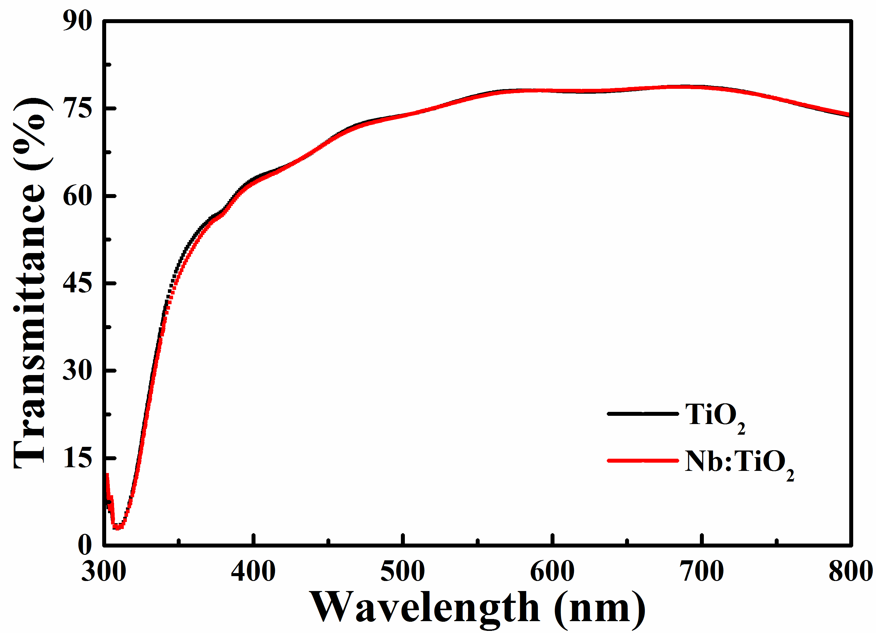
Fig. S1 The light permeation comparison of TiO₂ and Nb:TiO₂ based ETL

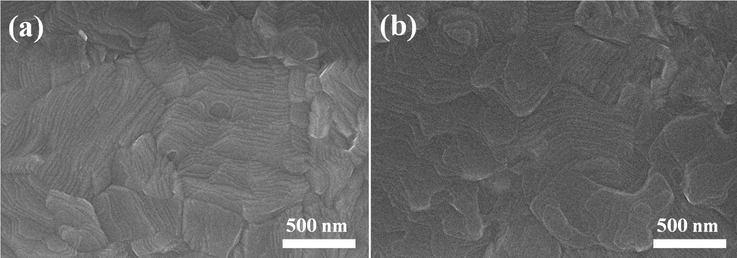
Fig. S2 SEM images of (a) perovskite deposited on the pure TiO₂ and (b) perovskite deposited on the TiO₂ layer doped with 2% Nb

Fig. S3 Absorbance spectra of perovskite film deposited on pure TiO₂ and 2%Nb:TiO₂ layer

Device | R_{s} (Ω) | R_{ct} (Ω) | R_{rec} (kΩ)
TiO₂ | 27.1 | 216 | 5.23
2% Nb:TiO₂ | 26.2 | 178 | 119
Table S1 Parameters employed for the fitting of the impedance spectra of devices based on the pure TiO₂ and 2%Nb:TiO₂

