Supplementary Information

Title: Effects of plastic fragment size and concentration on plant performance are mediated by soil properties and water availability
Authors: Anne Krehl^{1†}, Undine Schöllkopf^{1†}, Maria Májeková¹, Katja Tielbörger¹, Sara Tomiolo^{1*}
¹Plant Ecology Group, Institute for Evolution and Ecology, Tübingen University, Auf der Morgenstelle 5, 72076 Tübingen, Germany
† These authors contributed equally to the study

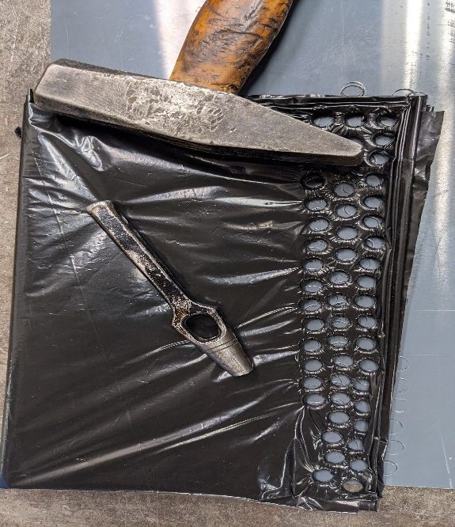
Fig. 4: Photo showing how plastic fragments were produced. Mulching foil was folded and hollow punches of varying sizes (4 mm, 6mm,8 mm) were pushed with a hammer through the layers of foil.

Fig. 5: Plot showing mean ±1SE radial growth of A. thaliana as a function of soil texture and plastic fragments’ size in a) low water treatments and b) high water treatments. Results of significant differences (p< 0.05) for pairwise comparisons of the effects of plastic fragments within each soil texture are reported with different letters Semi-transparent dots indicate the raw data
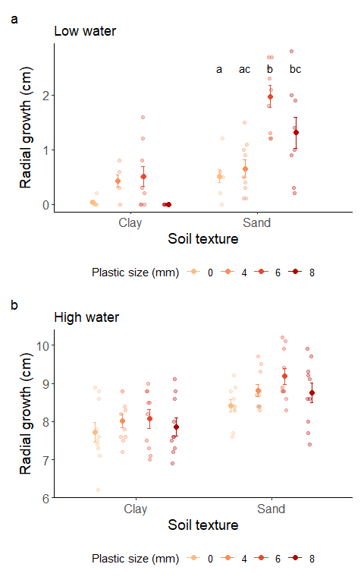

Table S1: results of linear models for Experiment 1 testing the effects of water treatment (‘watering’), soil texture (‘soil’) and concentration of plastic fragments (‘plast_conc’) on soil water content of planted pots and the aboveground biomass of A. thaliana plants. Significant effects (p< 0.05) are reported in bold.
 | Soil water content |  |  | Aboveground biomass
Model term | df | F.test | p.value | df | F.test |  | p.value
soil | 1 | 165.45 | <0.001 | 1 |  | 30.38 | <0.001
watering | 1 | 12.51 | 0.001 | 1 |  | 595.14 | <0.001
plast_conc | 3 | 25.94 | <0.001 | 3 |  | 13.72 | <0.001
soil:watering | 1 | 38.00 | <0.001 | 1 |  | 7.65 | 0.006
soil:plast_conc | 3 | 9.76 | <0.001 | 3 |  | 1.40 | 0.245
watering:plast_conc | 3 | 2.15 | 0.097 | 3 |  | 3.66 | 0.014
soil:watering:plast_conc | 3 | 5.90 | 0.001 | 3 |  | 1.04 | 0.379

Table S2: results of linear models for Experiment 2 testing the effects of water treatment (‘watering’), soil texture (‘soil’) and size of plastic fragments (‘plast_size’) on soil water content of planted pots and the aboveground biomass of A. thaliana plants. Significant effects (p< 0.05) are reported in bold.
 | Soil water content |  |  | Aboveground biomass
Model term | df | F.test | p.value | df | F.test | p.value
soil | 1 | 19.79 | <0.001 | 1 | 34.73 | <0.001
watering | 1 | 110.87 | <0.001 | 1 | 2240.29 | <0.001
plast_size | 3 | 2.44 | 0.067 | 3 | 6.87 | <0.001
soil:watering | 1 | 45.18 | <0.001 | 1 | 0.74 | 0.392
soil:plast_size | 3 | 21.14 | <0.001 | 3 | 3.13 | 0.028
watering:plast_size | 3 | 6.97 | <0.001 | 3 | 3.37 | 0.021
soil:watering:plastic_size | 3 | 6.99 | <0.001 | 3 | 1.25 | 0.294

Figure 6: Plots showing mean ±1SE soil water content (for which pot weight was used as a proxy) of planted pots, as a function of water treatment, soil texture and plastic fragments’ concentration (a) or size (b). Results of significant differences (p< 0.05) for pairwise comparisons of the effects of plastic fragments within each combination of soil texture and water treatment are reported with different letters. Semi-transparent dots represent the raw data. Lower pot weight represents a proxy for a lower soil water content.
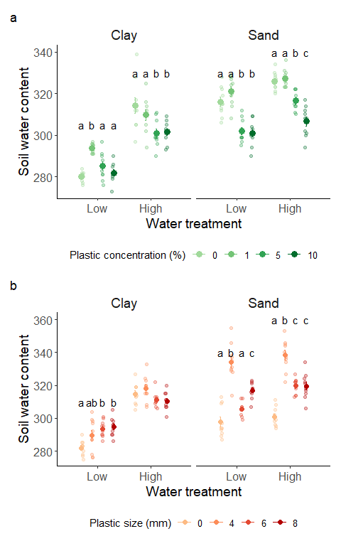

Fig 7: Correlation matrix showing the correlation coefficients among all response variables for Experiment 1 (a) and Experiment 2 (b). Correlation coefficients indicated by the numbers in each cell are marked in blue when negative and in red when positive.
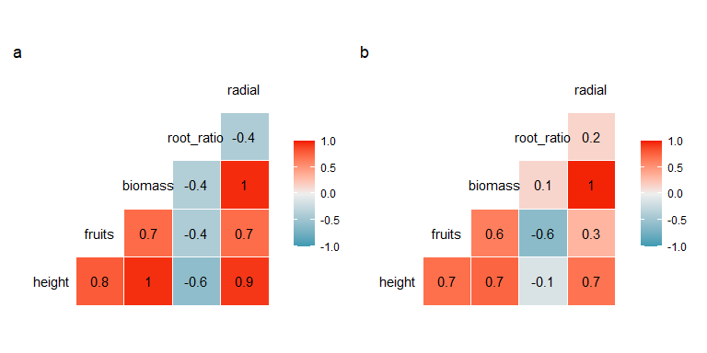

Appendix 1: results for the effects of water treatment, soil texture and plastic concentration (Experiment 1) or plastic size (Experiment 2) on the soil water content of planted pots and the aboveground biomass, root-to-total mass ratio, height, and fruit production of A. thaliana plants growth

Experiment 1:
Final height: plants grew significantly taller in high water treatments (F₁ = 226.86, p =<0.001), while no other factor showed significant effects. In clay-rich soils exposed to low water treatments and to plastic concentrations 0% and 0.1% plants remained flat and did not grow vertically (Fig. S5a). Root to total biomass ratio: we found a significant effect of soil texture (F₁ = 19.19, p<0.001) and a significant interaction between soil texture water treatment (F₁ = 11.52, p <0.001), indicating a higher production of roots in low compared to high water treatments in clay-rich soil, but no significant differences in sand-rich soil (Fig. S5b). Aboveground biomass: we found significant two-way interactions between soil texture and water treatment and between water treatment and plastic fragments (Table S1). The high water treatment had a significant positive effect on plant biomass, and the difference in biomass across water treatments was slightly higher in clay-rich soil. Plants attained the highest biomass in the highest plastic concentration (1%) (Fig. 5c). Number of fruits: Plants produced fruits only in high water treatments. Although, we found a trend of increasing number of fruits with higher concentration of plastic fragments, neither soil texture or plastic concentration had a significant effect (Fig. S7a).

Experiment 2

Final height: hardly any plant grew vertically in low water treatments (Fig. S6a). Plants grew significantly taller in sand-rich compared to clay-rich soil (F₁ = 7.92, p = 0.006). Root to total ratio: the significant interaction between soil texture and water treatment (F₁ = 6.46, p =0.01) indicated higher root to total biomass ratio in high water compared to low water treatments in sand-rich soil, while no differences were found in clay-rich soils (Fig. S6b), a pattern opposite to that found in Experiment 1. Aboveground biomass: we found significant two-way interactions between soil texture and watering and between watering and plastic fragments (Table S2). The high water treatment affected plant biomass positively, and this effect was stronger in sand-rich soil. Plants attained the highest biomass in the highest plastic size (8 mm) (Fig. S6c).

Number of fruits: plants produced fruits only in high water treatments, with a higher production of fruits in sand-rich compared to clay-rich soil (df =1, Chisq = 27.75, p<0.001), no significant effect of plastic fragments’ size was detected (Fig S7b)

Fig 8: plots showing mean ±1SE a) plant height, b) root-to-total biomass ratio, c) aboveground biomass as a function of water treatment, soil texture and plastic fragments’ concentration. Semi-transparent dots represent the raw data. Results of significant differences (p< 0.05) for pairwise comparisons of the effects of plastic fragments within each combination of soil texture and water treatment are reported with different letters.
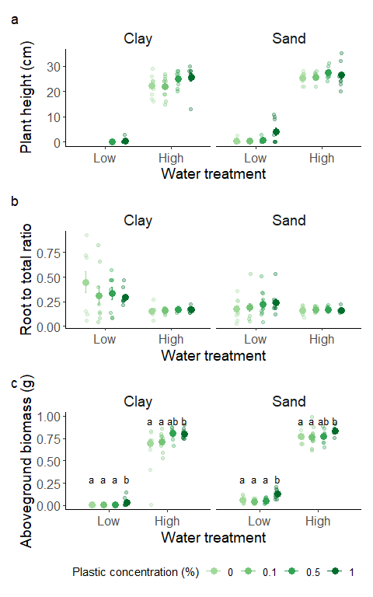
Fig 9: plots showing mean ±1SEa) plant height, b) root-to-total biomass ratio, c) aboveground biomass as a function of watering treatment, soil texture and plastic fragments’ size (b). Semi-transparent dots represent the raw data. Results of significant differences (p< 0.05) for pairwise comparisons of the effects of plastic fragments within each combination of soil texture and water treatment are reported with different letters.
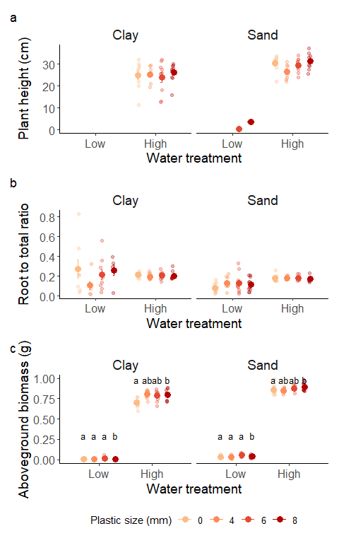

Fig. 10: plots showing mean +/-1SE number of fruits in high water treatments as a function soil texture and plastic fragments’ concentration (a) or plastic fragments’ size (b). Semi-transparent dots represent the raw data.

