Diffusion model-based understanding of unconscious affective priming in continuous flash suppression

Author names: Minchul Kim, MD¹, Jeeyeon Kim¹,
Jaejoong Kim, MD, PhD¹, Bumseok Jeong, MD, PhD¹

Author affiliations:
¹ Graduate School of Medical Science and Engineering (GSMSE), Korea Advanced Institute of Science and Technology (KAIST)
291 Daehak-ro, Yuseong-gu, Daejeon, 34141, Republic of Korea

Corresponding author:
Bumseok Jeong, MD, PhD
Graduate School of Medical Science and Engineering (GSMSE), Korea Advanced Institute of Science and Technology (KAIST)
291 Daehak-ro, Yuseong-gu, Daejeon, 34141, Republic of Korea
Tel: +82-42-350-4285
E-mail: bs.jeong@kaist.ac.kr

Supplemental material
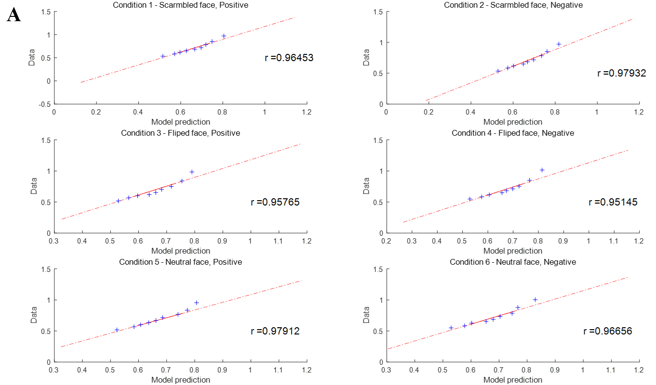
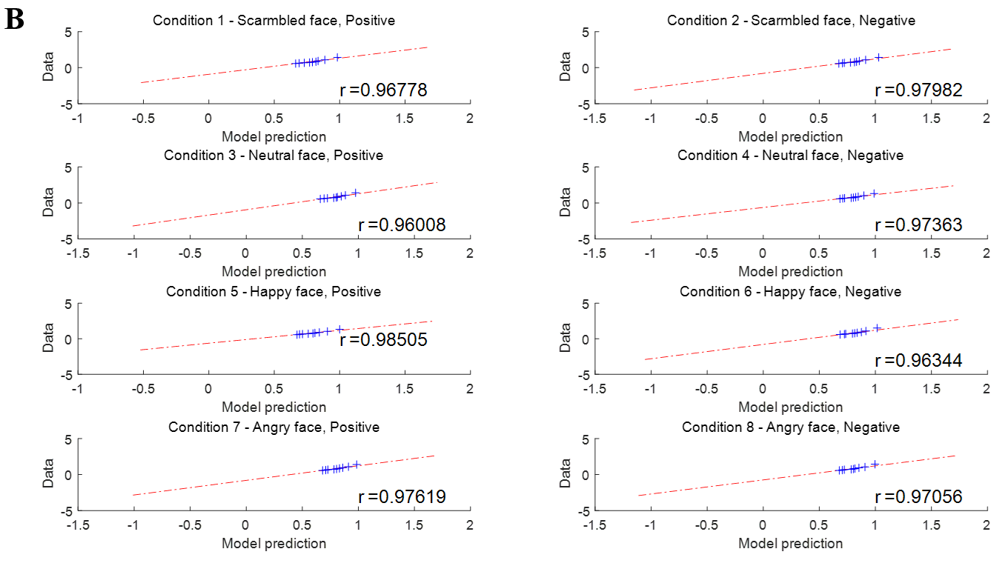
Figure S1. Plot of group RT quantiles (q = 0.1, 0.2, 0.3, 0.4, 0.5, 0.6, 0.7, 0.8, 0.9) based on empirical data and model prediction for each condition. Simulations of RT distributions for Experiment 1 (A) and Experiment 2 (B) showed that the model fit our data very well, as the correlation between the empirical and model RT quantiles was larger than r = 0.95. We coded error response as negative RT.

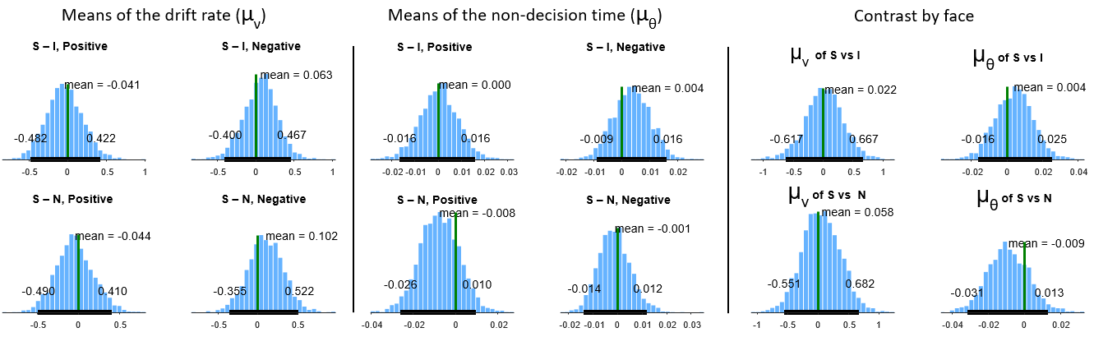
Figure S2. Posterior distributions of the difference in the mean of the drift rate (μ_{ν}) and the mean of the nondecision time (μ_{θ}) from Experiment 1. S, I, N in the figure indicate prime conditions with scrambled, inverted and neutral faces, respectively. Contrast by face was calculated as follows: (Scrambled, positive + Scrambled, negative) – (Inverted, positive + Inverted, negative) for S vs F. All of the posterior densities included the null value of 0.

