Supplementary Information
High Density 60-Channel Individually Addressable Platinum Nanoelectrodes for Neuronal Excitation and Measurement
Vidur Raj^{1,*}, Aswani Gopakumar², Gayatri Vaidya³, John Scott⁴, Milos Toth^{4,5,6}, Chennupati Jagadish^{2,6,*}, and Vini Gautam^{7,*}
¹James Watt School of Engineering, University of Glasgow, University Avenue, Glasgow G12 8QQ, UK
²Department of Electronic Materials Engineering, Research School of Physics, The Australian National University, Canberra, ACT 2601, Australia
³Australian National Fabrication Facility, Research School of Physics and Engineering, The Australian National University, Canberra, ACT 2601, Australia
⁴School of Mathematical and Physical Sciences, University of Technology Sydney, Ultimo, 2007, New South Wales, Australia
⁵Institute for Biomedical Materials and Devices (IBMD), Faculty of Science, University of Technology Sydney, 2007, New South Wales, Australia
⁶ARC Centre of Excellence for Transformative Meta-Optical Systems, Research School of Physics, The Australian National University, Canberra, ACT 2601, Australia
⁷Department of Biomedical Engineering, The University of Melbourne, VIC 3010, Melbourne, Australia

Corresponding authors: vidur.raj@glasgow.ac.uk; chennupati.jagadish@anu.edu.au; vini.gautam@unimelb.edu.au

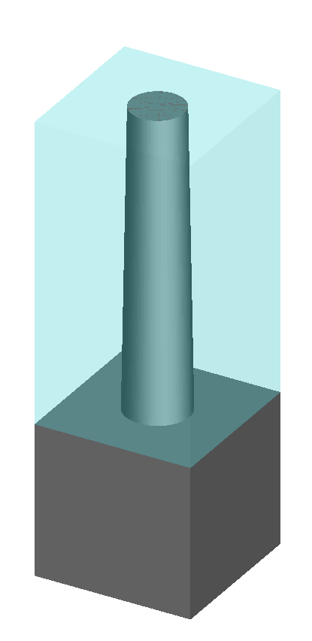
Figure S1. Geometric filling ratio of nanoelectrode array is defined as volume of cone (or cylinder) to the volume of cuboid (shown in light blue) base of which is equal to pitch of nanocone array and height of which is equal to the height of nanocones.
Geometric filling ratio is the ratio of the volume covered by the nanoelectrode to the volume of a cuboid, base of which is equal to pitch of nanocone array and height of which is equal to the height of nanoelectrode (see Figure S1). Therefore, the geometric filling ratio for a tapered nanowire (or nanocone) can be mathematically written as:
$$Filling Ratio \left(FR\right)for conical nanoelectrode= \frac{Volume of nanoelectrode}{Volume of cuboid}= = \frac{1}{3} π \frac{R_{top}^{2}+ R_{top} . R_{base}+R_{base}^{2} }{{Pitch}^{2}}$$
$$Filling Ratio \left(FR\right)for cylidrical nanoelectrode array= \frac{Volume of nanoelectrode}{Volume of cuboid}= \frac{π.R^{2}}{{Pitch}^{2}}$$
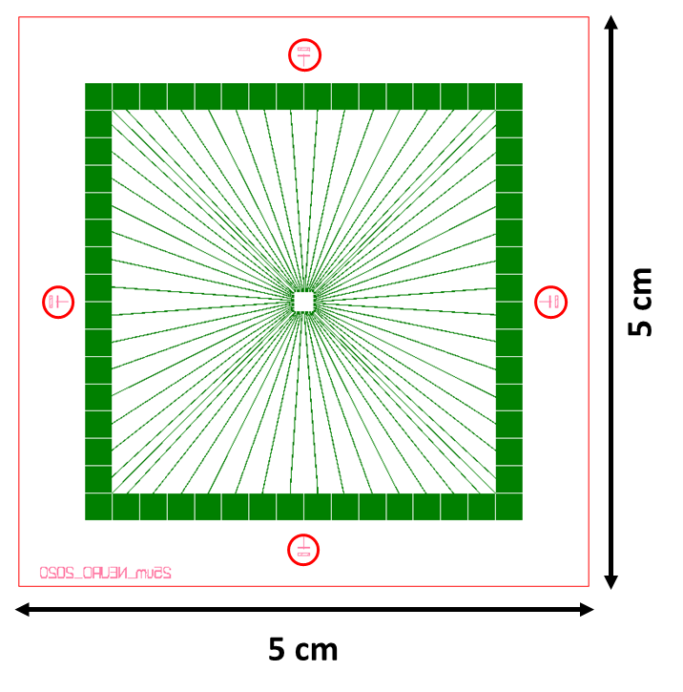
Figure S2. A symbolic representation of the general layout of 60-Channel individually addressable MEA chip compatible with MEA-2100 setup. The data from each electrode is read through an overhead stage which sits on 2.2 mm square gold contacts separated by 150 microns.

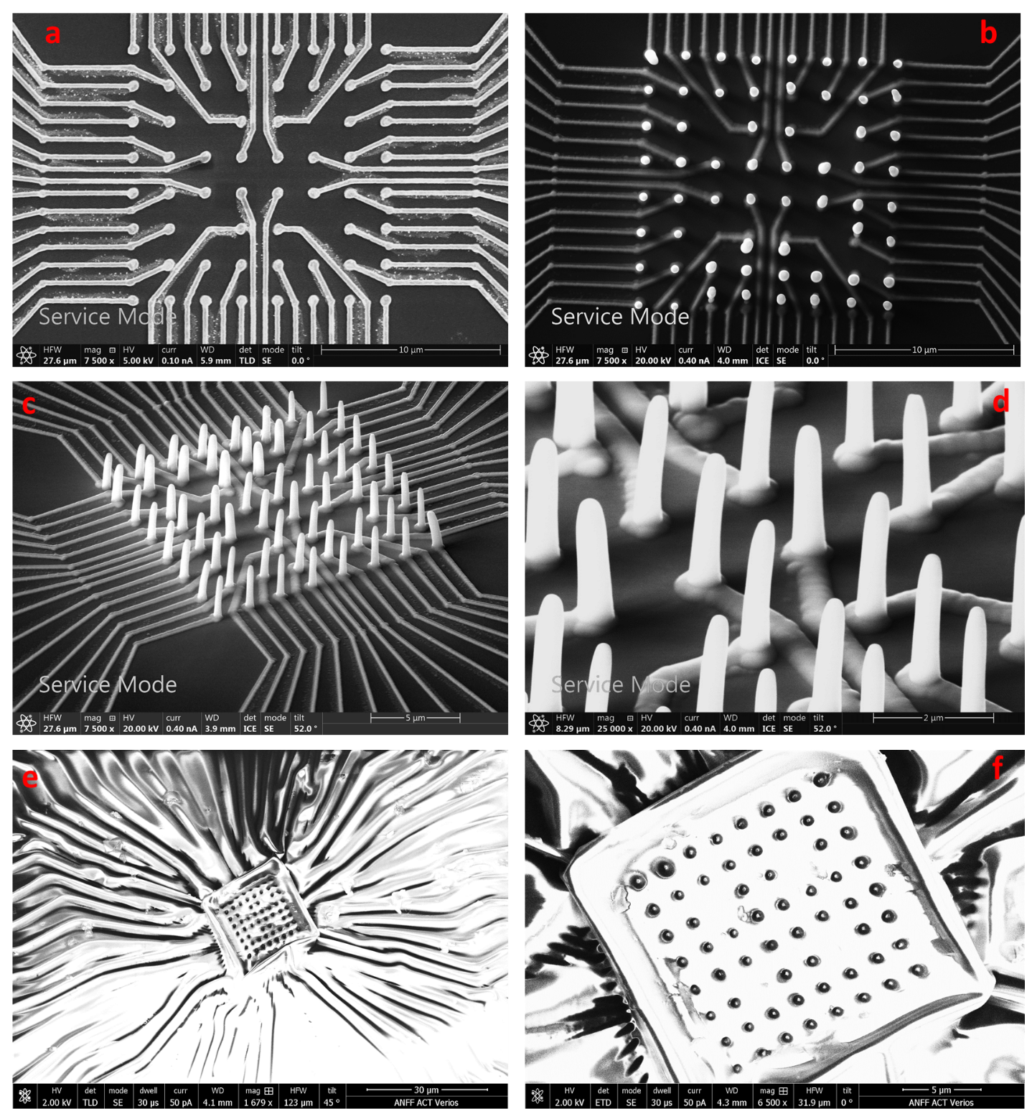
Figure S3: Example of platinum nanowires deposited by electron beam assisted metal deposition technique, before and after planarization. (a) 2d Ti/Au metal pads, (b) top view of nanoelectrode array after platinum deposition, and (c and d) 52º titled view of nanoelectrodes at different magnifications. (e) and (f) shows platinum nanowire array after planarization and the only nanowire tip exposed for EIS measurements.
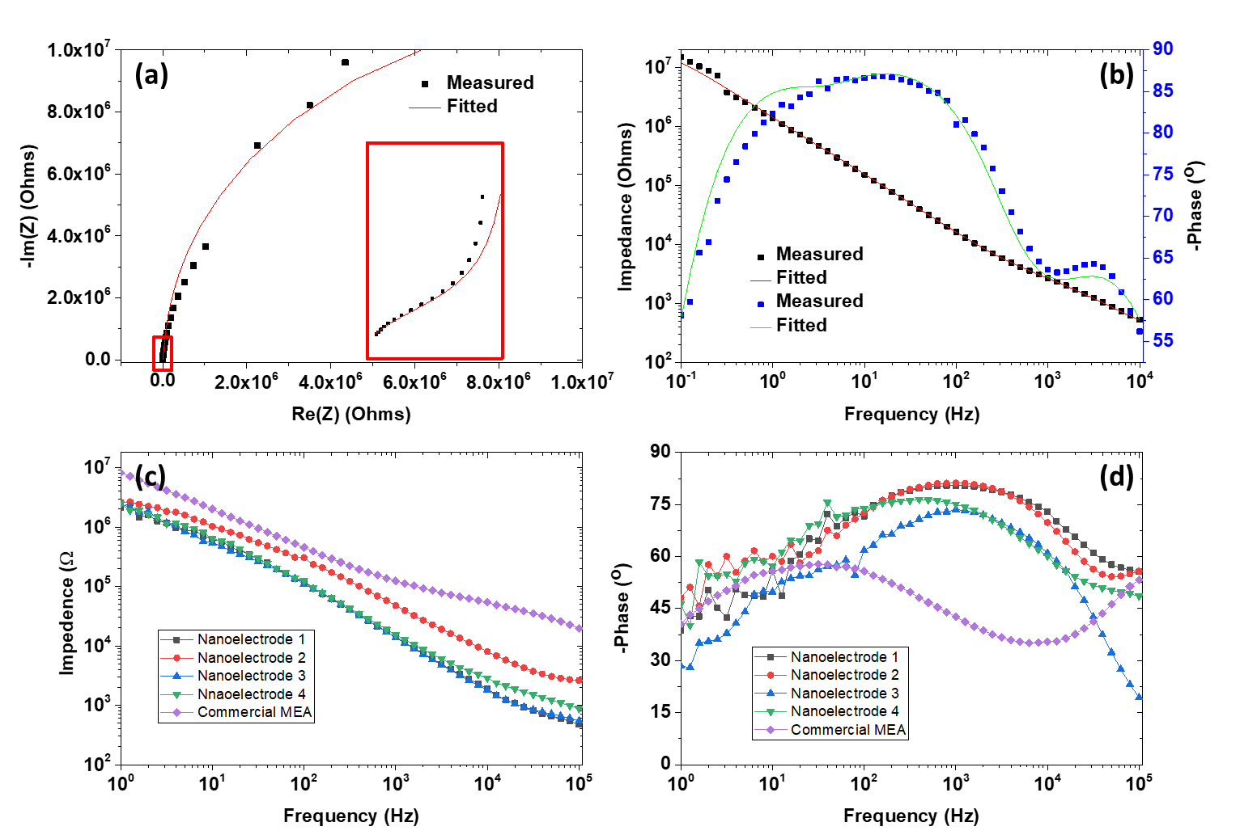
Figure S4. An example of fitted EIS (a) Nyquist and (b) Bode’s plot for shorted nanoelectrodes. Most of the nanowires were shorted for platinum nanoelectrodes deposited by electron beam as evident by (c) Impedance vs. Frequency plot and (d) Phase vs.Frequency plot.

