Supporting information

Minocycline might be an adjunctive therapy option for the treatment of COVID-19: in silico screening, structure-affinity relationship, and literature review
Bin Xiao^{1,2}, Haining Ning¹, Yixuan Niu¹, Yiqing Wang¹, Jinhua Wang², Liwen Ren²,Yin Xiao³, Xiulan Su⁴, Zhanfei She(✉)¹, Shumin Wang(✉)¹, Guanhua Du(✉)²
¹Laboratory of Clinical Pharmacy, Ordos Central Hospital, Ordos School of Clinical Medicine, Inner Mongolia Medical University, Ordos 017000, China；²Beijing Key Laboratory of Drug Target Identification and Drug Screen, Institute of Materia Medica, Chinese Academy of Medical Sciences & Peking Union Medical College, Beijing 100050, China；³Haikou People’s Hospital, Central South University Xiangya School of Medicine Affiliated Haikou Hospital, Haikou, 570208, China；⁴Clinical Medicine Research Center of Affiliated Hospital, Inner Mongolia Medical University, No.1 Tongdao North Street, Hohhot, Inner Mongolia 010050, China
*Correspondence: Guanhua Du, dugh@imm.ac.cn; shuminwang2014@163.com; Zhanfei She, shezhanfei71@sina.com

Table S2. Results of in silico screening of minocycline analogues.
Name identifier | Structure | Binding affinity (kcal/mol)
N3 | 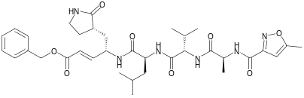 | -7.7
1-A Tetracycline class C4 and C7 position modified derivatives | 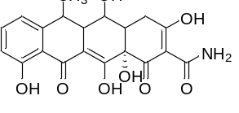 | -8.2
1-B Tetracycline class C4 and C7 position modified derivatives | 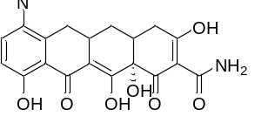 | -7.9
1-C Tetracycline class C4 and C7 position modified derivatives | 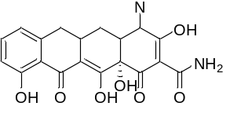 | -7.6
1-D Tetracycline class C4 and C7 position modified derivatives | 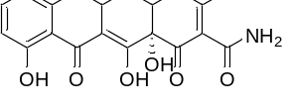 | -8.0
1-E Tetracycline class C4 and C7 position modified derivatives | 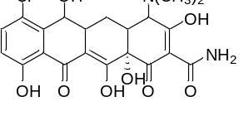 | -7.9
1-F Tetracycline class C4 and C7 position modified derivatives | 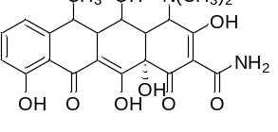 | -7.8
1-G Tetracycline class C4 and C7 position modified derivatives |  | -7.7
2-cyano compounds-a | 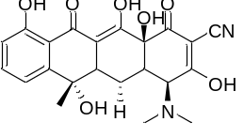 | -7.8
2-cyano compounds-b | 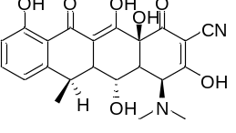 | -7.5
2-ethoxycarbonyl compound3a | 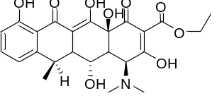 | -7.1
2-ethoxycarbonyl compound3b | 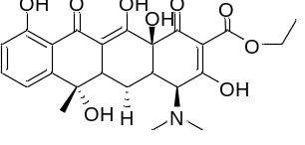 | -7.8
6-demethyltetracycline | 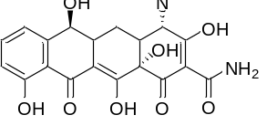 | -7.6
6-thiatetracycline | 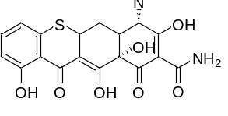 | -7.6
12S-12-hydroxy-1,12-pyrazolinote tracycline | 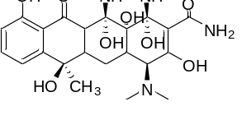 | -8.1
13-(3-chloropropyl)thiol-5-hydroxy-6-deoxytetracycline | 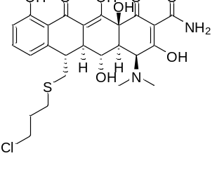
13-cyclopentylthio-5-hydroxy-deoxytetracycline | 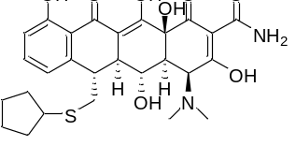 | -7.6
Amadacycline | 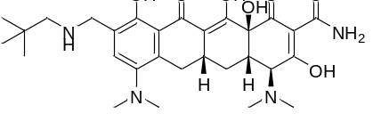 | -7.0
Anhydrochlortetracycline | 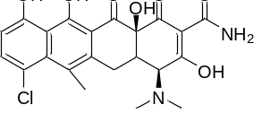 | -7.9
Anhydrotetracycline | 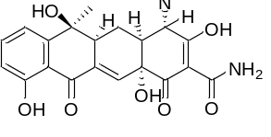 | -7.6
Chlorotetracycline | 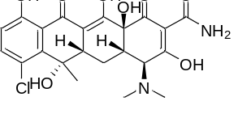 | -8.0
Demethylchlortetracycline | 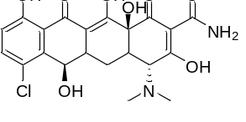 | -7.5
Desdimethylaminoterrarubein | 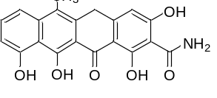 | -8.6
Dimethylamine Anhydrochlortetracycline | 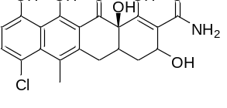 | -8.6
DMG-DMDOT | 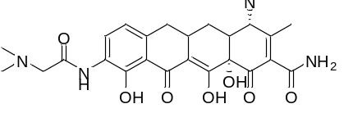 | -7.5
DMG-MINO | 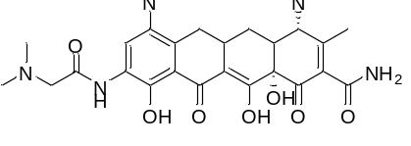 | -7.3
Doxorubicin | 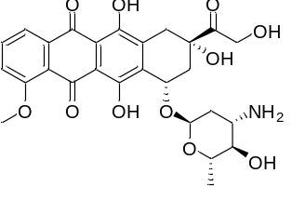 | -8.1
Doxycycline | 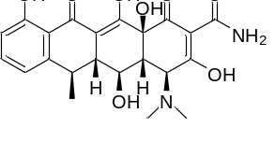 | -7.3
Epichortetracycline | 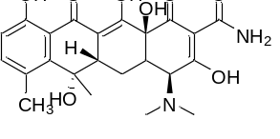 | -7.7
Imino Delta Minocycline | 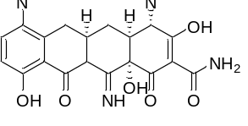 | -8.0
Isochlortetracycline | 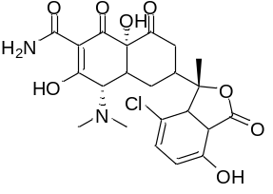 | -7.0
lymecycline | 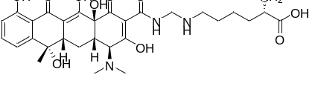 | -7.3
methacycline | 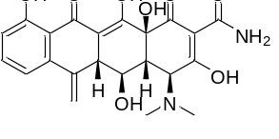 | -7.5
Minocycline Dehydro analogue | 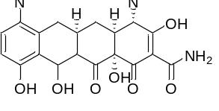 | -7.3
Minocycline Impurity A | 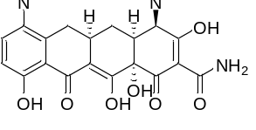 | -7.1
Minocycline Impurity B  (Sancycline) | 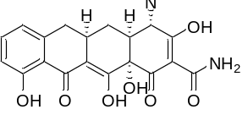 | -7.4
Minocycline Impurity C | 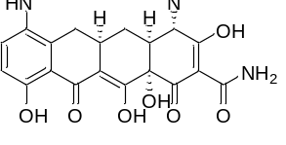 | -7.6
Minocycline Impurity D | 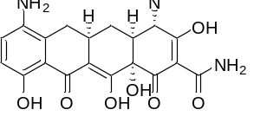 | -7.3
Minocycline | 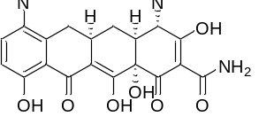 | -9.6
Oxytetracycline | 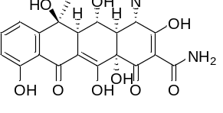 | -7.4
Rolitetracycline | 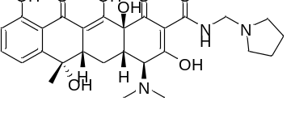 | -8.1
Sancycline ramification | 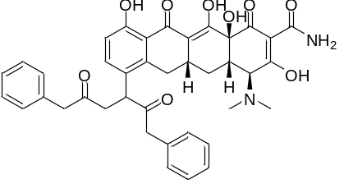 | -7.6
Tetracycline | 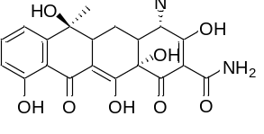 | -8.0
Thiatetracycline | 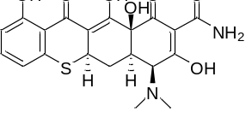 | -7.6
Tigecycline | 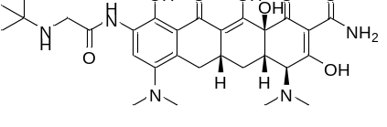 | -7.2
Eravacycline | 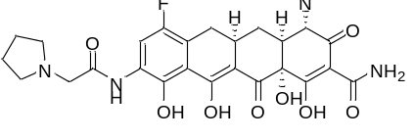 | -8.1

