TITLE PAGE
Title: Performance of a score to characterize adequate contact among the social network of persons with tuberculosis
Running Title: Performance score to measure contact TBI
María Eugenia Castellanos^{1,2}, Sarah Zalwango³, Trang Quach^{1,2,4}, Robert Kakaire^{1,2}, Leonardo Martínez^{5,6}, Mark H. Ebell², Kevin K. Dobbin², Noah Kiwanuka³ and Christopher C. Whalen^{1,2}
¹ Global Health Institute, College of Public Health, University of Georgia, Athens, Georgia, 30602, United States
² Department of Epidemiology and Biostatistics, College of Public Health, University of Georgia, Athens, Georgia, 30602, United States
³ Makerere University College of Health Sciences, School of Public Health, Kampala, Uganda
⁴Faculty of Pharmacy, Ho Chi Minh City University of Technology (HUTECH), Vietnam
⁵Division of Infectious Diseases and Geographic Medicine, Stanford University School of Medicine, Stanford, California, 94305, United States
⁶ Department of Epidemiology, School of Public Health, Boston University, Boston, Massachusetts, 02118, United States.
Corresponding author: María Eugenia Castellanos, M.Sc., Ph.D., Global Health Institute, College of Public Health, University of Georgia, Athens, GA 30602. E-mail: mecastellanos@uga.edu
ABSTRACT WORD COUNT. 298
TEXT WORD COUNT. 3,134
Supplementary Figure Legends

Figure S1. Flow diagram of study. 955 contacts out of 1006 contacts of 119 tuberculosis cases were evaluated regarding the association of the setting and relationship domains (exposures) with the presence or absence of tuberculous infection (outcome).
Figure S2. Probability of tuberculous infection among contacts of tuberculosis cases, according to setting and relationship scores. Nonparametric smoothed curve showing the probability of tuberculous infection against the setting and relationship scores, using a loess (locally weighted scatterplot smoothing) model. setting score (A) and relationship score (B). The dotted vertical lines indicate the limits of each of the quartiles.
Figure S3. Total number of contacts of tuberculosis cases and Number of infected contacts of tuberculosis cases according to their setting scores and relationship scores. A) Number in each cell represent the total number of contacts that have a given setting and relationship score (N=955). B) Number in each cell represents the number of infected contacts that have a given setting and relationship score (n=493/955).
Figure S4. Prevalence of tuberculous infection among contacts of tuberculosis cases, according to setting and relationship scores quartiles. Prevalence of tuberculosis (%) shown in overall population (top panel), household contacts (center panel) and extra-household contacts (bottom panel), according to setting and relationship score quartiles.
Figure S5. Prevalence of tuberculous infection among contacts of tuberculosis cases, according to setting and relationship scores quartiles. Prevalence of tuberculosis (%) show stratified by smear result of the index case: 0 or 1+ (top panel), 2 or 3+ (bottom panel) and setting and relationship score quartiles.

Figure S1. Flow diagram of study. 955 contacts out of 1006 contacts of 119 tuberculosis cases were evaluated regarding the association of the setting and relationship domains (exposures) with the presence or absence of tuberculous infection (outcome).

123 TB cases were included in the primary study
1006 enrolled contacts
955 contacts (95%) from 119 TB cases with complete data for exposures and outcome
(median 8 contacts/case)

Figure S2. Probability of tuberculous infection among contacts of tuberculosis cases, according to setting and relationship scores. Nonparametric smoothed curve showing the probability of tuberculous infection against the setting and relationship scores, using a loess (locally weighted scatterplot smoothing) model. setting score (A) and relationship score (B). The dotted vertical lines indicate the limits of each of the quartiles.
A
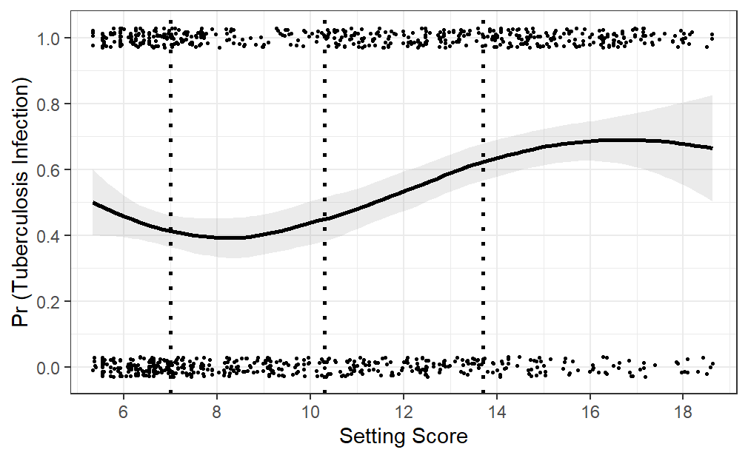
B
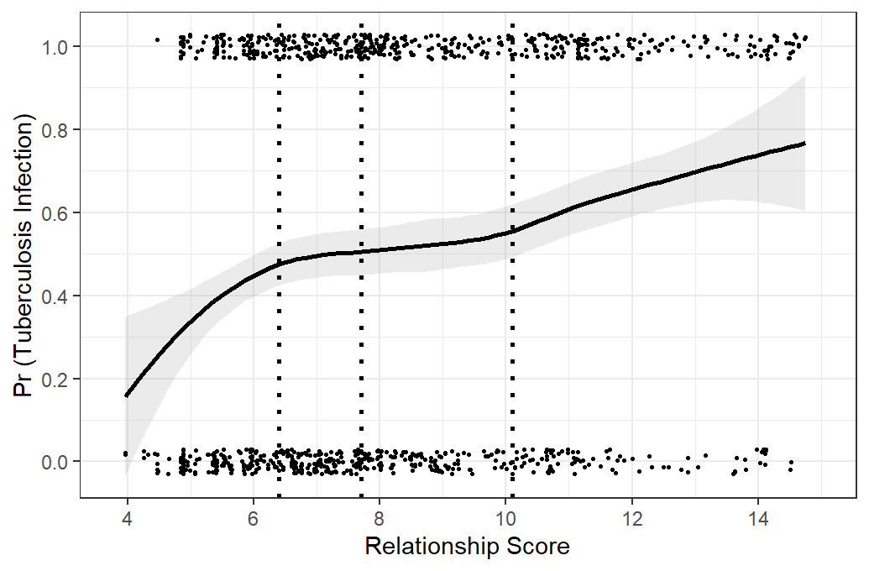

Figure S3. Total number of contacts of tuberculosis cases and Number of infected contacts of tuberculosis cases according to their setting scores and relationship scores. A) Number in each cell represent the total number of contacts that have a given setting and relationship score (N=955). B) Number in each cell represents the number of infected contacts that have a given setting and relationship score (n=493/955).

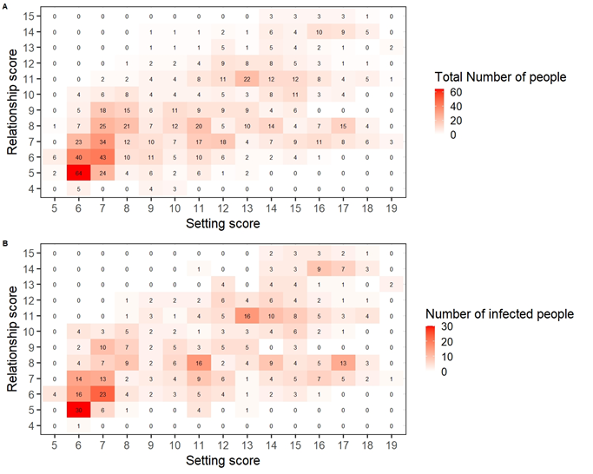

Figure S4. Prevalence of tuberculous infection among contacts of tuberculosis cases, according to setting and relationship scores quartiles. Prevalence of tuberculosis (%) shown in overall population (top panel), household contacts (center panel) and extra-household contacts (bottom panel), according to setting and relationship score quartiles

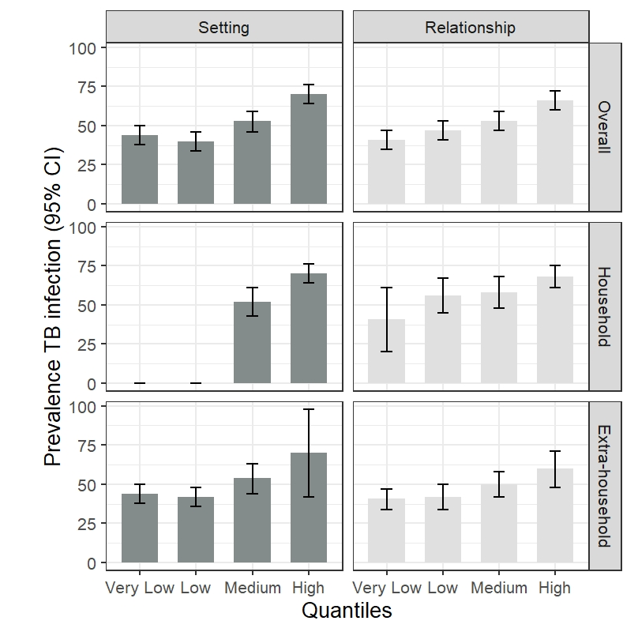
Figure S5. Prevalence of tuberculous infection among contacts of tuberculosis cases, according to setting and relationship scores quartiles. Prevalence of tuberculosis (%) show stratified by smear result of the index case: 0 or 1+ (top panel), 2 or 3+ (bottom panel) and setting and relationship score quartiles.

