Supporting information

Id | Silver fir | Norway spruce
1 | +95% Silver fir | +95% Norway spruce
2 | ≥50% silver fir, + Norway spruce and others | ≥50% Norway spruce, + silver fir and others
3 | ≥50% silver fir, + others; no Norway spruce | ≥50% Norway spruce, + others; no silver fir
4 | <50% silver fir, + Norway spruce and others | <50% Norway spruce, + silver fir and others
5 | <50% silver fir, + others; no Norway spruce | <50% Norway spruce, + others; no silver fir
6 | <5% silver fir | <5% Norway spruce
7 | Young stands | Young stands

Online resource 1: Evaluation of mixture classes for the silver fir and Norway spruce stands.

Online resource 2: Relative importance of the variables selected in the silver fir and Norway spruce models.

Variable | Modalities for qualitative variables | Coefficient | Coefficient ^2
Intercept |  | -2.3462
REL_ALT |  | 2.9993 | - 1.6372
COS_ASP |  | -0.4539 | -0.4225
RegSWD_su |  | 0.7869
TW |  | 27.2816
GEOL | Principal conglomerate and acidic granite | 0
 | Quaternary deposits, granites, sandstones little acidic | -0,8239
 | Voltzia sandstone, metamorphic rocks, acidic deposits | -1,8119
 | Acidic Vosges sandstone | -0,6203
 | Neutral magmatic and metamorphic rocks | -0,2841
 | Neutral to basic rocks and migmatite | 1,0868
 | Volcanic pyroclastic rock | 0,1552
COMP | Pure silver fir stand | 0
 | More than 50% silver fir with Norway spruce | 0,1046
 | More than 50% silver fir with broadleave sp. | 0,6036
 | Less than 50% silver fir with broadleave sp. | -1,4861
STRUCT | Even-aged stand | 0
 | Young stand | -0,686
 | Uneven-aged stand | -0,7077
STORM | Less than 50% damage | 0
 | More than 50% damage | -0,6936
EDGE_S | Absence of south forest edge | 0
 | Presence of south forest edge | 1,1293

Online resource 3: Coefficients for the silver fir model.

Variable | Modalities for qualitative variables | Coefficient | Coefficient ^2
Intercept |  | 1.3578
REL_ALT |  | 1.1820
COS_ASP |  | -0.4005
RegSWD_su |  | 0.7660
TW |  | 33.8845
GEOL | Granites, quaternary deposits, primary | 0
 | Granodiorites, migmatic rocks, sedimentary neutral to acidic | -1,1875
 | Voltzia or shells sandstone, magmatic, volcanic | 0,6745
 | Vosges or intermediate sandstone, granits, gneiss | -0,2069
 | Magmatic basic rock | -0,4483
 | Sedimentary basic rock | 2,4633
 | Pure Norway spruce stand | 0
COMP | More than 50% Norway spruce with Silver fir | -0,9841
 | More than 50% Norwauy spruce with broadleave sp. | -1,1953
 | Less than 50% Norway spruce with broadleave sp. | -2,0768
 | Even-aged stand | 0
STRUCT | Young stand | -1,0156
 | Uneven-aged stand | -0,5555
 | Less than 50% damage | 0
STORM | More than 50% damage | -0,825
 | Absence of forest edge | 0
EDGE | Presence of edge between two stands | 0,5407
 | Presence of edge with an open environment | 0,2568

Online resource 4: Coefficients for the Norway spruce model.

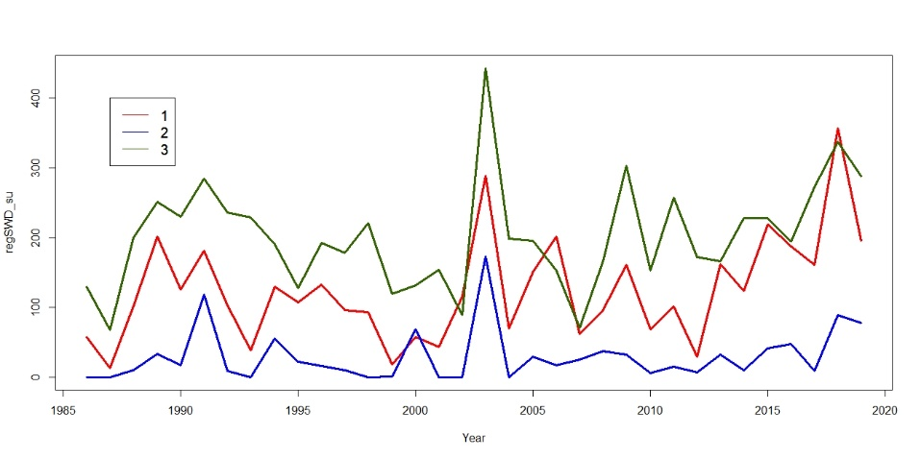
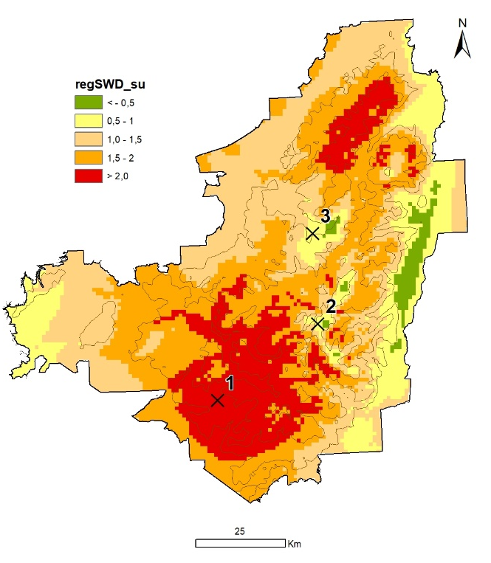
B
A
Online resource 5: Comparison of the summer SWD trend (variable regSWD_su) for three contrasted locations over the 1986-2019 period: A) map of summer SWD trends and localisation of the three time series, B) summer SWD time series for the 1986-2019 period. Vulnerability was most important in site n°1 (regSWDsu > 2), where the time series showed a substantial increase of water stress from 2012, with a high probability of dieback (0.70 and 0.78 for silver fir and Norway spruce respectively, see figures 5 and 6). Site n°3 showed similar water stress levels from 2012, but a higher one than site n°1 between 1986 and 2012. The probability of dieback was much lower (0.15 and 0.30 for silver fir and Norway spruce, respectively), suggesting that trees were more adapted to drought than in site n°1. Site n°2 was at a higher altitude, with little moisture stress and a low level of risk despite a slight increase of the water deficit from 2015 (probability of dieback: 0.15 and 0.30 for silver fir and Norway spruce, respectively).

