Novel Hybrid Hypercrosslinked Polymer Assisted Highly Efficient Thermal Energy Storage
Changhui Liu,* Jiahao Zhang, Jian Liu, Zengyi Tan, Yuqi Cao, Xia Li, Zhonghao Rao*
(School of Electrical and Power Engineering, China University of Mining and Technology, Xuzhou, Jiangsu 221116, China)
(Email: liuch915@cumt.edu.com, raozhonghao@cumt.edu.cn)

Note 1: Calculation method of different molar ratios of polymers.
The molar ratio of the prepared monomer of the hybrid polymer can be known from the hydrogen spectrum, Eq. (S1) was used to calculate the value of x,
$\frac{4x+5(1-x)}{9x}=\frac{Integration1}{Integration2}$ Eq. (S1)
where x is the number of benzene rings, Integration 1 represents the hydrogen atoms in benzene rings, Integration 2 is hydrogen atoms of silioxyl group.
Note 2: Calculation method of the Light-to-thermal conversion efficiency.
Light-to-thermal conversion efficiency (η) of HP/CB-PCMs was estimated according to the ratio of heat stored in the composite with respect to the light energy stored by sample during the phase change process. By referring literatures 1, Eq. (S2) was used to calculate the value of η,
$η=\frac{m∆H}{ρS(t_{f}-t_{s})}$ (Eq. S2)
where m is the mass of the HP/CB-PCMs composite, △H represents the phase change enthalpy obtained from DSC result, ρ is intensity of the simulant light source, t_{f} and t_{s} are the light driven phase change time of the sample before and after phase change, respectively.
m/g | S/cm² | t_{f}- t_{s}/s | ρ/mW.cm⁻² | η
3 | 7.065 | 362 | 110 | 93.7%

Fig. S1 ¹H NMR spectra of polymers with different mole ratios.
(a) The monomer molar ratio of polymer is 9:1.
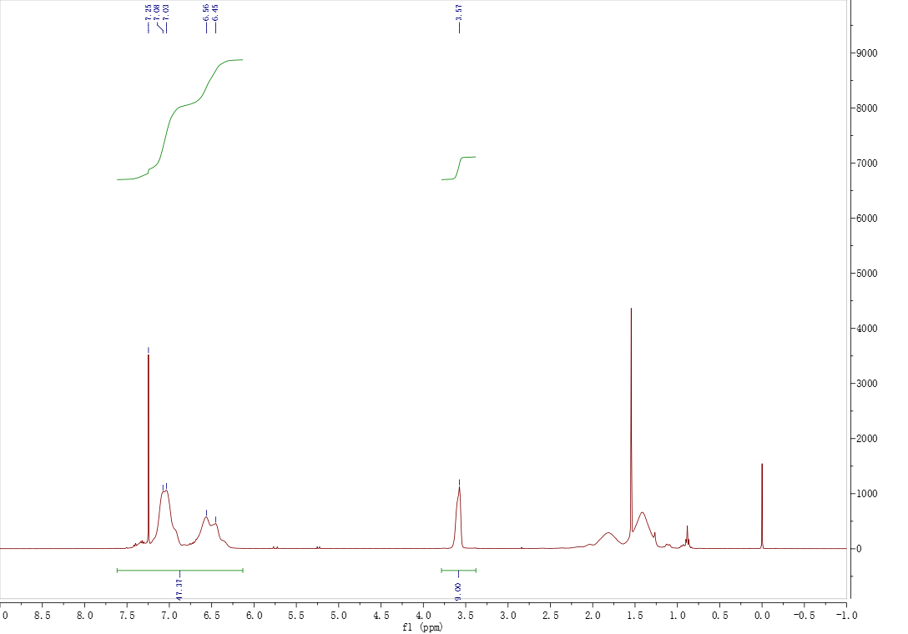
X=0.1

(b) The monomer molar ratio of polymer is 8.5:1.5.
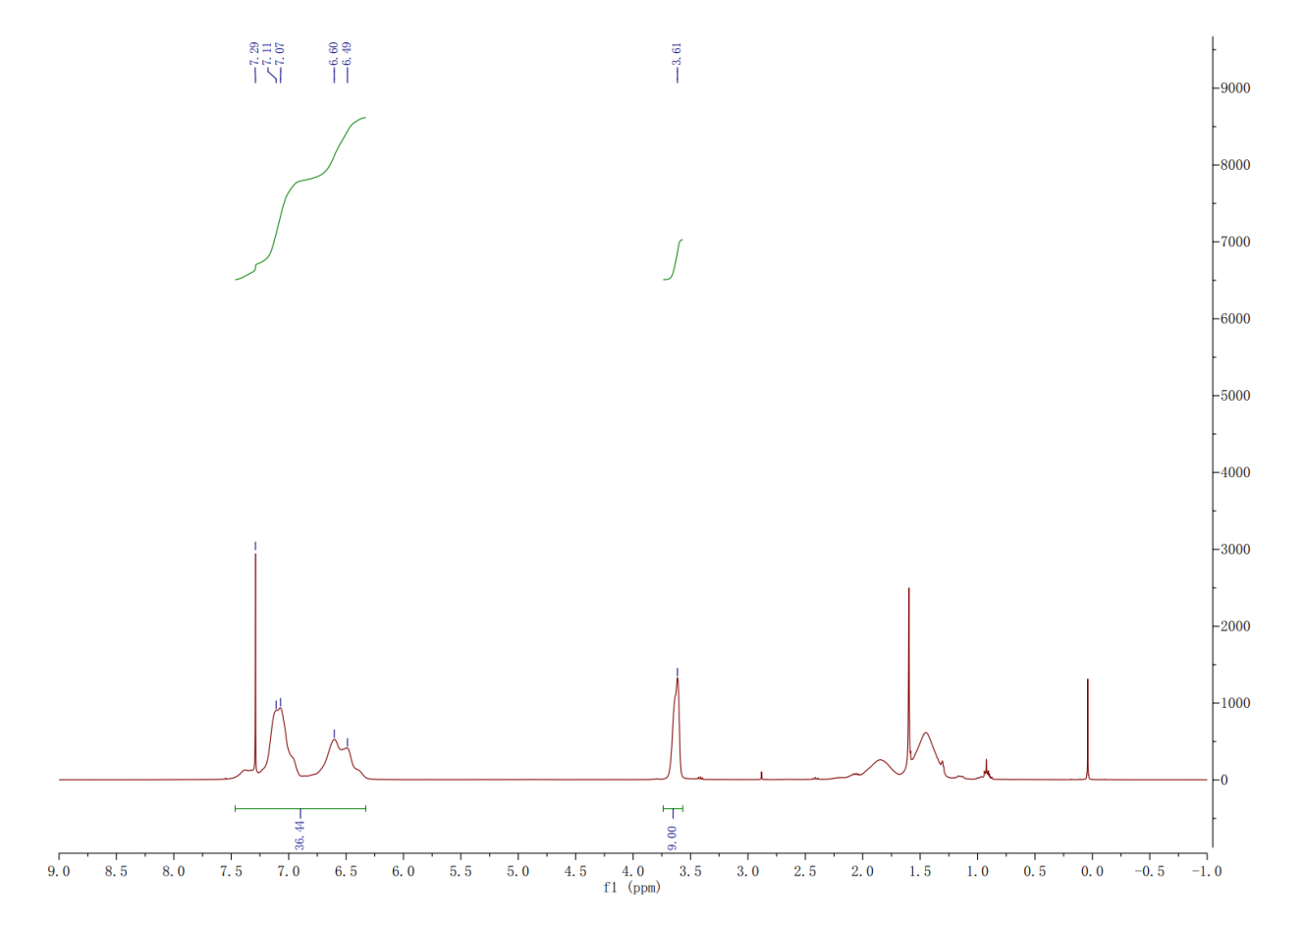
X=0.15
(c) The monomer molar ratio of polymer is 8:2.
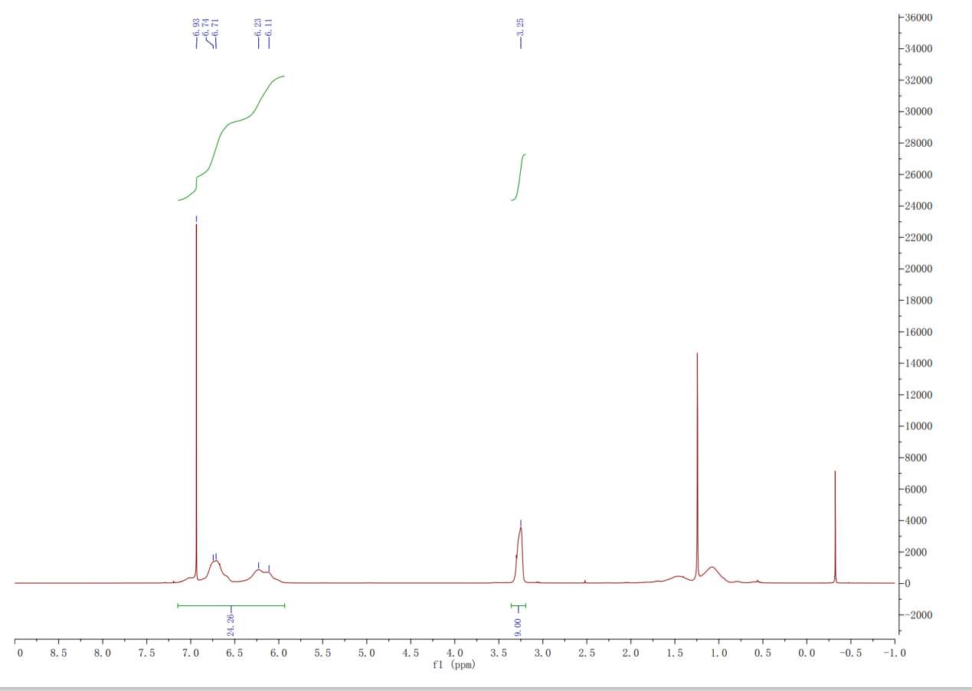
X=0.2

(d) The monomer molar ratio of polymer is 7.5:2.5.
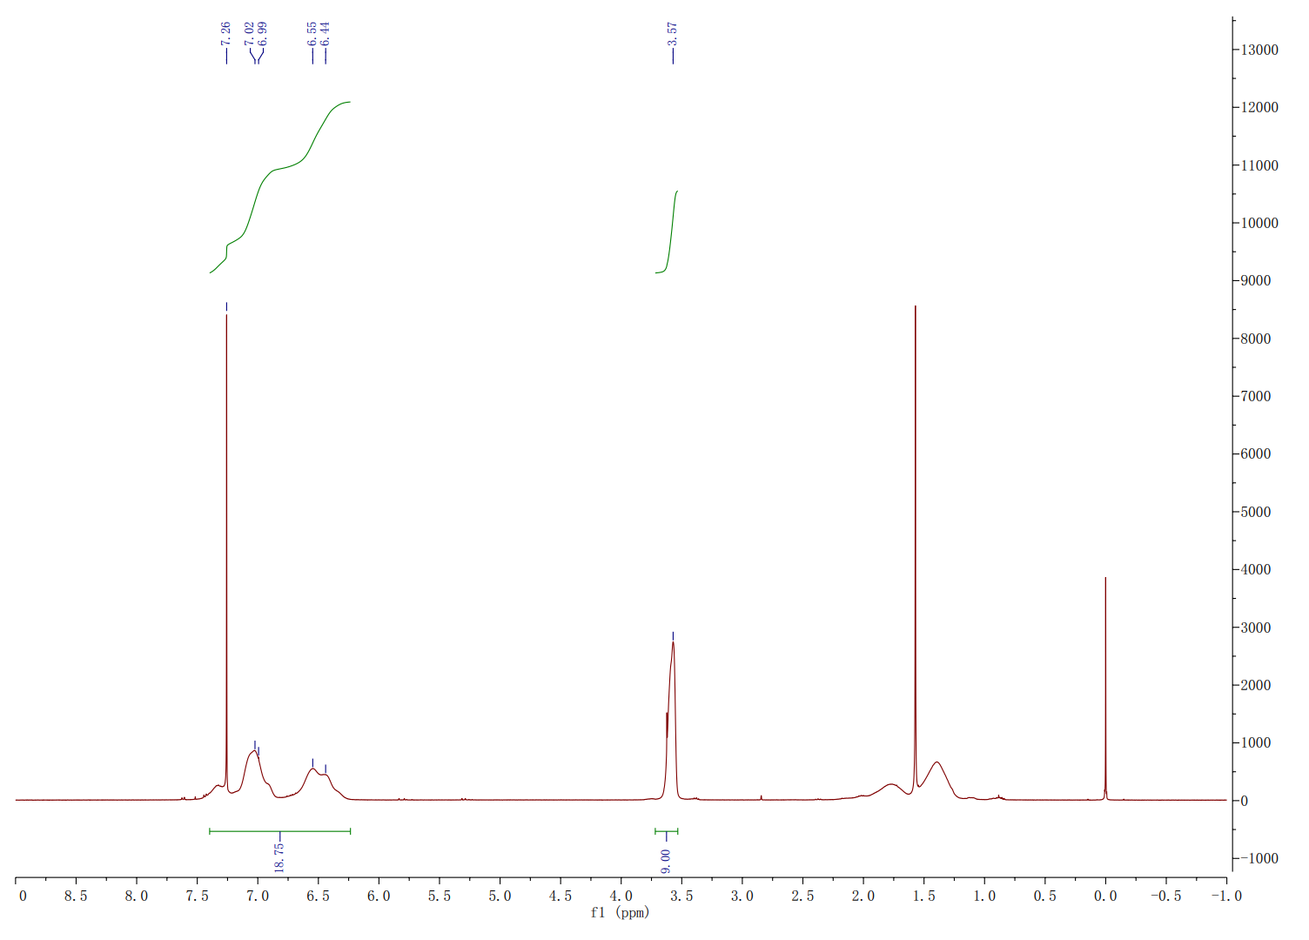
X=0.25
(e) The monomer molar ratio of polymer is 7:3.
X=0.3
(f) The monomer molar ratio of polymer is 6:4.
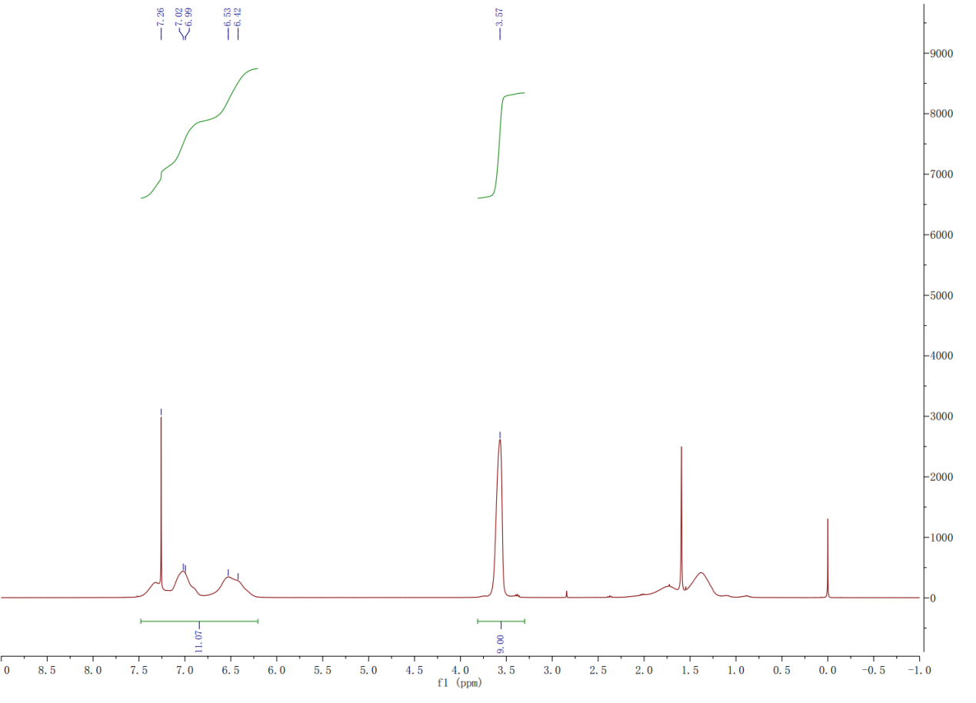
X=0.4
(g) The monomer molar ratio of polymer is 5:5.
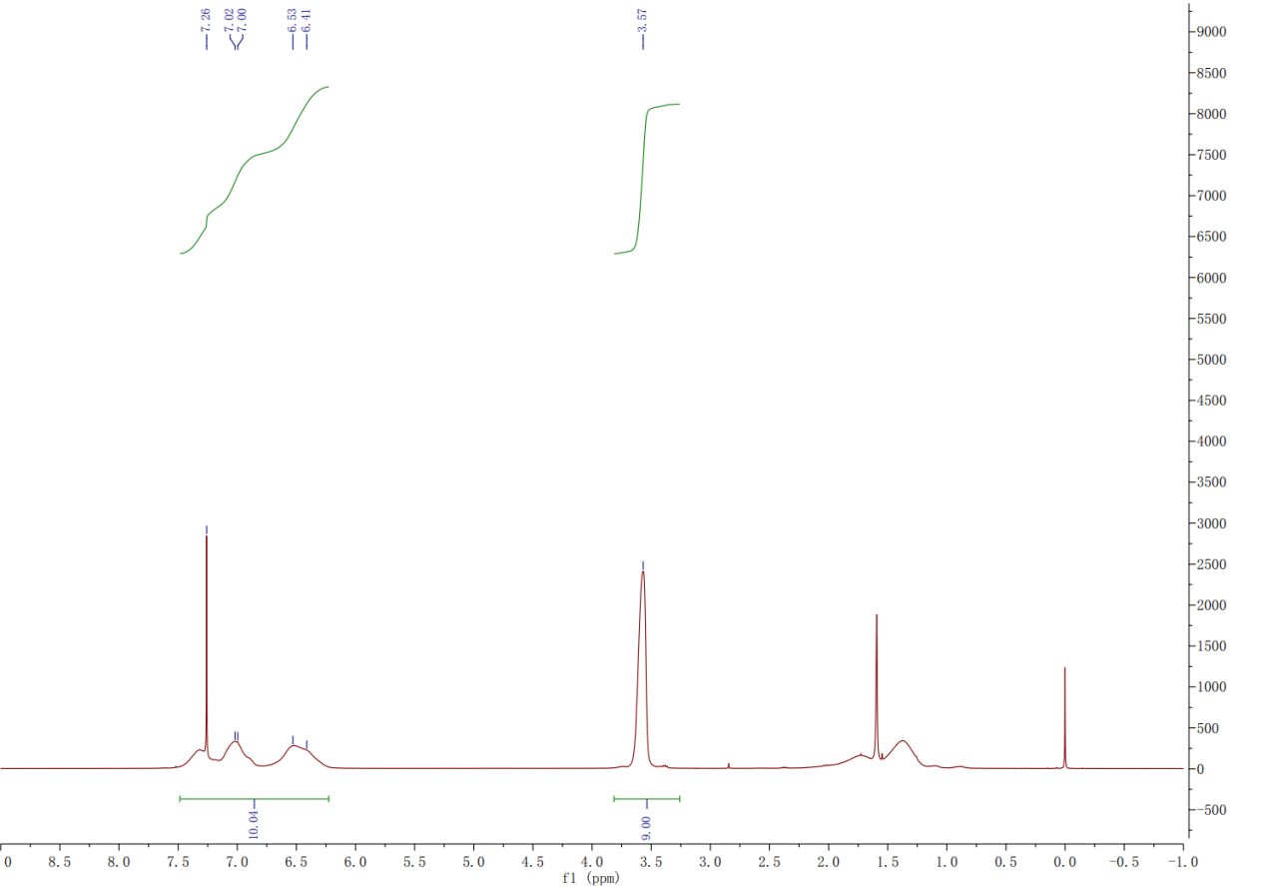
X=0.5

Fig. S2 (a) Proposed mechanism for the formation of polymer, schematic illustration of the materials preparation process of (b) polymer, (c) HP/CB-PCMs.
(a)
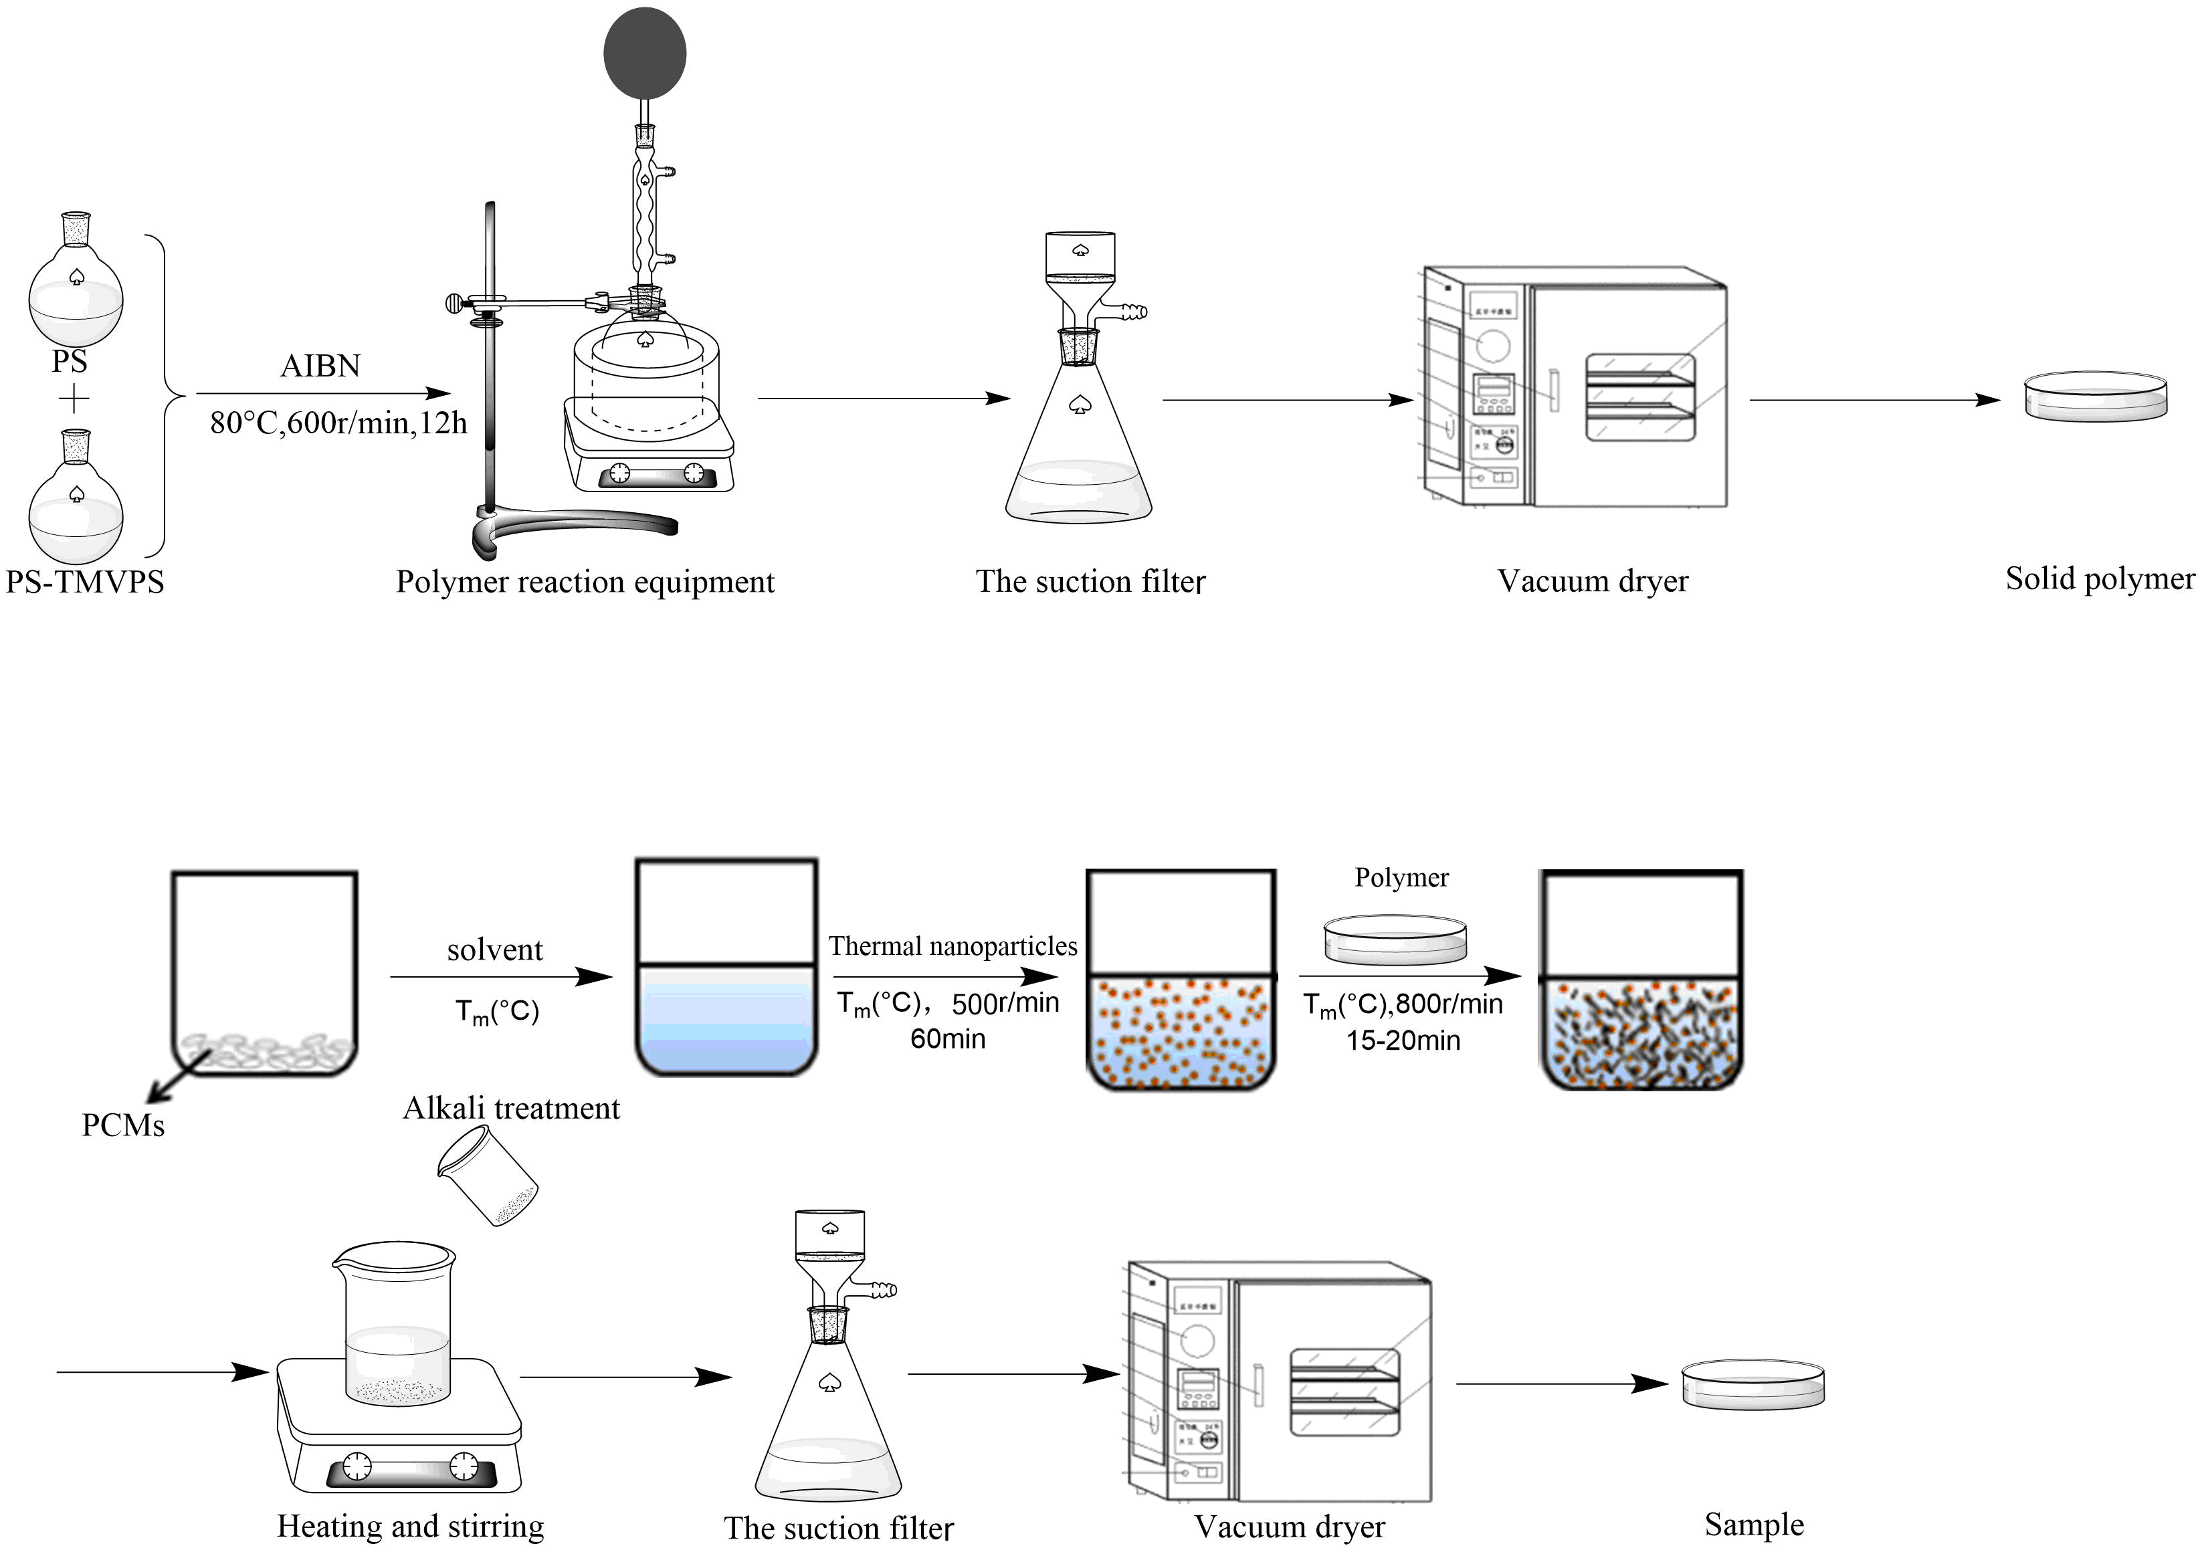
(b)
(c)
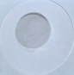
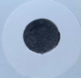
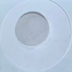
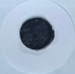
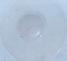
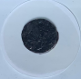
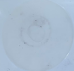
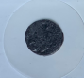
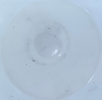
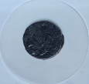
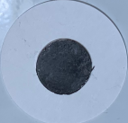
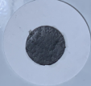
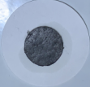
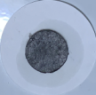
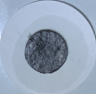
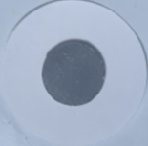
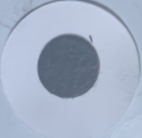
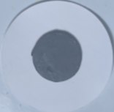
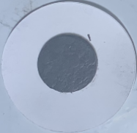
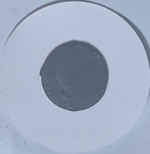
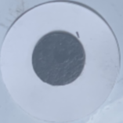
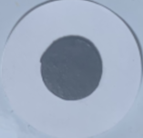
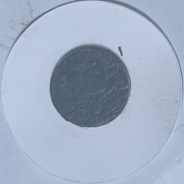
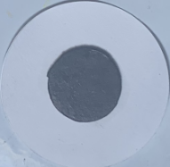
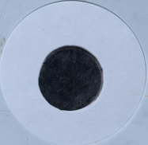
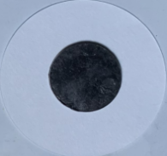
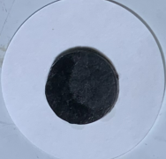
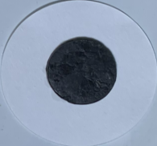
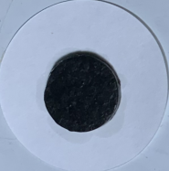
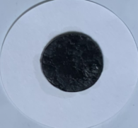
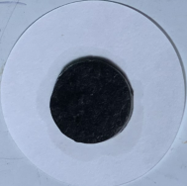
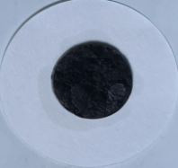
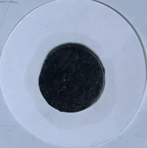
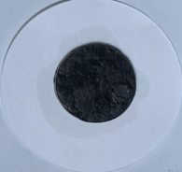
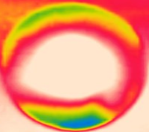
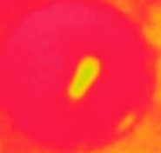
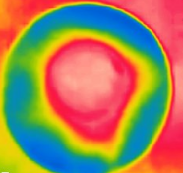
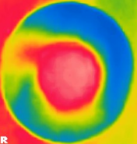
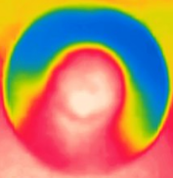
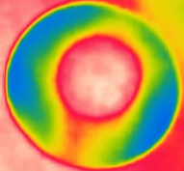
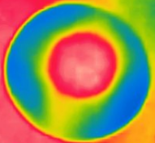
Fig. S3 Leakage testing of different HP/CB-OPCMs composite.
CB-OPCMs
80°C, 20min
Paraffin wax
80°C, 5min
80°C, 10min
80°C, 15min
HP/CB-OPCMs(5:5)
HP/CB-OPCMs(6:4)
HP/CB-OPCMs(7:3)
HP/CB-OPCMs(8:2)
HP/CB-OPCMs(9:1)
Infrared image
Fig. S4 SEM images of (a) HP/CB-OPCMs (9:1), (b) HP/CB-OPCMs (8:2), (c) HP/CB-OPCMs (7:3), (d) HP/CB-OPCMs (6:4), (e) HP/CB-OPCMs (5:5).
(a)
(b)
(d)
(e)
(c)
100 μm
100 μm
100 μm
100 μm
100 μm

Fig. S5 DSC curves of HP/CB-OPCMs composites with different monomer. (a) HP/CB-OPCMs (9:1); (b) HP/CB-OPCMs (8:2); (c) HP/CB-OPCMs (7:3); (d) HP/CB-OPCMs (6:4); (e) HP/CB-OPCMs (5:5).
(b)
(a)
(d)
(c)
(e)

Fig. S6 DSC curves of HP/CB-PCMs inorganinc composites with different monomer. (a) HP/CB-PCMs (9:1); (b) HP/CB-PCMs (8.5:1.5); (c) HP/CB-PCMs (8:2); (d) HP/CB-PCMs (7.5:2.5); (e) HP/CB-PCMs (7:3).
(a)
(d)
(c)
(b)
(e)

Fig. S7 SEM images of (a) HP/CB-IPCMs (9:1), (b) HP/CB-IPCMs (8.5:1.5), (c) HP/CB-IPCMs (8:2), (d) HP/CB-IPCMs (7.5:2.5), (e) HP/CB-IPCMs (7:3).
(b)
(a)
(e)
(c)
(d)
100 μm
100 μm
100 μm
100 μm
100 μm

Fig. S8 Leakage testing of different HP/CB-IPCMs composite.
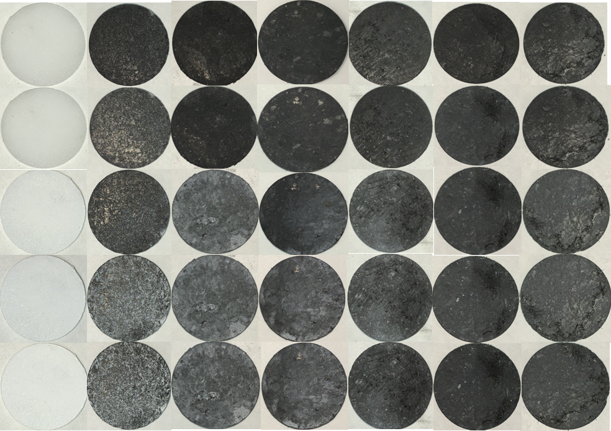
65°C,15min
65°C,10min
65°C,5min
65°C,2min
SAT
HP/CB-IPCMs(7:3)
HP/CB-IPCMs(7.5:2.5)
HP/CB-IPCMs(8:2)
HP/CB-IPCMs(8.5:1.5)
HP/CB-IPCMs(9:1)
CB-IPCMs
Fig. S9 (a) Photograph of light-to-thermal energy conversion and storage measuring platform; (b) photograph of Contact Angle test platform and (c) photograph of the thermal energy storage and release tests.
(a)
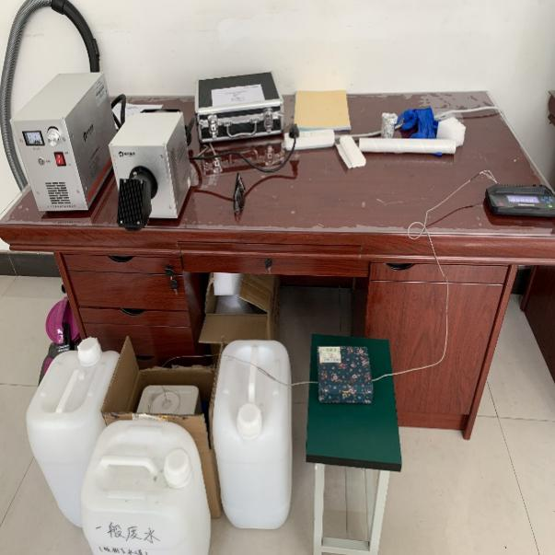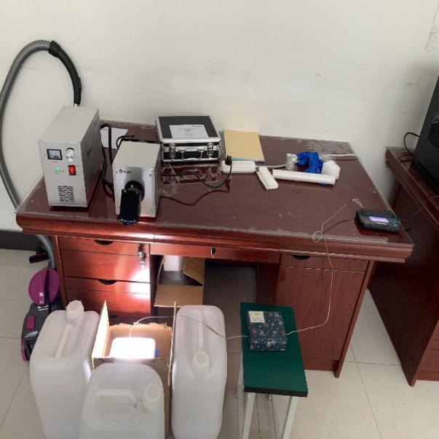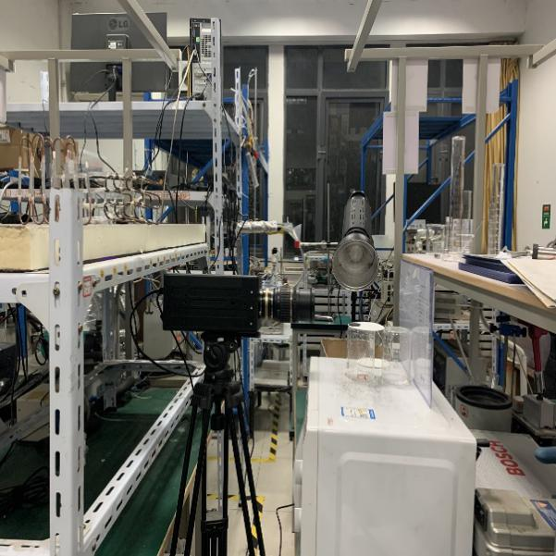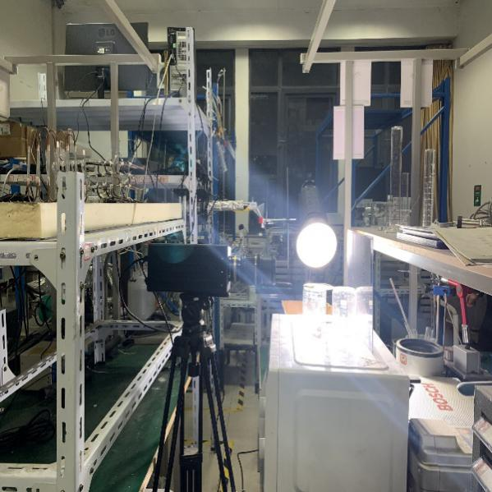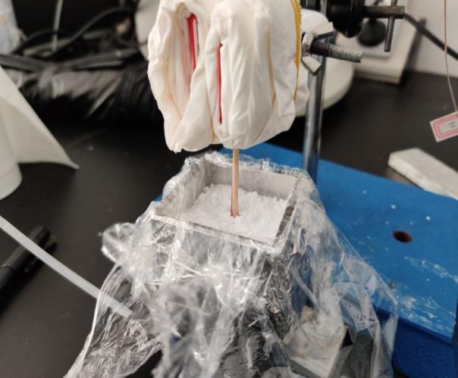
Heat storage unit
Laboratory spotlight
Date analyzer unit
High speed camera
Sample Foam box
Simulant light source
(c)
(b)

Fig. S10 Verification test of hypercrosslinked reaction of hybrid polymer, (a) Comparison diagram of polymer crosslinking with different monomer proportions. (b) General diagram of verification of all samples;
(a)
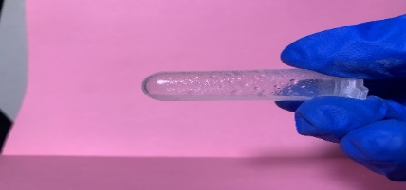
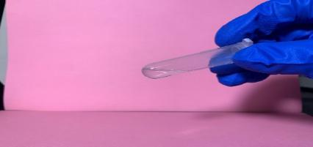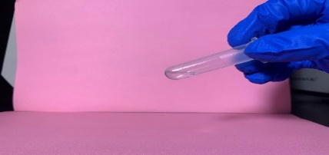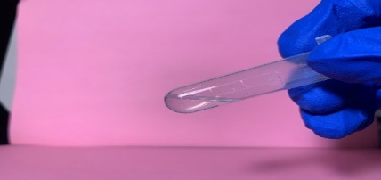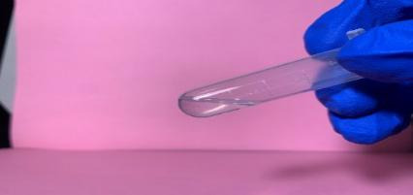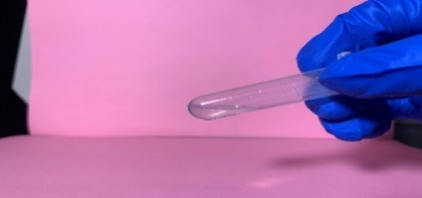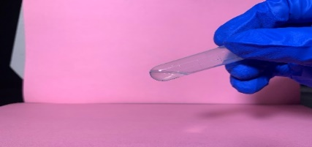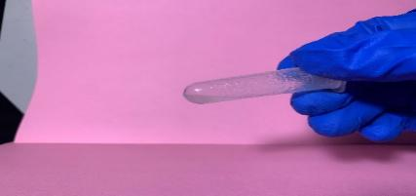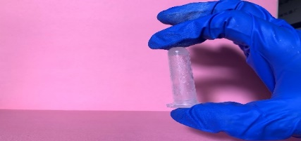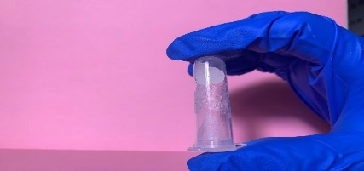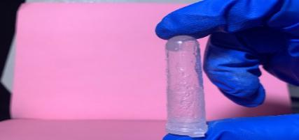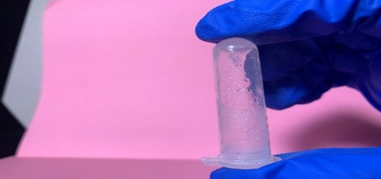
(b)
HP (5:5)
HP (5:5)
HP (6:4)
HP (6:4)
HP (7:3)
HP (7:3)
HP (7.5:2.5)
HP (7.5:2.5)
HP (8:2)
HP (8:2)
HP (8.5:1.5)
HP (8.5:1.5)
HP (9:1)
HP (9:1)
alkali treatment
80°C,30s
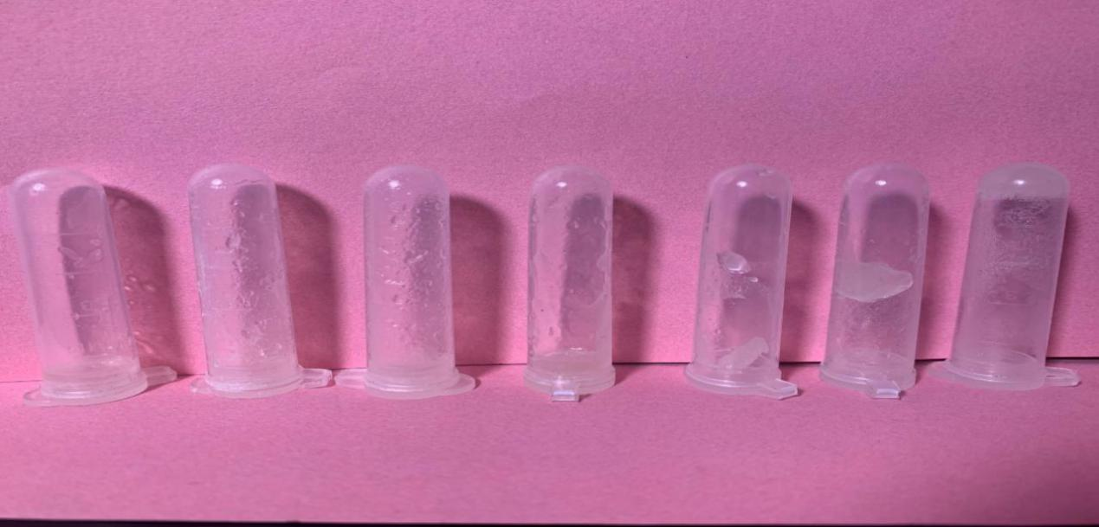
HP (8:2)
HP (9:1)
HP (8.5:1.5)
(b)
HP (5:5)
HP (6:4)
HP (7:3)
HP (7.5:2.5)

Fig. S11 Schematic diagram of the supercooling degree test.
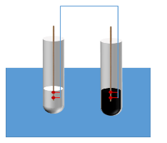
Supercooling test platform
80-20°C

Data collector unit

Data analyzer unit
Table S1 Comparison of research work between different scholars.
name | Thermal conductivity(W (m⁻¹ K⁻¹)) | Photothermal conversion efficiency(%) | Journal | Year
Yang′s work¹ | 10.54 | 95 | Applied Thermal Engineering | 2019
Liu′s work² | 3.7 | 93 | International Journal of Heat and Mass Transfer | 2019
Liu′s work³ | 55.37 | 93.8 | Journal of Materials Chemistry A | 2020
Mishra′s work⁴ | 0.55 | 68 | Energy | 2020
Du′s work⁵ | 0.448 | 87.6 | Cellulose | 2020
Zhang′s work⁶ | 0.414 | 88.7 | Applied Energy | 2018
Du′s work⁷ | 0.421 | 89.3 | Acs Sustainable Chemistry & Engineering | 2019
Yang′s work⁸ | 0.54 | 81 | International Journal of Energy Research | 2020

Table S2 Parameters of paraffin and carbon black composites.
CB(g)-OPCMs(g)ª | Sample quality before leakage quality(g) | Sample quality after leakage quality(g) | Leakage rate(%) | Time^{b}(min)
2-5 | 3.0150 | 2.3109 | 23 | 23
2.5-5 | 2.9992 | 2.6455 | 11.70 | 23
3-5 | 3.0203 | 2.7330 | 9.50 | 23
3.5-5 | 3.0394 | 2.7624 | 9.10 | 23
4-5 | 3.0094 | 2.8186 | 6.30 | 23
4.5-5 | 2.9416 | 2.7624 | 6.10 | 23
5-5 | 3.024 | 2.829 | 6.40 | 23
6-5 | 3.022 | 2.850 | 5.60 | 23
7-5 | 2.962 | 2.86 | 3.40 | 23
8-5 | 3.022 | 2.955 | 2.20 | 23
9-5 | 3.023 | 3g | 0.70 | 23
ª Unless otherwise stated, the melting phase transition temperature of paraffin is 60 ºC. ^{b} 23min corresponds to the time it takes for the paraffin wax to melt completely during the leak test.

Table S3 Parameters of HP/CB-OPCMs sample.
HP/CB-OPCMS ª(g) | Sample quality before leakage quality(g) | Sample quality after leakage quality(g) | Leakage rate(%) | Time(min) ^{b}
0.5/5-5 | 3.0 | 2.894 | 3.50 | 23
1.0/5-5 | 3.056 | 3.011 | 1.40 | 23
1.5/5-5 | 3.0170 | 2.9975 | 0.60 | 23
2.0/5-5 | 2.9977 | 2.9810 | 0.55 | 23
ª Unless otherwise stated, the ratio of polymer synthesized by monomer is 8:2, and the melting phase transition temperature of paraffin is 60 º C. ^{b} 23min corresponds to the time it takes for the paraffin wax to melt completely during the leak test.
Fig. S11 Leakage images of HP/CB-IPCMs.
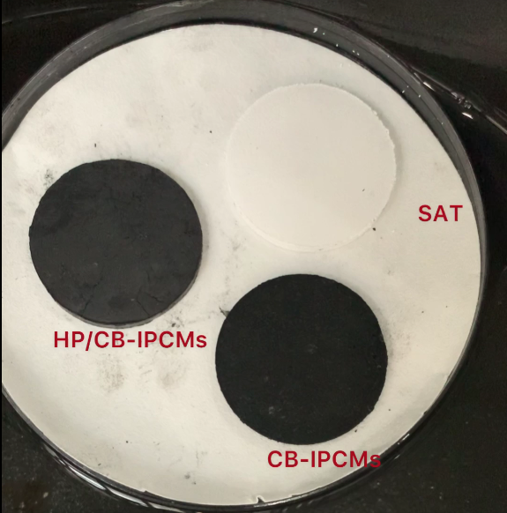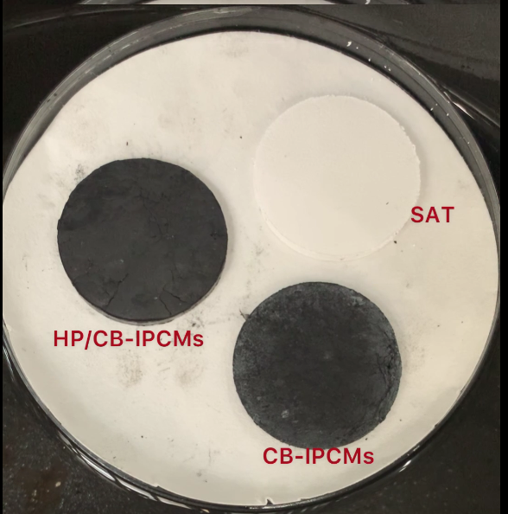
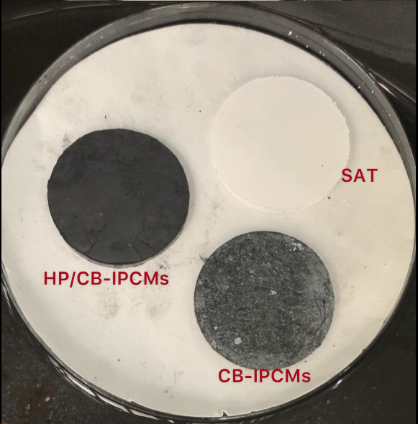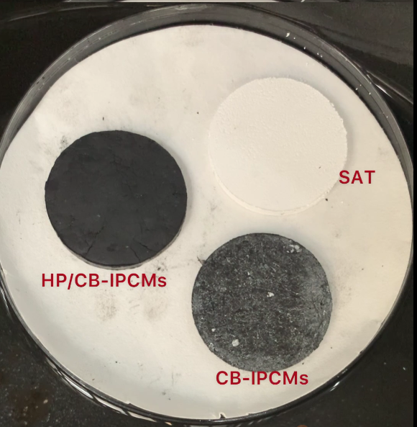

Reference
1. Yang, J.; Jia, Y. L.; Bing, N. C.; Wang, L. L.; Xie, H. Q.; Yu, W., Reduced graphene oxide and zirconium carbide co-modified melamine sponge/paraffin wax composites as new form-stable phase change materials for photothermal energy conversion and storage. Appl. Therm. Eng. 2019, 163, 9.
2. Liu, C. H.; Song, Y.; Xu, Z.; Zhao, J. T.; Rao, Z. H., Highly efficient thermal energy storage enabled by a hierarchical structured hypercrosslinked polymer/expanded graphite composite. International Journal of Heat and Mass Transfer 2020, 148, 11.
3. Liu, C. H.; Zong, J. H.; Zhang, J. H.; He, D. Q.; Guo, C. L.; Xu, B.; Rao, Z. H., Knitting aryl network polymers (KAPs)-embedded copper foam enables highly efficient thermal energy storage. J. Mater. Chem. A 2020, 8 (30), 15177-15186.
4. Mishra, A. K.; Lahiri, B. B.; Philip, J., Carbon black nano particle loaded lauric acid-based form-stable phase change material with enhanced thermal conductivity and photo-thermal conversion for thermal energy storage. Energy 2020, 191, 15.
5. Du, X. S.; Zhou, M.; Deng, S.; Du, Z. L.; Cheng, X.; Wang, H. B., Poly(ethylene glycol)-grafted nanofibrillated cellulose/graphene hybrid aerogels supported phase change composites with superior energy storage capacity and solar-thermal conversion efficiency. Cellulose 2020, 27 (8), 4679-4690.
6. Zhang, Y.; Wang, J. S.; Qiu, J. J.; Jin, X.; Umair, M. M.; Lu, R. W.; Zhang, S. F.; Tang, B. T., Ag-graphene/PEG composite phase change materials for enhancing solar-thermal energy conversion and storage capacity. Applied Energy 2019, 237, 83-90.
7. Du, X. S.; Xu, J. I.; Deng, S.; Du, Z. L.; Cheng, X.; Wang, H. B., Amino-Functionalized Single-Walled Carbon Nanotubes-Integrated Polyurethane Phase Change Composites with Superior Photothermal Conversion Efficiency and Thermal Conductivity. Acs Sustainable Chemistry & Engineering 2019, 7 (21), 17682-17690.
8. Yang, L.; Yuan, Y. P.; Zhang, N.; Dong, Y. F.; Sun, Y. F.; Ji, W. H., Photo-to-thermal conversion and energy storage of lauric acid/expanded graphite composite phase change materials. Int. J. Energy Res. 2020, 44 (11), 8555-8566.

