Metapopulation of Ellobium chinense through the Late-middle and Late Pleistocene expansions: four covariate COI hotspots linked to G-quadruplex conformation

Cho Rong Shin, Eun Hwa Choi, Gyeongmin Kim, Su Youn Baek, Bia Park, Jihye Hwang, Jumin Jun, Hyun Jong Kil, Hyunkyung Oh, Kyungjin Lee, Sa Heung Kim, Jongrak Lee, Seung Jik Suh, Dong-min Park, Ho Young Suk, Yong Seok Lee, Young Sup Lee, and Ui Wook Hwang

*To whom co-correspondence should be addressed Prof. Ui Wook Hwang (email: uwhwang1@gmail.com)

Scientific Reports
2021. 01. 22.

Table S1. Primer sequences, repeat motifs, and expected sizes for the 10 microsatellite loci selected for genotyping the endangered species Ellobium chinense inhabiting in South Korea and Japan.

Loci | Primer sequences (5'-3') | Repeat motifs | Expected sizes (bp) | GenBank Acc. No.
ECHm13 | TTACTGGTGGTCTCCCCTGT | (GTT)₁₅ | 372 – 474 |  | KX881643
ECHm13 | ACGCTAACATGTGGTGCTCT | (GTT)₁₅ |  |  | KX881643
ECHm24 | GTGGATCCGTACCGTCCATC | (ATCC)₁₀ | 212 – 276 |  | KX881646
ECHm24 | AAAGGGGTAGTTGCCTTGGG | (ATCC)₁₀ |  |  | KX881646
ECHm27 | GCCAGCTTTGTCTCTCCAGA | (GCTT)₁₁ | 370 – 454 |  | KX881647
ECHm27 | CAGTATAGACCAGCCCGCAG | (GCTT)₁₁ |  |  | KX881647
ECHm28 | ACCCGCTCAAACTTTAGGCA | (ATCC)₁₂ | 277 – 416 |  | KX881648
ECHm28 | TGGTGTGCAGGTCTGTGAAA | (ATCC)₁₂ |  |  | KX881648
ECHm31 | TCAACGGTGCTTTAGCCACT | (CTTT)₁₂ | 418 – 502 |  | KX881650
ECHm31 | CATCTGGTTTGGGGGTGTGA | (CTTT)₁₂ |  |  | KX881650
ECHm35 | GTCACAGTGACCACTCCTGG | (GGAT)₁₅ | 293 – 457 |  | KX881653
ECHm35 | GCGTTTGACAAACAGCCAGT | (GGAT)₁₅ |  |  | KX881653
ECHm36 | TTGGGCCAAGTCCAGTTGAA | (AAGG)₁₈ | 287 – 506 |  | KX881654
ECHm36 | TCCGATGCACCCACACATAA | (AAGG)₁₈ |  |  | KX881654
ECHm40 | AGAAAGAACAGGCCCAGGTG | (ATGT)₂₀ | 219 – 375 |  | KX881656
ECHm40 | GATGGACAGGCAGGCAAGTA | (ATGT)₂₀ |  |  | KX881656
ECHm41 | TTCCGTTACCATCGGGAAGG | (CATT)₂₁ | 322 – 422 |  | KX881657
ECHm41 | TTTCATCCCCCTGCCTTTGT | (CATT)₂₁ |  |  | KX881657
ECHm45 | CAAAGACCGTTTTCGTCGCA | (AAAC)₂₂ | 234 – 338 |  | KX881658
ECHm45 | TGTTGATCTCCACTGTGGCC | (AAAC)₂₂ |  |  | KX881658

Table S2. The summary of 58 COI haplotypes observed from 140 COI sequences of Ellobium chinense along the nine populations in South Korea and Japan.
Haplotypes |  |  | South Korea |  |  |  |  |  | JK* | Total | GenBank Acc. No.
Haplotypes | SC | BG | YG | HK | JB | BY | GY | HS | JK* | Total | GenBank Acc. No.
ECH01 | 1 | 5 | 7 |  | 1 | 2 | 2 | 9 |  | 27 | MK696959.1, MK696968.1,  MK696967.1, MK696948.1
ECH02 |  | 1 |  |  |  |  |  |  |  | 1 | MW265437
ECH03 |  | 1 |  |  |  |  |  |  |  | 1 | MW265438
ECH04 |  | 1 |  | 1 |  | 3 |  |  |  | 5 | MK696961.1
ECH05 |  | 1 |  |  |  | 2 |  | 3 |  | 6 | MK696964.1
ECH06 |  | 1 |  |  |  |  |  |  |  | 1 | MW265439
ECH07 |  | 1 |  |  |  |  |  |  |  | 1 | MW265440
ECH08 |  | 1 |  |  |  |  |  |  |  | 1 | MW265441
ECH09 |  | 1 |  | 1 |  |  |  | 1 |  | 3 | MW265442
ECH10 |  | 1 |  |  |  |  |  |  |  | 1 | MW265443
ECH11 |  | 1 |  |  |  |  |  | 1 |  | 2 | MW265444
ECH12 |  | 1 | 2 |  |  |  |  | 1 |  | 4 | MW265445
ECH13 |  | 3 | 1 | 1 |  |  |  | 4 |  | 9 | MK696953.1, MK696952.1, MK696950.1
ECH14 |  | 1 |  |  |  |  |  |  |  | 1 | MK696951.1
ECH15 |  | 1 | 3 |  |  |  |  |  |  | 4 | MK696949.1
ECH16 |  |  | 3 |  |  | 2 | 1 | 3 |  | 9 | MW265446
ECH17 |  |  |  |  |  | 1 |  |  |  | 1 | MW265447
ECH18 | 1 |  |  | 1 |  | 1 |  | 1 |  | 4 | MK696965.1, MK696946.1
ECH19 |  |  |  |  |  | 1 |  |  |  | 1 | MW265448
ECH20 |  |  | 3 | 3 | 1 | 1 | 2 | 6 |  | 16 | MK696957.1, MK696954.1, MK696963.1
ECH21 |  |  |  |  |  | 2 |  |  |  | 2 | MK696962.1, MK696960.1
ECH22 |  |  |  |  |  |  | 1 |  |  | 1 | MW265449
ECH23 |  |  |  |  |  |  | 1 |  |  | 1 | MW265450
ECH24 |  |  |  |  |  |  | 1 |  |  | 1 | MW265451
ECH25 |  |  |  |  |  |  | 1 |  |  | 1 | MW265452
ECH26 |  |  |  | 1 |  |  |  | 2 |  | 3 | MW265453
ECH27 |  |  |  | 1 |  |  |  |  |  | 1 | MW265454
ECH28 |  |  |  | 1 |  |  |  |  |  | 1 | MW265455
ECH29 |  |  |  | 2 |  |  |  |  |  | 2 | MW265456
ECH30 |  |  |  | 1 |  |  |  |  |  | 1 | MW265457
ECH31 |  |  |  | 1 |  |  |  |  |  | 1 | MK696958.1
ECH32 |  |  |  | 1 |  |  |  |  |  | 1 | MK696956.1
ECH33 |  |  |  | 1 |  |  |  |  |  | 1 | MK696955.1
ECH34 |  |  |  |  |  |  |  | 1 |  | 1 | MW265458
ECH35 |  |  |  |  |  |  |  | 1 |  | 1 | MW265459
ECH36 |  |  |  |  |  |  |  | 1 |  | 1 | MW265460
ECH37 |  |  |  |  |  |  |  | 1 |  | 1 | MW265461
ECH38 |  |  |  |  |  |  |  | 1 |  | 1 | MW265462
ECH39 |  |  |  |  |  |  |  | 1 |  | 1 | MW265463
ECH40 |  |  |  |  |  |  |  | 1 |  | 1 | MW265464
ECH41 |  |  |  |  |  |  |  | 1 |  | 1 | MW265465
ECH42 |  |  |  |  |  |  |  | 1 |  | 1 | MW265466
ECH43 |  |  |  |  |  |  |  | 1 |  | 1 | MK696966.1
ECH44 | 1 |  |  |  |  |  |  |  |  | 1 | MK696947.1
ECH45 | 1 |  |  |  |  |  |  |  |  | 1 | MK696945.1
ECH46 | 1 |  |  |  |  |  |  |  |  | 1 | MK696944.1
ECH47 |  |  | 1 |  |  |  |  |  |  | 1 | MW265467
ECH48 |  |  | 1 |  |  |  |  |  |  | 1 | MW265468
ECH49 |  |  | 1 |  |  |  |  |  |  | 1 | MW265469
ECH50 |  |  | 1 |  |  |  |  |  |  | 1 | MW265470
ECH51 |  |  | 1 |  |  |  |  |  |  | 1 | MW265471
ECH52 |  |  | 1 |  |  |  |  |  |  | 1 | MW265472
ECH53 |  |  | 1 |  |  |  |  |  |  | 1 | MW265473
ECH54 |  |  | 1 |  |  |  |  |  |  | 1 | MW265474
ECH55 |  |  | 1 |  |  |  |  |  |  | 1 | MW265475
ECH56 |  |  | 1 |  |  |  |  |  |  | 1 | MW265476
ECH57 |  |  |  |  |  |  |  | 1 |  | 1  1 | MW265477
ECH58 |  |  |  |  |  |  |  |  | 1 | 1  1 | KM281098.1
Total | 5 | 21 | 29 | 16 | 2 | 15 | 9 | 42 | 1 | 140
*Japan. The localities of the populations refer to Table 1 and Figure 1.

Table S3. Pairwise F_{ST} values estimated with 140 COI sequences from Ellobium chinense along the nine populations in South Korea and Japan.
Populations |  |  | South Korea |  |  |  |  |  | JK*
Populations | BG | BY | GY | HK | HS | JB | YG | SC | JK*
BG | 0
BY | -0.01429 | 0
GY | -0.02505 | -0.01798 | 0
HK | 0.00060 | -0.00744 | -0.03204 | 0
HS | -0.01146 | -0.01389 | -0.02311 | -0.01664 | 0
JB | -0.08155 | -0.00371 | -0.21177 | -0.12690 | -0.12255 | 0
YG | 0.00644 | 0.01001 | -0.03209 | 0.02426 | 0.00935 | -0.12712 | 0
SC | -0.02042 | -0.04433 | -0.04716 | -0.01570 | -0.04828 | -0.13654 | -0.05606 | 0
JK | 0.06400 | 0.01984 | -0.04082 | -0.03415 | 0.00697 | 0.09091 | 0.06293 | -0.06897 | 0
*Japan. The lowest and highest values are highlighted in bold. The localities of the populations refer to Table 1 and Figure 1.
Table S4. Analysis of molecular variance (AMOVA) results performed with the COI sequences of 140 individuals from the nine populations of Ellobium chinense.
Source of variation | Df¹⁾ | Sum of squares | Variance components | Percentage of variation²⁾
Among populations | 8 | 17.657 | -0.02692 | -1.05
Within populations | 131 | 339.393 | 2.59079 | 101.05
Total | 139 | 357.050 | 2.56387 | 100.00
1) Degree of freedom
2) The distribution of variation at a given level of hierarchy (among/within populations).

Table S5. Genetic diversity estimated with the 10 microsatellite loci from 54 individuals representing the four populations of Ellobium chinense inhabiting South Korea and Japan.
Populations | N | N_{A} | N_{E} | H_{O} | H_{E} | F_{IS}
BG | 16 | 16.0 | 11.189 | 0.800 | 0.909 | 0.121
YG | 10 | 11.4 | 8.537 | 0.810 | 0.875 | 0.078
HK | 10 | 10.5 | 8.127 | 0.870 | 0.870 | 0.060
HS | 18 | 15.7 | 10.126 | 0.881 | 0.881 | 0.103
Total/Mean | 54 | 13.4 | 9.495 | 0.806 | 0.883 | 0.090
N: sample size (= the number of genotyped individuals), N_{A}: the mean number of alleles, N_{E}: the number of effective alleles, H_{O}: observed heterozygosity, H_{E}: expected heterozygosity, F_{IS}: inbreeding coefficient (indicates populations with heterozygote deficit). The localities of the populations refer to Table 1 and Figure 1.

Table S6. Pairwise F_{ST} and R_{ST} values obtained from the AMOVA test (analysis of molecular variance) using the 10 selected microsatellite loci, with 54 individuals representing the four populations of Ellobium chinense in South Korea and Japan.
Populations | BG | YG | HK | HS
BG |  | 0.0018 | 0.0000 | 0.0000
YG | 0.0054 |  | 0.0000 | 0.0141
HK | 0.0089 | 0.0146 |  | 0.0000
HS | 0.0120* | 0.0077 | 0.0184*
Below diagonal: pairwise Fst values between the populations, above diagonal: pairwise Rst values between the populations. The localities of the populations refer to Table 1 and Figure 1. Statistically significant values are written in bold: *P < 0.05.

Table S7. Analysis of molecular variance (AMOVA) results among the four populations of Ellobium chinense in South Korea and Japan, analyzed with the 10 selected microsatellite markers.
Source of variation | Df¹⁾ | Sum of Squares | Variance components | Percentage of variation²⁾
Among populations | 3 | 17.894 | 0.02794 | 0.60
Among individuals within populations | 50 | 261.384 | 0.60458 | 13.00
Within populations | 54 | 217.000 | 4.01852 | 86.40
Total | 107 | 496.278 | 4.65104 | 100.00
1) Degree of freedom
2) The distribution of variation at a given level of hierarchy (among populations/within populations).

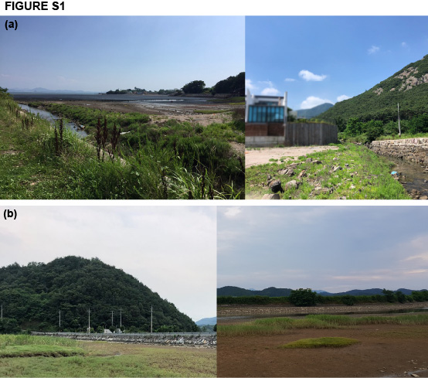

Figure S1. Photographs of the habitat landscapes of the land snail Ellobium chinense in South Korea. (a) The estuary of the Dongjin River, South Korea, where is close to salt marsh. E. chinense dwells between-stones and halophytes at this site. The photo was taken by CRS. in Byeonsan-myeon, Buan, Jeonbuk, South Korea. (b) The downstream region of the Seomjin River, South Korea, where is a little further from the shore. E. chinense mainly inhabits Zoysia sinica at this site. The photo was taken by CRS. in Jingyo-myeon, Hadong, Gyeongnam, South Korea.
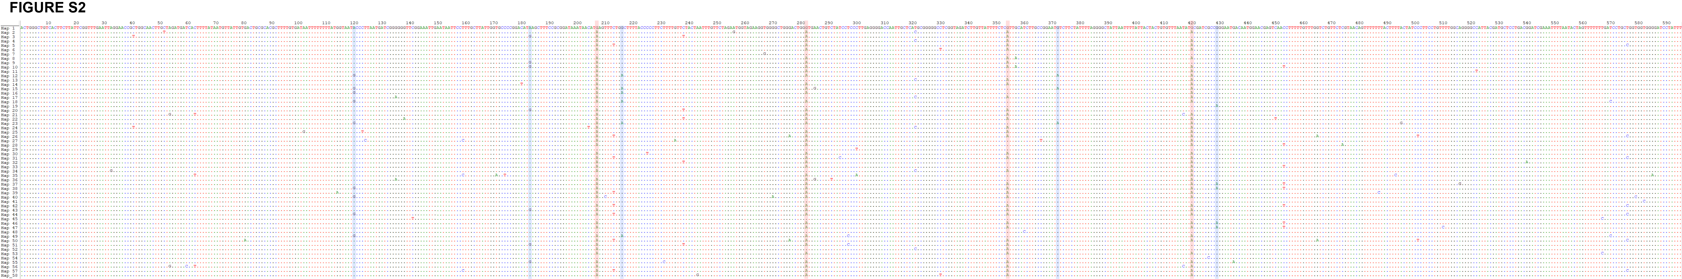

Figure S2. The sequence alignment of 58 COI haplotypes obtained from 140 Ellobium chinense individuals collected from South Korea and Japan. The dots mark sequences that are the same as those from the first line, ECH01. The four columns colored light pink indicate the four unidirectional stepwise A→G transition hotspots, which could be key sequences for classifying the haplotypes. The five sites partially colored with light aquamarine are additional A→G transitions, with a few exceptional G→A transitions.

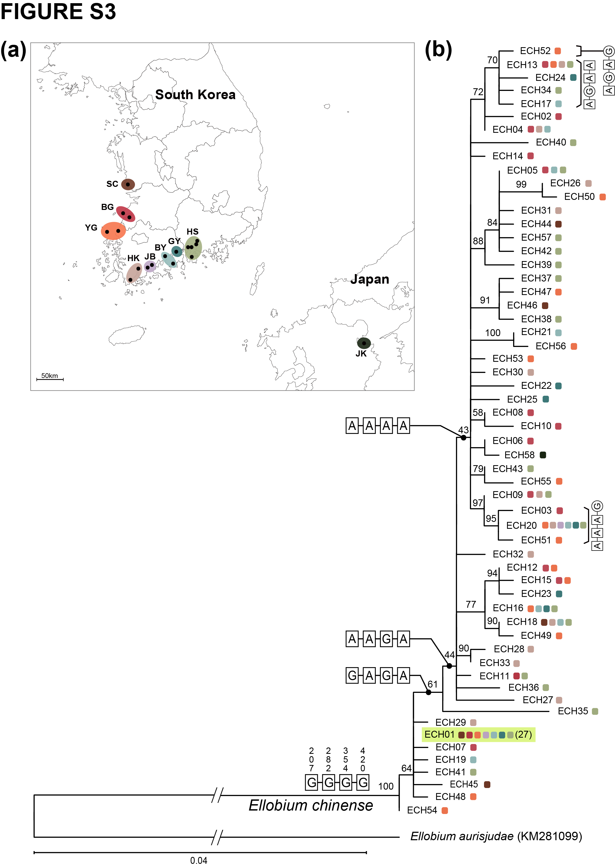

Figure S3. An outgroup-rooted maximum likelihood tree based on 58 COI haplotypes obtained from 140 Ellobium chinense individuals collected from South Korea and Japan. The numbers indicate bootstrap support values; when the value was <40, the branches collapsed. The color boxes on the map and the maximum likelihood tree indicate populations from sample collection sites. The dominant haplotype was ECH01, which was observed in 27 individuals of E. chinense from the eight collection sites at South Korea. The four genetic groups, namely A-A-A-A, A-A-G-A, G-A-G-A, and G-G-G-G, are depicted on the nodes of the maximum likelihood tree. Ellobium aurisjudae was used as an outgroup.
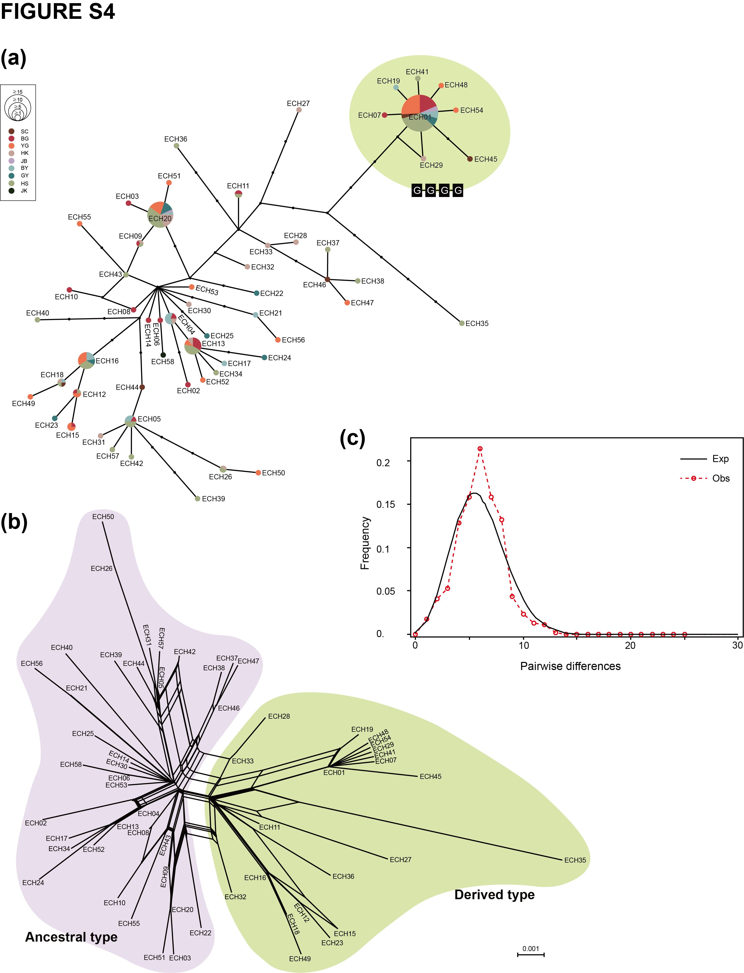

Figure S4. TCS network analysis, phylogenetic network analysis, and mismatch distribution analysis (MDA) based on 58 COI haplotypes obtained from 140 Ellobium chinense individuals collected from South Korea and Japan. (a) TCS network analysis results. Each of the crosshatched black dots represents one base pair difference between the haplotypes, and haplotype frequency is reflected by the size of the circle. The colors of the circles mark the collection sites at which the haplotypes were sampled. The COI haplotypes are listed with the GenBank accession numbers in Table S2. The most derived group of G-G-G-G is indicated by a light green-colored circle. (b) Phylogenetic network analysis results. The examined haplotypes were apparently closely related and exhibited metapopulation dynamics. The gray and light green areas indicate the ancestral genetic group and derived group, respectively. (c) MDA results. The unimodal graph implies that all the examined haplotypes form a single large metapopulation with frequent genetic flows.

Figure S5. Molecular clock analysis based on 58 COI haplotypes obtained from 140 Ellobium chinense individuals collected from South Korea and Japan. Analysis was conducted in BEAST 2.6.0. The first appearance of the subfamily Ellobiinae was estimated to be approximately 58.0 mya based on the BEAST result. Refer to Fig. 4b for the detailed divergence times of the COI haplotypes of E. chinense. Outgroups and calibration point are described in the Materials and Methods.

Data S1. The alignment set of the 140 COI sequences of Ellobium chinense inhabiting South Korea and Japan, among which 103 COI sequences were obtained from the present study and 37 COI sequences were retrieved from the GenBank database.

Data S2. The sequence alignment set of the 58 COI haplotypes observed in 140 individuals of Ellobium chinense inhabiting South Korea and Japan, which are from the results of the present study and retrieved ones from the GenBank database.

Data S3.

Data S4. Putative GQRS-Conserve motifs capable of G-quadruplex structures on CDS of the COI barcoding region of Ellobium chinense inhabiting South Korea and Japan. The green boxes mean the selected plausible G-quadruplex motifs shown in Figure 2b.

