Supplementary Data

Orally bioavailable Bruton’s tyrosine kinase proteolysis-targeting chimeras active against wild-type and C481 mutant BTKs in murine hematology models
Ye Seul Lim^{#1}, Sun-Mi Yoo^{#1}, Vineet Patil^{2,3}, Han Wool Kim¹, Hyun-Hwi Kim¹, Beomseon Suh¹, Ji Youn Park¹, Na-rae Jeong¹, Chi Hoon Park^{2,3}, Je Ho Ryu¹, Byung-Hoon Lee⁴, Pilho Kim^{2,3*}, and Song Hee Lee^{1*}
¹Ubix Therapeutics, #1508, 7, Beobwon-ro 11-gil, Songpa-gu, Seoul, 05836, South Korea; ²Therapeutics & Biotechnology Division, Korea Research Institute of Chemical Technology, 141 Gajeong-ro, Yuseong-gu, Daejeon, South Korea; ³Department of Medicinal Chemistry and Pharmacology, University of Science & Technology, 217, Gajeong-ro, Yuseong-gu, Daejeon, South Korea; ⁴Department of New Biology, Daegu Gyeongbuk Institute of Science and Technology (DGIST), Daegu 42988, Korea

# These authors contributed equally to this work.

*Corresponding authors:

Song Hee Lee
Ubix Therapeutics, #1508, 7, Beobwon-ro 11-gil, Songpa-gu, Seoul, 05836, South Korea
Phone: +82-10-3390-3745
Fax: +82-2-6334-2476
Email: shlee@ubixtrx.com

Pilho Kim
Therapeutics & Biotechnology Division, Korea Research Institute of Chemical Technology, 141 Gajeong-ro, Yuseong-gu, Daejeon, South Korea
Phone: 82-10-5518-3069
Fax: +82-42-860-7160
Email: pkim@krict.re.kr

Supplementary Data

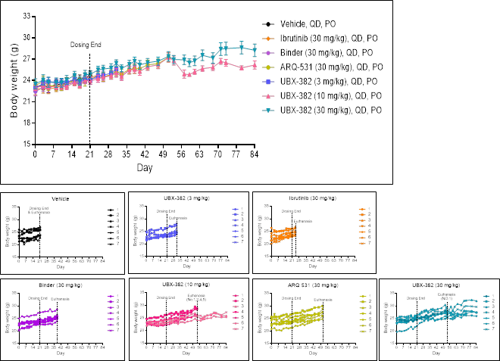
Supplementary Fig. 1. Curves of body weight in xenograft TMD-8 (BTK C481S)-bearing mice models. The mice were treated with vehicle, ibrutinib, Binder, ARQ-531, and UBX-382. Each drug was administered for 3 weeks, and the mice were euthanized when the tumor size reached an average of approximately 2000 mm³. Body weights were recorded 3 times a week, n=7 per group. Values are presented as mean ± SEM. Below data are expressed as individual mouse in each group.

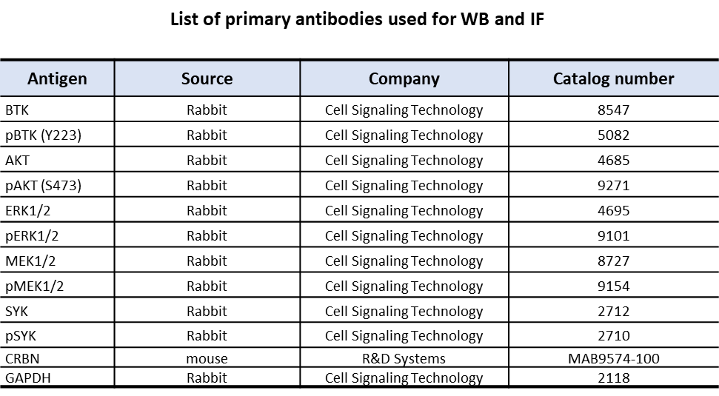
Supplementary Table 1. List of primary antibodies used for WB and IF

