Supplementary Data

Supplementary Materials and Methods

Immunohistochemistry
For immunofluorescent labelling, frozen sections were blocked for 1 hour at room temperature in blocking solution (10% normal goat serum in PBS + 0.1% Triton X-100), followed by incubation with primary antibodies against phosphorylated tau (AT8 Pierce Endogen Mouse monoclonal 1:100), Iba1 (Wako Chemicals 019-19741 Rabbit polyclonal 1:100), GFAP-Cy3 (Sigma G-A-5 Mouse monoclonal 1:1000), β-III tubulin (TUJ1, Cambridge Bioscience 3525-100 Rabbit polyclonal 1:100), Tia1 (Abcam ab205063 Rabbit polyclonal 1:50), G3BP (BD Bioscience Mouse monoclonal 1:200), FMRP (Abcam 1D10 Mouse monoclonal 1:200), for 1 hour at room temperature. Sections were washed in PBS and incubated for 2 hours at room temperature with the appropriate fluorescently labelled secondary antibodies and 4’, 6-Diamidino-2-Phenylindole (DAPI; Sigma) to label nuclei. Sudan black was applied to sections for 10 minutes to quench autofluorescence prior to coverslip mounting. Tissue sections from three mice per experimental groups were assessed for each antibody tested and compared to negative controls run simultaneously. Final fluorescent images were visualised under a Leica fluorescent microscope and analysed using Leica Application Suite software (Leica Microsystems, Germany).

Western blots

Tissue samples and patient fibroblast cultures were homogenised in RIPA buffer (2% SDS, 2 mM EDTA, 2 mM EGTA in 5mM Tris, pH 6.8) and spun at 14,000 rpm for 15 minutes to pellet the cells.
Protein concentration was determined using a colorimetric protein assay system according to manufacturer’s instructions (Bio-Rad Laboratories). Plates were incubated for 15 minutes at room temperature before absorbance was measured at 750 nm on a spectrophotometer.
Homogenised samples in Laemmli sample buffer were loaded on acrylamide gels run at 160 V for 1 hour. Proteins were transferred onto a nitrocellulose membrane (Amersham) by running at 90V for 70 minutes.
Blots were blocked in TBS+ 0.1% Tween 20+ 5% BSA for 1 hour at room temperature before incubating overnight at 4°C with primary antibody LC3 (Novus biologicals NB100 Rabbit polyclonal at 1:1,000 dilution. α-tubulin (Sigma Aldrich DM1A Mouse monoclonal) was used as a loading control. Membranes were washed in either PBS+ 0.1% TWEEN or TBS+ 0.1% TWEEN and then incubated in HRP-conjugated secondary antibodies (Dako, 1:1000; Thermo Scientific, 1:500) for 2 hours at room temperature. StrepTactin (Bio-Rad; 1:10,000) was also added for visualisation of the protein ladder. Blots were visualised using Supersignal chemiluminescent HRP substrate (Thermo Scientific). Densitometry was analysed using ImageJ software (National Institutes of Health, Bethesda, MD, USA). Densities for the samples were normalized against densities of the loading control in each blot.

TUNEL Staining

The TACS® 2 TdT Fluorescein kit (Trevigen) was used for in situ detection of apoptosis by TUNEL in VCP patient fibroblasts using the manufacturer’s instructions. Coverslips were counterstained with DAPI to label nuclei. Images were visualised using a Leica fluorescent microscope.

Supplementary Figures
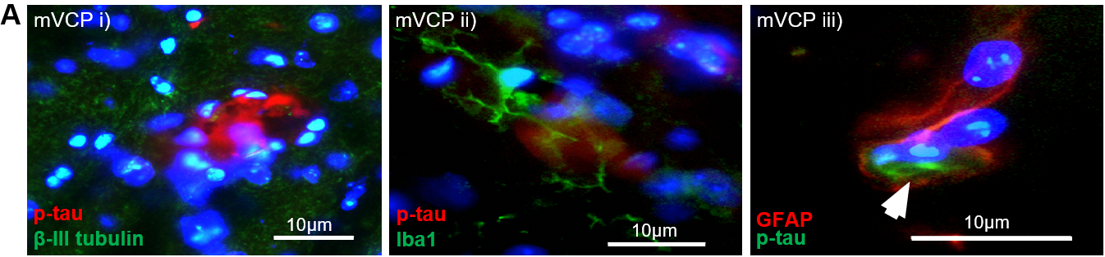
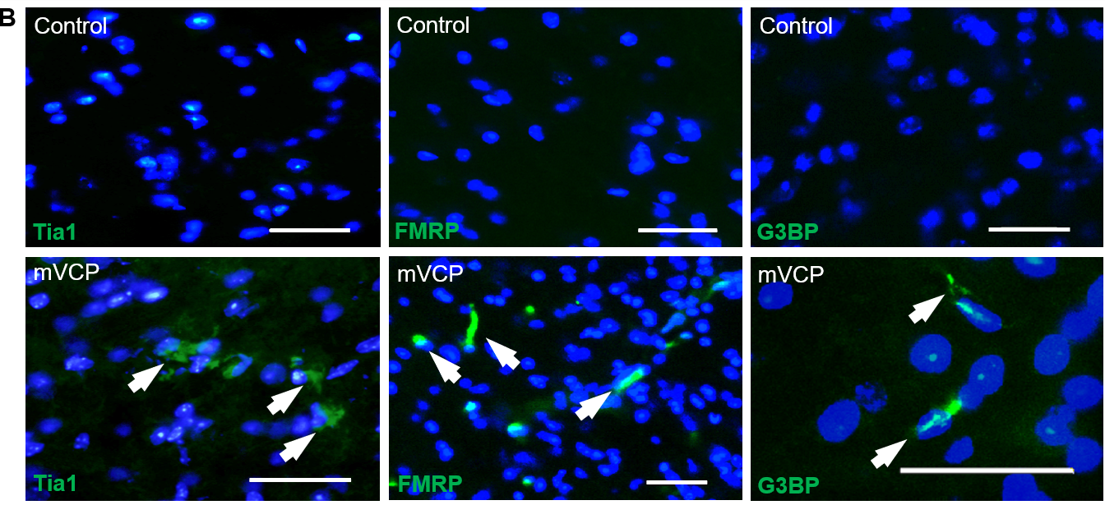

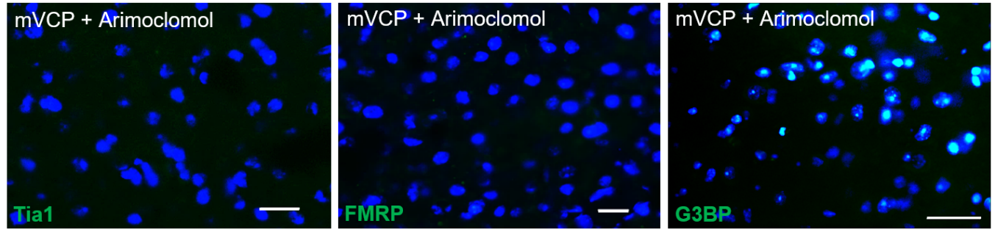

Supplementary Figure 1. Additional pathology in mouse brain shows tau pathology and aggregation of stress granule markers. (A) phosphorylated tau (p-tau)- positive extracellular lesions in mVCP mouse brain co-immunostained with i) β-III tubulin, ii) Iba1 and iii) GFAP. (B) Representative images showing immunoreactivity of stress granule markers FMRP, Tia1 and G3BP in sagittal brain sections with and without Arimoclomol treatment. DAPI labels nuclei (blue). Arrows indicate stress granule-positive aggregates. Scale bar = 20µm unless otherwise indicated.

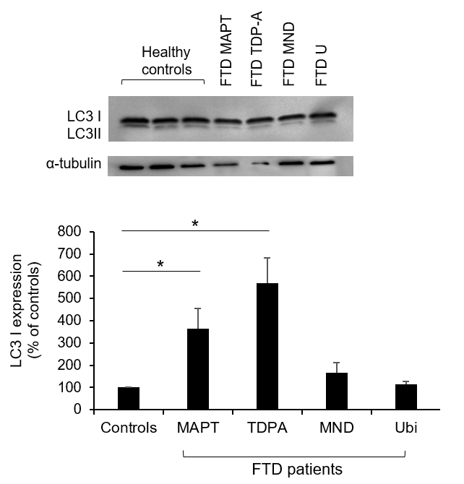

Supplementary figure 2. LC3 expression in post-mortem brain from FTD patients. Representative western blot of LC3 expression in human brain cortex, with bar chart below showing percentage relative density of LC3 I to controls. (*p<0.05, n=3).

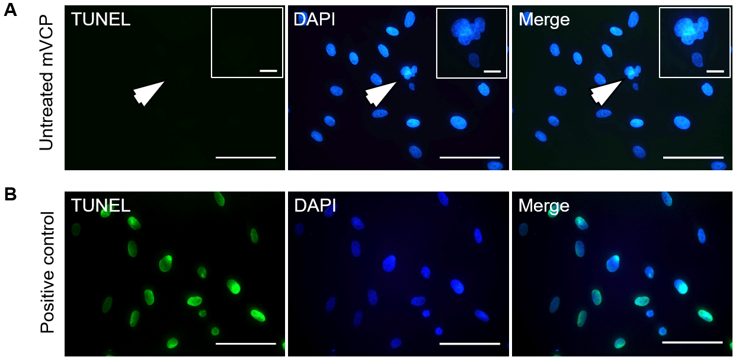
Supplementary Figure 3. Abnormal nuclear morphology in mutant VCP patient fibroblasts show no evidence of apoptosis. TUNEL analysis of (A) untreated patient fibroblasts and (B) a TACS-Nuclease-treated positive control sample, co-stained with the nuclear marker DAPI (blue). Arrows indicate a disrupted nucleus that is TUNEL-negative. Scale bar = 50μm. Insets: higher magnification. Scale bar = 10μm.

Supplementary Table 1. FTD patient information. Details of age, sex, post-mortem (PM) delay and diagnosis for patients and healthy control from whom cortical brain samples were obtained for this study.
Patient code | Age | Sex | PM delay  (hours) | FTD abbreviation | Diagnosed subtype
P27/05 | 70 | M | 9.50 | FTLD-U | FTD with ubiquitin inclusions
P28/07 | 74 | M | 19.00 | FTLD-MND | FTD associated with motor neuron disease
P65/10 | 62 | M | 93.00 | FTLD-TDPA | FTD associated with TDP-43
P6/07 | 66 | M | 80.45 | FTLD-MAPT | FTD associated with tau mutation
Control code
P44/02 | 78 | F | 23.30
P47/11 | 79 | F | 78.50
P94/05 | 71 | M | 38.50

